

MODULE: OPEN SOURCE CODING

MODULE CODE: OPSC6311
FINAL PORTFOLIO OF EVIDENCE

EduBudget – Student Personal Budget Tracker App
GROUP MEMBERS
Rafiqah Kirby – ST10438554
Armalene Magerman – ST10454097
Chloe Jade Langenhoven – ST10435895

GitHub Link: Armalene18/EDUBUDGET-APP
YouTube Demo: https://youtube.com/@rafiqahkirby7?si=v1P281Rg-AW2mTRF
Date of Submission: 15 June 2026

TABLE OF CONTENTS
1. Introduction and Objectives 3
Introduction 3
Objectives 3
How We Planned and Built EduBudget 4
Tools and Technologies Used 4
Data Layer – Room Database 5
Login and Profile Screens 5
Main App Screens 6
Final POE Feature Screens 6
3. App Screenshots and Outcomes 8
Login Screen 8
Create Profile Screen 9
Dashboard Screen 9
Add Expense Screen 10
Expense History 11
Budget Categories 11
Set Budget Goal 12
Spending Graph 13
My Badges 13
Savings Goals 14
No Spend Day Challenge 15
4. GitHub and GitHub Actions 16
GitHub Repository 16
GitHub Actions – Automated Testing 16
README File 16
5. Our Own Features 17
6. References 18

1. Introduction and Objectives

Introduction
Personal budgeting applications have become very important tools for people who want to manage their money better in a digital world. With most people using Android smartphones, budgeting apps make it easy to track spending, plan budgets, and work towards saving goals. These apps range from simple manual tracking tools to more advanced systems that use gamification to make budgeting more fun and engaging.
For this module, OPSC6311 Open-Source Coding, our group had to create a user-friendly Personal Budget Tracker app. The app had to help users track their spending habits and savings goals, and it also had to make budgeting more enjoyable through gamification elements. The app code also had to be pushed to GitHub and make use of unit testing and GitHub Actions.
We decided to build EduBudget, a budgeting app designed specifically for students in South Africa. Many students struggle with managing limited allowances, handling transport costs, buying data, and balancing school and personal expenses. EduBudget was built to give students a simple, fun, and effective way to manage their finances.
The idea for EduBudget came from the research we did in Part 1 of the POE, where we looked at three existing budgeting apps:
- WalletCorner – a gamified budgeting app that uses rewards and achievements to keep users motivated.
- Goodbudget – a traditional envelope-style budgeting system that encourages users to plan their spending before they spend.
- PocketGuard – an automated expense tracking app that shows users how much they have left to spend after bills and savings.
From this research, we identified the best features from each app and combined them into EduBudget, while also adding our own features that are relevant to South African students.

Objectives
The main goals of the EduBudget app are:
- To allow students to register and log in to the app using a username and password.
- To let users create categories for their expenses, like Groceries, Transport, and NSFAS/Allowance.
- To allow users to add expense entries with the amount, date, description, and category.
- To let users optionally attach a photo of a receipt to each expense.
- To allow users to set a monthly total budget goal and specific limits for each category.
- To let users view all their expenses over a selected time period.
- To show users how much they have spent in each category over a selected time period.
- To save all data to a local database on the device so the app works offline.
- To display a graph showing daily spending per category with minimum and maximum goal lines.
- To show a progress dashboard that highlights how well the user is staying within their budget goals, with overspending shown in red.
- To include gamification elements such as badges and challenges to reward users for good financial behaviour.
- To include at least two self-proposed features from our Part 1 design document.

How We Planned and Built EduBudget
We followed the Research – Plan – Design – Build – Evaluate cycle taught in this module:
Part 1
- Research: We each researched one budgeting app and wrote a detailed report comparing WalletCorner, Goodbudget, and PocketGuard. We looked at their features, strengths, weaknesses, and what made them unique. This helped us decide what features to include in EduBudget.
- Planning and Design : We planned EduBudget by writing out the functional and non-functional requirements, drawing wireframe designs of five screens (Login, Dashboard, Add Expense, Budget Categories, Reports/Graphs), creating a navigation flow diagram, and building a Gantt chart showing our 12-week project timeline.
Part 2 and Final POE
- Build: We built the app using Android Studio and Kotlin. In Part 2 we got the core features working – login, adding expenses, creating categories, and setting budget goals. For the Final POE we added the graph, progress dashboard, gamification badges, and all six of our own features.
We also downloaded and set up Android Studio, installed the Room Database and MPAndroidChart libraries, connected our Huawei Nova 11i physical device for testing, and pushed all our code to GitHub throughout the project.

Tools and Technologies Used
Tool / Technology | What We Used It For
Android Studio | Our main coding environment where we wrote and tested all the code
Kotlin | The programming language we used to write the app
Room Database | A local database that saves all the user's data on their phone
Android Jetpack | A set of tools that helped us manage the app lifecycle and navigation
MPAndroidChart | A library that draws the spending bar chart in the app
GitHub | Where we stored and shared our code as a team
GitHub Actions | Automatically runs our tests every time we push new code
AlarmManager | Schedules the daily 8pm reminder notification
SharedPreferences | Saves the user's login details and settings on the device
DALL·E / OpenAI | Used to generate the EduBudget logo image

2. Prototype – Code Overview
This section explains the main classes and screens of the EduBudget app. Each explanation is kept short and simple so it is easy to understand what each part of the code does.

Data Layer – Room Database
AppDatabase.kt
This is the main database class for the whole app. It connects all five tables (Category, Expense, BudgetGoal, SavingsGoal, Badge) to the app and makes sure only one copy of the database runs at a time. If the database structure changes, it automatically rebuilds itself so the app does not crash.
@Database(entities = [Category::class, Expense::class,
BudgetGoal::class, SavingsGoal::class, Badge::class],
version = 3)
abstract class AppDatabase : RoomDatabase() {
abstract fun categoryDao(): CategoryDao
abstract fun expenseDao(): ExpenseDao
abstract fun budgetGoalDao(): BudgetGoalDao
abstract fun savingsGoalDao(): SavingsGoalDao
abstract fun badgeDao(): BadgeDao
}

Expense.kt and ExpenseDao.kt
Expense.kt is the data class that stores all the details of one expense entry, including the description, date, time, category, amount, and an optional photo of the receipt. ExpenseDao.kt has the database functions (insert and getAll) that save and fetch expenses. All database work runs in the background so the app stays smooth and does not freeze.
DatabaseSeeder.kt
This class fills the database with starter data when the app is first opened. It adds eight South African student-friendly categories (NSFAS/Allowance, Rent/Res, Taxi Fare, Data Bundles, Groceries, Entertainment, Stationery, Medical) and four example expenses. It checks if categories already exist before adding them so the same data is not added twice.

Login and Profile Screens
LoginActivity.kt
This screen lets existing users log in. It checks the email and password that the user types against what was saved when they created their profile. If they match, the user is taken to the Dashboard. If they do not match, an error message is shown. This works fully offline because all credentials are saved on the device using SharedPreferences.

CreateProfileActivity.kt
This is the registration screen for new users. It takes the user's full name, email, and password. It also shows a green circle with the user's initials, which updates as they type their name. The user can tap the circle to choose a profile photo from their gallery instead. All details are saved to SharedPreferences when the Create Profile button is pressed.

Main App Screens
DashboardActivity.kt
The Dashboard is the home screen of the app. It shows the user a summary of their finances: how much they have spent in total, how many expenses they have logged, what their budget goal range is, a progress bar, a green or red status message, and their Safe to Spend amount. It also has buttons to go to all other screens and a Dark Mode toggle at the top.
ExpenseActivity.kt
This screen is where users add a new expense. They fill in the amount in Rands, a description, the date (chosen from a date picker), start and end time (chosen from a time picker), and the category from a dropdown list. They can also upload a photo of their receipt. When they tap Save Expense, all the details are saved to the Room database.
ExpenseListActivity.kt
This screen shows the user all their saved expenses in a scrollable list. Each expense is shown as a card with the description in bold, the amount in green, the category and date below. The list is loaded from the Room database using a RecyclerView and a custom adapter that formats each card neatly.
CategoryActivity.kt
This screen allows users to add new spending categories. The input field and save button are at the top of the screen. Below that, all existing categories are shown in a list with a tag emoji next to each name. The list updates automatically each time a new category is saved, so the user can always see what categories are available.
BudgetGoalActivity.kt
This screen lets users set their monthly budget goals. There are two ways to enter an amount: by dragging a slider bar or by typing the number directly into the text field. Both methods are linked, so changing one updates the other. Saved goals appear at the bottom of the screen, with the most recent goal marked as Current in green and older goals shown in grey.

Final POE Feature Screens
SpendingGraphActivity.kt
This screen shows a bar chart of how much the user has spent in each category. The chart is drawn using the MPAndroidChart library. A green dashed line shows the minimum budget goal and a red dashed line shows the maximum budget goal, so the user can easily see which categories are within range and which are over the limit. The chart can be zoomed in and out by pinching the screen.

BadgesActivity.kt and BadgeEngine.kt
BadgesActivity shows all the badges the user has earned. Each badge is displayed as a large card with a big emoji, a title, a short description, and the date it was earned. BadgeEngine is the class that checks whether the user deserves a new badge every time they open the Dashboard. It awards badges for actions like logging the first expense, staying within budget, and logging five or more expenses.

SavingsGoalActivity.kt
This screen lets users set savings goals, like saving for a new laptop or textbooks. The user enters a goal name, the total amount they want to save, and how much they have already saved. Each goal shows a progress bar with the percentage completed. Users can have multiple savings goals at the same time and track their progress towards each one.

NoSpendDayActivity.kt
This is the No Spend Day Challenge screen. The user taps the Check My Status Today button to see if they have spent any money today. If no expenses have been logged for today, a success message appears in green and the No Spend Hero badge is automatically awarded. If they have spent money today, the app shows the total amount spent in red and encourages them to try again tomorrow.

NotificationHelper.kt and ReminderReceiver.kt
NotificationHelper sets up the notification system and schedules a reminder at 8:00 PM every day using Android's AlarmManager. ReminderReceiver is a BroadcastReceiver that fires when the alarm goes off and sends a push notification to the user's phone saying: 'Don't forget to log your expenses for today!' Tapping the notification opens the app directly on the Dashboard.

3. App Screenshots and Outcomes
All screenshots below were taken from the EduBudget app running on a real Huawei Nova 11i phone (model MAO-LX9). They show all the features of the app working correctly.

Login Screen
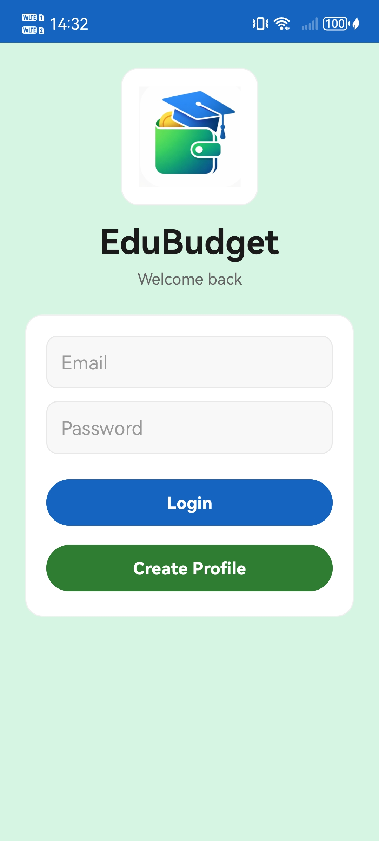

The login screen shows the EduBudget logo at the top on a soft mint green background. Below the logo are fields for Email and Password, a blue Login button and a green Create Profile button. The text is dark and easy to read against the light background.

Create Profile Screen
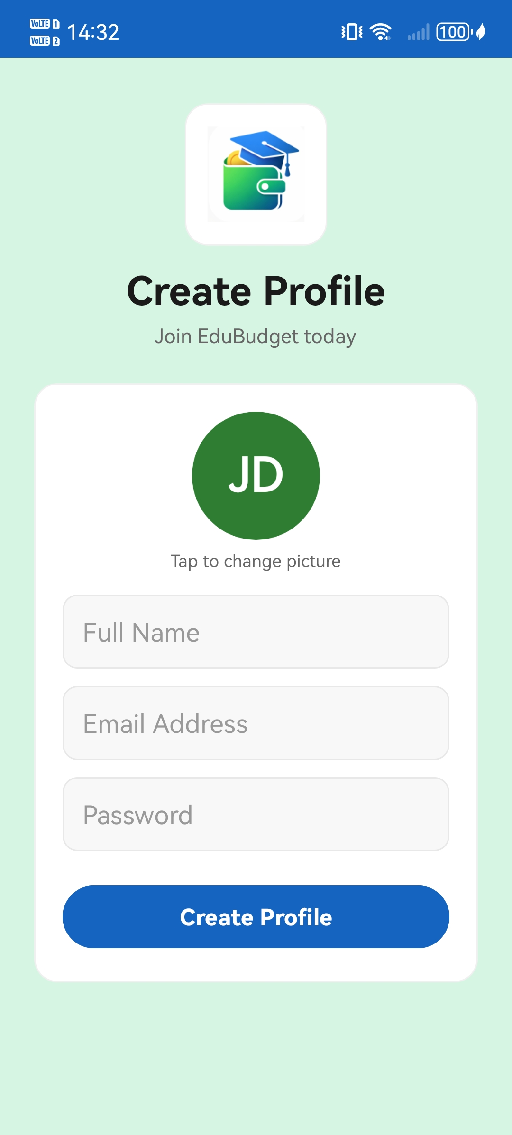

The Create Profile screen shows the app logo, a green circle with the initials 'JD' (which updates as the user types their name), and fields for Full Name, Email Address, and Password. The user can tap the circle to change the profile picture from their phone gallery.

Dashboard Screen
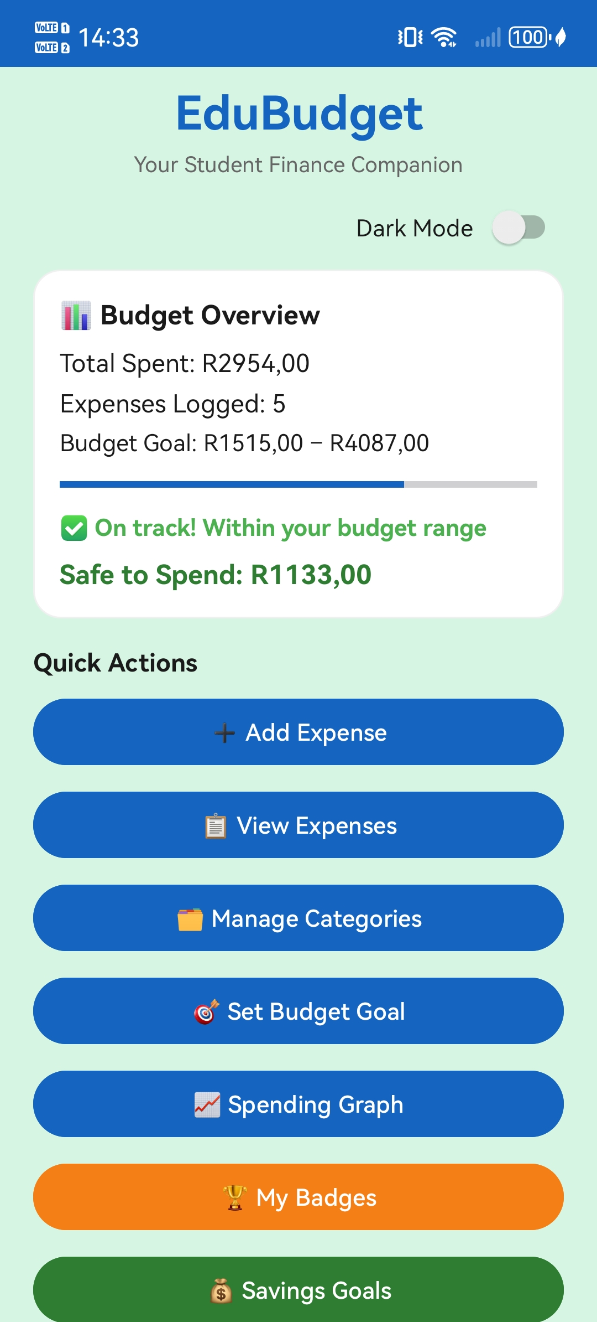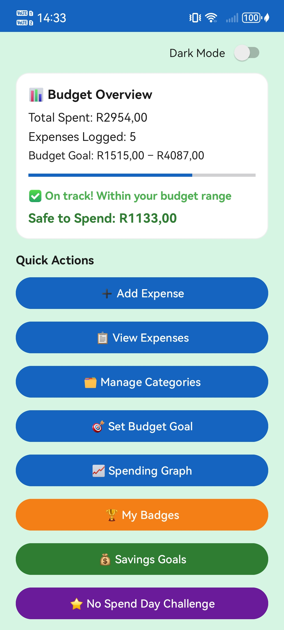

The Dashboard shows the Budget Overview card at the top with the total amount spent (R2,954.00), number of expenses logged (5), the budget goal range (R1,515 – R4,087), a blue progress bar, a green status message ('On track! Within your budget range'), and the Safe to Spend amount (R1,133.00). Below are buttons to navigate to all app features. The Dark Mode toggle is in the top right.

Add Expense Screen
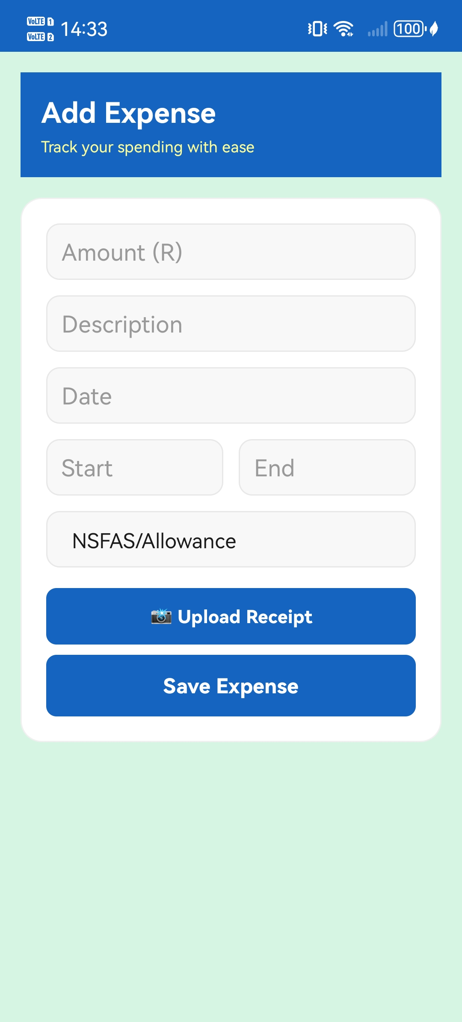

The Add Expense screen has input fields for Amount, Description, Date, Start Time, End Time, and a dropdown to select the category. The Upload Receipt button lets users attach a photo from their phone. At the bottom is the Save Expense button. The blue header bar and mint green background match the rest of the app.

Expense History
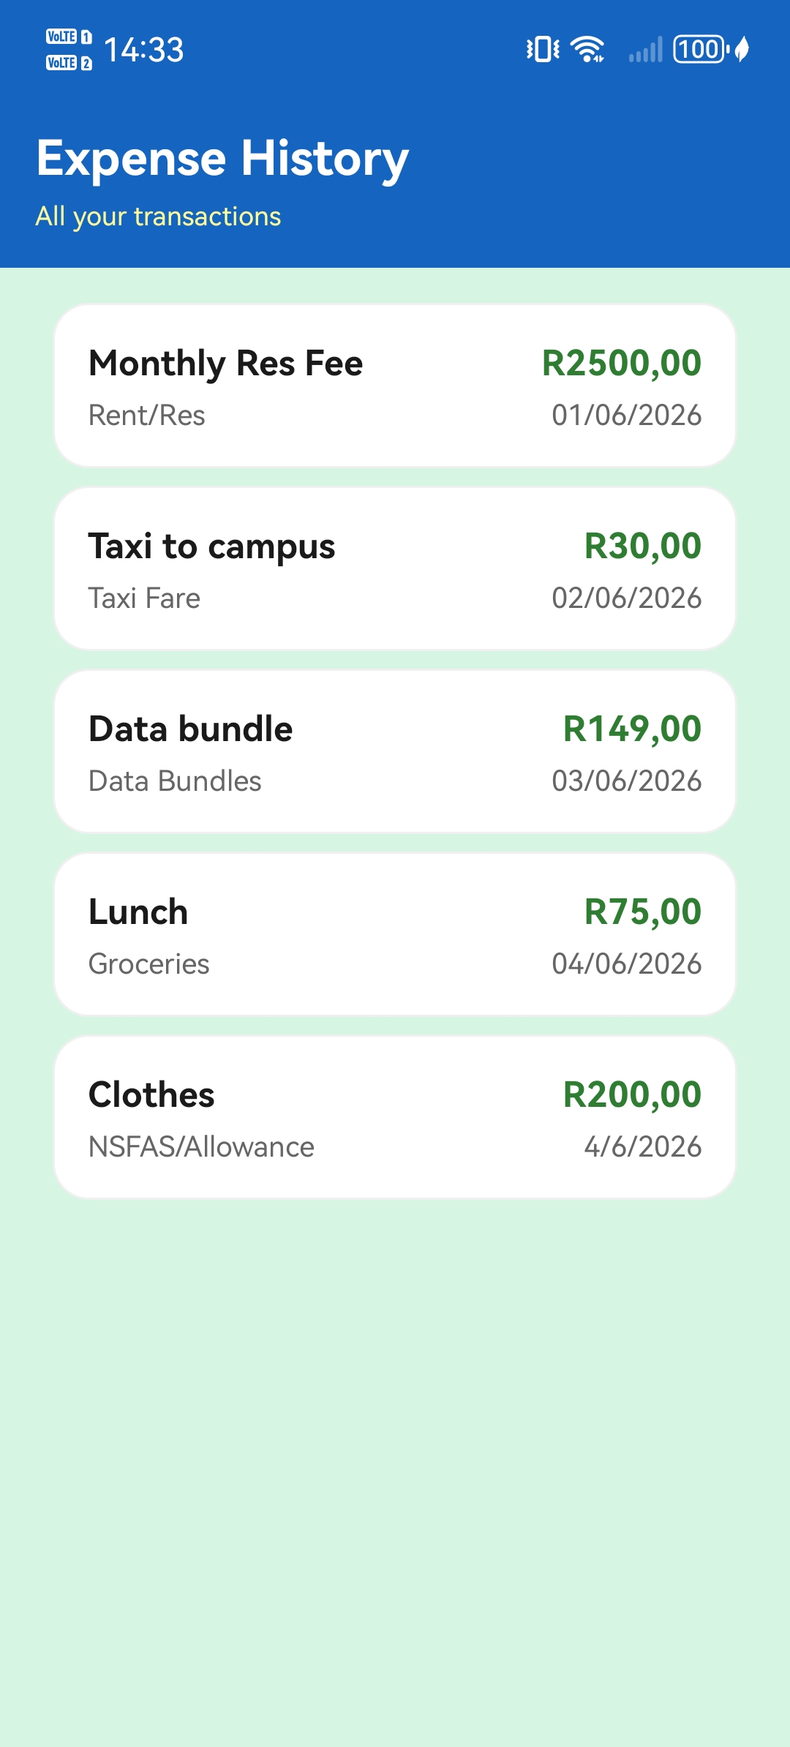

The Expense History screen shows all saved expenses as cards in a scrollable list. Each card shows the description in bold on the left, the amount in green on the right, and the category and date below. The five seeded expenses (Monthly Res Fee, Taxi to campus, Data bundle, Lunch, Clothes) are clearly visible.

Budget Categories
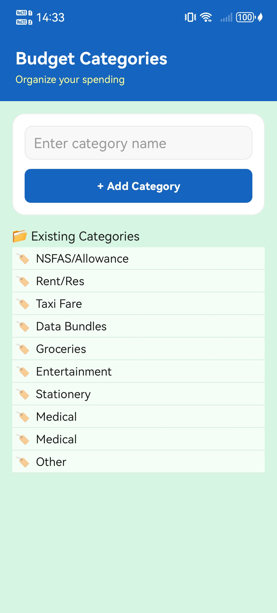

The Categories screen shows the input field and Add Category button at the top. Below that is the full list of existing categories: NSFAS/Allowance, Rent/Res, Taxi Fare, Data Bundles, Groceries, Entertainment, Stationery, Medical, and any custom ones the user has added. Each category has a tag emoji and a dividing line.

Set Budget Goal
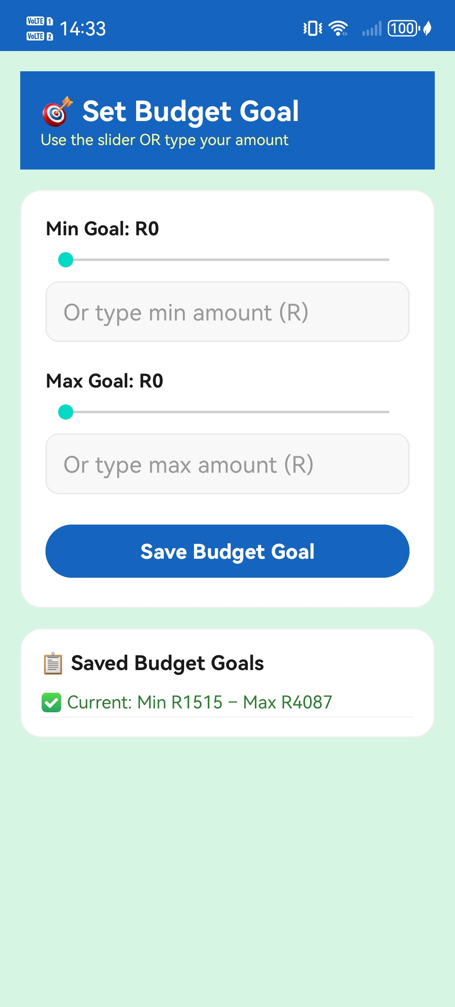

The Budget Goal screen shows the slider and manual input field for both the Minimum and Maximum monthly goals. The user can drag the slider or type the amount directly. At the bottom, the Saved Budget Goals card shows the current goal in green: Min R1,515 – Max R4,087.

Spending Graph
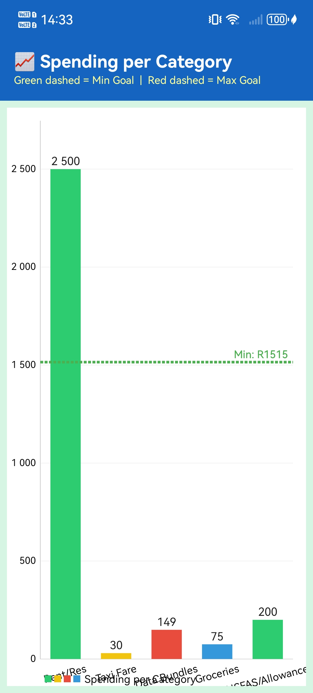

The Spending Graph shows a colour-coded bar chart of spending per category. The green dashed line shows the minimum goal (R1,515) and the red dashed line shows the maximum goal (not visible at this scale as it is higher than all bars). Rent/Res is the highest bar at R2,500, followed by NSFAS/Allowance at R200, Data Bundles at R149, Groceries at R75, and Taxi Fare at R30.

My Badges
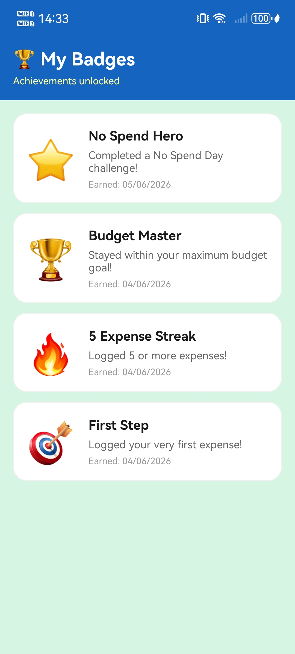

The Badges screen shows four badges that have been earned. Each badge has a large emoji (visible and clear), a bold title, a short description, and the date it was earned. The badges shown are No Spend Hero (⭐), Budget Master (🏆), 5 Expense Streak (🔥), and First Step (🎯). Badges are automatically awarded when the user meets certain goals.

Savings Goals
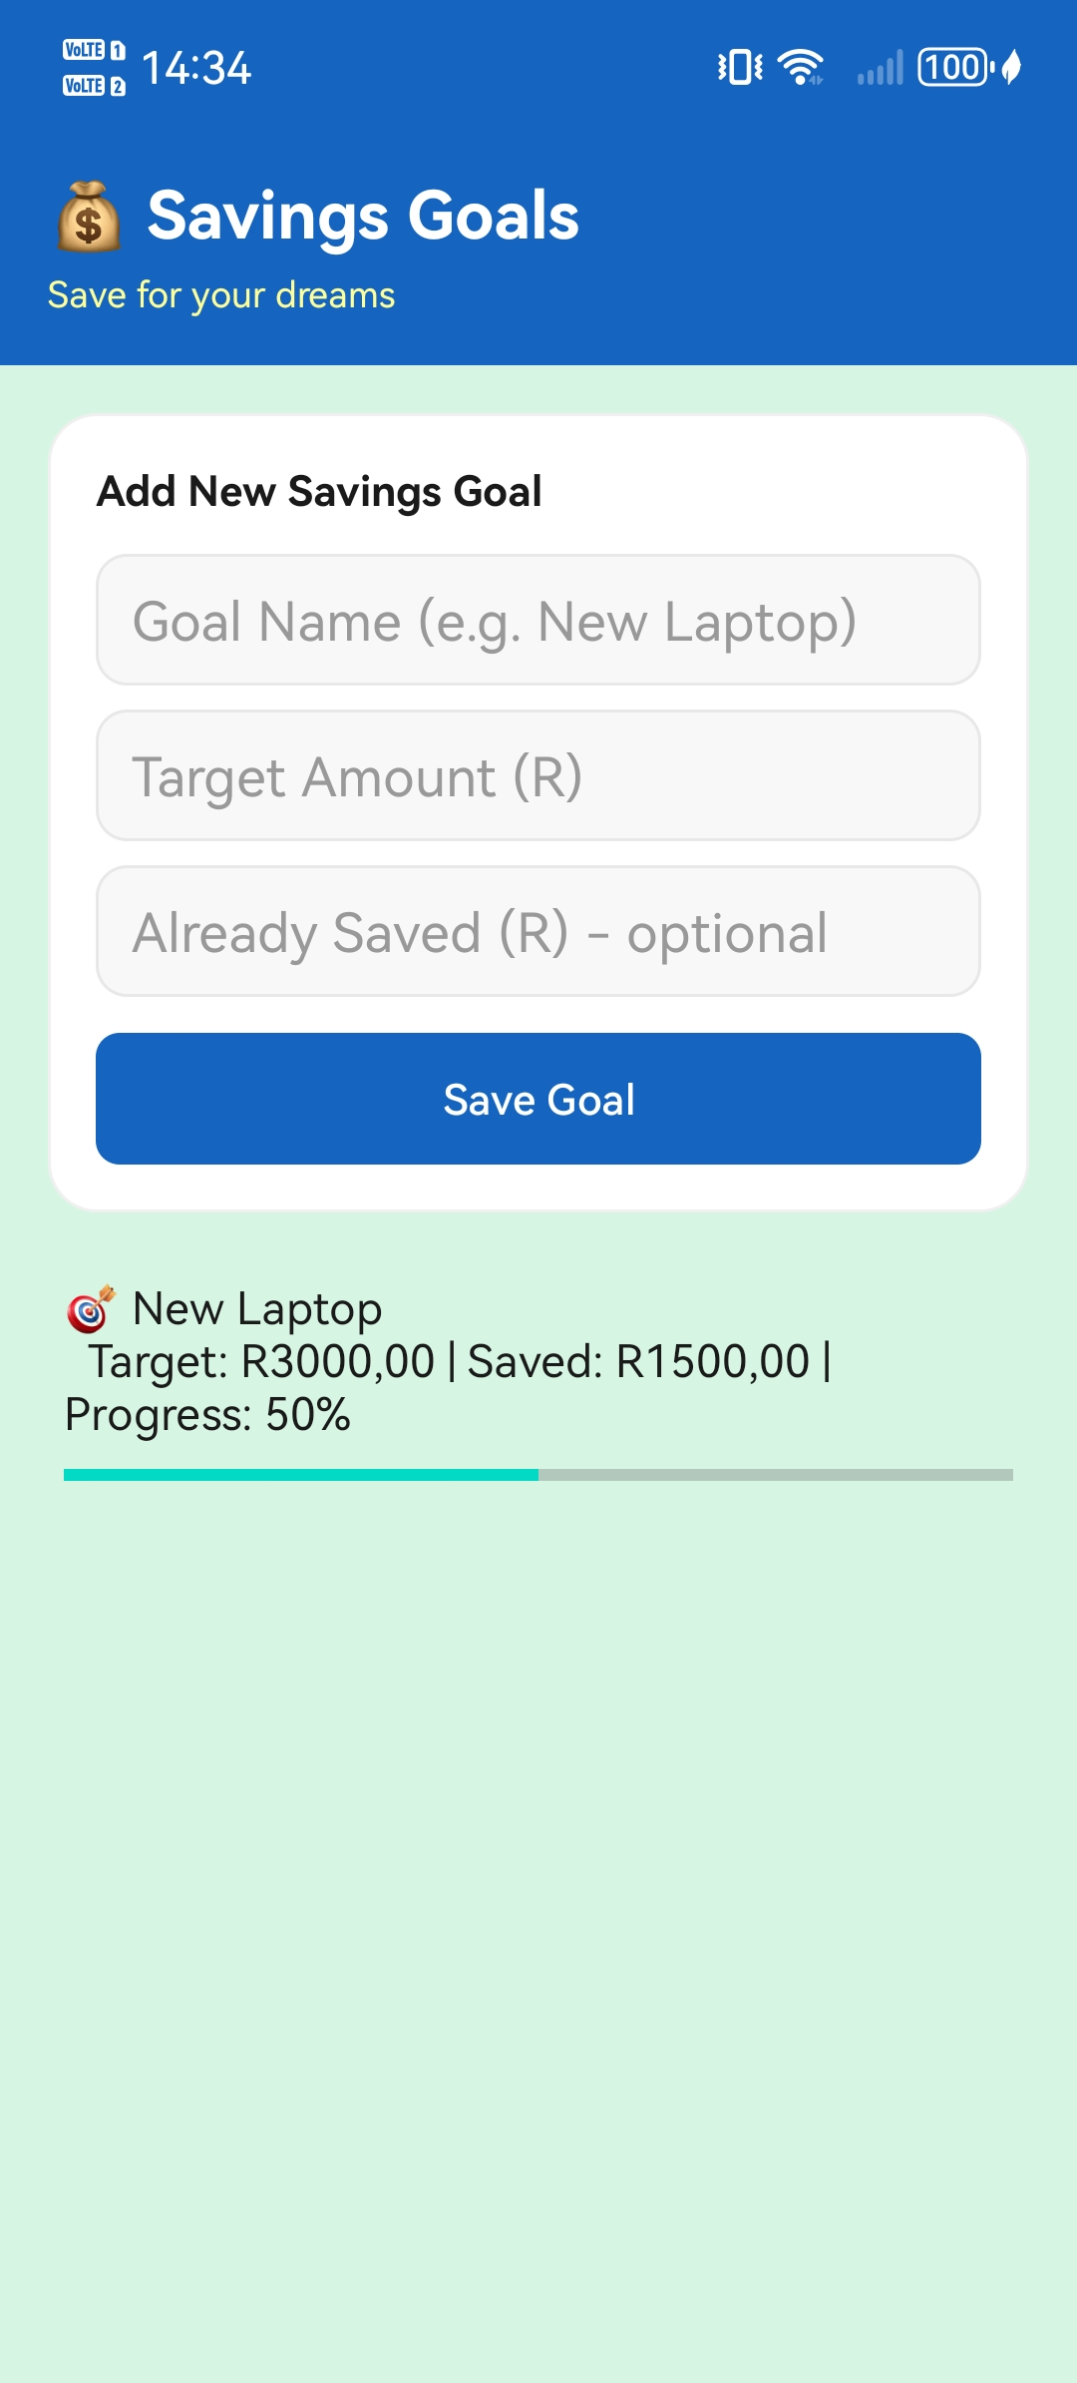

The Savings Goals screen shows the form for adding a new savings goal at the top. Below that is an existing goal: New Laptop, with a target of R3,000, R1,500 already saved, and a 50% progress bar. The screen is clean and easy to use, with a consistent blue and mint green style.

No Spend Day Challenge
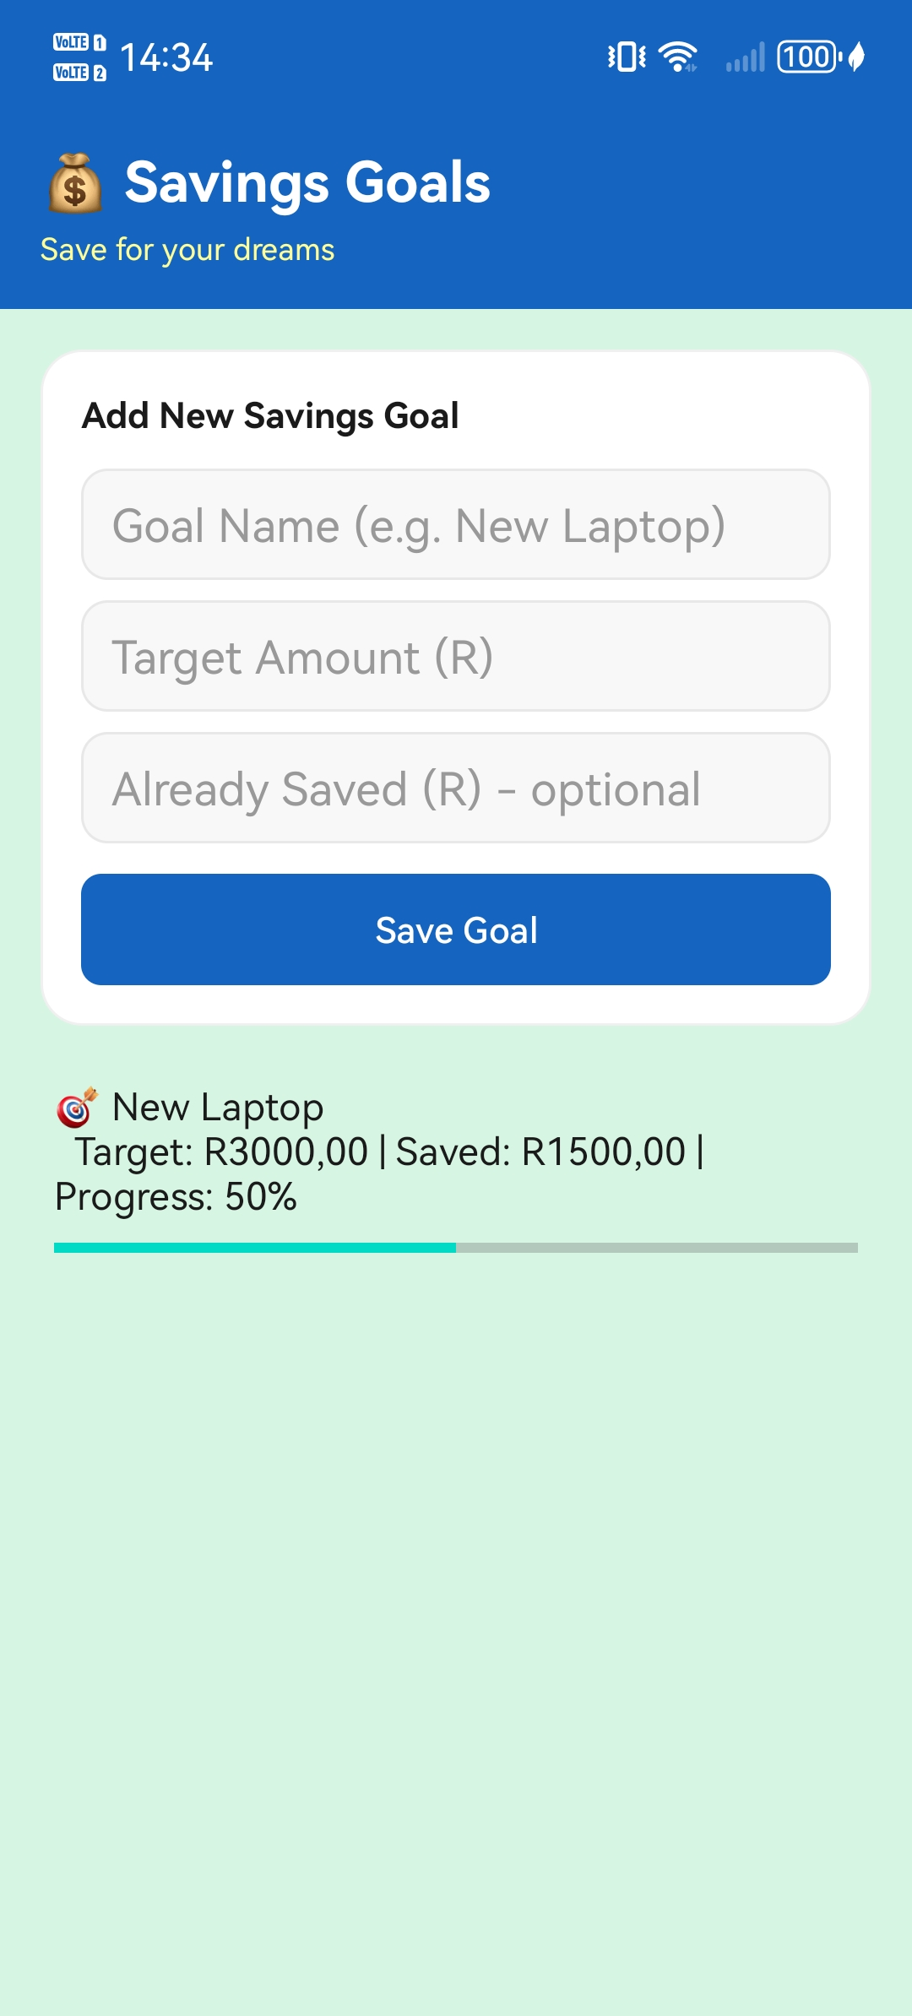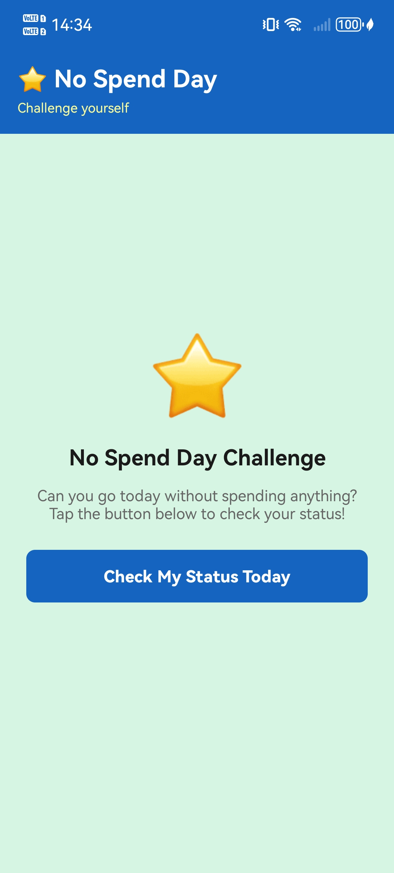

The left screenshot shows the No Spend Day Challenge before the button is tapped. The right screenshot shows the success message in green: 'Amazing! You haven't spent anything today! You completed the No Spend Day Challenge!' This also automatically earns the No Spend Hero badge. If the user has spent money, a red message shows the total spent and tells them to try again tomorrow.

4. GitHub and GitHub Actions

GitHub Repository
We used GitHub throughout the whole project to save and share our code as a team. Every time we made changes, we pushed our code to the repository. This made it easy for all three group members to work on different parts of the app without losing any code.

- Repository Link: https://github.com/ST10438554-kirby/EduBudget_app.git
- README Link: https://github.com/ST10438554-kirby/EduBudget_app/tree/master?tab=readme-ov-file

The repository contains all the source code files including all Kotlin activity files, all XML layout files, the Room database classes, drawable resources, the app icon, the AndroidManifest, Gradle build files, and the GitHub Actions workflow file.

GitHub Actions – Automated Testing
We set up GitHub Actions so that every time we push code to the main branch, the project automatically builds and runs the unit tests. This helped us catch problems early. If the build or tests fail, GitHub sends an alert so we know something needs to be fixed.

name: Android CI
on:
push:
branches: [ master ]
pull_request:
branches: [ master ]
jobs:
build:
runs-on: ubuntu-latest
steps:
- uses: actions/checkout@v3
- uses: actions/setup-java@v3
with:
java-version: '17'
distribution: 'temurin'
- name: Run Unit Tests
run: ./gradlew test

README File
We wrote a README file inside the GitHub repository that explains everything a reader needs to know about EduBudget. The README includes the purpose of the app, a list of all features (required and self-proposed), the tech stack, setup instructions for running the project, the group members' names and student numbers, the YouTube demo video link, and the GitHub Actions badge.

5. Our Own Features
In our Part 1 planning document, we listed several features that we wanted to add ourselves, on top of the required POE features. We managed to implement all six of them in the final app. The table below explains each one.

Feature | What It Does | Where It Is
SA Student Categories | Pre-loads eight categories that are specifically relevant to South African students: NSFAS/Allowance, Rent/Res, Taxi Fare, Data Bundles, Groceries, Entertainment, Stationery, and Medical. These are ready to use from the first time the app opens. | DatabaseSeeder.kt
Safe to Spend | Shows the student exactly how much money they still have left to spend before going over their maximum budget goal. It is calculated as: Max Goal minus Total Spent. | DashboardActivity.kt
Daily Reminders | Sends a push notification every evening at 8:00 PM to remind the student to log their expenses for the day. This helps students stay on top of their tracking. | NotificationHelper.kt
No Spend Day Challenge | Challenges the student to go a full day without spending anything. When they tap the check button, the app looks at today's expenses. If there are none, a success message shows and a badge is awarded. | NoSpendDayActivity.kt
Savings Goal Tracker | Let’s students set personal savings targets (like saving for a laptop or a trip). Each goal shows a progress bar so the student can see how close they are to reaching their target. | SavingsGoalActivity.kt
Dark Mode Toggle | A switch on the Dashboard that changes the whole app to a dark theme. The setting is remembered so the app stays in dark mode the next time the user opens it. | DashboardActivity.kt

6. References
- Clements, J. (2022) The envelope method: Does manual budgeting still work? Journal of Personal Finance Technology, 14(3), pp. 112–125.
- Forbes Advisor. (2025) Best Budgeting Apps. Available at: https://www.forbes.com/advisor/banking/best-budgeting-apps (Accessed: 06 May 2026).
- Google Play Store. (2026) WalletCorner: Expense Tracker & Budget App. Available at: WalletCorner: Gamify budgeting - Apps on Google Play (Accessed: 06 May 2026).
- Goodbudget. (2024) About Goodbudget. Available at: https://goodbudget.com (Accessed: 06 May 2026).
- Google Play Store. (2024) PocketGuard: Money & Budgeting App. Available at: https://play.google.com/store/apps/details?id=com.pocketguard.android.app (Accessed: 06 May 2026).
- Investopedia. (2025) Top Budgeting Apps for Personal Finance. Available at: https://www.investopedia.com (Accessed: 06 May 2026).
- JitPack. (2026) MPAndroidChart by PhilJay. Available at: https://jitpack.io/#PhilJay/MPAndroidChart (Accessed: 06 May 2026).
- NerdWallet. (2025) Best Budgeting Apps of 2025. Available at: https://www.nerdwallet.com/article/finance/best-budget-apps (Accessed: 06 May 2026).
- OpenAI. (2026) EduBudget logo generated using DALL-E. Available at: https://chat.openai.com (Accessed: 06 May 2026).
- Perez, L. (2021) 'Usability challenges in manual-entry budgeting apps', International Journal of Mobile UX Design, 6(2), pp. 55–70.
- Statista. (2023) Finance App Market Size Worldwide. Available at: https://statista.com (Accessed: 06 May 2026).
- Thompson, R. (2020) Modern Digital Budgeting Systems. MIT Press, Cambridge.
- Tindall, T. (2026) PocketGuard App Review. NerdWallet. Available at: https://www.nerdwallet.com/finance/learn/pocketguard-app-review (Accessed: 06 May 2026).

