AI Imaging Analysis: From VLM Description to U-Net, Classical Segmentation and Numbers-First LLM

Name: Arman Ali Zaib Student ID: 24168194
Code Repository:

Executive summary
This project explored whether a vision-language model (VLM) based locally, a trained U-Net segmenter, classical Otsu thresh-holding and a numbers-first language-model stage can create an accurate and auditable image processing pipeline. The dataset is comprised of small 256×256 nucleus images with corresponding masks. Task 1 used Qwen2.5-VL after initial choice of the Llama 3.2 Vision model turned out to be problematic as the server which was used for testing did not support the specified mllama architecture of the model. Best results in terms of segmentation were obtained using U-Net validation (Dice 0.9948 and IoU 0.9897), Otsu performed also well on 12 test images (Dice 0.9776, IoU 0.9561). The Language Model was intentionally left downstream of any measurable parameters.

Analysis approach and rationale
Dataset was initially checked for train/validation/test splitting, image/mask matching and intensity properties. Task 1 utilized gray-scale 256x256 input for visual description, whereas U-Net used RGB input as its checkpoint required it to be three-channel. The exploratory data analysis included examination of typical images, masks, their overlays and intensity distributions.

The task of learned segmentation was addressed via training of small U-Net with 4 levels of encoder for 15 epochs with Adam optimizer and BCE + Dice loss function. Validation metrics Dice and IoU were recorded during training and the checkpoint corresponding to the lowest validation loss was saved. The U-Net architecture was selected due to its ability to capture context on the contracting path and localize precisely on the expanding path, which is very important for biomedical segmentation [1]. As an example of the transparent baseline, Otsu’s thresh-holding [2] was applied followed by cleaning up with morphological operations and connected components with region properties were used for measurement of objects.
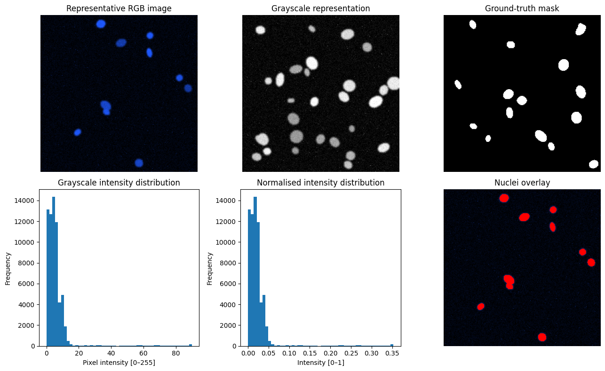
The resulting workflow for the final hybrid system was: unknown image -> U-Net Mask -> Connected Components -> Region Properties -> Numerical Summary -> Text-based Qwen LLM -> Structured JSON + Narrative. The chosen local VLM/LLM for the experiment was Qwen2.5-VL, which could not be loaded due to the incompatibility of the initial model, the report about the model is available [3].

Figure 1. Exploratory view of the image modality: representative RGB image, grayscale representation, ground-truth mask, intensity distributions and nuclei overlay.

Task 1 - Direct VLM description
While the naive prompt was able to generate fluent writing, it quickly demonstrated a major issue in terms of reliability: it generated descriptions suggesting galaxies, star clusters, tidal tails and companion galaxies as a possible celestial scene. These statements were plausible and yet had no factual basis. This is in line with the rest of the literature on hallucination as plausible generation that lacks grounding in source data [4].
The optimized prompt, then, forced the model to remain in a descriptive mode, demanded explicit uncertainty, prevented any diagnoses and imposed a strict JSON schema. Five repetitions were made to assess variability of the output. The direct VLM can still be used in a cautious descriptive capacity, but its prose is not considered a measurement.

Task 2 - Classical segmentation and numbers-first interpretation
First, Otsu thresh-holding generated the foreground binary mask. Then, image processing and analysis were done using morphological operations and connected component analysis. Twelve unknown test images having ground truth masks were analyzed. Mean Dice score, Mean IoU score, Precision and Recall values were 0.9776, 0.9561, 0.9776, and 0.9775 respectively. Best Dice score was 0.9819 (test_000.png) while the worst one was 0.9694 (test_006.png).

Metric | Dice | IoU | Precision | Recall
Otsu test | 0.9776 | 0.9561 | 0.9776 | 0.9775
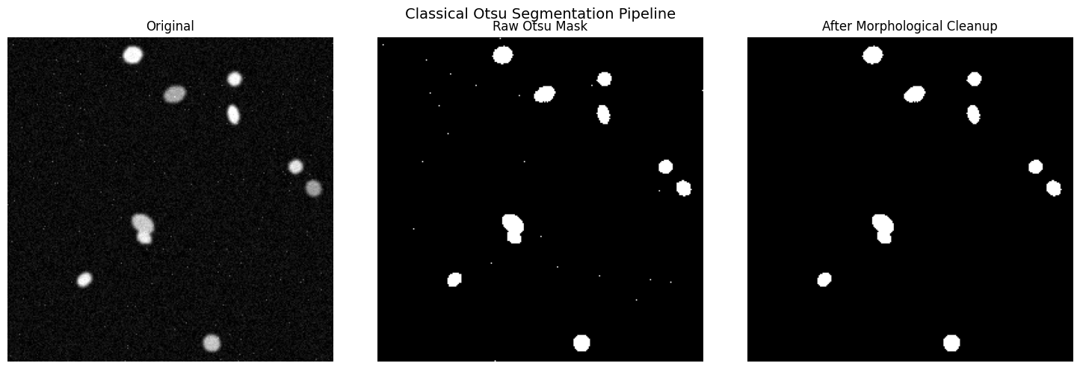
Figure 2. Classical Otsu baseline: original image, raw threshold mask and mask after morphological cleanup.

Optimised Task 1 VLM prompt

Direct VLM prompt:
You are an image-description assistant for a biomedical imaging analysis pipeline. Your task is DESCRIPTIVE ONLY. Do not diagnose disease, identify a medical condition, recommend treatment or infer clinical outcomes. Describe only visual characteristics supported by the image. If evidence is insufficient, use exactly “uncertain”. Return ONLY one valid JSON object with exactly four keys: modality, tissue_type, notable_features, image_quality. Do not invent information or add text outside the JSON.

Required structured output: {modality, tissue_type, notable_features, image_quality}.

Optimised numbers-first LLM prompt

Numbers-first prompt:
Use ONLY the numerical measurements below. Do not describe visual details that are not supported by the numbers. Do not diagnose anything. Return: (1) one short paragraph based only on the measurements, (2) a JSON object with exactly n_objects (integer), density_class (low/moderate/high/uncertain), shape_regularity (regular/mixed/irregular/uncertain), and quality_flag (good/acceptable/poor/uncertain). If a conclusion is unsupported, return uncertain. Keep the paragraph under 80 words.

Required structured output: {n_objects, density_class, shape_regularity, quality_flag}.
Question 1 - Which description is more useful and trustworthy?
The numbers-first description is more helpful and more reliable for this pipeline. Although the direct VLM provides a description of the appearance and is valuable in exploring the data, the naive run showed that the image model can produce a whole semantic interpretation that is not substantiated by the image. The numbers-first step has fewer dimensions, but each of the five inputs – object number, object area, object eccentricity, object solidity, and foreground fraction – can be individually checked. However, the LLM remains an interpreter, not a creator, of the measurements.

Question 2 - Did U-Net improve on Otsu?
From the results obtained above, U-Net shows better performance than Otsu. However, this is not a proof of the superiority of U-Net over Otsu since the results were obtained using different datasets, U-Net uses 20 validation images while Otsu uses 12 new test images. The test masks for U-Net were not saved in the post-processing notebook. Thus, a fair comparison between the two models on the same images cannot be conducted. What can be concluded from the above findings is that validation Dice of U-Net (0.9948) is greater than the test Dice of Otsu (0.9776). Test_000.png (Dice 0.9819) is the best example of Otsu. Image 12 (Dice 0.9891) is the lowest validation image of U-Net.
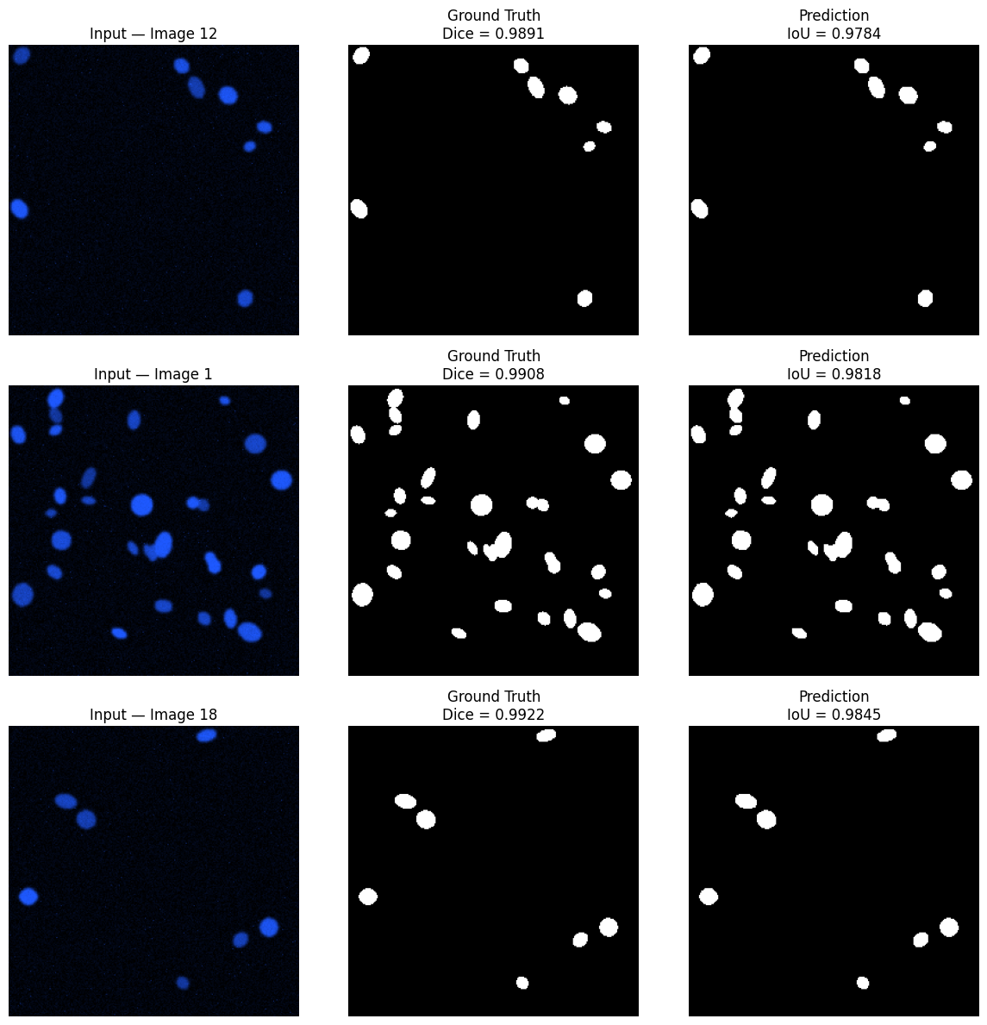
Task 3 - U-Net segmentation
Training and evaluation for the U-Net was done with 80 training images and 20 validation images. The model was trained for 15 epochs using Adam optimizer and learning rate schedule along with BCE+Dice loss function. The validation loss achieved was 0.0559. The mean Dice and IoU scores were 0.9948 and 0.9897, respectively, whereas the best Dice and IoU scores were achieved at epoch 14.The lowest Dice case was image 12 (0.9891).

Figure 3. U-Net validation error analysis: the five lowest-performing validation images.

Question 3 - What do Dice and IoU mean, and where does U-Net make mistakes?
Dice calculates the similarity between the predicted foreground mask and the ground-truth one, whereas IoU calculates the intersection divided by the union. Higher values are more desirable, and closer values are more accurate. It is an outstanding score when considering this validation dataset, but we should consider that the average masks the worst cases. The five worst Dice scores correspond to image 12 with a score of 0.9891, image 1 with a score of 0.9908, image 18 with 0.9922, image 15 with 0.9923 and image 6 with 0.9932. From observation, the differences are small and occur at the edges of objects, smaller objects, and shape/position differences.

Question 4 - Where can the LLM hallucinate?

There are many points where the hallucination can appear: the VLM can make false interpretation of the raw picture, numbers-first approach can create an ungrounded semantic label from correlated measurements, and finally, narrative can be fabricated from the measurement. There are three ways how this design minimizes the chance of hallucination occurrence. First, the prompt defines the task and provides an "uncertain" option. Second, downstream LLM will work with numerical features, not an image, so there will be less chances to fabricate the visual information. Finally, JSON data will be schema checked and the original image, mask, and measurements will be stored. This corresponds to the pragmatic approach which claims that the possibility of hallucination decreases with constrained and verified language generation [4].

Structured JSON will remain the source of truth as fields can be validated, counted, filtered and duplicated. Free-form narrative will become the interpretation of those fields, but not another source of facts.

Task 4 - final hybrid pipeline
The final hybrid process applied to all 12 unknown images was: U-Net mask -> connected components -> region properties -> numeric summary -> textual LLM. The final output was a CSV file with 12 rows containing measurements, quality and shape columns, LLM status, and narration.
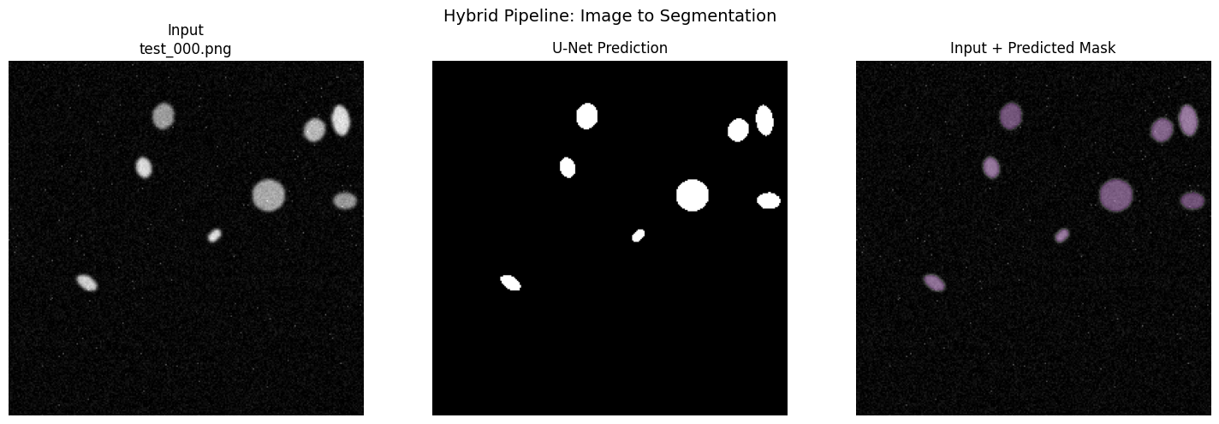
Figure 4. Representative hybrid output: unseen test image, U-Net prediction and input/predicted-mask overlay.

Question 5 - Would any part of the system be trusted clinically?

Not as a diagnostic decision-making tool. The U-Net is the most interesting part of the pipeline since its output is quantifiable and highly accurate on the held-out validation set. Another appealing model is Otsu since it's highly auditable and was able to achieve Dice 0.9776 on 12 test images. However, the size and control over the dataset is low, and the robustness across different machines, sites, and actual patients' population is unknown. LLM should not be trusted as a diagnostic tool since its output can vary and hallucinate.

The biggest improvement to trustworthiness would be the large external held-out validation study on patient level with pre-processing and models fixed and predefined failure analysis criteria.

6. Conclusions

The project shows a productive labor division whereby classical processing provides transparency in measurement, U-Net provides accurate segmentation, and the LLM translates the measurements to structured description. The LLM must never be taken as the source of the truth, as the strongest form of evidence lies in the image, mask, segmentation results, and numeric features. High scores are promising, although a small data size and a lack of same image comparison of U-Net/Otsu make any claim of clinical readiness hard.

References

[1] Ronneberger, O., Fischer, P. & Brox, T. (2015). U-Net: Convolutional Networks for Biomedical Image Segmentation. Medical Image Computing and Computer-Assisted Intervention (MICCAI 2015), LNCS 9351, pp. 234–241.
https://doi.org/10.1007/978-3-319-24574-4_28

[2] Otsu, N. (1979). A Threshold Selection Method from Gray-Level Histograms. IEEE Transactions on Systems, Man, and Cybernetics, 9(1), pp. 62–66.
https://doi.org/10.1109/TSMC.1979.4310076

[3] Bai, S. et al. (2025). Qwen2.5-VL Technical Report. arXiv. https://doi.org/10.48550/arXiv.2502.13923

[4] Huang, L. et al. (2024). A Survey on Hallucination in Large Language Models: Principles, Taxonomy, Challenges, and Open Questions. ACM Transactions on Information Systems. https://doi.org/10.1145/3703155

[5] Dice, L. R. (1945). Measures of the Amount of Ecologic Association Between Species. Ecology, 26(3), pp. 297–302. https://doi.org/10.2307/1932409

