BMI Calculator Manual

This manual demonstrates instructions on how to use a simple BMI Calculator. Most of the functionalities of this project are dynamically coded and are manipulatable from the corresponding database, **FamilyWeights.accdb**.

Table of Contents

Contents

General 2

Calculate BMI 3

Export Records 4

Report Tools 4

Data Management 5

# 

# General

Upon opening the **Arya5150_a05.xlsm** file, you will view your base worksheet as below:

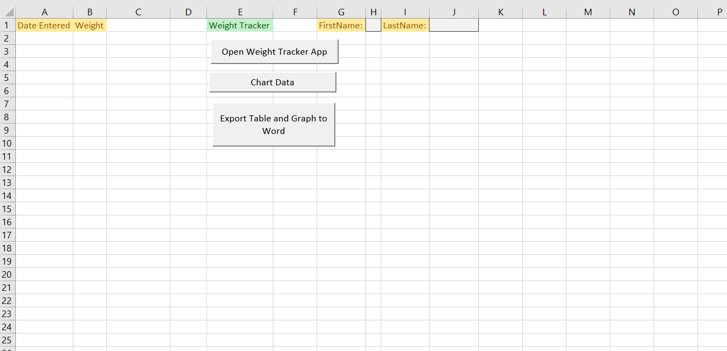

Where you may launch the **Dashboard** by pressing the corresponding button.

In your dashboard, you can use the utilities of the BMI Calculator program.

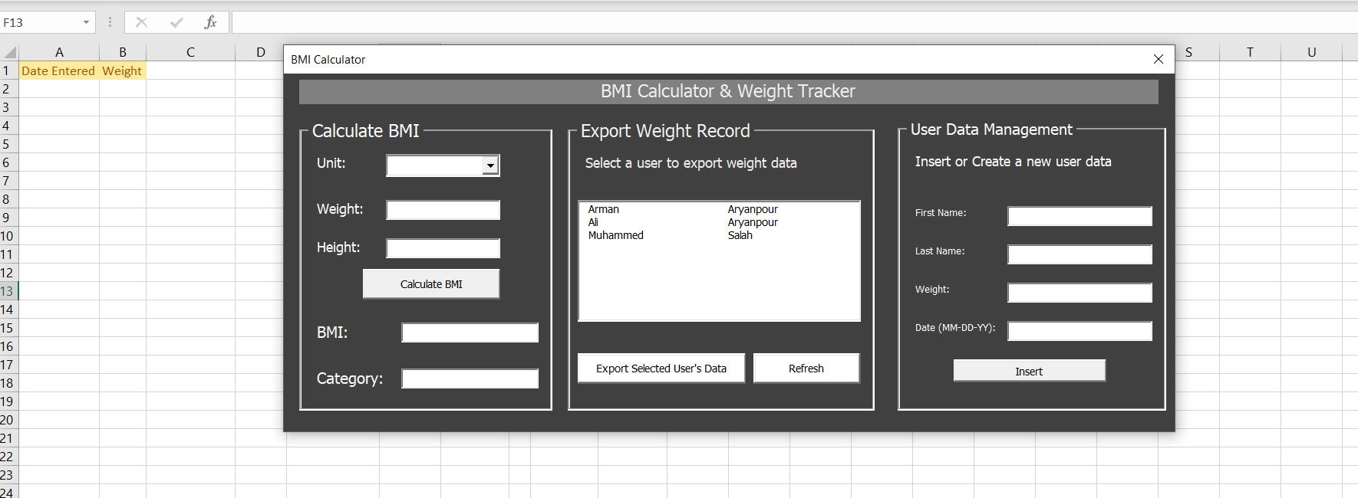

# Calculate BMI

In this segment of the dashboard, you can calculate Body Mass Index using Weight and Height with different units(metric/imperial). The program will display your BMI and the category that the BMI belongs to. It will also generate a **BMI Table index.**

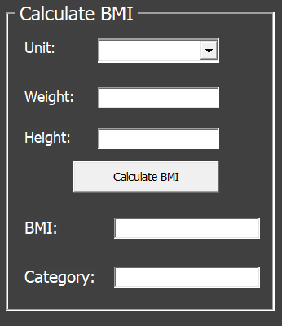

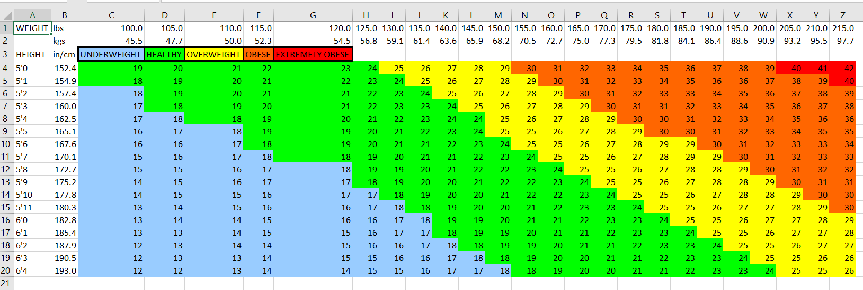

# Export Records

In this segment, you can export weight data related to a specific user and append them to the main excel worksheet.

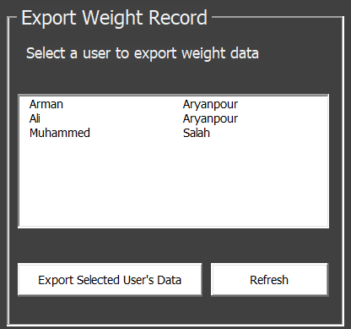

## Report Tools

Additionally, you are able to use the reporting tool buttons on the main worksheet to generate charts and word reports of the exported records.

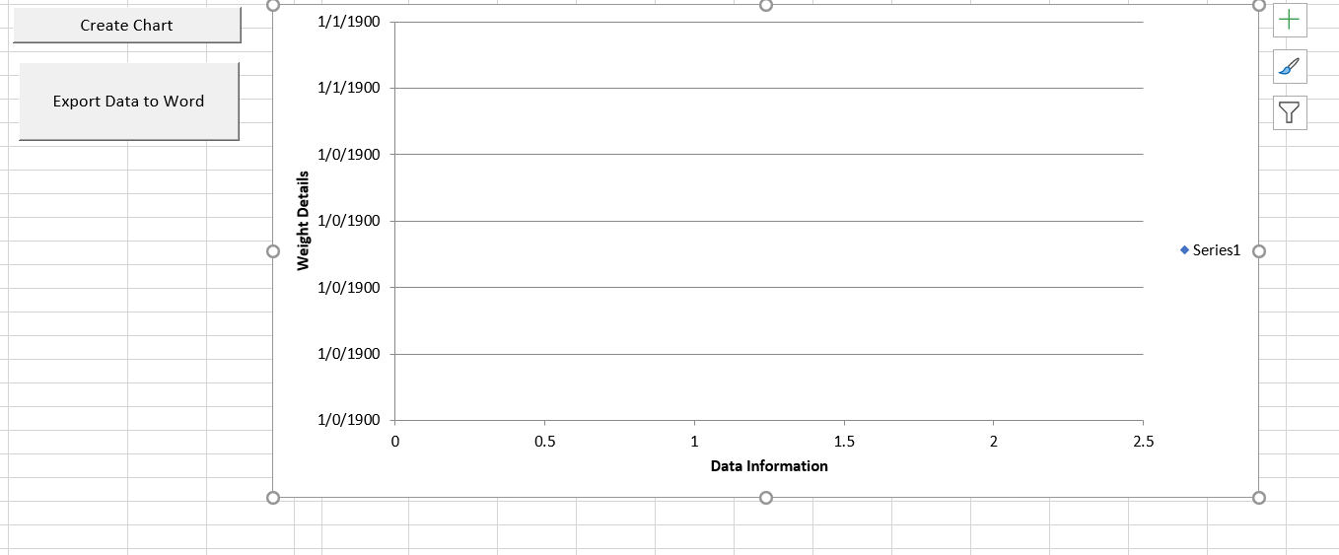

# Data Management

Generally, you would like to insert new records to a user record history. This section allows you to append records to a current user’s record history or create a new user for the first time and append the appropriate records.

