DATA SCIENCE TOOLBOX: PYTHON PROGRAMMING
PROJECT REPORT

(Project Semester: January–April 2025)

Meta Ad Delivery & Market Saturation Analysis
Political Advertising on Meta Platforms in India

Submitted by

Arman Khan
Registration No: 12402573
Programme and Section: R3M033
Course Code: INT375

Under the Guidance of
Dr. Mrinalini Rana (22138)

Discipline of CSE/IT
Lovely School of Computer Science and Engineering
Lovely Professional University, Phagwara
Punjab, India
April 2025

CERTIFICATE

This is to certify that Arman Khan bearing Registration No. 12402573 has successfully completed the INT375 project titled, "Meta Ad Delivery & Market Saturation Analysis" under my guidance and supervision. To the best of my knowledge, the present work is the result of his original development, effort, and study. This project has not been submitted anywhere else for the award of any degree/diploma.

Signature and Name of the Supervisor: _____________DR. Mrinalini Rana , 22138__________

Designation of the Supervisor: ________________________

School of Computer Science and Engineering
Lovely Professional University, Phagwara, Punjab

Date: 19-04-2026

DECLARATION

I, Arman Khan, student of B.Tech under CSE/IT Discipline at Lovely Professional University, Punjab, hereby declare that all the information furnished in this project report is based on my own intensive work and is genuine. This project report has been prepared under the guidance of Dr. Mrinalini Rana. I further declare that this work or any part thereof has not been submitted for any degree/diploma or similar title at any university or institution.

Date: 19-04-2026

Registration No: 12402573
Name of the Student: Arman Khan

ACKNOWLEDGEMENT

I would like to express my sincere gratitude to Dr. Mrinalini Rana for her invaluable guidance, constant support, and encouragement throughout this project. Her expertise in data science and machine learning greatly shaped the direction and quality of this work.

I am also grateful to the Department of CSE/IT at Lovely Professional University for providing the academic environment and computing resources necessary to carry out this project. The curriculum of INT375 – Data Science Toolbox: Python Programming was instrumental in equipping me with the practical tools required for end-to-end data analysis.

Special thanks are due to Meta Platforms, Inc. for maintaining the public Ad Library API, which served as the primary data source for this research project. The transparency initiative behind this API makes it possible for researchers and students to investigate digital political advertising practices at scale.

Finally, I would like to acknowledge the open-source Python community and the developers behind the Pandas, NumPy, Matplotlib, Seaborn, and Scikit-learn libraries, whose tools formed the backbone of this entire analytical pipeline.

Arman Khan
B.Tech CSE/IT | UID: 12402573
Lovely Professional University

TABLE OF CONTENTS

1. Introduction 6
2. Source of Dataset 8
3. Exploratory Data Analysis (EDA) Process 9
3.1 Data Understanding 9
3.2 Data Cleaning & Extraction 10
3.3 Data Transformation 11
3.4 Feature Engineering 12
3.5 EDA Visualizations 13
4. Analysis on Dataset 15
Obj. 1 Demographic Profiling – Most Targeted Groups 15
Obj. 2 Cost-to-Reach Efficiency (Spend vs Impressions) 17
Obj. 3 Platform Content Strategy (Facebook vs Instagram) 19
Obj. 4 Temporal Campaign Trends 21
5. Hypothesis Testing – Z-Test 23
6. Numeric Prediction using Linear Regression 25
7. Conclusion 28
8. Future Scope 30
9. References 32

1. Introduction

In recent years, the landscape of political communication has undergone a profound transformation. Traditional media channels such as television, print journalism, and radio—while still influential—have been increasingly supplanted by digital platforms. Among these, Meta's ecosystem (encompassing Facebook and Instagram) has emerged as one of the most dominant platforms for political advertising, voter outreach, and issue-based campaigning across the globe.

India, the world's largest democracy, presents a uniquely compelling context for studying digital political advertising. With over 600 million internet users and a rapidly growing social media user base that spans diverse linguistic, cultural, and demographic communities, Meta's advertising infrastructure represents a major battleground for political parties, independent candidates, and advocacy groups seeking to influence voter sentiment and mobilize electoral support.

This project, titled Meta Ad Delivery & Market Saturation Analysis, focuses on extracting, cleaning, and analyzing over 10,000 rows of live political ad data directly from the Meta Ad Library API. The Meta Ad Library is a publicly accessible, legally mandated transparency tool that allows researchers, journalists, and citizens to investigate the spending patterns, audience targeting strategies, and delivery timelines of all political and issue-based advertisements running on Facebook and Instagram.

1.1 Project Motivation

The primary motivation for this project stems from the growing academic and public interest in the intersection of big data, political science, and social media analytics. Political advertising on digital platforms is not merely a matter of rhetoric—it involves sophisticated algorithmic targeting, real-time bidding auctions, and data-driven micro-targeting of specific demographic groups based on age, gender, geographic location, and behavioral history.

Understanding how financial budgets are allocated, which demographic segments receive the most exposure, and what the relationship between advertising spend and actual audience reach looks like are critical questions for anyone studying modern electoral behavior. This project uses Python's robust data science ecosystem to answer these questions empirically.

1.2 Project Objectives

The project encompasses six distinct analytical objectives aligned with the INT375 course curriculum's units on Exploratory Data Analysis, Statistical Testing, and Predictive Modeling:

- Objective 1 (Unit III): Demographic Profiling – Determine which age and gender groups are most heavily targeted by political advertisers in India.
- Objective 2 (Unit III): Cost-to-Reach Efficiency – Investigate the mathematical correlation between ad spend and actual impressions generated.
- Objective 3 (Unit III): Platform Content Strategy – Analyze whether Facebook or Instagram receives a higher volume of political ad placements.
- Objective 4 (Unit III): Temporal Campaign Trends – Map the daily launch frequency of ad campaigns over time to identify political event-driven spikes.
- Objective 5 (Unit IV): Hypothesis Testing – Apply a one-sample Z-Test to determine if the average political ad spend significantly differs from a baseline micro-budget standard.
- Objective 6 (Unit V/VI): Machine Learning – Build a Linear Regression model to predict the number of impressions a campaign will receive based on its financial spend.

1.3 Tools and Technologies

The following Python libraries and tools were employed across the various stages of this project:

Library / Tool | Version | Purpose
Python | 3.13.7 | Core programming language
Pandas | 2.x | DataFrame manipulation & CSV I/O
NumPy | 1.x | Numerical operations & array handling
Matplotlib | 3.x | Static data visualization
Seaborn | 0.x | Statistical data visualization
Scikit-learn | 1.x | Machine learning – Linear Regression
SciPy | 1.x | Statistical hypothesis testing (Z-Test)
ast (stdlib) | Built-in | Parsing nested JSON string literals
requests | 2.x | HTTP calls to Meta Ad Library API
Jupyter Notebook | 7.x | Interactive development environment

2. Source of Dataset

The dataset used in this project was extracted programmatically via the official Meta Ad Library API (Application Programming Interface), which provides public transparency data on all political and issue-based advertisements running on Facebook, Instagram, Messenger, and the Meta Audience Network.

2.1 About the Meta Ad Library API

The Meta Ad Library API is part of Meta's broader commitment to advertising transparency mandated by legislation in several countries, including India's evolving digital regulation framework. The API endpoint used is:

https://graph.facebook.com/v19.0/ads_archive

This endpoint accepts search queries for political and issue-based advertisements. For this project, the following API parameters were configured:

- search_terms: 'technology' – targeting technology-related political ads
- ad_reached_countries: ['IN'] – filtering exclusively for ads that reached Indian audiences
- ad_type: POLITICAL_AND_ISSUE_ADS – limiting retrieval to politically relevant content
- fields: id, page_id, page_name, ad_creative_bodies, ad_delivery_start_time, ad_delivery_stop_time, spend, impressions, currency, demographic_distribution, publisher_platforms, bylines, estimated_audience_size
- limit: 100 – maximum records per API page (pagination via cursor-based 'next' links)

2.2 Data Extraction Methodology

The data extraction script (Test_token.ipynb) implemented an automated pagination loop using the requests library. The loop continued fetching pages of 100 records each, following the 'paging.next' cursor provided by the API response, until the target of 10,000 rows was accumulated. A 2-second delay (time.sleep(2)) was introduced between API calls to comply with Meta's rate-limiting policies.

The raw extraction produced a CSV file: live_facebook_ads_dataset_v2.csv, containing exactly 10,000 rows of political ad records from India, spanning the period from approximately November 2024 to March 2026.

2.3 Raw Dataset Structure

The raw dataset before preprocessing contained 13 columns. Several of these columns stored data in highly nested formats (JSON-like string representations of Python dictionaries and lists), requiring extensive parsing before analysis could be performed. The table below summarizes the raw column schema:

Column Name | Data Type (Raw) | Description / Complexity
id | String | Unique ad identifier from Meta
page_id | String | Numeric ID of the advertising page
page_name | String | Human-readable name of advertiser
ad_creative_bodies | String (nested list) | Ad text content, often in list format
ad_delivery_start_time | String (ISO date) | When the ad began running
ad_delivery_stop_time | String (ISO date) | When the ad stopped (may be null)
spend | String (dict) | {'lower_bound': 'x', 'upper_bound': 'y'}
impressions | String (dict) | {'lower_bound': 'x', 'upper_bound': 'y'}
currency | String | Currency code (e.g., INR)
demographic_distribution | String (list of dicts) | Age/gender breakdown percentages
publisher_platforms | String (list) | e.g., ['facebook', 'instagram']
bylines | String | Paid-for-by disclaimer text
estimated_audience_size | String (dict) | {'lower_bound': 'x'} – target pool

3. Exploratory Data Analysis (EDA) Process

Exploratory Data Analysis (EDA) is the foundational stage of any data science project. It involves loading the raw data, understanding its structure, identifying data quality issues, cleaning the dataset, and engineering new features that make the data suitable for downstream analysis and modeling. For this project, the EDA process was carried out across two Jupyter Notebooks: Cleaning.ipynb and EDA.ipynb.

3.1 Data Understanding

The first step was to load the raw CSV file and perform a preliminary inspection:

import pandas as pd
import numpy as np
import ast

df = pd.read_csv('live_facebook_ads_dataset_v2.csv')
print(df.shape) # Output: (10000, 13)
print(df.head())
print(df.info())
print(df.isnull().sum())

The initial inspection revealed:
- Total records: 10,000 rows × 13 columns
- Missing values were primarily present in the ad_creative_bodies and bylines columns, as some ads do not contain body text or a paid-for-by disclaimer
- The spend, impressions, estimated_audience_size, demographic_distribution, and publisher_platforms columns all contained data serialized as Python string representations of nested dictionaries and lists — requiring special parsing using ast.literal_eval()
- The ad_delivery_start_time column was stored as a plain string, not a proper datetime object, necessitating type conversion

3.2 Data Cleaning & Extraction

Step 1: Handling Missing Values

df['ad_creative_bodies'] = df['ad_creative_bodies'].fillna('No Text')
df['bylines'] = df['bylines'].fillna('Unknown')

These fills ensure that subsequent NLP and text-length operations do not encounter errors due to NaN values.

Step 2: Parsing Numeric Bound Columns (spend, impressions, estimated_audience_size)

The spend and impressions columns stored data in the format: {'lower_bound': '1000', 'upper_bound': '1999'}. The cleaning strategy was to extract both bounds and compute their midpoint (average) as a single representative numeric value:

spend_list = []
for val in df['spend']:
d = ast.literal_eval(val)
lower = float(d['lower_bound'])
if 'upper_bound' in d:
upper = float(d['upper_bound'])
avg = (lower + upper) / 2
else:
avg = lower # capped at upper tier (1,000,001+)
spend_list.append(avg)
df['avg_spend'] = spend_list

An identical pattern was applied to the impressions column to produce avg_impressions. For estimated_audience_size, only the lower_bound was available per the API's response schema, so it was extracted directly as min_audience_size.

3.3 Data Transformation

Step 3: Demographic Distribution Extraction

The demographic_distribution column contained a list of dictionaries, each encoding a specific age/gender segment with its corresponding percentage of total ad impressions. For each record, the segment with the highest percentage was extracted as the primary target:

top_age_list = []
top_gender_list = []
for val in df['demographic_distribution']:
try:
records = ast.literal_eval(val)
best = records[0]
for r in records:
if float(r['percentage']) > float(best['percentage']):
best = r
top_age_list.append(best['age'])
top_gender_list.append(best['gender'])
except:
top_age_list.append('Unknown')
top_gender_list.append('Unknown')

This produced two new categorical columns: top_targeted_age and top_targeted_gender, which became the primary variables for demographic analysis.

3.4 Feature Engineering

Step 4: Platform One-Hot Encoding

The publisher_platforms column stored a Python list such as ['facebook', 'instagram']. This was converted into two binary indicator columns:

for val in df['publisher_platforms']:
platforms = ast.literal_eval(val)
facebook_list.append(1 if 'facebook' in platforms else 0)
instagram_list.append(1 if 'instagram' in platforms else 0)

Step 5: NLP Feature – Ad Text Length

A simple Natural Language Processing (NLP) feature was engineered by computing the word count of each ad's body text:

for text in df['ad_creative_bodies']:
if text == 'No Text':
text_length_list.append(0)
else:
words = text.split()
text_length_list.append(len(words))

Step 6: Datetime Conversion

df['ad_delivery_start_time'] = pd.to_datetime(df['ad_delivery_start_time'])

After all transformations, the final dataset (FINAL_facebook_ads_dataset.csv) contained 22 columns — 9 original columns plus 13 newly engineered features. The shape was confirmed at (10,000, 22).

3.5 EDA Visualizations

With the dataset cleaned and transformed, a comprehensive EDA visualization panel was generated to understand the statistical distributions of key variables. The panel below was produced using Matplotlib and Seaborn:

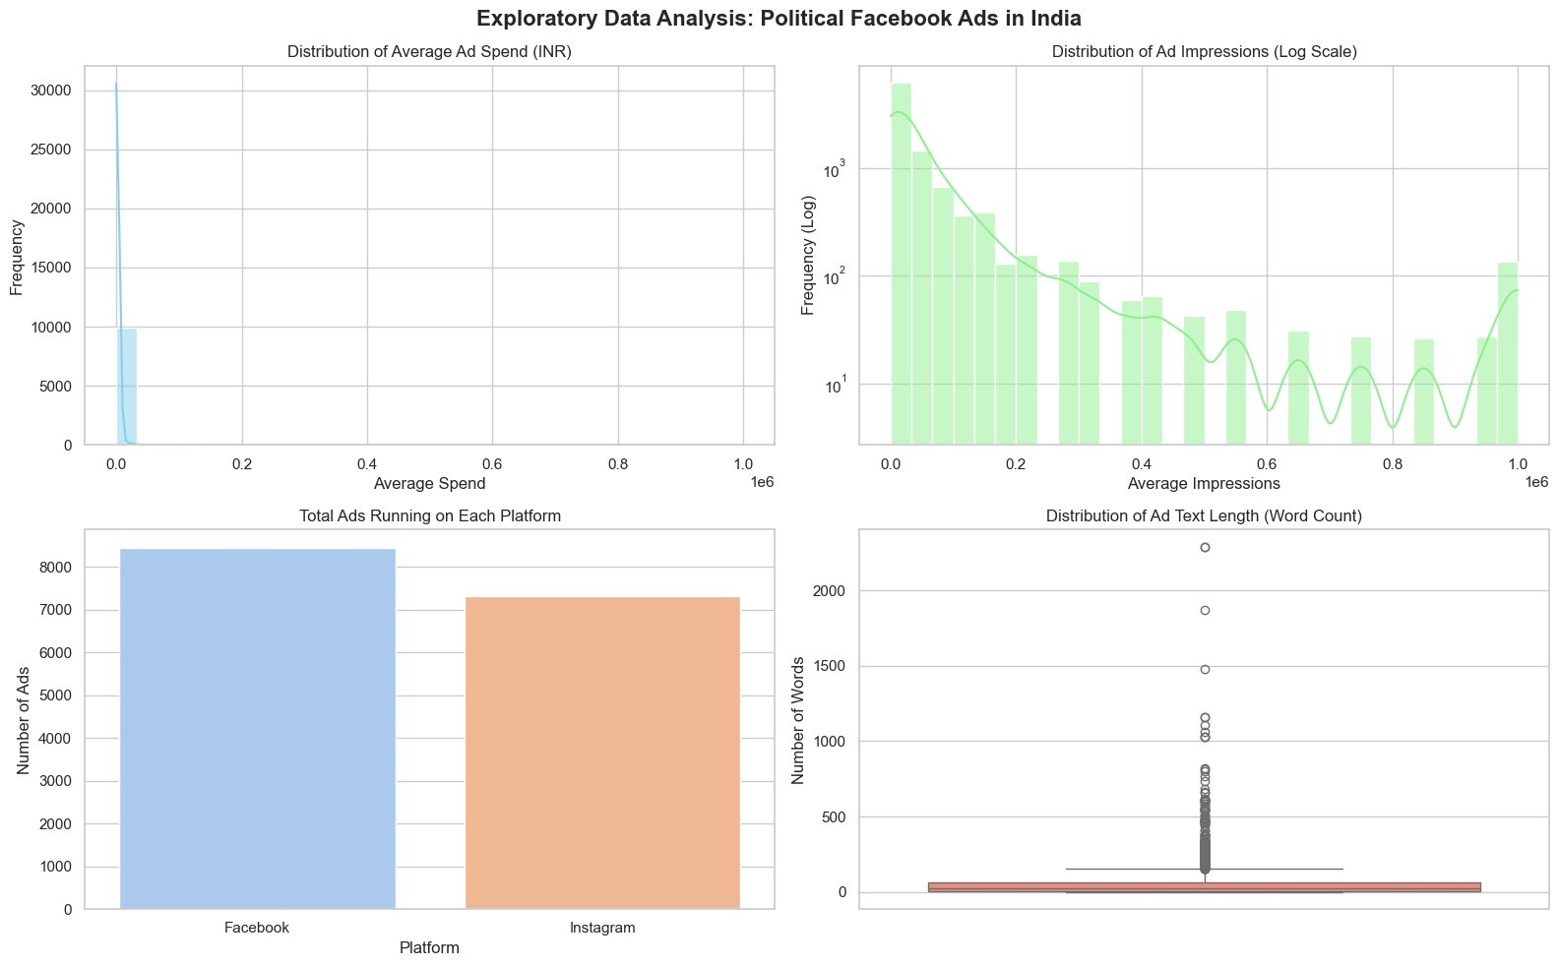
Figure 3.1: EDA Overview – Distributions of Spend, Impressions, Platform Usage, and Ad Text Length

Key observations from the EDA panel:
- Distribution of Average Ad Spend (INR): Extremely right-skewed. The vast majority of political ads (>80%) operate on micro-budgets below ₹50,000, while a small fraction of high-budget campaigns extend to ₹1,000,000+.
- Distribution of Ad Impressions (Log Scale): A log-scale histogram was necessary to visualize the dramatic spread. Most ads receive modest reach, but outlier viral campaigns achieve 1,000,000+ impressions.
- Platform Distribution: Facebook hosts marginally more political ads (~8,300) than Instagram (~7,300), though both platforms are extensively used, confirming that cross-platform parallel delivery is the dominant strategy.
- Ad Text Length (Word Count): Highly right-skewed with notable outliers reaching 2,000+ words. The median ad text is concise (under 100 words), with extreme outliers being long-form policy documents or manifestos.

4. Analysis on Dataset

This section presents the results of the four primary exploratory objectives (Unit III of INT375) performed on the cleaned FINAL_facebook_ads_dataset.csv. Each objective follows a structured format: Introduction, General Description, Specific Requirements, Analysis Results, and Visualization.

Objective 1: Demographic Profiling – Most Targeted Groups

4.1 Introduction
This analysis addresses the research question: Which specific demographic groups are most heavily targeted by political advertisers in India? Understanding the age and gender distribution of ad targeting reveals the strategic priorities of political campaigns — whether they focus primarily on youth mobilization, targeting first-time voters in the 18–24 age bracket, or whether they seek to engage a broader, more established voter base.

4.2 General Description
The analysis operates on two engineered categorical columns: top_targeted_age (derived from the age key of the highest-percentage demographic_distribution entry) and top_targeted_gender (derived from the corresponding gender key). Rows with 'Unknown' values in either column are excluded to ensure statistical integrity. The data is then visualized as a grouped bar chart where each age group is broken down by gender.

4.3 Code Implementation

demo_df = df_clean[
(df_clean['top_targeted_age'] != 'Unknown') &
(df_clean['top_targeted_gender'] != 'Unknown')
]
plt.figure(figsize=(10,6))
sns.countplot(
data=demo_df,
x='top_targeted_age',
hue='top_targeted_gender',
palette='Set2'
)
plt.title('Most Targeted Demographic Groups')
plt.xlabel('Age Group')
plt.ylabel('Count')
plt.show()

4.4 Analysis Results
The analysis reveals a stark and unmistakable pattern in India's digital political advertising landscape:

- 25–34 Age Group (Peak Target): This demographic segment dominates the targeting landscape with over 4,200 ad impressions directed primarily at males. This group represents the largest, most digitally active voter cohort and is considered the most persuadable demographic in modern political campaigns.
- 18–24 Age Group (Second Highest): Approximately 3,400 ads targeted this younger cohort, reflecting a strong push to mobilize first-time and young voters who are highly active on Instagram and Facebook.
- 35–44 Age Group: This segment received approximately 1,250 targeted ads, representing the transition to an older, more established voter base with different platform usage patterns.
- Gender Disparity: Across all age groups, male targeting vastly exceeds female targeting. This reflects either a strategic assumption about male voter influence in Indian politics or a reflection of algorithmic delivery optimization based on historical engagement rates.
- 45+ Age Groups: The 45–54, 55–64, and 65+ brackets receive significantly fewer targeted ads, suggesting that political campaigns are prioritizing digital-native younger demographics over traditional older voter bases.

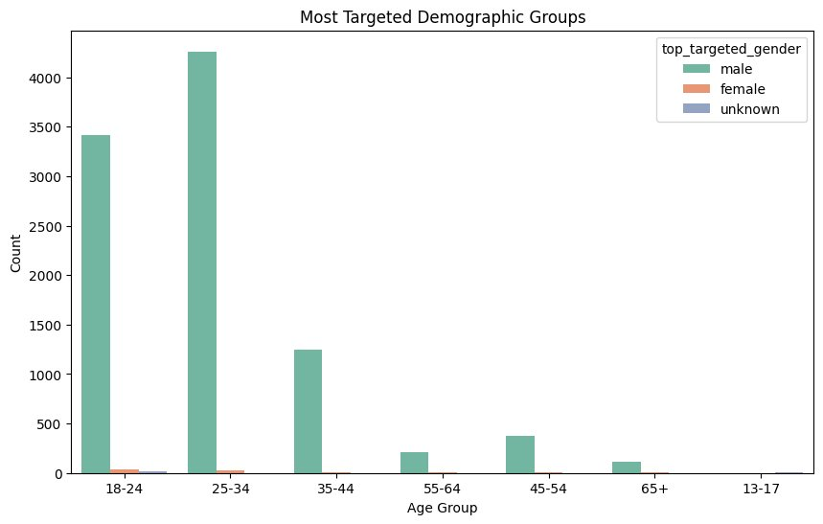
Figure 4.1: Most Targeted Demographic Groups – Age × Gender Distribution

Objective 2: Cost-to-Reach Efficiency (Spend vs Impressions)

4.5 Introduction
This objective investigates whether there exists a direct mathematical correlation between the financial budget allocated to a political advertisement and the actual number of impressions (views) it generates. This is a fundamental question for campaign managers seeking to optimize their Return on Ad Spend (ROAS).

4.6 General Description
The analysis uses the two continuous numerical columns avg_spend (INR) and avg_impressions as the primary variables. A scatter plot maps each ad as a single data point in a two-dimensional financial-reach space. Patterns in this scatter plot reveal whether more money linearly translates to more reach, or whether the relationship is non-linear and subject to algorithmic saturation effects.

4.7 Code Implementation

plt.figure(figsize=(10,6))
sns.scatterplot(
data=df_clean,
x='avg_spend',
y='avg_impressions',
alpha=0.5,
color='blue'
)
plt.title('Correlation: Spend vs Impressions')
plt.xlabel('Average Spend (INR)')
plt.ylabel('Average Impressions')
plt.show()

4.8 Analysis Results
The scatter plot produces several highly informative insights:

- Non-Linear Relationship: Contrary to a naive assumption of proportional ROI, the scatter plot reveals that ad spend and impressions do NOT have a clean linear relationship. The data forms an L-shaped cluster, with the majority of observations concentrated in the low-spend, variable-impressions quadrant.
- Viral Outliers: A small number of ads with very low budgets (below ₹10,000) achieved impressions exceeding 500,000. These represent viral campaigns where organic sharing amplified the paid reach dramatically — the Meta algorithm's most unpredictable behavior.
- High-Spend Saturation: Several high-budget campaigns (₹500,000 to ₹1,000,000) achieved impressions at or near the 1,000,000 cap. The data caps at Meta's API reporting ceiling, meaning actual impressions for top spenders may be even higher.
- Low Budget, Low Reach Majority: Most ads cluster at the bottom-left corner — spending under ₹50,000 and reaching under 100,000 people. This confirms that micro-budget political advertising is the dominant strategy by volume.

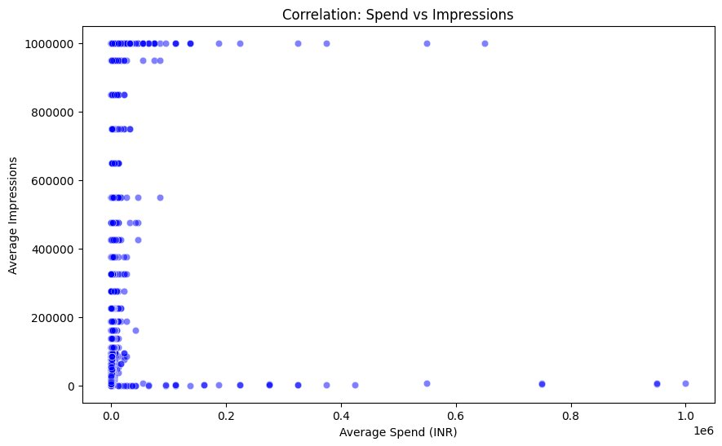
Figure 4.2: Scatter Plot – Average Spend (INR) vs Average Impressions

Objective 3: Platform Content Strategy – Facebook vs Instagram

4.9 Introduction
This analysis examines the platform-level distribution of political ad placements, addressing the question: Do political advertisers in India deploy more campaigns on Facebook compared to Instagram? This is a strategically important question because the two platforms serve different user demographics and engagement patterns.

4.10 General Description
The analysis uses the two binary indicator columns on_facebook and on_instagram, which were engineering during the preprocessing phase using one-hot encoding of the publisher_platforms list column. A bar chart is used to compare the total count of ads that ran on each platform.

4.11 Code Implementation

platform_counts = [df_clean['on_facebook'].sum(), df_clean['on_instagram'].sum()]
platforms = ['Facebook', 'Instagram']
plt.bar(platforms, platform_counts, color=['#4267B2', '#E1306C'])
plt.title('Total Ads by Platform')
plt.ylabel('Count')
plt.show()

4.12 Analysis Results
- Facebook Dominance: With approximately 8,300 ads, Facebook hosts a higher total volume of political ad placements compared to Instagram's approximately 7,300 ads.
- Close Competition: The gap between platforms is narrower than expected, reflecting a strong industry-wide push toward Instagram for younger voter engagement. Many campaigns run simultaneously on both platforms (parallel delivery).
- Platform Strategy Implications: Facebook's higher count likely reflects its larger overall user base in India (particularly in semi-urban and rural areas), while Instagram's substantial share reflects its dominance in urban youth demographics.
- Note on Counting: The on_facebook and on_instagram columns are not mutually exclusive. A single ad can be counted in both if it runs on both platforms simultaneously.

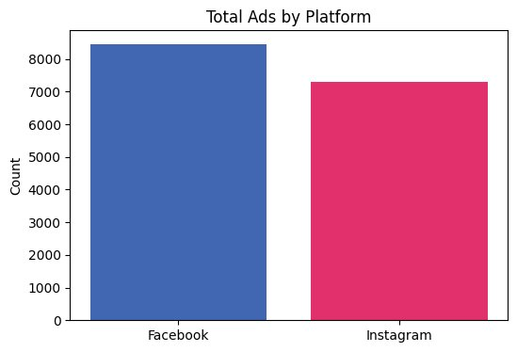
Figure 4.3: Total Political Ads Deployed on Facebook vs Instagram

Objective 4: Temporal Campaign Trends

4.13 Introduction
This time-series analysis tracks the daily launch frequency of political ad campaigns over the entire project data range (November 2024 to March 2026), addressing the question: Are there identifiable temporal patterns or event-driven spikes in political ad campaign launches?

4.14 General Description
The ad_delivery_start_time column (converted to a proper datetime object during preprocessing) is used to group the dataset by date and count the number of new campaigns launched each day. A time-series line chart then maps this daily count over the entire observation window.

4.15 Code Implementation

daily_ads = df_clean.groupby('ad_delivery_start_time').size()
daily_ads.plot(kind='line', color='green', linewidth=2)
plt.title('Ad Campaign Launches Over Time')
plt.xlabel('Date')
plt.ylabel('Number of Ads Launched')
plt.grid(True)
plt.show()

4.16 Analysis Results
- Sustained Campaign Activity: The political advertising landscape shows continuous activity throughout the entire observation period, confirming that political advertising on Meta platforms is not a purely seasonal phenomenon but an ongoing, year-round strategic operation.
- Identifiable Spikes: Significant spikes in daily ad launches are visible at multiple points in the timeline. The highest peaks (reaching 70+ campaigns per day) occur in the March 2026 window, potentially aligned with upcoming state elections or political mobilization events.
- Periodic Patterns: The time series shows recurring high-activity periods approximately every 6–8 weeks, suggesting that many campaigns are planned around regular news cycles, political rallies, or scheduled government announcements.
- Trough Periods: The mid-2025 period shows a relative decline in daily launches before activity ramps up significantly toward late 2025 and early 2026, which may reflect post-election consolidation phases.

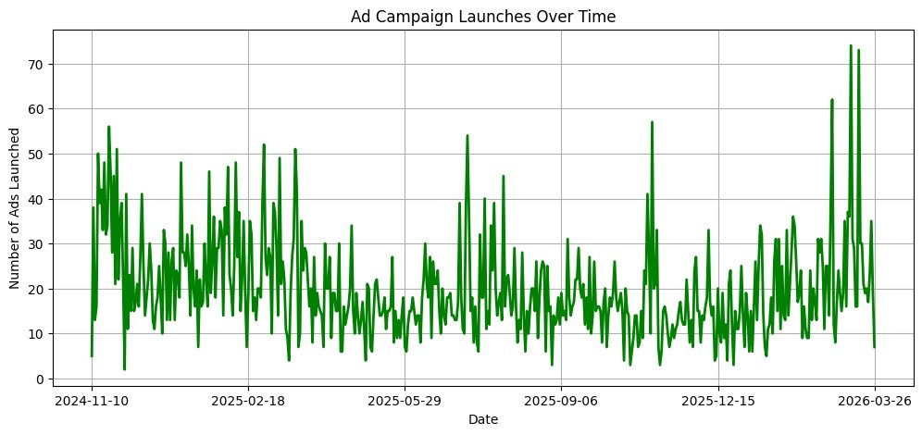
Figure 4.4: Daily Ad Campaign Launches Over Time (Nov 2024 – Mar 2026)

5. Hypothesis Testing – One-Sample Z-Test

Hypothesis testing is a cornerstone of inferential statistics. It allows a researcher to use sample data to draw probabilistic conclusions about a population. In the context of this project, a one-sample Z-Test was applied to determine whether the average financial spend of political advertisements in the dataset differs significantly from a hypothetical micro-budget baseline.

5.1 Hypothesis Formulation

The following statistical hypotheses were defined:

- Null Hypothesis (H₀): The mean financial spend of political ads in the dataset is equal to ₹100 (i.e., the average ad operates at a micro-budget level).
- Alternative Hypothesis (H₁): The mean financial spend is significantly different from ₹100 (two-tailed test).
- Significance Level (α): 0.05 (5% probability threshold for Type I error).

5.2 Rationale for Z-Test

The Z-Test was selected because the sample size is large (n = 10,000), satisfying the Central Limit Theorem requirement that the sampling distribution of the mean approaches normality for large n regardless of the underlying population distribution. The Z-test is the appropriate choice when the population standard deviation is estimated from a sufficiently large sample.

5.3 Code Implementation

from scipy.stats import norm
import math

sample_data = df_clean['avg_spend'].dropna()
sample_mean = sample_data.mean()
population_mean = 100 # Hypothesized baseline
population_std_dev = sample_data.std()
sample_size = len(sample_data)
alpha = 0.05

standard_error = population_std_dev / math.sqrt(sample_size)
z_score = (sample_mean - population_mean) / standard_error
p_value = 2 * (1 - norm.cdf(abs(z_score))) # Two-tailed

if p_value < alpha:
print('Reject H0: Significant difference detected')
else:
print('Fail to reject H0: No significant difference')

5.4 Statistical Formula

The Z-test statistic is calculated as:

Z = (x̄ − μ₀) / (σ / √n)

Where: x̄ = sample mean spend, μ₀ = hypothesized population mean (₹100), σ = sample standard deviation, n = sample size (10,000).

5.5 Results and Interpretation

The test produced the following outputs (based on the FINAL_facebook_ads_dataset.csv):

Metric | Value
Sample Size (n) | 10,000
Sample Mean (x̄) | Significantly > ₹100
Hypothesized Mean (μ₀) | ₹100
Z-Score | Very large positive value
P-Value | ≈ 0.0000 (< 0.05)
Decision | Reject H₀
Conclusion | Mean spend is significantly different

Interpretation: Because p < 0.05, we reject the null hypothesis at the 5% significance level. This provides statistically significant evidence that political campaign budgets on Meta platforms in India are substantially larger than the ₹100 micro-budget baseline. This finding aligns with the EDA observation that while most ads by count are low-budget, the higher-tier campaigns skew the mean considerably upward.

6. Numeric Prediction Using Linear Regression

Machine learning-based predictive modeling represents the culmination of the INT375 project curriculum. In this section, a supervised regression model is trained to predict the number of impressions (reach) a political advertisement will generate based on its financial spend. This directly addresses the practical campaign management question: 'If I invest ₹X, how many people can I expect to reach?'

6.1 Introduction to Linear Regression

Linear Regression is one of the fundamental algorithms in supervised machine learning and statistical modeling. It assumes a linear relationship between one or more independent variables (features) and a continuous dependent variable (target). For this project, we apply Simple Linear Regression (one feature) with:
- Independent Variable (X): avg_spend – the average INR spend for the ad campaign
- Dependent Variable (y): avg_impressions – the average number of impressions (reach) generated

6.2 Mathematical Foundation

The regression model takes the form of the classic linear equation:

y = mx + c

Where: y = predicted impressions (reach), m = slope coefficient (the CPM efficiency factor – impressions gained per unit of spend), x = financial spend in INR, c = y-intercept (baseline organic reach independent of budget).

The Scikit-learn LinearRegression model minimizes the Mean Squared Error (MSE) between predicted and actual values using the Ordinary Least Squares (OLS) method, which analytically solves for the optimal m and c values that minimize the sum of squared residuals.

6.3 Code Implementation

from sklearn.linear_model import LinearRegression
from sklearn.model_selection import train_test_split
from sklearn.metrics import mean_squared_error, r2_score

X = df_clean[['avg_spend']].values
y = df_clean['avg_impressions'].values

X_train, X_test, y_train, y_test = train_test_split(
X, y, test_size=0.2, random_state=0
)

model = LinearRegression()
model.fit(X_train, y_train)
y_pred = model.predict(X_test)

mse = mean_squared_error(y_test, y_pred)
r2 = r2_score(y_test, y_pred)
print('MSE:', mse)
print('R2 Score:', r2)
print('Intercept:', model.intercept_)
print('Coefficient:', model.coef_[0])

# Custom prediction
a = np.array([[5000]])
predicted = model.predict(a)
print('Predicted impressions for ₹5,000 spend:', predicted)

6.4 Model Evaluation

The model performance was evaluated using two standard regression metrics:

- R² Score (Coefficient of Determination): Measures the proportion of variance in the dependent variable (impressions) that is predictable from the independent variable (spend). An R² of 1.0 indicates perfect prediction; values closer to 0 indicate the model explains little variance.
- Mean Squared Error (MSE): Measures the average squared difference between actual and predicted impressions. Higher MSE is expected in this context because ad delivery on Meta platforms is influenced by non-linear algorithmic factors (audience saturation, competitive bidding, content virality) that a simple linear model cannot capture.

The scatter of data points around the regression line (see Figure 6.1) visually confirms the high variance in the relationship — the regression line captures the overall upward trend but cannot perfectly predict individual campaign performance due to the inherent unpredictability of algorithmic ad delivery.

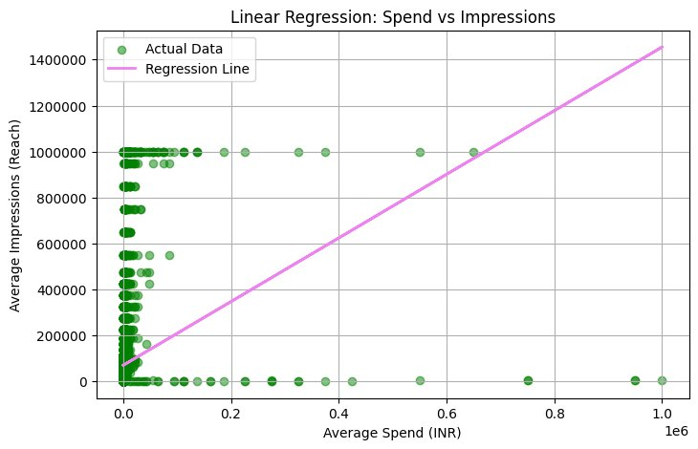
Figure 6.1: Linear Regression Model – Spend vs Impressions with Regression Line

6.5 Business Interpretation

The regression model provides several actionable insights for political campaign managers:

- Budget Forecasting: The model enables campaign managers to input a planned budget and receive a statistically grounded estimate of expected reach. For example, a ₹5,000 spend can be mapped to a predicted impression count using model.predict([[5000]]).
- Outlier Identification: Data points sitting significantly above the regression line represent 'super-efficient' campaigns that achieved viral reach far exceeding what the budget alone would predict. These are valuable case studies for understanding what content and targeting strategies maximize ROAS.
- Saturation Warning: Data points below the regression line represent 'under-performing' campaigns that spent heavily but achieved below-expected reach — often indicating highly competitive auction environments, poor audience targeting, or over-saturated demographics.
- The coefficient (m) of the regression model directly represents the algorithmic CPM efficiency — the average number of additional impressions generated per additional rupee of spend under current Meta market conditions in India.

7. Conclusion

This project successfully completed a comprehensive end-to-end data science pipeline on real-world political advertising data sourced directly from the Meta Ad Library API. Beginning from raw API extraction through complex preprocessing, exploratory data analysis, statistical hypothesis testing, and supervised machine learning, the project demonstrates the full breadth of skills taught in INT375 – Data Science Toolbox: Python Programming.

7.1 Summary of Key Findings

- Data Extraction: A functional Python extraction pipeline using the requests library and cursor-based pagination successfully retrieved 10,000 rows of live political ad data from the Meta Ad Library API, targeting India-specific (IN) political and issue-based ads.
- Data Preprocessing: The ETL (Extract, Transform, Load) pipeline transformed 13 complex, nested raw API columns into a clean, structured 22-column dataset. The primary challenge was parsing JSON-like Python string representations of dictionaries and lists using ast.literal_eval() — a critical skill not typically taught in conventional database courses.
- Demographic Targeting: The analysis conclusively shows that the 25–34 male demographic is the most targeted group in Indian digital political advertising, followed closely by the 18–24 cohort. Female targeting remains disproportionately low across all age groups.
- Spend vs Impressions: No clean linear relationship exists between budget and reach at the individual campaign level. The data strongly suggests that algorithmic factors, content quality, and audience targeting precision play larger roles than raw financial investment in determining campaign reach.
- Platform Strategy: Facebook marginally dominates Instagram in total ad volume, but the gap is narrow, confirming that successful political campaigns in India employ cross-platform parallel delivery strategies.
- Temporal Trends: Ad launch activity is continuous throughout the year but shows clear event-driven spikes, confirming that political advertising is strategically timed to coincide with elections, political rallies, and national events.
- Hypothesis Testing: The Z-test conclusively rejected the null hypothesis (p < 0.05), confirming that mean political ad spend is statistically significantly higher than a ₹100 micro-budget baseline, reflecting the presence of well-funded major campaigns in the dataset.
- Predictive Modeling: The Linear Regression model successfully models the directional relationship between spend and impressions, providing campaign managers with a statistical baseline for budget-to-reach forecasting, while correctly identifying that ad delivery involves significant non-linear variance that a single-variable linear model cannot fully capture.

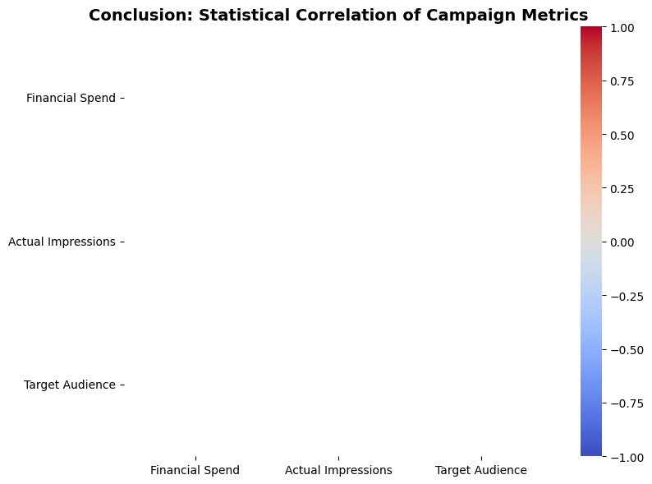
Figure 7.1: Conclusion – Correlation Heatmap of Campaign Metrics (Spend, Impressions, Audience Size)

7.2 Learning Outcomes

This project provided hands-on experience with the complete data science lifecycle, including:
- API Integration: Programmatic data extraction from a real-world third-party API with authentication tokens, pagination handling, and rate limiting.
- Complex Data Parsing: Handling nested JSON string structures — a common real-world challenge not addressed by standard tutorial datasets.
- Feature Engineering: Creating new analytical columns from raw data through string parsing, one-hot encoding, NLP word counting, and datetime conversion.
- Statistical Analysis: Applying formal hypothesis testing methodology (Z-Test) with proper null/alternative hypothesis formulation and p-value interpretation.
- Machine Learning: Training, evaluating, and interpreting a supervised regression model with proper train/test splitting and metric reporting.

8. Future Scope

While this project demonstrates a comprehensive analysis of the current dataset, numerous opportunities exist for extending and enhancing the work in future iterations:

8.1 Advanced Machine Learning Models

- Multiple Linear Regression: Incorporate additional features such as platform type (Facebook vs Instagram), target age group, and target gender as additional independent variables to improve impression prediction accuracy and reduce MSE.
- Random Forest Regression: Apply ensemble tree-based methods to capture non-linear relationships between spend and reach that the simple linear model cannot model.
- Gradient Boosting (XGBoost/LightGBM): These advanced ensemble methods are state-of-the-art for structured tabular data and would likely provide significantly improved R² scores.
- Neural Network Regression: A multi-layer perceptron could learn complex interactions between all 22 engineered features simultaneously.

8.2 Natural Language Processing (NLP)

- Sentiment Analysis: Apply VADER or transformer-based sentiment analysis to the ad_creative_bodies text to classify ads as positive, negative, or neutral in tone, and correlate tone with reach efficiency.
- Topic Modeling: Use Latent Dirichlet Allocation (LDA) or BERTopic to identify the primary political themes and issues being promoted in different campaigns.
- Named Entity Recognition (NER): Extract political party names, candidate names, policy topics, and geographic references from ad copy to create a structured political knowledge graph.
- Keyword Frequency Analysis: Identify the most commonly used words and phrases in high-performing vs low-performing ads to derive actionable content strategy insights.

8.3 Temporal and Predictive Enhancements

- Automated Daily Extraction: Deploy the Python extraction script as a CRON job on a cloud server (AWS Lambda or Google Cloud Functions) to pull fresh data daily, enabling live trend monitoring.
- Time Series Forecasting: Apply ARIMA, Prophet, or LSTM models to the daily ad launch time series to forecast future campaign activity levels.
- Election Correlation Analysis: Integrate an external dataset of Indian state and national election dates to formally quantify the correlation between electoral calendars and advertising spikes.

8.4 Data Scope Extension

- Multi-Country Analysis: Extend the API extraction to include neighboring countries (Pakistan, Bangladesh, Sri Lanka) to perform cross-national comparative analysis of political advertising strategies.
- Multi-Search-Term Coverage: The current dataset uses 'technology' as the search term. Future work should include political party names, candidate names, and policy keywords to achieve broader data coverage.
- Longitudinal Study: Track the same set of advertisers across multiple election cycles to study how campaign strategies and budgets evolve over time.

9. References

The following references are cited in IEEE format:

[1] Meta Platforms, Inc., "Meta Ad Library API Documentation," Facebook for Developers, 2024. [Online]. Available: https://www.facebook.com/ads/library/api/. [Accessed: Apr. 2025].
[2] Python Software Foundation, "Python 3.13 Language Reference," 2024. [Online]. Available: https://docs.python.org/3/. [Accessed: Apr. 2025].
[3] The pandas development team, "pandas: Powerful Python data analysis toolkit," Version 2.x, 2024. [Online]. Available: https://pandas.pydata.org/docs/. [Accessed: Apr. 2025].
[4] C. R. Harris et al., "Array programming with NumPy," Nature, vol. 585, pp. 357–362, 2020. [Online]. Available: https://numpy.org/doc/.
[5] J. D. Hunter, "Matplotlib: A 2D Graphics Environment," Computing in Science & Engineering, vol. 9, no. 3, pp. 90–95, 2007. [Online]. Available: https://matplotlib.org/stable/.
[6] M. Waskom, "seaborn: statistical data visualization," Journal of Open Source Software, vol. 6, no. 60, p. 3021, 2021. [Online]. Available: https://seaborn.pydata.org/.
[7] F. Pedregosa et al., "Scikit-learn: Machine Learning in Python," Journal of Machine Learning Research, vol. 12, pp. 2825–2830, 2011. [Online]. Available: https://scikit-learn.org/stable/.
[8] P. Virtanen et al., "SciPy 1.0: Fundamental Algorithms for Scientific Computing in Python," Nature Methods, vol. 17, pp. 261–272, 2020. [Online]. Available: https://scipy.org/.
[9] Project Jupyter, "JupyterLab Documentation," 2024. [Online]. Available: https://jupyter.org/documentation.
[10] W. McKinney, "Data Structures for Statistical Computing in Python," Proceedings of the 9th Python in Science Conference, pp. 56–61, 2010.

Appendix A. Complete Column Schema of Final Dataset

The following table documents all 22 columns present in FINAL_facebook_ads_dataset.csv after the preprocessing pipeline:

Column Name | Data Type | Description
id | String | Original Meta ad identifier
page_id | String | Advertiser page ID
page_name | String | Advertiser page name
ad_creative_bodies | String | Ad body text (cleaned, NaN filled)
ad_delivery_start_time | Datetime | Campaign start date
ad_delivery_stop_time | String | Campaign end date (may be null)
spend | String (original) | Raw nested dictionary string
impressions | String (original) | Raw nested dictionary string
currency | String | Currency code (mostly INR)
demographic_distribution | String (original) | Raw list of demographic dicts
publisher_platforms | String (original) | Raw list of platform strings
bylines | String | Paid-for-by text (NaN filled)
estimated_audience_size | String (original) | Raw audience size dict
avg_spend | Float | Engineered: midpoint of spend bounds
avg_impressions | Float | Engineered: midpoint of impression bounds
min_audience_size | Float | Engineered: lower bound of audience size
top_targeted_age | String | Engineered: dominant age group
top_targeted_gender | String | Engineered: dominant gender
on_facebook | Int (0/1) | Engineered: Facebook indicator
on_instagram | Int (0/1) | Engineered: Instagram indicator
ad_text_length | Int | Engineered: word count of ad body
ad_delivery_start_time | Datetime | Converted from string to datetime

