RACING TRACK NAVIGATION

Arman Vardanyan

Program pozostáva z nasledujúcich častí:

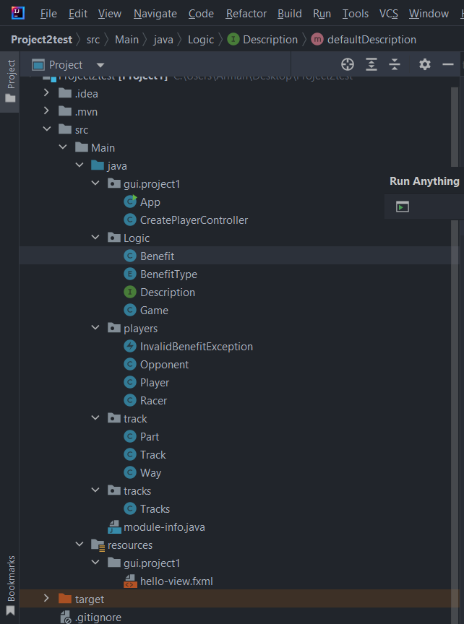

Hlavne Classi su: -Racer, z ktoreho dedia Player a Opponent  
 -Track, ktora má Part, Part má Way a Way má Benefity

-Benefity maju typi z enum a implementuju interface

-celý interface je v CreatePlayerController a celá funckinalita gui implementovana v game classe

program ako celok funguje ako v prvom popise hry. Program je v podstate navigátor pretekárskej dráhy, v programe sa vytvorí hráč a súperi a začína sa ťahový pretek, v programe je niekoľko chýb, ktoré treba ešte dokončiť a vylepšiť, ale tie najjednoduchšie akcie fungujú bezchybne. program končí vyhlásením víťazného jazdca

v guthub bola odovzdana pracovna verzia.

Z Ďalšich kriterii su:

* handling exceptional states using own exceptions – one exception is sufficient, but it has to be actually thrown and handled
* *package* players;  
    
  *public class* InvalidBenefitException *extends* Exception {  
   *public* InvalidBenefitException(String message) {  
   *super*(message);  
   }  
  }
* *public void* addBenefit(String name) *throws* InvalidBenefitException {  
   *try* {  
   BenefitType type = BenefitType.valueOf(name.toUpperCase());  
   *this*.benefit = *new* Benefit(name, type);  
   } *catch* (IllegalArgumentException e) {  
   *throw new* InvalidBenefitException("Invalid benefit: " + name);  
   }  
  }
* providing a graphical user interface separated from application logic and with at least part of the event handlers created manually – counts as a fulfillment of two further criteria

*package* gui.project1;  
  
*import* javafx.event.ActionEvent;  
*import* javafx.fxml.*FXML*;  
*import* javafx.scene.control.Label;  
*import* Logic.Game;  
*import* javafx.scene.control.TextArea;  
*import* players.InvalidBenefitException;  
  
  
*public class* CreatePlayerController {  
  
 *@FXML  
 public* TextArea consoleTextArea;  
  
 *private* Game game;  
  
 *public* CreatePlayerController() {  
 game = *new* Game("Hello", consoleTextArea);  
 }  
  
 *@FXML  
 private* Label welcomeText;  
  
 *@FXML  
 void* onHelloWorld(ActionEvent event) {  
 game.helloWorld();  
 }  
  
 *@FXML  
 void* onCreatePlayer(ActionEvent event) {  
 game.createPlayer();  
 }  
  
 *@FXML  
 void* onCreateOpponent(ActionEvent event) {  
 game.createOpponent();  
 }  
  
  
  
 *public void* onPlay(ActionEvent actionEvent) {  
 game.play();  
 }  
  
 *public void* onAction(ActionEvent actionEvent) *throws* InvalidBenefitException {  
 game.next();  
 }  
  
 *@FXML  
 public void* onRestart(ActionEvent actionEvent) {  
 game.resetGame();  
 }  
  
 *@FXML  
 public void* onCreateTrack(ActionEvent actionEvent) {  
 *// TODO* }  
  
 *@FXML  
 public void* onStart(ActionEvent actionEvent) {  
 game.start();  
 }  
  
 *public void* onChooseOne(ActionEvent actionEvent) {  
 game.chooseOne();  
 }  
  
 *public void* onChoosetwo(ActionEvent actionEvent) {  
 game.chooseTwo();  
  
 }

* using generics in own classes – implementing and using an own generic class (as in the linked list example provided with lecture 5)
* *package* Logic;  
    
    
  *public class* Benefit<T> *implements* Description {  
   *private* String name;  
   *private* BenefitType type;  
   *private* T cast;  
    
   *private* String description;  
    
   *public* Benefit(String name, T cast) {  
   *this*.name = name;  
   *this*.cast = cast;  
   }

explicit use of RTTI – for example, to determine the type of on object or to create an object of a certain type (as in determining the number of beings in the ogre and knights game)

*// Method to create a Benefit object based on the provided type  
private* Benefit createBenefitInstance(String name, BenefitType type) {  
 Benefit benefit = *null*;  
  
 *// Use RTTI to create an object of a specific type  
 if* (type == BenefitType.TURBO) {  
 benefit = *new* TurboBenefit(name, type); *// Assuming TurboBenefit is a subclass of Benefit* } *else if* (type == BenefitType.OIL) {  
 benefit = *new* OilBenefit(name, type); *// Assuming OilBenefit is a subclass of Benefit* }  
  
 *return* benefit;  
}

* using nested classes and interfaces – only using them within the application logic counts, not in the GUI, whereby the interfaces have to be own (one possibility is present in the inner class example provided with lecture 4)
* *public class* Benefit<T> *implements* Description {  
   *private* String name;  
   *private* BenefitType type;  
   *private* T cast;  
     
    *public* Benefit(String name, BenefitType type) {  
   *this*.name = name;  
   *this*.type = type;  
   }
* using default method implementation in interfaces

*package* Logic;  
  
*public interface* Description {  
 *void* addDescription(String Desctiption);  
  
 *default void* defaultDescription() {  
 System.out.println("this is an benefit which you can get on the road");  
 }  
}