UNIT – 1 MINI PROJECT
ENTERPRISE STUDENT RECORD AND
ACADEMIC MANAGEMENT PLATFORM
Design Thinking and Product Planning
Student Name: Arman
Roll Number: 2125UMLM1097
Program: B.Tech CSE (AIML)
Institute: Sanjivani University
Academic Year: 2nd Year
Submitted To: Karan Sir

Table of Contents

- 1. Introduction to Software Product Development
- 2. Business Understanding: Higher Education & Academic Management
- 3. Problem Identification
- 4. Introduction to Design Thinking
- 5. Five Stages of Design Thinking
- 6. IBM Design Thinking
- 7. IBM Loop Engine
- 8. Stakeholder Analysis
- 9. User Personas
- 10. Requirements Engineering
- 11. Product Vision
- 12. MVP Definition
- 13. Product Roadmap
- 14. Initial System Architecture
- 15. Repository / Folder Structure
- 16. Project Charter
- 17. Product Discovery Documentation
- 18. Design & Visual Requirements
- 19. UI/UX Wireframes
Design Decision Summary
The product is intentionally centered on a focused academic-management MVP: centralized records, course information, attendance, examination/marks, results, reporting, and role-based dashboards. Advanced analytics, AI capabilities, mobile delivery, and external integrations are deferred so that the first release remains feasible, testable, and aligned with the Unit-1 product-planning objective.
- 20. Conclusion
- 21. References / Source Basis

1. Introduction to Software Product Development
Software product development is a structured engineering activity in which a team transforms user and business needs into a useful, maintainable, secure, and continuously improvable software product. Coding is one part of this lifecycle; product engineering also includes requirement discovery, architecture, user experience, quality assurance, deployment, and feedback.

1.1 Programming/Coding vs Software Product Engineering
Dimension | Programming / Coding | Software Product Engineering
Primary goal | Implement logic, algorithms, and features. | Deliver a useful, maintainable, scalable product for real users.
Scope | Functions, classes, scripts, or individual modules. | End-to-end lifecycle including discovery, UX, architecture, testing, deployment, and improvement.
Main question | How should this code work? | What user problem are we solving and how will the product create value?
Success | Correct execution and acceptable test results. | User satisfaction, reliability, maintainability, performance, and business/academic outcomes.
Collaboration | Often focused on developers. | Cross-functional collaboration among users, product, UX, engineering, QA, data, and operations.

1.2 Why Structured Engineering Matters
- Requirements can be validated before expensive implementation begins.
- User needs remain connected to product decisions.
- Architecture and data design reduce avoidable rework.
- Testing and deployment become planned engineering activities rather than last-minute tasks.
- Feedback can continuously improve the product after the first release.
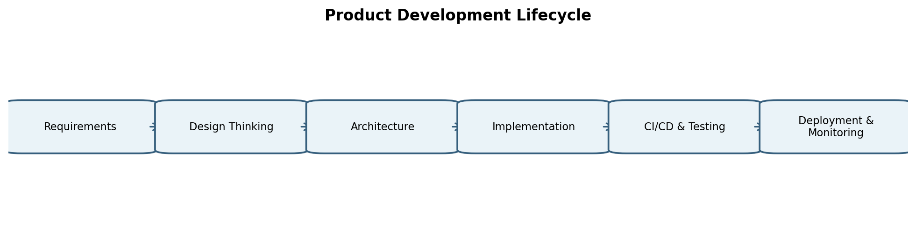
Figure 1. Product development lifecycle adapted for the academic-management platform.

2. Business Understanding: Higher Education & Academic Management
The target domain is higher-education academic administration. The proposed platform brings student and academic information into a coordinated system so that students, faculty, administrators, and examination staff can work with consistent records.

2.1 Core Academic Operations
- Student admission and registration: capturing identity and academic information.
- Student profile management: maintaining program, semester, contact, and academic records.
- Course registration: associating students with courses and academic offerings.
- Attendance management: recording and reviewing attendance against enrolled courses.
- Examination management: organizing assessment information and examination records.
- Marks and result management: recording marks and producing academic results.
- Academic report generation: producing student and administrative reports.
- Faculty/academic administration: supporting faculty workflows and academic oversight.
- Student academic history: maintaining a consistent longitudinal record.
- Administrative reporting: providing consolidated information for academic decisions.

2.2 Manual Challenges and Digital Responses
Manual process challenge | Proposed digital solution | Expected outcome
Student information spread across files or disconnected records. | Centralized role-based student record system. | Faster access and fewer duplicate records.
Attendance maintained in separate sheets or registers. | Course-wise digital attendance workflow. | Clearer attendance visibility for students and faculty.
Marks and results require repeated manual compilation. | Structured marks entry and result-generation workflow. | More consistent processing and easier review.
Students depend on notices or staff for routine academic information. | Student dashboard with current academic information. | Self-service access to important records.
Administrative reports require manual consolidation. | Role-based reporting and export capability. | Reduced repetitive reporting effort and improved visibility.

3. Problem Identification

3.1 User and Operational Problems
User group | Key problems
Students | Difficulty tracking attendance, courses, results, and academic updates across multiple channels.
Faculty | Repetitive record entry, attendance maintenance, marks handling, and limited consolidated student visibility.
Academic administrators | Need to coordinate records, monitor academic operations, and prepare reports from distributed information.
Examination cell | Need accurate examination and result records with controlled access and traceability.
IT/support personnel | Need a maintainable system with clear roles, data integrity, security, and manageable operational workflows.

3.2 Core Problem Statement
Core Problem Statement: Students and academic staff may experience delays, duplication, and inconsistent visibility when student records, attendance, examination information, and results are managed through disconnected or manual processes. A centralized, role-based academic management platform is therefore needed to provide reliable access to academic information, simplify routine workflows, and support better administrative visibility.

4. Introduction to Design Thinking
Design Thinking is a human-centered, iterative approach for understanding real user needs before committing to a solution. For this project, it helps the team understand how students and academic staff actually perform tasks, identify the most important problems, explore alternative solutions, create low-cost prototypes, and validate the proposed experience.
- Human-centered innovation: design around user goals and constraints.
- Pain-point discovery: understand where users lose time, clarity, or confidence.
- Creative ideation: explore multiple possible solutions before selecting a direction.
- Rapid prototyping: test workflows and screens before investing in full implementation.
- Early validation: use feedback to refine the product and reduce avoidable rework.

5. Five Stages of Design Thinking
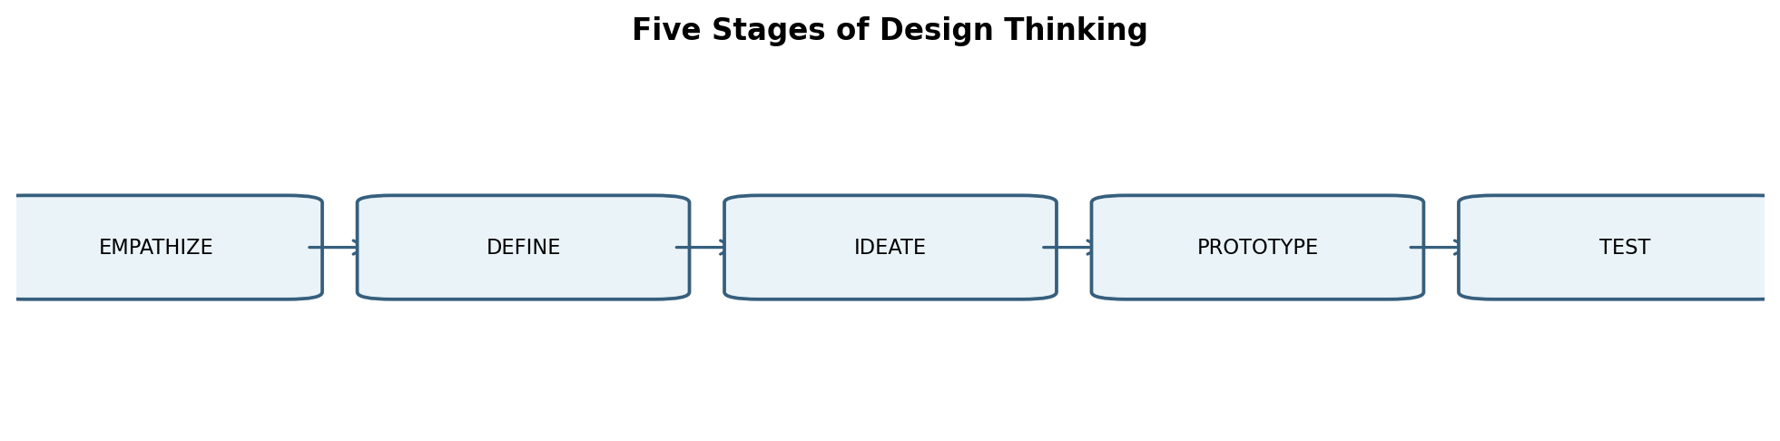
Figure 2. Five-stage Design Thinking flow.

5.1 Empathize
Purpose: understand users and their context.
Activities: observe academic workflows, discuss pain points, identify information needs.
Users: students, faculty, administrators, examination staff.
Output: user needs, frustrations, observations, and opportunity areas.

5.2 Define
Purpose: convert observations into a focused problem.
Activities: cluster pain points, identify common causes, prioritize high-value problems.
Users: product/design team with stakeholder validation.
Output: core problem statement and design goals.

5.3 Ideate
Purpose: generate solution alternatives.
Activities: brainstorm dashboards, workflows, notifications, centralized records, reports, and role-based access.
Users: cross-functional team.
Output: prioritized solution ideas.

5.4 Prototype
Purpose: make ideas tangible at low cost.
Activities: create conceptual login, dashboards, attendance, result, and admin screens.
Users: design/product team.
Output: clickable or presentable low/medium-fidelity concepts.

5.5 Test
Purpose: validate whether the proposed experience works for users.
Activities: task walkthroughs, usability feedback, navigation checks, and iteration.
Users: representative students and staff.
Output: findings, improvements, and refined product assumptions.

6. IBM Design Thinking

6.1 Focus on User Outcomes
Technical/product activity | Desired user outcome
Build centralized student record search. | Allow authorized users to find relevant student information without checking multiple records.
Create an attendance module. | Give students and faculty a clear course-wise attendance view.
Provide result workflows. | Enable students to access published results while authorized staff retain controlled editing rights.
Create administrative reports. | Help academic administrators obtain consistent information for routine monitoring.

6.2 Restless Reinvention
The platform should be treated as a product that evolves. Feedback, usage observations, support issues, and changing academic workflows can be reviewed regularly. Improvements may involve simplifying screens, refining validation rules, improving reports, or changing workflows.

6.3 Diverse Empowered Teams
- Academic stakeholders explain domain needs and validate workflows.
- UX/product contributors translate user needs into understandable experiences.
- Developers implement application behavior and integrations.
- QA engineers validate functional and usability expectations.
- Database specialists protect data integrity and structure.
- DevOps and IT support teams help with environments, deployment, reliability, and operational concerns.
- Security contributors help define access control and protection requirements.

7. IBM Loop Engine
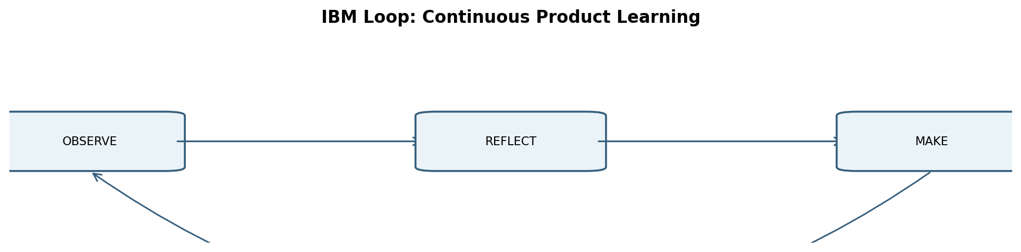
Figure 3. Observe → Reflect → Make loop for continuous product learning.
Loop stage | Application to this project
OBSERVE | Study user interactions, workflow friction, support questions, and prototype feedback.
REFLECT | Analyze recurring issues, compare them with product objectives, and identify what should change.
MAKE | Improve requirements, screens, workflows, data handling, or delivery practices based on the learning.
Repeat | Return to observation after the change to determine whether the improvement actually helped.

8. Stakeholder Analysis
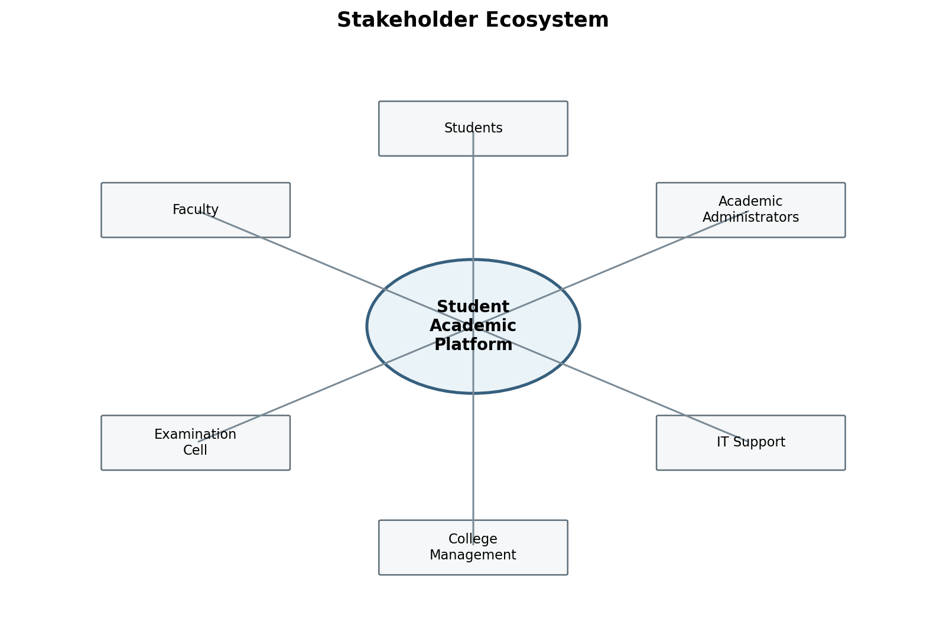
Figure 4. Stakeholder ecosystem.
Stakeholder | Role | Responsibilities | Expectations | Influence
Students | Primary users | Maintain/view academic information, register courses, review attendance and results. | Simple access, clarity, privacy, timely information. | High
Faculty | Academic operators | Manage attendance, marks, course information, and student academic activities. | Efficient workflows and accurate records. | High
Academic Administrators | Process owners | Oversee student records, academic operations, and reports. | Centralized visibility and reliable reporting. | High
Examination Cell | Assessment operations | Manage examination information, marks/results, and controlled publication. | Accuracy, traceability, controlled access. | High
IT Support | Technical support | Assist users and maintain operational availability. | Maintainability, diagnostics, predictable operation. | Medium
Database Administrators | Data operations | Maintain data structures, integrity, backup, and recovery practices. | Consistency, security, recoverability. | Medium
Developers / QA | Engineering | Build, test, and maintain the product. | Clear requirements and testable behavior. | Medium
DevOps Engineers | Operations | Support CI/CD, environments, deployment, and monitoring. | Repeatable delivery and operational visibility. | Medium
College Management | Governance | Set institutional priorities and review outcomes. | Reliable information and governance support. | High

9. User Personas

Persona 1 — Aarav: Student
- Goal: manage academic information with minimal effort.
- Needs: course information, attendance visibility, results, notices, academic history.
- Pain points: delayed updates, multiple channels, uncertainty about current records.
- Expected experience: one dashboard with clear, current information and role-appropriate actions.

Persona 2 — Neha: Faculty Member
- Goal: manage academic activities accurately and efficiently.
- Needs: course-wise student lists, attendance entry, marks entry, student academic context.
- Pain points: repetitive entry and difficulty consolidating information.
- Expected experience: simple course workflows with validation and clear status.

Persona 3 — Dr. Mehta: Academic Administrator
- Goal: monitor academic operations and generate reliable reports.
- Needs: consolidated records, filters, dashboards, and report generation.
- Pain points: manual consolidation and limited real-time visibility.
- Expected experience: controlled dashboards and consistent reports.

Persona 4 — Priya: Examination Cell Staff
- Goal: process examination and result information accurately.
- Needs: examination records, marks processing, result workflows, auditability.
- Pain points: repeated verification and risk of inconsistent records.
- Expected experience: structured, role-restricted result workflows with traceable updates.

10. Requirements Engineering

10.1 Functional Requirements Specification (FRS)
ID | Requirement | Description
FR-01 | Authentication and Role-Based Access | The platform shall provide authenticated access with permissions appropriate to Student, Faculty, Administrator, and Examination roles.
FR-02 | Student Registration | The platform shall support creation and maintenance of student registration records.
FR-03 | Student Profile Management | Authorized users shall be able to view or update permitted student profile information.
FR-04 | Course Registration | The platform shall maintain course information and student-course associations.
FR-05 | Attendance Management | Faculty shall be able to record attendance for assigned courses and students shall be able to view permitted attendance information.
FR-06 | Examination Management | Authorized examination staff shall manage examination-related records.
FR-07 | Marks Entry | Authorized faculty/examination users shall record assessment marks according to configured academic workflows.
FR-08 | Result Generation | The system shall support generation and publication of academic results according to authorization rules.
FR-09 | Academic Report Generation | Authorized users shall generate relevant student or administrative academic reports.
FR-10 | Notifications | The platform may provide role-appropriate notifications for important academic events and updates.
FR-11 | Administrative Dashboard | Administrators shall have a consolidated view of permitted academic records and operational information.
FR-12 | Audit/Record Tracking | Important changes should be traceable through appropriate audit information.

10.2 Non-Functional Requirements Specification (NFRS)
NFR Area | Requirement
Security | Protect credentials and academic information through strong authentication, authorization, secure transport, and least-privilege access.
Performance | The platform should provide responsive interaction for common academic workflows under the expected user load; exact targets can be established during later engineering stages.
Availability | Core academic information should remain accessible according to institutional availability objectives.
Scalability | The architecture should permit growth in users, courses, records, and academic periods without requiring a complete redesign.
Reliability | Transactions should behave consistently and avoid partial or ambiguous record updates.
Usability | Common tasks should be understandable to users with different technical familiarity.
Maintainability | Modules, documentation, tests, and deployment configuration should be organized for future maintenance.
Data Integrity | Relationships and validation rules should prevent inconsistent academic records.
Backup and Recovery | Important records should be protected through defined backup and recovery procedures.

11. Product Vision

11.1 Vision Statement
To deliver a secure, centralized, and user-friendly academic management platform that simplifies student record administration, improves access to attendance and examination information, and gives authorized stakeholders a consistent view of academic data.

11.2 Mission
Create a practical digital foundation for academic record management by combining clear user workflows, role-based access, structured data, and iterative product improvement.

11.3 Business Objectives
- Reduce dependence on fragmented academic records.
- Improve consistency of student and academic information.
- Provide role-appropriate visibility to students and staff.
- Support more structured attendance, examination, and result workflows.
- Create a maintainable foundation for future digital academic services.

11.4 User Objectives
- Students can quickly understand their current academic status.
- Faculty can perform routine academic tasks without unnecessary repetition.
- Administrators can monitor information and produce reports efficiently.
- Examination staff can manage assessment information with controlled access and traceability.

11.5 Success Criteria
- Key academic workflows are represented in a coherent end-to-end product design.
- Users can identify where to perform common tasks without unnecessary navigation.
- Requirements, MVP scope, architecture, and roadmap remain consistent with the problem statement.
- Feedback from prototype evaluation can be converted into documented improvements.

12. Minimum Viable Product (MVP)
MVP feature | Purpose | Primary users
Login and RBAC | Control access by role. | All users
Student registration/profile | Maintain core student records. | Admin, authorized staff
Course information | Maintain and view course-related information. | Students, Faculty, Admin
Attendance management | Record and review course attendance. | Faculty, Students
Examination/marks management | Manage assessment and marks workflows. | Faculty, Examination Cell
Result viewing | Provide published results to authorized users. | Students, Faculty/Admin
Basic academic reports | Generate essential academic information. | Admin, Examination Cell
Administrative dashboard | Provide consolidated visibility. | Academic Admin

12.1 Deferred / Future Features
- Dedicated mobile application.
- Advanced analytics and visualization.
- AI-assisted academic insights or recommendations.
- Predictive academic alerts.
- Integration with external institutional systems.
- Expanded notification and workflow automation.
The deferred features are intentionally outside the first release so that the MVP remains focused on the core academic record and workflow problem.

13. Product Roadmap
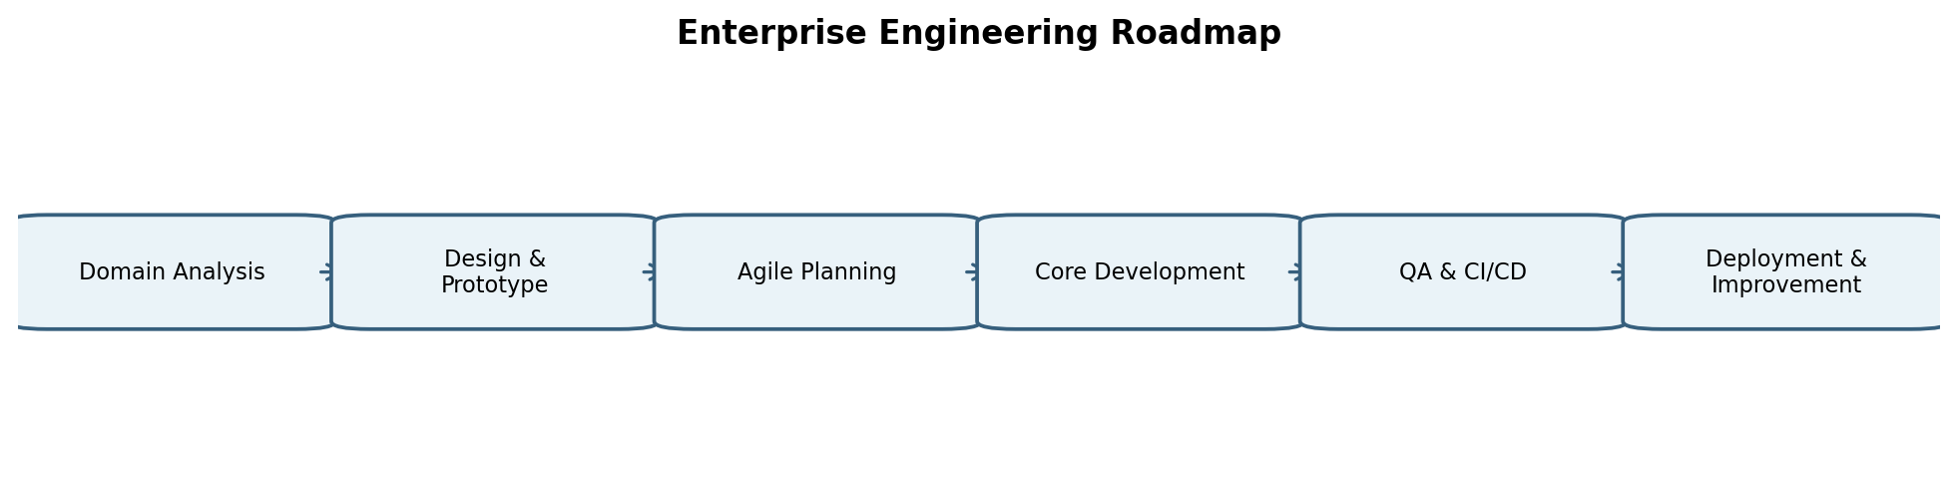
Figure 5. Proposed product-engineering roadmap.

Phase 1 — Domain Analysis & Problem Understanding
Objective: Map academic workflows, identify stakeholders, document pain points, and confirm the problem statement.
Expected deliverable: BRD, stakeholder map, discovery notes

Phase 2 — Design Thinking & Prototyping
Objective: Develop personas, ideate solutions, create wireframes, and validate workflows.
Expected deliverable: Personas, prototype, test feedback

Phase 3 — Agile Planning & Backlog
Objective: Convert validated needs into user stories, acceptance criteria, priorities, and sprint candidates.
Expected deliverable: Product backlog and sprint plan

Phase 4 — Core Application Development
Objective: Build the MVP modules and supporting data structures.
Expected deliverable: Working application modules

Phase 5 — Testing & Quality Assurance
Objective: Validate functional behavior, usability, security expectations, and data integrity.
Expected deliverable: Test results and defect records

Phase 6 — DevOps, CI/CD & Containerization
Objective: Automate repeatable build/test/deployment workflows and package the application consistently.
Expected deliverable: CI/CD pipeline and containerized deployment setup

Phase 7 — Deployment, Monitoring & Continuous Improvement
Objective: Deploy the product, observe usage/health, collect feedback, and iterate.
Expected deliverable: Operational dashboards, feedback loop, improvement backlog

14. Initial System Architecture
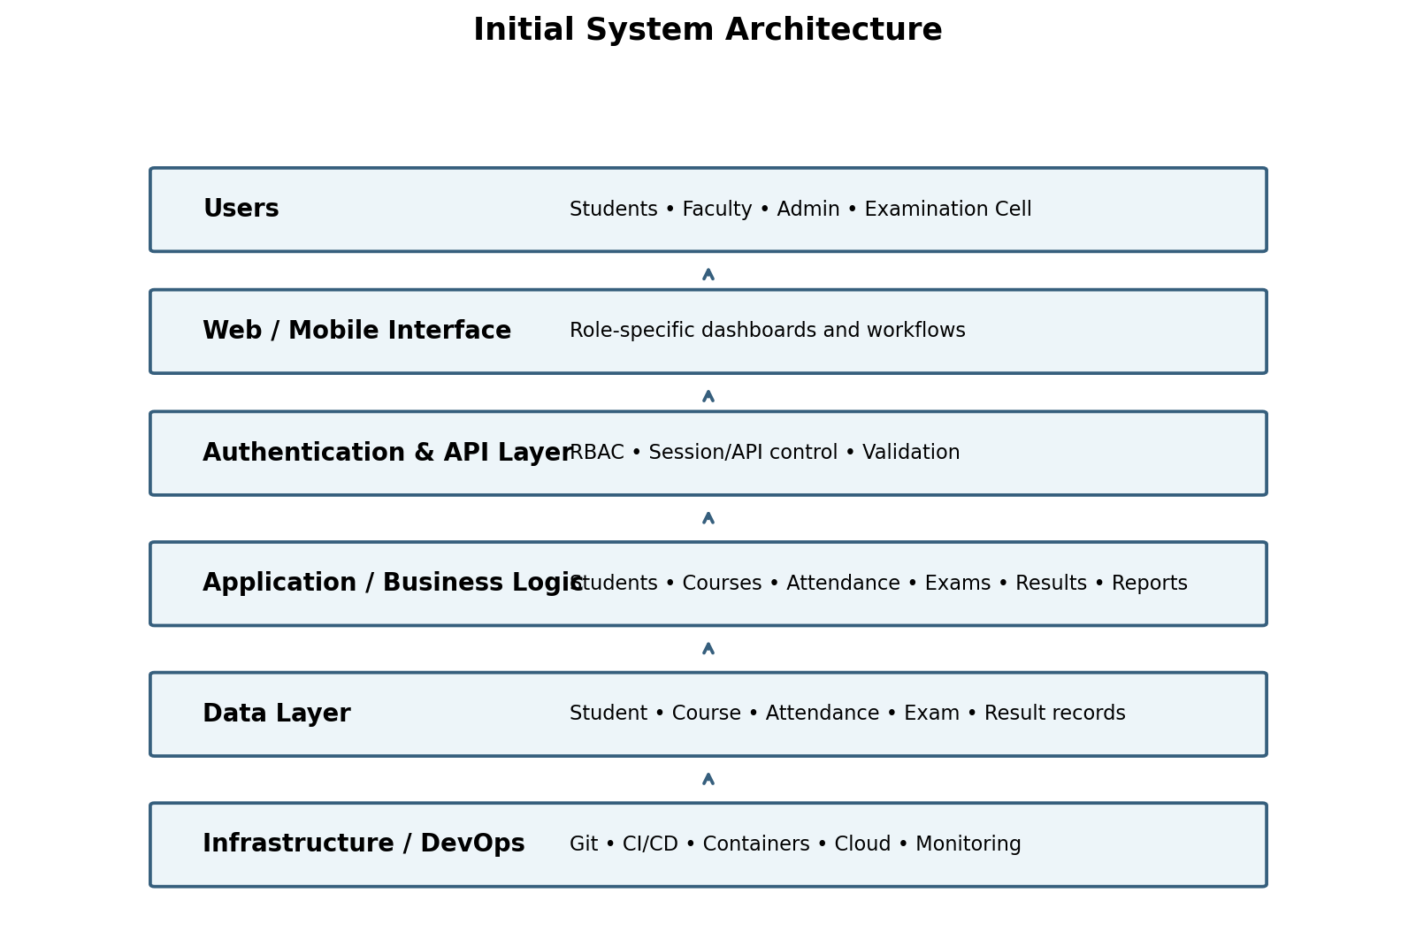
Figure 6. Initial layered architecture concept.

14.1 Architecture Explanation
- Users layer: students, faculty, administrators, and examination staff interact through role-specific experiences.
- Interface layer: web or mobile interfaces present dashboards and task workflows.
- Authentication/API layer: validates requests and applies role-based access rules.
- Business logic layer: contains student, course, attendance, examination, result, and reporting modules.
- Data layer: stores structured academic records and relationships.
- Infrastructure/DevOps layer: supports source control, automated delivery, deployment, and monitoring.
Technology choices such as a specific framework, cloud provider, database engine, or container platform can be finalized during later engineering units. The architecture above defines responsibilities rather than forcing an implementation stack.

15. Repository / Folder Structure
student-academic-management-platform/
├── .github/ # CI/CD workflows
├── app/ # Application source
│ ├── modules/
│ │ ├── students/ # Student records
│ │ ├── courses/ # Course workflows
│ │ ├── attendance/ # Attendance logic
│ │ ├── examinations/ # Examination workflows
│ │ └── results/ # Marks and result logic
│ ├── database/ # Schemas, migrations, models
│ └── tests/ # Unit and integration tests
├── frontend/ # User interface
├── backend/ # API/business services
├── docs/ # Requirements, diagrams, product documents
├── docker/ # Container definitions
├── kubernetes/ # Deployment/service manifests
├── terraform/ # Infrastructure-as-code
├── monitoring/ # Monitoring configuration
└── README.md # Setup and onboarding guide

15.1 Repository Principles
- Keep business modules separated by domain responsibility.
- Store documentation with the project so requirements and architecture remain discoverable.
- Keep tests close to the application lifecycle and automate them in delivery workflows.
- Separate infrastructure configuration from application code.
- Maintain a clear README so a new contributor can understand the project structure.

16. Project Charter
Charter item | Definition
Project Name | Enterprise Student Record and Academic Management Platform
Problem | Fragmented/manual academic record processes can make information difficult to maintain, access, and report consistently.
Purpose | Plan a centralized product using Design Thinking and product-engineering practices.
Scope | Student records, course information, attendance, examination/marks, results, reports, dashboards, and supporting access control.
Out of Scope | Full production implementation, advanced AI features, and external integrations unless later approved.
Primary stakeholders | Students, Faculty, Academic Administrators, Examination Cell.
Major deliverables | BRD, vision, stakeholder analysis, personas, FRS, NFRS, Design Thinking report, IBM reports, MVP, roadmap, architecture, charter, repository plan, discovery documentation.
Assumptions | The institution has defined academic roles and authorized users; detailed policies will be finalized during later requirements work.
Constraints | Academic rules may vary by program, semester, and institution; privacy and access restrictions must be respected.
Risks | Unclear requirements, role-permission mistakes, inconsistent data, scope expansion, and insufficient user validation.
Success criteria | A coherent, validated product plan with consistent requirements, MVP, architecture, roadmap, and stakeholder alignment.
High-level timeline | Unit 1: discovery and planning; later units: Agile development, testing, DevOps, and deployment.

17. Product Discovery Documentation

17.1 User Problems
- Users may need to consult multiple sources to understand academic status.
- Routine academic information may not be presented in one consistent view.
- Faculty workflows can involve repeated record handling.
- Administrative reporting can require consolidation of information.
- Different roles need different permissions and views of the same underlying data.

17.2 User Needs
- Accessible and understandable academic information.
- Clear role-specific workflows.
- Reliable attendance and result records.
- Controlled access to sensitive academic information.
- Reports that reflect consistent underlying records.

17.3 Opportunity Areas
- Unified student profile and academic history.
- Course-wise attendance visibility.
- Structured examination and result workflows.
- Role-based dashboards.
- Automated reporting and notifications.
- Continuous feedback and usability improvement.

17.4 MVP Hypothesis
If core student, course, attendance, examination, result, and reporting workflows are brought into one role-based platform, then students and academic staff should be able to complete common academic information tasks with greater clarity and less dependence on disconnected records.

17.5 Validation Approach
- Walk representative users through the conceptual workflows.
- Ask users to complete common tasks such as checking attendance or locating a result.
- Observe navigation confusion, missing information, and permission concerns.
- Record feedback and convert it into design or requirement changes.
- Repeat testing after revisions.

18. Design & Visual Requirements
The visual design of the proposed product emphasizes clarity, hierarchy, and role-specific information rather than decorative complexity. The following original diagrams communicate the major product concepts.

18.1 Student Academic Workflow
Figure 7. Design Thinking flow used to shape the student academic product.

18.2 Visual Design Principles
- Use consistent navigation and terminology across role-specific screens.
- Make high-priority academic information easy to scan.
- Use clear status indicators for attendance, results, and pending actions.
- Keep sensitive information behind appropriate role permissions.
- Use accessible typography, spacing, and contrast.
- Design for simple task completion before adding advanced visual features.

19. UI/UX Wireframes
The following are conceptual wireframes for the Unit-1 prototype. They are intentionally low/medium fidelity because the purpose of this stage is to validate structure and workflow before detailed implementation.
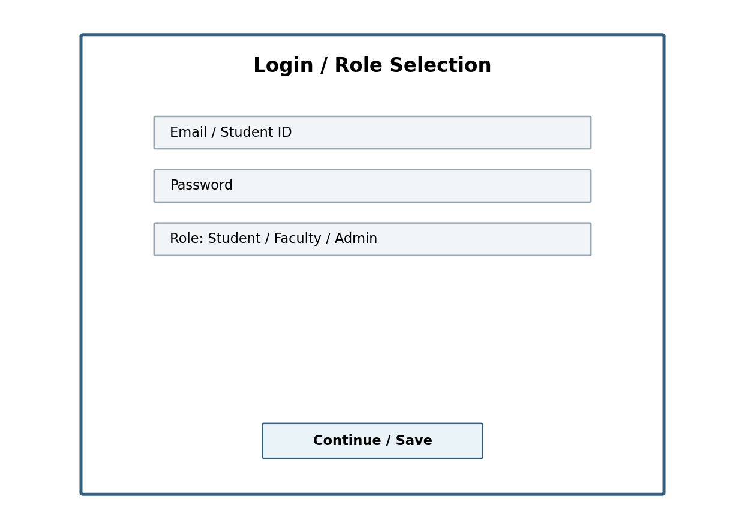
Figure 8. Conceptual login and role-selection wireframe.
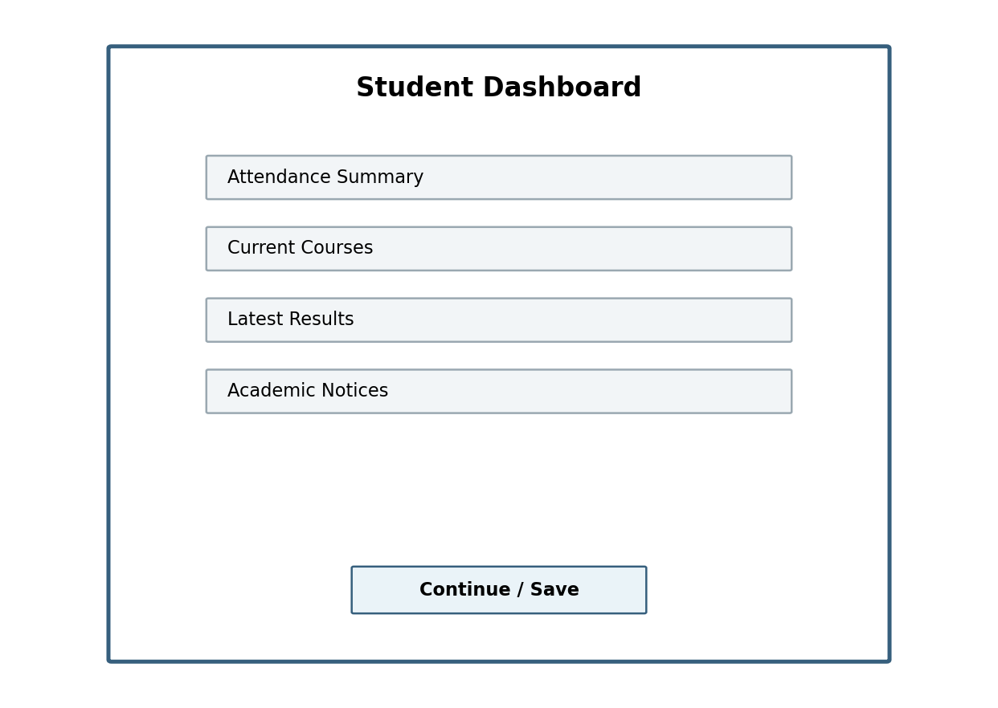
Figure 9. Conceptual student dashboard wireframe.
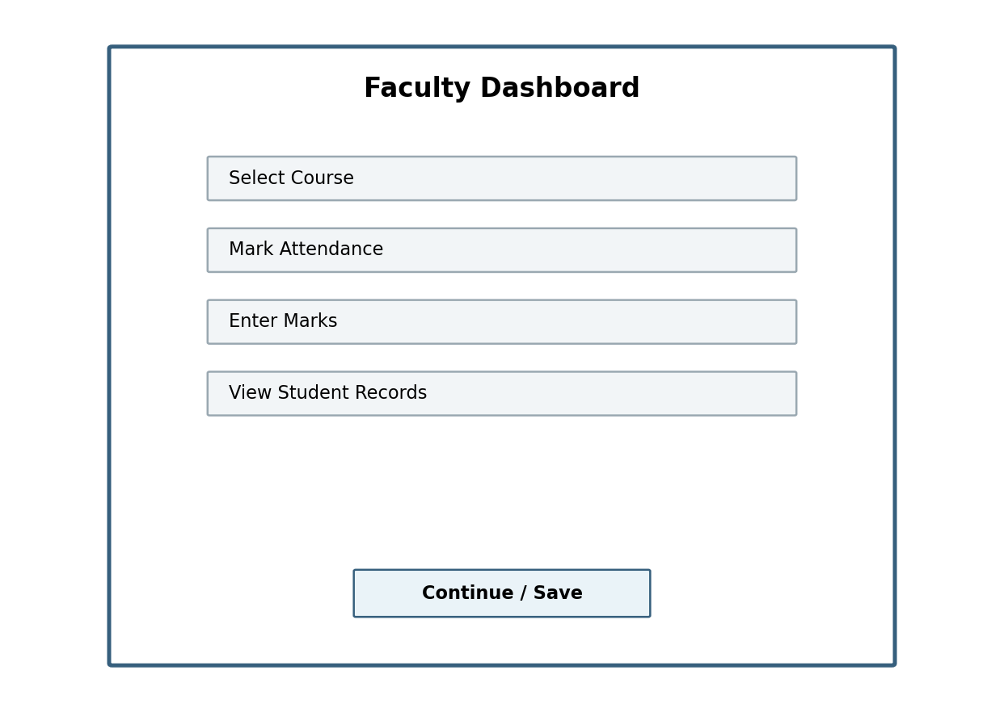
Figure 10. Conceptual faculty dashboard wireframe.
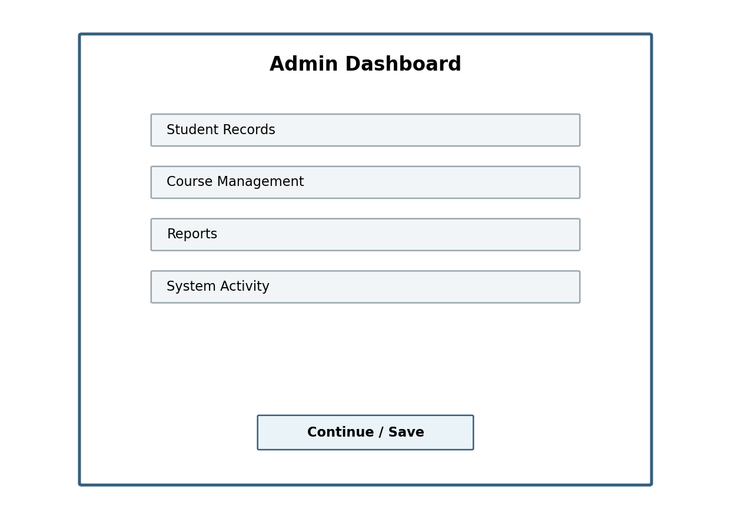
Figure 11. Conceptual administrative dashboard wireframe.

20. Conclusion
This Unit-1 mini project applies the product-engineering and Design Thinking approach to an Enterprise Student Record and Academic Management Platform. The project begins with business understanding and stakeholder needs rather than implementation alone. It defines user personas, a focused problem statement, functional and non-functional requirements, a product vision, an MVP, a roadmap, an initial architecture, and a repository plan.
The resulting product concept is intended to provide a coherent foundation for later Agile development, testing, DevOps automation, deployment, and continuous improvement. The core principle is to keep technical decisions connected to real academic user outcomes.

21. References / Source Basis
This report was prepared from the two provided Unit-1 project documents:
- DevOps-Unit-1-Mini-Project-Guide-Doc.docx — trainer/reference document used for structure, terminology, depth, and product-engineering methodology.
- Unit-1-mini-project.docx — assignment specification used as the authority for the actual Student Record and Academic Management Platform deliverables.
Note: The content of this report is newly written for the assigned academic-management domain. The reference document's Library Management example was used only as a structural and methodological guide.

