Customer Churn Analysis for Telecommunications Company

Sishir Pandey - Project Manager
Fahim Arman - Data Engineer
Jitesh Akaveeti - Data Analyst ( Predictive Modelling)
Chen - Data Analyst (Clustering)
Preeti Khatri - Data Analyst (Predictive Modelling)
Bishesh Aryal - Business Analyst

Data Loading:
In python pandas library is used for data collection. The data is loaded from “preprocessed_ dataset.csv” and saved it in a variable named “churn”.
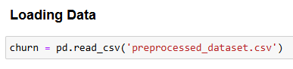
This line loads a preprocessed CSV dataset into a Pandas DataFrame called churn so you can work with it in Python.
Data View:
In churn.head() we can view the full loaded data.
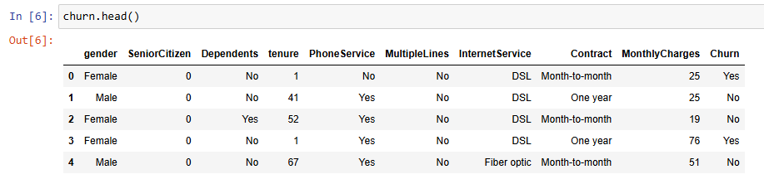
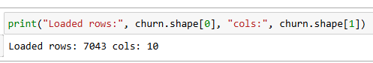
In this data set there is there is 7043 rows and 10 columns.
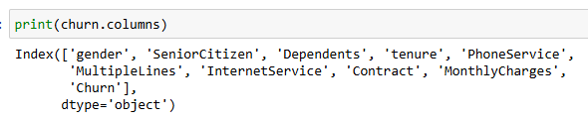
The name of the columns are 'gender', 'SeniorCitizen', 'Dependents', 'tenure', 'PhoneService', 'MultipleLines', 'InternetService', 'Contract', 'MonthlyCharges' and'Churn'.

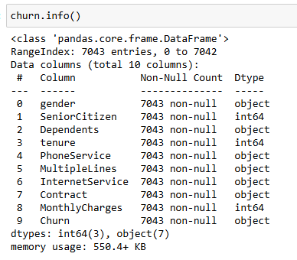
In this data set 'SeniorCitizen', 'tenure' and 'MonthlyCharges' are int64 and 'gender', 'Dependents', 'PhoneService', 'MultipleLines', 'InternetService', 'Contract', and'Churn' are object.
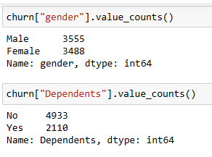
In “gender” column there is 2 types of data Male and female. Where male is 3555 and Female is 3488. In the “Dependents” column there is 4933 “No” and 2110 “Yes”.
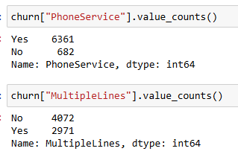
In “PhoneService” there is 6361 “YES” and 682 “No”. In the “MultipleLines” column there is 4072 “No” and 2971 “Yes”.

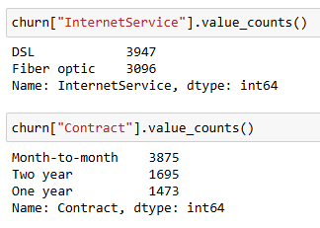
In “InternetService” column there is two values “DSL” and “Fiber optic”. In “Contract” column there is 3 types of data they are “Month-to-month”, Two year and One year.
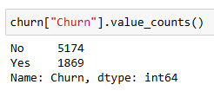
In the “Churn” column there is 5174 “No” and 1869 “Yes”.
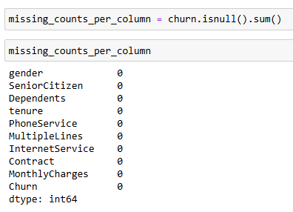

The is no missing values in the data set.

Data Clean:
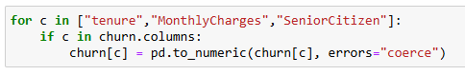
The parameter errors="coerce" forces non-convertible values (such as "N/A", "unknown", or other text) to be replaced with NaN, representing missing data. This ensures that all values in numeric columns are properly converted to numeric types, allowing accurate mathematical operations and data scaling in subsequent steps.
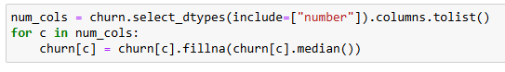
This step selects all numeric columns in the DataFrame and replaces any missing values (NaN) in those columns with the median value of each respective column. Filling in missing values ensures that the dataset remains complete and prevents potential errors during the model training process. The median is chosen instead of the mean because it is less sensitive to outliers, providing a more accurate and robust representation of the data when extreme values are present.
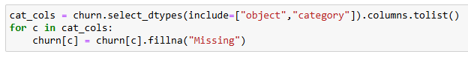
This step identifies all columns containing categorical or text data (such as “InternetService”, “Contract”, or “Gender”) and replaces any missing values with the string “Missing”. This ensures there are no null values before encoding, as most machine learning algorithms cannot process missing text data, while also preserving information about which entries originally had missing values.
This step checks whether the “Churn” column exists and converts its text values “Yes” and “No” into numeric values 1 and 0, respectively. Any missing values are filled with 0, treating them as “No”, and the resulting column is ensured to be of integer type. This transformation is necessary because machine learning models require numeric target variables, and it creates a new column, Churn_binary, for use in modeling and analysis.

One-hot Encode:
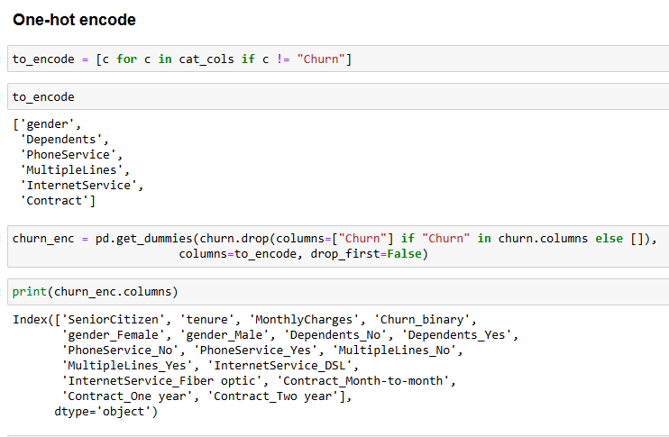
This step performs one-hot encoding on all categorical features in the dataset except the “Churn” column. It first identifies which columns are categorical and stores them in the variable to_encode. Then, using the pd.get_dummies() function, it converts each categorical column into multiple binary (0 or 1) columns, one for each unique category. This process allows machine learning models to interpret categorical data numerically without implying any ordinal relationship between categories. The “Churn” column is excluded from encoding to preserve it as the target variable for prediction. The output is shown below.
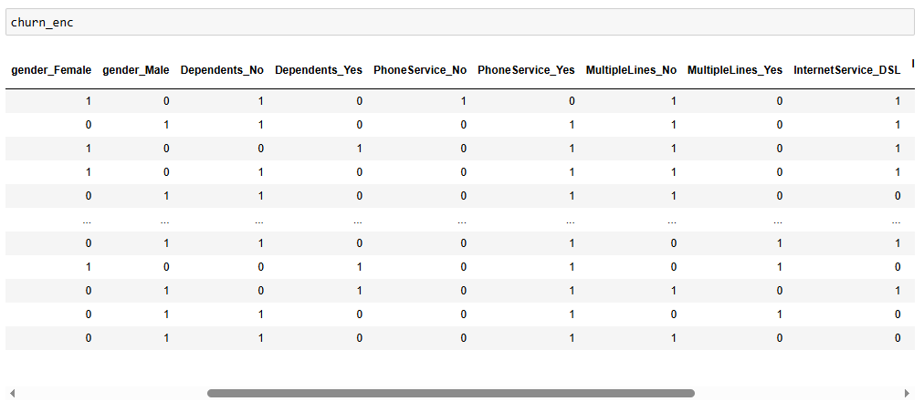
Prepare Features and Target:
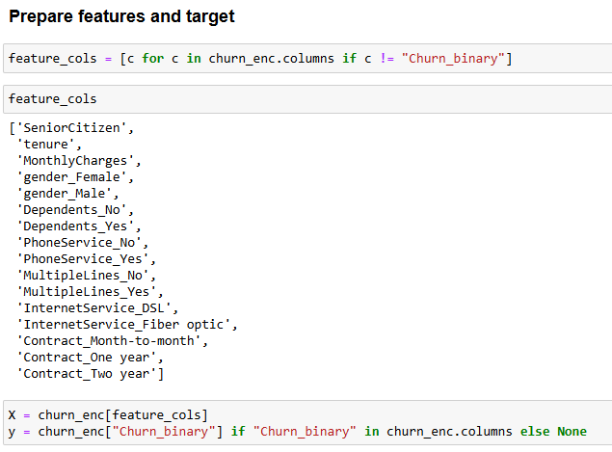

This step prepares the dataset for modeling by separating the features and the target variable. All columns except “Churn_binary” are selected as input features and stored in X, while the “Churn_binary” column is assigned to y as the target variable for prediction. If the “Churn_binary” column does not exist, y is set to None. This separation ensures that the machine learning model can clearly distinguish between input data and the outcome it needs to predict.

Train Test Split:
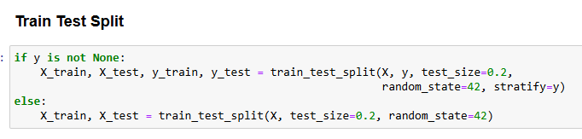
This step splits the dataset into training and testing sets to evaluate the model’s performance. If the target variable y exists, both the features (X) and target (y) are split, with 20% of the data reserved for testing. The “stratify=y” parameter ensures that the proportion of classes in the target variable is maintained in both training and testing sets. If y does not exist, only the features X are split into training and testing sets. The random_state=42 ensures the split is reproducible.
Save Data :
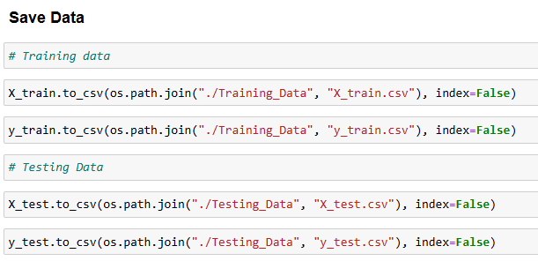
This step saves the training and testing datasets to separate CSV files for future use. The feature and target variables for the training set (X_train and y_train) are saved in the ./Training_Data folder, while the corresponding testing set (X_test and y_test) is saved in the ./Testing_Data folder. The index=False parameter ensures that row indices are not included in the saved files, keeping the data clean and ready for modeling or analysis.

