## ARTIFICIAL INTELLIGENCE

NAME :- MD ARMAN HASAN

**Market Basket ANALYSIS:-**

A market basket is a selected group of products or assets designed to track the general performance of a specific market segment. This is sometimes known as a basket of good.

Market basket economics focuses on which tracks various consumer goods and uses their price levels to provide an estimate of inflation. However, for investors, a market basket relates to financial securities and is the principle idea behind index fund

"Baskets" can also be found in securities markets, where program traders may enter into series of position in several stocks or currency  at the same

time.

*It is a data mining technique used to identify patterns and relationships between products that customers frequently purchase together. The purpose of market basket analysis is to understand customers’ purchasing behavior and identify cross-selling and upselling opportunities.*

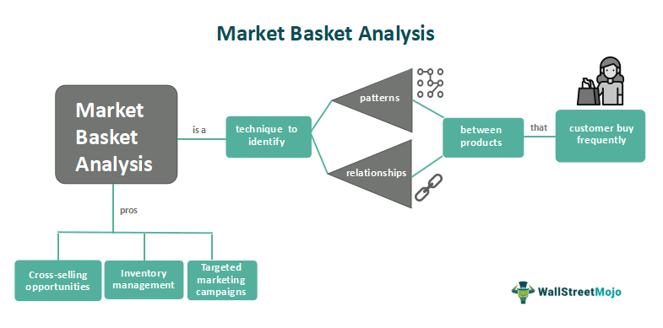

Keys:-

* A market basket is a selected mix of goods and services that tracks the performance of a specific market or segment.
* A popular market basket is the Consumer Price Index (CPI), which provides an estimate for inflation based on the average change of price paid for a specific basket of goods and services over time.
* The CPI uses over 200 categories, including education, housing, transportation, and recreation, as an economic measure.
* A market basket analysis is used by retail stores to predict and increase impulse purchases based on groups of items a customer buys.

How a market basket works :-

A market basket refers to a selection of goods and services that are consistently purchased and sold throughout an economic system. Economists, politicians, and financial analysts use market baskets to track price changes over time and determine inflation levels. The most well-known and widely used market basket is the CPI, which helps economists predict consumer purchase trends. This basket is used to track in a specific market or country.

The financial system uses market baskets like the S&P 500 and index funds, which are essentially a broad sample of stocks, bonds, or other securities in the market. This provides investors with a benchmark against which to compare their investment returns.

### Applications

Let us look at its applications across various industries.

1. **Retail and E-commerce**: -Market basket analysis helps retailers optimize product placement and design effective cross-selling strategies. It enables personalized recommendations, improves inventory management, and aids in targeted marketing campaigns, ultimately increasing sales and customer satisfaction.
2. **Supply Chain Management**: -Understanding product associations can optimize inventory levels, streamline supply chain processes, and improve demand forecasting . It helps in managing stock replenishment, reducing stockouts, and minimizing wastage.
3. **Pricing and Promotions:-** It assists in optimizing pricing strategies by identifying complementary products that can be bundled together for promotional offers. It helps determine optimal price points and discount strategies to maximize revenue and profitability.
4. **Online Recommendations:-** E-commerce platforms and streaming services utilize this analysis to provide personalized recommendations to customers. By leveraging associations between products or content, these platforms can suggest related items or similar content based on user preferences.

### Advantages And Disadvantages

* Let us look at the Advantages of Market Basket Analysis:-

1. **Cross-selling opportunities**: -It uncovers product associations, enabling businesses to identify cross-selling opportunities. This leads to increased sales and higher average order values.
2. **Inventory management:-** It helps optimize inventory levels by identifying popular product combinations and adjusting stock accordingly. This reduces stockouts, minimizes wastage, and improves overall inventory management.
3. **Targeted marketing campaigns**: -Insights gained from market basket analysis enable businesses to design targeted marketing campaigns. Businesses can achieve higher response rates and better campaign effectiveness by tailoring promotions and advertisements based on customer preferences.

* Let us look at the disadvantages of Market Basket Analysis:

1. **Data quality and integrity**: -Market basket analysis heavily relies on accurate and complete transactional data. Inaccurate or incomplete data can lead to erroneous associations and biased results, affecting the reliability of the analysis.
2. **Interpretation challenges**: -It generates association rules, but interpreting these rules and translating them into actionable strategies can be challenging. Businesses need to carefully analyze and validate the associations before implementing them effectivel.