Setting Up a Netcat Listener & Client:
1. Check the Linux machine's network info: ip addr — this confirms its IP address (172.18.139.199) on eth0.
2. Start the listener on a free port instead: nc -lv 4300 — the terminal shows "Listening on 0.0.0.0 4300".
3. BEFORE: From the other machine, connect as a client: nc -v 172.18.139.199 4300 — it reports "Connection to 172.18.139.199 4300 port [tcp/*] succeeded!". Type a message on the client ("Hello! This is coming from the client. Please respond!!!!!!!!!"); the listener side shows "Connection received on 172.18.139.199 33932" followed by that same message, but no reply has been sent yet.
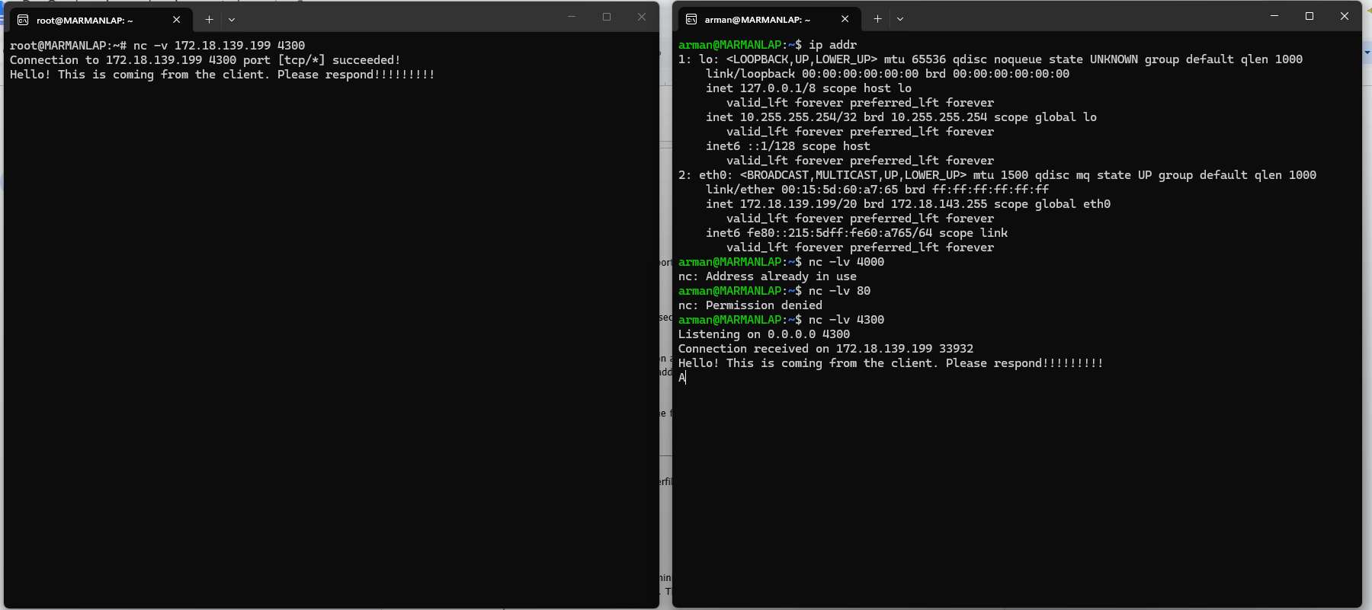

4. AFTER: On the listener (server) side, type a reply ("Hi!! This is coming from the server. Thanks for connecting!!!!!"). This reply now shows up on both terminals, proving netcat supports a live two-way TCP conversation once the connection is open.
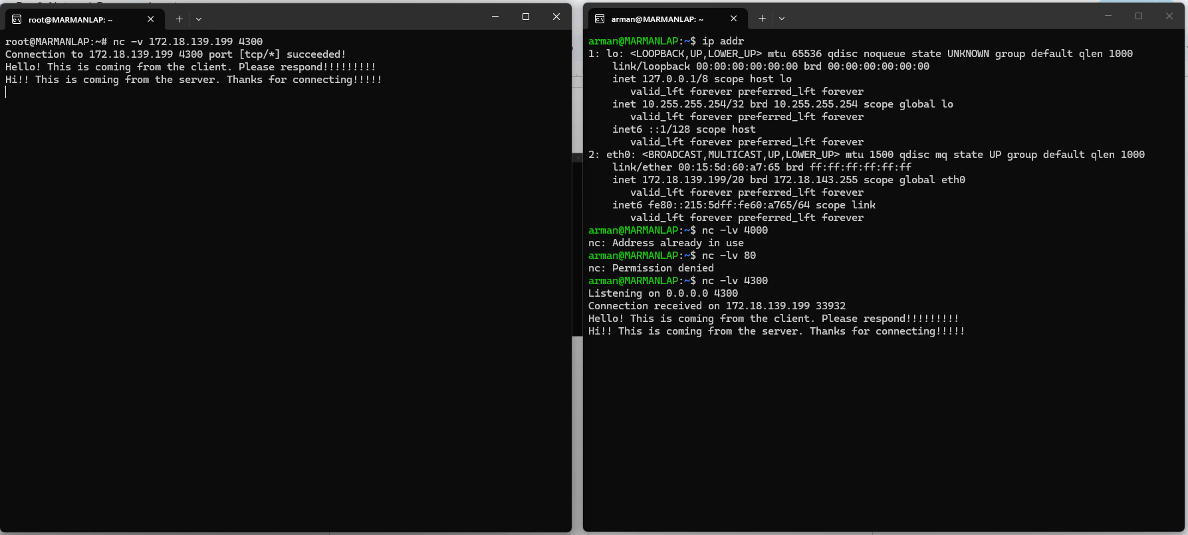

5. To transfer a file instead of chatting, first check the file to be sent on the client: cat client.txt.
6. On the server side, start a listener that writes everything it receives straight into a file: nc -lv 4000 > server.txt.
7. On the client side, send the file through netcat: nc -v 172.18.139.199 4000 < client.txt — "Connection to 172.18.139.199 4000 port [tcp/*] succeeded!" confirms the data was sent.
8. Stop the listener with Ctrl+C once the transfer finishes, then verify the received copy: cat server.txt — its content matches client.txt exactly, confirming the file was transferred successfully over the network using nc.

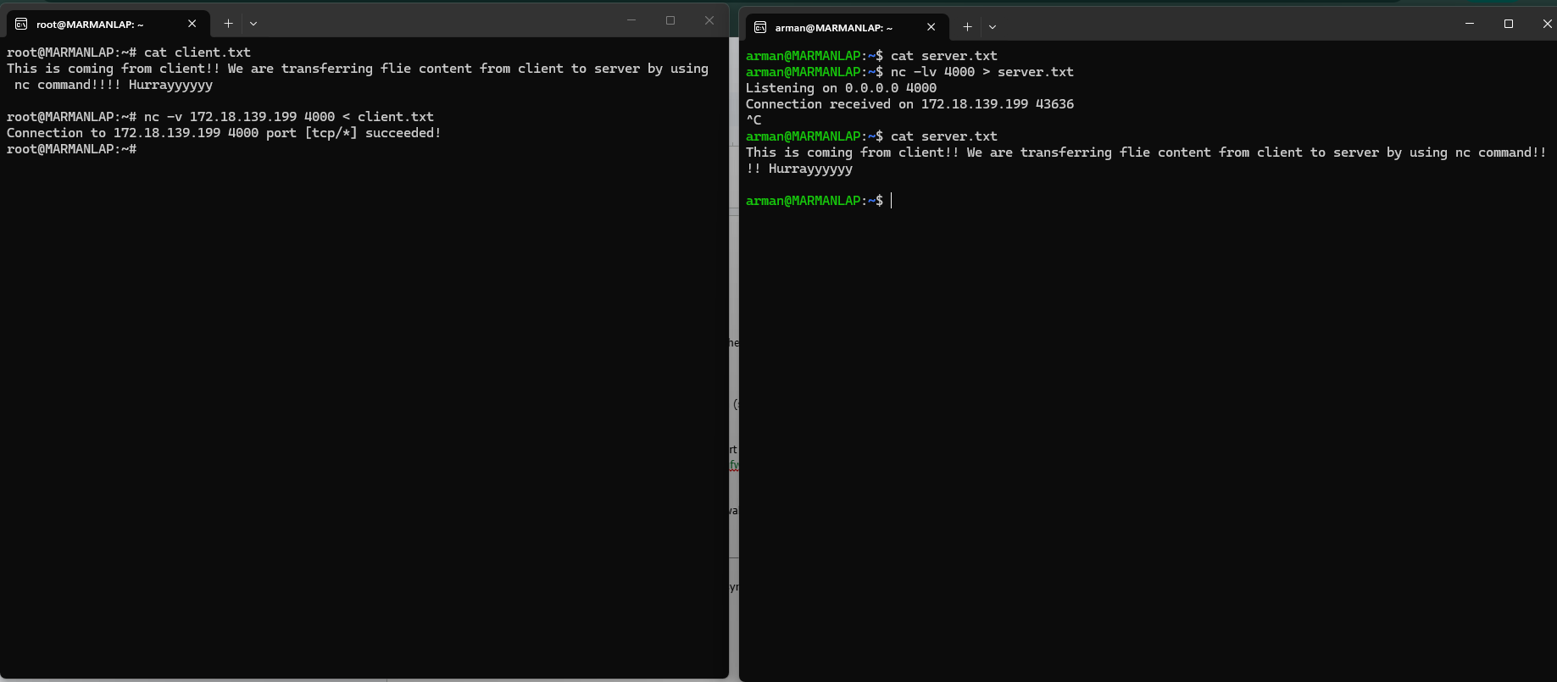

Testing HTTP Endpoints with Verbose cURL:
1. BEFORE: Run a verbose request against the live site: curl -v http://www.netflix.com. The verbose markers show what happened: * lines are connection info (DNS/connect to 207.45.72.1:80), > lines are the request curl sent (GET / HTTP/1.1, Host, User-Agent, Accept), and < lines are the response headers received: HTTP/1.1 301 Moved Permanently with Location: https://www.netflix.com/. curl stops right after showing the redirect, it does not follow it automatically.

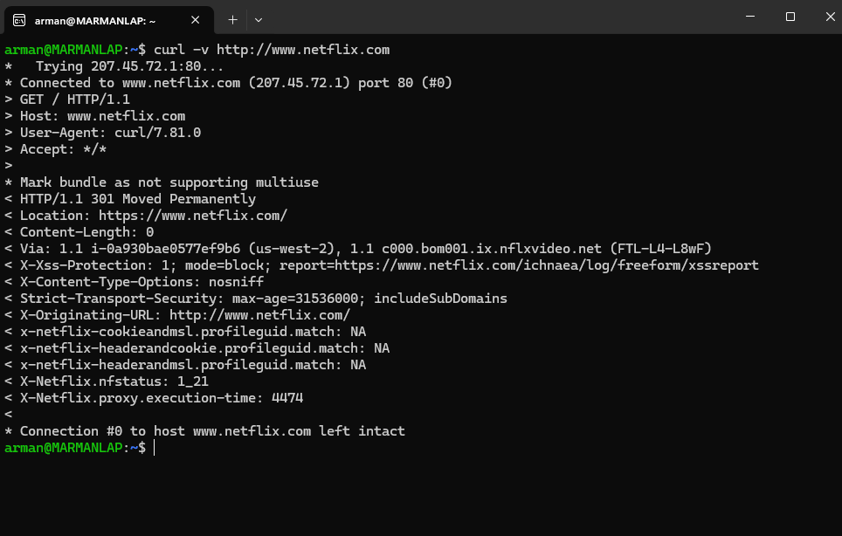

2. AFTER: Re-run the request with -L so curl follows the redirect, and save everything to a file: curl -L -v http://www.netflix.com > netflix.html 2>&1 (this redirects both normal output and verbose/error output into netflix.html).
3. Inspect the end of the saved file: tail -n 15 netflix.html — it now shows real HTML/JavaScript content (script tags, service-worker cleanup code) from the final page, proving curl followed the 301 redirect to the HTTPS site and downloaded the actual page body instead of stopping at the redirect header.
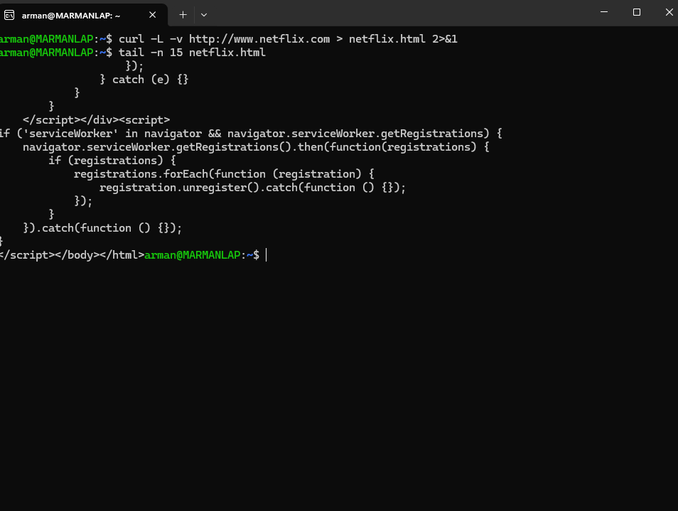

Testing UFW Port Blocking and Allowing:
1. BEFORE: On the Linux machine, start a netcat listener: nc -l 4300. From the Windows host, test reachability: Test-NetConnection 172.18.139.199 -Port 4300 — the result shows TcpTestSucceeded : True, confirming the port is open and reachable with nothing blocking it.
2. Check UFW's current status on the Linux machine: sudo ufw status — it reports Status: inactive.
3. Turn the firewall on: sudo ufw --force enable — "Firewall is active and enabled on system startup"; running sudo ufw status again confirms Status: active.
4. Add a rule to block the port tested earlier: sudo ufw deny 4300/tcp. sudo ufw status to check the current status.
5. Start the listener again on the Linux machine: nc -l 4300.
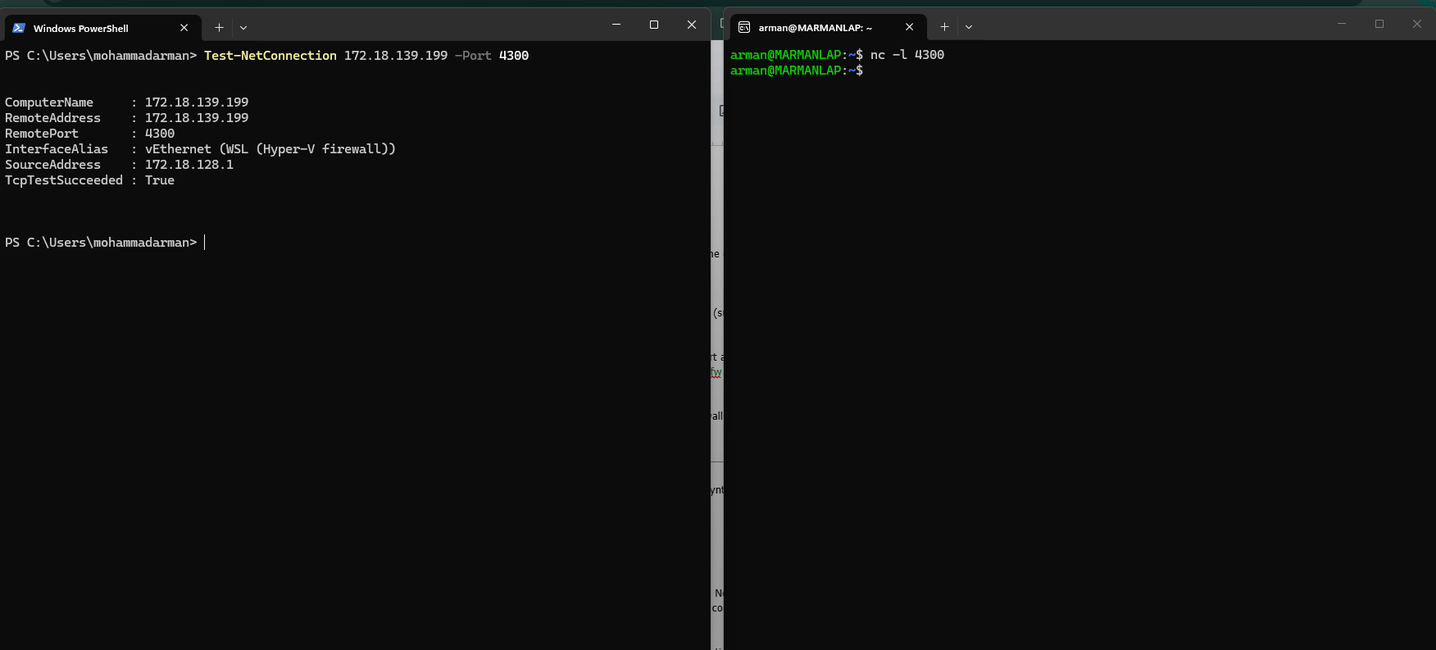

6. AFTER: From Windows, run the exact same test again: Test-NetConnection 172.18.139.199 -Port 4300 — this time it prints "WARNING: TCP connect to (172.18.139.199 : 4300) failed" and TcpTestSucceeded : False. PingSucceeded is still True, which shows the host itself is still reachable — UFW is specifically blocking that one TCP port, proving the deny rule works.

