

**DECLARATION**

This project report is the original research work of the author, except as otherwise stated. The Project has not been submitted, either in the same or different form, to this or any other university for a degree. The findings of the research have not been/will not be published anywhere without the concurrence of the concerned supervisor.

**Sajedur Rahman Arman**

Student Roll No: 190807

Registration No: 1908165

Session: 2019-20

Department of Petroleum and Mining Engineering

Jashore University of Science and Technology



**SUPERVISOR’S DECLARATION**

I hereby declare that I have checked this research project and, in my opinion, this project is adequate in terms of scope and quality for the degree of Bachelor of Science in the Department of Petroleum and Mining Engineering, Jashore University of Science and Technology, Bangladesh.

**Dr. Mohammad Tofayal Ahmed**

Professor

Date : October 20, 2023

Department of Petroleum and Mining Engineering

Jashore University of Science and Technology, Jahore-7408

**Acknowledgement**

The author tribute to express her deep sense of gratitude and indebtedness to Almighty Allah whose mercy enables her to complete this work successfully.

The author also give her heartily gratitude to her parents for all their prodigious blessing, pecuniary Support and help throughout this study.

The author expresses profound regards, deep sense of gratitude and heartfelt respect to her respected supervisor **Dr. Mohammad Tofayal Ahmed**, Professor, Department of Petroleum and Mining Engineering, Jashore University of Science and technology, for introducing the present topic and for his inspiring guidance, constructive criticism and valuable suggestions throughout the project work. His proper advice showed the author a proper way to make the work successful.

The author would to thank all the respectful teachers of Petroleum and Mining Engineering Department, Jashore University of Science and Technology for their valuable advice which helped to accomplish the project work. The spontaneous encouragement of them worked as the inspiration for the author to complete the project successfully.

Last but not least, the author tremendously grateful to all her friends who have patiently extended all sorts of help for accomplishing this undertaking.

The Author

**Abstract**

In longwall top coal caving (LTCC), due to the fractures and migration of top coal, the roof will break and collapse, which causes serious impact damage to hydraulic support. Therefore, we aimed to reveal the relationship between the roof instability effect and the bearing characteristics for hydraulic support in the LTCC face. Based on the occurrence conditions of the mining area in the Barapukuria Coal Mining, The instability model of the upper immediate roof was established, and the working resistance of hydraulic support was derived. Secondly, the dynamic coupling model of roof-top coal-hydraulic support was established in LS-DYNA and the crushing degree of top coal and the bearing characteristics of the hydraulic support in different roof instability fields were analyzed. The results show that the main factors affecting the working resistance of hydraulic support are the fracture positions of the upper immediate roof, the acting force of the lower immediate roof, and the distributions of the gangue is the goaf. The rotary instability of the upper immediate roof at the coal wall brings serious impact effects, resulting in fractures in front of the coal wall and a large amount of crushed coal concentrated at the front end of the canopy. The cursing degree of top coal significantly impacts the canopy, especially the back end of the canopy and the hinged pin shaft, which is prone to bending fracture. The research results can provide reference and experience for the stability control of roof strata and the structural optimization of hydraulic support.

**Chapter 1**

**1.1 Introduction**

In advancing the LTCC face, the coal and rock structures are affected by the mining disturbance. As a result, it is difficult for the roof to form an effective self-bearing structure,(Balasubrahmanyam & Budi, 2021) and the roof collapse occurs over the stability threshold. The impact of roof instability on the working face makes the stability of the coal wall worse, increasing the probability of rib spalling (Z. Liu, Fan, & Zhang, 2019). On the other hand, different bearing conditions of hydraulic support have a significant impact on the subsidence and collapse of roofs (Singh & Singh, 2010). Therefore, the movement instability of the roof is closely related to the bearing characteristics of the hydraulic support.

Underground geological conditions are increasingly complex. Scholars have investigated the structural properties and movement laws of the roof. Many theoretical models have been proposed to study the structural characteristics of the roof. These models have given a basic understanding of roof activities studied the structural parameters of the roof in the LTCC face and summed up the impact of immediate roof characteristics on mine pressure. Based on the energy variation principle, simulated the collapse of the roof and explained the mine pressure. In addition to theoretical models, in situ monitoring tests play important roles in understanding the movement and failure of roof (Wang, 2013). However, because of the complexity of geological conditions, in situ monitoring tests may not be carried out extensively. To solve this situation, some scholars use physically similar simulation tests to analyze the movement laws of the roof (Z. Liu et al., 2019). However, such important in situ factors as the initial stress cannot be considered in physically similar simulation tests. In contrast, numerical simulations may be more feasible to study the problems. Many investigators have attempted to simulate the coal mining process and the movement laws of the roof (Balasubrahmanyam & Budi, 2021). The stress and types of failure in the coal seam were investigated by (Behera, Yadav, Singh, & Sharma, 2020)By numerical simulation and underground measurement, Pang et al. discovered the mechanical mechanism of rock fracture instability and the mining stress development law in the deep stope.

However, as a result of the complex and changeable geological conditions, various coupling states will be formed between the roof and the hydraulic support (Mangal & Paul, 2016). The safety of the hydraulic support could not be guaranteed by a single analysis of the movement laws of the roof. Consequently, the primary focus of underground safety support has moved to the investigation of the interaction between the roof and the hydraulic support divided the interaction between the roof and the hydraulic support into strength coupling, stiffness coupling, and stability coupling. In addition, they qualitatively described the adaptability of the hydraulic support under different coupling states. With the development of numerical simulation, some scholars have extended the interaction between the roof and the hydraulic support to their respective interiors (Islavath, Deb, & Kumar, 2016). Thus, the movement characteristics of the roof and the bearing capacity of the hydraulic support are more intuitively reflected.(Arasteh, Esmaeili, Saeedi, & Farsangi Mohammad Ali, 2022) investigated the features of roof caving in the LTCC face by numerical simulation. In addition, they generated a summary of the bearing capacity of the hydraulic support. Through theoretical analysis and numerical simulation, (Rajwa, Janoszek, & Prusek, 2020)analyzed the influence of roof strength and different support states of the canopy on the stability of the working face.

**1.2 Location of study area**

The Barapukuria Coal Mine is situated in the Dinajpur district, northwestern Bangladesh, approximately 50 kilometers southeast of the district town and around 300 kilometers from the capital city, Dhaka. This underground coal mine is located within the Barapukuria basin, which is part of the greater Bengal Basin and holds a significant coal reserve. The geological structure of the basin is characterized by Gondwana formations, and the coal seam is buried at depths ranging from 118 to 506 meters. The Barapukuria coal deposit lies within a faulted and folded structure, leading to geological complexities that affect mining operations. The coal seam, which has a thickness of about 36 meters, is composed of high-quality bituminous coal. Barapukuria is the only active coal mine in Bangladesh, utilizing longwall top coal caving (LTCC) and conventional longwall mining techniques for extraction. The mine's total reserve is estimated to be around 390 million tons, with a production capacity of 1 million tons annually.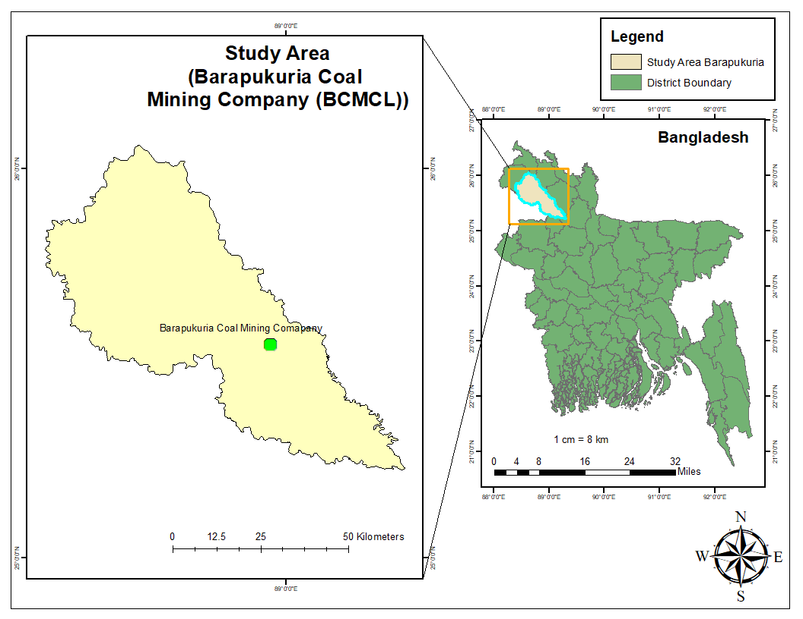

**1.3 Problem Statement:**

1. The instability of the roof in LTCC faces due to mining disturbances makes it difficult to maintain an effective self-bearing structure, leading to roof collapses and increased rib spalling risks.
2. The varying geological conditions complicate in situ monitoring, limiting the extensive use of physical tests, which makes it challenging to assess the roof's movement and stability under real conditions.
3. There is a lack of integration between the roof's movement laws and hydraulic support conditions, requiring more comprehensive analyses to ensure underground safety.
4. Existing models and tests often fail to account for critical factors such as initial stress and complex coupling states, making it difficult to predict roof behavior and ensure the hydraulic support system’s effectiveness.

**1.4 Objective of the study**

1. To investigate the interaction between the roof and hydraulic support in longwall top coal caving (LTCC) operations, particularly under complex geological conditions, with a focus on different coupling states (strength, stiffness, and stability coupling).
2. To analyze the movement characteristics and instability of the roof caused by mining activities, using numerical simulations and physically similar tests to simulate roof behavior and mine pressure.
3. To evaluate the adaptability of hydraulic support systems under different coupling conditions, ensuring the roof's stability and safety during coal extraction.
4. To enhance predictive models and simulations that incorporate geological complexities, improving the understanding of roof collapse mechanisms and optimizing hydraulic support design.

**Chapter 2**

**2.1 Methodology:**

The rock strata that cannot be self-stabilized and collapse in the caving zone are collectively referred to as the immediate roof . Due to the rock strata’s different fracture locations and lithology, there are two types of immediate roofs: the lower immediate roof and the upper immediate roof. In order to quantitatively analyze the impact load caused by the instability of the upper immediate roof on the hydraulic support [41], the thickness HZ of the immediate roof can be defined as Equation (1): and the upper immediate roof. In order to quantitatively analyze the impact load caused by the instability of the upper immediate roof on the hydraulic support (C. Liu et al., 2017), the thickness Hz of the immediate roof can be defined as Equation (1):

=………….(1)

where Hz is the thickness of the immediate roof, m; H is the cutting height, m; T is the thickness of the top coal; SA is the subsidence of the main roof, m; C is the thickness of residual coal, m; KA is a constant under certain roof conditions, which is set to 1.4. The subsidence of the main roof SA can be defined as Equation (2):

………….(2)

where Ks is the main roof subsidence coefficient, which is set to 0.2. The thickness of residual coal C can be defined as Equation (3):

………….(3)

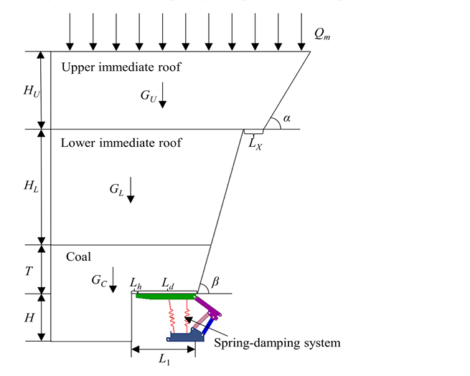

Fig-1:Coupling mechanical model of roof-top coal-hydraulic support

According to the location and lithology of the root, the instability of the upper immediate roof is the main factor causing the pressure on the working face. The different crushing conditions of the lower strata directly affect the stability and rotation angle of the upper immediate roof. In addition, the instability of the roof has a certain lag. Therefore, the fracture line of the roof is located on the extension line of the coal wall and roof cutting, respectively. There are three forms of the upper immediate roof instability sliding instability at the coal wall , rotary instability at the coal wall, and rotary instability at the roof cutting. The instability model of the upper immediate roof is established, as shown in fig

The horizontal force cannot be transmitted after the rock strata breaks, which results in the upper immediate roof presenting a cantilever beam state. Different crushing conditions directly affect the cantilever beam’s instability forms. Fig-4a shows that the cantilever beam showed sliding instability at the coal wall. The working resistance of the hydraulic support can be defined as Equation (4)

………….(4)

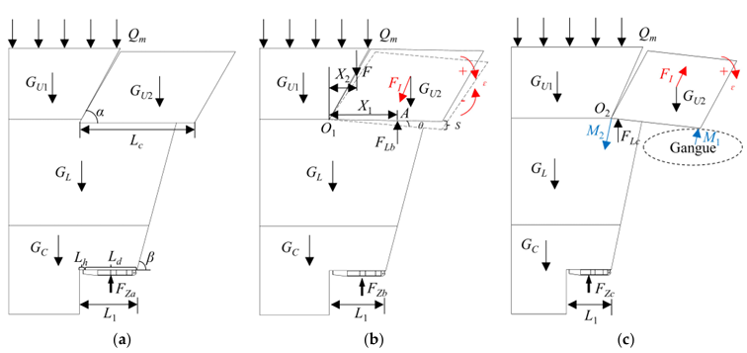

Fig-2: Instability model of the upper immediate roof; (a) sliding instability at the coal wall, (b)Rotary instability at the top coal, (c)Rotary instability at the roof cutting

Because of rotary instability, the impact load will be transferred to the lower immediate roof and top coal. This will make the support resistance of the hydraulic support go up. Usually, the fracture length of the upper immediate roof is the same, but fracture positions differ. Figure 4b shows that the cantilever beam rotated with instability at the coal wall. In the initial state of the rotary , the working resistance of the hydraulic support can be defined as Equation

1=………….(5)

Where 1 is the working resistance of the hydraulic support under the initial state of the rotary instability at the coal wall, kN: F is the additional force of the overlying strata, kN; GC is the gravity of the top coal, kN; GL is the gravity of the lower immediate roof, kN;GU1 is the gravity of unbroken upper immediate roof, kN; GU2 is the gravity of the cantilever beam, kN.

According to Equation(5), the working resistance is impacted by the additional force of overlying strata. Figure 4b demonstrates that the support force of the lower immediate roof acts at the .According to the moment balance, the additional force can be defined as Equation (6)

………….(6)

Where Lc is the length of the cantilever beam, m; X1 is the length of the lower immediate roof support positions from the rotary center O1,m; X2 is the length of the additional force position from the rotary center O1,m.

Due to the lower immediate roof force, the cantilever beam began to slow subsidence. According to the d`Alembert principle, the greater the acceleration during decelebration, the greater the inertial force and the stronger the impact on hydraulic support. As shown in Figure 4b, the working resistance of the hydraulic support can be defined as Equation (7)

………….(7)

Where is the working resistance of the hydraulic support under the deceleration state of the rotary instability at the coal wall, kN; is the lower immediate roof force,kN;(Zeng, Li, Wan, & Ma, 2023)

**Reference**

Arasteh, H., Esmaeili, K., Saeedi, G., & Farsangi Mohammad Ali, E. (2022). Discontinuous Modeling of Roof Strata Caving in a Mechanized Longwall Mine in Tabas Coal Mine. *International Journal of Geomechanics, 22*(5), 04022040. doi:10.1061/(ASCE)GM.1943-5622.0002337

Balasubrahmanyam, N., & Budi, G. (2021). Techno-Economic Feasibility of the Longwall Top Coal Caving Method Based on the FTCD Index: A Parametric Case Study in India. *Energies, 14*(19), 6115. Retrieved from <https://www.mdpi.com/1996-1073/14/19/6115>

Behera, B., Yadav, A., Singh, G. S. P., & Sharma, S. K. (2020). A numerical modeling approach for evaluation of spalling associated face instability in longwall workings under massive sandstone roof. *Engineering Failure Analysis, 117*, 104927. doi:<https://doi.org/10.1016/j.engfailanal.2020.104927>

Islavath, S. R., Deb, D., & Kumar, H. (2016). Numerical analysis of a longwall mining cycle and development of a composite longwall index. *International Journal of Rock Mechanics and Mining Sciences, 89*, 43-54. doi:<https://doi.org/10.1016/j.ijrmms.2016.08.003>

Liu, C., Li, H., Mitri, H., Jiang, D., Li, H., & Feng, J. (2017). Voussoir beam model for lower strong roof strata movement in longwall mining – Case study. *Journal of Rock Mechanics and Geotechnical Engineering, 9*(6), 1171-1176. doi:<https://doi.org/10.1016/j.jrmge.2017.07.002>

Liu, Z., Fan, Z., & Zhang, Y. (2019). Fracture Characteristics of Overlying Bedrock and Clay Aquiclude Subjected to Shallow Coal Seam Mining. *Mine Water and the Environment, 38*(1), 136-147. doi:10.1007/s10230-018-0549-6

Mangal, A., & Paul, P. S. (2016). Rock mechanical investigation of strata loading characteristics to assess caving and requirement of support resistance in a mechanized powered support longwall face. *International Journal of Mining Science and Technology, 26*(6), 1081-1087. doi:<https://doi.org/10.1016/j.ijmst.2016.09.017>

Rajwa, S., Janoszek, T., & Prusek, S. (2020). Model tests of the effect of active roof support on the working stability of a longwall. *Computers and Geotechnics, 118*, 103302. doi:<https://doi.org/10.1016/j.compgeo.2019.103302>

Singh, G. S. P., & Singh, U. K. (2010). Numerical Modeling Study of the Effect of Some Critical Parameters on Caving Behavior of Strata and Support Performance in a Longwall Working. *Rock Mechanics and Rock Engineering, 43*(4), 475-489. doi:10.1007/s00603-009-0061-1

Wang, J.-H. (2013). Key technology for fully-mechanized top coal caving with large mining height in extra-thick coal seam. *Journal of China Coal Society, 38*.

Zeng, Q., Li, Z., Wan, L., & Ma, D. (2023). Study on Roof Instability Effect and Bearing Characteristics of Hydraulic Support in Longwall Top Coal Caving. *Applied Sciences, 13*(14), 8102.