upay Shield
Stopping coached-transfer fraud at the moment of sending
AI Dev Fest 2026 · DIU CPC × upay · Tracks 01 (Trust & Risk) and 05 (Merchant & Agent) · Project report
Team: [add team name and member names]
Repository: https://github.com/ArmanAhmedMiraj/upay-trustflow
Live demo: https://YOUR-SERVICE.onrender.com (free plan: allow a minute to wake up)
Data: all data in this project is synthetic. No real customer data was used.

1. Summary
Many mobile-money losses in Bangladesh do not come from hacked accounts. The customer is talked into sending the money themselves, using the correct PIN on their own phone, so ordinary account security sees a normal transfer. We built upay Shield, a security layer that sits inside the wallet and judges each transfer before the PIN step. It combines the sender's own habits, the recipient wallet's behaviour, and a check of the fraudster's story against the upay ledger into one calibrated security-risk percentage, explains it in Bangla, and responds in proportion: nothing, a note, two safety questions, or a cancellable 30-minute hold reviewed by a fraud analyst.
The prototype is a working wallet with a phone app, the Shield engine, an analyst console and an impact dashboard, deployed on one web address. On a synthetic test period that the model never saw, it caught 72% of fraudulent transfers (82% by value) while disturbing 0.2% of genuine ones, and its risk percentages were well calibrated.
A second module keeps agents stocked with cash. For every agent it forecasts how much cash will be needed over the next 24 hours, when it will run out and how much to add. It tells the agent in Bangla on their phone, shows upay's operations team a map, and suggests where another agent would help. On days the model never saw, refilling from the forecast turned away 0.14% of customers, against 26% when refilling from last week's numbers with the same average cash.

2. The problem
Typical scripts used against customers include: a call saying "your account will be blocked"; an SMS claiming money was "sent to you by mistake" with a request to send it back; a prize or loan that needs a fee first; an urgent request from a relative using a new number; and advance payment for an online shop, a job or a visa.
In all of them the customer authorises the transfer. Device checks, PIN checks and account-takeover rules all pass. The result is permanent loss for the customer, damaged trust in digital finance, and extra complaint and reimbursement pressure for upay. The gap is a defence that works at transfer time and looks at the whole situation, not just the account.

3. The idea
- Judge the transfer, not just the account. Three views are combined: how unusual this is for this sender, how the recipient wallet behaves, and whether the fraudster's story is true.
- The story check is unique to upay. If an SMS claims money was received but the upay ledger shows no such credit, that is a verified fact that only the wallet provider can establish.
- No single signal raises an alert. Many honest transfers look unusual (a first payment to a landlord, a night-time family emergency). Only the overall score decides, and a test proves it.
- Graded, human-in-the-loop response. Shield never blocks money by itself. The customer can cancel, an analyst can approve or reject, and an unanswered hold is released.
- The network learns. When customers report a number, the next sender sees a higher risk.

4. What we built
Component | What it does
Customer phone app | React web app, installable on a phone, in English and Bangla. Login, balance, send money with the live risk meter, safety questions, hold countdown with cancel, messages, history, add money, cash out, report a number.
Wallet API | FastAPI. Accounts with PIN login and lockout, a ledger, 30-minute holds in escrow, analyst decisions, a live feature builder that works out Shield's 23 signals from the database, an impact calculation.
Shield API and engine | FastAPI service that scores a transfer: calibrated LightGBM, one verified-fact rule, reasons, scam type, safety-check update, Bangla warnings.
Analyst console | Desktop view of held cases with reasons and a live countdown; approve or reject; impact dashboard; one-click demo reset.
Agent cash forecasting (Module 2) | Hour-by-hour cash-out and cash-in forecasts for 120 simulated agents, run-out time and refill amount, a phone screen for the agent in English and Bangla, an operations map, refill requests, and suggestions for where to add agents.
Simulator and seeding | Synthetic customers, sellers, shops, group-fund wallets and fraud wallets with weeks of history; named demo characters.
Deployment | One Docker service on Render that serves the app, the wallet and Shield on one address and builds its demo world on start-up.

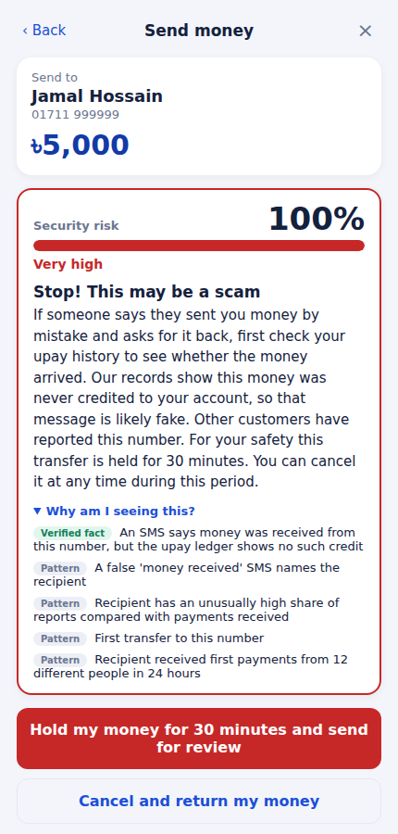  Figure 1. Fake-SMS scam: 100% risk before the PIN, with the verified ledger fact. | 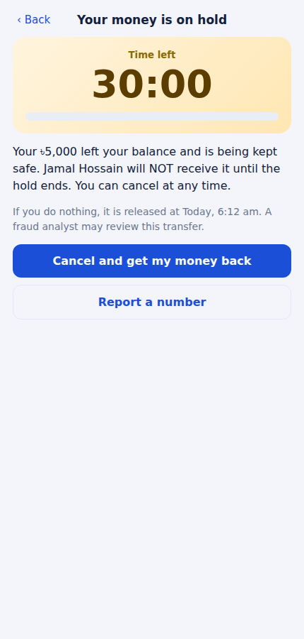  Figure 2. The money is on hold with a countdown and a cancel button. | 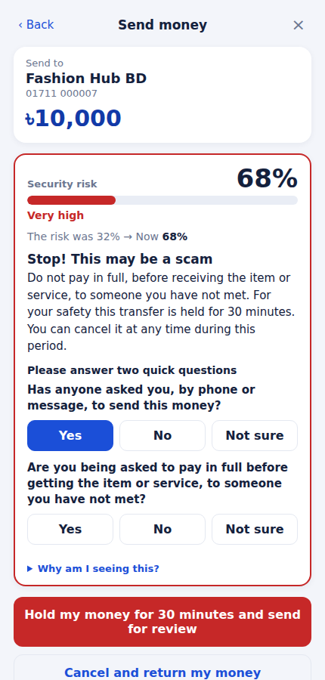  Figure 3. Safety questions: a "Yes" moved the risk from 32% to 68%.
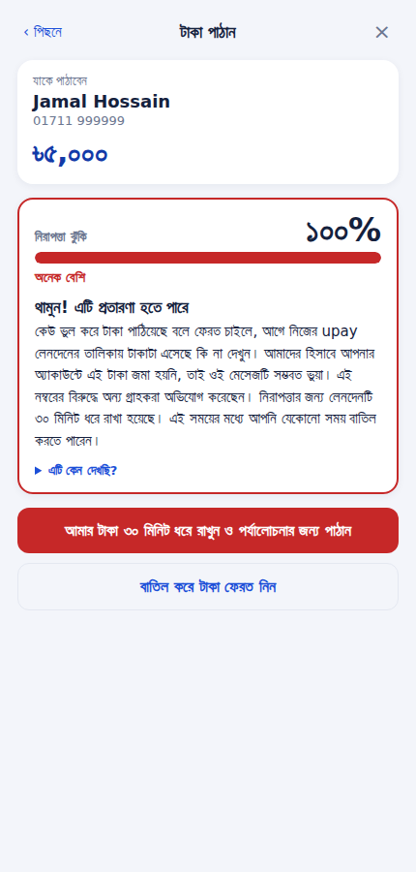  Figure 4. The same warning in Bangla. | 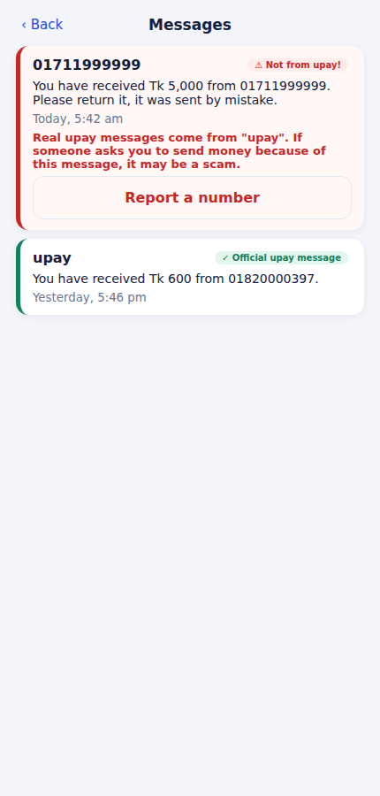  Figure 5. Fake "money received" messages are flagged in the inbox.
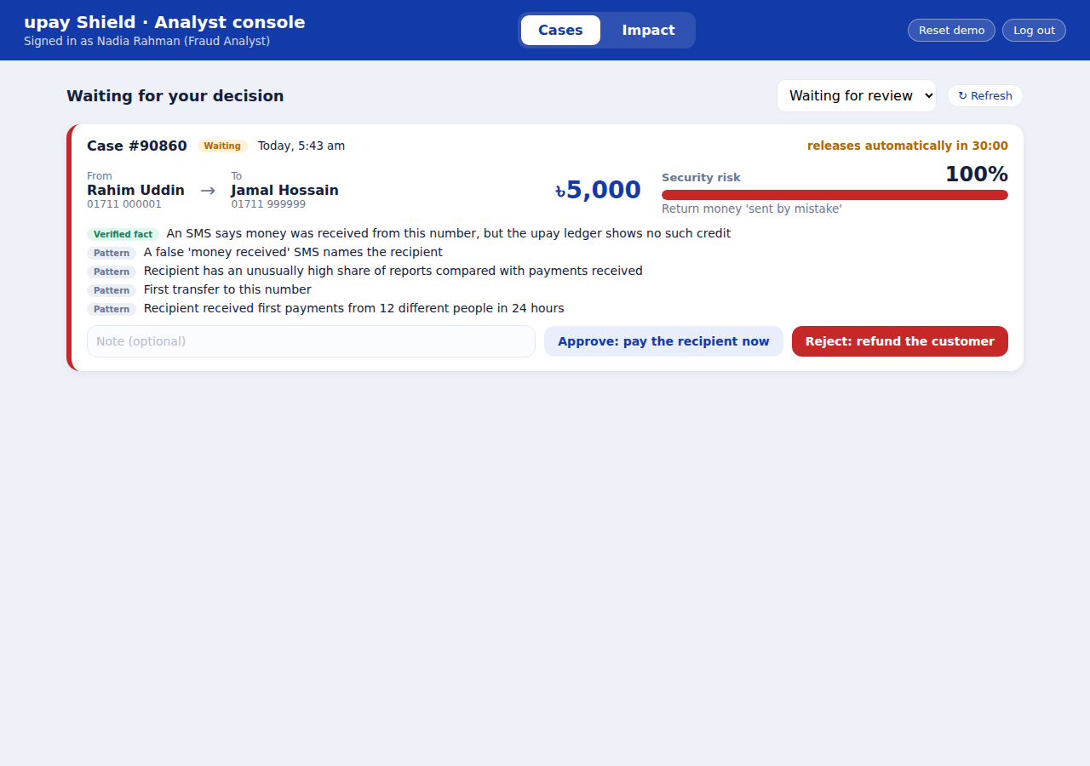
Figure 6. Analyst console: a held case with the reasons and approve / reject.

5. The AI approach

5.1 Synthetic data
No production data is available, so we built a simulator: 6,000 customers over 120 days and about 318,600 transfers, 1.8% of them fraud. It contains five fraud scripts (return-by-mistake, fake officer, prize fee, relative emergency, advance payment) and many honest look-alikes on purpose: first payments to new sellers, night-time family emergencies, young group-fund wallets that collect from many people and pass money on, and customers who hesitate or are on calls. 40% of fraud looks ordinary on the sender side and 30% of victims pay "quiet mule" accounts. An early version scored 99.99%, which told us the data was too easy, so we made it harder until the results were believable. Training, calibration and testing use separate time periods, never random splits. Every assumption is documented in docs/synthetic-assumptions.md.

5.2 The 23 signals
Group | Signals
Sender behaviour (10) | Amount against the sender's own history, share of balance, first-time recipient, round amount, unusual hour, time since money arrived, hesitation, amount edits, on a call, history length.
Recipient wallet (7) | Wallet age, first-time senders in 24 hours, payments in 24 hours, share cashed out, prior payments, reports, report rate.
Story check (6) | An SMS claims a credit, it names the recipient, the ledger confirms or not, the claim does not match, the false claim names the recipient, the SMS did not come from the official sender.

Every signal is computed only from information that existed before the transfer. A test rebuilds the features from truncated history and fails if any value changes; we confirmed it catches a deliberately injected leak. A second test replays a whole simulated world into the wallet database and checks that the live feature builder matches the training builder, so the demo sees the same numbers the model learned from.

5.3 Model, calibration and rules
- A LightGBM classifier with monotone constraints (more of a risky signal can only raise risk) produces the score.
- Isotonic calibration, fitted on a separate period, turns the score into a true probability. A reliability chart and error figure are in the repository.
- One hard rule, kept separate from the model and labelled "Verified fact": a false "money received" SMS naming a new recipient sets a minimum risk. A second rule (many reports) was tested and removed because it was only 33% precise; the model now uses a report rate instead.
- TreeSHAP contributions give the reasons, each labelled as a rule or a learned pattern.
- A second LightGBM classifier guesses the scam type to match the advice. It is only about 54% accurate, so general advice is used until a transfer is held.
- Tier cut-offs come from a stated policy on a separate period: the safety-check tier disturbs about 2% of genuine transfers at most.

5.4 Safety questions
At the safety-check level the customer answers two short questions in Bangla (one general, one for the likely scam type). A risky answer adds a fixed amount to the log-odds (+1.5); a reassuring answer subtracts only a little (-0.3) and the total fall is capped (-0.6), because fraudsters coach victims to answer "no". Rules are never lowered, and every adjustment is returned so the final percentage can be traced. The score is recomputed from the signals each time, so it cannot be tampered with.

5.5 Generative AI
Bangla warnings use reviewed fixed templates by default. An optional LLM can rewrite them in warmer Bangla, but it never decides anything and never sees SMS text, phone numbers, names or amounts: its prompt is built only from a fixed list of phrases chosen by our code. Its reply is checked (Bangla only, no links or phone numbers, must tell the customer they can cancel, must mention the 30-minute hold when there is one); anything else, or any error or timeout, falls back to the template. A test shows that malicious text cannot reach the prompt. This LLM path is switched off unless an API key is set, and it has been tested against its guards but not against the live service.

6. Results
The test period holds 50,960 unseen transfers, 943 of them fraud.
System | PR-AUC | Fraud caught while disturbing 2% of genuine transfers
Simple rules | 0.32 | 34%
Logistic regression | 0.83 | 84%
LightGBM | 0.83 | 84%
Full system (LightGBM + calibration + rule) | 0.82 | 84%

Level | Genuine disturbed | Fraud caught (count) | by value | Warnings that were fraud
Safety check or above | 0.2% | 72.0% | 82.1% | 86.9%
30-minute hold | 0.1% | 68.9% | 77.9% | 91.4%

- Calibration. Calibration error 0.002 (0.004 before calibrating). In the 60-80% band the model predicted 65% and 68.5% were fraud; in the 80-100% band it predicted 96.1% and 96.6% were fraud.
- By scam type (safety check or above). Return-by-mistake 78%, relative emergency 75%, fake officer 71%, advance payment 69%, prize fee 64%.
- Generalisation. For a scam type the model never saw in training, fraud caught at 2% friction ranged from 62% (return-by-mistake) to 86%, against 80-86% when trained on all.
- Fairness. Across newer and established senders, low and high balances, and night and day, genuine customers disturbed stayed between 0.1% and 0.4% and fraud caught between 71% and 78%.
- Robustness. Splitting amounts lowers detection from 72% to 66%, and acting at normal hours changes almost nothing (72%). But a fraudster who collects on an old, quiet account drops detection from 72% to 25%, and to 0% if they also hide every other signal. This is the main weakness.
- Speed. About 4 ms per transfer on one CPU core.
- Honest note. LightGBM performs about the same as logistic regression on this synthetic data; the large gain is over simple rules.
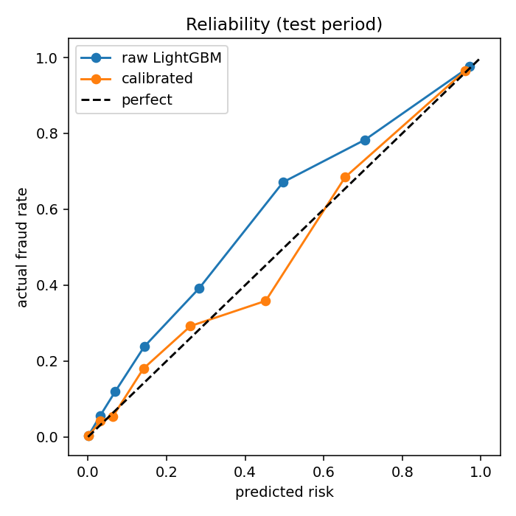
Figure 7. Reliability chart: predicted risk against actual fraud rate on the test period.

7. Impact for customers and for upay
Measured in the live wallet: the impact dashboard follows every flagged transfer and records what the customer did next: walked away after the warning, confirmed and then cancelled, was stopped by an analyst, was released after the hold, or sent anyway. It reports the taka kept back from flagged wallets, the share of customers who heeded the warning, how often customers were interrupted, the money on hold, and the number of reports. In our end-to-end test, a customer who was warned three times kept back ৳12,500 and every taka was returned.
Because the real share of customers who heed a warning is unknown, the offline simulation shows three assumed values. On the test period, with ৳3,956,627 of fraud attempted and 102 genuine transfers interrupted (assuming a cost of ৳15 per interruption):
Customers who heed a warning | Fraud stopped | Net benefit
30% | ৳974,087 | ৳972,557
50% | ৳1,623,478 | ৳1,621,948
70% | ৳2,272,869 | ৳2,271,339

- For customers (expected): fewer losses, a warning in their own language at the right moment, and an easy way to cancel and report.
- For upay (expected): lower fraud losses and complaint load, higher trust (the foundation of wallet adoption), a human-review queue that stays small because only about 0.1-0.2% of genuine transfers are interrupted, and a fraud-intelligence loop from customer reports.
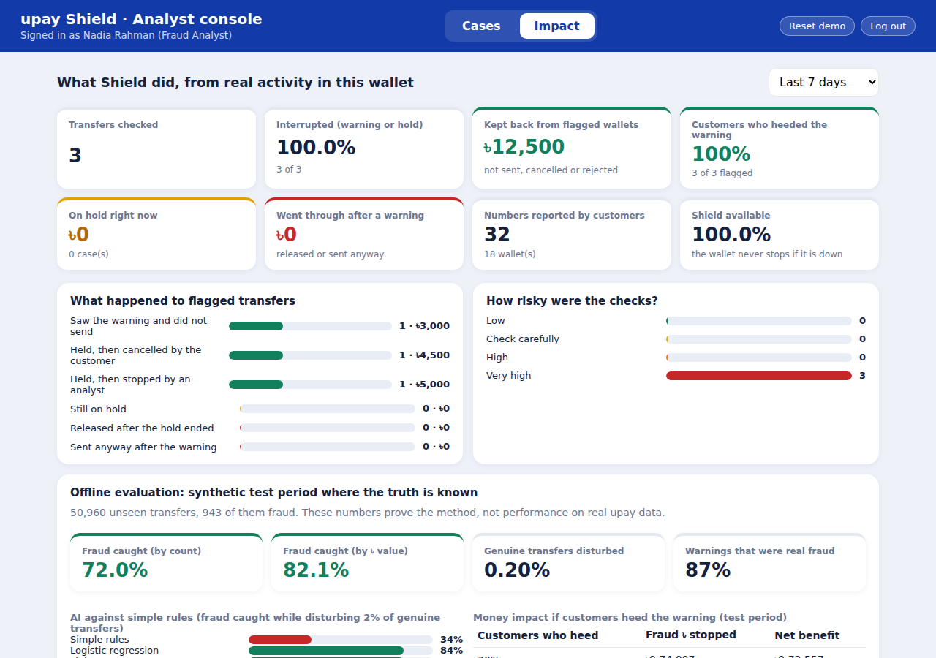
Figure 8. Impact dashboard: measured outcomes in taka, and the offline evaluation.

8. Module 2: keeping agents stocked with cash
Agents hold physical cash and e-float. They run short at predictable moments: payday, market days and the days before Eid. A customer turned away at the counter loses trust in the service and the agent loses commission, while upay's operations team must decide whom to refill first, usually by guesswork.

8.1 What it does
- Forecasts cash-out and cash-in for each agent, hour by hour, for the next 48 hours, with a normal-day line and a busy-day line.
- Works out how much cash is needed over the next 24 hours, the first hour the cash would run out, and how much to add.
- Tells the agent on their phone, in English or Bangla, and lets them ask upay to bring cash with one tap. Operations sees every agent on a map, sorted by urgency, and dispatches requests.
- Finds areas where each agent carries far more than the city's typical load and estimates what a new agent would take.
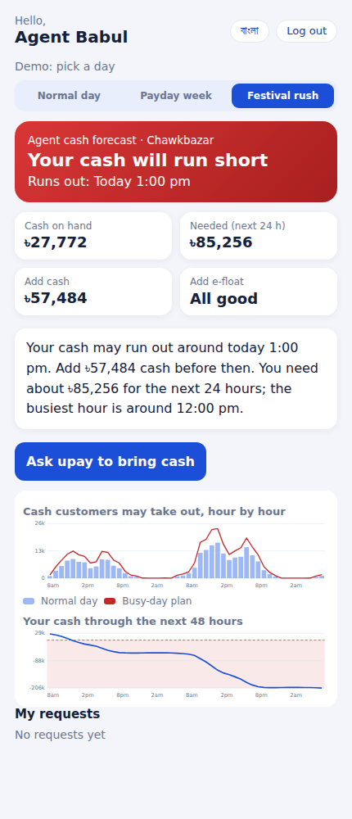  Figure 9. The agent's phone screen: status, run-out time, how much to add, and a one-tap request. | 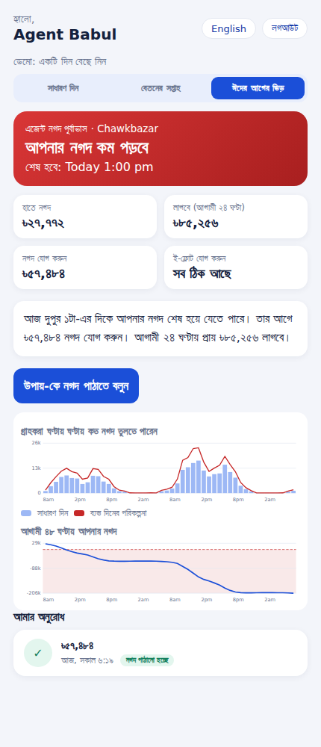  Figure 10. The same screen in Bangla, after upay dispatched the cash.
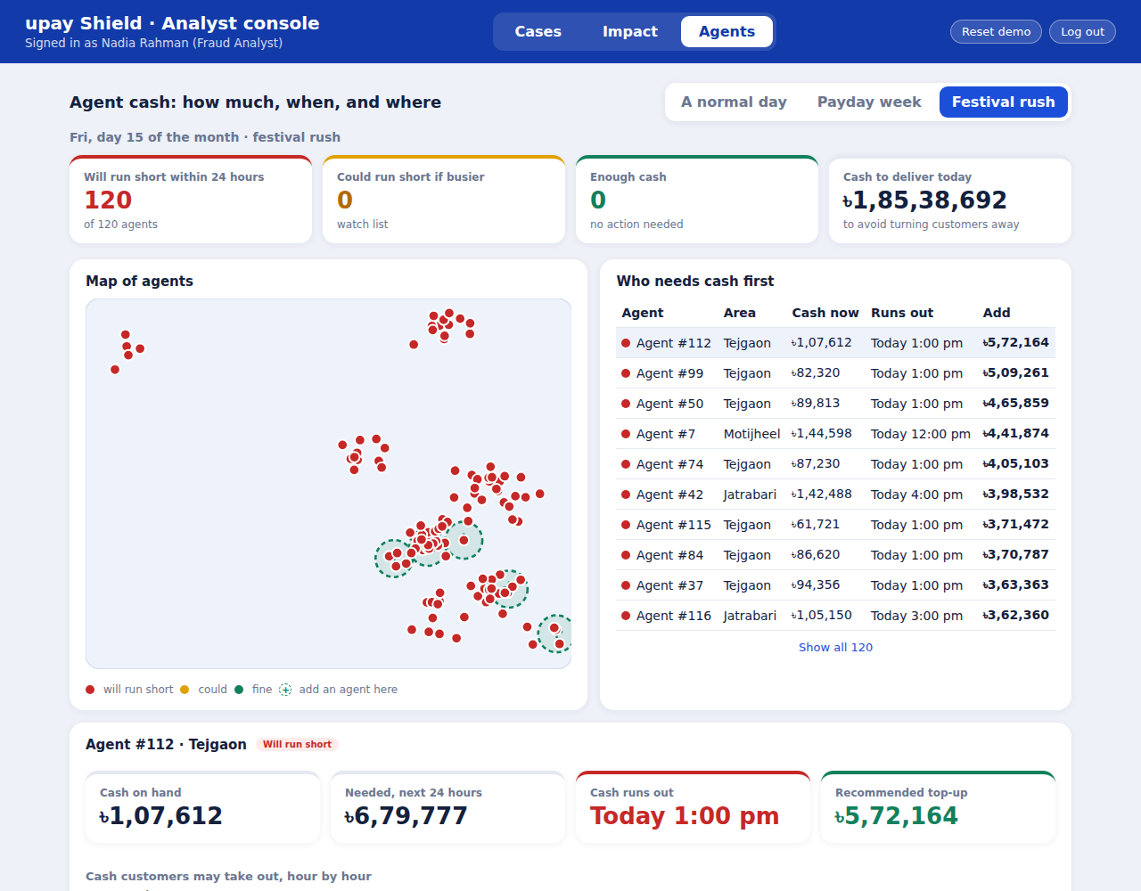
Figure 11. Operations: all 120 agents turn red in the festival rush, with the map, the urgency list and suggested new-agent spots.

8.2 How it works
- Data. 120 simulated agents across 12 areas of Dhaka and 90 days of hourly demand: lunch and evening peaks that differ by area type (garment, residential, campus, market, transit), a payday surge, a festival rush before Eid, a weekly market day, and quieter Fridays and Saturdays.
- Features, point in time. The calendar (known in advance), the agent's normal level (the median of the last 28 days, so one rush does not distort it) and the same hour on earlier weeks. A test changes everything from the forecast day onwards and confirms no feature moves.
- Model. Four LightGBM quantile models: cash-out and cash-in, each at the median and at a busy-day level. They predict demand as a ratio of the agent's normal level, so one model serves large and small agents.
- Planning level. Adding up 24 separate busy-hour forecasts plans for a day far busier than any real day, so we plan 60% of the way from the normal-day to the busy-day line. We chose 60% on earlier validation days, as the smallest setting that turned away under 0.25% of demand.
- Arithmetic, not AI. Cash needed is the deepest point of the running balance (cash out minus cash in); the run-out hour is the first hour it goes below zero. This is kept separate from the model so an operator can audit it. Red means the cash is expected to run out within 24 hours, yellow means it could within 12 hours if the day is busier.
- Where to add agents. For each map cell of about 2 km, compare the cash-out per agent with the city median; a cell where each agent carries at least 1.15 times the median is under-served. A new agent would take roughly the cell's demand divided by one more agent.

8.3 Results on 19 days the model never saw
We simulated each refill method hour by hour for all 120 agents (2,280 agent-days). Customers are served from the cash on hand; anyone who cannot be served is turned away.
Refill method | Turned away | Average cash | Normal days | Payday | Festival
Last week's need + 20% | 26.4% | ৳86,711 | 0.05% | 26.6% | 45.5%
Last week's need, same average cash | 28.0% | ৳78,506 | 0.13% | 31.2% | 47.5%
From the forecast | 0.14% | ৳78,506 | 0.37% | 0.27% | 0%

- Forecast quality. The median forecast has 67% lower error than copying the same hour from last week. The busy-day line covered 92.7% of cash-out hours (target 90%) and 95.1% of hours during the festival rush.
- Where the gain comes from. Rush days. Copying last week works on quiet days and fails when demand jumps. On normal days the forecast method is not better (0.37% against 0.05% turned away).
- What it costs. The forecast method moves about 84% more cash through refills (৳180 million against ৳98 million over the 19 days), because it stocks up before rush days. Refill logistics are not modelled.
- Commission. At an assumed 0.5% commission, turned-away demand cost the agents ৳390,000 under last week's method and ৳2,100 under the forecast method over the 19 days.
- The safety setting. Planning 0% of the way to a busy day turns away 3.6% of demand with ৳38,800 on hand; 30% gives 0.85% with ৳56,800; 60% (our choice) gives 0.14% with ৳78,500; 100% gives 0.01% with ৳110,100. Operations can move this dial.
- New agents. Tejgaon (each agent carries 2.5 times the typical load), Jatrabari (1.9 times), Motijheel (1.7 times), Dhanmondi (1.5 times) and Farmgate (1.4 times).

8.4 Honest notes
- The agents, their demand and the Eid and payday patterns are all simulated. The comparison baseline is simple on purpose: it is what an operator without a forecast does.
- The model saw only one festival in training. An earlier version confused the days before the festival with payday, because the two overlapped in the simulated calendar; we moved the festival and said so. Real use needs several years of calendar history.
- A brand-new agent with no history cannot be forecast, and the new-agent suggestions use demand per agent only: they ignore roads, rent and competitors.

9. Responsible AI and security
Principle | What we did
Privacy | Synthetic data only. SMS content is reduced to three fields by fixed patterns, not an LLM. The LLM never sees SMS text, numbers or names.
Explainability | Every alert lists its reasons, marked "Verified fact" (rule) or "Pattern" (model), and every safety-question adjustment is returned.
Fairness | Error rates compared across sender age, balance and time of day, with the figures above.
Security | PINs hashed with PBKDF2 and a secret, lockout after five wrong PINs, session tokens stored only as hashes, duplicate-request keys so a double tap cannot pay twice, the server re-checks every transfer, and evasion tests on the model.
Human oversight | Holds can be cancelled by the customer and reviewed by an analyst; nothing is blocked automatically.
Transparency | Predictions, assumptions and generated text are kept separate; the report states the limits below.
Availability | If Shield is down the wallet keeps working (it allows the transfer and logs it); a malformed reply from Shield is treated the same way.

10. From prototype to product
- Validate in shadow mode: score real transfers without showing warnings, and compare with confirmed fraud, using appropriately governed, anonymised or aggregated data.
- Retrain and recalibrate on that data with the same code, and re-check the tier cut-offs against the friction budget.
- Integrate through two calls: the app asks Shield before the PIN step, and the wallet asks again when the PIN is sent. The production app would read the SMS fields and call state on the phone.
- Monitor calibration drift, friction on genuine customers and analyst workload; add account-level controls for the quiet-account weakness.

11. Limitations
- All results are from synthetic data and prove the method, not performance on real upay data.
- A wallet with no history looks risky to the model; the demo is seeded so everyday wallets have history.
- A calm fraudster using an old, quiet account can slip through.
- The scam-type guess is about 54% accurate.
- Money forwarded by send-money rather than cash-out is not counted by the cash-out-speed signal, which matches how the training data was built.
- SMS reading and the "on a call" flag are simulated; the optional LLM wording has not been tested against the live service.
- Module 2 uses simulated agents and calendar patterns, saw only one festival in training, and does not model refill logistics.
- The free hosting plan sleeps when idle and does not keep data between restarts.

12. Quality and testing
The project has 278 backend tests and 134 phone-app tests, a commit history showing step-by-step work, and instructions in the README to run everything. Beyond ordinary tests we checked that the tests can fail: we broke key behaviours on purpose (a leak from the future, a missing refund, a disabled lockout, wrong impact counting, a cash forecast that peeks at the day being forecast, a refill that ignores the cash already held) and confirmed that a test failed each time. End-to-end checks in a real browser covered the scam story, the safety questions, the analyst review, the refund, the impact numbers, the demo reset, and the agent story (forecast, refill request, dispatch, Bangla screen).

