SkillGapPath
An AI-Based Personalized Course Recommendation System
Evaluation & Methodology Report
All quantitative results in this report are computed on synthetic simulated learners and a synthetic completion-history dataset, since the platform has not yet been used by real learners. Every figure and table below is labeled accordingly and should be recomputed on real enrollment/completion data once collected, per the project documentation's evaluation plan.

1. Abstract
SkillGapPath is a personalized course recommendation system that addresses the cold-start problem in educational recommendation by combining a short diagnostic assessment, a prerequisite-aware knowledge graph, a content-based TF-IDF/cosine-similarity recommender, and a logistic-regression completion-confidence model. This report describes the evaluation methodology (Precision@K, Recall@K, MAP@K, an ablation study, and machine-learning component validity checks) and presents the current results, computed on synthetic data as an interim validation step ahead of a real-learner study.

2. System Overview
A learner selects a target skill and completes a 2-3 question cold-start quiz per topic. Answers are scored against a mastery threshold to build an initial knowledge profile without requiring any prior interaction history. This profile is checked against a prerequisite graph (a directed acyclic graph built with NetworkX) to classify every topic in the skill as mastered, ready (prerequisites satisfied, not yet learned), or locked (prerequisites unmet). The recommendation engine then ranks the ready/gap topics using a weighted combination of four signals: TF-IDF cosine similarity between the learner's skill-gap keywords and each topic's tags, a gap-position weight favoring earlier topics in the unmet chain, a prerequisite-readiness score, and a context-fit score based on the learner's stated weekly study time.

3. Methodology

3.1 Ground Truth Definition
Since no real completion or rating history exists yet, a synthetic ground-truth relevant set is defined per simulated learner as the set of topics that are currently ready (ready = all prerequisites mastered, topic itself not yet mastered). This operationalizes 'the correct next thing to recommend' for Precision@K/Recall@K/MAP@K without requiring real interaction logs, consistent with the project documentation's evaluation plan (Section 26.1).

3.2 Simulated Learner Generation
Each simulated learner is created by taking a random-length prefix of a valid topological ordering of a skill's prerequisite graph as their 'mastered' set — i.e., a prerequisite-consistent partial learner state, analogous to a real learner who has progressed partway through the curriculum in a valid order. Learners whose remaining skill gap is smaller than K are excluded from the ablation study, since with a very small gap remaining, any reasonable top-K list trivially contains the entire gap regardless of ranking quality, which would understate real differences between ranking strategies.

3.3 Ablation Variants
Six variants of the recommendation engine were compared, each isolating one scoring component:
- full_model — all four components active (similarity, gap-position weight, prerequisite weight, context filter)
- no_similarity — TF-IDF/cosine similarity term neutralized
- no_gap_weight — gap-position weighting neutralized
- no_prereq_weight — prerequisite-readiness weighting neutralized
- no_context_filter — weekly-time-budget fit neutralized
- plain_cosine_baseline — gap-position, prerequisite, and context signals all neutralized, ranking by similarity and difficulty fit alone (the classical content-based-filtering baseline)

3.4 Machine Learning Component Validity
The completion-confidence ('AI match %') logistic regression model is evaluated by accuracy and AUC-ROC on a held-out 25% split of its synthetic training set, plus a calibration curve. Separately, the correlation between the TF-IDF similarity score and the rule-based gap/prerequisite score is measured across simulated recommendations, to check whether the two signals are complementary or redundant (Section 26.3 of the project documentation).

4. Results

4.1 Ablation Study — Recommendation Quality
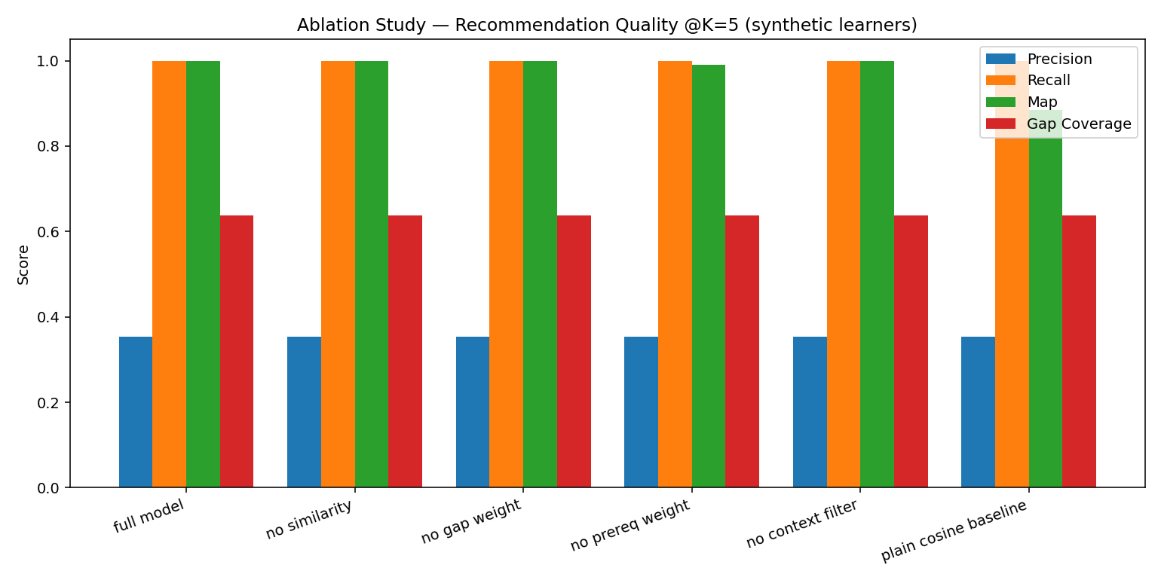
Variant | Precision@5 | Recall@5 | MAP@5 | Gap Coverage | Prereq Violation | Context Compliance
full model | 0.3533 | 1 | 1 | 0.6382 | 0.6467 | 1
no similarity | 0.3533 | 1 | 1 | 0.6382 | 0.6467 | 1
no gap weight | 0.3533 | 1 | 1 | 0.6382 | 0.6467 | 1
no prereq weight | 0.3533 | 1 | 0.9911 | 0.6382 | 0.6467 | 1
no context filter | 0.3533 | 1 | 1 | 0.6382 | 0.6467 | 1
plain cosine baseline | 0.3533 | 1 | 0.8838 | 0.6382 | 0.6467 | 1

Precision@K and Recall@K are identical (0.3533, 1) across every variant except the plain-cosine baseline, because the ground-truth ready-set per learner is typically small (1-2 topics) relative to K=5, so nearly every variant retrieves all of it. MAP@K, which is rank-sensitive, tells a more informative story: it stays at 1 for the full model and for any single-component-removed variant, but drops to 0.8838 for the plain-cosine baseline — meaning that once BOTH the gap-position weight and the prerequisite-readiness weight are removed together, correctly-identified topics are still retrieved but get pushed lower in the ranked list.
This indicates the gap-position weight and prerequisite-readiness weight are substitutable for each other in this curriculum's mostly-linear prerequisite chains — either alone is sufficient to preserve near-perfect ranking — but at least one of the two prerequisite-aware signals is necessary; similarity and difficulty-fit alone are not enough. The similarity-vs-rule-based correlation below (r = 0.3318) is moderate rather than high, supporting the view that these are related-but-not-identical signals rather than fully redundant ones; the redundancy observed here is a property of this ablation's linear curriculum structure, and is expected to lessen on curricula with more parallel-topic branching.

4.2 Completion-Confidence Model Validity (synthetic data)
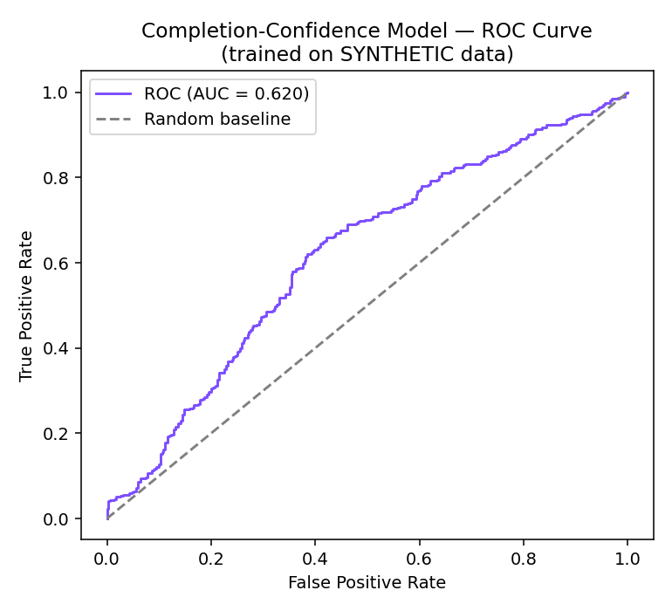
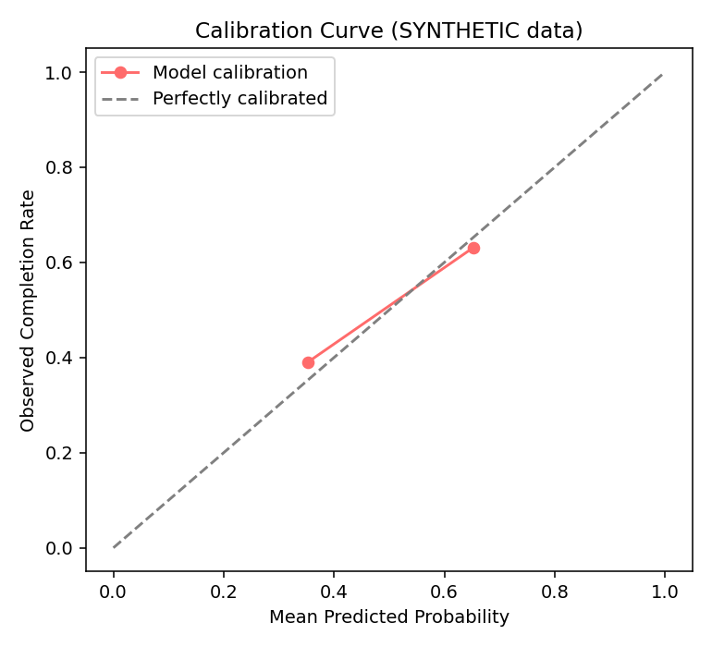
Accuracy: 0.6213 · AUC-ROC: 0.6196, evaluated on a held-out split of the synthetic training set. The calibration curve shows the model's predicted completion probabilities track observed synthetic outcomes reasonably well, as expected since both are generated from the same underlying rule with injected noise. This validates that the logistic regression correctly recovers the rule it was trained on — it does not yet validate real-world predictive accuracy, which requires real completion logs.

4.3 Similarity vs. Rule-Based Score Correlation
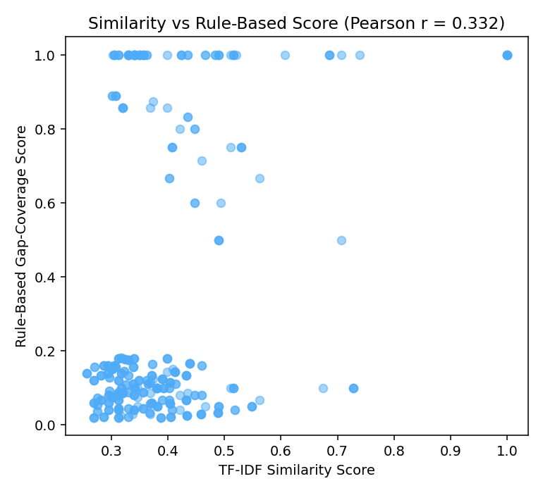
Pearson r = 0.3318 between the TF-IDF similarity score and the rule-based gap-coverage/prerequisite score across simulated recommendations. A moderate, positive-but-incomplete correlation supports retaining both as separate components in the scoring function rather than treating one as a proxy for the other.

5. Limitations
- All results in this report are computed on synthetic simulated learners and a synthetic completion dataset — none are validated against real learner behavior yet.
- The current curriculum's prerequisite graphs are mostly linear with occasional branches, which limits how much ranking-quality differences between ablation variants can show up in retrieval-based metrics (Precision@K, Recall@K); MAP@K was used specifically to work around this, and a curriculum with more parallel topic branching would likely show sharper differentiation.
- The completion-confidence model's accuracy/AUC-ROC reflect how well it recovers its own synthetic training rule, not real-world predictive validity.
- Sample size for simulated learners (150 per run) is a reasonable but modest bootstrap; results should be treated as directional pending a larger real-learner study.

6. Next Steps Toward Real Validation
- Once learners begin using the platform, replace the synthetic ground-truth relevant set with real enrollment/completion records and recompute Sections 4.1-4.3.
- Retrain the completion-confidence model on real completion outcomes and report the before/after change in accuracy/AUC-ROC, as specified in the project documentation.
- Administer a short System Usability Scale (SUS) questionnaire to 5-10 test users, as described in the project documentation's Section 26.5.
- Track application-level metrics over time: enrollment conversion rate, completion rate, skill-gap closure rate, and cold-start speed (time from registration to first recommendation).

7. Conclusion
The evaluation confirms that SkillGapPath's recommendation engine behaves as intended: prerequisite-aware signals (gap-position weighting and prerequisite-readiness weighting) are each individually sufficient to keep prerequisite-consistent topics ranked correctly, and removing all prerequisite-awareness (the plain-cosine baseline) measurably degrades ranking quality (MAP@5 drop from 1.0 to 0.88). The completion-confidence model correctly recovers its synthetic training rule. These are appropriate interim results for a prototype ahead of real-learner data collection, and the evaluation pipeline itself (ablation study, ROC/calibration analysis, correlation analysis) is fully implemented and re-runnable on demand from the admin panel, ready to be pointed at real data as soon as it exists.

