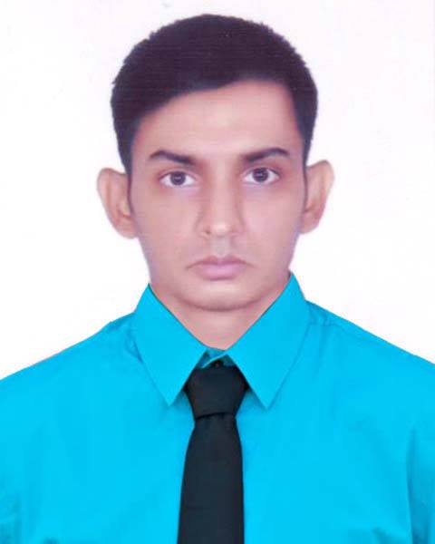

**Arman Ahmed**

E-mail : aaarmanapu@gmail.com

Contact no : 01916972560

|  |
| --- |
| **OBJECTIVE:** |

To obtain a position that will enable the use of my IT skills, expertise and ability to work well with people where all parties are considered as achiever.

|  |
| --- |
| **EXPERIENCE:** |

Position : Front-End Web Developer

Company Name : Codexin Technologies

Responsibility : PSD to HTML5, Wordpress Customization

Duration : **10 month** (February 2017 to November 2017)

Position : MIS Officer

Company Name : Sino-Bangla Industries Ltd.

Responsibility : Computer Operator

Duration : February 2010 to July 2010

Position : Office Manager

Company Name : At Deed writer’s office

Responsibility : Manage Office & Computer operator

Duration : **1 Year** (2011)

­­­

|  |
| --- |
| **PROFESSIONAL TRAINING:** |

**Training Title : Database Management and Administration**

Institute : BUET (Bangladesh University of Engineering and Technology)

Location : Zahir Raihan Rd, Dhaka -1000.

**Training Title : Web Application Development - PHP**

Institute : SEIP project organized by BASIS

Location : BDBL Bhaban (3rd floor – East), 12 Karwan Bazar, Dhaka- 1215.

**Training Title : Laravel - the PHP Framework for Web Artisans**

Institute : Talha Training Center

Location : 1st floor, 161/B, Lake Circus, Kalabagan, Dhaka 1205.

|  |
| --- |
| **LANGUAGE PROFICIENCY:** |

* Bengali – Native Language
* English – Well versed in both writing and speaking
* Hindi – Verbal
* Chinese – Learning at ‘Confucious center at BOU’.

|  |
| --- |
| **IT PROFICIENCY:** |

* Expertise : Bootstrap, Saas, JQuery, AJAX, PHP, MySQL, Oracle 11g, Laravel, Wordpress.
* Current learning : AngularJS, VueJS.

|  |
| --- |
| **ACADEMIC QUALIFICATION:** |

**Level : B.Sc in IT**

Institution : Daffodil International Academy

Year of passing : 2018

**Level : Higher Secondary Certificate in Business Management**

Group : Computer Operation

G.P.A : **4.77**(Out of 5)

Year of passing : 2012

Institution : Munshigonj Engineering School and College, Munshiganj

**Level : Secondary School Certificate**

Group : Science

G.P.A : **4.81**(Out of 5)

Year of passing : 2005

Institution : Gov. Laboratory High School

|  |
| --- |
| **PERSONAL DETAILS:** |

Name : Arman Ahmed

Father’s Name : Mostaq Ahammed

Mother’s Name : Rowshon Ara

Present Address : 58/E (Ground floor), West Razabazar, Tejgaon, Dhaka- 1215.

Permanent Address : House – 4, Charpathalia Road, Po.- Baberchar, Th.- Gazaria, Dis.- Munshiganj

Date of Birth : 26-11-1990

Nationality : Bangladeshi (by Birth)

Religion : Islam

Marital Status : Single

Blood Group : A+ (positive)

|  |
| --- |
| **REFERENCES:** |

**Prof. Md. Sarwar Hossain Mollah Md. Shafiul Alam**

Deputy Academic Director, Co-founder and Chief Executive

Daffodil International Academy, Talha Training

E-mail – sarwar.hossain@diit.info Mobile - 01712742217

With Regard

……………………

Arman Ahmed

Date: 29 Mar, 2018