# Star Field

The star field is implemented as 6 planes that form a cube around the playable area. Vertex and fragment shaders have been edited to render the texture properly. We have a boolean "IsTexture" that gets toggled on/off when rendering the texture specifically. The texture is a 640x425 .raw file edited via irfanview. The placement / rotation axes of each plane (or square) are stored in the following arrays.

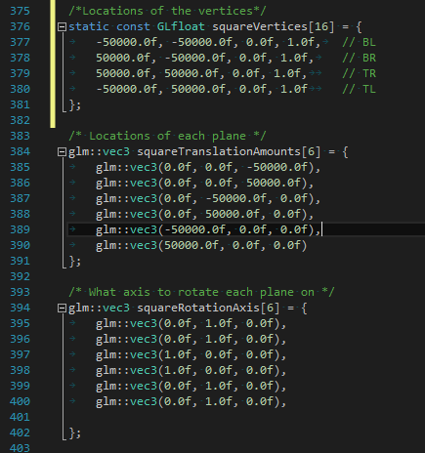

# Lights

Point light from Ruber

Ruber is supposed to be set up as a point light that is diffuse when facing away from the light. Meaning that when you look at a planet and Ruber’s light is hitting it you will see the planet light up. In the pointLightPosition method in the simpleFragment.glsl file we attempted to calculate the diffuse by taking the dot product of the point’s normal surface by the direction of the light ( basically where the camera was in place in our space box ). Following the example form the shaders, lights slides and the example given in chapter 7 of the OpenGL programming textbook we attempted to add attenuation to the point light off Ruber to make it seem more like a real system.

Head Lamp Light looking same direction as camera down z-axis

On this section we began by creating a new vec3 method for the directional light that would be given down the camera view. Our main goals were to check if there was any ambient light that we would have to contend with, to see if any surfaces would not light up by the light, and to see how much light should be reflected.

# Additions to Phase 2:

When the user restarts the game the camera is reset back to the warbird camera.

# Things we wanted to do but couldn’t get around to it due to Time constraints:

The extra credit spot light for the ship. We found an example of the spot light from the Red Book and implemented it in the Fragment Shader but we didn’t get around to finish implementing it in the project due to time constraints.

We wanted to have a graphic or texture displayed on the screen when the player wins or loses.

Lastly we wanted to have a way to display credits displaying the team’s names when the player wins the game.

# Extra Things we Added:

## Sounds and Music (MIND YOUR EARS)

**Warning: Make sure your sound is on low initially since it varies from system to system.**

Sounds and music were added using [irrklang](http://www.ambiera.com/irrklang/) a cross platform sound library using C++, C#, and all .NET languages.

We Simply had to download and copy the files to the project, link the library and create an object from that library and we were able to utilize its functionality.

### Sounds:

* Added various sounds from Star Trek: The Original Series, Star Trek: The Next Generation television series, and Star Trek: Armada video game.
  + When the user restarts the game all the sounds reset, the randomly selected music track replays and a uncloaking sound plays with a new warbird appears since a new student is trying out for the war college.
  + When the user’s ship collides with an object it plays an explosion sound from Star Trek TOS.
  + When the user warps it plays a warping sound from Star Trek: The Next Generation.
  + When the user fires a missile it plays a photon torpedo sound from Star Trek TNG.
  + We were planning on adding a sound when a missile site missile is locked onto the warbird but didn’t get around it. The sound is still in our project folder/media its called: MRom300.wav
  + We were also planning on using the Romulan cloaking sound when the warbird is hit but it didn’t make sense for a Star Trek fan!
  + We were planning on having a special missile firing sound for the missile site but didn’t get around to it.
  + Finally we were planning on adding 3D sound sources where the sound volume is based on its location or distance from the camera.
* Voices
  + Various voices were added from Star Trek Armada 1.
    - When the program is started there are three voice lines that are randomly selected to play. You can keep pressing the restart button ‘r’ to hear all the **three** different voice lines!
    - When already fired the missile there are **two** different voice lines that may play to give feedback.

### Music:

* When the user restarts the game the music resets.
* There are **two** different music tracks that can play.
  + Music is the Romulan Faction themes from Star Trek Armada 1 and Star Trek: Armada 2 Video Games.
* Added special “surprise” music if you win the game! When you win the game all the other sounds and music are stopped so you can listen to the wonderful victory music.

### Warbird Model Credits:

The model we imported and used for our Warbird is modeled after the Warbird design from Star Trek TOS. We changed it to a tri model and colored it based on how it looked in the original series.

Romulan Bird of Prey, Classic Star Trek by jpcotedsbn is licensed under CC Attribution-NonCommercial-ShareAlike

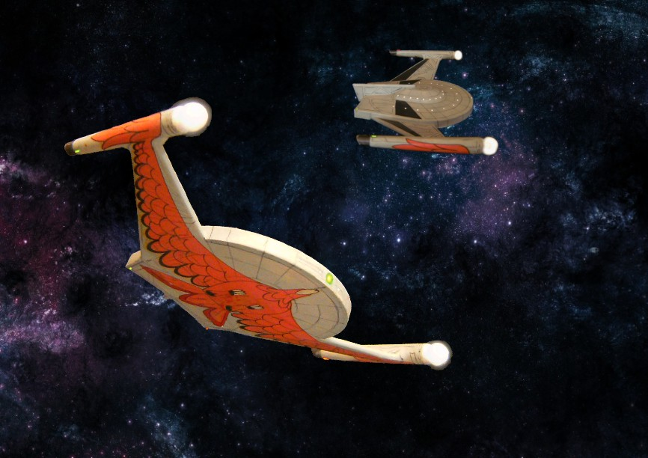

This picture is not what the model looks like but on how it relatively looked in the television series.

