***1- Login as a root user on my AWS Account***

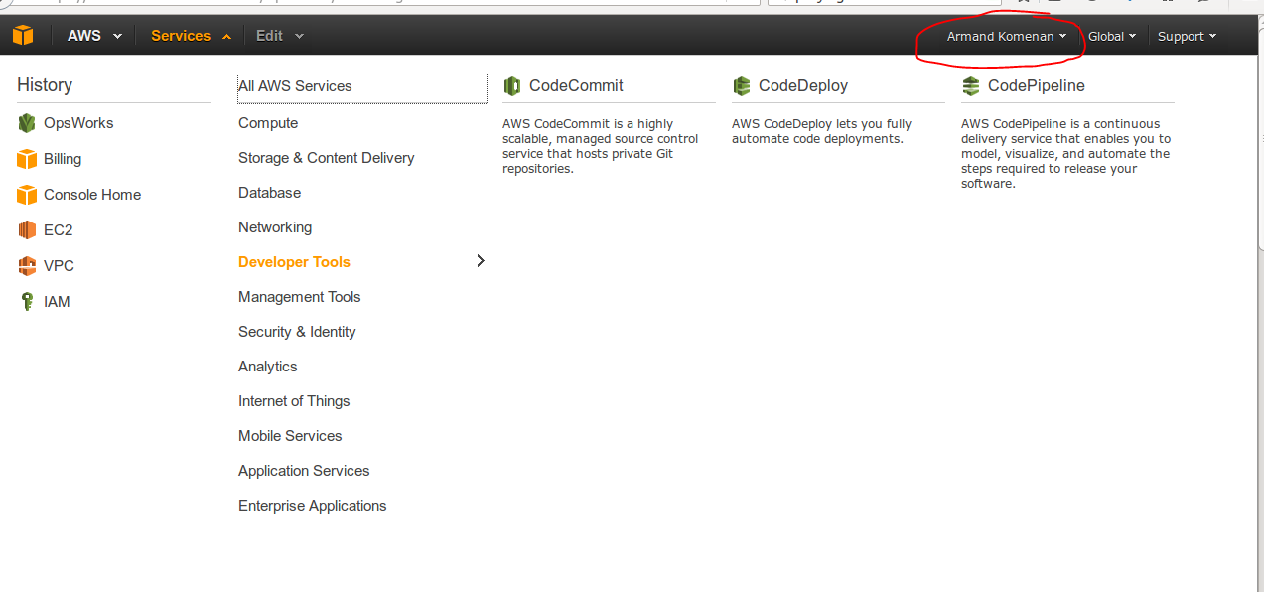

***2- Best practices require not to use root credentials to access AWS services. I am creating a user called 'comcast' who will have admin access***

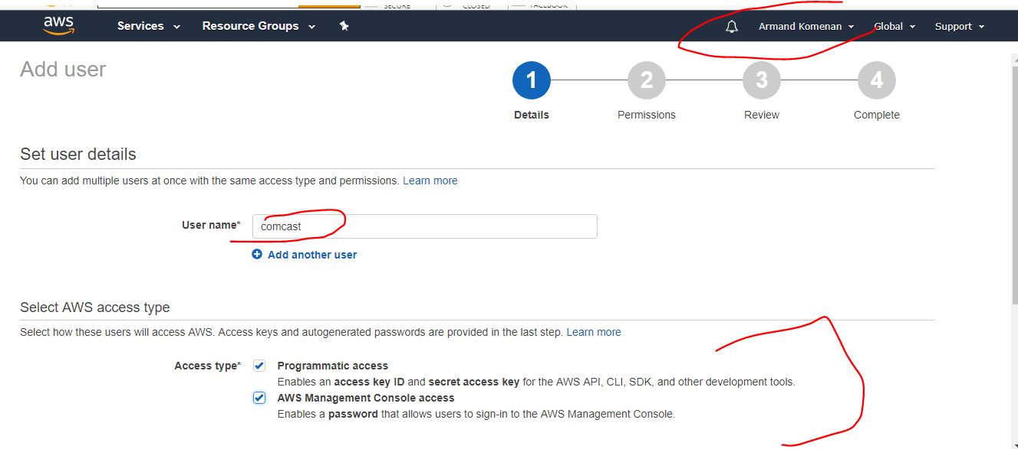

***2- Giving 'AdministratorAccess' to the new user***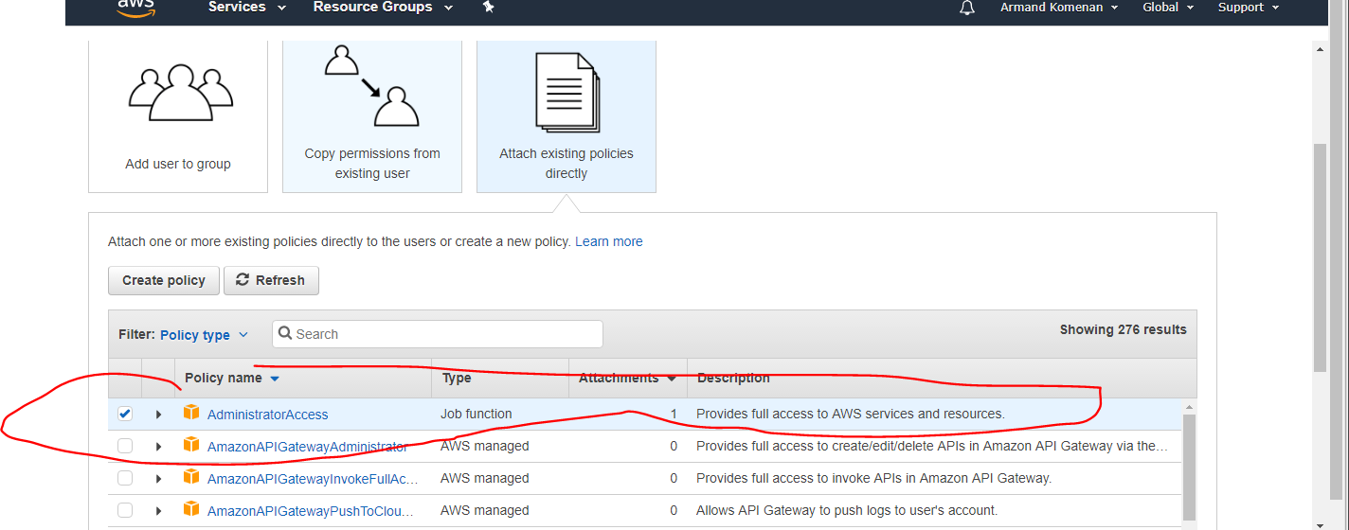

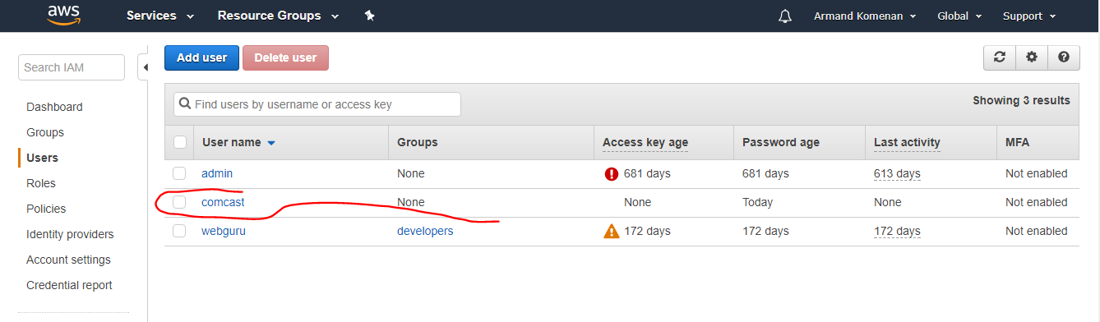

***3- I am login as a new user with full access to all AWS resources.***

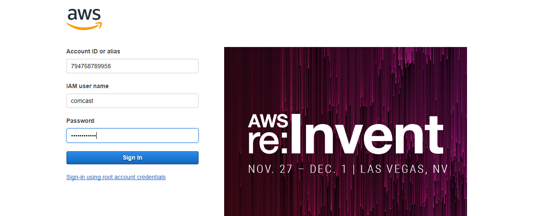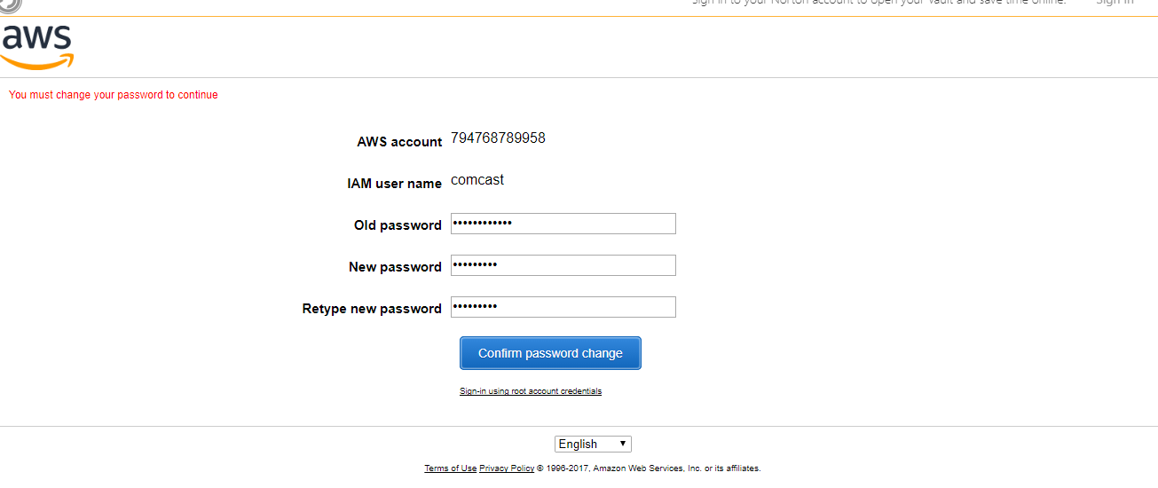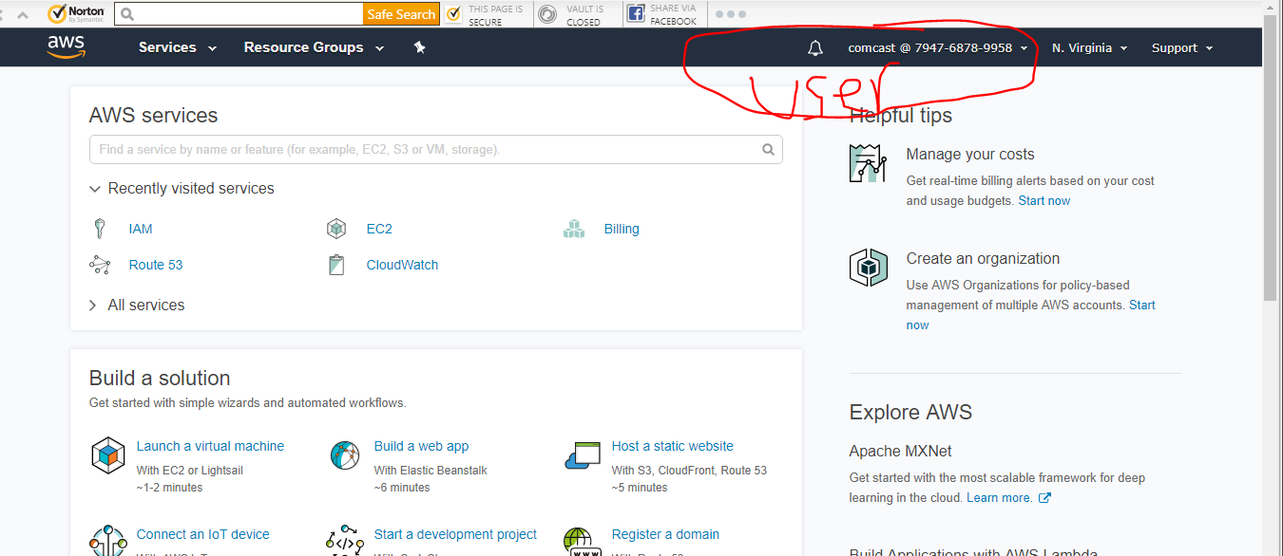

***4- I am lunching a new EC2 instance (Assuming that I have a VPC with couple sub-nets- --no need to have public subnet or elastic IP)*** 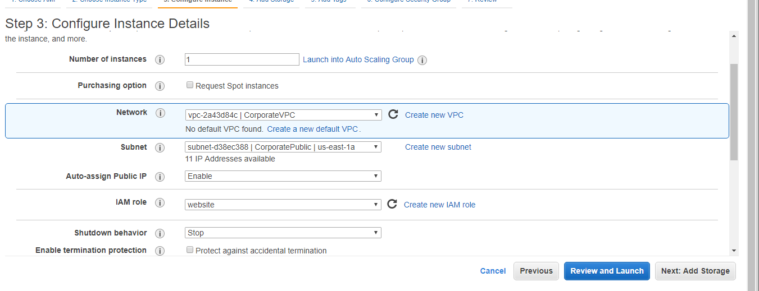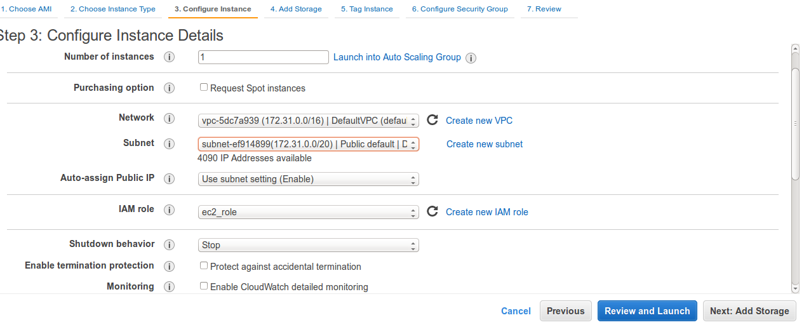

***5- Download instance pem key***

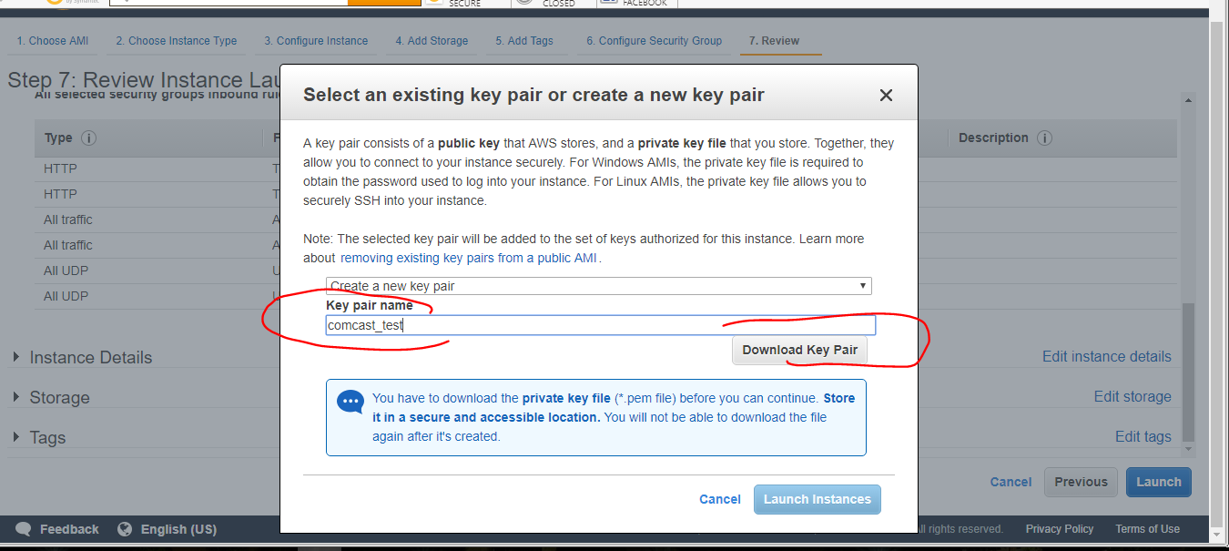

***6- Configuring Security Group. We need only port 22 open to ssh*** ***8- Downloading the pem file***

***7-Instance is running***

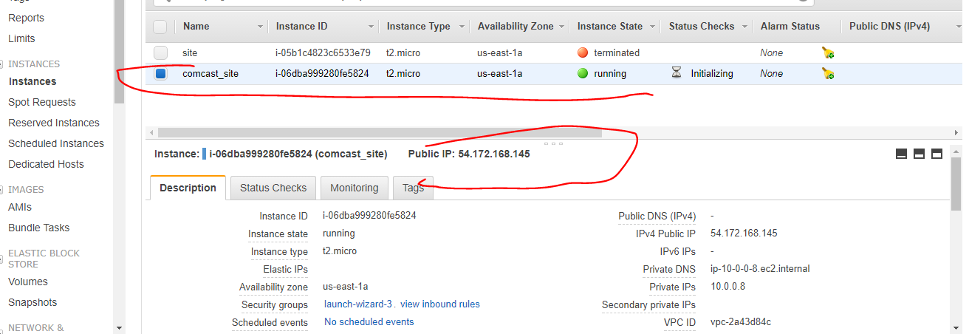

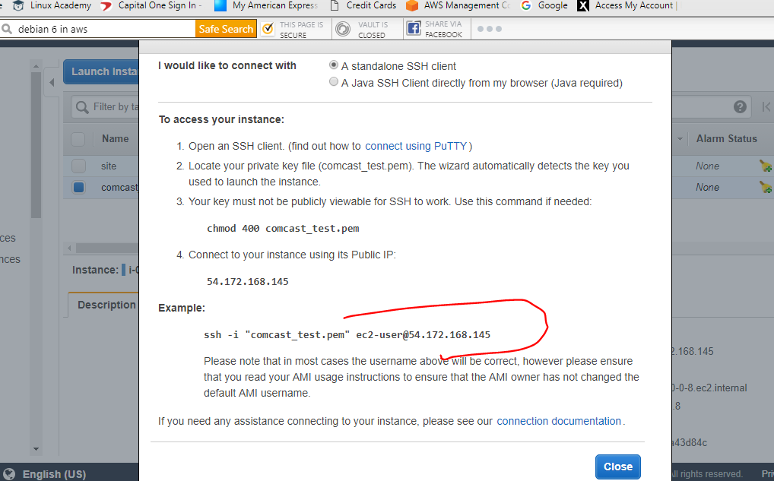

***8-The EC2 instance is our node, so to bootstrap we need to have root login enable. We login to the instance we need to edit /etc/ssh/sshd_config file and run >service sshd_restart***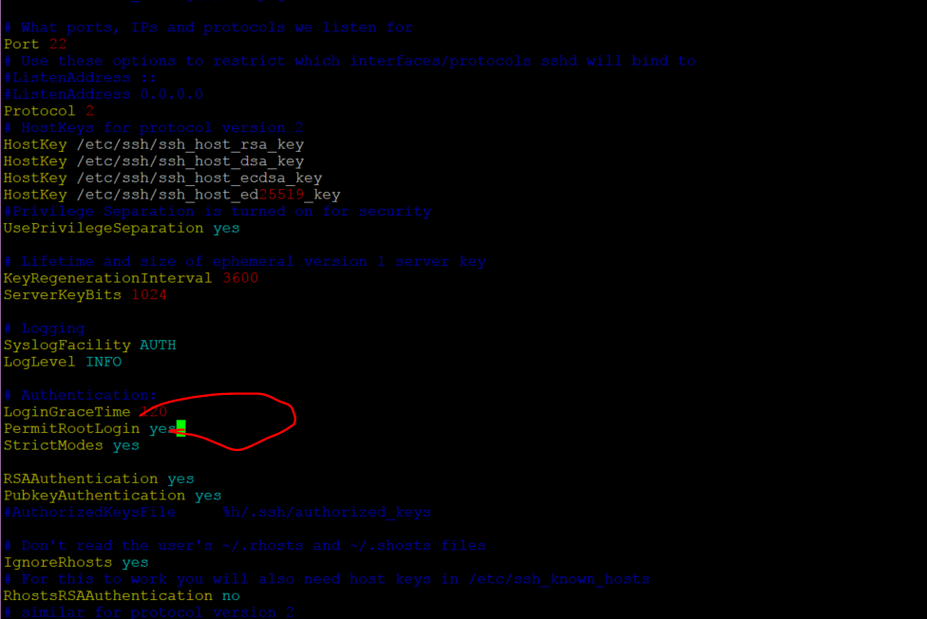

***9- Setting the Workstation to install Chef ( I am using Hosted Chef to download the Starter Kit)..Note: I called the hostname : workstation*** 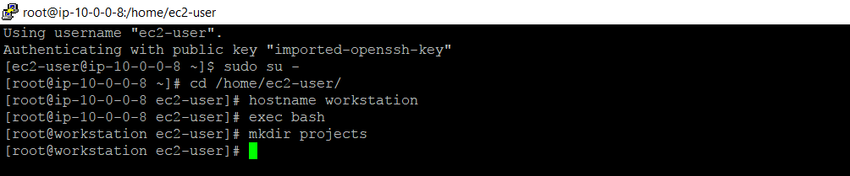

***10- Downloading Chef*** 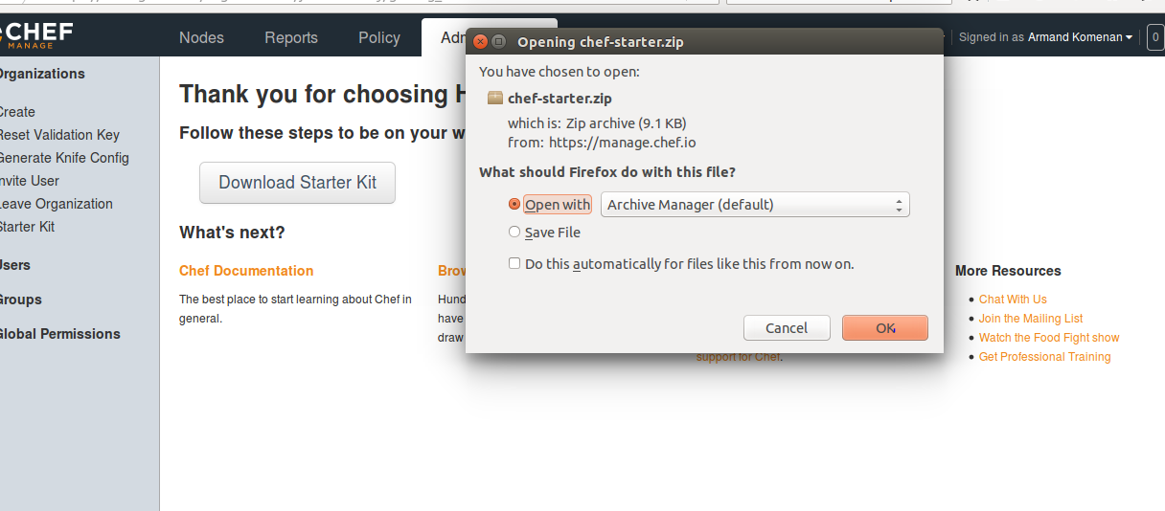

***11- Installing Chef tools (cookbook, recipes, knife)***

$> curl -L https://www.opscode.com/chef/install.sh | sudo bash -s -- -v 12.11

***12- Creating our cookbook 'myapacheserver'***

#> knife cookbook create myapacheserver

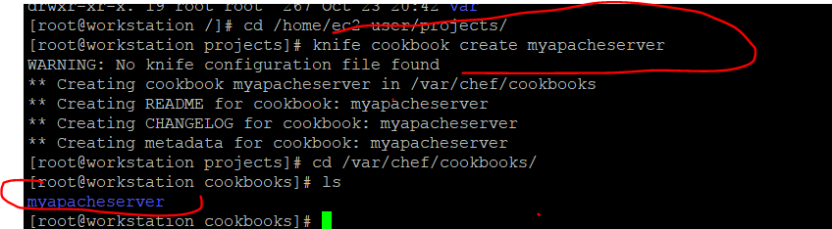

***13. Creating our recipe by editing recipe/default.rb***

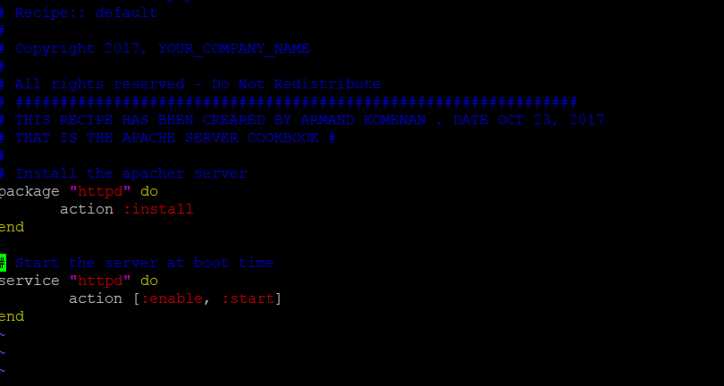

***14- Uploading and Creating our cookbook 'myapacheserver'***

chef-repo#> knife cookbook upload myapacheserver

***15- Adding a recipe run list to our node***

chef-repo#> knife node run_list add ComcastNode "recipe[myapacheserver]"

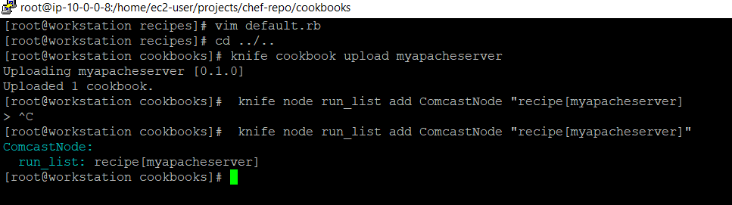

***16- From the chef-repo, we are bootstraping our node, that is the EC2 instance. Make sure you have the pem file. That runs successfully our first Convergence***

chef-repo#> knife bootstrap 54.172.168.145 --ssh-user ec2-user --sudo --identity-file comcast_test.pem --node-name ComcastNode

***17- Running the client***

#> chef-client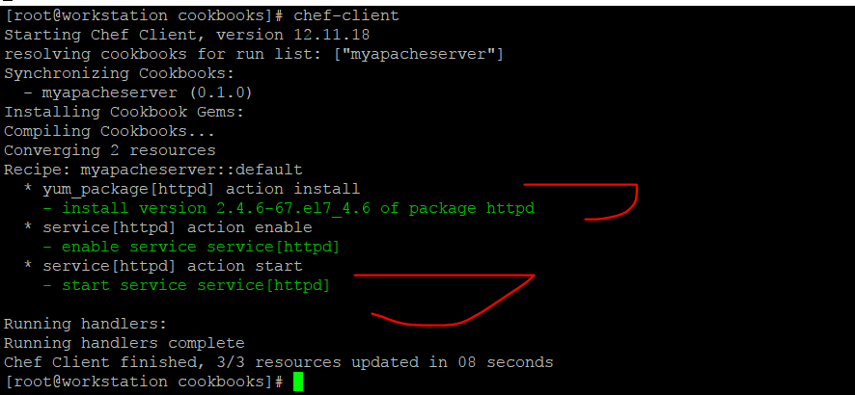

***17- Viewing the Service from Chef Dashboard***

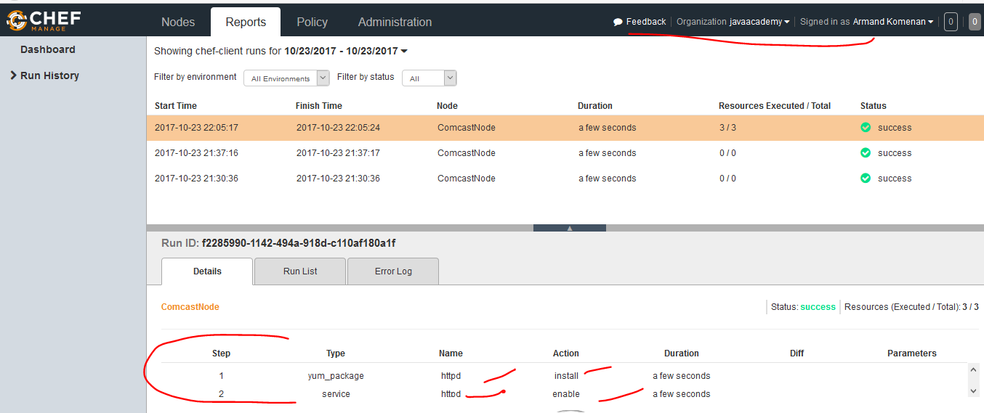***18- Editing the index.html inside [root@workstation /]# cd /usr/share/httpd/noindex/ to add the required html page and opening a browser http://54.172.168.145:80***

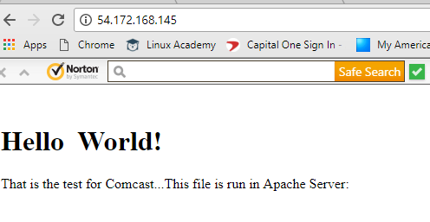

***19- Create self-signed certificate***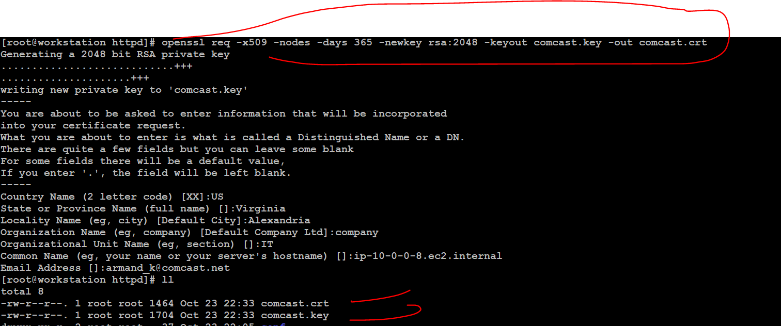

***20. Copy the certificates files into /etc/httpd directory and give right access..Edit vim ./etc/httpd/conf/httpd.conf the like this to add the <VirtualHost> tag***

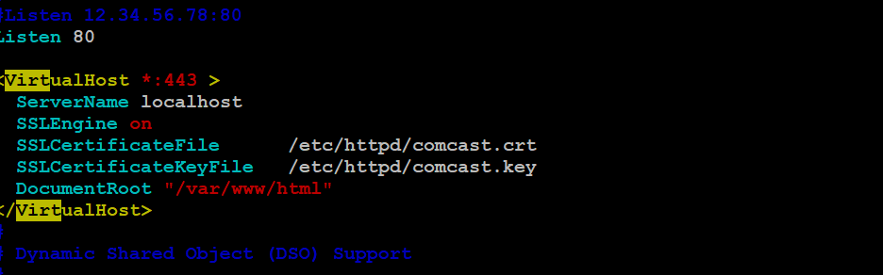

***20. Restart the Service***

[root@workstation /]# service httpd restart

***21. Test the URL internal (You will see that is not accessible***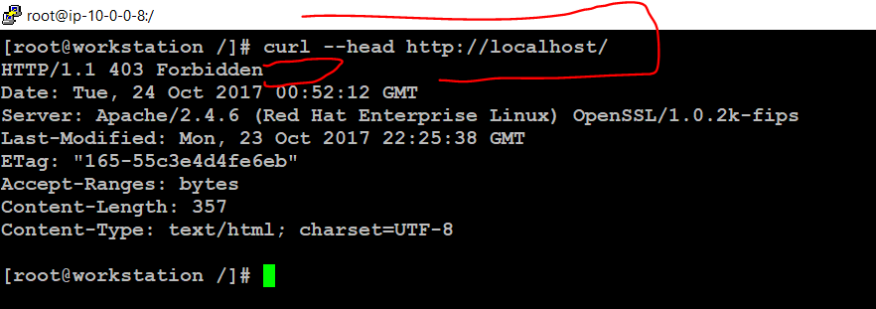

***21. The site is asking now to be trusted https://54.172.168.145:80***

