HomeScreen – User Interface

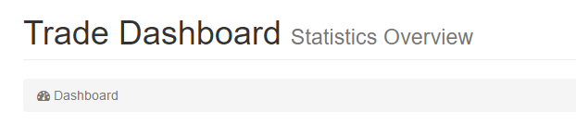

* Remove the grey bar and text.
* Change: Trade Dashboard to Fast Coin Trader. For now, till we have another name for the system.



* Center and Change text to: We provide the most affordable exchange service in the world with a fee of only 0.5%

Change the following 4 objects to have the same height and make individual changes as well.

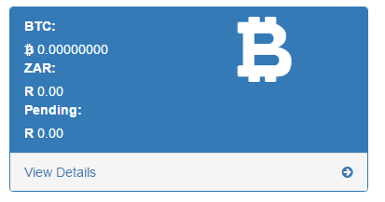

* On click on view details – change location to my wallet page. Located at /Wallet/MyWallet

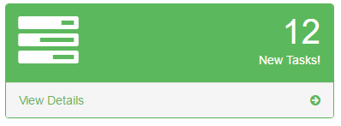

* Change this to show the amount of transactions that the specific user has made.
* Change glyphicon to something that fits transactions a bit better like the two arrows that are underneath each-other facing opposite directions. (Or whatever fits best)
* Create a link to buy and sell pages. Where view details is, replace with View buy transactions, View sale transactions.

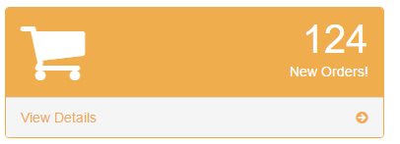

* Show the newest transaction’s details in here:
  + Amount of BTC
  + Price per BTC
  + Total amount paid
* View latest transactions link. Link to trade history screen

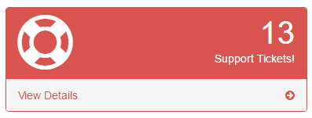

* Change text content to: Any Questions?
* Change Link to View FAQ

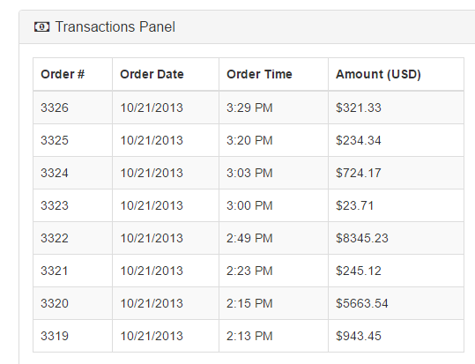

* Change text of this table to be Top 10 trades to date
* Stretch this to be full width, remove other panels and charts for now.
* This is the end of the home screen at this time…