**Evaluation of Master Devices for TAVI/TAVR Teleoperated Robot**

**Abstract**

This thesis work intends to find the most suitable master device type for a TAVI/TAVR teleoperated robot, capable of controlling the 2 DOF (translation and rotation) of the different catheters and guide wires used during the intervention.

After a state-of-the-art research in catheter handling teleoperated robots, four different master devices were tested, each device controls each one of the 2 DOF independently. The first device with completely digital inputs (Keyboard type), the second device hybrid with 1 digital input (translation) and 1 analogical input (rotation) (Remote Controller type), and the remaining two devices with completely analogical inputs (Joystick type and CatheterLike type).

The experiments were performed by 15 candidates from which 1 was an expert TAVI surgeon. Each device was tested under three different experiments and by the appreciation of the users, the first two experiments were designed as a follow the target task assessing the precision and response of each DOF independently. The third experiment was designed as a navigation task, using both DOF, measuring the time and smoothness of the movements and path followed until reaching the goal.

The results of the experiments and the user’s poll responses indicate that the Joystick type device has a better overall performance for controlling the 2 DOF of a regular catheter used in TAVI/TAVR surgery.

**Symbols**

TAVI/TAVR – Transcatheter aortic valve implantation/replacement  
AS – Aortic Stenosis  
FDA – Food and Drug Administration  
DOF – Degrees of freedom  
RMSE – Root Mean Squared Error  
DSJ – Dimensionless Squared Jerk

**Introduction**

* **TAVI/TAVR**

TAVI/TAVR stands for Transcatheter Aortic Valve Implantation/Replacement (In the following only named TAVI), which is a minimal invasive surgery meant to treat AS (Aortic Stenosis), a condition caused for the calcification of the aortic valve, making it harder and thicker [4]. This condition in the valve disturbs the blood flow going into the aortic artery, making the heart work harder.

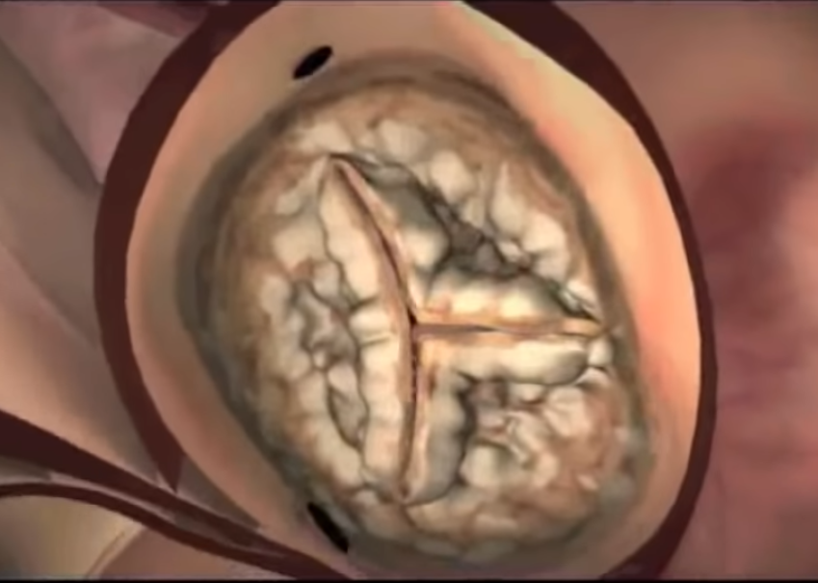[5](watch the video for more visual understanding)

TAVI surgery is performed through an incision in the groin, where a sheath is placed in order to give access to a variety of guide wires and catheters to the aortic artery. Different guide wires and catheters are used to first gain access to the aortic arch, then go through it and finally gain access to the left heart ventricle crossing the calcified aortic valve. Each one of these steps require a combination of axial and rotation movements performed by the surgeon to avoid damages in the artery and valve.

Once access to the left ventricle of the heart is granted, a balloon-expandable mounted on a catheter is inserted and positioned in the calcified valve. When in position, the balloon is expanded in order to retract the leaflets of the diseased valve.

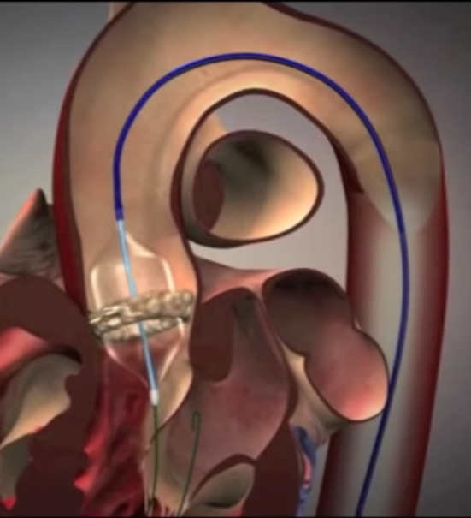

Last, the new aortic valve is inserted mounted on a catheter and placed over the retracted old calcified valve. After the new valve is in position and fully expanded, the leaflets start working regulating the blood flow. If the placement was successful, the catheter and guide wire are retracted and the groin incision closed.

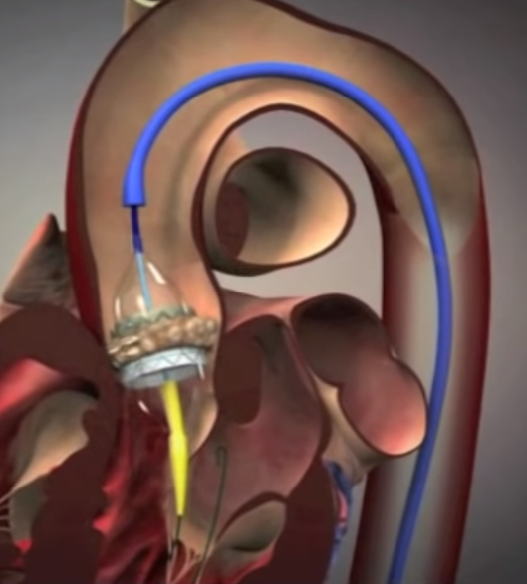

During the whole surgery, the physicians have visual guidance help provided by fluoroscopy image (2D image), in order to track the position of the catheter and wires at any time, as well as the positioning of the balloon-expandable and the new aortic valve when being deployed.

* **Motivation**

TAVI procedure has become more popular since the FDA approved, in 2016, the procedure for intermediate risk patients that present sever AS [1], and estimates predict that numbers in North America and Europe will raise more than double (270 000 patients annually) if it is approved for low risk patients [2].

Each one of these surgeries suppose a risk not only for the patients, but for every interventionalist present in the room, given that per each intervention interventionalists are exposed to a median of 5.5 mRad produced by the fluoroscopy imaging [3], being cardiologist, the medical professionals exposed to the highest amounts of radiation [6]. Recent studies have shown that:

* + 85% of the brain tumors found in interventionalists are located on the left side of the brain, consistently with the closest side of the brain to the radiation source in the surgery room [6].
  + 50% of the interventionalists have significant posterior subcapsular lens changes, causing propensions to cataracts [7].

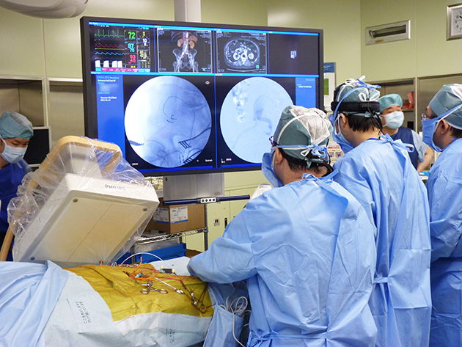[13]

In order to mitigate the risks inherent to radiation exposure, a common practice is wearing a leaded suit as protective equipment. These suits have to be worn at any time while the fluoroscopy imaging system is turned on. Such suits are commonly made of lead and may weight up to 7 Kgs. This additional weight may cause orthopedic issues as proven in recent studies:

* + 60% have suffered spine issues after 21 years in practice [8].
  + 33% miss work due to orthopedic issues [9]

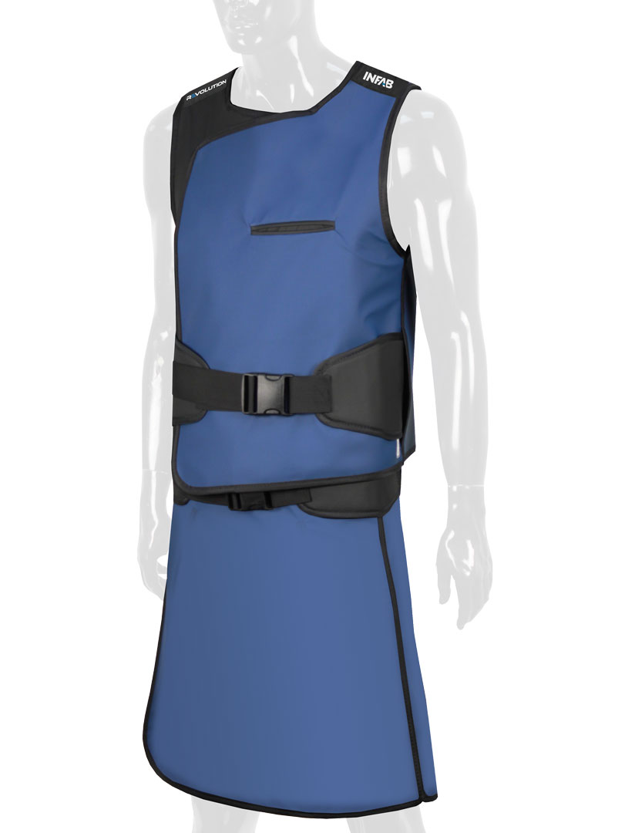[12]

This is why we believe TAVI procedures should be performed assisted by a teleoperated robot, allowing this way to set the interventionalists away from the radiation source. Although many teleoperated robots already exist in the market for surgeries involving the use of catheters, none has been developed specifically for TAVI and its specific needs.

* **Teleoperation**

A teleoperated surgical robot allows the surgeon to be located away from the operation table, and thus, for TAVI procedure, away from the radiation source. Teleoperation has proven in similar surgeries to reduce the radiation in patients on 17% [10] and to reduce as well the exposure to the primary surgeon in 95% [11], beside the orthopedic benefits implied by not wearing the lead suits at all times during the surgery.

As depicted in figure () the working station for the surgeon can be located away from the operation table, together with the fluoroscopy imaging screen and the master device, which may be actuated for haptic feedback, giving the surgeon another dimension given that the visual cues are poorly displayed in a black and white 2D image.

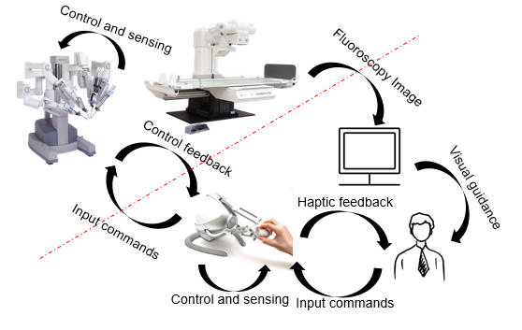

* **Objective**

This thesis work intends to find the most suitable master device type for a TAVI/TAVR teleoperated robot, capable not only of controlling the 2 DOF (translation and rotation) of the different catheters and guide wires used during the intervention, but also capable to allow the surgeons to succeed in the most complex maneuvers involving both DOF movements at the same time when crossing the aortic valve~\cite{raptech}~\cite{anatomic} and to perform accurate movements to position the artificial valve before deployment, avoiding this way paravalvular leak complications~\cite{pvl}~\cite{pvl2}.

**State of the art**

Teleoperated robots for similar types of surgeries as TAVI have been developed. In table () is appreciated robot’s characteristics, such as the type of catheter they handle, the kind of intervention they were created for and the kind of master slave they operate with.

|  |  |  |  |
| --- | --- | --- | --- |
| **Company – Robot name** | **Catheter Type** | **Surgery type** | **Master device type** |
| **Catheter Robotics Inc. – The Amigo remote control system [14]** | **At least 3 DOF, steerable catheter** | **Electrophysiology (EP), and radiofrequency catheter ablation of arrhythmias** | **Remote Controller** |
| **Stereoaxis – Niobe [15]** | **At least 3 DOF, steerable catheter** | **Endocardial ablation, gastrointestinal endoscopy, and others.** | **Regular 2D or 3D mouse** |
| **Hansen Medical – Sensei X** | **At least 3 DOF, steerable catheter** | **Atrial Fibrillation (AF), and other arrhythmia procedures.** | **Combination of keyboard, and haptic device in delta robot configuration.** |
| **Auris – Monarch [16]** | **At least 3 DOF, steerable catheter** | **Bronchoscopic visualization and access to patient airways for diagnostic and therapeutic procedures.** | **Videogame console type remote controller with buttons and joysticks.** |
| **Commercial Robots – CorPath GRX [17]** | **2 DOF catheters and guide wires.** | **Percutaneous coronary intervention (PCI) and Pulmonary vein isolation (PVI)** | **Joysticks** |

Devices like Niobe and Monarch are highly costly and complex (much more than needed for a TAVI intervention, not mentioning that TAVI catheters could not be operated by Niobe magnetic fields, since they are plastic), on the other hand The Amigo system was designed to overcome these points having simpler and cheaper designs. Nevertheless, all these systems are designed to operate steerable catheters with 3 or more DOF, which make them an overkill for TAVI surgery, however, the concept behind their robotic devices could be simplified and adapted to only manage the 2 DOF necessary for TAVI.

Moreover, the CorPath GRX is the system with more similarities to what is needed for TAVI, handling 2 DOF catheters, guide wires and a stent balloon. However, TAVI surgery requires more than one catheter and guide wire to gain access to the left ventricle of the heart, as well as managing the new aortic valve deployer catheter.

Due to these differences in characteristics and needs is why the devices in section\~ref{sec:} where selected, taking into account the inherent research and effort the devices of the state of the art suppose, some of them were just simplified enough to cover TAVI surgery needs.

**Chosen Devices and Characteristics**

Every device was chosen to control independently each one of the catheters DOF as shown in figure (). In this section the mechanics, electronics and functioning of every input device is explained. After, a comparison between all device’s characteristics, advantages and disadvantages is made.

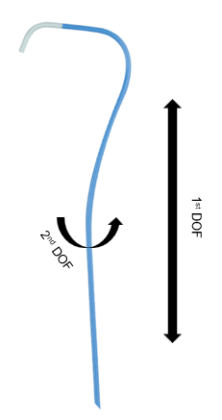

* **Keyboard**

The keyboard device intends to represent any other device only controlled by on-off buttons, working in a digital configuration. For this experiment a numerical keypad was used figure ().

The control of the catheter was performed with the arrow key, being t UP and Down arrow key the control for the 1st DOF of the catheter. The 2nd DOF was controlled with the RIGHT and LEFT arrow keys.

Both types of movements are mapped to the simulated catheter with a PressedTime-Velocity mapping. For information about the mapping refer to section ()

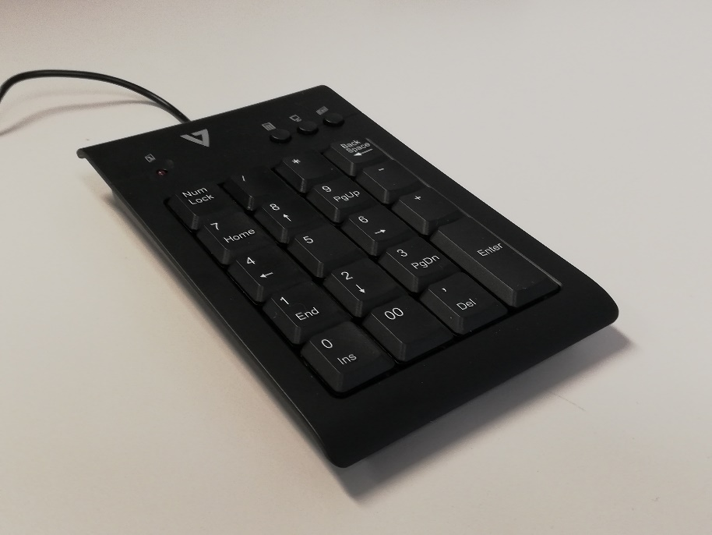 V7-KP1019-USB-4EB with USB connection

* **Remote**

The Remote device is a combination of on-off buttons and a semi-analogical sensor figure (). The shell of the device was 3D printed in ABS. Also equipped with two push buttons, and a continuous 360 degrees rolling disk.

The 1st DOF of the catheter is controlled using the two push buttons in a digital configuration. Movements in this DOF are mapped to the simulated catheter with a PressedTime-Velocity mapping.

The 2nd DOF is controlled by a non-contacting rotatory position sensor attached to the rolling disk, which gives a semi-analogical reading with a 12 BIT resolution per 360 degrees, this means. It Is important to notice that the experiment setup as can be seen in section () uses an Arduino with a 10BIT ADC channel, which trims the initial sensor’s 12BIT resolution. Movements in this DOF are mapped suing a Velocity-Velocity mapping.

For information about the mapping refer to section ()

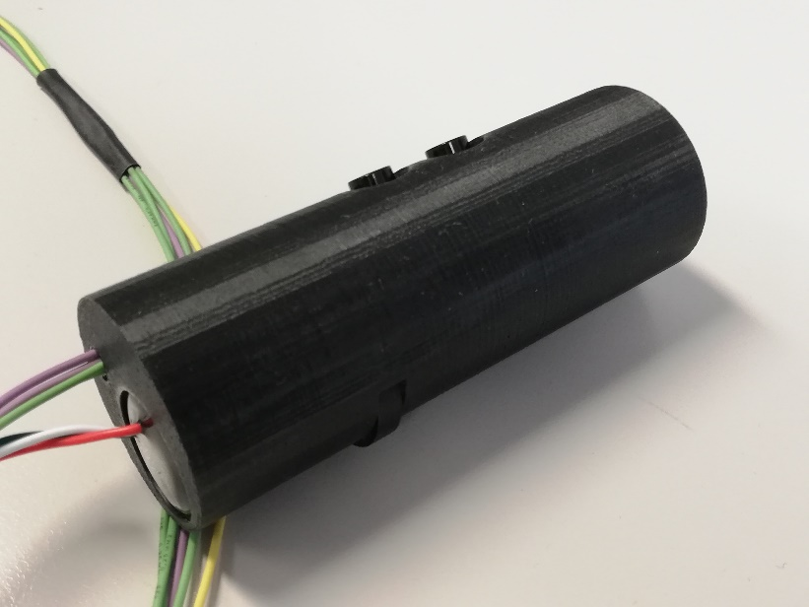 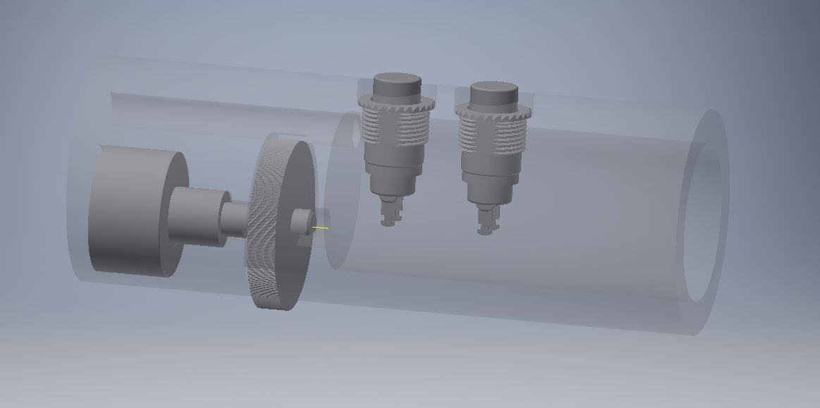(push buttons C&K 8532T1ZBE2 and CTS 285CCDFSAAB4C1)

* **Joystick**

The Joystick device is implemented with fully with analogical sensors figure (). Originally the Joystick has 3 DOF available, plus a push button on the top. The roll DOF and the button are not connected at all. Thus, performing any movement on them will not make any difference in the outputs.

The 1st DOF of the catheter is controlled by a regular 5Kohm potentiometer, mapped on the pitch movement of the joystick. The movements in this DOF are translated to the simulation catheter with a Distance-Velocity mapping.

The 2nd DOF is also controlled by regular 5Kohm potentiometer mapped to the yaw movement of the joystick.

Both used DOF, pitch and yaw, are limited on their angle and brought back automatically to initial position by springs once any force is applied. The movements in both DOF are translated into the simulated catheter with a Position-Velocity mapping. For information about the mapping refer to section ().

The potentiometers have essentially infinite resolution, only trimmed by the Arduino’s ADC channel (See section () for experiment setup) used to read out the sensors.

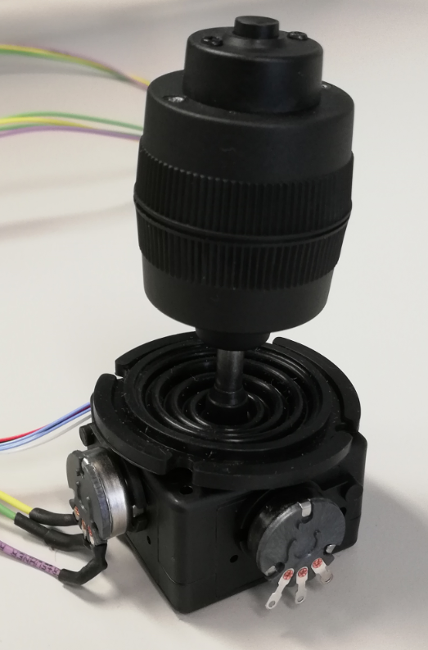

* **CatheterLike**

The CatheterLike device is a combination of an analogic sensor and a semi-analogic sensor (). The shell of the device was 3D printed in ABS. The device has a handle on the outside that can be pushed and pulled axially coming back automatically to resting position (activated by springs), and can also be rotated over its own axis continuously 360 degrees.

The 1st DOF of the catheter is controlled by a 10Kohm and 30mm slide potentiometer. Activated by the push and pull movement on the device, is mapped to the simulated catheter with a Position-velocity mapping

The 2nd DOF is activated by the rotation of the device, mapped Velocity-Velocity to the simulated catheter and controlled by a non-contacting rotatory position sensor, which gives a semi-analogical reading with a 12 BIT resolution per 360 degrees. It Is important to notice that the experiment setup as can be seen in section () uses an Arduino with a 10BIT ADC channel, which trims the initial sensor’s 12BIT resolution.

For information about the mapping refer to section ()

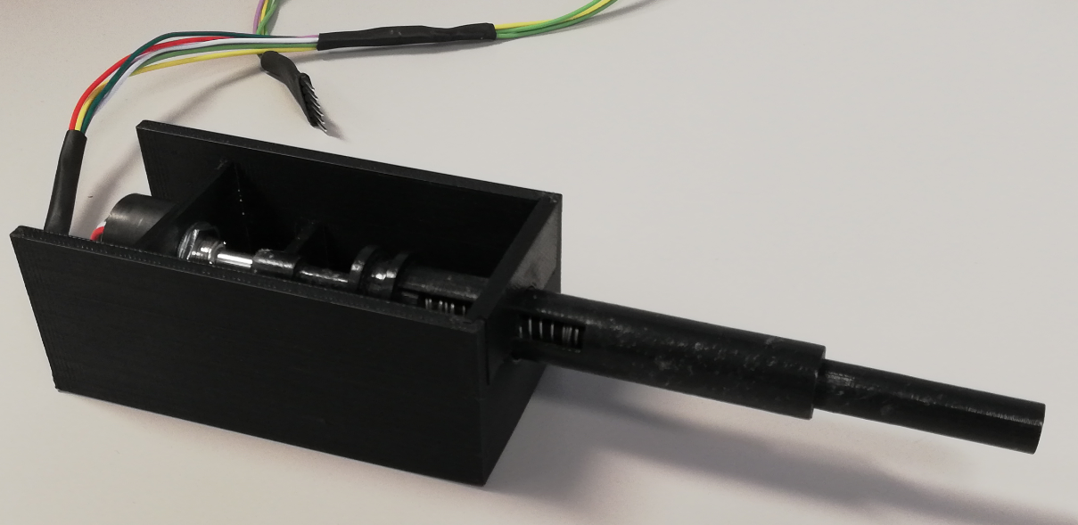

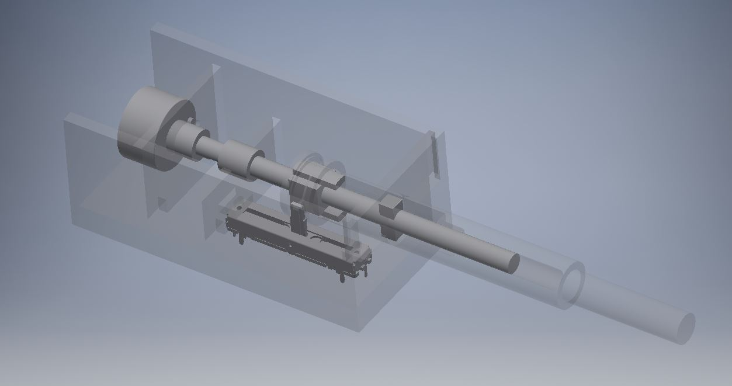(Slide Pot PTA3043-2210CIB103 and and CTS 285CCDFSAAB4C1)

* **Mapping types, Advantages and disadvantages**

Every device with its different type of sensor is better adapted for a specific mapping. This means, how specific movements in each one of the devices, in each one of its degrees of freedom, translates to movements on simulation catheter.

The **PressedTime-Velocity** mapping was created to mitigate the clear disadvantage devices with on-off buttons have against analogical/semi-analogical ones. This disadvantage is due to the fact that on-off devices have always the same speed applied over the catheter. If that speed is too high, it is not possible to apply small movement. On the other hand, if it is too low, it would take too much time to perform long movements. On the contrary, analogical sensor devices have a wide range resolution from where low and high speeds can be applied in the same configuration.

This mapping consists in incrementing the output velocity linearly with a defined slope in relation with the time the button was pressed, starting from an initial offset.

The **Position-Velocity** mapping is used in devices with analogical sensors, mapping linearly with a defined slope the position of the sensors to the velocity of the output catheters.

The threshold variable is meant to create a dead zone around the resting point of the device, given that the mechanism that automatically return the device to the resting point is never perfect and it is also important to avoid accidental activation movements on the simulated catheter.

The **Velocity-Velocity** mapping is used for the semi-analogical rotatory sensors, which are able to rotate continuously 360 degrees (multi turn). This method maps the velocity of the device to the velocity of the simulated catheter, multiplied by a constant.

Using this type of sensors simplify the mechanics of the device but adds an additional challenge when getting the information from the Arduino to Matlab (See Experiment Environment section for setup). This happens because the sample rate the Arduino board has to sample the device is much faster than the sample rate from Matlab to the Arduino, which makes the simulation to take noisy data and the behavior of the simulation catheter looks highly erratic. In order to overcome this and make the user experience smoother, the Arduino sample rate has to match with Matlab simulation sample rate (Being Ts on equation () now the Matlab sample rate), making Arduino to implicitly take the average of all the movements between samples. A visual explanation of this phenomena can be observed in figure ().

All the advantages and disadvantages are resumed in figure ()

**Experiment Setup**

The hardware of the experiment setup consisted on a computer running the Matlab graphic simulation, the four master devices (Remote, Keyboard, Remote and CatheterLike) and an Arduino board, used to read the sensors of the devices (The keyboard was connected directly to the computer) and communicated with Matlab through USB serial. 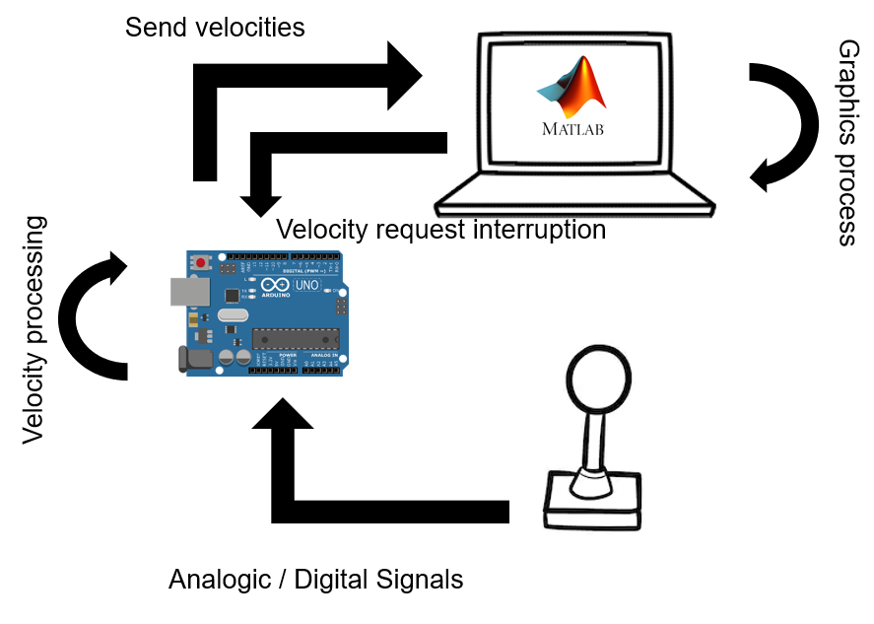

* **Graphic Environment**

The graphic environment is fully developed on Matlab, it consists on a representation of a catheter (With a green square following the tip) in a simulated fluoroscopy image, as surgeons would see it in the operation room. This means the image showed on screen is a 2D black and withe plain representation. The catheter can be moved in its 2 DOF, being the 1st DOF the axial movement (defined in simulation by the Y coordinate), the catheter would move up and down only. The 2nd DOF is the rotation (defined in simulation as radians starting from the left most possible position of the catheter’s tip), which is translated to a left and right movement on the screen.

Since the 2nd DOF is defined by the rotation (in radians) of the catheter, some dynamics are implicitly stated in the simulation during the left to right movements. Since the image shown is intended to be a 2D representation of an actual 3D catheter in real life, when the catheter is rotating over its own axis a sinusoidal movement can be observed, moving slower when the tip of the catheter is on the most left/right side of the screen. Thus, moving fast when the tip is near the center of the catheter. 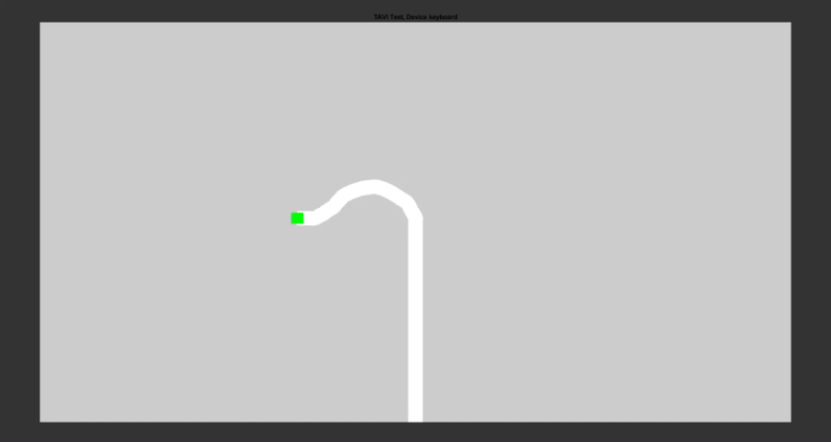

* **Matlab/Arduino interface**

The Arduino board and Matlab are connected through USB serial communication. The Arduino board is responsible to sense the devices’ sensors. When the Matlab simulation starts, Matlab sends the necessary commands to Arduino in order to set it up for the specific device that is going to be in use, after this the Arduino board start to capture the states of the sensors instantly.

Matlab simulation runs in a loop after setting up all the initial conditions. First it requests the Arduino board for the current states of the device. After it updates the graphics accordingly with the movements reported by Arduino. Lastly it stores the states in a log file, for later data analysis.

The Arduino board is programed with serial communication interruptions, which means it’s constantly getting the current states of the device and storing them into a buffer. Once the Matlab code request for the information, the Arduino board code will be interrupted in order to send the last saved states from the device, once this is done the Arduino board will go back to its state reading task.

The only device that works in a different fashion is the keyboard, which is connected directly to the computer through USB. This device interrupts Matlab directly when one of the keys is pressed and stores the device state directly in the simulation environment. In order to avoid adding/subtracting external latency, even do the Keyboard doesn’t interact directly with the Arduino board, the simulation in Matlab runs the communication with the Arduino board, which returns by default the constant from equation (). The constant variable form equation () is substituted by the keyboardConsat defined in equation (), being {-1,0,1} the possible states of keyboardMatlabState. Then the specific equation for the keyboard changes from () to ().

* **Arduino/Device interface**

The Arduino board has analogical and digital input in which the devices are directly connected to, according each device sensor types. Once the Arduino board is initialized by Matlab, readings to the corresponding inputs are performed and processed according to the programed mapping type (see section ()). The processes information is stored in a buffer and the loop keeps running in the same way.

* **Physical setup**

All the experiments were run in the same environment under the same conditions. An external monitor was setup to run the graphic simulation over a desk with a chair for the experiment candidate to sit. Every device was presented in front the candidate to be taken when necessary according the running experiment.

All the simulations start only once the candidate had perform the first movement, in that moment the simulation starts recording data, and the simulation time or the goal is reached, it closes itself and immediately launches the next simulation, waiting for the candidate to perform the first movement again, until all the repetitions are finish.

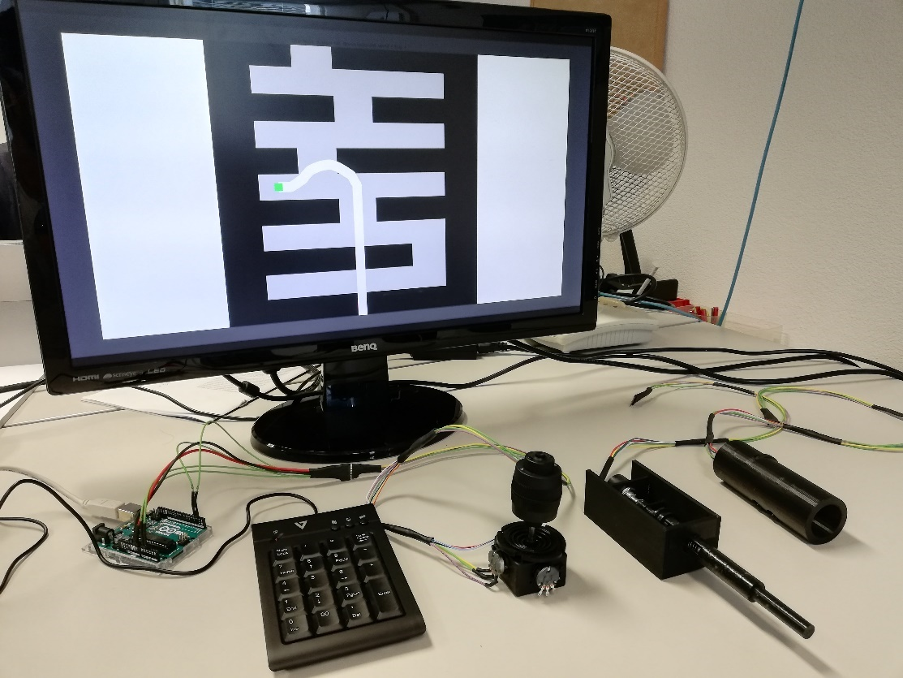

**Instructions**

Before initiating the experiments, a instruction set as the one shown in appendix () was handed to each one of the participants.

**Practice rounds**

Before any experiment was performed, each participant had time to try and play with every device and how it interacts with the graphic simulation on each one of the DOF. An empty world simulation was displayed as shown in figure (). The devices were randomly selected and handed to the participant, who could manipulate the simulated catheter until he would decide to stop or maximum 2 minutes had passed.

**Experiment 1st DOF and 2nd DOF**

* **Overview**

This experiment was designed to test the performance of the 1st DOF and 2nd DOF of every device independently. The objective is to try to collocate the tip of the catheter (green square) inside a target (red square) that is only moving up and down for the 1st DOF experiment and left to right for the 2nd DOF experiment, as shown in figure (). The target is always initially collocated above the initial tip of the catheter position for the 1st DOF and to the right of the initial tip of the catheter position for the 2nd DOF experiment. The target starts moving automatically once the simulation detects the first movement of the user, following a predefined path for 10 seconds.

For each DOF three different predefined paths (worlds) for the target were created, trying to cover two main purposes, the first one was to exploit the capabilities of every device, reaction time, resolution, change of direction, acceleration and deceleration. The second purpose was to simulate movements surgeons would face in a normal TAVI procedure. For the 1st DOF having to pull back rapidly after being moving front and small precise movements when placing the new valve or trying to cross the aortic valve. On the other hand, for the 2nd DOF having to rotate to avoid a blockage in the artery or contacting with the wall of the aortic artery, and small precise rotation movements surgeons need to perform as technique for crossing the aortic valve [18][19].

During the 10 seconds of simulation the RMSE between the tip of the catheter and the target is recorded in X and Y coordinates independently. This measurement was selected as it encloses information and gives insight of the experiment purpose previously mentioned.

For each one of the DOF every participant had to complete five times each one of the three target’s predefined paths, which means 15 randomly order repetitions per device. The repetitions were executed all, one device at a time; however, the devices were ordered randomly at the beginning of the experiment. Also, the order on which every DOF experiment was performed, was randomized for every participant.

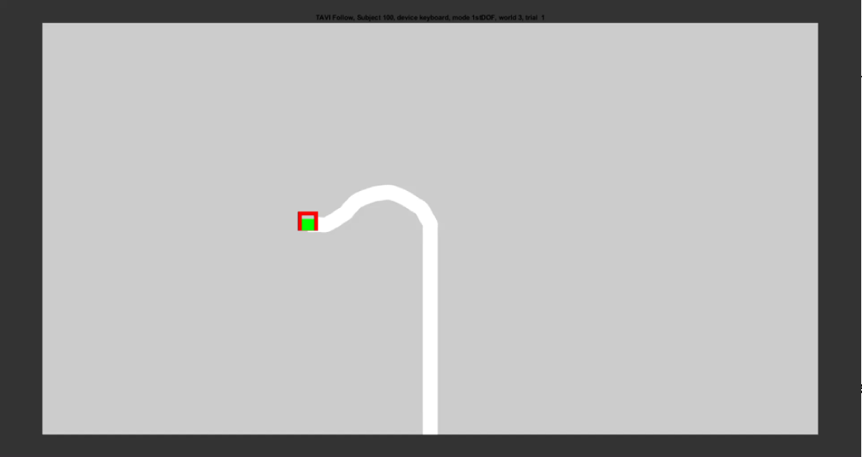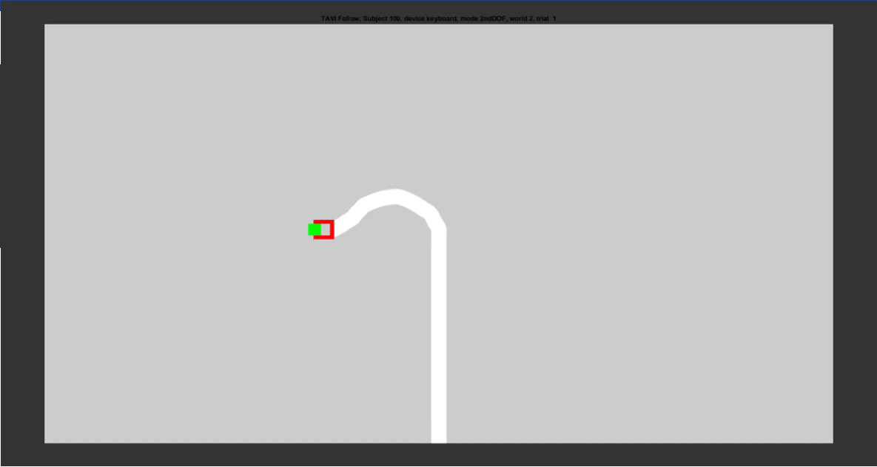

* **Results**

All the data from the 15 participants was gathered and the RMSE in both coordinates X and Y for each one of the two DOF computed.

As can be observed in figure (), the 1st DOF experiment shows that the Joystick device has a better performance than the rest of the devices at every different world, followed by the keyboard. However, in figure () when showing all the samples from the 3 words together, two important things are observed. First, the joystick device seems to still show a better performance, but this cannot be concluded when comparing with the keyboard, due to interaction P-Value of 0.006. On the second place, the Joystick device can be observed a high number of atypical values far away from the box plot, which at first seemed to be failed experiments. However, if those atypical values are traced, the majority of them belong to the first trials of different participants. Thus, if each number of trials is plotted separately as in figure () (a participant without previous training using Joysticks), a pronounced training curve can be observed. On the other hand, if we plot the same information from a participant that reported experience with the type of the devices used for the experiment as in figure (), can be observed the superior performance of the Joystick again followed by the keyboard at every attempt.

Another important thing to look at, is the accidental activation error, which means movements in the DOF that was not being tested at each experiment. In order to quantify this involuntary movements, since some of them were too small to be quantified, a percentage of trials where and activation error was present was calculated, as can be observed in figure (). It is intuitive that the Keyboard has 0% due to its digital characteristics, something that would be expected as well from the Remote device, however, that was not the case, since 2.7% of the cases had an activation error, which can be attributed to experiment errors or issues with the ergonomics of the device. Finally, it can be observed that the catheter had the higher activation error, followed by the joystick.

On the 2nd DOF the figure () shows that the keyboard had a better performance at every world than any other device, without a clear differentiation between the other three. Also, in the boxplots of figure () can be observed how the Joystick, Remote and Catheter devices have similar distributions, and the keyboard having a better performance with a P-Value of 4.5e-10.

The same training behavior as in the 1st DOF experiment can be observed in the 2nd DOF for some of the devices, as shown in figure () from a candidate without experience manipulating devices. Also, in figure () the accidental activation error, of the 1st DOF in this case, shows a 0% in the Keyboard and Remote (devices involving digital inputs in at least one of the two DOF), followed by the Joystick with 3.5% of test cases and the Catheter with the worst performance with 8%. Both devices with 0% proven to be better than the Catheter with P-Value of 0.001, but failed to prove superiority with the Joystick due to an interaction P-Value of 0.03

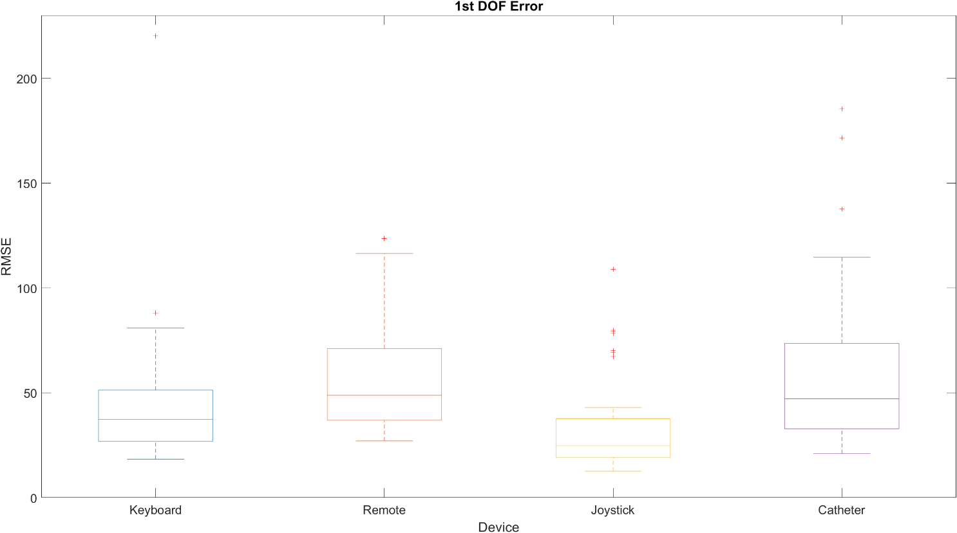 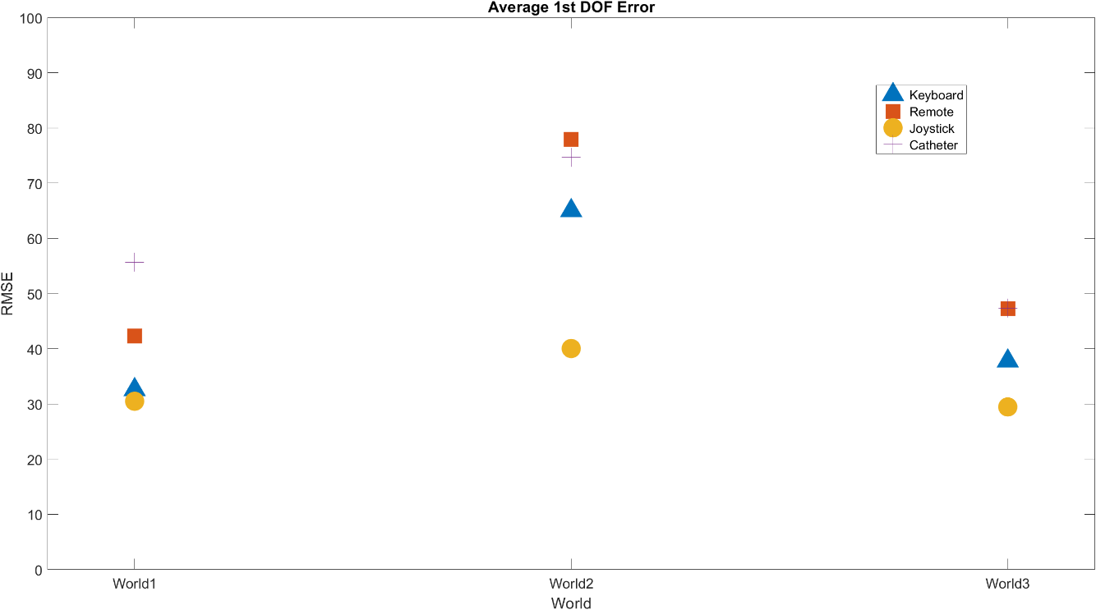 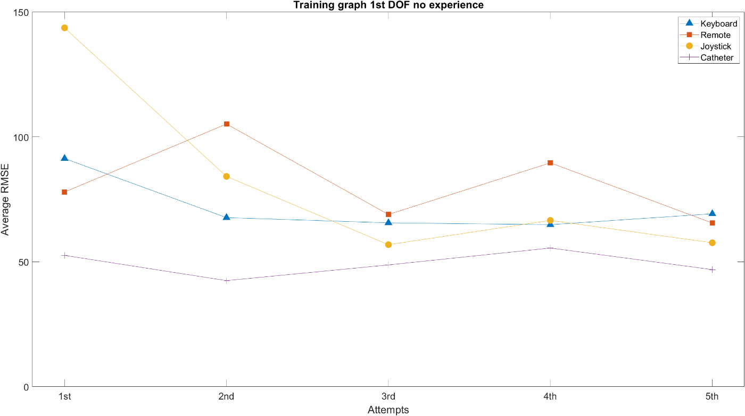 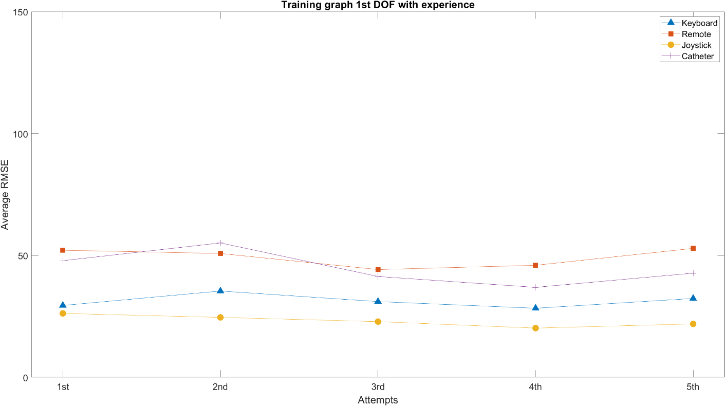 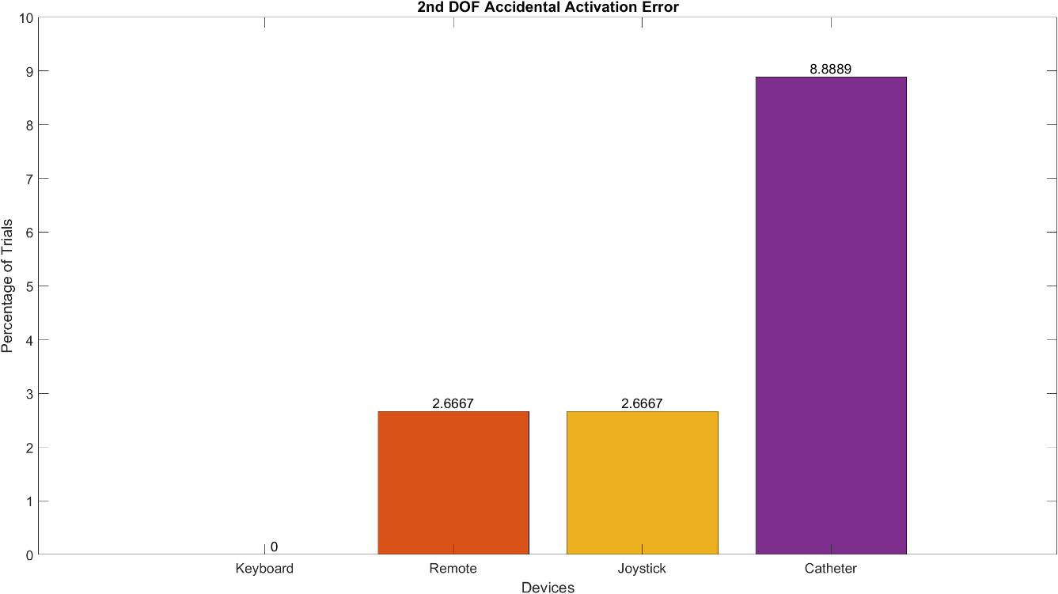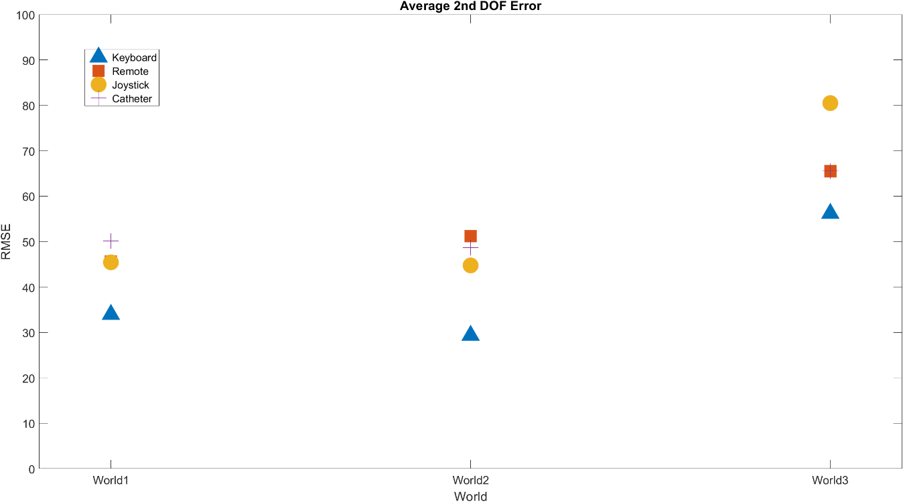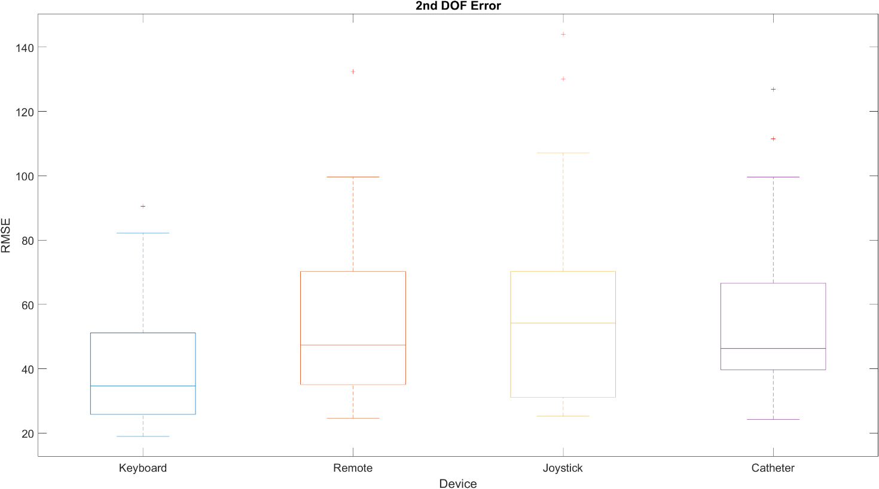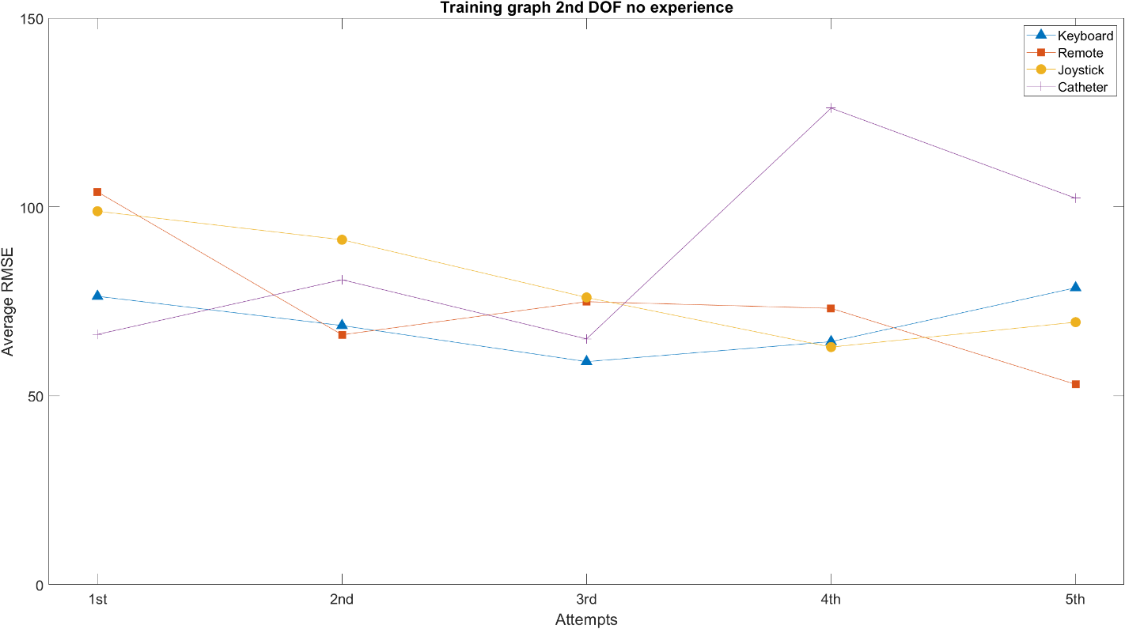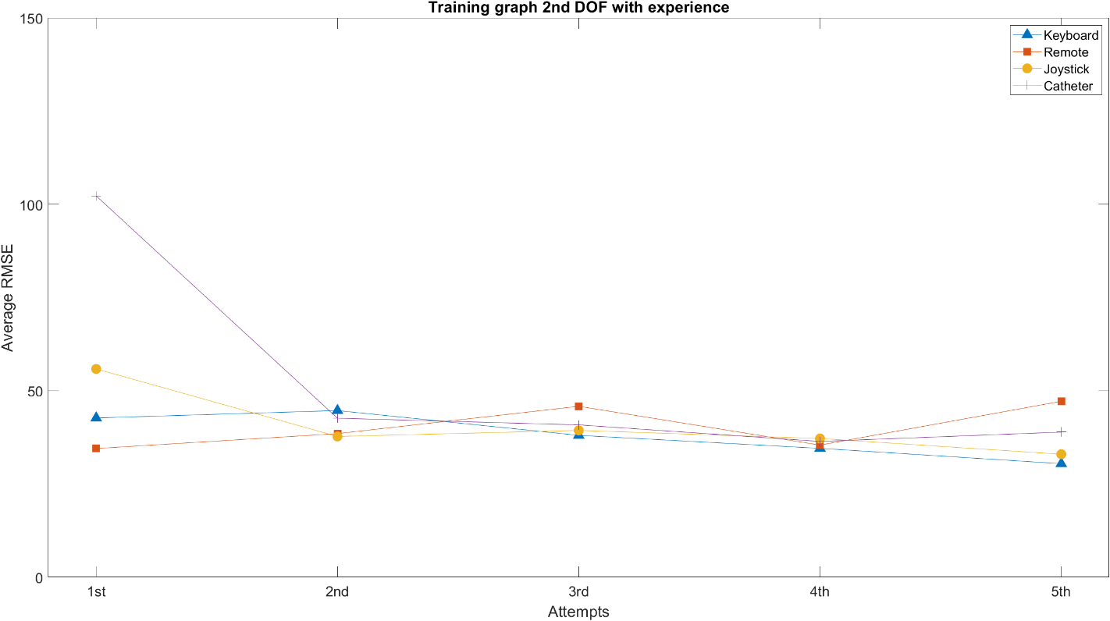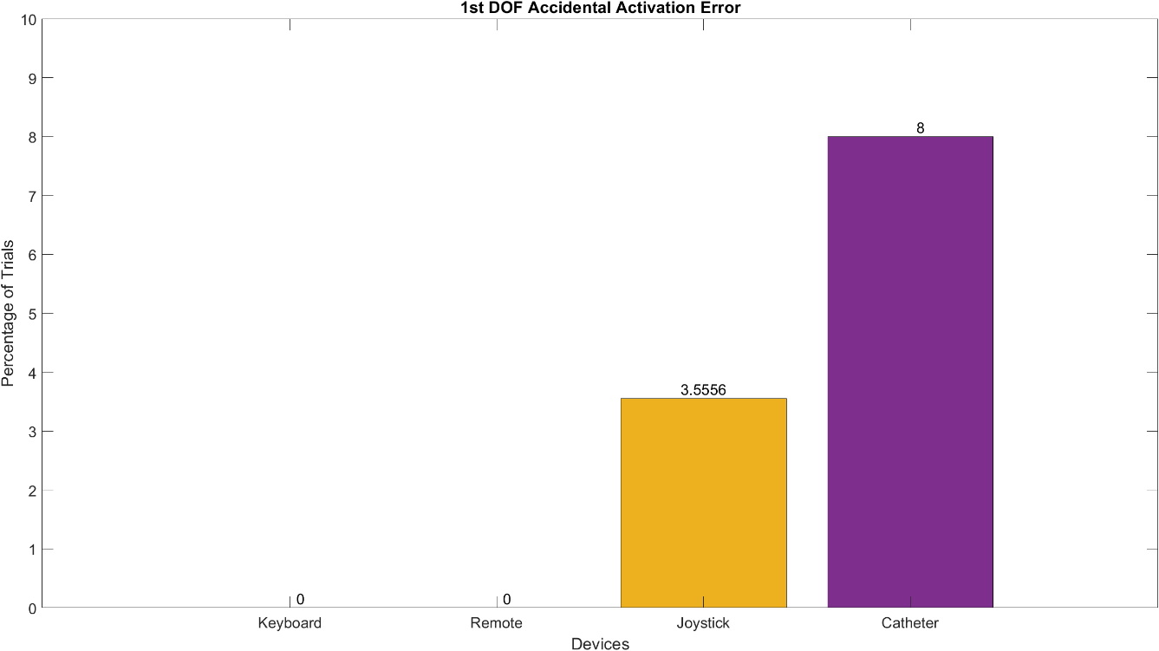

**Experiment Maze**

* **Overview**

This experiment was designed to test the joint performance of the two DOF of every device. The objective is to navigate the tip of the simulated catheter (green square) through a one-way maze as shown in figure (), until reaching the top part of the maze. The users were instructed (as shown in appendix ()) to navigate the maze keeping the maximum distance to the walls as possible, avoid collisions and reach the top wall of the maze in the minor time possible.

The simulation starts recording the data when the first movement of the user is detected. In case of colliding with a wall, the tip of the catheter stops moving and changes color from green to red (as shown in figure ()), indicating a collisions status. In order clear the collision the user has to back off, any other movement that would keep the collision is not permitted and would not move the simulated catheter at all. Once the tip of the simulated catheter touches the upper wall (as shown in figure ()) the simulation stops.

In order to exploit all the capabilities of each device, two different mazes (worlds) were used for this experiment. The first maze (world1) has longer stretches in the 1st DOF, occasionally stopped by a short rotation movement, in order to simulate the first fast strokes the surgeons have to perform in order to reach the aortic arch, if a blockage is found, a small rotation is made and try to keep going forward. The second one (world2) with higher alternation between left/right and up/down movements, simulating scenarios where surgeons have to maneuver both DOF at the same time, example of that is when they cross the aortic valve [18][19].

For this experiment three main metrics were measured, Time to complete the experiment, Number of collisions and Dimensionless squared Jerk. These metrics were selected since they enclose relevant information on the capabilities of the devices and how suitable to perform the tasks they are. Time to complete the tasks is of high importance, since one of the objectives of a Teleoperated robots is to reduce the radiation exposure both, to patients and practitioners. Number of collisions is important to give an insight of the maneuverability of every device (acceleration rate, deceleration rate, precision, among others) which is highly important for the patient safety. The dimensionless squared jerk has been previously used in similar studies to asses performance of catheter trajectories [20][21], it is useful to describe the smoothness of the path as well as the accelerations and decelerations, while being independent of time and longitude of the path. The formula to calculate is described in equation () where TP is the experiment time and PL the path length of the trajectory followed by the user.

For each one of the mazes every participant had to complete 5 repetitions, which means 10 randomly order repetitions per device. The repetitions were executed all, one device at a time; however, the devices were ordered randomly at the beginning of the experiment.

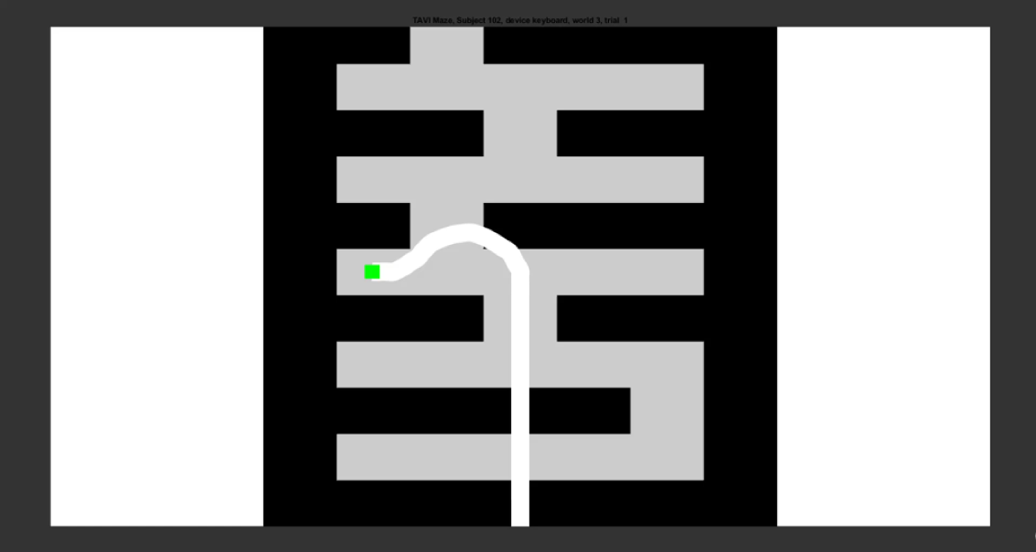 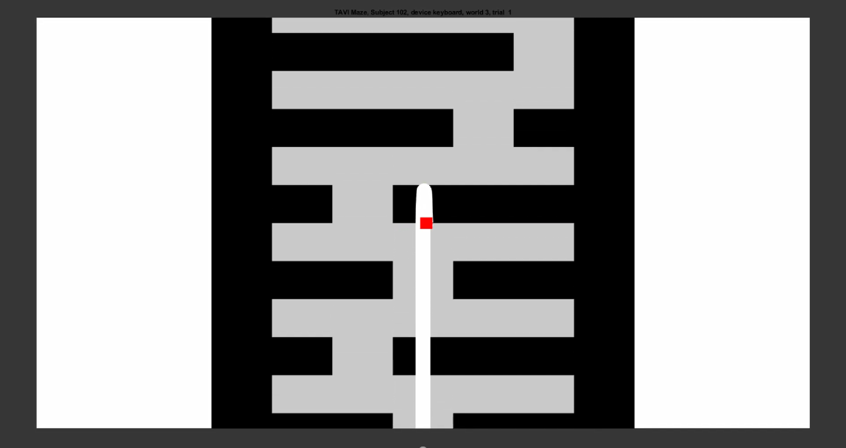

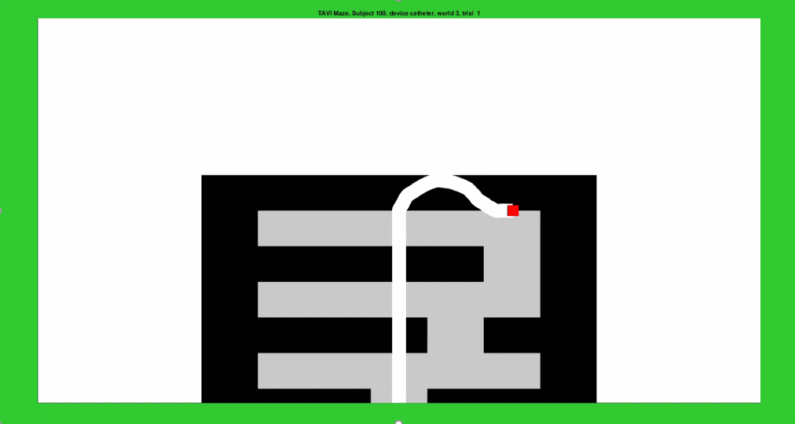

* **Results**

The Time result of the experiment were not statistically conclusive, since interaction with P-Value < 0.05 was always present in the comparison between all the devices. As can be seen in figure (), the Keyboard and the Joystick had a close average time in world1, however, in world2 (with the long stretches) Keyboard dominates. This can be related to the easy control of the keyboard with out any training given the immediate stop advantage, as mentioned in figure (), this allows the user to advance confident with high velocity without expecting a collision. Overall it can be observed in figure() that the lowest times were achieved with the Keyboard and Joystick, however, the distribution in the upper quartile in the joystick device as with the remote is widely spread, which as in the experiment for the 1st DOF and 2nd DOF may be attributed to the learning curve.

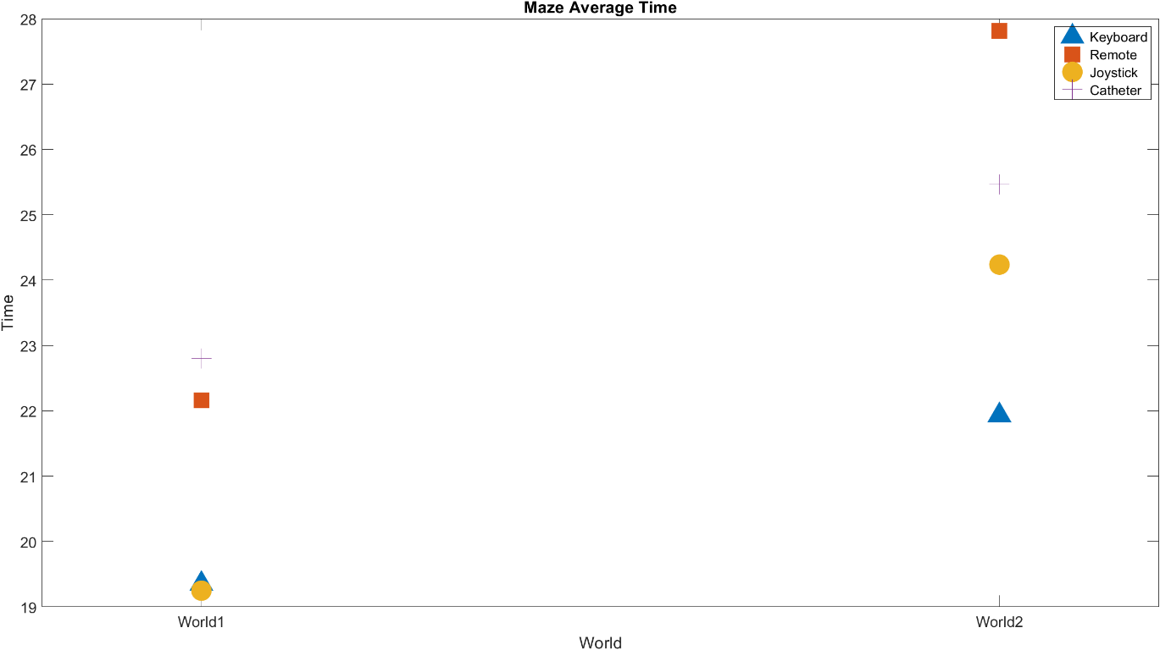

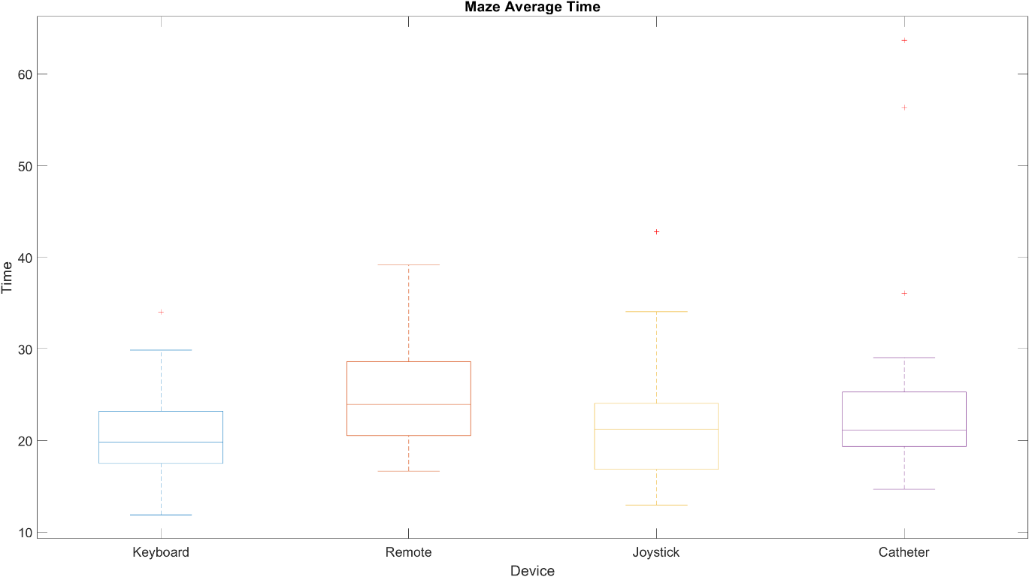

The average number of collisions (per repetition) shown in figure () states that the Keyboard and Remote are significantly better than the Joystick and Catheter with a P-Value < 0.01. This result gives again intuition about the importance of the advantages and disadvantages shown in table (), if taking into account the information from figure (), where analogical sensor devices have a significant higher amount of collisions in world2 (world with longer stretches) than in world1, combined to the proneness of analogical sensor devices to overshot show how important is the participants training, and coming back to the Time results, it confirms how these collisions are related. This can be directly corroborated for the Joystick when putting together figure () showing the collision training curve and figure () showing the time training curve, where it can be appreciated how time pero attempt go down as collisions per attempt go down

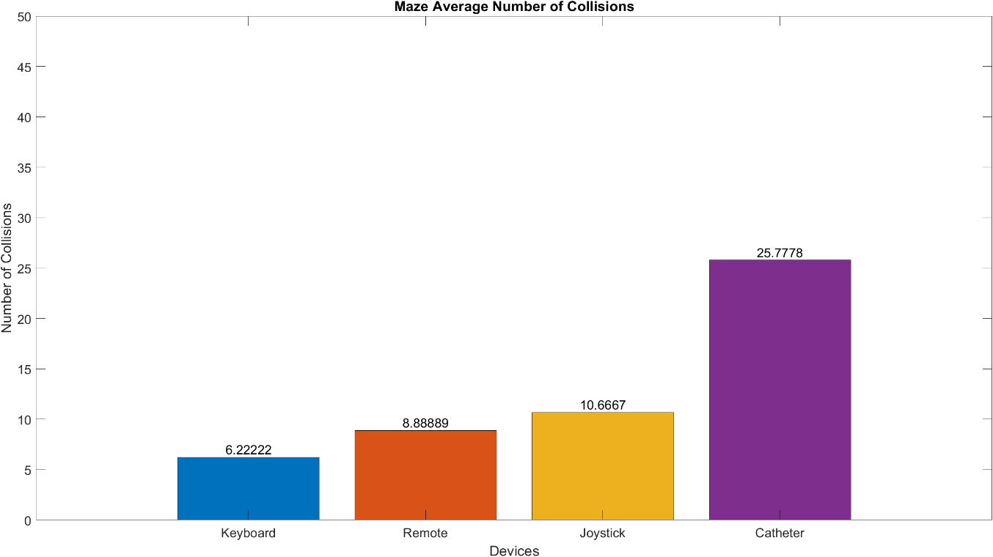 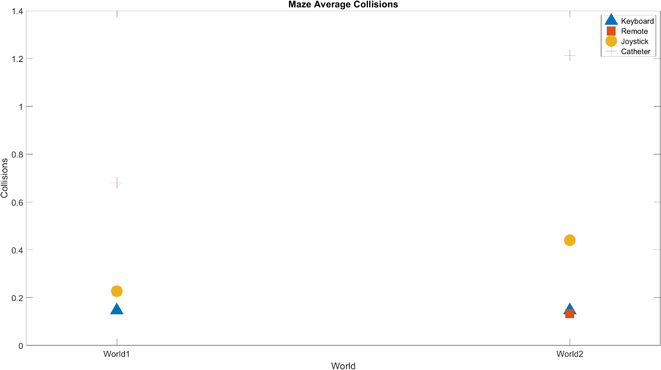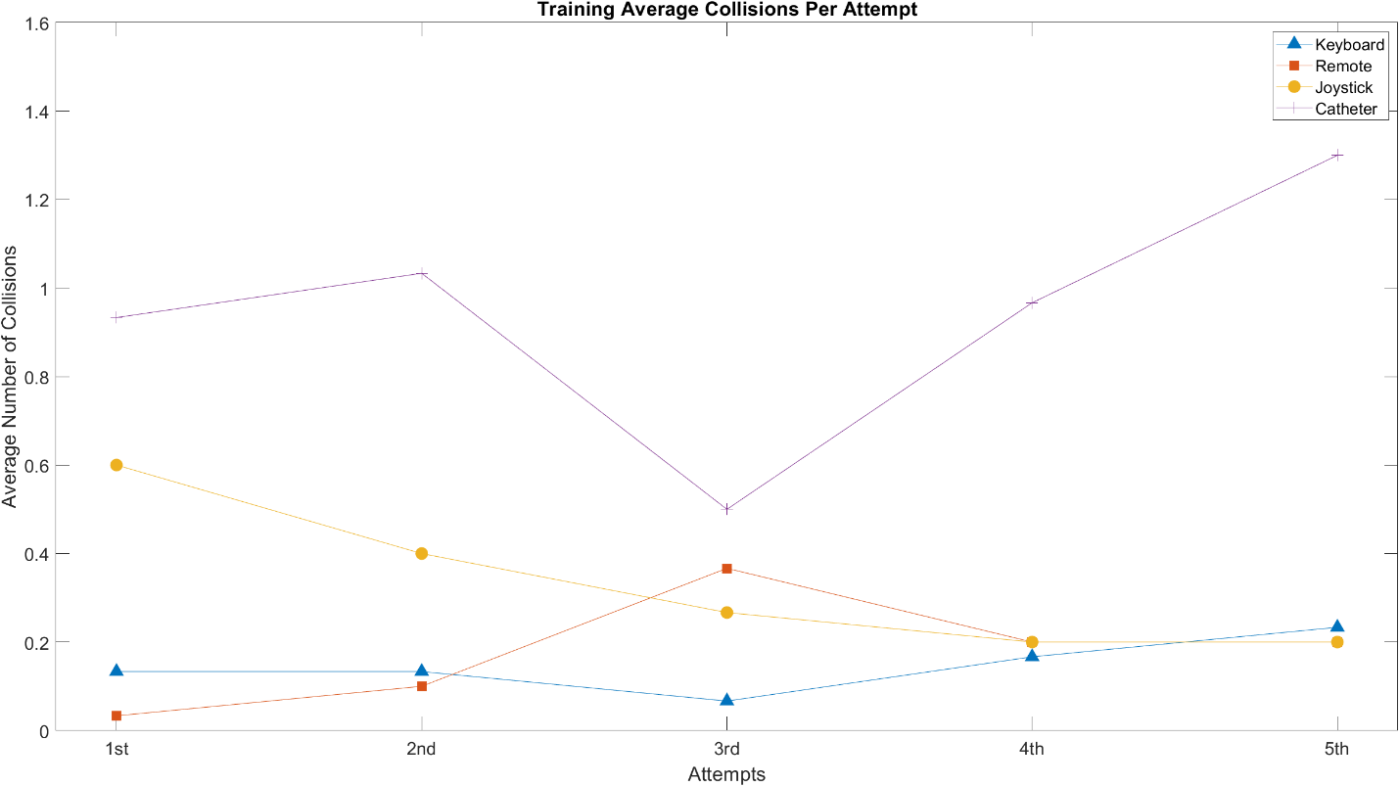

The joystick got a lower average Dimensionless Squared Jerk number in both worlds as shown in figure (), altough not significative due to interaction P-Value lower than 0.05, immedeatly followed by the keyboard device. It is important to remark that part of the good result of the keyboard in the DSJ is due to the linear increment of thevelocity over time of the PressedTime-Velocity mapping, thus, if the function is changed to something non linear, this will have a high impact in this metric.

Also, it’s important to remark how even though the Joystick had a worst performance than the keyboard in the collision average, and this collisions cause higher DSJ values, the performance overall in the DSJ was better. This may be caused due to the fact that the Keyboard can stop instactly, giving really high jerking values, which in a real world is also translated to high stress in the actuators.

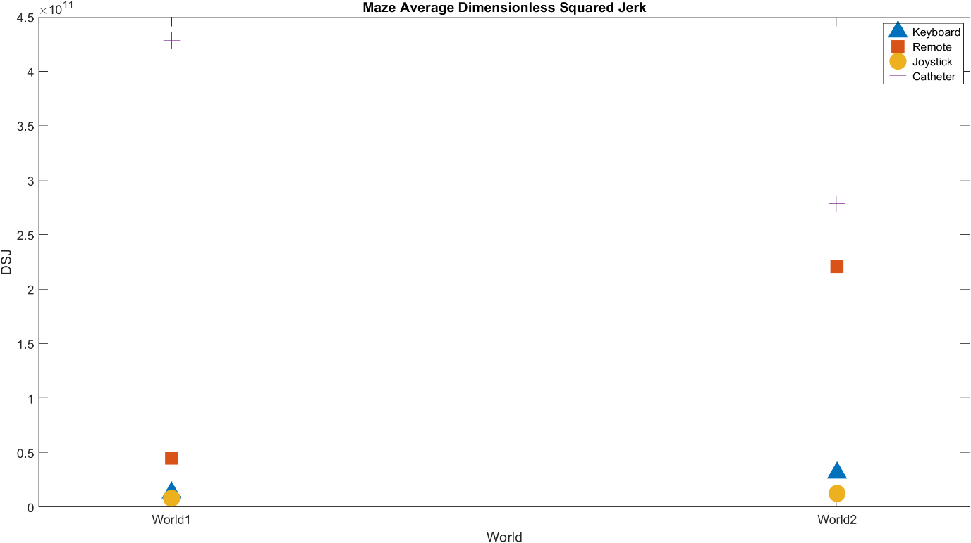 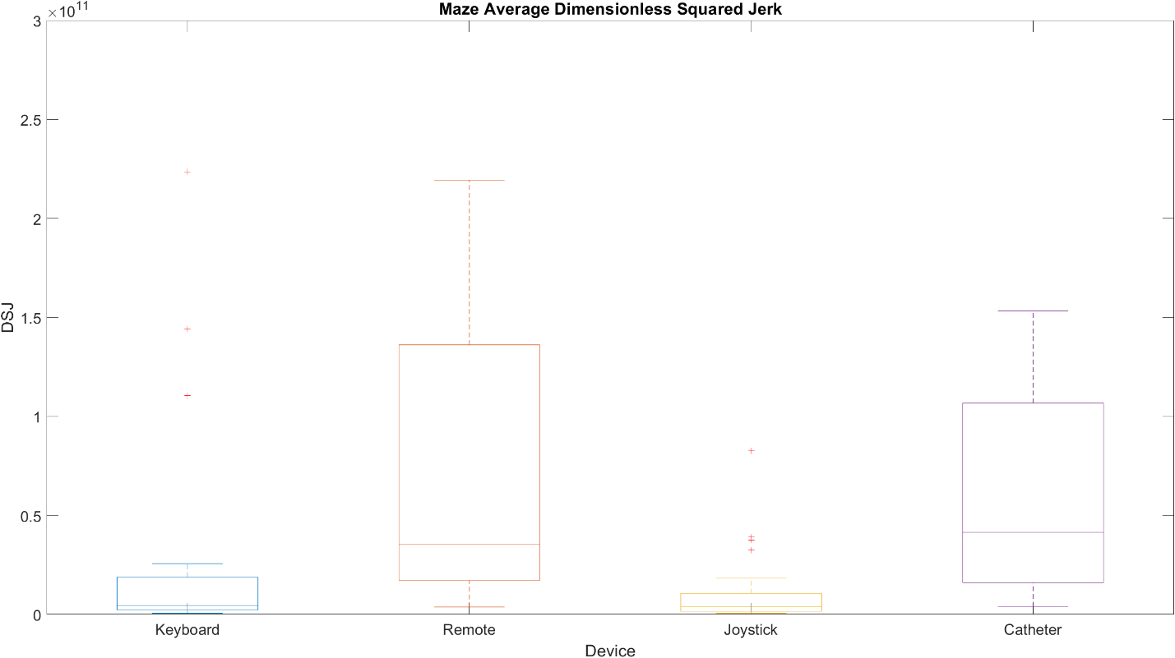

* **Polls results**

After completing the experiment, each one of the participants was requested to answer questions about the performance of the devices and give any additional comment about the experiment/devices. The exact questions as they were handed to the participants can be found in appendix ().

Since the poll requested to enumerate the preference for the devices from 1-4, the figure (), figure () and figure (), were calculated as a percentage by adding all the points each device got and dividing by the total amount of points. It can be seen for the 1st DOF device preference, the Joystick has the higher punctuation, followed by the keyboard and then the remote, leaving the catheter like last. Moreover, the 2nd DOF has in first place the Joystick again, in this case followed by the remote, then the keyboard and last the catheter device. The overall poll had the same results than the 1st DOF, but note that the difference between keyboard and remote got significantly reduced.

Another of the question asked to the participants was the experience with the devices, we can see in figure (), which shows how many participants out of the 15 declared experience in any of the devices, being the keyboard the most used, followed by the joystick.

The most relevant comments made by the participants are as follow:

* Remote appears to be significantly slower than keyboard in the 1st DOF
* Takes some time to operate the joystick, but with time it feels the easiest to use
* Rotation in joystick has too much dead zone and no low velocity
* (From Surgeon) The final user interface could use the Joystick as main device and the Remote as detachable device for being able to operate near the patient if necessary.

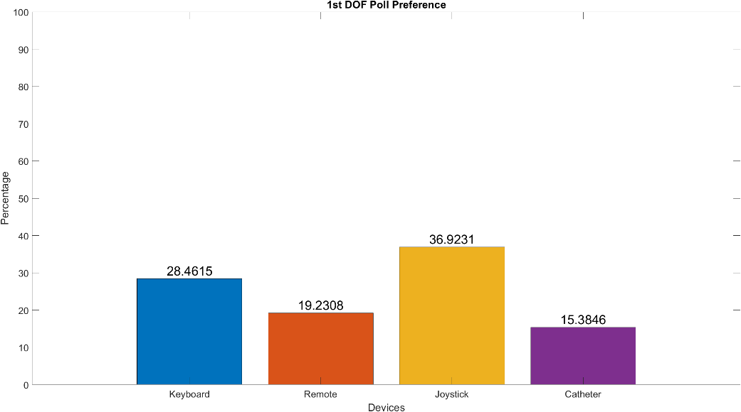 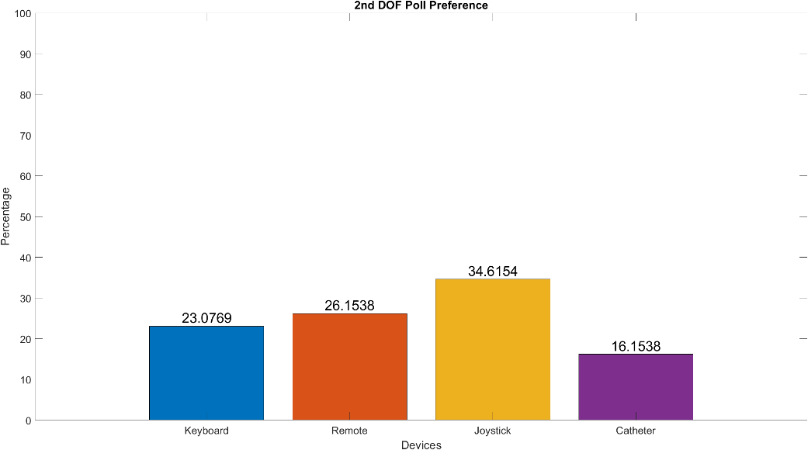 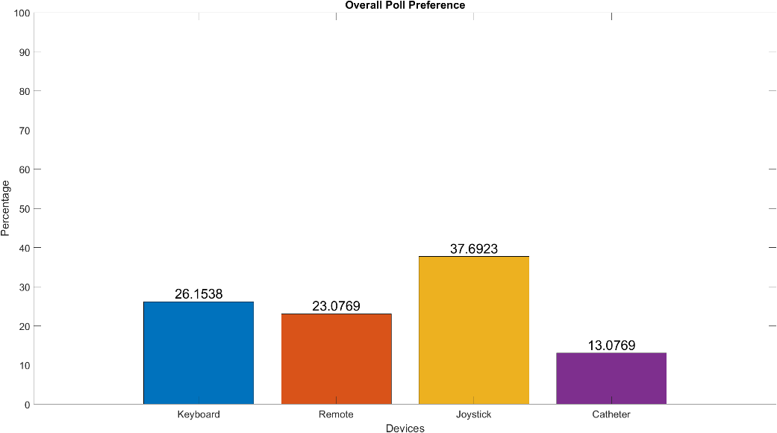 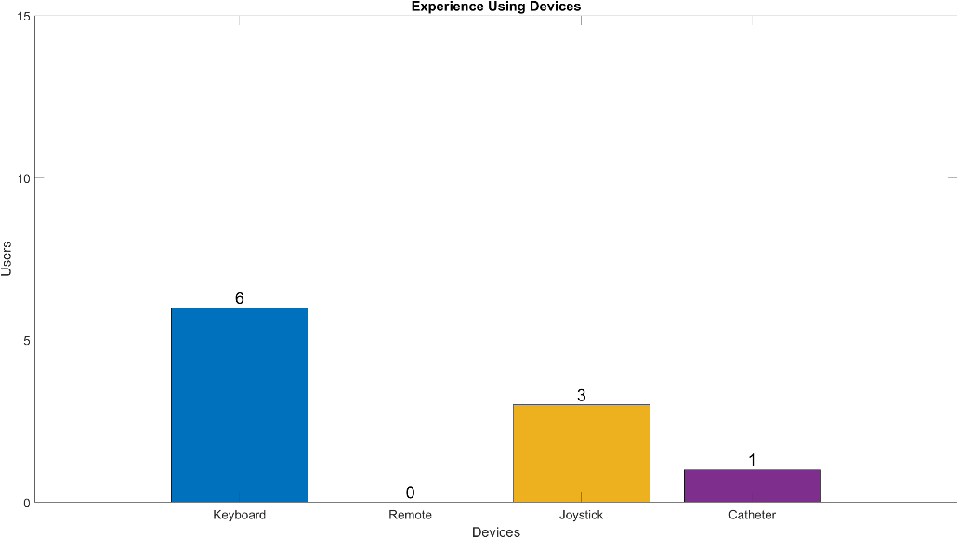

* **Participants statistics**

The 15 participant that participated, only 1 was an expert surgeon in TAVI procedure.

* + The average age of the participants is: 30.23
  + 46.15 were Male
  + 53.85 were Female

**Final Conclusions**

* **Conclusions and Discussions**

The discussion raised along the experiments was mostly focused on if the quality of the in house-made devices (Remote and CatheterLike) was too low compared with the production devices (Keyboard and Joystick). Figure~\ref{img:devcomp} shows the qualitative measurements of basic parameters both reported by the participants of the experiments (reported through the survey in appendix~\ref(sec:apsurv)) and noted by myself during the sessions. The CatheterLike device had the most reported issues, however, as explained in ~\ref{sec:catheterlike}, this device tries to replicate the usual handling of a catheter in TAVI and as can be seen in figure~\ref{img: 1stTrainNoExp} (the figure shows the attempts in the 1st DOF experiment of the expert TAVI surgeon), the CatheterLike device had the best performance, showing how with proper training the device has the mechanic capabilities to perform better than the rest of the devices, explaining the lower performance of the CatheterLike device mostly due to the lack of training of the remaining participants.

After how the experiments develop and specially the results of the 1st DOF Experiment, the DSJ in the maze experiment, the training curves and the poll results and comments. I consider the Joystick to be the most suitable option as a master device for a TAVI teleoperated robot

* **Following steps**

Explore different functions for how the velocity over time is incremented in the PressedTime-Velocity mapping, for this thesis work a linear function was used.

Explore different mapping functions for the analogical sensor devices in the Position-velocity mapping, for this thesis work a linear function was used.

Explore feedback strategies for the possibility of making the devices haptic.

Explore the possibility to have two master devices, adding a detachable secondary master device

**Apendix**

**Bibliography**

[1] Mahmaljy H, Young M. Transcatheter Aortic Valve Replacement (TAVR/TAVI, Percutaneous Replacement) [Updated 2019 May 18]. In: StatPearls [Internet]. Treasure Island (FL): StatPearls Publishing; 2019 Jan-. Available from: <https://www.ncbi.nlm.nih.gov/books/NBK431075/>

[2] Andras P Durko, Ruben L Osnabrugge, Nicolas M Van Mieghem, Milan Milojevic, Darren Mylotte, Vuyisile T Nkomo, A Pieter Kappetein, Annual number of candidates for transcatheter aortic valve implantation per country: current estimates and future projections, European Heart Journal, Volume 39, Issue 28, 21 July 2018, Pages 2635–2642, <https://doi.org/10.1093/eurheartj/ehy107>

[3] Alejandro Aquino, Ali J. Khiabani, Matthew C. Henn, Alan Zajarias, Spencer J. Melby, Marc Sintek, John Lasala, Puja Kachroo, Eric Novak, Hersh S. Maniar, Radiation Exposure During Transcatheter Valve Replacement: What Cardiac Surgeons Need to Know, The Annals of Thoracic Surgery, 2019,

[4] Díez, José G. “Transcatheter aortic valve implantation (TAVI): the hype and the hope.” Texas Heart Institute journal vol. 40,3 (2013): 298-301.

[5] “Transcatheter Aortic Valve Replacement (TAVR) Program.” Maimonides Medical Center, https://www.maimonidesmed.org/heart-vascular-institute/centers/structural-heart-center/tavr.

[6] Roguin A, et al. Brain tumours among interventional cardiologists: a cause for alarm? Report of four new cases from two cities and a review of the literature. Eurointervention 2012;7:1081-1086.

[7] Vano E, et al. Radiation-associated lens opacities in catheterization personnel: results of a survey and direct assessments. Journal of Vascular Interventional Radiology 2013;2: 197-204.

[8] Dehmer G, et al. Occupational Hazards for Interventional Cardiologists, The Society for Cardiovascular Angiography and Interventions. Catheterization and Cardiovascular Interventions; 2006;68, 6, 974-976.

[9] 5. 211-407:63; 2004 Interv Cardiovasc Catheter. practice contemporary in problems health orthopedic of prevalence: cardiologists interventional of hazards Occupational. al et, J G

[10] Smilowitz N, et al. Robotic-Enhanced PCI Compared to the Traditional Manual Approach. J Invasive Cardiol, 2014;26(7):318-321.

[11] Weisz G, et al. Safety and Feasibility of Robotic Percutaneous Coronary Intervention: PRECISE Study. J American College of Cardiol, 2013, Vol 61, No. 15: 1596-1600.

[12] “Revolution Full Overlap Lumbar Vest & Skirt - 703.” Infab, <https://www.infabcorp.com/product/revolution-full-overlap-lumbar-vest-skirt-703/>.

[13] “Shimane Prefectural Central Hospital.” EIZO, <https://www.eizoglobal.com/solutions/casestudies/spch/index.html>.

[14] Zohaib A. Shaikh, Michael F. Eilenberg, Todd J. Cohen, The Amigo™ Remote Catheter System: From Concept to Bedside, The Journal of Innovations in Cardiac Rhythm Management, 2017, 2795–2802

[15] “Stereotaxis Products.” Stereotaxis, <http://www.stereotaxis.com/products/#!/niobe>.

[16] “Transforming Medical Intervention.” Auris Health, <https://www.aurishealth.com/monarch-platform>.

[17] “Corindus Vascular Robotics.” Corindus Vascular Robotics, <https://www.corindus.com/>.

[18] J. Kevin Harrison, Charles J. Davidson, Harry R. Phillips, Michael B. Harding, Katherine B. Kisslo, Thomas M. Bashore. A Rapid, Effective Technique for Retrograde Crossing of Valvular Aortic Stenosis using Standard Coronary Catheters. Catherization and Cardiovascular Diagnosis 21:51-54 (1990)

[19] Albert M. Kasel, Anupama Shivaraju, Wolfgang von Scheidt, Adnan Kastrati, Christian Thilo, Anatomic Guided Crossing of a Stenotic Aortic Valve Under Fluoroscopy: “Right Cusp Rule, Part III”, JACC: Cardiovascular Interventions, Volume 8, Issue 1, Part A, 2015, Pages 119-120, ISSN 1936-8798,

[20] Mazomenos, Evangelos B et al. “Catheter manipulation analysis for objective performance and technical skills assessment in transcatheter aortic valve implantation.” International journal of computer assisted radiology and surgery vol. 11,6 (2016): 1121-31. doi:10.1007/s11548-016-1391-6

[21] Jae-Man Kwak, Erica Kholinne, Maulik Gandhi, Arnold Adikrishna, Hanpyo Hong, Yucheng Sun, Kyoung-Hwan Koh, and In-Ho Jeon, “Improvement of arthroscopic surgical performance using a new wide-angle arthroscope in the surgical training,” Plos One, vol. 14, no. 3, pp. e0203578, 2019

[22] Tarantini G, Gasparetto V, Napodano M, Fraccaro C, Gerosa G, Isabella G. Valvular leak after transcatheter aortic valve implantation: a clinician update on epidemiology, pathophysiology and clinical implications. Am J Cardiovasc Dis. 2011;1(3):312–320.

[23] Wilczek K, Bujak K, Reguła R, Chodór P, Osadnik T. Risk factors for paravalvular leak after transcatheter aortic valve implantation. Kardiochir Torakochirurgia Pol. 2015;12(2):89–94. doi:10.5114/kitp.2015.52848

[24] Alsara O, Alsarah A, Laird-Fick H. Advanced age and the clinical outcomes of transcatheter aortic valve implantation. *J Geriatr Cardiol*. 2014;11(2):163–170. doi:10.3969/j.issn.1671-5411.2014.02.004

Some feedback from my side. Please try to incorporate it into the thesis:

* Try to find more literature about similar tracking tasks, a) in surgery and b) in general haptic/drawing tasks outside surgery. Add the literature
* Add better conclusions