Welcome to the “**Choosing a master device for TAVI teleoperated surgery”** experiment. The experiment is divided in 4 sections, Training, Experiment 1, Experiment 2 and Experiment 3. Experiment 1 to 3 are not necessarily executed in that order; they will be randomized for means of the experiment. You will get informed which experiment is to be executed next.

Every device control 2 degrees of freedom (is able to make 2 kind of movements), the first one gets reflected up and down on the screen, and the second one gets reflected left and right on the screen.

All the experiments are a simulation of the control of a catheter (shown in white), displayed on the screen as a 2D projection (as it would be seen in fluoroscopy image).

The 4 sections are described as follows:

**Training:**

In this section, you will have the opportunity to try and get familiar with every device moving the catheter freely around the screen. (3 mins max. each).

**Experiment 1:**

In this experiment there is a floating red square (target) and a green square attached to the tip of the catheter (in white).

This experiment starts moving the target as soon as any movement in the device is performed. The task is to follow the target as close as possible with the green square commanded by the device.

In this experiment the target is only moving up and down.

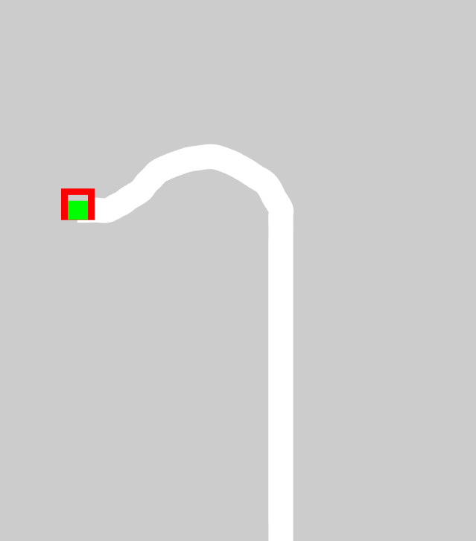

**Experiment 2:**

In this experiment there is a floating red square (target) and a green square attached to the tip of the catheter (in white).

This experiment starts moving the target as soon as any movement in the device is performed. The task is to follow the target as close as possible with the green square commanded by the device.

In this experiment the target is only moving left and right.

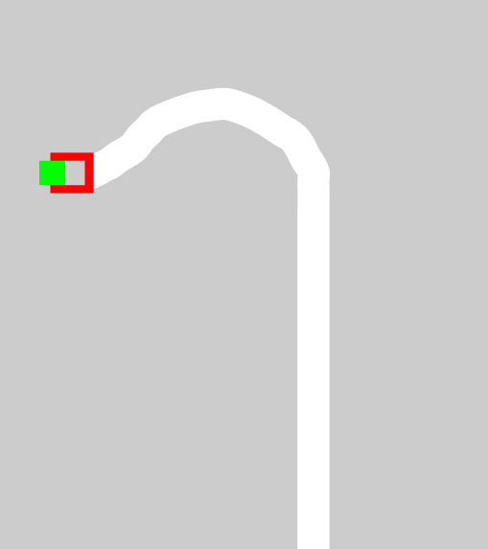

**Experiment 3:**

In this experiment there is a maze with only one way possible and a green square attached to the tip of the catheter (in white).

The task is to navigate through the maze and arrive to the upper part of the maze, the experiment will finish once the upper wall is touched with the green square commanded by the device.

Objective:

- Avoid collisions of the green square with the walls of the maze. If a collision occurs, the square will turn red and it’s necessary to move back in order to keep moving, once the square turns green again it is possible to move in any direction again.

- Keep the green square as far from the walls as possible, meaning, try to move as centered in the maze as possible

- Try to reach the upper wall as fast as possible.

- Try to keep the same strategy consistently through all the devices.

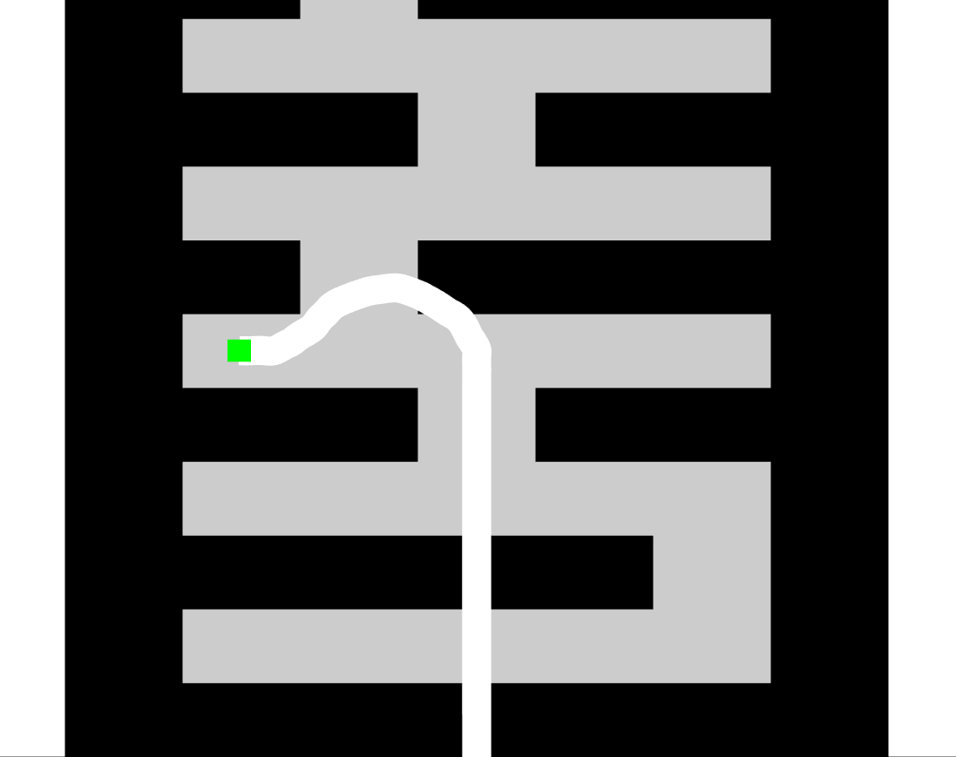

The following information is only for statistical purposes and is not going to be linked to your name in any way. If you do not feel comfortable answering any of them, leave them blank.

Which device did you find simpler to use in the 1st DOF (up and down)? Enumerate from 1 to 4, being 1 the simplest one

Keyboard Joystick Remote Catheter

Which device did you find simpler to use in the 2nd DOF (left and right)? Enumerate from 1 to 4, being 1 the simplest one

Keyboard Joystick Remote Catheter

Which device did you find simpler to use overall? Enumerate from 1 to 4, being 1 the simplest one

Keyboard Joystick Remote Catheter

Do you think you had any advantage using any of the devices because of some previous experience or work (gaming, operation of robots, office work)? Please specify.

Do you have any comment or suggestion about the experiment?

Age:

Gender: