**Data Structures & Algorithms**

**Assignment 1 : Huffman Coding**

**By: Armando Ciobanu B00125495**

**Declaration**

I hereby certify that this material, which I now submit for assessment on the program of study leading to the award of Ordinary Degree in Computing in the Technological University Dublin, Blanchardstown, is entirely my work except where otherwise stated.

Author:  Armando Ciobanu Dated: 1/12/2021

**Introduction**

In this assignment I was tasked to implement Hufman coding using the provided lettercount.txt file by generating the Huffman tree, encoding an alphabetical character and decoding the binary value back into an alphabetical char.

**Tree Generation**

In the treeGenerator method I initialised a while loop that will iterate as long as the length of the list is greater than 1, I then initialised my left and right node (variable l and r) to get the first reference and second reference to my list and later type casted them to huffitems to be able to use the getitems method. The next step I took was to initialise a variable to store the sum of the left and right frequencies.

The last step in my tree generation method is to use a bubble sort algorithm (the bubble sort was adapted from JavaTPoint)to sort the list by frequency.

**Encoding**

In this method my aim was to traverse the tree and generate a binary code for each of the characters.

My approach was to use an if statement to check if the root is equal to my variable symbol which represents the characters in the tree if it was I would set the encodeResult variable equal to code (example being the character or symbol T would encode to 10010) the code is determined from the traversal of the tree in my case if the left node is not null a 0 will be added to the code and if the right node is not null a 1 will be added to the code.

**Decoding**

In this method my aim was to get an input of a binary code from the text area in my GUI and traverse the tree starting at the root until it finds the symbol

In my code I have achieved this by using an if else statement to traverse the left path if the int is a 0 and traverse the right path if the int is 1, it will then return the character(symbol) at the end.

**GUI**

For my GUI I had decided to keep it simple as I was starting to run out of time as the deadline was approaching so I kept it simple with 1 input text area to take in a character or symbol a second text area to display the output of the button pressed which are encode and decode buttons.

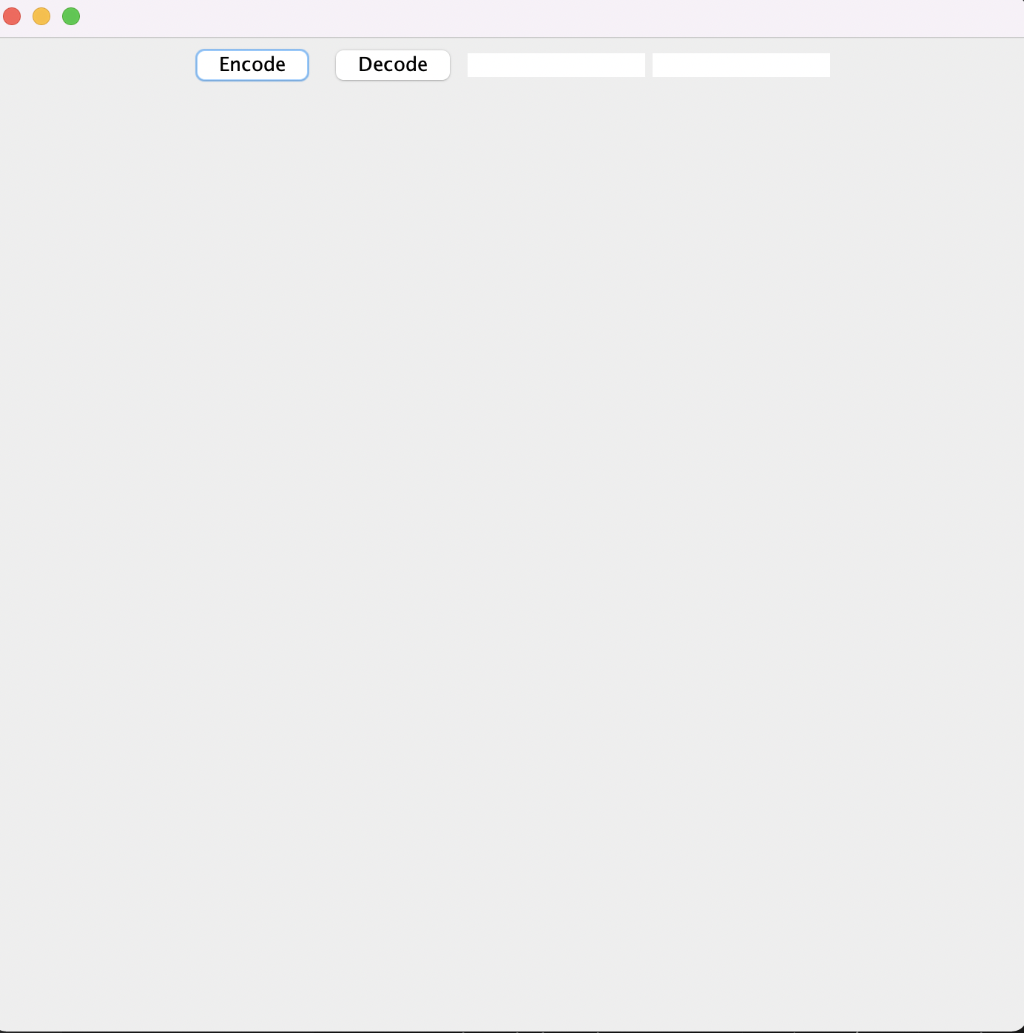

*(Image of the gui)*



*(Output when encoding a capital letter)*



*(Output when decoding a binary code)*

**Testing**

As previously mentioned with the deadline quickly approaching I did not implement much validation although I did conduct some tests for the inputs encoding and decoding



*(Leaving the input text area blank and encoding will result in a code of 10010 which is the binary code for T)*

**

*(Leaving the input text area blank and decoding will result in the symbol “@” )*



*(Typing a lower case letter as shown in the above image will give a nullpointer exception as no lower case letters exist in my tree)*

**

*(Decoding a lower case will out an “@” symbol as there is no frequency for the lowercase tl)*

**

*(Encoding two uppercase letters will not output a binary code as I do not have the necessary implementation but it does not produce an error)*

**

*(Uppercase TA will output an “@” symbol also as there is no frequency for TA)*

*I have concluded from my testing that decoding an input that does not exist in the frequency table outputs an “@” symbol and that encoding lower case letters will produce a Nullpointer error.*

***References & Resources***

www.javatpoint.com. 2021. *Bubble Sort in Java - Javatpoint*. [online] Available at: <https://www.javatpoint.com/bubble-sort-in-java> [Accessed 2 December 2021].

Week 5 files provided on moodle