Assignment Two

University of Saint Thomas of Mozambique

Computer Science 3rd Year,

Parallel Computing, Lecturer: Lars Albino Lemos

**Group Members:**

**Antonio Andre Jr**

**Armando Eliseu Phacule**

**Luan Pachiesso**

**Introduction**

On this assignment we were tasked with using a parallel computing formula, which is used to calculate the energy consumption of a task or program, to substitute the variables with new variables from the first assignment: Supermarket Algorithm.

*What we did on the previous assignment:*

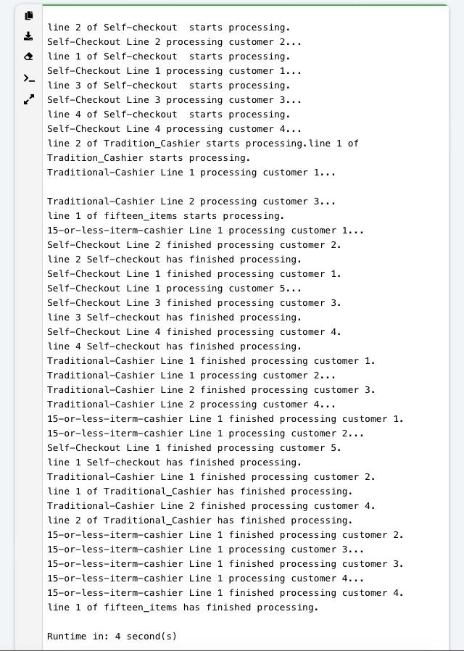

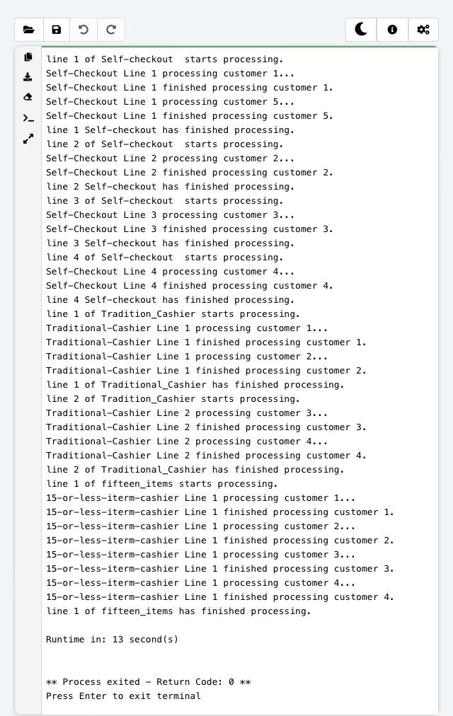

**Assignment 2:**

Based on this formula:

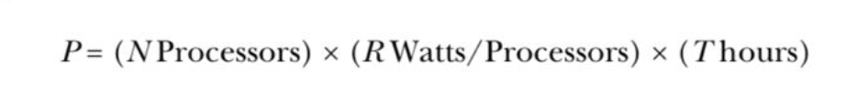

Here, ( N ) represents the number of cashiers, ( R ) represents the number of users, and ( T ) represents the number of hours the supermarket is open.

**Frist Scenario: Individual Checkout Lanes**

- Number of cashiers ( N ): 1 cashier

- Number of users ( R ): 4 users

- Time ( T ): 16 hours

**The amount of users(R) processed by cashiers (N) in hours(T) is calculated as:**

P = N x R x T = 1 x 4 x 16 = 64 usershrs

**Scenario: Individual Checkout Lanes**

- Number of cashiers N : 4 cashiers

- Number of users R : 4 users (one user per cashier)

- Time ( T ): 16 hours

**The amount of users(R) processed by cashiers (N) in hours(T) is calculated as:**

P = N x R x T = 4 x 4 x 16 = 256 usershrs

By comparing the two scenarios, we observe the following user processing/consumption:

- First Scenario (1 Lane/Cashier): 64 usershrs

- Second Scenario (4 Lanes/Cashiers): 256 usershrs

**Approach to Solution and Conclusion**

To substitute ( N ) with the number of cashiers, ( R ) with the number of users and ( T ) with hours in the formula ( P = N x R x T ), considering the supermarket is open for 16 hours a day, we calculate the total user consumption for two scenarios :

In the first scenario, there is 1 cashier and 4 users (one per cashier), operating for 16 hours. The total user consumption is 1 times 4 times 16 = 64 usershrs.

In the second scenario with 4 lanes, there are 4 cashiers and 4 users (one per cashier), also operating for 16 hours. The total user consumption is 4 times 4 times 16 = 256 usershrs.

Therefore, by comparing the two scenarios, we see that first scenario (one user per one lane) can intake lesser users than the second scenario (one user per 4 lanes).