Supplementary Material File

A crossroads between the Mediterranean and the Alps: Lithic technology and mobility in the Aurignacian of Riparo Bombrini (Liguria, northwestern Italy)

Armando Falcucci, Stefano Bertola, Martina Parise, Matteo Del Rio, Julien Riel-Salvatore & Fabio Negrino

Table of Contents

SM Figures 2

Figure S1 2

Figure S2 3

Figure S3 3

Figure S4 4

Figure S5 5

Figure S6 5

Figure S7 6

Figure S8 7

Figure S9 8

Figure S10 8

Figure S11 9

SM Tables 10

Table S1 10

Table S2 10

Table S3 11

Table S4 11

Table S5 11

Table S6 12

Table S7 12

Table S8 12

Table S9 12

Table S10 13

Table S11 13

Table S12 13

Table S13 14

Table S14 14

Table S15 14

Table S16 15

Table S17 15

Table S18 15

Table S19 16

Table S20 16

Table S21 17

Table S22 17

Table S23 17

## SM Figures

### Figure S1

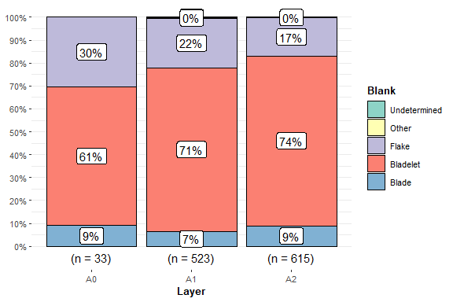

**Figure S1.** Distribution of blank types with percentages across layers A2 and A1.

### Figure S2

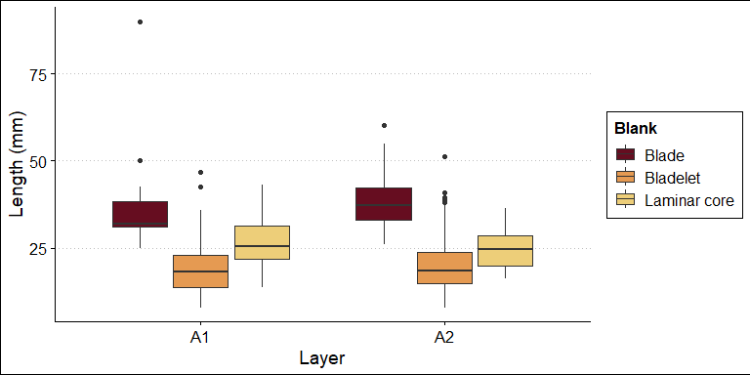

**Figure S2.** Boxplots comparing the lengths of complete blades and bladelets with the flaking surface lengths of laminar cores across layers A1 and A2. Refer to the legend for color coding.

### Figure S3

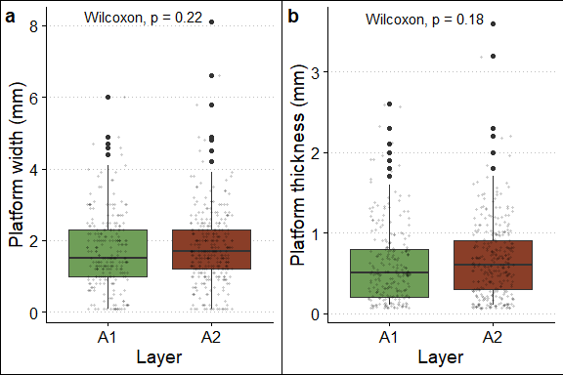

**Figure S3.** Boxplots showing the distribution of platform width (a) and thickness (b) values in layers A1 and A2. The figure includes the results of the Wilcoxon tests, which confirm the similarity of these attributes between the two layers.

### Figure S4

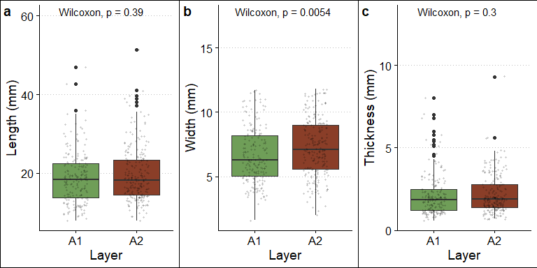

**Figure S4.** Boxplots showing the distribution of length (a), width (b), and thickness (c) of non-modified complete bladelets from layers A1 and A2. The figure includes the results of the Wilcoxon tests, which show that the only statistically significant difference is in the width of the bladelets.

### Figure S5

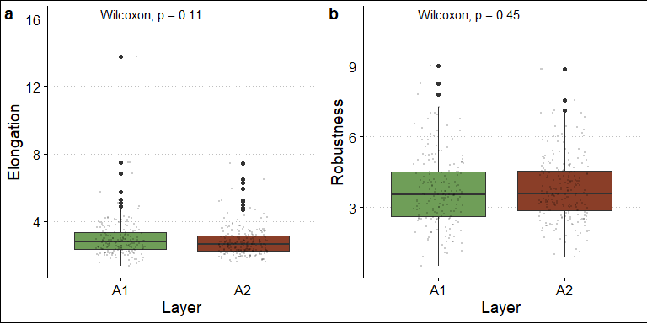

**Figure S5.** Boxplots showing the distribution of elongation (a) and robustness (b) ratios of bladelets in layers A1 and A2. The figure includes the results of the Wilcoxon tests, which confirm the similarity of these attributes between the layers.

### Figure S6

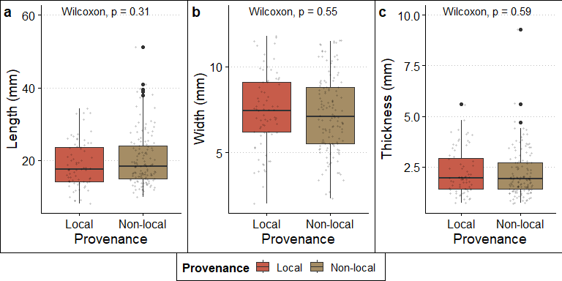

**Figure S6.** Boxplots showing the distribution of length (a), width (b), and thickness (c) of non-modified complete bladelets from layers A1 and A2, categorized by local and non-local (i.e., circum-local, distant, and very distant) raw materials. The figure includes the results of the Wilcoxon tests, which show no statistically significant differences in any of the comparisons.

### Figure S7

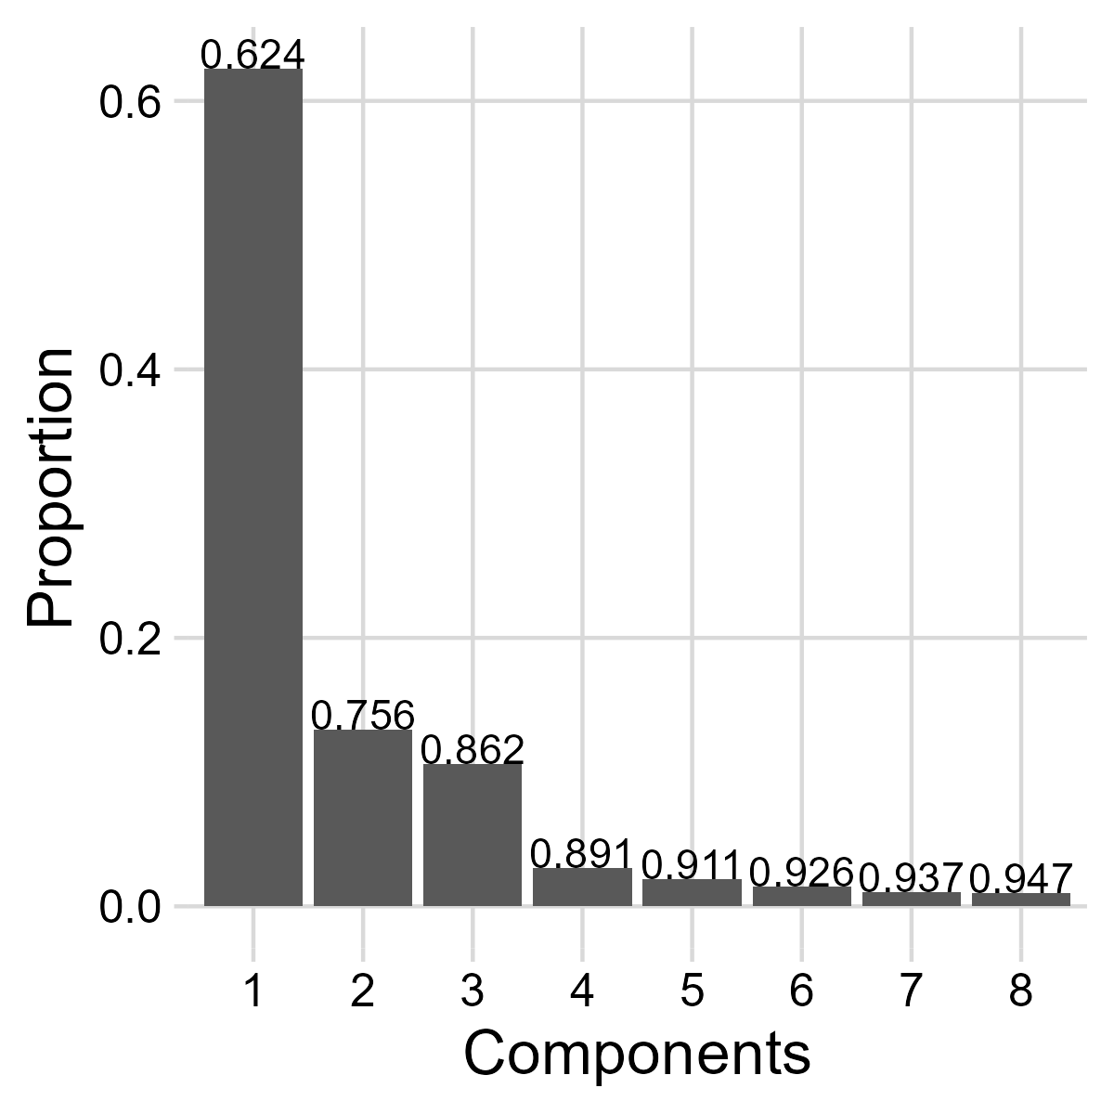

**Figure S7.** Scree plot illustrating the proportion of variance explained by the first eight principal components of the 2D outline analysis.

### Figure S8

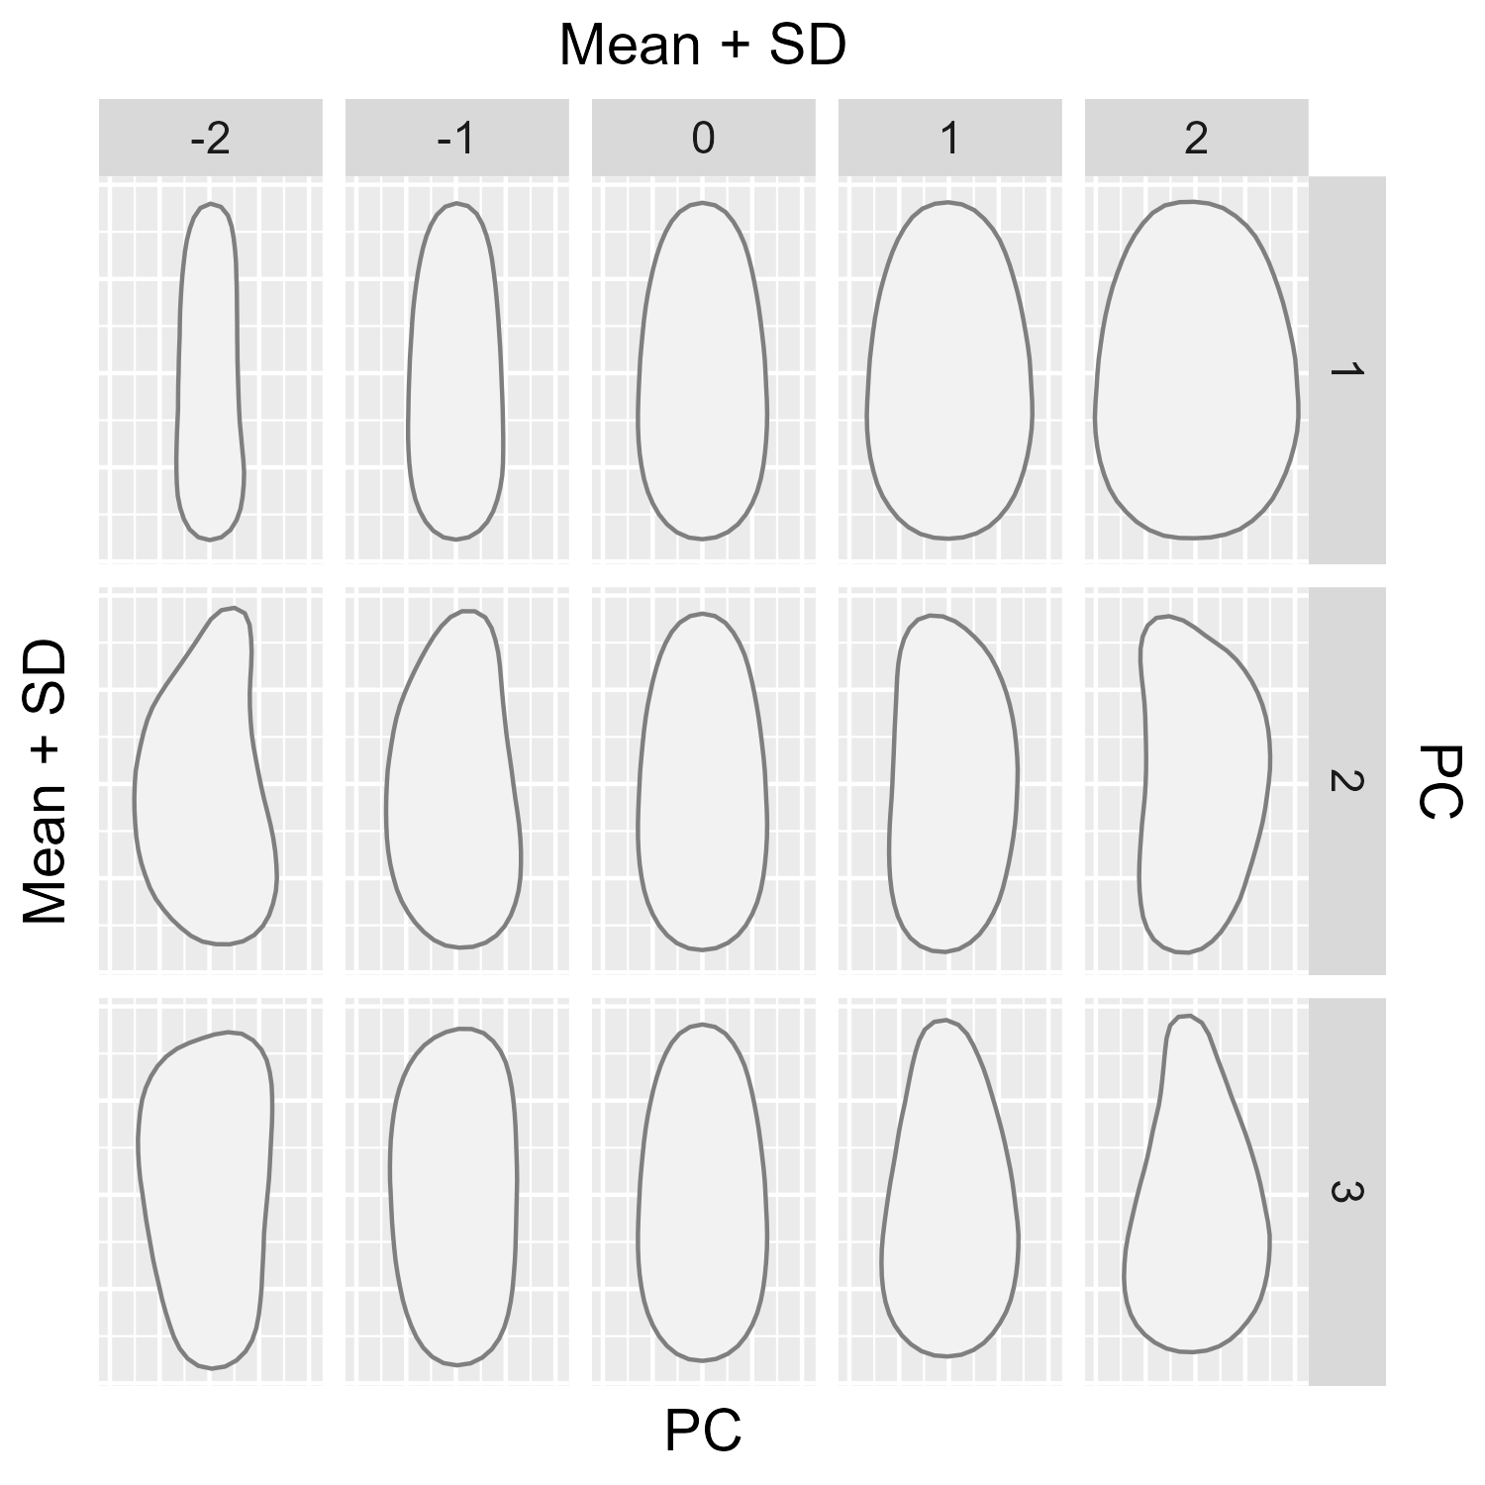

**Figure S8.** Plot displaying the shape variation across the first three principal components (PCs) of the 2D outline analysis. The mean shape and standard deviation (SD) are shown for each component.

### Figure S9

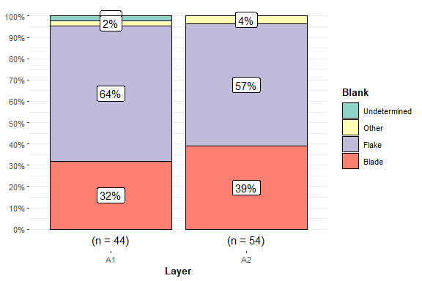

**Figure S9.** Selection of blank types used for fabricating tools, excluding retouched bladelets, across layers A1 and A2. Rounded percentages are provided within the bars.

### Figure S10

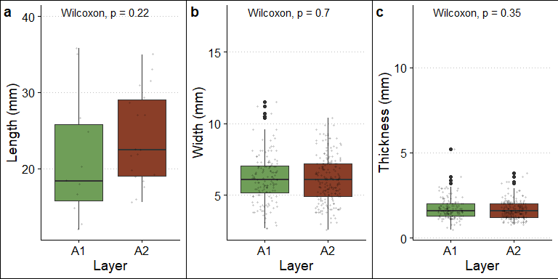

**Figure S10.** Boxplots showing the distribution of length (a), width (b), and thickness (c) of retouched bladelets from layers A1 and A2. For width and thickness, broken bladelets are also included. The figure includes the results of the Wilcoxon tests, which confirm the high similarity between retouched bladelets from layers A1 and A2.

### Figure S11

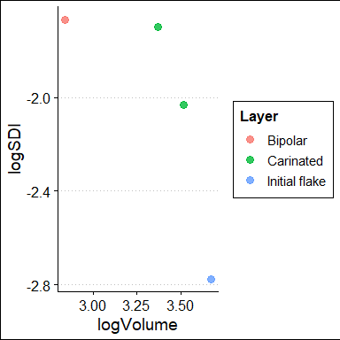

**Figure S11.** Logarithmically transformed Scar Density Index (logSDI) plotted against the logarithmically transformed volume (logVolume) of cores from layer A0, colored by technological classification. Core shatters are excluded from the analysis.

## SM Tables

### Table S1

| **Raw material** | **A1** | **A2** | **Total** |
| --- | --- | --- | --- |
| Chert | 506 (91.8%) | 585 (89.9%) | 1,091 (90.8%) |
| Jasper | 15 (2.7%) | 30 (4.6%) | 45 (3.7%) |
| Quartzarenite | 2 (0.4%) | 2 (0.3%) | 4 (0.3%) |
| Magmatic rock | 0 (0.0%) | 1 (0.2%) | 1 (0.1%) |
| Metamorphic rock | 0 (0.0%) | 1 (0.2%) | 1 (0.1%) |
| Volcanic rock | 2 (0.4%) | 2 (0.3%) | 4 (0.3%) |
| Undetermined | 26 (4.7%) | 28 (4.3%) | 54 (4.5%) |
| Unknown | 0 (0.0%) | 2 (0.3%) | 2 (0.2%) |
| Total | 551 (100.0%) | 651 (100.0%) | 1,202 (100.0%) |

**Table S1.** Distribution of raw material types across layers A2 and A1, with percentages provided in brackets.

### Table S2

| **Provenance** | **A1** | **A2** | **Total** |
| --- | --- | --- | --- |
| Local | 158 (29.2%) | 213 (33.5%) | 371 (31.5%) |
| Circum-local France | 47 (8.7%) | 81 (12.8%) | 128 (10.9%) |
| Distant France | 164 (30.3%) | 132 (20.8%) | 296 (25.1%) |
| Very-distant France | 90 (16.6%) | 98 (15.4%) | 188 (16.0%) |
| Distant Italy | 15 (2.8%) | 29 (4.6%) | 44 (3.7%) |
| Very-distant Italy | 42 (7.7%) | 54 (8.5%) | 96 (8.2%) |
| Undetermined | 26 (4.8%) | 28 (4.4%) | 54 (4.6%) |
| Total | 542 (100.0%) | 635 (100.0%) | 1,177 (100.0%) |

**Table S2.** Distribution of raw material provenance across layers A2 and A1, with percentages provided in brackets. Lithics with unavailable raw material data are excluded from the table.

### Table S3

| **Layer** | **0%** | **1-33%** | **100%** | **33-66%** | **66-99%** | **Total** |
| --- | --- | --- | --- | --- | --- | --- |
| A1 | 467 (84.8%) | 58 (10.5%) | 3 (0.5%) | 18 (3.3%) | 5 (0.9%) | 551 (100.0%) |
| A2 | 586 (90.0%) | 42 (6.5%) | 3 (0.5%) | 19 (2.9%) | 1 (0.2%) | 651 (100.0%) |
| Total | 1,053 (87.6%) | 100 (8.3%) | 6 (0.5%) | 37 (3.1%) | 6 (0.5%) | 1,202 (100.0%) |

**Table S3.** Distribution of cortex coverage across layers A2 and A1, with percentages provided in brackets.

### Table S4

| **Layer** | **Cortical** | **Crest** | **Spall crest** |
| --- | --- | --- | --- |
| A1 | 8 (66.7%) | 12 (66.7%) | 0 (0.0%) |
| A2 | 4 (33.3%) | 6 (33.3%) | 5 (100.0%) |
| Total | 12 (100.0%) | 18 (100.0%) | 5 (100.0%) |

**Table S4.** Distribution of blanks associated with the initialization core reduction phase across Layers A2 and A1, with percentages provided in brackets.

### Table S5

| **Layer** | **Circum-local** | **Distant** | **Local** | **Very distant** | **Total** |
| --- | --- | --- | --- | --- | --- |
| A1 | 2 (10.0%) | 4 (20.0%) | 11 (55.0%) | 3 (15.0%) | 20 (100.0%) |
| A2 | 3 (20.0%) | 3 (20.0%) | 4 (26.7%) | 5 (33.3%) | 15 (100.0%) |
| Total | 5 (14.3%) | 7 (20.0%) | 15 (42.9%) | 8 (22.9%) | 35 (100.0%) |

**Table S5.** Distribution of raw materials, sorted according to their provenance, associated with initialization blanks across layers A2 and A1, with percentages provided in brackets. Undetermined and unknown categories are excluded.

### Table S6

| **Layer** | **Initialization** | **Maintenance** | **Optimal** | **Semi-cortical** | **Total** |
| --- | --- | --- | --- | --- | --- |
| A1 | 2 (10.0%) | 6 (30.0%) | 8 (40.0%) | 4 (20.0%) | 20 (100.0%) |
| A2 | 2 (5.9%) | 13 (38.2%) | 13 (38.2%) | 6 (17.6%) | 34 (100.0%) |
| Total | 4 (7.4%) | 19 (35.2%) | 21 (38.9%) | 10 (18.5%) | 54 (100.0%) |

**Table S6.** Distribution of technological categories among non-modified blades across layers A2 and A1, with percentages provided in brackets.

### Table S7

| **Layer** | **Maintenance** | **Optimal** | **Total** |
| --- | --- | --- | --- |
| A1 | 3 (23.1%) | 10 (76.9%) | 13 (100.0%) |
| A2 | 4 (19.0%) | 17 (81.0%) | 21 (100.0%) |
| Total | 7 (20.6%) | 27 (79.4%) | 34 (100.0%) |

**Table S7.** Distribution of technological categories among blade tools across layers A2 and A1, with percentages provided in brackets.

### Table S8

| **Layer** | **Bidirectional** | **Unidirectional** | **Total** |
| --- | --- | --- | --- |
| A1 | 2 (8%) | 22 (92%) | 24 (100%) |
| A2 | 1 (8%) | 12 (92%) | 13 (100%) |
| Total | 3 (8%) | 34 (92%) | 37 (100%) |

**Table S8.** Flaking direction among laminar cores across layers A1 and A2, with percentages provided in brackets. Tested raw materials and core shatters are excluded.

### Table S9

| **Layer** | **Convergent** | **Sub-parallel** | **Total** |
| --- | --- | --- | --- |
| A1 | 8 (33%) | 16 (67%) | 24 (100%) |
| A2 | 4 (31%) | 9 (69%) | 13 (100%) |
| Total | 12 (32%) | 25 (68%) | 37 (100%) |

**Table S9.** Reduction pattern among laminar cores across layers A1 and A2, with percentages provided in brackets. Tested raw materials and core shatters are excluded.

### Table S10

| **Platform type** | **A1** | **A2** |
| --- | --- | --- |
| Plain | 161 (65.7%) | 217 (70.5%) |
| Linear | 54 (22.0%) | 65 (21.1%) |
| Punctiform | 25 (10.2%) | 23 (7.5%) |
| Cortical | 3 (1.2%) | 2 (0.6%) |
| Undetermined | 2 (0.8%) | 1 (0.3%) |
| Total | 245 (100.0%) | 308 (100.0%) |

**Table S10.** Distribution of platform types among bladelet blanks and tools across layers A1 and A2, with percentages provided in brackets.

### Table S11

| **Layer** | **Absent** | **Moderate** | **Pronounced** | **Total** |
| --- | --- | --- | --- | --- |
| A1 | 169 (66.8%) | 81 (32.0%) | 3 (1.2%) | 253 (100.0%) |
| A2 | 206 (65.2%) | 102 (32.3%) | 8 (2.5%) | 316 (100.0%) |

**Table S11.** Distribution of bulb types across layers A1 and A2 for bladelet blanks and tools, with percentages provided in brackets. Shattered bulbs are considered absent.

### Table S12

| **Layer** | **Absent** | **Moderate** | **Pronounced** | **Total** |
| --- | --- | --- | --- | --- |
| A1 | 47 (18.6%) | 165 (65.2%) | 41 (16.2%) | 253 (100.0%) |
| A2 | 33 (10.4%) | 212 (67.1%) | 71 (22.5%) | 316 (100.0%) |

**Table S12.** Distribution of lip types across layers A1 and A2 for bladelet blanks and tools, with percentages provided in brackets.

### Table S13

| **Layer** | **Unidirectional parallel** | **Unidirectional convergent** | **Bidirectional** | **Other** | **Total** |
| --- | --- | --- | --- | --- | --- |
| A1 | 108 (56.0%) | 66 (34.2%) | 4 (2.1%) | 15 (7.8%) | 193 (100.0%) |
| A2 | 140 (58.6%) | 84 (35.1%) | 4 (1.7%) | 11 (4.6%) | 239 (100.0%) |

**Table S13.** Distribution of scar patterns among bladelet blanks and tools across layers A1 and A2, with percentages provided in brackets.

### Table S14

| **Layer** | **Curved** | **Curved intense** | **Curved slightly** | **Straight** | **Total** |
| --- | --- | --- | --- | --- | --- |
| A1 | 37 (19.2%) | 7 (3.6%) | 57 (29.5%) | 92 (47.7%) | 193 (100.0%) |
| A2 | 41 (17.2%) | 18 (7.5%) | 73 (30.5%) | 107 (44.8%) | 239 (100.0%) |

**Table S14.** Distribution of profile curvature intensity among bladelet blanks and tools across layers A1 and A2, with percentages provided in brackets.

### Table S15

| **Layer** | **Non-twisted** | **Slightly twisted** | **Twisted** | **Total** |
| --- | --- | --- | --- | --- |
| A1 | 148 (76.7%) | 31 (16.1%) | 14 (7.3%) | 193 (100.0%) |
| A2 | 176 (73.6%) | 52 (21.8%) | 11 (4.6%) | 239 (100.0%) |

**Table S15.** Distribution of profile torsion intensity among bladelet blanks and tools across layers A1 and A2, with percentages provided in brackets.

### Table S16

| **Layer** | **Flat** | **Lateral steep** | **Polyhedral** | **Rectangular** | **Trapezoidal** | **Triangular** | **Total** |
| --- | --- | --- | --- | --- | --- | --- | --- |
| A1 | 12 (6.2%) | 26 (13.5%) | 11 (5.7%) | 3 (1.6%) | 64 (33.2%) | 77 (39.9%) | 193 (100.0%) |
| A2 | 15 (6.3%) | 17 (7.1%) | 14 (5.9%) | 3 (1.3%) | 100 (41.8%) | 90 (37.7%) | 239 (100.0%) |

**Table S16.** Distribution of cross-section types among bladelet blanks and tools across layers A1 and A2, with percentages provided in brackets.

### Table S17

| **Layer** | **variable** | **n** | **mean** | **sd** | **min** | **median** | **max** |
| --- | --- | --- | --- | --- | --- | --- | --- |
| A1 | Length | 182 | 18.904 | 6.662 | 8.0 | 18.45 | 46.9 |
| A1 | Width | 182 | 6.677 | 2.183 | 1.6 | 6.30 | 11.7 |
| A1 | Thickness | 182 | 2.136 | 1.273 | 0.6 | 1.85 | 8.0 |
| A2 | Length | 218 | 19.649 | 6.919 | 8.0 | 18.25 | 51.3 |
| A2 | Width | 218 | 7.263 | 2.225 | 2.0 | 7.10 | 11.8 |
| A2 | Thickness | 218 | 2.180 | 1.149 | 0.7 | 1.90 | 9.3 |

**Table S17.** Summary statistics for the length, width, and thickness of bladelet blanks across layers A1 and A2. sd = standard deviation.

### Table S18

| **Measurement** | **Principal Component** | **Spearman** | **p-value** |
| --- | --- | --- | --- |
| Length | PC1 | -0.440 | 0.000 |
| Width | PC1 | 0.251 | 0.000 |
| Thickness | PC1 | -0.103 | 0.047 |
| Length | PC2 | 0.056 | 0.283 |
| Width | PC2 | 0.001 | 0.988 |
| Thickness | PC2 | 0.056 | 0.284 |
| Length | PC3 | -0.122 | 0.019 |
| Width | PC3 | -0.053 | 0.313 |
| Thickness | PC3 | -0.137 | 0.008 |

**Table S18.** Results of the Spearman tests on the correlation between size (length, width, and thickness) and the first three principal components (PC1, PC2, and PC3) of the bladelet outline analysis.

### Table S19

| **Layer** | **Blank** | **0%** | **1-33%** | **Total** | **100%** | **33-66%** | **66-99%** |
| --- | --- | --- | --- | --- | --- | --- | --- |
| A1 | Bladelet | 144 (99.3%) | 1 (0.7%) | 145 (100.0%) |  |  |  |
| A2 | Bladelet | 199 (100.0%) | 0 (0.0%) | 199 (100.0%) |  |  |  |
| A1 | Blade | 12 (85.7%) | 2 (14.3%) | 14 (100.0%) |  |  |  |
| A2 | Blade | 19 (90.5%) | 2 (9.5%) | 21 (100.0%) |  |  |  |
| A1 | Flake | 13 (46.4%) | 8 (28.6%) | 28 (100.0%) | 1 (3.6%) | 3 (10.7%) | 3 (10.7%) |
| A2 | Flake | 22 (71.0%) | 5 (16.1%) | 31 (100.0%) | 1 (3.2%) | 3 (9.7%) | 0 (0.0%) |

**Table S19.** Distribution of cortex coverage across layers A2 and A1 for bladelet, blade, and flake tools, with percentages provided in brackets.

### Table S20

| **Raw material** | **A0** |
| --- | --- |
| Local | 9 (25.0%) |
| Circum-local | 3 (8.3%) |
| Distant | 11 (30.6%) |
| Very distant | 12 (33.3%) |
| Undetermined | 1 (2.8%) |

**Table S20.** Distribution of raw material provenance in Layer A0, with percentages provided in brackets.

### Table S21

| **Classification** | **Circum-local** | **Distant** | **Local** | **Total** |
| --- | --- | --- | --- | --- |
| Initial flake | 0 | 0 | 1 | 1 |
| Bipolar | 0 | 1 | 0 | 1 |
| Carinated | 1 | 1 | 0 | 2 |
| Shatter | 0 | 0 | 1 | 1 |
| Total | 1 | 2 | 2 | 5 |

**Table S21.** Core classification for layer A0 and distribution of raw material provenance.

### Table S22

| **variable** | **n** | **mean** | **sd** | **min** | **median** | **max** |
| --- | --- | --- | --- | --- | --- | --- |
| Length | 8 | 11.575 | 3.212 | 6.1 | 11.85 | 17.3 |
| Width | 8 | 5.787 | 1.609 | 3.5 | 6.15 | 8.4 |
| Thickness | 8 | 1.425 | 0.568 | 0.6 | 1.45 | 2.3 |

**Table S22.** Summary statistics for the length, width, and thickness of bladelet blanks in layer A0. sd = standard deviation.

### Table S23

| **Type** | **Local** | **Circum-local** | **Distant** | **Very distant** | **Undetermined** | **Total** |
| --- | --- | --- | --- | --- | --- | --- |
| Compsite tool | 0 | 0 | 2 | 0 | 0 | 2 |
| Endscraper carinated | 0 | 1 | 0 | 0 | 0 | 1 |
| Endscraper thick-nosed | 0 | 0 | 1 | 0 | 0 | 1 |
| Retouched blade | 0 | 0 | 0 | 0 | 1 | 1 |
| Retouched bladelet | 0 | 0 | 1 | 2 | 0 | 3 |
| Scaled piece | 1 | 0 | 0 | 0 | 0 | 1 |
| Total | 1 | 1 | 4 | 2 | 1 | 9 |

**Table S23.** Classification of tool types from layer A0.