Submatrices

Crear un método que reemplace una submatriz de la matriz rectangular A[6][6] por otra submatriz correspondiente a la matriz rectangular B[6][6]:

void submat(int l, int u, int i, int j, int A[][6], int B[][6]);

l, u: Índice inferior y superior de los renglones, respectivamente;

i, j: Índice inferior y superior de las columnas, respectivamente;

A, B: Matrices

***Ejemplo:***

***Ejemplo:***

A: B:

|  |  |  |  |  |  |
| --- | --- | --- | --- | --- | --- |
| 1 | 2 | 3 | 4 | 5 | 6 |
| 7 | 8 | 9 | 10 | 11 | 12 |
| 13 | 14 | 15 | 16 | 17 | 18 |
| 19 | 20 | 21 | 22 | 23 | 24 |
| 25 | 26 | 27 | 28 | 29 | 30 |
| 31 | 32 | 33 | 34 | 35 | 36 |

|  |  |  |  |  |  |
| --- | --- | --- | --- | --- | --- |
| 60 | 61 | 62 | 63 | 64 | 65 |
| 66 | 67 | 68 | 69 | 70 | 71 |
| 72 | 73 | 74 | 75 | 76 | 77 |
| 78 | 79 | 80 | 81 | 82 | 83 |
| 84 | 85 | 86 | 87 | 88 | 89 |
| 90 | 91 | 92 | 93 | 94 | 95 |

submat(1, 4, 1, 3, A, B);

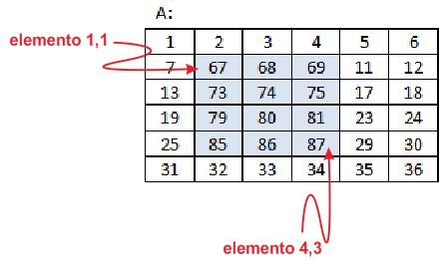

***Valor: 0.1***