**DEMAND AND SUPPLY**

**Demand** in economics refers to the quantity of a good or service that consumers are willing and able to purchase at various prices over a certain period. It is a fundamental concept that helps to understand consumer behavior and market dynamics. Demand typically follows the **Law of Demand**, which states that, all other things being equal, as the price of a product decreases, the quantity demanded increases, and vice versa.

**Determinants of Demand**

**1. Price of the Good or Service**

The price of the product is the most immediate factor that affects demand. According to the **Law of Demand**, as the price of a good or service rises, the quantity demanded typically falls, and as the price drops, the quantity demanded usually increases. This inverse relationship creates a **demand curve**, which generally slopes downward from left to right on a graph.

* **Example**: If the price of coffee increases significantly, consumers might buy less coffee and seek cheaper alternatives, leading to a decrease in the quantity demanded.

**2. Income of Consumers**

The effect of consumer income on demand depends on the type of goods:

* **Normal Goods**: These are goods for which demand increases as income rises. For example, as people earn more, they may buy more premium clothing or dine out more frequently.
* **Inferior Goods**: These are goods for which demand decreases as income rises because consumers opt for higher-quality substitutes. For example, instant noodles might see a decrease in demand as consumers with higher incomes switch to fresh or gourmet meals.

**Elasticity of Demand and Income**: The degree to which demand changes in response to income changes can vary. This concept is known as **income elasticity of demand**. Luxury goods tend to have higher income elasticity, meaning their demand is more sensitive to income changes.

**3. Prices of Related Goods**

The demand for a good can be influenced by the prices of related goods, which include:

* **Substitute Goods**: These are goods that can be used in place of another. If the price of a substitute good increases, consumers may switch to the original good, boosting its demand.
  + **Example**: If the price of tea rises, more people might buy coffee instead, increasing the demand for coffee.
* **Complementary Goods**: These are goods that are consumed together. If the price of one complementary good rises, the demand for its counterpart might fall.
  + **Example**: If the price of printers drops, the demand for printer ink might rise because more people are buying printers.

**4. Tastes and Preferences**

Consumer preferences play a significant role in shaping demand. These preferences can be influenced by cultural trends, social factors, advertising, and individual tastes.

* **Example**: If a new diet trend promotes oat milk as a healthier alternative to dairy, the demand for oat milk will likely rise as consumer preferences shift.

**Influence of Marketing and Advertising**: Effective marketing campaigns can shape consumer tastes and drive demand for products by creating a perception of desirability or necessity.

**5. Expectations of Future Prices and Income**

Consumers' expectations about future changes can influence current demand:

* **Price Expectations**: If consumers expect prices to rise in the future, they may purchase more now to avoid paying a higher price later, boosting current demand.
  + **Example**: If there is speculation that gasoline prices will increase, drivers might fill their tanks more frequently, increasing immediate demand.
* **Income Expectations**: If consumers expect their income to rise, they may spend more freely now, increasing current demand.
  + **Example**: If people anticipate a salary raise or tax refund, they might make more discretionary purchases, such as electronics or vacations.

**6. Population Size and Demographics**

The overall size and composition of the population affect demand for goods and services:

* **Population Growth**: An increase in population typically leads to higher demand for products, as there are more consumers in the market.
* **Demographic Changes**: The age, gender, and cultural background of a population can influence demand. For example, an aging population might increase the demand for healthcare services and retirement homes, while a younger population could boost demand for educational services and technological gadgets.

**7. Seasonal Factors**

Certain goods and services have seasonal demand patterns:

* **Examples**:
  + **Winter Clothing**: The demand for coats, scarves, and gloves increases in colder months.
  + **Holiday-Related Items**: Decorations, gifts, and seasonal foods see spikes in demand around holidays like Christmas or Halloween.
  + **Ice Cream and Cold Drinks**: These products typically see increased demand during the summer months.

**Economic Cycles and Seasonal Demand**: Understanding these fluctuations helps businesses plan production and inventory to meet demand during peak seasons.

**8. Government Policies and Regulations**

Changes in laws, regulations, and government policies can impact demand:

* **Taxes and Subsidies**: Higher taxes on products can reduce demand, while subsidies can make products cheaper and increase demand.
* **Regulatory Changes**: Policies that ban or restrict certain products can decrease demand, while those that encourage their use (e.g., subsidies for solar panels) can boost it.

**9. Consumer Confidence**

The level of optimism that consumers feel about the overall state of the economy and their personal financial situation can affect demand:

* **High Confidence**: When consumer confidence is high, people are more likely to spend money, increasing demand for a wide range of goods and services.
* **Low Confidence**: In times of economic uncertainty or recession, consumers might reduce spending, leading to a decrease in demand.

**Types of Demand**

**1. Individual vs. Market Demand**

* **Individual Demand**: The quantity of a good or service that a single consumer is willing and able to purchase at different price levels within a specific period.
* **Market Demand**: The total quantity of a good or service that all consumers in a market are willing and able to purchase at various price points. It is the summation of all individual demands for a product.

**2. Direct vs. Derived Demand**

* **Direct (Autonomous) Demand**: The demand for a good or service that is directly consumed to satisfy human wants. Examples include food, clothing, and personal items.
* **Derived Demand**: The demand for a product that arises from the demand for another product or service. For example, the demand for steel is derived from the demand for cars and construction projects.

**3. Joint vs. Composite Demand**

* **Joint Demand**: This occurs when two or more goods are used together to satisfy a need. The demand for one product is linked to the demand for its complement.
  + **Example**: The demand for printers and printer ink, or bread and butter.
* **Composite Demand**: This is when a product is demanded for multiple purposes. Any change in the demand for one use of the product can affect the total demand.
  + **Example**: Milk is used to produce cheese, butter, and yogurt, so the demand for any of these can influence the overall demand for milk.

**4. Competitive Demand**

* This type of demand exists when two or more products are substitutes for each other and compete for consumer spending. If the price of one substitute good changes, it can affect the demand for the competing good.
  + **Example**: The demand for tea versus coffee or gas versus electric vehicles.

**5. Latent Demand**

* **Latent (Potential) Demand**: This represents demand that exists in theory but is not supported by purchasing power or market conditions. It occurs when people desire a product but do not have the financial ability or access to purchase it.
  + **Example**: A demand for electric cars in a region where charging infrastructure is limited or expensive.

**6. Short-Run vs. Long-Run Demand**

* **Short-Run Demand**: The demand that responds to immediate price changes or consumer needs, without significant changes in consumer habits or market structure.
* **Long-Run Demand**: Demand that reflects consumer behavior over a longer period, allowing for adjustments such as changes in preferences, technological developments, or the introduction of new products.

**7. Price Demand**

* **Price Demand**: This type refers to how much of a product consumers will purchase at different price points. It highlights the relationship between the price of a good and the quantity demanded, following the Law of Demand.

**8. Income Demand**

* **Income Demand**: This type describes how demand changes as consumer income levels change. It distinguishes between **normal goods** (demand increases as income increases), **inferior goods** (demand decreases as income increases), and **luxury goods** (demand increases disproportionately as income rises).

**9. Cross Demand**

* **Cross Demand**: This refers to the change in the quantity demanded of one good due to the change in price of another good. It involves the relationship between substitutes and complements:
  + **Substitute Goods**: An increase in the price of one good can lead to an increase in the demand for its substitute.
  + **Complementary Goods**: An increase in the price of one good can lead to a decrease in the demand for its complement.

**10. Perishable vs. Durable Goods Demand**

* **Demand for Perishable Goods**: These are goods that cannot be stored for long periods (e.g., fresh produce, dairy products). Demand is usually immediate and varies frequently.
* **Demand for Durable Goods**: These goods can be used over a long period (e.g., appliances, vehicles). Demand may be more sensitive to economic cycles and consumer expectations regarding future conditions.

**11. Industrial vs. Consumer Demand**

* **Consumer Demand**: The demand for products and services that are purchased by individual consumers for personal use.
* **Industrial Demand**: The demand for products and services used by businesses to produce other goods and services. This type of demand is often **derived demand** because it depends on the demand for the final products that use these industrial inputs.

**Law of Demand**

The **Law of Demand** is a fundamental principle in economics that describes the relationship between the price of a good or service and the quantity demanded by consumers, assuming all other factors remain constant (ceteris paribus). The law states:

**Definition:**

**As the price of a good or service increases, the quantity demanded decreases, and as the price decreases, the quantity demanded increases.**

This creates an **inverse relationship** between price and quantity demanded, represented graphically by a **downward-sloping demand curve** on a price-quantity graph.

**Explanation:**

* **Price Increase**: When the price of a product rises, consumers tend to buy less of it because it becomes more expensive relative to their income or compared to substitute goods.
* **Price Decrease**: When the price of a product falls, it becomes more affordable, leading consumers to buy more of it. This increased consumption is due to two main effects:
  + **Substitution Effect**: As the price of a good falls, it becomes cheaper relative to substitutes, so consumers may switch from more expensive alternatives to the cheaper option.
  + **Income Effect**: When the price of a good decreases, consumers' purchasing power effectively increases because they can buy more of the good with the same income.

**Assumptions of the Law of Demand:**

1. **Ceteris Paribus (All Else Being Equal)**: The law holds true when other factors, such as consumer income, tastes, and prices of related goods, remain unchanged.
2. **No Change in Consumer Preferences**: The preferences or tastes of consumers are assumed to remain constant.
3. **Constant Number of Buyers**: The number of consumers in the market is assumed to stay the same.

**Exceptions to the Law of Demand:**

While the law of demand applies in most situations, there are exceptions and special cases, including:

1. **Giffen Goods**: These are inferior goods for which demand increases as the price rises because the income effect outweighs the substitution effect. They are typically staple foods that constitute a large part of low-income consumers' budgets (e.g., bread or rice).
2. **Veblen Goods**: These are luxury items for which demand increases as the price rises because higher prices make them more desirable as status symbols (e.g., designer handbags or luxury cars).
3. **Necessities**: Some essential items (like medications) have inelastic demand, meaning the quantity demanded does not change significantly when the price changes.
4. **Speculative Goods**: In cases where people expect prices to rise further, such as in certain investment markets, higher prices may lead to increased demand.

**Graphical Representation:**

The **demand curve** on a graph typically slopes downward from left to right. The vertical axis represents the price, while the horizontal axis represents the quantity demanded. The downward slope illustrates that as price decreases, the quantity demanded increases, and vice versa.

**Example:**

* If the price of a cup of coffee falls from $4 to $2, consumers may be more inclined to buy more cups of coffee due to the lower cost.
* Conversely, if the price rises from $2 to $4, consumers might reduce the number of cups they purchase or switch to cheaper substitutes like tea or water.

In summary, the Law of Demand is a basic economic principle that helps explain consumer purchasing behavior and market dynamics, forming the foundation for many other economic concepts and models.

**What is Demand Function and Demand Schedule?**

Demand refers to the quantity of a commodity the customer is willing and capable to purchase, at any given time and at each possible price. The above definition highlights essential components of demand: (i) Quantity of the commodity (ii) Willingness to buy (iii) Price of the commodity (iv) Period of time. Demand for a commodity can be expressed with respect to the individual (Individual Demand) or the entire market (Market Demand).  
The quantity of a good or service that a consumer is willing and capable to purchase at each possible price during a given time period is referred to as an [**Individual Demand**](https://www.geeksforgeeks.org/individual-and-market-demand/). However, the quantity of goods or services that all consumers are willing and capable to purchase at every possible price within a given time period is referred to as [**Market Demand**](https://www.geeksforgeeks.org/individual-and-market-demand/)**.**

**Demand Function**

The relationship between the quantity demanded of a particular commodity and the factors influencing it is expressed by the Demand Function. It can be with respect to an individual customer (Individual Demand Function) or all consumers in the market (Market Demand Function).

**1. Individual Demand Function**

The functional relationship between the individual quantity demanded of a particular commodity and the factors influencing it is defined as the **Individual Demand Function**.

It is expressed as:

**Dx = f (Px, Pr, Y, T, F)**

Where,

Dx= Demand for Commodity x,

Px= Price of the given Commodity x,

Pr = Prices of Related Goods,

Y = Income of the Consumer,

T = Tastes and Preferences, and

F = Expectation of Change in Price in the future.

**2. Market Demand Function**

The functional relationship between the market demand of a particular commodity and the factors influencing it is defined as the **Market Demand Function**. As earlier stated, market demand is influenced by all of the factors that influence individual demand. In addition to those factors, it is also influenced by population size and composition, season and weather, and income distribution.

It is expressed as:

**Dx = f (Px, Pr, Y, T, F, Po, S, D)**

Where,

Dx= Demand for Commodity x,

Px= Price of the given Commodity x,

Pr = Prices of Related Goods,

Y = Income of the Consumer,

T = Tastes and Preferences, and

F = Expectation of Change in Price in the future.

Po= Size and Composition of the population,

S = Season and Weather, and

D  = Distribution of Income.

**Demand Schedule**

A demand schedule is a tabular statement that shows different quantities of a commodity that are demanded at different prices, over the course of a particular time period. It shows the association between the quantity demanded and the price of the commodity. A demand schedule can be created for both individual buyers and the entire market.

Therefore there are two types of demand schedules:

1. Individual Demand Schedule
2. Market Demand Schedule

**1. Individual Demand Schedule**

The tabular statement that shows different quantities of a commodity that a consumer is willing and capable to purchase at different levels of prices during a given time period is referred to as the **Individual Demand Schedule**.

**Example:**

**Individual Demand Schedule**

| **Price (in taka)** | **Quantity Demanded of commodity x (in units)** |
| --- | --- |
| 10 | 20 |
| 9 | 21 |
| 8 | 22 |
| 7 | 23 |
| 6 | 24 |
| 5 | 25 |

As shown in the above schedule, with the decrease in the price of commodity x, the quantity demanded increases. The consumer is willing to buy 20 units at taka 10, and when the price drops to taka 9, demand increases to 21 units. Thus with the decrease in the price to taka 8, taka 7, taka 6, and taka 5, the demand increases to 22, 23, 24, and 25 units, respectively.

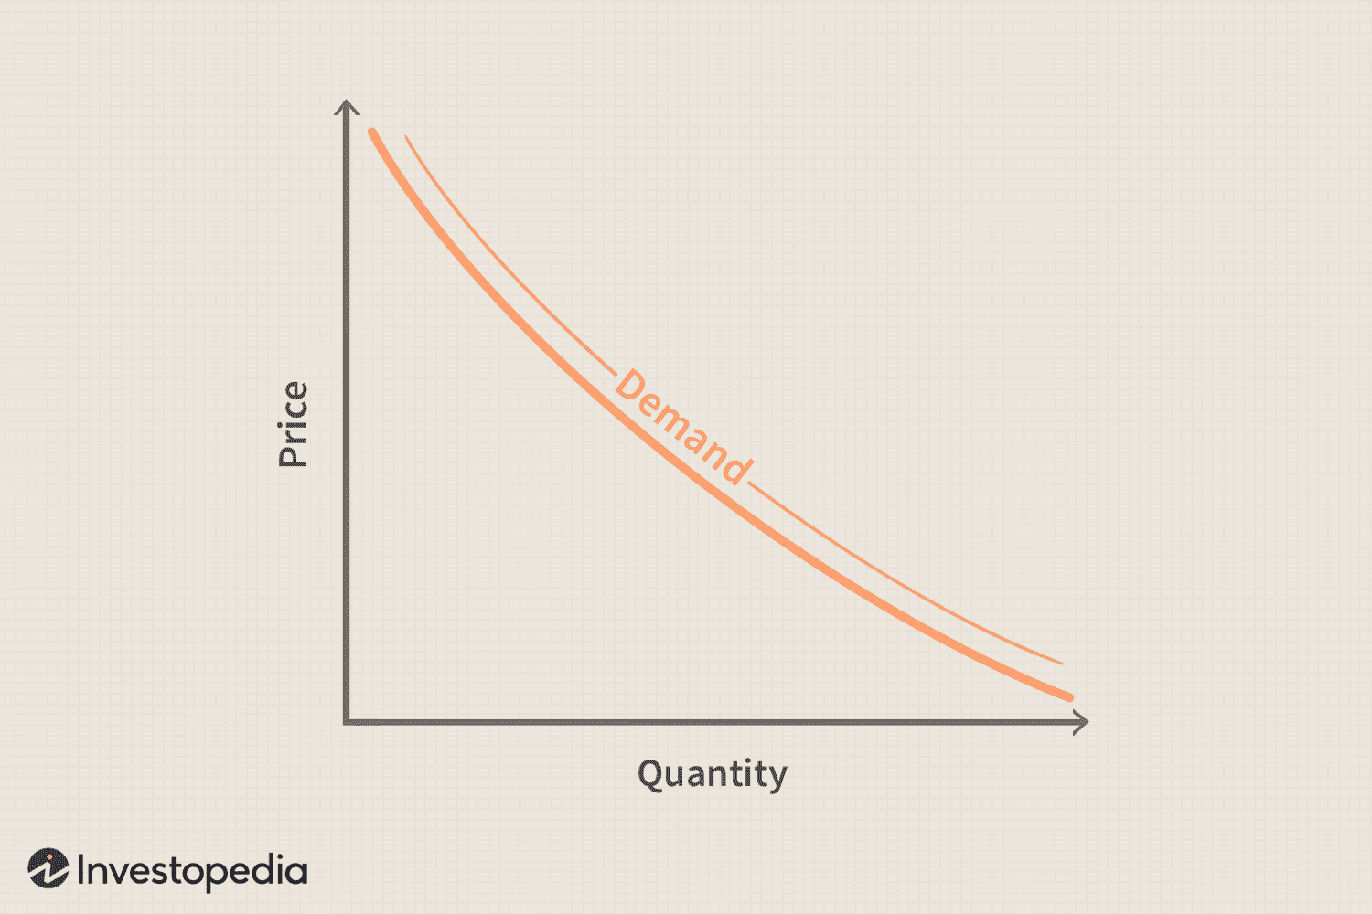

**2. Market Demand Schedule**

The tabular statement that shows different quantities of a commodity that all the consumers are willing and capable to purchase at different levels of prices during a given time period is referred to as the **Market Demand Schedule**. It is the aggregate of all individual demand schedules at all prices. The formula for the market demand schedule is:

**Dm = DA+DB+…….**

Where,

Dm is the market demand, and

DA+DB…… are the individual demands of Household A, Household B, and so on.

**Example:**

Assume that A and B are two consumers in the market of commodity x. The below table illustrates how the market demand schedule is created by horizontally adding the individual demand.

**Market Demand Schedule**

| **Price (in taka)** | **Individual Demand (in units)** | | **Market Demand (in units)**  **(DA+DB)** |
| --- | --- | --- | --- |
| **Household A (DA)** | **Household B (DB)** |
| 10 | 20 | 22 | 20 + 22 = 42 |
| 9 | 21 | 23 | 21 + 23 = 44 |
| 8 | 22 | 24 | 22 + 24 = 46 |
| 7 | 23 | 25 | 23 + 25 = 48 |
| 6 | 24 | 26 | 24 + 26 = 50 |
| 5 | 25 | 27 | 25 + 27 = 52 |

As shown in the above table, the market demand is calculated by adding together the demand of households A and B at various prices. Market demand is 42 units at taka 10 per unit. It increases to 44 units as the price drops to taka 9 per unit. As a result, the schedule of market demand also indicates the inverse relationship between quantity demanded and price.

**Supply**

**Supply** is a fundamental economic concept that refers to the total amount of a specific good or service that is available to consumers at various price levels during a certain time period. Supply represents the willingness and ability of producers to offer goods for sale in the market and is influenced by various factors. Here’s a more detailed explanation:

**Meaning of Supply:**

**Supply** can be defined as the quantity of a good or service that producers are prepared to sell at different price levels at a given time, holding all other factors constant (**ceteris paribus**). The concept encompasses the behavior of producers and how they respond to changes in market conditions.

**Characteristics of Supply:**

1. **Direct Relationship with Price**: Unlike demand, supply typically has a direct relationship with price. This means that as the price of a good or service increases, producers are generally willing to supply more of it, since higher prices can lead to higher revenue and profit. Conversely, if the price decreases, producers may be less inclined to supply the product because of reduced profitability.
2. **Market Supply vs. Individual Supply**:
   * **Individual Supply**: The supply of a good or service offered by a single producer.
   * **Market Supply**: The sum of the individual supplies from all producers in a market.

**The Law of Supply:**

The **Law of Supply** states that, **ceteris paribus**, an increase in the price of a good or service will result in an increase in the quantity supplied, and a decrease in price will lead to a decrease in the quantity supplied. This positive correlation between price and quantity supplied is due to the motivation to maximize profit.

**Supply Curve:**

* The **supply curve** is a graphical representation of the relationship between the price of a good and the quantity supplied.
* **Shape**: The curve generally slopes **upward** from left to right, indicating that as price increases, the quantity supplied increases.
* **Movement vs. Shift**:
  + **Movement Along the Curve**: Caused by a change in the price of the good, which results in a change in quantity supplied.
  + **Shift of the Curve**: Caused by changes in non-price factors (e.g., input costs, technology, taxes, subsidies), leading to an increase or decrease in supply at all price levels.

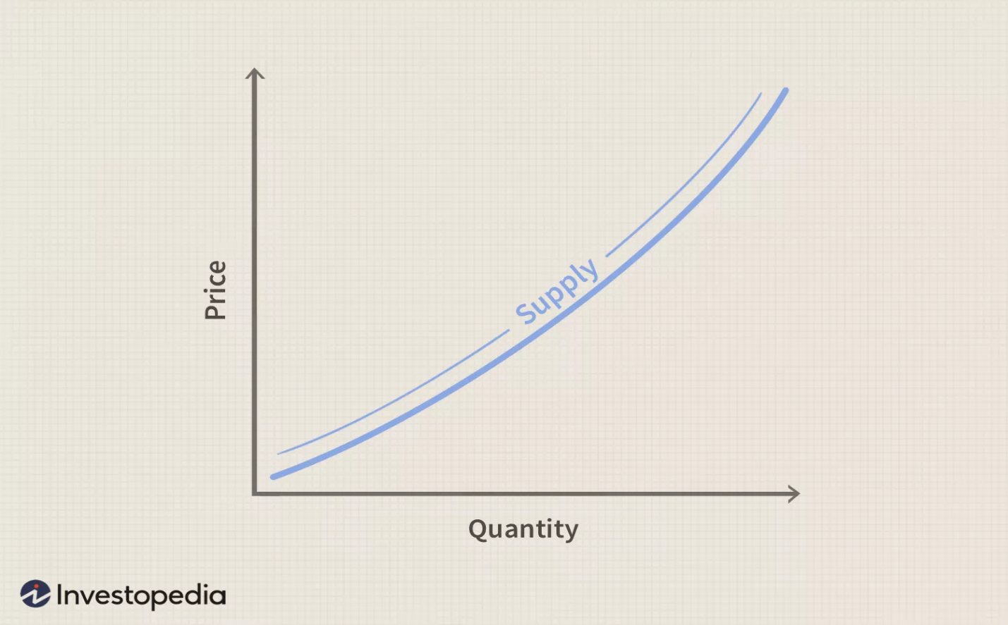

**Determinants of Supply:**

Several factors can affect supply and cause the supply curve to shift. These include:

1. **Production Costs**: Changes in the cost of inputs (e.g., raw materials, labor) can affect supply. Higher production costs reduce supply, while lower costs increase it.
2. **Technology**: Technological advancements can make production more efficient, increasing supply.
3. **Number of Producers**: An increase in the number of producers in the market increases supply, while a decrease reduces it.
4. **Expectations**: If producers expect future prices to be higher, they may hold back current supply to sell more in the future.
5. **Government Policies**: Taxes, subsidies, and regulations can affect production costs and the willingness of producers to supply a good.
6. **Natural Factors**: Events such as weather, natural disasters, or other external shocks can impact supply, especially for agricultural or resource-dependent industries.

The **Law of Supply**

The **Law of Supply** states that, **all else being equal**, the quantity of a good or service supplied by producers increases as the market price increases, and conversely, the quantity supplied decreases as the market price decreases. This is because higher prices provide an incentive for producers to produce and sell more of the good, as they can earn more revenue.

**Key points of the Law of Supply:**

1. **Positive Relationship**: There is a direct, positive relationship between price and quantity supplied. As the price of a good rises, producers are willing and able to produce more of it.
2. **Motivation**: Higher prices incentivize producers to increase production because they expect higher profits from selling at those prices.
3. **Ceteris Paribus**: The law holds true when other factors influencing supply (like production costs or technological advancements) remain constant.

**Example:**

* If the price of smartphones increases, manufacturers will be more inclined to produce and supply more smartphones because they can sell them at higher prices and make more profit.

A shift in the **demand** or **supply** curve refers to a change in the quantity of a good or service that consumers are willing to buy (demand) or producers are willing to sell (supply) at every price level, due to factors other than the good's price. Here’s an explanation of both:

**Shift in the Demand Curve**

A **demand curve** shows the relationship between the price of a good and the quantity demanded by consumers. A **shift** in the demand curve occurs when something other than the price of the good changes, leading consumers to buy more or less of the good at every price point.

**Factors that Cause a Shift in Demand:**

1. **Income:** If consumers’ incomes increase, they may demand more of a good, shifting the demand curve to the right. If income decreases, demand may fall, shifting the curve to the left.
2. **Tastes and Preferences:** A change in consumer preferences, such as a trend or a new health consideration, can lead to more demand for a good (rightward shift) or less demand (leftward shift).
3. **Prices of Related Goods:**
   * **Substitutes:** If the price of a substitute good (e.g., tea for coffee) rises, demand for the original good may increase (shift right).
   * **Complements:** If the price of a complementary good (e.g., printers for computers) falls, demand for the original good may increase (shift right).
4. **Expectations:** If consumers expect prices to rise in the future, they might buy more now, shifting the demand curve to the right.
5. **Population Size:** An increase in population or a change in demographics (e.g., more young families) may increase demand for certain goods.

**Effects of a Shift in Demand:**

* **Rightward Shift (Increase in Demand):** At every price level, consumers are willing to buy more of the good.
* **Leftward Shift (Decrease in Demand):** At every price level, consumers are willing to buy less of the good.

**Shift in the Supply Curve**

A **supply curve** shows the relationship between the price of a good and the quantity supplied by producers. A **shift** in the supply curve occurs when factors other than the price of the good change, leading producers to supply more or less of the good at every price level.

**Factors that Cause a Shift in Supply:**

1. **Production Costs:** If the cost of raw materials or labor increases, producers may supply less of a good, shifting the supply curve to the left. If production costs fall, the supply curve may shift to the right.
2. **Technology:** Technological advancements can make production more efficient, increasing supply (rightward shift).
3. **Number of Sellers:** If more producers enter the market, supply increases (rightward shift). If producers exit, supply decreases (leftward shift).
4. **Expectations:** If producers expect higher prices in the future, they may decrease current supply (shift left), anticipating higher profits later.
5. **Government Policies:** Taxes, subsidies, and regulations can affect supply. For example, a subsidy may encourage producers to supply more, shifting the supply curve to the right, while a tax may discourage supply, shifting it to the left.

**Effects of a Shift in Supply:**

* **Rightward Shift (Increase in Supply):** At every price level, producers are willing to supply more of the good.
* **Leftward Shift (Decrease in Supply):** At every price level, producers are willing to supply less of the good.

**Summary of Shifts:**

| **Factor** | **Shift in Demand Curve** | **Shift in Supply Curve** |
| --- | --- | --- |
| **Income** | Right (increase) or Left (decrease) | No effect |
| **Tastes/Preferences** | Right (increase) or Left (decrease) | No effect |
| **Prices of Related Goods** | Right (substitutes, price increase) or Left (complements, price increase) | No effect |
| **Expectations** | Right (future price increase) or Left (future price decrease) | Right (future price increase) or Left (future price decrease) |
| **Population** | Right (increase) | No effect |
| **Production Costs** | No effect | Left (increase) or Right (decrease) |
| **Technology** | No effect | Right (improvement) |
| **Number of Sellers** | No effect | Right (increase) or Left (decrease) |
| **Government Policies** | No effect | Right (subsidy) or Left (tax) |

These shifts play a critical role in determining equilibrium prices and quantities in the market.

**Equilibrium**

**Equilibrium** in economics refers to a state where the forces in a market are balanced, and there is no tendency for change. In the context of a market, equilibrium occurs when the quantity of a good or service demanded by consumers equals the quantity supplied by producers. This results in a stable market price and quantity, where neither buyers nor sellers have an incentive to change their behavior.

To explain market equilibrium using demand and supply curves:

1. **Demand Curve**: The demand curve shows the relationship between the price of a good and the quantity demanded by consumers. Typically, it slopes downward from left to right, meaning as the price decreases, consumers demand more of the good.
2. **Supply Curve**: The supply curve shows the relationship between the price of a good and the quantity supplied by producers. It usually slopes upward from left to right, meaning as the price increases, producers are willing to supply more of the good.

**Market Equilibrium**

The **equilibrium price** is where the demand curve intersects the supply curve. At this point:

* **Quantity demanded** (the amount buyers want to purchase) equals **quantity supplied** (the amount sellers want to produce and sell).
* There is no shortage or surplus in the market.
* The market "clears," meaning all goods are bought and sold at the equilibrium price.

Graphically:

* The **horizontal axis** represents the quantity of the good.
* The **vertical axis** represents the price of the good.
* The point where the demand and supply curves intersect is the **equilibrium point** (P*, Q*), where P* is the equilibrium price and Q* is the equilibrium quantity.

**Effects of Shifts in Demand or Supply**

1. **Shift in Demand**: If demand increases (the demand curve shifts to the right), the equilibrium price rises, and the equilibrium quantity increases. Conversely, if demand decreases (the demand curve shifts left), both the equilibrium price and quantity decrease.
2. **Shift in Supply**: If supply increases (the supply curve shifts to the right), the equilibrium price falls, and the equilibrium quantity rises. If supply decreases (the supply curve shifts left), the equilibrium price rises, and the equilibrium quantity falls.

In summary, equilibrium in a market is achieved when supply and demand are balanced, and any shifts in these curves lead to changes in the equilibrium price and quantity.

**What does Market Equilibrium mean?**

Market equilibrium is a stable state in a market where the quantities of supply and demand are equal. Market equilibrium occurs at an equilibrium price where the amount that buyers wish to purchase matches the amount that sellers wish to sell. Equilibrium creates a state where there are no inherent market pressures to raise or lower the price.

Market equilibrium results from the forces of supply and demand. The equilibrium price is determined by the intersection of the supply and demand curves. Below is a pictorial representation of the supply and demand curve.

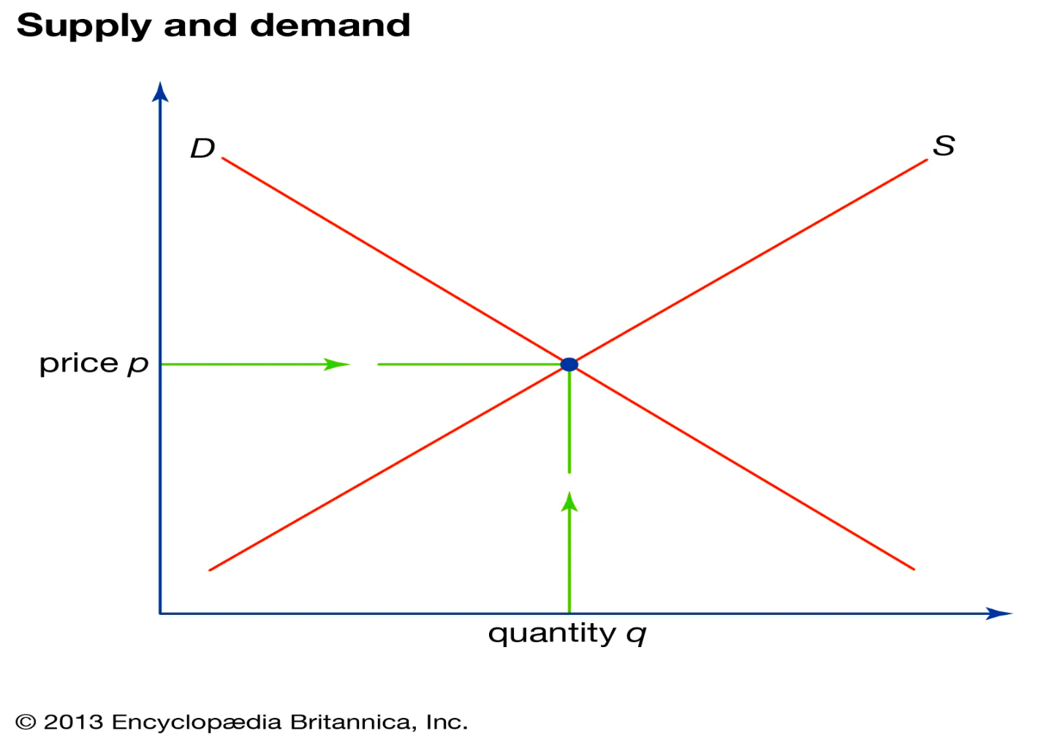

The quantity supplied exceeds demand at a higher price, resulting in a surplus that causes the price to fall. Demand exceeds supply at a lower price, resulting in a shortage that causes the price to rise. The equilibrium price balances these forces at a stable point.

Three characteristics of market equilibrium are equilibrium price, quantity and the absence of shortages and surpluses.

E**quilibrium price**

The quantity supplied by sellers equals the quantity demanded by buyers at the equilibrium price. Neither buyers nor sellers have an incentive to change from this price.

**Equilibrium quantity**

The quantity transacted that corresponds to the equilibrium price. Buyers purchase the same amount that sellers provide.

**Absence of shortages and surpluses**

Since the quantity supplied and demanded are equal, there is no leftover amount or unmet amount. The market clears.

The key factor that determine a market’s equilibrium is cost of production. The lower the cost to produce a good or service, the lower the equilibrium price. Higher costs require higher equilibrium prices to earn a profit. How sensitive consumers are to price changes impacts the equilibrium price as well. For inelastic goods, equilibrium prices remain stable. For elastic goods, small price changes significantly impact the equilibrium.

The difficulty of new suppliers entering a market allows existing suppliers to set higher equilibrium prices, as barriers to entry prevent easy access for new competitors. The market experiences an influx of new entrants, leading to reduced equilibrium prices.

Additionally, the availability of substitutes plays a crucial role in determining the equilibrium price, as markets with close substitutes tend to maintain lower prices, while those with limited alternatives can charge higher amounts. Seasonal factors also impact the equilibrium prices in certain markets, particularly for agricultural goods, as supply and demand change throughout the year.

Economic conditions significantly influence the equilibrium price, with strong economies and high demand driving prices upwards, whereas weak economies often result in lower equilibrium prices.

**How does Market Equilibrium function?**

Market equilibrium functions through the interaction of supply and demand in a market. The quantity supplied by sellers matches the quantity demanded by buyers at the equilibrium price. The market achieves a stable state where there are no shortages or surpluses and no pressures for the price to rise or fall.

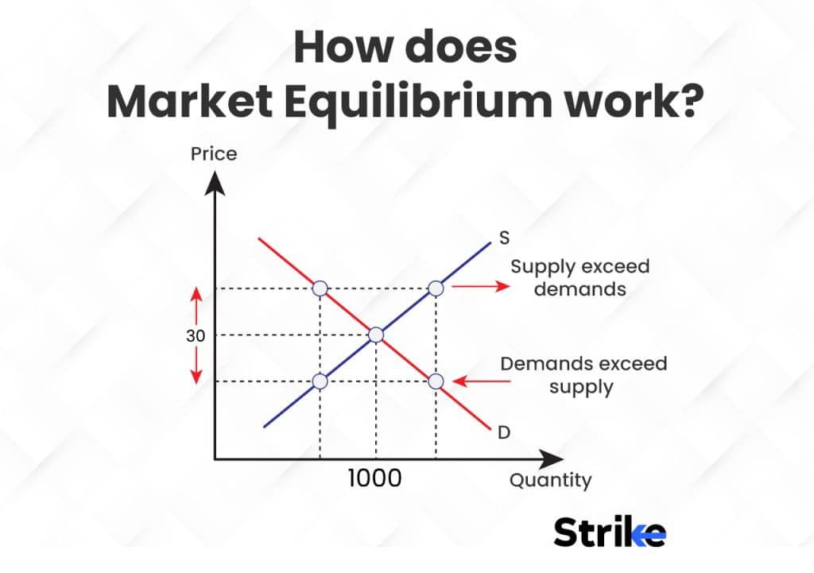

The market equilibrium works when the price is above equilibrium, the quantity supplied exceeds the quantity demanded. This results in a surplus that causes the price to decline. Sellers have to lower their price to sell excess supply. The quantity demanded exceeds the quantity supplied when the price is below equilibrium. This results in a shortage that causes the price to rise.

Buyers have to bid the price up to obtain limited supply. The price continues to fluctuate based on surpluses and shortages until it reaches the equilibrium price where supply and demand are in balance. The market achieves a state of rest with a stable quantity transacted at this price.

Equilibrium price or quantity changes signal a shift in the supply or demand curves due to influencing factors. The market equilibrium re-balances at a new price to clear surpluses or shortages. Equilibrium is a dynamic mechanism that is always seeking stability.

Microeconomists and business analysts pay close attention to market equilibrium, as it plays a crucial role in determining pricing strategies that maximize profitability without resulting in surpluses or shortages. The equilibrium price serves as the focal point in these analyses. Factors such as the sensitivity of demand to price changes, the availability of substitutes, and the elasticity of demand influence equilibrium prices. Equilibrium prices must remain competitive when demand is more elastic, while inelastic demand allows for higher equilibrium prices.

Market entry barriers and the market power of existing suppliers also impact equilibrium price levels. A more accessible market encourages new entrants, which leads to increased competition and lower equilibrium prices. Seasonal shifts in equilibrium quantity and pricing are essential to consider, as they inform tailored production, marketing, and sales strategies based on seasonal demand.

Analyzing the health of a market based on its current equilibrium state is vital. A high quantity and stable equilibrium price may signal a robust market, whereas volatile or declining equilibrium conditions could indicate a weakening market.

**Elasticity of Demand** and **Elasticity of Supply** are economic concepts that describe how the quantity demanded or supplied of a good or service changes in response to a change in its price.

1. **Elasticity of Demand**: This measures how sensitive the quantity demanded of a good or service is to changes in its price. It is calculated as the percentage change in the quantity demanded divided by the percentage change in price.
   * **Elastic Demand**: If demand is elastic, a small change in price will result in a large change in the quantity demanded. This typically happens with non-essential or luxury items, or when there are many substitutes available.
   * **Inelastic Demand**: If demand is inelastic, a change in price leads to a small change in quantity demanded. This is often the case for necessities like medicine or basic utilities, where consumers will buy roughly the same amount regardless of price changes.
   * **Unitary Elastic Demand**: If demand is unitary elastic, the percentage change in quantity demanded equals the percentage change in price.

**Formula**:

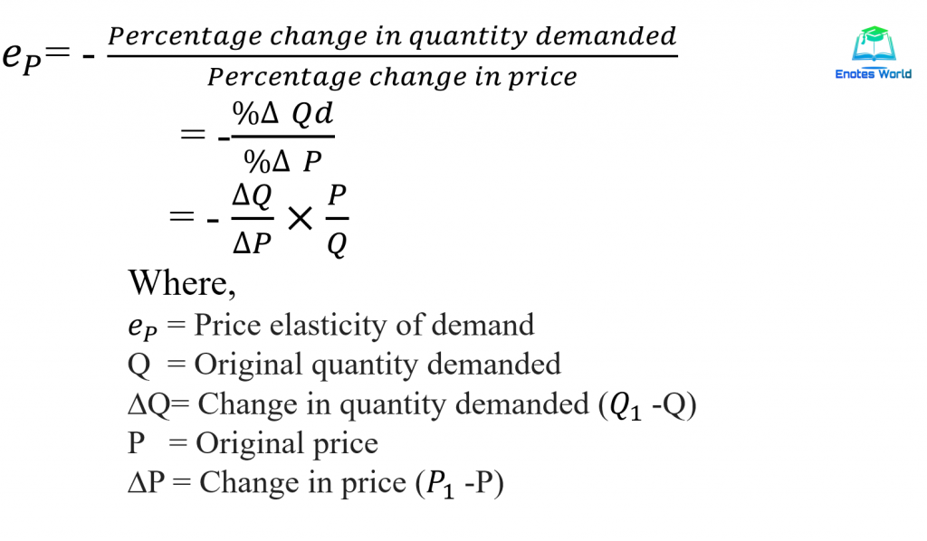

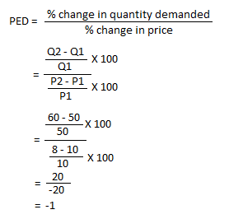

1. **Elasticity of Supply**: This measures how sensitive the quantity supplied of a good or service is to changes in its price. Similar to demand, it is calculated as the percentage change in the quantity supplied divided by the percentage change in price.
   * **Elastic Supply**: If supply is elastic, a small change in price will result in a large change in the quantity supplied. This is often seen in industries where production can easily be increased or decreased.
   * **Inelastic Supply**: If supply is inelastic, a change in price will cause only a small change in the quantity supplied. This often occurs in markets where production is limited or requires significant time to adjust.
   * **Unitary Elastic Supply**: If supply is unitary elastic, the percentage change in quantity supplied equals the percentage change in price.

**Understanding PES and Its Importance**

**Price Elasticity of Supply** is a measure used in economics to show how the quantity supplied of a good is affected by a change in its price. It is a crucial indicator for businesses and economists to understand market dynamics and to make informed decisions regarding production and pricing.

**Formula for Calculating PES**

The formula for calculating Price Elasticity of Supply is:

**PES = (% Change in Quantity Supplied) / (% Change in Price)**

The percentage changes are calculated using the following formulas:

* % Change in Quantity Supplied = [(New Quantity Supplied - Original Quantity Supplied) / Original Quantity Supplied] × 100
* % Change in Price = [(New Price - Original Price) / Original Price] × 100

**Detailed Interpretation of PES Values**

* 1. **PES > 1 (Elastic Supply):**Indicates that the supply is sensitive to price changes. A small increase in price results in a larger increase in quantity supplied.
* 2. **PES < 1 (Inelastic Supply):**Suggests that supply is relatively unresponsive to price changes. Changes in price have a lesser impact on the quantity supplied.
* 3. **PES = 1 (Unit Elastic Supply):**This is a balanced scenario where any change in price is matched by an equal percentage change in quantity supplied.
* 4.**PES = 0 (Perfectly Inelastic Supply):** The quantity supplied remains constant regardless of price changes.
* 5.**PES = ∞ (Perfectly Elastic Supply):** Any small change in price leads to an infinite change in the quantity supplied.

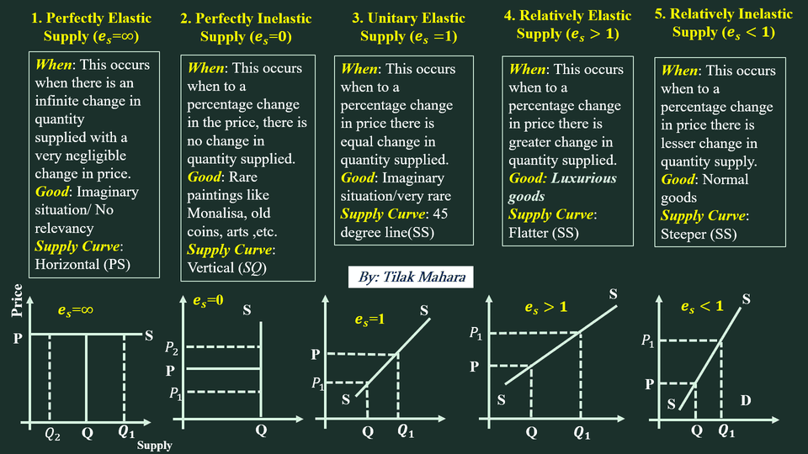

**Calculating PES: Practical Examples and Exercises**

**Example 1: Basic PES Calculation**

Let's consider a local bakery that increases its bread supply from 200 to 300 loaves due to a price rise from £2 to £2.50 per loaf.

* 1. Calculate the % change in quantity supplied: ((300 - 200) / 200) × 100 = 50%
* 2. Calculate the % change in price: ((£2.50 - £2) / £2) × 100 = 25%
* 3. PES = 50% / 25% = 2

The PES of 2 indicates an elastic supply, as the quantity supplied changes by a larger percentage than the price.

**Example 2: Application in Technology Industry**

Consider a tech company that increases the production of its gadgets from 10,000 to 12,000 units following a price increase from £300 to £330.

* 1. % Change in Quantity Supplied = ((12,000 - 10,000) / 10,000) × 100 = 20%
* 2. % Change in Price = ((£330 - £300) / £300) × 100 = 10%
* 3. PES = 20% / 10% = 2

**In both cases, the *greater than 1* elasticity indicates greater sensitivity to price changes (elastic), while *less than 1* elasticity means less sensitivity (inelastic).**