IoT-Enabled Multi-User PIC Microcontroller Remote Laboratory: Design and Simulation

Abstract—In the South Asia region most of the university laboratories and training institutes are only accessible during office hours. So, hands on training are possible only for one-third of the duration of a day, typically 9.00 am to 5.00 pm. The traditional microcontroller trainers come with a single on-board chip and a group of peripherals. Most of the peripherals remain idle and physical presence is necessary during a microcontroller experiment. This paper presents the design and simulation of a web controlled PIC microcontroller trainer that can be controlled from a remote place, and peripherals can be shared among 4 different users simultaneously. The microcontrollers can be programmed and monitored peripherals via IP camera over the internet. The proposed system has a wide variety of PIC microcontrollers including two PIC16F877A, one PIC18F452 and one PIC18F4520 microcontrollers. The web interface allows user authentication, scheduling system and single IP camera sharing among the four users. Simulation was done through Proteus ISIS professional software and, using test modules, the system performs at a 95% programming success rate via Raspberry Pi Zero 2W and PICKIT2 programmer. The result shows 5-8 second hex upload time and 200ms to 300ms average video latency for the proposed cost-effective system.
Index Terms—IoT-based laboratory, PIC microcontroller, remote programming, resource constraints, scheduling, multi-user access and microcontroller trainer.

I. Introduction
University laboratories in South Asia operate only during standard working hours, and students typically have access to microcontroller trainer for only a limited portion of the day. Remote laboratories overcome this limit and let students operate real equipment from any location [1]. Microcontroller trainer kits remain essential for embedded system courses, and platforms such as Arduino support peripheral interfacing, programming, and debugging with simple wiring [2]. Tight budgets push most universities in the region toward low-cost single-user trainers [3]. Internet of Things (IoT) trainer kits now serve digital circuit and electronics courses, yet they still assume for one user inside a fixed laboratory slot [4], [5].
Single-user design wastes the hardware. A trainer kit having one microcontroller and a full peripheral set, but an experiment drives only a few while the rest peripherals sit idle. Remote access alone does not fix this, because one remote user still locks the entire kit. Sharing the peripheral pool therefore substances as much as removing the physical barrier.
We address both problems with a web-controlled PIC trainer that serves four students at once. This paper makes four contributions:
- Designing an IoT-enabled, web-controlled PIC training system and validating its circuit in Proteus ISIS;
- Scheduling four concurrent users through a first-come, first-serve (FCFS) queue that blocks booking conflicts on microcontrollers and peripherals;
- Programming four PIC devices over the internet through one PICkit2 programmer, including chip detection, HEX transfer, and verification;
- Streaming hardware behavior to four simultaneous authorized users at 1080p and 30 frames per second through one shared IP camera.

II. Related Work
Remote laboratories for embedded hardware already exist, but none of them targets the PIC family. Jacko et al. built a remote IoT laboratory on STM32 devices that students program from a browser [6]. Garefalakis et al. joined a supervised remote laboratory to a learning management system and tested it with a class [7], [8]. RaspyControl Lab runs control experiments on a Raspberry Pi in real time [9]. Kandala et al. retrofitted existing benches with IoT gateways to hold the cost down [10], and Mehrtash and Ghalkhani streamed a wind tunnel to remote students [11]. At the infrastructure level, Rejon et al. and Czekalski et al. describe remote laboratory architectures for Industry 4.0 teaching [12], [13]. Guerrero-Osuna et al. placed an FPGA motor-control bench behind a cloud service [1], and ESP32 platforms serve STEM courses, security training, and collaborative SoC experiments [14]-[17].
Concurrent access remains an open problem. Villazon et al. report that most remote laboratories never enforce exclusive access, and they add a booking layer [18], while Lei et al. and Vilches et al. run several online experiments together [19], [20], though not using the trainer-kit hardware. Mahmoud and Abozariba show in their WebRTC review how latency and image quality trade against each other [21], so any claim of observable hardware needs an explicit streaming path.
Table I. Comparison of Remote Embedded Systems Laboratory Solutions
Metric | [6], [8], [9] | [10] | [1] | [18] | Ours
Platform | STM32 / R. Pi | IoT retrofit | FPGA | Energy lab | PIC16/18F
Concurrent users | No/ Single Use | Partial | No/ Single Use | Yes (booking) | Yes, FCFS (4/20)
Remote programming | Yes / GPIO | Partial | Yes | No | Yes, HEX
Video monitoring | No | Yes | Yes | No | Yes, 1080p
Peripheral sharing | Fixed | No | Fixed | No | Per-MCU multiplexing

Table I compares the proposed system with representative solutions. No reported platform joins remote HEX programming of PIC devices, live video, FCFS arbitration, and per-microcontroller peripheral multiplexing inside one low-cost kit.

III. System Architecture

A. Overall System Architecture
The system consists of five blocks: a client browser, a Raspberry Pi Zero 2W gateway, a programming and monitoring block, a microcontroller block, and a routing block. The browser lets an authorized user to access the microcontrollers and peripherals. The gateway runs the web server and the FCFS scheduler. The programming and monitoring block holds the PICkit2 programmer and the IP camera. The microcontroller block carries four PIC devices. The routing block holds dedicated relays that direct the in-circuit serial programming (ICSP) header to one microcontroller. A group of multiplexers controlled by Arduino and peripherals forms shared peripheral device pool that directs each peripheral control pin to a microcontroller pin.
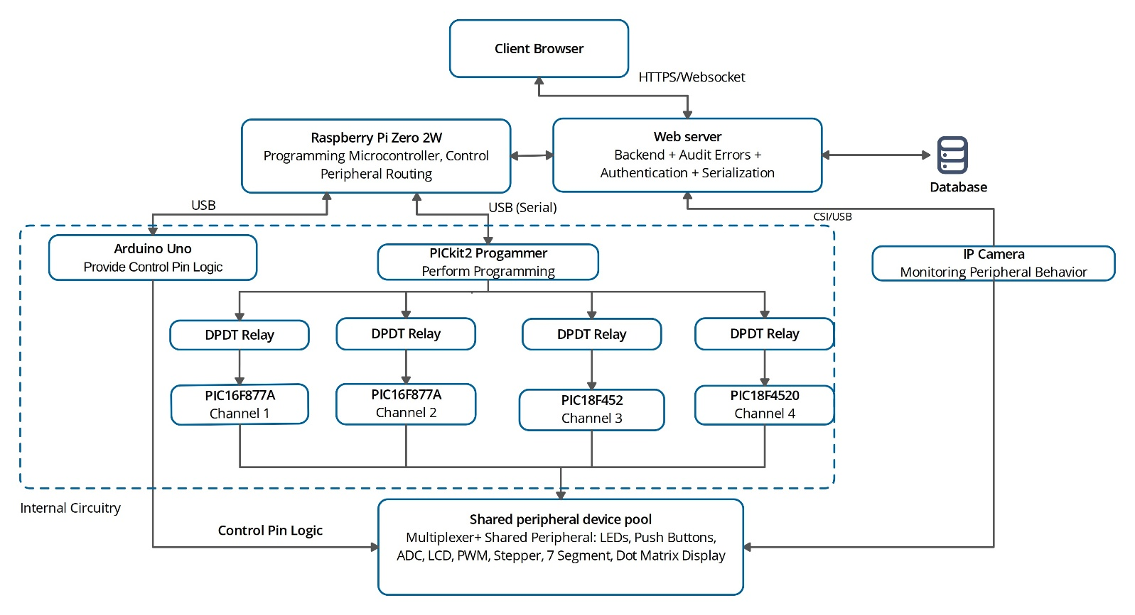
Fig. 1. Architectural block diagram of the proposed system.
Each session follows a fixed path. The user connects over the internet, and the scheduler grants a slot on one microcontroller. The gateway then accepts the .hex file, checks it against the target device, and receives it over the network. At the same time the gateway sends control logic to an Arduino UNO, which switches the routing circuitry so that the PICkit2 reaches the selected microcontroller and the requested peripherals reach the same device. Fig. 1 shows the complete architecture of the proposed system.
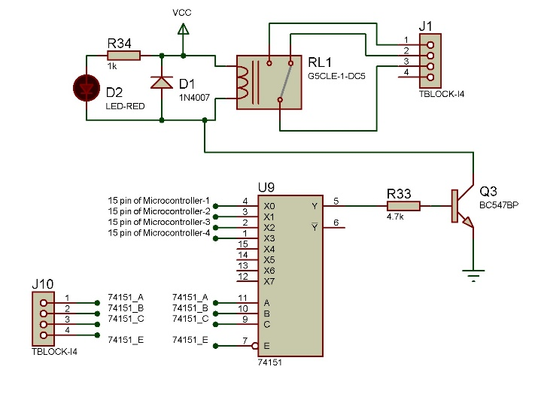
Fig. 2. Simulation technique of relay interfacing by 15th pin of four microcontrollers

B. Hardware Components
The web hosting and IP camera server activity is performed by a separate server computer while the Raspberry Pi Zero 2W connects the entire system to the specific server IP so that entire controlling can be performed smoothly. The Raspberry Pi controls the PICkit2 over USB through the pk2cmd utility. An Arduino UNO receives short serial commands from the Raspberry PI and drives the select lines of the routing circuitry and peripherals multiplexing. The microcontroller array holds two PIC16F877A, one PIC18F452, and one PIC18F4520 device on a single board. PICkit2 detects the chip, erases the chip memory, writes the HEX files, and verifies it on whichever channel the relays connect to the ICSP bus. Combination of PIC16 and PIC18 devices lets one kit to cover exercises written for either architecture.

C. Peripheral Sharing Through Multiplexing Circuitry
The peripheral sharing through multiplexing circuitry is termed as shared peripheral device pool and carries the main architectural contribution. A bank of IC 74151 8-to-1 data selectors sits between the microcontroller GPIO pin array and the peripheral’s control pins instead of a fixed peripheral set per device. Each group of IC 74151 takes its own select-line commands from the Arduino UNO to connect one peripheral to the specific microcontroller. Fig. 2 illustrates this technique through the simulation in Proteus ISIS Professional software. As, the design switches each peripheral separately through high-speed multiplexer ICs and these are controlled by GPIO pins rather than at one shared stage, the gateway grants or withdraws a peripheral on one channel without disturbing the other three. The select lines follow the FCFS scheduler, so a channel stay connected only while its session runs. Every microcontroller therefore reaches the entire pool, which removes the idle-peripheral problem of Section I.

D. Network and Security
Three channels carry traffic between the client and the hardware. HTTPS carries session control and queue updates, a WebSocket carries live scheduler state such as queue position and programming progress, and the real-time streaming protocol (RTSP) carries video from the IP camera. The session identifier issued at login binds all three, and a video zoom control lets each user framing the region that belongs to their own channel.
Security works at three levels. SSL/TLS protects the transport, bcrypt hashes every password before it enters the SQLite database, and JSON web tokens expire with the session duration so a captured token cannot be replayed. The gateway checks each uploaded file for valid standard HEX structure and for a size within the flash capacity of the target microcontroller before the file reaches the pickit2 programmer. In hardware, overcurrent protection guards the peripheral outputs and a watchdog timer resets the target microcontroller between sessions.

IV. Software and Scheduling Design

A. Web Interface and Session Flow
Registration and approval control lets a user to access the system and hardware. A new user submits a full name, an institutional identifier, an email address, and a password of at least eight characters that mixes letters, digits, and one special symbol. The administrator then approves the account, this keeps the platform inside the enrolled class. Returning users sign in through the login interface, shown in Fig. 3. Five failed attempts within fifteen minutes lock the form, and a short-lived reset link handles forgotten passwords through user registered email without administrator work.
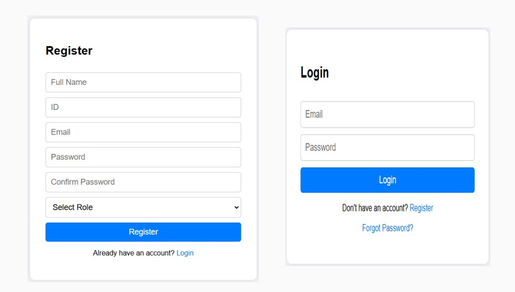
Fig. 3. Registration and login interface ((a) registration, (b) login).
At successful login, the dashboard then displays everything and a user needs to plan a session. It shows the state of the four PIC channels, the queue position of the user, the time left in the running session, and links to the upload page and the video window. It refreshes over the WebSocket of Section III-D, so a student decides whether to wait for a preferred channel without reloading the browser. The lab scheduling page in Fig. 4 adds the full queue and an estimated wait for each microcontroller, while administrators end sessions or clear conflicts from a separate panel.
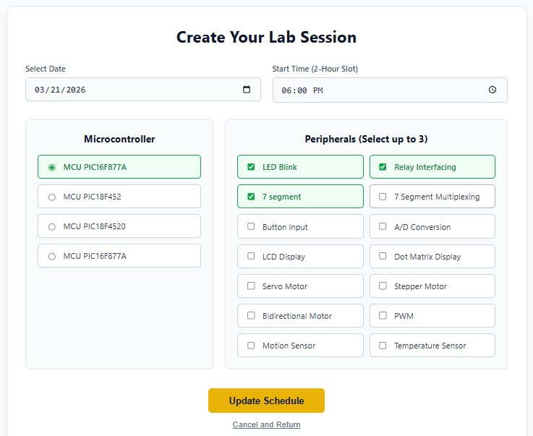
Fig. 4. Student’s session scheduling interface.

B. Session Scheduling and Resource Allocation
The scheduler allocates one microcontroller and up to three peripherals per slot. A user picks a date and a time window, and the system assigns the allotted hardware for the required two hours by default. Pressing Update Schedule button queries the current bookings and returns the conflicting booking of microcontrollers and peripherals as error message in that window. If no error is reported then Update Schedule confirms the reservation, and Start Session opens the programming interface once the window begins. If another user already holds the microcontroller or any requested peripheral within that time-slot, the system refuses the request and offers the next free slot.

C. Remote HEX Programming Pipeline
Eight stages carry a program from the student's machine to the target device in the lab.
- Generating the HEX file: The student compiles the source locally in MikroC PRO, MPLAB X, or any compatible IDE.
- Validating the upload: The dashboard accepts a .hex file within the flash size of the target program, that is 14 KB for PIC16F877A and 32 KB for PIC18F452 and PIC18F4520.
- Transferring to the gateway: The Node.js backend copies the validated file to the Raspberry Pi through the secure copy protocol over an encrypted SSH channel.
- Executing the program: The Raspberry Pi commands the Arduino UNO to switch the router, which ties the ICSP pins to the selected microcontroller.
- Erasing the Microcontroller Memory: Before programming, a memory erase operation should be done automatically for new hex file programming.
- Burning or Programming the Microcontroller: After erasing the microcontroller, burning or programming is performed through the PK2 command.
- Verifying the program: PICkit2 reads the programmed flash back and compares its checksum with the original file.
- Reporting the status: The pipeline loop repeats execution and verification up to five times. Within these five attempts, if all stages are successful, it returns a success message; otherwise it will provide an error message to the dashboard.
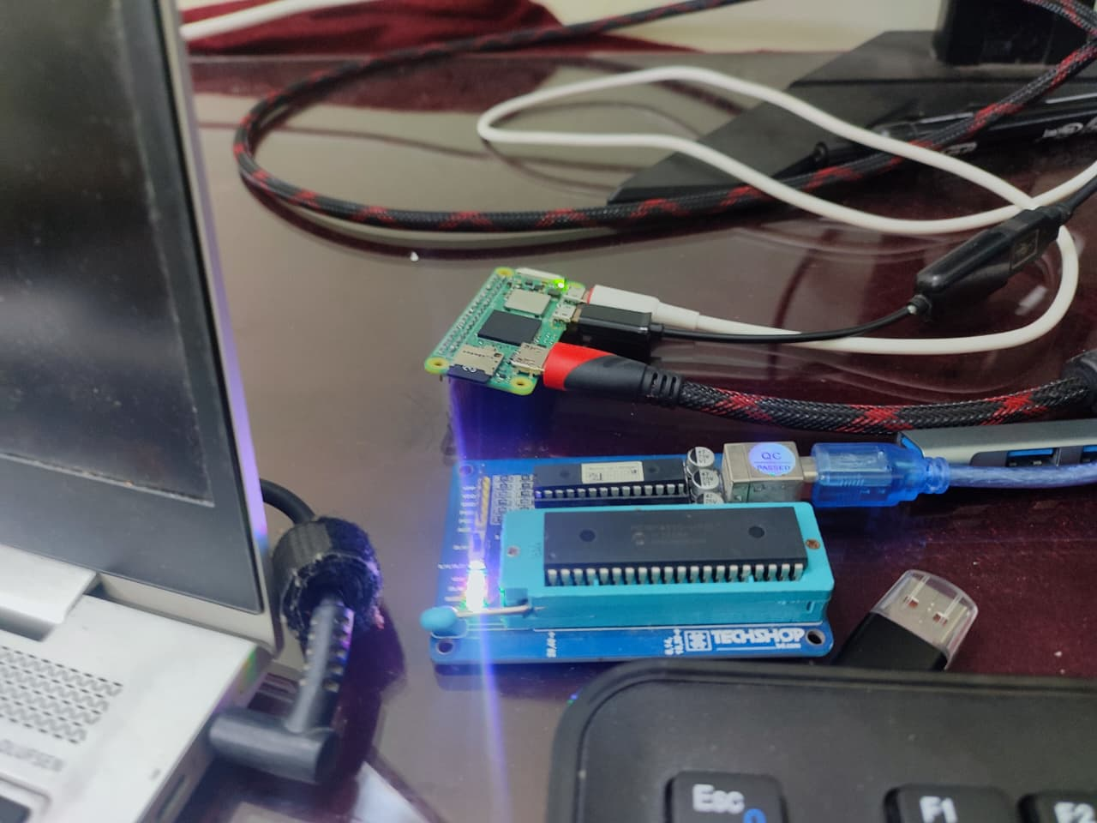
Fig. 5. Hex programming process using Raspberry Pi and PICKIT2 over internet.
Trial attempts is kept five. If any of one stage out of the abovementioned becomes failed due to hardware connectivity, VDD or VPP programming voltage issues the system provides programming failed message and tries again from beginning up to five times to provide final status. Programming is indicated by blinking LED of PICKIT2 programmer illustrated in Fig. 5 and the command performed by Raspberry PI for programming is:
localhost:~/pk2cmd/pk2cmd$ pk2cmd -M -PPIC18F4520 -F test.hex

D. Multiplexer-Based Peripheral Routing
The IC74151 8-to-1 data selector routes the allotted peripherals to the active microcontroller. When a session starts, the Raspberry Pi reads the peripheral allocation from the database and commands the Arduino UNO to raise the matching select lines. Those lines connect the data pins of the requested peripherals to the port pins of the assigned microcontroller for the length of the session. At logout, or when the slot ends, the connections return to a neutral state until the next login. As, one user holds at most three peripherals, the arrangement keeps four simultaneous sessions electrically isolated.
Table II. System Specifications and Hardware Components
Component | Specification | Purpose
Server Computer | Core I9 13 Gen, 64GB RAM, 24 GB Graphics card, 2 TB SSD | Hosting web pages, database processing and backend activities.
Assistive controller | Raspberry Pi Zero 2W (512 MB SDRAM, 1 GHz) | Programming command and controlling command.
Microcontrollers | PIC16F877A (2 pcs) (8 MHz), PIC18F452 (1 pcs) (10 MHz), PIC18F4520 (1 pcs) (10 MHz) | Target programming platform
Logic controller | Arduino UNO | Serial processing and logic control
Programmer | PICkit2 (USB) | ICSP HEX programming
Communication | WebSocket, RTSP, UART, HTTP | Real-time data exchange
Database | SQLite | Session and password storage, queue management
Backend | Node.js, Python and Flask | Authentication logic
Frontend | HTML5, JavaScript, CSS | Web interface
Compiler | MikroC PRO | MikroC-to-HEX compilation and file generation
Simulation | Proteus ISIS Professional 8.12 | Virtual circuit simulation and validation
Security | SSL/TLS, bcrypt | Authentication and password protection
Peripherals | LED, LCD, DC motor, ADC, temperature sensor, dot matrix, 7 segment, stepper motor, servo motor, PWM etc. | Experiment modules and simulation
Max concurrent users | 4 simultaneous users and a maximum of 20 | Scalability limit, and reconfigurable
Session duration | 2 hours (configurable) | Resource time allocation

E. Real-Time Hardware Behavior Monitoring
One IP camera above the kit serves all four users. It streams a continuous 1080p HD video feed to the dashboard as motion JPEG over RTSP, a format that every browser plays without any plug-in. At 30 frames per second and 200 to 300 ms latency, the feed resolves LED blinking patterns, LCD text, stepper motor step sequences, DC motor direction changes, seven-segment counter increments, standard servo angles, and push-button responses (will appear on the user dashboard for remote control if scheduled). Each simultaneous user selects and zooms the region that holds their own peripherals, and each user may reposition or reset that view during the session. Thus, one camera covers four independent experiments and makes the system cost-effective.

V. Results and Evaluation
We validated the routing and peripheral stages in Proteus ISIS Professional 8.12 and then deployed the web platform on the departmental local network. The complete schematic spans several sheets, so we omit it here for space. Every number below comes from sectional development and testing each section. Table II lists the system specification, and Table III summarizes the measured performance of each section.

A. Remote Programming Performance
The pipeline programmed the target correctly in 95% of attempts achieved through a lot of trials. We ran all peripherals simulation including: LED blinking, seven-segment counting, LCD text display, pulse-width modulation (PWM) motor control, analog-to-digital converter (ADC) sensor reading, and servo positioning. Transient USB interruptions between the Raspberry Pi and the PICkit2 caused most failures, and the programmer occasionally missed the programming voltage on the first try. As single line pk2cmd performs chip detection, erase memory, programing and verification, the five-attempt retry loop of Section IV-C recovered nearly all of them without any action from the user. Each attempt took 5 to 8 seconds from the program button to a verified device in the local network, close to the time a student spends with a local programmer physically in lab.

B. Multi-User Concurrency and Scheduling
Four users ran different hex programming on different microcontrollers at individual schedule without interfering with each other. No booking overlap, resource conflict, or cross-session coupling appeared in any run, and the scheduler rejected every attempted double booking. The system released and reassigned resources automatically at session boundaries, and the administrator panel reported session state, peripheral allocation, and queue position correctly for all four units.

C. Peripheral Operation Accuracy
All 14 types peripheral in the shared pool responded correctly when tested individually under remote control using ICSP pins only. The pool holds LED arrays, relay modules, seven-segment and dot-matrix displays, push-button arrays, ADC modules, LCD panels, servo, stepper, and bidirectional DC motors, PWM outputs, motion sensors, and temperature sensors. We observed no electrical coupling between channels during programming and individual peripheral actions while all four units were in operation, which confirms the isolation that the per-microcontroller multiplexer provides. Fig. 6 shows the camera view that users can view during peripheral tests.
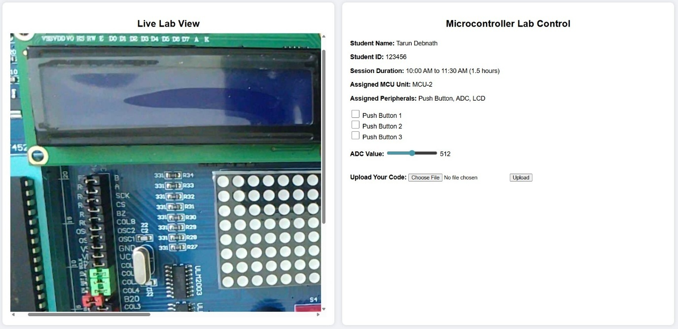
Fig. 6. Real-time IP camera view of the hardware part through web dashboard.
Table III. Summary of System Performance Metrics
Metric | Value | Remarks
HEX programming success rate | 95% | Residual 5% from USB interrupts or PICkit2 programming voltage VDD or VPP.
Typical programming time | 5 to 8 seconds | Acceptable for real-time educational use
IP camera frame and resolution rate | 30 fps and 1080p resolution | Motion JPEG over RTSP and HTTP
Video latency | 200 to 300 ms | Suitable for live hardware observation
Max simultaneous users | 4 active and 20 queued users | Per trainer kit (Scalable)
Session duration | 2 hours | First-come, first-serve (FCFS) queue scheduling
Scheduling conflicts detected | 0 | No double bookings in all test runs
Simulated Peripherals tested | LED +13 types | All passed in simulation and only LED blinking is performed through remote operation verification
Message latency | Less than 500 ms | Dashboard visualization over local network
WebSocket update interval | 200 ms | Dashboard peripheral state refresh

D. Video Monitoring Quality
The camera held 1080p at 30 frames per second with 200 to 300 ms latency in every session. That rate resolves all dynamic behavior of the kit, and the zoom control will let the user to observe LED blinking, motor direction, display updates, or button responses in one region of interest. During simultaneous sessions, four users watched four separate regions through the same camera without conflict and without quality loss, which keeps the system cost low.

VI. Discussion
A. Advantages and Educational Impact
24/7 access and peripheral sharing together answer the barriers of Section I. Continuous access roughly triples the window that students have for experiments. A conventional kit runs one experiment, while this kit runs four at a comparable cost and queues twenty(scalable), so a department that owns few kits lowers its hardware cost per student. Live video keeps much of the feedback of physical laboratory work, because the student still watches a real device answer their own code.
B. Limitations
Four concurrent users per kit is the present ceiling. Additionally, in future Fig. 6. live lab view will show our deployed peripherals instead of the present one. This basically shows the testing of the IP camera. The platform also depends on a stable network at both ends, since limited bandwidth degrades the camera stream. We tested all peripherals through simulation, not deployed in an integrated format. Because of remote access, students cannot move a jumper wire or probe from their own instruments. The proposed system introduces fixed I/O pins for each peripheral. Finally, we validated the circuit in Proteus ISIS and using local network, so behavior over the public internet and with a full class still needs to be tested.

VII. Conclusion and Future Work
We designed and simulated a web-controlled, IoT-based PIC microcontroller training system. The platform authenticates users, accepts HEX uploads over the internet, and shows hardware behaviour through one IP camera. An Arduino UNO binds the scheduled microcontroller and peripherals to each user, and an FCFS queue controls the schedule. Unlike a traditional trainer that serves one user, this kit serves four users at once, thus the system cost reduces, and frees hands-on practice from official hours.
Future work will complete the implementation and deploy the system in an institutional environment with active internet service. We also plan to add microcontroller families beyond PIC, to optimize the hardware and to measure server load in real time as the number of users grows.
References
[1] H. A. Guerrero-Osuna et al., “Developing a cloud- and IoT-integrated remote laboratory to enhance Education 4.0: An approach for FPGA-based motor control,” Appl. Sci., vol. 14, no. 22, Art. no. 10115, Nov. 2024, doi: 10.3390/app142210115.
[2] A. Nayak, N. Hiremath, U. F. M., V. Garagad, and S. Chickerur, “Teaching microcontrollers using Arduino as a platform,” in Proc. 2022 IEEE Global Eng. Educ. Conf. (EDUCON), Mar. 2022, pp. 941–945, doi: 10.1109/EDUCON52537.2022.9766727.
[3] M. M. Devarajan, S. Parthasarathi, and M. A. Ganesh, “Low-cost digital trainer experimentation platform: A case study,” J. Eng. Educ. Transform., vol. 36, no. S2, pp. 500–503, Jan. 2023, doi: 10.16920/jeet/2023/v36is2/23076.
[4] W. Mustakim, H. Effendi, Aswardi, M. Giatman, Hariyadi, and W. D. Pratiwi, “Development of Internet of Things trainer kit as a learning medium for digital circuit subjects in higher education,” Int. J. Online Biomed. Eng., vol. 20, no. 9, pp. 4–16, Jun. 2024, doi: 10.3991/ijoe.v20i09.48349.
[5] A. Efendi, Armansyah, M. M. Sakanti, A. Surjanto, and C. B. D. Kuncoro, “Development of microcontroller trainer kit as a teaching aid for electronics course,” AIP Conf. Proc., vol. 3115, no. 1, Art. no. 040003, Sep. 2024, doi: 10.1063/5.0207460.
[6] P. Jacko et al., “Remote IoT education laboratory for microcontrollers based on the STM32 chips,” Sensors, vol. 22, no. 4, Art. no. 1440, Feb. 2022, doi: 10.3390/s22041440.
[7] M. Garefalakis and S. Panagiotakis, “Integration of a remote lab with a learning system for training on microcontroller programming,” in Proc. 27th Pan-Hellenic Conf. Progress Comput. Informatics, Nov. 2023, pp. 224–231, doi: 10.1145/3635059.3635094.
[8] M. Garefalakis, Z. Kamarianakis, and S. Panagiotakis, “Towards a supervised remote laboratory platform for teaching microcontroller programming,” Information, vol. 15, no. 4, Art. no. 209, Apr. 2024, doi: 10.3390/info15040209.
[9] J. Alvarez Ariza and C. Nomesqui Galvis, “RaspyControl Lab: A fully open-source and real-time remote laboratory for education in automatic control systems using Raspberry Pi and Python,” HardwareX, vol. 13, Art. no. e00396, Mar. 2023, doi: 10.1016/j.ohx.2023.e00396.
[10] S. V. Kandala et al., “Engineering end-to-end remote labs using IoT-based retrofitting,” IEEE Access, vol. 13, pp. 1106–1132, 2025, doi: 10.1109/ACCESS.2024.3523066.
[11] M. Mehrtash and M. Ghalkhani, “Adapting experiential e-learning in engineering education with the use of a telepresence system for wind tunnel experiences in automotive engineering,” in Towards a Hybrid, Flexible and Socially Engaged Higher Education, M. E. Auer, U. R. Cukierman, E. Vendrell Vidal, and E. Tovar Caro, Eds., Lecture Notes in Networks and Systems, vol. 901. Cham, Switzerland: Springer, 2024, pp. 305–313, doi: 10.1007/978-3-031-53022-7_31.
[12] C. Rejon, S. Martin, and A. Robles-Gomez, “Easy development of Industry 4.0 remote labs,” Electronics, vol. 13, no. 8, Art. no. 1508, Apr. 2024, doi: 10.3390/electronics13081508.
[13] P. Czekalski et al., “Design and implementation of a next-generation remote lab for IoT and Industry 4.0,” Procedia Comput. Sci., vol. 270, pp. 387–396, 2025, doi: 10.1016/j.procs.2025.09.157.
[14] S. Amador Nelke et al., “Enhancing lessons on the Internet of Things in science, technology, engineering, and medical education with a remote lab,” Sensors, vol. 24, no. 19, Art. no. 6424, Oct. 2024, doi: 10.3390/s24196424.
[15] A. R. Rao and A. Elias-Medina, “Designing an Internet of Things laboratory to improve student understanding of secure IoT systems,” Internet Things Cyber-Phys. Syst., vol. 4, pp. 154–166, 2024, doi: 10.1016/j.iotcps.2023.10.002.
[16] N. Abekiri, A. Rachdy, M. Ajaamoum, B. Nassiri, L. Elmahni, and Y. Oubail, “Platform for hands-on remote labs based on the ESP32 and Node-RED,” Sci. Afr., vol. 19, Art. no. e01502, Mar. 2023, doi: 10.1016/j.sciaf.2022.e01502.
[17] R. Al Amin, V. Wiese, M. M. Rahman, S. Jacobs, S. Jaschke, and R. Obermaisser, “Architecture of IoT-based collaborative laboratory for reconfigurable SoC: Review and development,” in Proc. 2023 IEEE 2nd German Educ. Conf. (GECon), Aug. 2023, pp. 1–6, doi: 10.1109/GECon58119.2023.10295073.
[18] A. Villazón, O. Ormachea, A. Orellana, A. Zenteno, and T. Fransson, “Work in progress: A booking system for remote laboratories—The EXPLORE Energy Digital Academy case study,” in Open Science in Engineering, M. E. Auer, R. Langmann, and T. Tsiatsos, Eds., Lecture Notes in Networks and Systems, vol. 763. Cham, Switzerland: Springer, 2024, pp. 341–348, doi: 10.1007/978-3-031-42467-0_31.
[19] Z. Lei, H. Zhou, W. Hu, and G.-P. Liu, “Concurrent experimentation in NCSLab: A scalable approach for online laboratories,” Future Gener. Comput. Syst., vol. 148, pp. 139–149, Nov. 2023, doi: 10.1016/j.future.2023.05.014.
[20] M. Vilches, H. Vargas, L. de la Torre, and R. Heradio, “Scalable hybrid laboratories: Application in industrial automation,” Results Eng., vol. 26, Art. no. 105342, Jun. 2025, doi: 10.1016/j.rineng.2025.105342.
[21] H. Mahmoud and R. Abozariba, “A systematic review on WebRTC for potential applications and challenges beyond audio-video streaming,” Multimedia Tools Appl., vol. 84, no. 6, pp. 2909–2946, 2025, doi: 10.1007/s11042-024-20448-9.

