Report

In this Assessment Project I have design and Display UI Interface for the MoviesRentalSystem. Through this project the shopkeeper can Add customers Name and also keep the data for the rented Movie issued. Shopkeeper Also delete and add Movie to The Data List of the movies. Below is the Implementation of Design of UI with full code and Unit Test.

Code:-

using System;

using System.Collections.Generic;

using System.ComponentModel;

using System.Data;

using System.Drawing;

using System.Linq;

using System.Text;

using System.Threading.Tasks;

using System.Windows.Forms;

using System.Data.SqlClient;

namespace MoviesRentalSystems

{

public partial class Form1 : Form

{

public SqlConnection conn = null;

public bool Connection,Show_Lists;

public Form1()

{

InitializeComponent();

string connect = "Server=localhost\\SQLEXPRESS;Database=master;Trusted_Connection=True;";

try {

Connection = false;

conn = new SqlConnection(connect);

conn.Open();

Connection = true;

SqlCommand cmd;

Show_Lists = false;

String Sql_Movies = "Select MovieID,Title,Genre,Rental_Cost,Year From Movies";

String Sql_Rentals = "Select RMID, C.FirstName as FirstName, C.LastName as LastName, C.Address as Address,M.Title as Title, M.Rental_Cost as Rental_Cost, R.DateRented, R.DateReturned From RentedMovies R join Customer C on R.CustIDFK=C.CustID join Movies M on R.MovieIDFK=M.MovieID";

String Sql_Customers = "Select CustID,FirstName,LastName, Address, Phone From Customer";

cmd = new SqlCommand(Sql_Movies,conn);

SqlDataAdapter Adp_Movies = new SqlDataAdapter(cmd);

DataTable Data_Grid = new DataTable();

Adp_Movies.Fill(Data_Grid);

moviesGrid.DataSource = Data_Grid;

cmd = new SqlCommand(Sql_Rentals, conn);

SqlDataAdapter Adp_Rentals = new SqlDataAdapter(cmd);

DataTable Data_Grid1 = new DataTable();

Adp_Rentals.Fill(Data_Grid1);

RentalGrid.DataSource = Data_Grid1;

cmd = new SqlCommand(Sql_Customers, conn);

SqlDataAdapter adpCus = new SqlDataAdapter(cmd);

DataTable Data_Grid2 = new DataTable();

adpCus.Fill(Data_Grid2);

CustGrid.DataSource = Data_Grid2;

// dataReader = cmd.ExecuteReader();

Show_Lists = true;

}

catch(Exception e)

{

if (Connection == false)

conn = null;

Show_Lists = false;

MessageBox.Show("Connection Error");

}

}

private void Form1_Load(object sender, EventArgs e)

{

}

private void AddressCust_TextChanged(object sender, EventArgs e)

{

}

private void Cust_ID_TextChanged(object sender, EventArgs e)

{

}

String First_Name = "", Last_Name = "",Title="";

String Issue_Date = "", Return_Date = "";

DateTime iss_Date,rtn_Date;

private void RentalGrid_CellContentClick(object sender, DataGridViewCellEventArgs e)

{

String Mobile = "";

First_Name = (string)RentalGrid[1, e.RowIndex].Value;

Last_Name = (string)RentalGrid[2, e.RowIndex].Value;

Title = (string)RentalGrid[4, e.RowIndex].Value;

String Phone_No = "Select Phone From Customer Where FirstName='"+First_Name+"' and LastName='"+Last_Name+"'";

SqlCommand cmd = new SqlCommand(Phone_No, conn);

SqlDataReader dataReader= cmd.ExecuteReader();

if(dataReader.Read())

{

Mobile = dataReader.GetString(0);

}

dataReader.Close();

Cust_ID.Text = RentalGrid[0, e.RowIndex].Value.ToString();

FirstNameCust.Text = First_Name;

LastName_Cust.Text = Last_Name;

AddressCust.Text = (string)RentalGrid[3, e.RowIndex].Value;

PhoneCust.Text = Mobile;

Issue_Date = RentalGrid[6, e.RowIndex].Value.ToString();

iss_Date = Convert.ToDateTime(Issue_Date);

Return_Date = RentalGrid[7, e.RowIndex].Value.ToString();

rtn_Date = Convert.ToDateTime(Return_Date);

IssueMovieDate.Text = Issue_Date;

ReturnedDate.Text = Return_Date;

}

String Custmer_ID = "";

private void CustGrid_CellContentClick(object sender, DataGridViewCellEventArgs e)

{

Custmer_ID = CustGrid[0, e.RowIndex].Value.ToString();

Cust_ID.Text = Custmer_ID;

FirstNameCust.Text= (string)CustGrid[1, e.RowIndex].Value;

LastName_Cust.Text = (string)CustGrid[2, e.RowIndex].Value;

AddressCust.Text = (string)CustGrid[3, e.RowIndex].Value;

PhoneCust.Text = (string)CustGrid[4, e.RowIndex].Value;

}

private void deleteCust_Click(object sender, EventArgs e)

{

String Delete_Query = "Delete From Customer where CustID ="+Custmer_ID+"";

SqlCommand cmd = new SqlCommand(Delete_Query, conn);

SqlDataReader dataReader = cmd.ExecuteReader();

MessageBox.Show("Customer deleted sucessfully");

dataReader.Close();

}

private void updateButton_Click(object sender, EventArgs e)

{

tabControl1_movisRenatl.SelectedTab = customersTab;

String Sql_Customers = "Select * From Customer";

SqlCommand cmd = new SqlCommand(Sql_Customers, conn);

SqlDataAdapter Adp_Rentals = new SqlDataAdapter(cmd);

DataTable Data_Grid1 = new DataTable();

Adp_Rentals.Fill(Data_Grid1);

CustGrid.DataSource = Data_Grid1;

}

private void button_Deletemovie_Click(object sender, EventArgs e)

{

String Delete_Query = "Delete From Movies where MovieID =" + MovId + "";

Console.WriteLine(Delete_Query);

SqlCommand cmd = new SqlCommand(Delete_Query, conn);

SqlDataReader dataReader = cmd.ExecuteReader();

MessageBox.Show("Movie Deleted sucessfully");

dataReader.Close();

}

private void button_updatemovie_Click(object sender, EventArgs e)

{

tabControl1_movisRenatl.SelectedTab = MoviesTab;

String Sql_Customers = "Select * From Movies";

SqlCommand cmd = new SqlCommand(Sql_Customers, conn);

SqlDataAdapter Adp_Rentals = new SqlDataAdapter(cmd);

DataTable Data_Grid1 = new DataTable();

Adp_Rentals.Fill(Data_Grid1);

moviesGrid.DataSource = Data_Grid1;

}

private void button_AddCustomer_Click(object sender, EventArgs e)

{

String FirstName = FirstNameCust.Text;

String LastName = LastName_Cust.Text;

String Addrss = AddressCust.Text;

String phone_No = PhoneCust.Text;

String Insert_Query = "Insert into Customer ([FirstName], [LastName], [Address], [Phone]) Values('" + FirstName+"','"+LastName+"','"+Addrss+"','"+phone_No+"')";

SqlCommand cmd = new SqlCommand(Insert_Query, conn);

SqlDataReader dataReader = cmd.ExecuteReader();

MessageBox.Show("Customer Added sucessfully");

dataReader.Close();

}

private void button_Addmovie_Click(object sender, EventArgs e)

{

String Titlemov = TitleMovie.Text;

String genre = GenreMovie.Text;

String Rentalmov = RentalCostMovie.Text;

String RelDate = ReleaseDate.Text;

String Insert_Query = "Insert into Movies ( [Title], [Genre], [Rental_Cost], [Year]) Values('" + Titlemov + "','" + genre + "','" + Rentalmov + "','" + RelDate + "')";

SqlCommand cmd = new SqlCommand(Insert_Query, conn);

SqlDataReader dataReader = cmd.ExecuteReader();

MessageBox.Show("Movie Added sucessfully");

dataReader.Close();

}

String MovId = "";

private void moviesGrid_CellContentClick(object sender, DataGridViewCellEventArgs e)

{

MovId = moviesGrid[0, e.RowIndex].Value.ToString();

MovieID.Text = MovId;

TitleMovie.Text = (string)moviesGrid[1, e.RowIndex].Value;

GenreMovie.Text = moviesGrid[2, e.RowIndex].Value.ToString();

RentalCostMovie.Text = moviesGrid[3, e.RowIndex].Value.ToString();

ReleaseDate.Text = moviesGrid[4, e.RowIndex].Value.ToString();

}

private void issueMovie_Click(object sender, EventArgs e)

{

String Insert_Qry = "Insert into RentedMovies ( [MovieIDFK], [CustIDFK], [DateRented], [DateReturned]) Values("+MovId+","+Custmer_ID+",'"+ iss_Date + "','"+rtn_Date+"')";

SqlCommand cmd = new SqlCommand(Insert_Qry, conn);

SqlDataReader dataReader = cmd.ExecuteReader();

dataReader.Close();

String Sql_Rentals = "Select RMID, C.FirstName as FirstName, C.LastName as LastName, C.Address as Address,M.Title as Title, M.Rental_Cost as Rental_Cost, R.DateRented, R.DateReturned From RentedMovies R join Customer C on R.CustIDFK=C.CustID join Movies M on R.MovieIDFK=M.MovieID";

MessageBox.Show("Movie issued sucessfully");

cmd = new SqlCommand(Sql_Rentals, conn);

SqlDataAdapter Adp_Rentals = new SqlDataAdapter(cmd);

DataTable Data_Grid1 = new DataTable();

Adp_Rentals.Fill(Data_Grid1);

RentalGrid.DataSource = Data_Grid1;

}

private void returnMovie_Click(object sender, EventArgs e)

{

String Delete_Query = "Delete From RentedMovies where CustIDFK =(Select CustID from Customer where FirstName ='"+First_Name+"') and MovieIDFK =(Select MovieID from Movies where Title = '"+Title+"')";

SqlCommand cmd = new SqlCommand(Delete_Query, conn);

SqlDataReader dataReader = cmd.ExecuteReader();

MessageBox.Show("Customer Rented Information deleted sucessfully");

String Sql_Rentals = "Select RMID, C.FirstName as FirstName, C.LastName as LastName, C.Address as Address,M.Title as Title, M.Rental_Cost as Rental_Cost, R.DateRented, R.DateReturned From RentedMovies R join Customer C on R.CustIDFK=C.CustID join Movies M on R.MovieIDFK=M.MovieID";

dataReader.Close();

cmd = new SqlCommand(Sql_Rentals, conn);

SqlDataAdapter Adp_Rentals = new SqlDataAdapter(cmd);

DataTable Data_Grid1 = new DataTable();

Adp_Rentals.Fill(Data_Grid1);

RentalGrid.DataSource = Data_Grid1;

}

private void radioButton_Allrented_CheckedChanged(object sender, EventArgs e)

{

tabControl1_movisRenatl.SelectedTab = RenatlTAb;

String Sql_Rentals = "Select RMID, C.FirstName as FirstName, C.LastName as LastName, C.Address as Address,M.Title as Title, M.Rental_Cost as Rental_Cost, R.DateRented, R.DateReturned From RentedMovies R join Customer C on R.CustIDFK=C.CustID join Movies M on R.MovieIDFK=M.MovieID";

SqlCommand cmd = new SqlCommand(Sql_Rentals, conn);

SqlDataAdapter Adp_Rentals = new SqlDataAdapter(cmd);

DataTable Data_Grid1 = new DataTable();

Adp_Rentals.Fill(Data_Grid1);

RentalGrid.DataSource = Data_Grid1;

}

}

}

Output :

1. When We Start Debugging Code the below Screen Will appear.

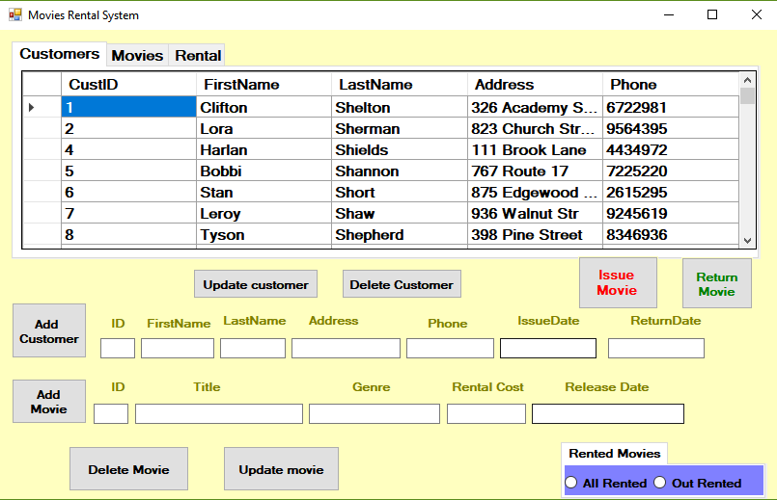

2. Shopkeeper can Add the Customer Name To the Database.

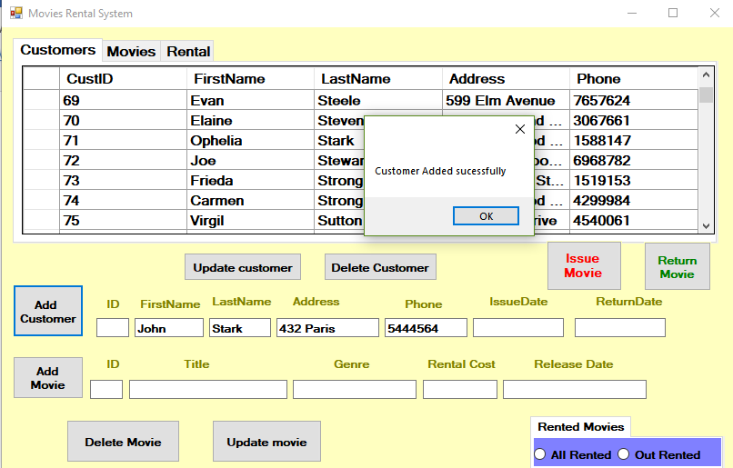

3. After Adding The Customer Name to the Database, Updated the Customer lists.

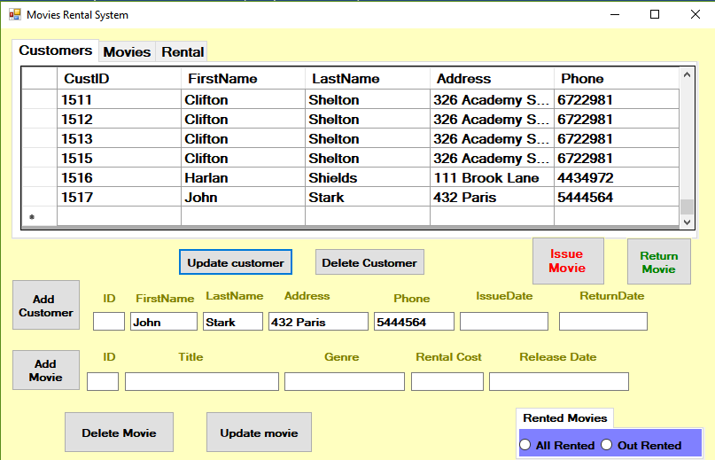

4. Shopkeeper Can delete the Customer Information from The Database, which has not rented any movies.

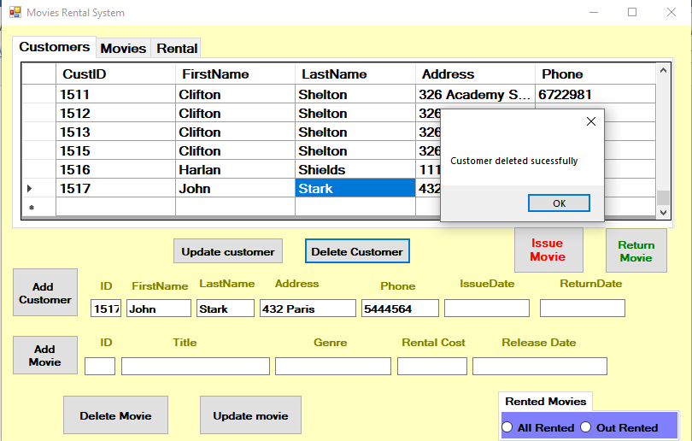

5. Shopkeeper can issue the movies to Customer.

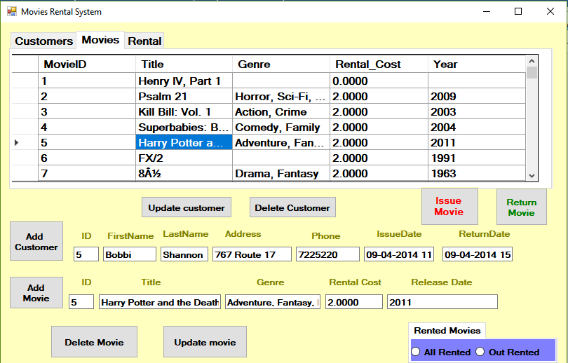

6. Movie issued and database added information.

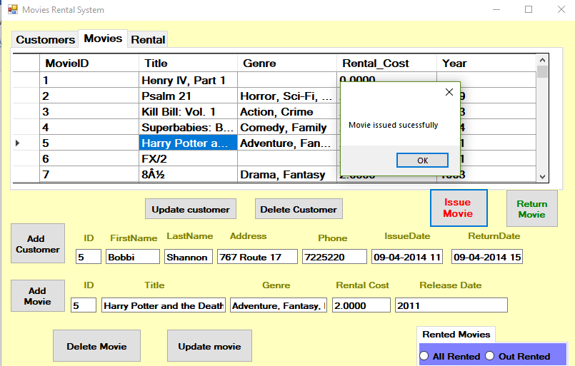

7. Movie Rented information deleted.

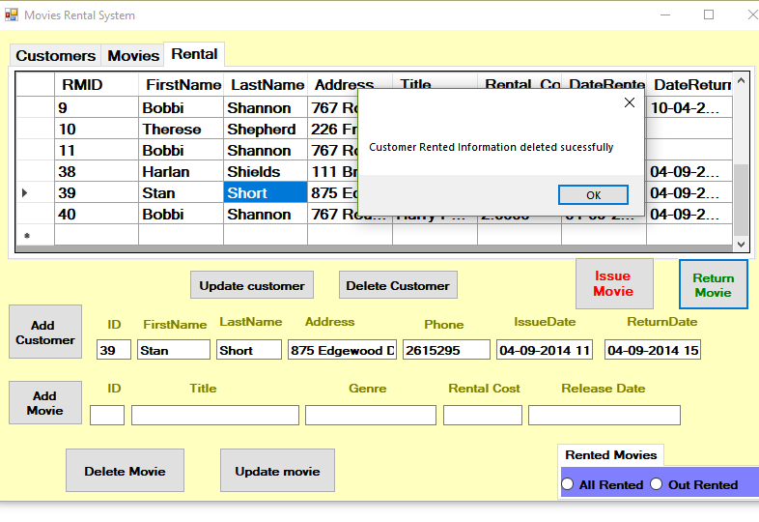

8. Shopkeeper can Add the movies to The Database.

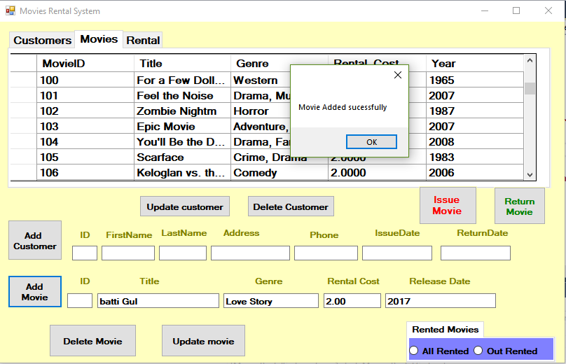

9. Once Movies Added to the Database, Updated List in The Database.

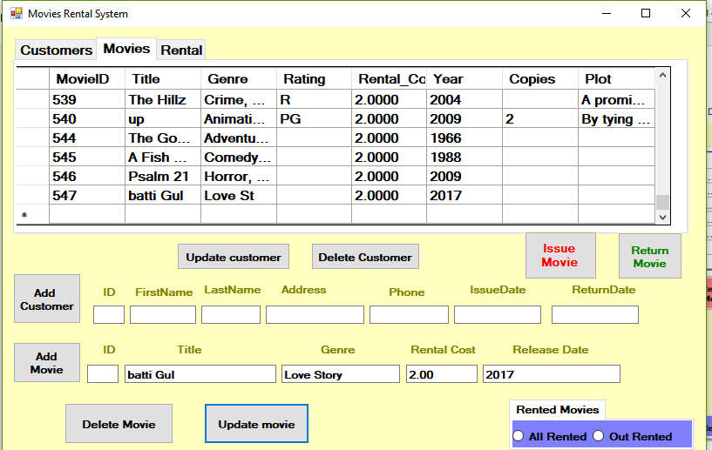

10. Delete movie from Database.

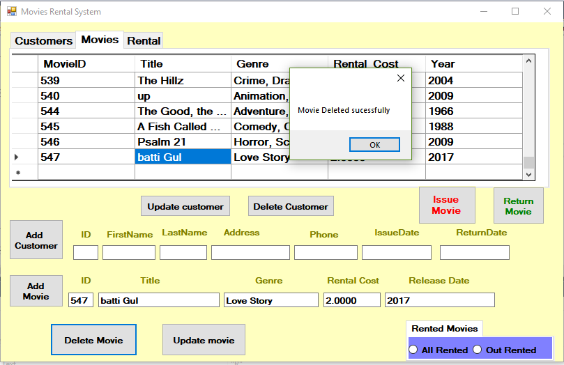

11. Update Movies database after deleting movie.

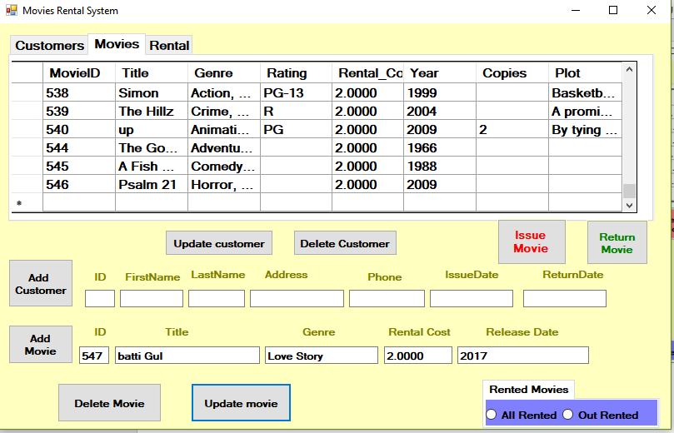

12. Unit Testing.

a). I have Testing The connection to the Database By Unit Testing Methods.

code :-

using Microsoft.VisualStudio.TestTools.UnitTesting;

using MoviesRentalSystems;

namespace moviRentalSystemTest

{

[TestClass]

public class UnitTest1

{

Form1 form = new Form1();

[TestMethod]

public void ConnectionTest()

{

if(form.conn ==null)

{

form.Connection = false;

}

else

{

form.Connection = true;

}

Assert.IsTrue(form.Connection);

}

[TestMethod]

public void Show_Lists_Test()

{

bool rtrnMov = form.Show_Lists;

Assert.IsTrue(rtrnMov);

}

}

}

Test result :-

When test completed successfully

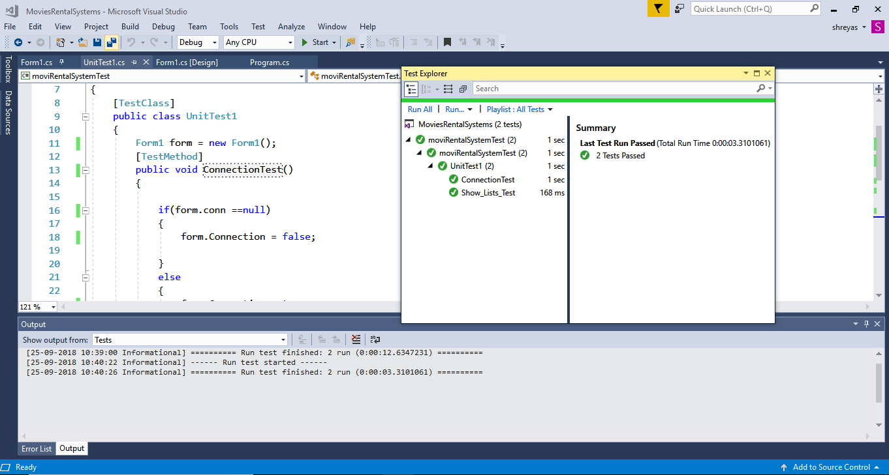

b). Test for Show_List

code:

[TestMethod]

public void Show_Lists_Test()

{

bool rtrnMov = form.Show_Lists;

Assert.IsTrue(rtrnMov);

}

Test Result:-



Relational Model Design: -

