How the Groth 16 utilization works

Abstract: in this doc, we are mainly focusing on how the Groth16 algorithm works. Although the functionalities and steps are clearly described and mentioned in references, but we will bring the algorithm in practice and use it in our voting system application.

Basically, we want an algorithm have certain characteristics:

1- be a zero knowledge proof: meaning no information will be revealed between two peers and all of the information between the peers are encoded.

2- succinct: the ability to verify and extract the desired information from a given proof in an efficient way. In the realm of computer science, this means to take a constant time(O(1)) to extract and verify desired information.

Algebraic problem:

Every equation, constraint and condition can be represented using algebraic math equations. This means that a problem can be embedded as a math equation, alongside symbols. So we first need to write down the problem and represent it as a set of operands and operations.

Here, we need to define our problem as a set of math equations.
So we have a decentralized voting system, powered by blockchain.

What are the requirements?

We need three circuits:
1- The first time user votes (nullifier verification).
2- User vote ciphertext acknowledgement.
3- Tally and final step, vote aggregation and result decryption.

1- Nullifier circuit:

Public keys:

(ElectionID, Nullifier)

Private keys:

(MKT leaf hash value, MKT path siblings hash values, Candidate choice, User secret key)

Conditions:

The next step, we will have to define some constraints and equations that hold our requirements.

1- Merkle path validity:

MerklePathCheck(MerklePath, leafValue) == MerkleRoot(election_id)

Since we cant just place this in our circuit, lets break the functionality down into consisting equations:
H(i+1) = Hash(H(i) + Sib(i))

Where H(0) is the leaf hash value.

2- Nullifier correctness:

N = H(sk || ElectionID)
Because hash functions are not usually polynomials so we will have to use
ZK friendly hash functions that can be represented as polynomials.

The hash value of secret_key + ElectionID must be equal to the nullifier.

One challenge rises here: how can we embed and represent this equality as a polynomial equation?

3- Vote validity:

To show vote values, we have to encode them as numbers and then we can have the value integrity:

1≤ v≤ m

Because the circuit only accepts equations, we can turn this condition into an equation:

(v-1)(v-2)(v-3)...(v-m) = 0
This will ensure that v is within the specified range.

With these three conditions satisfied, we can make sure that:
1- the user is the one who pretends to be
2- stop forging votes and double voting
3- the user’s vote claim matches the one in chain

If we were to create the circuits corresponding to each condition, that would take so much time and be overwhelming for this project. Fortunately, there are already implementations and ready-to-run common circuits in gnark, a golang library, which we will use it in this project:

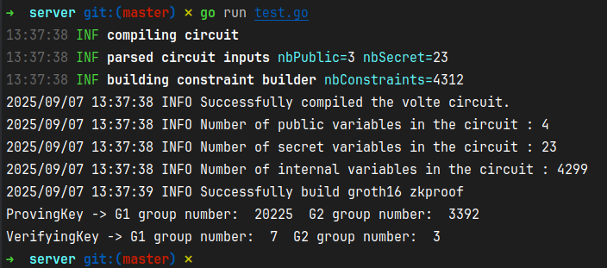
Fig 1: shows a sample of compiled volte circuit in golang alongside number of public variables, secret variables, internal variables. And the groth16 outputs including proving key, verifying key alongside their corresponding public group points on BLS12377 elliptic curve

2- Ciphertext acknowledgement:

Public keys:

Private keys:

(r,m , sk)
Conditions:
C = (c1, c2) = (r·G, M + r·PK)
c2 - sk·c1 = M

3- Tally decryption:

At the end, we need to aggregate the votes for tally.
For this, we will need homomorphic encryption. In these encryptions, the result of operation on the encrypted operands will result in the encryption of the operation on the raw data. In other words:
E(x + y) = E(x) + E(y)

Since votes are all encrypted, we can aggregate the votes and that culminates in the following equation:
m1.G + m2.G + … mn.G = (mt).G
And we know that:
mi.G = c2i - sk.c1i

So we will need to decrypt mi from mi.G.
Since 0 < mt < max(m) and max(m) is a small number, we can calculate mt simply by broute forcing through all the numbers between 1 and max(m).

But all of the equations only needs a secret key that is stored on trustee server. Why do we even need zk proof?

Because we have to make sure that the trustee has correctly calculated the output without actually knowing how it calculated!
So we define our zk proof like this:

Public keys:
(out)

Private keys:
(ri, mi, sk) for i in votes

Conditions
Sigma(mi) = out
c2i−sk⋅c1i=Mi
PK=sk⋅G

