University of Liberal Arts Bangladesh

**Course Code: CSE304**

**Course Title: Database Lab**

**Complex Engineering Project**

**Submitted to:**

Moumita Kabir

Lecturer

**Submitted by:**

Md Armanur Rakib

ID: 192014032

Department of CSE

Spring2022

**Date of Submission**

26.05.2022o

**Movie Ticketing System**

**Introduction**

This project is aimed at developing a database driven movie ticketing system. This database system helps you manage your movie theater. A comprehensive and fast workspace where you can store all the information pertaining to the booking & attendance of your customers like Name, Contact details, Details of what they want to watch and when; Hall number, Seats allotted, Prices charged & lots more. Similarly, it stores all the movie names that are now showing in the theaters,corresponding hall numbers, show times and ticket details. This product also provides seating arrangements for vacant seats.The developed database will be highly user-friendly and easy to maintain.This database driven movie ticketing system is developed to help people find the details of the movie they want to see and book their tickets. The tool provides a list of all the movies that are currently showing in nearby theatre along with their seating details, show timings along with ticket prices. Users can easily search and filter based on their preferred criteria . A unique feature of the app is the ability to quickly generate reports that present current show times and ticket prices, as well as seat availability at multiple cinemas.

**Objective**

The movie ticketing system database objective is to create a simple and user friendly movie ticketing system with all basic functionalities. The project is totally built at administrative end and thus only the administrator is guaranteed the access. The purpose of the project is to build an application program to reduce the manual work for managing the Movie, Movie Type, Ticket, Movie Language. It tracks all the details about the Movie Language, Customer, Booking. Functionalities provided by Movie Ticket Booking System are as follows: •

* Provides the searching facilities based on various factors. Such as Movie, Movie cast name, Customer, Booking.
* Movie Ticket Booking System also manage the Ticket details online for Customer details, Booking details, Movie.
* It tracks all the information of Movie Type, Ticket, Customer etc.
* Editing, adding and updating of Records is improved which results in proper resource management of Movie data.

**Illustration and Description of the database system**

Movie Ticketing System had created a database management system to store data of the attributes with computer-based system. To identify the database management system, a primary key is needed in each of the table record. A primary key also used to create the table relationships.

|  |  |
| --- | --- |
| Table name | Primary Key |
| Customer | Customer_ID |
| Movies | Movie_ID |
| Movie Details | Movie_Details_ID |
| Upcoming Movies | Upcoming_Movie_ID |
| Currently Showing Movies | Showing_Movies_ID |
| Booking Status | Booking_ID |
| Cinema Hall | Cinema_Hall_ID |
| Hall Details | Hall_ID |

* There are **Eight** tables which consist of customer, movie,movie details,upcoming movies,currently showing movies,booking status,hall details and cinema hall. Basically, this is make users (staffs) easy to find and view all of the record in faster way. To define a relationship or link between two tables, we use a foreign key for the dependent table. Foreign key is a field or combination of fields used to link tables with a corresponding  primary key field occurs in the same database. For instance, if there are two tables, customer and booking, a relationship can be created between them by introducing a foreign key into the **booking details** table that refers to the **customer ID** in the **customer table**. The **customer ID** column exists in both **customer** and **booking details** tables. The customer ID in the booking details table becomes the foreign key, referring to the primary key in the customer table. To insert an entry into the booking details table, the foreign key constraint must be satisfied. An attempt to enter a customer ID that is not present in the customer table fails, thus maintaining the table's referential integrity.

The **8** Tables

1. Customer Table

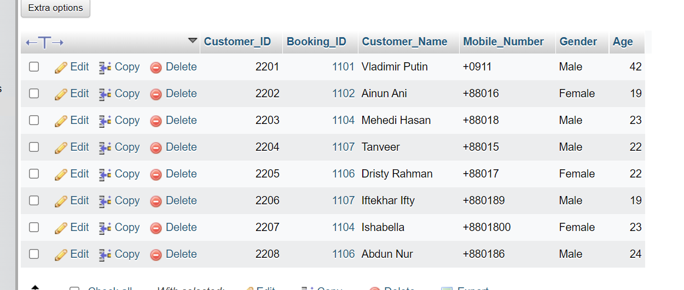

1. Booking_status Table

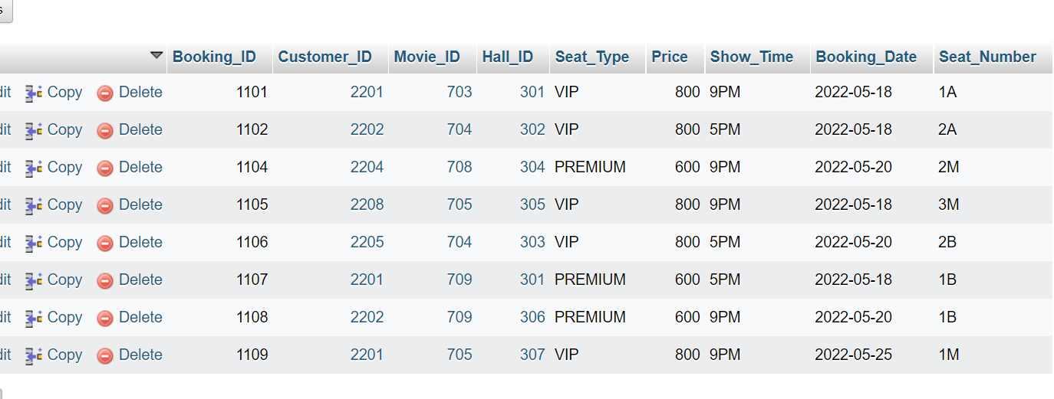

3.Cinema_hall Table

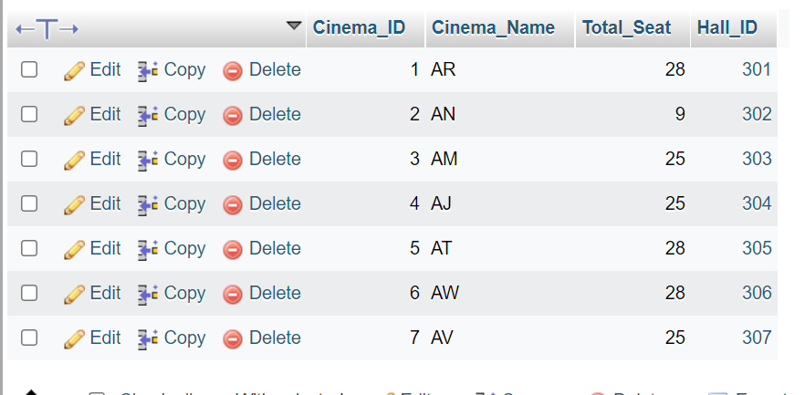

4.Hall_details Table

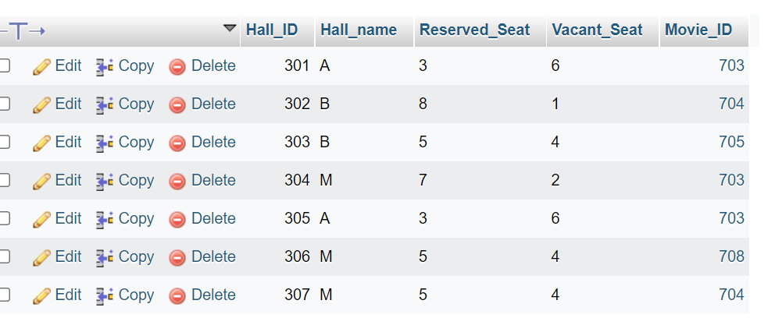

1. Movies

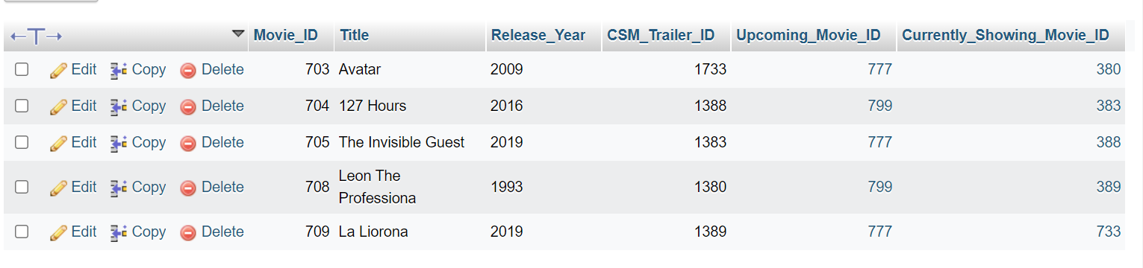

1. Movie_Details

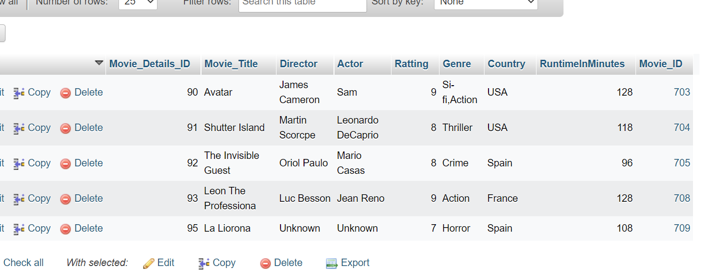

1. Upcoming_Movies

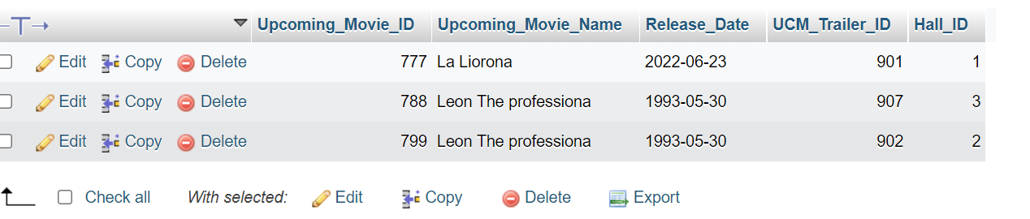

8.Currently_Showing_Movies

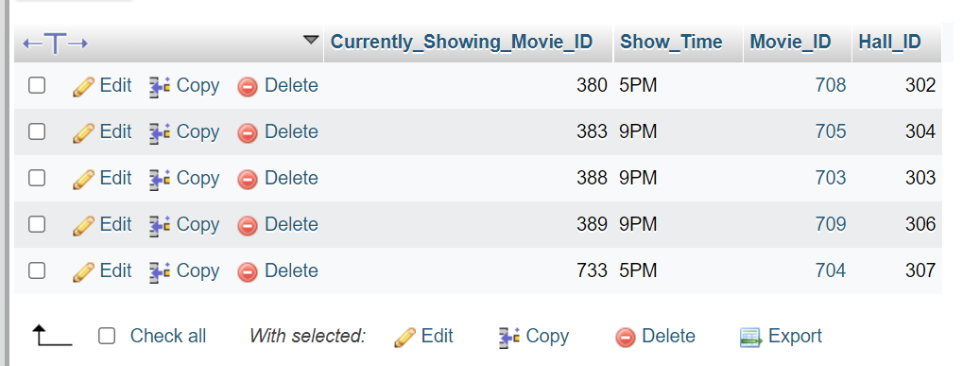

**ENTITY RELATIONSHIP DIAGRAM**

An entity–relationship model is usually the result of systematic analysis to define and describe what is important to processes in an area of a project. An ER model is typically implemented as a database. In a simple relational database implementation, each row of a table represents one instance of an entity type, and each field in a table represents an attribute type. In a relational database a relationship between entities is implemented by storing the primary key of one entity as a pointer or "foreign key" in the table of another entity.

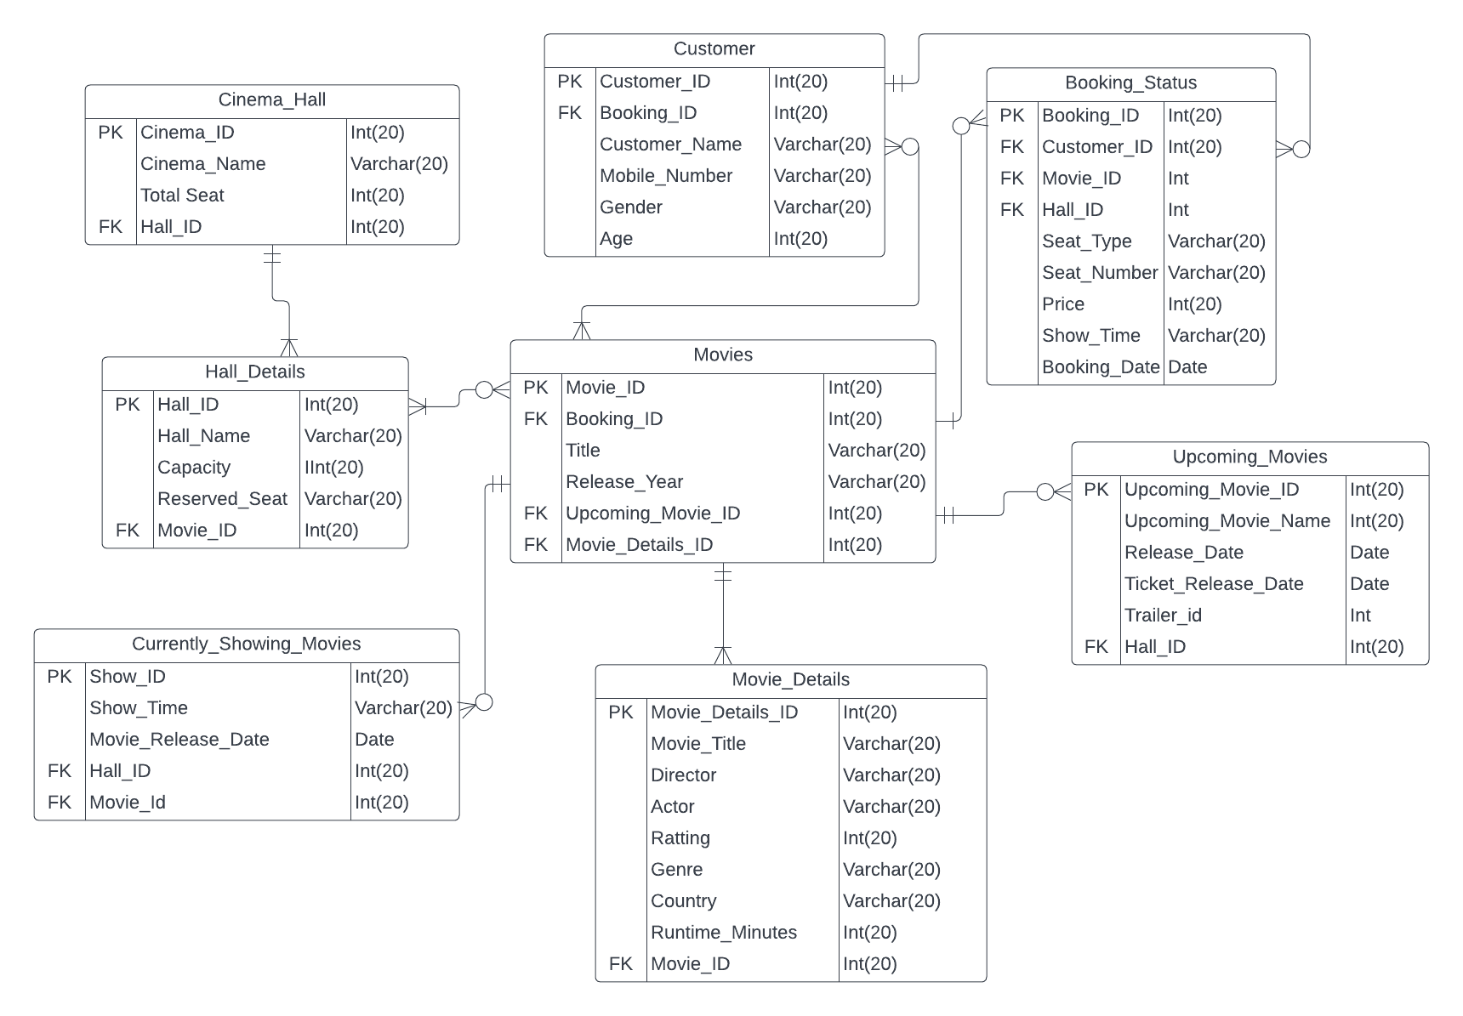

Conclusion

This Movie Ticketing database management system record complex data like customer information, movie details, booking details,ticket details and cinema hall details etc.It will make our business going smoothly and easy to get access on each data for every customer, movie, seat and hall. We also able to edit or modify the information that has  been recorded before to make it more organize.