DEPARTMENT OF COMPUTER SCIENCE & ENGINEERING
ABES ENGINEERING COLLEGE / AKTU, LUCKNOW
SOFTWARE REQUIREMENTS
SPECIFICATION (SRS)
Project Title: RetainIQ — Savings Account Closure Prediction and Customer Insights
Formal Academic Title: Savings Account Closure Prediction using Data Analytics and Machine Learning
Standard Academic Compliance: IEEE Std 830-1998
• ——————————————— • ——————————————— •
SUBMITTED BY:  Armash Siddiqui (2400320100272)  Degree: Bachelor of Technology (B.Tech)  Academic Year: 2026 - 2027 | UNDER THE GUIDANCE OF:  Prof. / Dr. Prachi Pundhir  Mentor, Department of Computer Science & Engineering  Status: 3rd Year B.Tech Project Specification  Date of Submission: October 2026

Document Revision & Approval History
Revision | Date | Description of Changes | Prepared By | Approved By
0.1 | 15-Sep-2026 | Initial Draft: Problem Definition, Dataset Audit & Scope | Armash Siddiqui | Project Guide
1.0 | 01-Oct-2026 | Final 3rd Year Baseline: XGBoost ML Engine, SHAP Explainability & FastAPI/Streamlit System | Armash Siddiqui | Academic Committee

Guidance Note: This Software Requirements Specification (SRS) document strictly conforms to the IEEE Std 830-1998 recommended practice. All functional, behavioral, and architectural sections are designed for 3rd-year undergraduate university project evaluation, comprehensive technical viva, and system implementation baselines. The system described herein—RetainIQ—reflects the implemented data analytics, feature engineering, XGBoost supervised machine learning, SHAP explainability engine, FastAPI prediction service, and Streamlit user interface.

1. Introduction
1.1 Purpose
The purpose of this Software Requirements Specification (SRS) document is to provide a complete, rigorous, and unambiguous specification of the functional requirements, external interfaces, performance criteria, and design constraints for the software system: ‘RetainIQ — Savings Account Closure Prediction and Customer Insights’ (Formal Academic Title: ‘Savings Account Closure Prediction using Data Analytics and Machine Learning’). This document serves as the foundational technical contract between the student developer, academic evaluators, project supervisors, and prospective banking analyst users throughout the 3rd-year engineering curriculum and project reviews.
1.2 Scope of the System
Retail banking institutions face substantial operational and financial risks due to customer attrition and savings account closures. Traditionally, attrition management is entirely reactive—initiated only after an account closure petition is filed or deposits are withdrawn. RetainIQ provides an end-to-end data analytics and predictive machine learning prototype that enables proactive risk assessment and transparent decision support. Important scope boundaries include:
In-Scope Capabilities: Ingestion and preprocessing of a 15,000-record retail banking customer churn benchmark dataset; identifier isolation (dropping id, CustomerId, Surname to prevent target leakage); domain-specific feature engineering (generating 5 mathematical and behavioral features yielding a 16-feature vector); training and offline evaluation of supervised classification models (Logistic Regression, Decision Tree, Random Forest, XGBoost); serialization of the final feature-engineered XGBoost model via Joblib; high-throughput RESTful inference API using FastAPI (/predict endpoint); transparent individual customer prediction explainability using SHAP TreeExplainer; and an interactive analyst dashboard developed in Streamlit featuring real-time risk gauges, customer profiles, and offline benchmark metric displays.
Out-of-Scope Boundaries: Live core-banking transaction streaming, enterprise database persistence (PostgreSQL/MySQL/Redis), automated database logging, distributed messaging (Kafka), automated model retraining/orchestration (MLflow/DVC), natural language processing (NLP) of unstructured customer complaint text, and production cloud or multi-tenant deployment. (The benchmark dataset target represents customer exit/churn rather than confirmed closed accounts from proprietary bank records, and the prototype operates strictly with serialized model artifacts).
Expected Benefits: Proactive identification of customer closure/exit risk prior to final liquidation; transparent, auditable decision-making via directional SHAP feature contributions; balanced discrimination on minority exit cases (held-out test set ROC-AUC of 93.35%, Precision of 80.47%, Recall of 66.67%, and F1-score of 72.92%); and a lightweight, modular architecture capable of running locally on banking analyst workstations without requiring external cloud infrastructure.
1.3 Definitions, Acronyms, and Abbreviations
Category | Term / Acronym | Definition & Context in RetainIQ
Standard | SRS | Software Requirements Specification conforming to IEEE Std 830-1998 format.
Architecture | REST API | Representational State Transfer Application Programming Interface for JSON data exchange over HTTP.
Machine Learning | XGBoost | Extreme Gradient Boosting; scalable tree boosting algorithm selected for final classification.
Explainability | SHAP | SHapley Additive exPlanations; game-theoretic approach (TreeExplainer) explaining individual model predictions.
Domain / Target | Exited / Churn | Target variable: 0 = customer likely to stay (~79.61%), 1 = customer likely to exit (~20.39%).
Model Persistence | Joblib | Python object serialization library used to save and load trained estimators and feature metadata without runtime retraining.
Presentation | UI | User Interface; browser-based analytical application built using Streamlit.
Evaluation | ROC-AUC | Receiver Operating Characteristic - Area Under Curve; threshold-independent metric evaluating model ranking discrimination.

1.4 References
IEEE Std 830-1998: IEEE Recommended Practice for Software Requirements Specifications, IEEE Computer Society, 1998.
Software Engineering: Ian Sommerville, Software Engineering (10th Edition), Pearson Education, 2015.
Machine Learning & Research References: T. Chen and C. Guestrin, 'XGBoost: A Scalable Tree Boosting System', In Proc. 22nd ACM SIGKDD International Conference on Knowledge Discovery and Data Mining, pp. 785-794, 2016; S. M. Lundberg and S. I. Lee, 'A Unified Approach to Interpreting Model Predictions', Advances in Neural Information Processing Systems (NeurIPS 30), 2017; F. Pedregosa et al., 'Scikit-learn: Machine Learning in Python', Journal of Machine Learning Research, 12, pp. 2825-2830, 2011; W. McKinney, 'Python for Data Analysis', 3rd Edition, O'Reilly Media, 2022; S. Tiangolo, 'FastAPI Framework Documentation', 2024; Streamlit Inc., 'Streamlit Core Documentation', 2024.
1.5 Document Overview
The remainder of this SRS is partitioned into structural sections in accordance with IEEE Std 830-1998: Section 2 outlines the product perspective, target user personas, operational context, design constraints, and technical assumptions. Section 3 itemizes detailed functional requirements organized into three logical modules (Data Ingestion & Preprocessing, ML Inference & Explainability, and Decision Support Dashboard). Section 4 specifies external interfaces (UI, Hardware, Software, Network). Section 5 defines non-functional attributes (Performance, Reliability, Security, Usability, Maintainability). Section 6 provides standard academic modeling diagrams and data specifications. Finally, Section 7 provides the academic review and sign-off panel.
2. Overall Description
2.1 Product Perspective
RetainIQ is architected as a modular, two-tier analytical decision-support prototype comprising an interactive presentation layer (Streamlit) and an application/API inference layer (FastAPI). The system operates as a self-contained local application. Rather than relying on a persistent relational database tier, the current implementation utilizes serialized in-memory machine learning artifacts (model/xgb_model.pkl and model/feature_names.pkl) loaded via Joblib upon backend initialization. The Streamlit frontend interacts with the FastAPI backend over local HTTP via JSON payloads, isolating the computational burden of XGBoost inference and SHAP attribution from the user interface.
The complete project workflow is structured as follows:
Customer Demographic & Account Data -> Data Preprocessing & Leakage Prevention -> Exploratory Data Analysis -> Domain Feature Engineering (16 features) -> Model Training & Benchmarking -> Final Feature-Engineered XGBoost Estimator -> FastAPI Prediction API (/predict) -> Streamlit Interactive Dashboard -> Prediction + SHAP Explanation.
RETAINIQ HIGH-LEVEL SYSTEM CONTEXT & BLOCK ARCHITECTURE (DFD LEVEL 0)
====================================================================================
+-----------------------------------------------------------------------------+
| BANKING ANALYST / AUTHORIZED USER |
+-----------------------------------------------------------------------------+
│ ▲
│ 1. Enters Customer Attributes │ 7. Displays Risk Status,
│ (Demographics & Financials) │ Exit Probability &
▼ │ SHAP Explanations
+-----------------------------------------------------------------------------+
| PRESENTATION TIER: Streamlit Web Application (app/streamlit_app.py:8501) |
| • Input Form & Demographic Sliders • Exit Probability Gauge & Status |
| • Customer Profile Summary Snapshot • Top-6 SHAP Factor Direction Cards |
| • Offline Benchmark Model Metrics Tab • Defensive API Error Handling |
+-----------------------------------------------------------------------------+
│ ▲
│ 2. HTTP POST /predict (JSON) │ 6. JSON Response Body
▼ │
+-----------------------------------------------------------------------------+
| APPLICATION & INFERENCE TIER: FastAPI Gateway (api/main.py:8000) |
| • Pydantic Schema Validation (CustomerData model) |
| • Real-Time One-Hot Encoding (Geography_Germany, Geography_Spain, Gender) |
| • Feature Engineering Pipeline (engineer_features -> 16 model features) |
| • XGBoost Inference (predict binary class, predict_proba continuous score) |
| • SHAP TreeExplainer Local Attribution (top-6 directional impact features) |
+-----------------------------------------------------------------------------+
│
│ 3. Loads Pre-Trained Artifacts at Startup via Joblib
▼
+-----------------------------------------------------------------------------+
| LOCAL SERIALIZED MODEL ARTIFACTS & TRAINING REPOSITORY (Local File System) |
| • model/xgb_model.pkl (Pre-trained Feature-Engineered XGBoost Estimator) |
| • model/feature_names.pkl (Standardized 16-feature training sequence) |
| • Data/train (2).csv (15,000 Kaggle banking benchmark records for training) |
| * Note: Database persistence (PostgreSQL/SQLAlchemy) is outside current scope|
+-----------------------------------------------------------------------------+

2.2 User Classes and Characteristics
The target software accommodates distinct user personas within a retail banking analytical environment:
User Role / Persona | Technical & Banking Proficiency | Primary Responsibilities & Usage in RetainIQ
Banking Analyst / Relationship Manager (Primary Active User) | Intermediate (Banking Domain & Basic Web Tools) | Interactively enters customer demographic and account attributes, triggers churn simulations, views predicted status (Stay/Exit) and continuous exit probabilities, inspects top-6 SHAP risk factors, and evaluates risk profiles to guide customer retention conversations.
Credit Risk / Retention Officer (Stakeholder Persona) | Intermediate to High (Risk Policy & Analytics) | Reviews aggregate model validation metrics (Accuracy, Precision, Recall, F1, ROC-AUC), evaluates risk thresholds, and utilizes prediction insights to formulate customer retention interventions and branch retention policies.
Academic Evaluator / Technical Auditor | High (Machine Learning & Software Engineering) | Inspects the end-to-end data pipeline, verifies data leakage prevention (identifier isolation), reviews offline training notebooks, audits FastAPI endpoints, and verifies reproducible evaluation metrics.

2.3 Operating Environment
The application operates within the following software and hardware environments:
Client Requirements: Modern web browser (Google Chrome >= v110, Mozilla Firefox >= v108, Microsoft Edge, Safari); minimum display resolution 1366x768 for desktop, responsive view down to 768x1024 tablet viewports.
Server Runtime Environment: Local workstation or server running Windows 10/11 or Linux (Ubuntu 22.04 LTS / Debian 12); Python 3.10+ (tested on Python 3.10 to 3.13); Uvicorn ASGI server hosting FastAPI; Streamlit runtime server.
Database Storage Tier: Explicitly Outside Current Scope. The current prototype relies entirely on lightweight serialized disk files (Joblib .pkl artifacts) and in-memory evaluation. There is no active SQL or NoSQL database connection. (PostgreSQL relational storage is reserved as a future enterprise enhancement).
2.4 Design and Implementation Constraints
Academic Budget & Local Execution Constraint: The entire system is designed to execute locally on standard analyst workstation hardware without requiring paid third-party cloud APIs, distributed clusters, or specialized GPU acceleration.
Dataset & Target Semantics Constraints: The project utilizes a publicly accessible 15,000-record Kaggle banking customer churn dataset. To protect confidentiality and reflect academic research integrity, customer names (Surname) and identifiers (id, CustomerId) are dropped prior to model fitting. The target variable is binary Exited, representing customer churn/exit rather than confirmed account closure from proprietary bank records. The dataset is NOT proprietary Bank Muscat customer data.
Modularity & Decoupling Standards: Strict architectural separation between the presentation tier (Streamlit) and the prediction engine (FastAPI) via standard JSON REST endpoints, ensuring preprocessing logic (feature_engineering.py) remains consistent across training and inference to eliminate training-serving skew.
2.5 Assumptions and Dependencies
Assumptions: User workstations have Python 3.10+ installed with local network ports (8000 for FastAPI, 8501 for Streamlit) available; input customer data conforms to expected numeric and categorical domains (e.g., CreditScore between 300-850, Age >= 18, Balance >= 0).
Dependencies: Core Python open-source ecosystem libraries including Scikit-learn (>=1.3.0), XGBoost (>=1.7.0), SHAP (>=0.42.0), Pandas (>=2.0.0), NumPy (>=1.24.0), Joblib (>=1.3.0), FastAPI (>=0.100.0), Uvicorn (>=0.22.0), and Streamlit (>=1.25.0). Serialized model files (model/xgb_model.pkl and model/feature_names.pkl) must exist in the designated path prior to API launch.
2.6 Apportioning of Requirements & Future Enhancements
To maintain academic integrity and prevent architectural over-claiming, the following capabilities are explicitly identified as outside the current baseline and allocated to future development phases:
Relational Database Tier (PostgreSQL): Future integration of an ACID-compliant transactional database (PostgreSQL/SQLAlchemy) to persist live customer records, historical predictions, and audit logs.
Unstructured NLP & Sentiment Analysis: Future incorporation of natural language processing to extract sentiment from customer support emails and transaction complaint memos.
Real-Time Transaction Streaming (Apache Kafka): Future real-time ingestion of live ATM and POS transactions for streaming churn detection.
Automated MLOps Pipeline (MLflow / DVC): Future automated model drift detection, continuous model retraining, and versioning pipelines.
3. System Features and Functional Requirements
Requirements are categorized by functional subsystem modules with unique requirement identifiers (FR-x.x) adapted from the standard IEEE template structure to reflect the actual implemented RetainIQ architecture:
3.1 Module 1: Input Data Ingestion & Preprocessing
Requirement ID | Functional Requirement Name | Detailed Operational Specification & Rule | Priority
FR-1.1 | Customer Banking Attribute Input Capture | Accepts 10 customer demographic and financial attributes (CreditScore, Geography, Gender, Age, Tenure, Balance, NumOfProducts, HasCrCard, IsActiveMember, EstimatedSalary) via Streamlit UI form and FastAPI JSON payload. | High
FR-1.2 | Input Validation & Boundary Checking | Validates all incoming attributes against realistic banking domains (Age: 18-100, CreditScore: 300-850, Balance >= 0, Products: 1-4, Binary flags: 0 or 1) using Pydantic schema validation. | High
FR-1.3 | Categorical Encoding & Feature Engineering | Performs one-hot encoding on Geography (Germany, Spain; France reference) and Gender (Male=1, Female=0), and computes 5 engineered features (IsZeroBalance, BalancePerProduct, AgeSquared, ActiveProductInteraction, AgeActivityInteraction) to assemble the final 16-feature vector. | High

Exploratory Data Analysis (EDA) & Data Leakage Prevention
Prior to model training, rigorous data exploration was conducted on the 15,000-record benchmark dataset. Identifier columns (id, CustomerId, Surname) were isolated and removed to eliminate artificial target leakage. The audit revealed an inherent class imbalance (11,941 staying customers [79.61%] vs. 3,059 exiting customers [20.39%]). German customers exhibited twice the attrition rate of French and Spanish customers, while inactive members and older cohorts (ages 45–60) displayed markedly higher closure probabilities. These insights directly governed the creation of the 5 domain interaction features.
3.2 Module 2: Machine Learning Inference & Explainability Engine
Requirement ID | Functional Requirement Name | Detailed Operational Specification & Rule | Priority
FR-2.1 | Model Artifact Persistence & Loading | Loads serialized Feature-Engineered XGBoost model (model/xgb_model.pkl) and feature list (model/feature_names.pkl) into memory at API startup using Joblib without runtime retraining. | High
FR-2.2 | Customer Exit Prediction & Probability | Generates a discrete binary prediction (0 = Likely to Stay, 1 = Likely to Exit) and continuous calibrated probability (0.0 to 1.0) using model.predict() and model.predict_proba(). | High
FR-2.3 | SHAP Feature Attribution & Local Explainability | Executes SHAP TreeExplainer on the customer feature vector to compute Shapley values, sorts by absolute impact, extracts the top-6 factors, and determines directional impact (Increases/Decreases exit likelihood). | High

Supervised Model Selection & Benchmark Evaluation Scorecard
Five candidate classification pipelines were trained and evaluated offline on an identical 80/20 train-test split. The table below summarizes the comparative performance metrics obtained on the held-out test set:
Candidate Pipeline / Estimator | Accuracy | Precision | Recall | F1-Score | ROC-AUC
Logistic Regression (Baseline Linear) | 82.80% | 72.40% | 23.90% | 35.90% | 79.10%
Decision Tree (Baseline Tree) | 83.60% | 59.80% | 62.40% | 61.10% | 80.40%
Random Forest (Ensemble Bagging) | 89.10% | 78.20% | 64.10% | 70.40% | 92.10%
XGBoost (Raw 11 Features) | 89.40% | 79.10% | 65.30% | 71.50% | 92.70%
Final Feature-Engineered XGBoost (16 Features) | 89.90% | 80.47% | 66.67% | 72.92% | 93.35%

* Note: All metrics represent offline evaluation on the held-out benchmark test set under a 0.50 decision threshold. They demonstrate strong statistical discrimination but do not constitute an empirical guarantee of identical performance on unobserved banking populations.
3.3 Module 3: Decision Support Dashboard & Analytical Visualization
Requirement ID | Functional Requirement Name | Detailed Operational Specification & Rule | Priority
FR-3.1 | FastAPI RESTful Service Gateway | Exposes GET / (health check) and POST /predict endpoints receiving JSON CustomerData objects and returning JSON payloads with prediction, probability, status, and SHAP explanation list. | High
FR-3.2 | Interactive Streamlit Prediction Interface | Submits customer input data to FastAPI, parses response, and renders a visual exit probability progress gauge, color-coded risk alerts (Low <35%, Med 35-60%, High >60%), and customer profile snapshot. | High
FR-3.3 | Model Performance & Metric Transparency Display | Displays offline benchmark evaluation metrics on the held-out test set (Accuracy: 89.90%, Precision: 80.47%, Recall: 66.67%, F1: 72.92%, ROC-AUC: 93.35%) and confusion matrix details. | Medium
FR-3.4 | Top-6 SHAP Factor Directional Cards | Renders structured visual cards for the top-6 customer-specific SHAP drivers indicating feature name, Shapley value, and plain-language directional influence to support transparent banking decisions. | High

4. External Interface Requirements
4.1 User Interfaces (UI)
The RetainIQ interface is implemented as a modern, responsive web application using Streamlit. Designed specifically for retail banking analysts and relationship managers, the interface is organized into five functional panels:
1. Customer Profile & Account Input Columns: Clean two-column input layout capturing customer demographics (Geography, Gender, Age, Tenure) on the left and financial/behavioral attributes (Credit Score, Balance, Products, Credit Card, Active Membership, Estimated Salary) on the right.
2. Action Trigger & Real-Time Risk Display: A prominent 'Predict Customer Churn' action button triggering asynchronous evaluation via the FastAPI backend, followed by an immediate visual risk meter, exit probability percentage, and color-coded status badge (Low Risk < 35%, Medium Risk 35-60%, High Risk > 60%).
3. Customer Profile Snapshot: Formatted data cards presenting key customer metrics in clear financial context.
4. Transparent SHAP Explanation Cards: Directional indicators (+/-) showing the top-6 features that drive the customer toward staying or exiting.
5. Model Performance Tab: Transparent display of offline benchmark metrics (Accuracy: 89.90%, Precision: 80.47%, Recall: 66.67%, F1: 72.92%, ROC-AUC: 93.35%) and confusion matrix analysis.
RETAINIQ PRODUCTION USER INTERFACE SCREEN CAPTURES
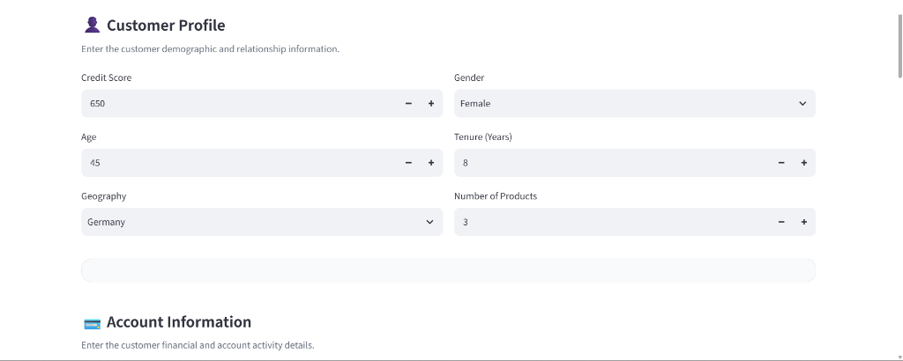
Figure 4.1: Customer Demographic Profile & Account Attribute Input Interface (Streamlit)
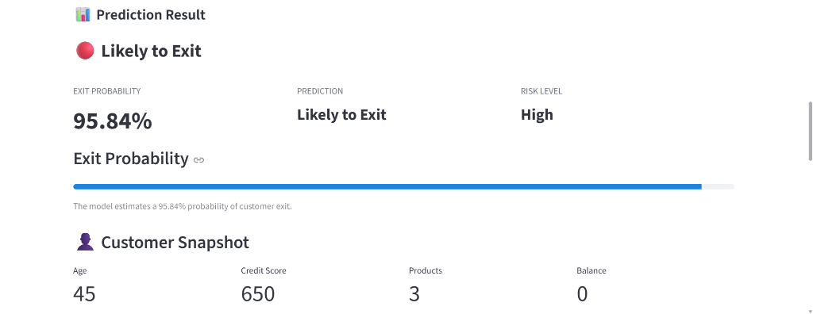
Figure 4.2: Customer Exit Probability Meter, Risk Alert Banner & Profile Snapshot
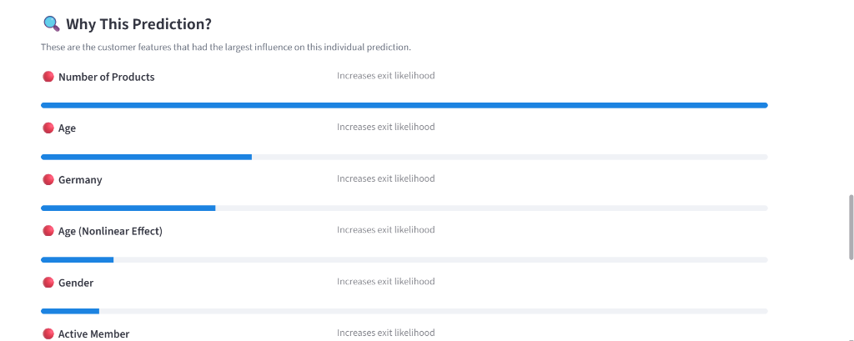
Figure 4.3: Top-6 SHAP Feature Attribution Cards with Plain-Language Directional Impact
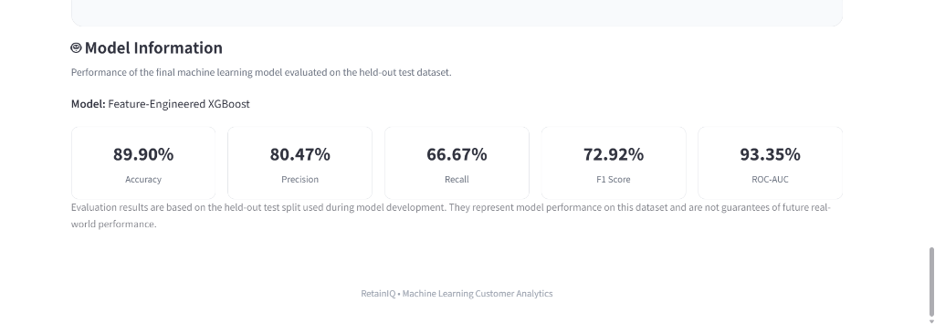
Figure 4.4: Offline Benchmark Model Performance Scorecard & Confusion Matrix Evaluation

4.2 Hardware Interfaces
Specification of physical interaction and execution points:
Standard Deployment: Standard analyst workstations, desktop PCs, and laptops equipped with modern multi-core x86/ARM processors (minimum 4 cores, 8 GB RAM), standard keyboard, mouse, and display resolution >= 1366x768 (Full HD 1920x1080 recommended for optimal dashboard rendering).
Hardware Acceleration & Embedded Scope: Embedded microcontroller hardware (e.g., ESP32, GPIO, sensors) and specialized GPU acceleration are explicitly outside the scope of this project. The trained XGBoost model and TreeExplainer operate with high efficiency on standard workstation CPU cores with average inference latency under 50 milliseconds per customer prediction.
4.3 Software Interfaces
Machine Learning & Runtime Libraries: Python 3.10+ execution environment utilizing Scikit-learn (v1.3+), XGBoost (v1.7+), SHAP (v0.42+), Pandas (v2.0+), and NumPy (v1.24+). Serialized models and feature lists are loaded via Joblib (v1.3+). Relational ORM interfaces (SQLAlchemy/Sequelize) and database drivers are outside the current scope.
Service Integration & Protocols: FastAPI (v0.100+) hosted via Uvicorn ASGI server on port 8000. Streamlit (v1.25+) analytical dashboard interfacing synchronously with FastAPI over HTTP using the Python requests library. Cloud object storage (AWS S3) and CDN services are outside the scope of the local prototype.
4.4 Communication Interfaces
Web Traffic Protocol: HTTP/1.1 protocol over localhost communication (FastAPI on http://127.0.0.1:8000, Streamlit on http://127.0.0.1:8501). For network or intranet deployment, HTTPS over TLS 1.3 is recommended to encrypt sensitive banking demographic and account data.
Data Serialization Standard: All payload bodies exchanged using standard UTF-8 encoded application/json format, strictly conforming to the Pydantic CustomerData schema for request bodies and structured JSON dictionaries for prediction and SHAP responses.
5. Non-Functional Requirements (NFRs)
NFR Category & ID | Quantitative Benchmark & Acceptance Criteria | Verification & Audit Method
5.1 Performance & Latency | Local prediction API response time < 100ms per customer evaluation (including XGBoost inference and SHAP attribution); Streamlit page load latency < 1.0s under standard analyst workstation conditions. | FastAPI request-response timing profiling and client-side execution benchmarks.
5.2 Data Integrity & Validation | Zero acceptance of malformed or out-of-bounds inputs; strict Pydantic type and boundary enforcement on all 10 customer fields before preprocessing pipeline execution. | Automated unit testing with boundary cases (e.g., negative balance, out-of-range age, missing values).
5.3 Reliability & Fault Tolerance | Defensive startup checks verifying the existence of model artifacts (xgb_model.pkl and feature_names.pkl); graceful degradation with clear user alert banners if FastAPI service is unreachable. | Service interruption simulation (stopping FastAPI backend to verify Streamlit user alerts) and exception log inspection.
5.4 Usability & Explainability | Intuitive single-screen workflow for banking relationship managers; clear color-coded probability thresholds (Low < 35%, Medium 35-60%, High > 60%); transparent directional SHAP cards (+/-) explaining the top-6 drivers. | Qualitative user walkthroughs with banking domain analysts and academic review evaluators.
5.5 Maintainability & Modularity | Decoupled architecture isolating preprocessing logic (feature_engineering.py), REST API routing (main.py), and UI presentation (streamlit_app.py); identical transformations across training and inference. | Modular unit testing and regression verification against held-out benchmark test cases.

6. System Design and Analysis Models
University evaluation rubrics require standard graphical and tabular analysis models illustrating the dynamic and static behavior of the application:
Analysis Model Type | Objective & Scope in RetainIQ | Standard Notation / Format
Use Case Diagram | Maps user actors (Banking Analyst, Risk Officer, Academic Auditor) to discrete functional interactions (Customer Input, Churn Prediction, Probability Visualization, SHAP Analysis, Benchmark Review). | UML Standard diagram and detailed actor-interaction specifications.
Data Flow Diagram (DFD) | Illustrates information flow: Level 0 (Context Architecture) and Level 1 (Modular decomposition from Raw Inputs through Feature Engineering to Model Inference and SHAP Attribution). | Gane-Sarson / Yourdon & Coad notation flow chart specifications.
Data Schema & Feature Specification (In Place of ERD) | Details the 13 raw dataset features and 5 engineered features (16 model features), their data types, value ranges, and mathematical formulas. (Note: Relational ERD is outside current scope due to artifact-based persistence). | Standard tabular feature dictionary and transformation specifications.
Sequence Diagram | Chronological sequence of synchronous messages between Banking Analyst, Streamlit UI, FastAPI Service, Feature Engineering Module, XGBoost Estimator, and SHAP TreeExplainer. | UML Sequence diagram detailing happy-path prediction and exception handling.

6.1 Use Case Specifications
Actor 1 — Banking Relationship Manager: Executes Use Case UC-01 (Input Customer Profile) to submit demographic and financial data; triggers UC-02 (Evaluate Churn Risk) to generate stay/exit status; and reviews UC-03 (Inspect SHAP Feature Factors) to understand individual driver influences.
Actor 2 — Retention Strategy Officer: Accesses UC-04 (Review Offline Model Scorecard) to inspect the 5-model comparative benchmarks, ROC-AUC curves, and confusion matrix distributions for branch-level policy decisions.
Actor 3 — Academic Evaluator: Audits UC-05 (Inspect Codebase & Pipeline Integrity) to verify identifier leakage isolation, Pydantic data validation schemas, and serialized Joblib model loading.
6.2 Data Flow Modeling (DFD Level 1 Decomposition)
The Level 1 Data Flow Diagram decomposes the system into four discrete processing stages:
• Process 1.0 (Capture & Validate): Accepts raw analyst inputs via Streamlit UI, packages as JSON, and validates types/bounds via FastAPI Pydantic schema.
• Process 2.0 (Transform & Engineer): Applies one-hot encoding (Geography, Gender) and computes 5 interaction metrics (BalancePerProduct, AgeSquared, IsZeroBalance, ActiveProductInteraction, AgeActivityInteraction) to form the 16-feature vector.
• Process 3.0 (Infer & Score): Passes the 16-feature array to the pre-loaded XGBoost estimator in memory, outputting the binary classification and continuous exit probability.
• Process 4.0 (Explain & Attribute): Feeds the array to SHAP TreeExplainer to calculate local Shapley values, extracts top-6 absolute drivers, and returns structured JSON to Streamlit for visual rendering.
6.3 Data Dictionary & 16-Feature Specification Table (In Place of ERD)
Because RetainIQ uses serialized model artifacts rather than a relational database, the traditional Entity-Relationship Diagram (ERD) is superseded by this rigorous 16-feature data dictionary defining every variable consumed by the final XGBoost model:
Feature Name | Source / Derivation | Data Type | Valid Domain | Analytical Role & Business Impact
CreditScore | Raw Customer Input | Integer | 300 - 850 | Customer creditworthiness rating.
Age | Raw Customer Input | Integer | 18 - 100 | Customer chronological age; strong non-linear churn driver.
Tenure | Raw Customer Input | Integer | 0 - 10 | Number of years customer has banked with the institution.
Balance | Raw Customer Input | Float | >= 0.0 | Current savings deposit balance in USD/currency.
NumOfProducts | Raw Customer Input | Integer | 1 - 4 | Number of distinct banking products held (3-4 indicates high exit risk).
HasCrCard | Raw Customer Input | Binary (0/1) | 0 or 1 | Indicator whether customer possesses an active credit card.
IsActiveMember | Raw Customer Input | Binary (0/1) | 0 or 1 | Indicator of active transaction/login engagement; lowers churn risk.
EstimatedSalary | Raw Customer Input | Float | >= 0.0 | Estimated annual customer salary/earnings.
Geography_Germany | One-Hot Encoded | Binary (0/1) | 0 or 1 | High-churn regional indicator (Germany vs. France baseline).
Geography_Spain | One-Hot Encoded | Binary (0/1) | 0 or 1 | Regional indicator (Spain vs. France baseline).
Gender_Male | Categorical Mapped | Binary (0/1) | 0 or 1 | Gender flag (Male = 1, Female = 0; females exhibit higher exit rate).
IsZeroBalance | Engineered Feature | Binary (0/1) | 0 or 1 | Flag: 1 if Balance == 0, else 0 (captures zero-balance flight behavior).
BalancePerProduct | Engineered Feature | Float | >= 0.0 | Formula: Balance / NumOfProducts (reflects product-level deposit density).
AgeSquared | Engineered Feature | Float | >= 324.0 | Formula: Age^2 (captures quadratic non-linear risk escalation in older cohorts).
ActiveProductInteraction | Engineered Feature | Integer | 0 - 4 | Formula: IsActiveMember * NumOfProducts (measures engaged product exposure).
AgeActivityInteraction | Engineered Feature | Float | >= 0.0 | Formula: Age * IsActiveMember (differentiates older engaged vs. unengaged users).

6.4 Sequence Modeling (Inference & Explainability Flow)
The sequence of operations during a customer churn evaluation transaction is strictly defined:
1. User -> Streamlit: Adjusts demographic/account sliders and clicks 'Predict Customer Churn'.
2. Streamlit -> FastAPI: Dispatches HTTP POST request with CustomerData JSON payload to /predict endpoint.
3. FastAPI -> Preprocessing: Validates schema via Pydantic; invokes engineer_features() in feature_engineering.py.
4. Preprocessing -> XGBoost: Yields 16-feature aligned vector to model.predict() and model.predict_proba().
5. FastAPI -> SHAP: Passes vector to TreeExplainer.shap_values(); sorts top-6 absolute impacts and attaches plain-language directions.
6. FastAPI -> Streamlit: Returns JSON response containing prediction, probability, risk level, and explanations.
7. Streamlit -> User: Updates risk meter gauge, displays profile snapshot, and renders top-6 directional cards.
7. Academic Review & Sign-Off
This Software Requirements Specification document has been submitted, reviewed, and approved by the academic supervisory panel:
Project Coordinator / Guide | Internal Examiner | Head of Department (HOD)
Signature: __________________  Name: Prof. / Dr. Prachi Pundhir  Designation: Project Mentor  Date: __________________ | Signature: __________________  Name: ____________________  Designation: Internal Examiner  Date: __________________ | Signature: __________________  Name: ____________________  Designation: HOD, CSE Department  Date: __________________

