

**Data Structures and Algorithms**

**( CS09203 )**

**Lab Report**

Name: Armghan ali

Registration #: SEU-F16-109

Lab Report #: 05

Dated: 30-04-2018

Submitted To: Sir. Usman Ahmed

The University of Lahore, Islamabad Campus

Department of Computer Science & Information Technology

**Experiment # 5**

**Link list-Basic Deletion at desired position**

**Objective**

The objective of this session is to insertion, traversal and deletion at desired position in link list using C++.

**Software Tool**

1. I use Code Blocks with GCC compiler.

# Theory

This section discusses how to insert an item into, and delete an item from, a linked list. Consider the following definition of a node. (For simplicity, we assume that the info type is int. struct nodeType int info nodeType* link; ; We will use the following variable nodeType *head, *p, *q, *newNode; INSERTION:- Algorithms which insert nodes into the linked list come up in various situations. We discuss three of them here. The first one inserts a node at the beginning of the list, the second one inserts a node after a node with a given location, and the third one inserts a node into the sorted list.

# Task

## Procedure: Task 5

Write a C++ code using functions for the following operations. 1.Creating a linked List. 2.Traversing a Linked List. 3.Inserting the node at the start of the list. 4.Inserting a node after a given node. 5.Inserting a node in a sorted list.

## 2.2

**#include***<*iostream*>*

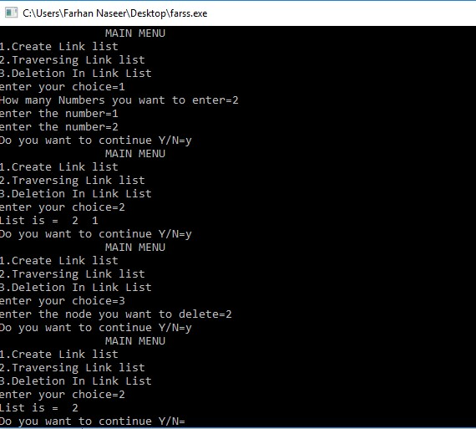

Figure 1: output

**#include***<*stdlib .h*>* **#include***<*conio .h*>* **using namespace** std ; **struct** Node{ **int** data ;

Node∗ next ;

};

**struct** Node∗ head ; **void** Insert ( **int** x){

Node∗ temp=(Node∗) malloc ( **sizeof** (Node )); temp−*>*data=x ; temp−*>*next=head ; head=temp ;

}

**void** print (){

Node∗ temp=head ; cout*<<*”List is =” ; **while**(temp != NULL){ cout*<<*” ”*<<*temp−*>*data ; temp=temp−*>*next ;

} cout*<<*endl ;

}

**void** Delete ( **int** n){

**struct** Node∗ temp1=head ;

**if** (n==1){ head=temp1−*>*next ;

free (temp1 );

**return** ;

}

**for** ( **int** i =0;i*<*n−2; i++){ temp1=temp1−*>*next ;} **struct** Node∗ temp2=temp1−*>*next ;

temp1−*>*next=temp2−*>*next ;

free (temp2 );

}

**int** main(){ head=NULL; **int** size , j , k ;

**char** ch , choice ; **do**{

cout*<<*”\t\tMAIN MENU\t\t”*<<*endl ; cout*<<*”1. Create Link l i s t ”*<<*endl ; cout*<<*”2. Traversing Link l i s t ”*<<*endl ; cout*<<*”3. Deletion In Link List”*<<*endl ; cout*<<*”enter your choice=” ; cin*>>*choice ;

**switch**( choice ){ **case** ’1 ’ :

{

cout*<<*”How many Numbers you want to enter=”

cin*>>*size ; **for** ( j =0;j*<*size ; j++){ cout*<<*”enter the number=” ; cin*>>*k ;

Insert (k );

}} **break**;

**case** ’2 ’ :

{

print ();

} **break**;

**case** ’3 ’ :

{

|  |  |  |
| --- | --- | --- |
| cin*>>*x ;  Delete (x );  } **break**; **default** : |  |  |
| cout*<<*” invalid | choice | ! ! ! ! ! ! ! ! ”*<<*endl ; |

|  |  |  |
| --- | --- | --- |
| } |  |  |
| cout*<<*”Do you want | to | continue Y/N=” ; |

**int** x ; cout*<<*”enter the node you want to delete=” ;

cin*>>*ch ;

}

**while** (( ch==’Y’ ) | | ( ch==’y ’ ));

getch ();

**return** 0;

}

# Conclusion

In today lab we have discussed how we can create a link list and alose learn to delete a node and display it on a screen by having a code.