The issue : folding paper Course: Algorithm design

**(Translated By Google Translate)**

A map of the of L and the line of the horizon of and perpendicular to the n Line and m Column division of M is )

N≤ 8, M≤4, Mn≤16 (. This is the map of the power of the of the of the line for all of the different of the fans of the.

Like shape of the f ) the number of K (:

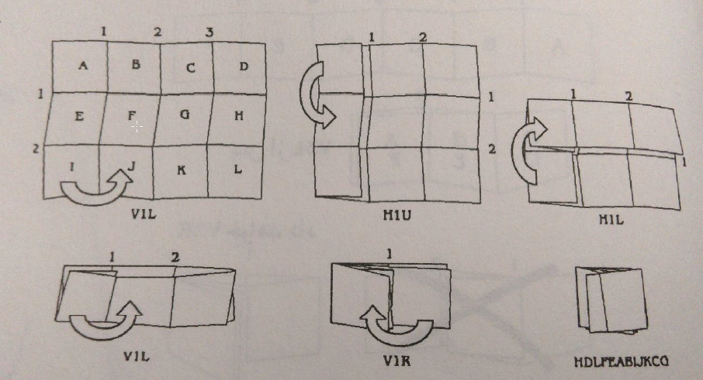

Application of the Benno the Q of the D that map to any of the up to that part of the map to arrange a B the specified top

Foot Yi the face of the exposed.

• parts of the map, line by line with uppercase A, B,… )Up to the maximum P ( have been marked.

• The " folding " with three new for Tuesday determined to be:

1. V for the folding perpendicular to and H For the folding horizon of.

2. Number of lines of the face of the paper of the M .

3. Folded part : L For the left,R To the right,U For the top and L For the feet, such as.

• Figure 1 situations in the first of the main , folding of the may include

V1 L, V 1R, V2L, V2R, V3L, V3R, H1U, H1L, H2U, H2L

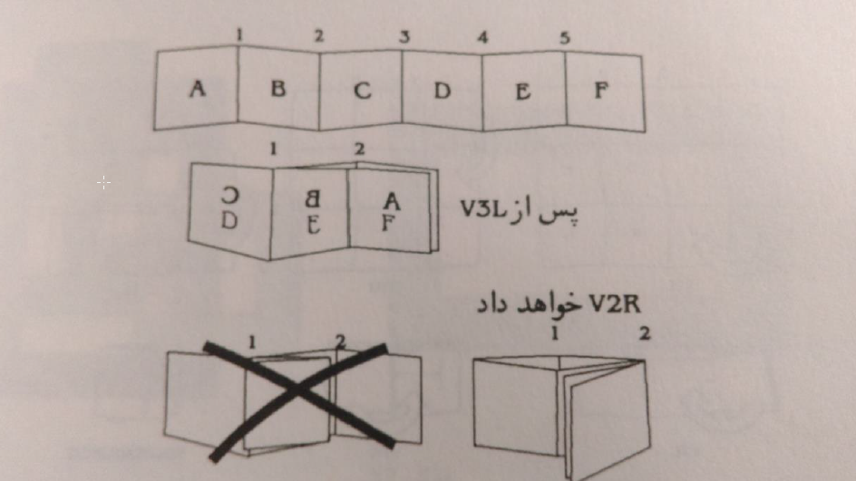

• Examples Yi of folding in the form of the B of A to D.

In the first row F of L arrival of ,input.txt ، n) Number of rows ( , in the second row m) Number of columns ( and

Out of the first row F of L output.txt By M to be . In the this row, folding of the need for the use of road

Respectively of the requested respectively of the Banu the Q of the D.

For example because of the attention to the figure of one of the of the example.

Input.txt:

3

4

HDLFEABIJKCG

Output:

V1L H1U H1L V1L V1R