برای آنالیز از زبان پایتون استفاده شده. از آنجایی که تعداد افراد سالم (GROUP1) کم بود از تکنیک GAN (به فارسی شبکه مولد متخاصم) که یکی از تکنیک های تولید داده بسیار شبیه به داده های واقعی است استفاده شده. (لینک مقاله GAN: [1406.2661] Generative Adversarial Networks)
برای ساختن شبکه GAN‌ از فریمورک PyTorch ( یکی از فریمورک های بسیار مطرح در زمینه هوش مصنوعی، منتشر شده توسط متا استفاده شده لینک مقاله : [1912.01703] PyTorch: An Imperative Style, High-Performance Deep Learning Library)
برای رسم نمودارها از کتابخانه Matplotlib استفاده شده است.
برای خواندن دیتاست ها و تولید دیتاست های csv در اکسل از کتابخانه pandas استفاده شده.
برای محابسه میانگین، انحراف معیار و دیگر محاسبات عددی از کتابخانه numpy استفاده شده.
از الگوریتم K-Means Clustering برای دسته بندی اتوماتیک (بدون نظارت به انگلیسی Unsupervises) برای دسته بندی گروه ۱ و ۲ استفاده شده است تا با اندازه گیری همزمان پارامترهای z ، voxel ، BSC و cop ببینیم آیا تفاوت معناداری بین افراد سالم و مریض در MRI آنها وجود دارد یا خیر لینک مقاله: [2304.09989] CKmeans and FCKmeans : Two deterministic initialization procedures for Kmeans algorithm using a modified crowding distance
برای پیاده سازی الگوریتم KMeans Clustering‌ از کتابخانه sklearn استفاده شده است.
لینک کدهای تولید دیتا با الگوریتم GAN به زبان پایتون:
https://github.com/ArminKardan/jal/blob/master/gan.py
لینک کدهای KMeans Clustering:
https://github.com/ArminKardan/jal/blob/master/kmeans.py
برای ارزیابی نرمالیتی دیتا از روش Shapiro-Wilk استفاده شده اما به دلیل کمبود دیتاها، دیتا های پرت میتواند نتیجه این الگوریتم را تغییر دهد به همین منظور برای اثبات نرمالیتی دیتا از روش Q-Q استفاده شده است و برای پیاده سازی Q-Q و Shapiro‌ از کتابخانه scipy استفاده شده است.
لینک کدهای Q-Q‌ برای نمایش نرمالیتی:
https://github.com/ArminKardan/jal/blob/master/QQ.py
برای بررسی و رسم نمودارهای t-test‌ از کتابخانه scipy‌ استفاده شده است.
لینک کدهای t-test:
https://github.com/ArminKardan/jal/blob/master/diagram.py

لینک های دیتاست ها:
گروه ۱ استم چپ (آگمنت شده):
https://github.com/ArminKardan/jal/blob/master/G1LT-A.csv
گروه ۱ استم چپ (اوریجینال):
https://github.com/ArminKardan/jal/blob/master/G1LT.csv
گروه ۲ استم چپ:
https://github.com/ArminKardan/jal/blob/master/G2LT.csv
گروه ۱ استم راست (آگمنت شده):
https://github.com/ArminKardan/jal/blob/master/G1RT-A.csv
گروه ۱ استم راست (اوریجینال):
https://github.com/ArminKardan/jal/blob/master/G1RT.csv
گروه ۲ استم راست:
https://github.com/ArminKardan/jal/blob/master/G2RT.csv

شاخص ARI:
Understanding the Adjusted Rand Index and Other Partition Comparison Indices Based on Counting Object Pairs | Journal of Classification

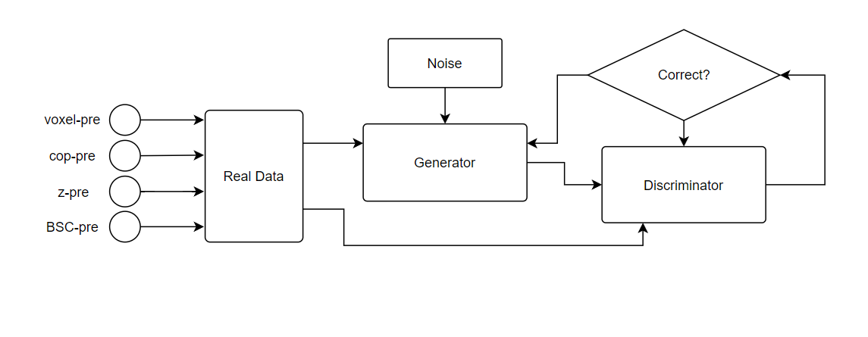
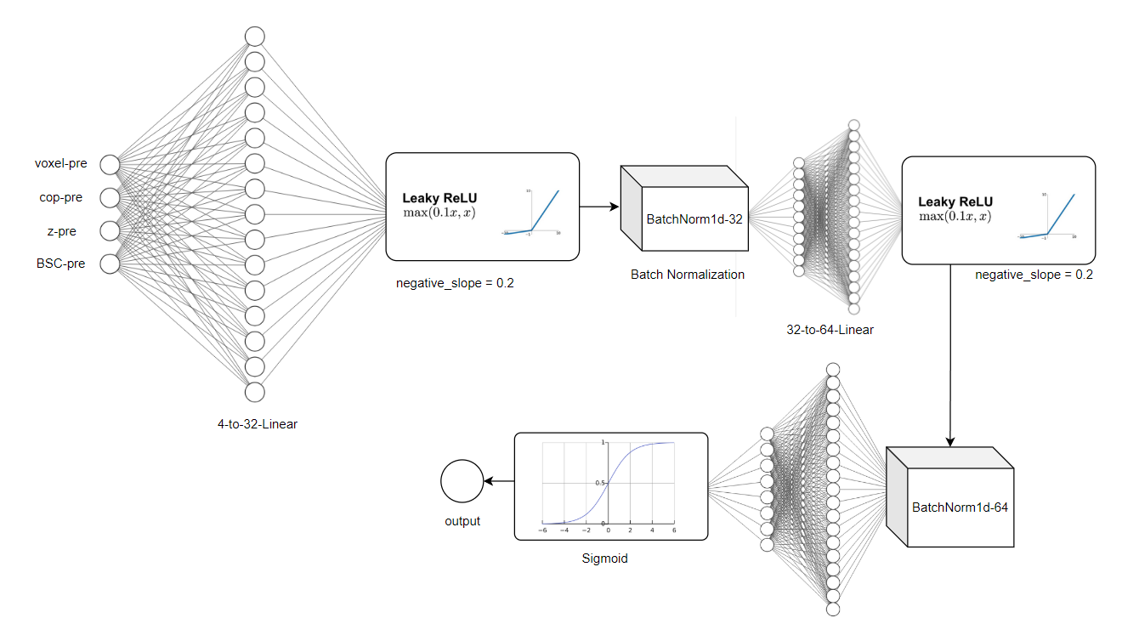
GAN DIAGRAM

GAN-Generator Unit Diagram

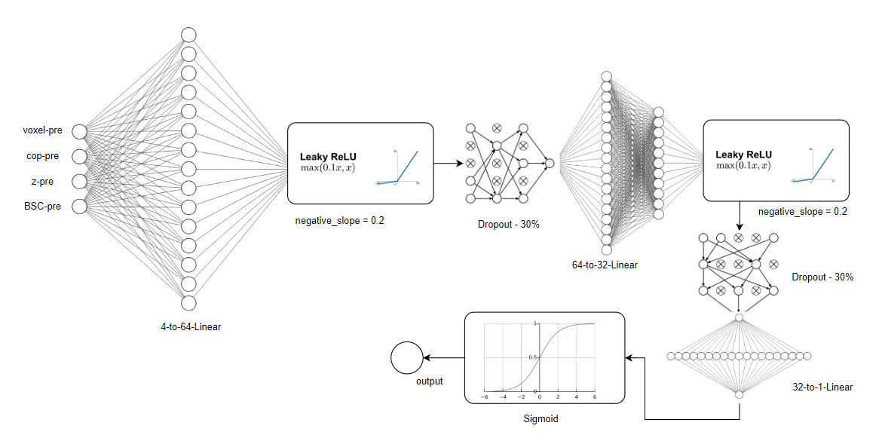

GAN-Discriminator Unit Diagram

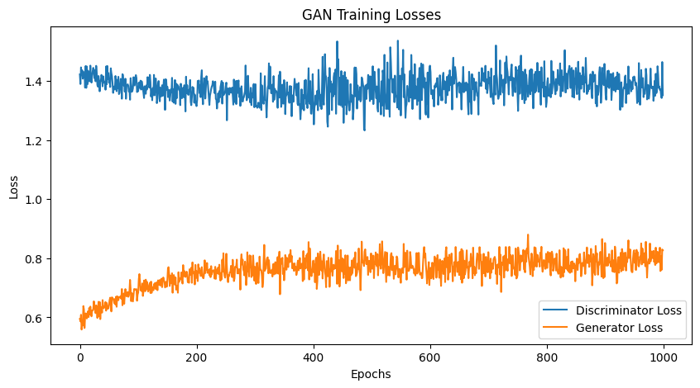

RIGHT STEM - GROUP1 – Augmented by GAN Network data result:
coppre voxelpre zpre BSCpre
0 189.10 65.0 7.086 0.200
1 193.69 61.0 3.747 0.200
2 181.00 57.0 4.099 0.115
3 116.30 55.0 4.750 0.160
4 126.70 76.0 4.950 0.200
5 173.60 53.0 4.330 0.250
6 126.80 64.0 3.810 0.160
7 75.39 73.0 3.761 0.180
8 154.23 62.0 3.660 0.240
9 108.00 74.0 4.507 0.150
10 181.10 46.0 2.830 0.196
11 150.54 61.0 4.092 0.176
12 138.75 57.0 2.766 0.222
13 97.11 78.0 4.168 0.216
14 160.04 78.0 6.349 0.173
15 100.88 60.0 5.005 0.208
16 157.72 72.0 4.357 0.200
17 156.99 66.0 5.747 0.191
18 126.73 77.0 3.730 0.154
19 156.02 72.0 3.785 0.153
20 112.36 72.0 2.469 0.162
21 202.70 61.0 3.706 0.155
22 113.60 64.0 5.498 0.216
23 137.71 71.0 3.423 0.176
24 153.21 46.0 4.094 0.203
25 103.95 50.0 4.998 0.192
26 141.47 54.0 4.421 0.186
27 198.31 73.0 3.512 0.183
28 84.53 68.0 5.175 0.199
29 114.09 68.0 3.291 0.247
30 166.40 63.0 4.520 0.122
31 198.41 72.0 4.552 0.181
32 173.60 58.0 4.487 0.173
33 129.98 72.0 4.585 0.125
34 140.47 71.0 4.315 0.205
35 172.74 78.0 3.189 0.171
36 177.98 77.0 3.629 0.191
37 148.16 60.0 4.633 0.134
38 148.71 75.0 3.716 0.145
39 154.01 64.0 4.335 0.123

RIGHT STEM - GROUP2:
0 186.200 57 9.5020 0.1540
1 44.550 57 0.9130 0.8000
2 92.200 56 3.9590 0.1000
3 125.300 65 4.5590 0.1200
4 45.520 56 2.4310 0.0930
5 299.300 59 4.4850 0.1000
6 171.700 66 5.5680 0.2000
7 29.070 69 1.6470 0.1000
8 181.900 56 2.6150 0.0250
9 57.190 60 3.2320 0.0550
10 44.390 63 2.1940 0.0500
11 74.730 60 3.7860 0.0650
12 105.400 55 2.3130 0.0375
13 74.500 67 3.6910 0.0900
14 112.800 59 6.9360 0.1100
15 97.250 63 3.0290 0.0800
16 78.650 57 3.0650 0.1000
17 122.700 60 2.1080 0.0450
18 6.849 50 0.1419 0.1400
19 126.300 66 6.8990 0.2300
20 135.200 50 4.9120 0.2000
21 101.500 53 4.6330 0.0800
22 59.850 61 2.2950 0.0500
23 183.000 58 4.4480 0.1000
24 89.190 60 4.2140 0.0500
25 83.360 63 2.6420 0.0650
26 77.160 57 3.9520 0.1430
27 57.890 65 3.7810 0.1800
28 71.110 69 2.6810 0.2500
29 179.100 63 7.7710 0.2600
30 134.000 63 3.7520 0.0700
31 37.470 65 1.9020 0.0500
32 65.390 69 3.3750 0.1550
33 38.550 57 2.4290 0.0500
34 81.260 63 3.8240 0.1300
35 52.540 58 2.5650 0.0480
36 77.800 54 3.9240 0.1350
37 149.300 64 5.7850 0.2000
38 88.590 62 4.4770 0.0780
RIGHT STEM - GROUP1-Augmented vs GROUP2 T-Test Report:
T-test for cop:
t-statistic: 4.582079295271485
p-value: 1.745892758673924e-05
------------------------------
T-test for voxel:
t-statistic: 3.187417358471499
p-value: 0.00207505127019278
------------------------------
T-test for z:
t-statistic: 1.5212140992126864
p-value: 0.13230225387940453
------------------------------
T-test for BSC:
t-statistic: 2.557337731018103
p-value: 0.012513091640255913
------------------------------

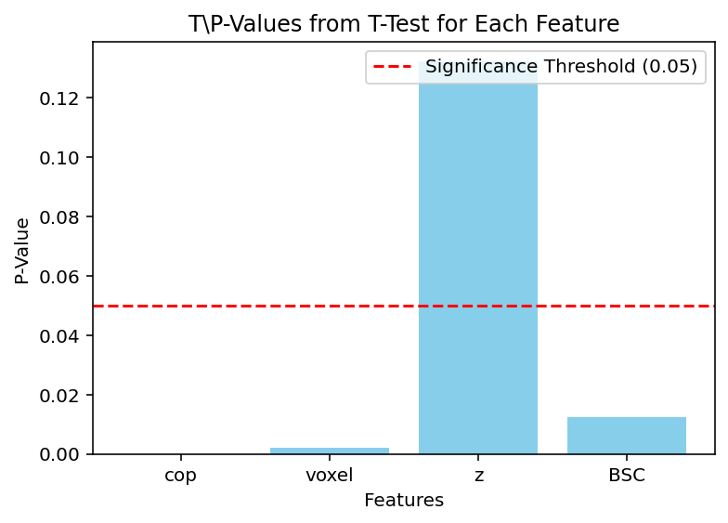

RIGHT STEM - GROUP1 (Original) vs GROUP2 T-Test Result:
T-test for cop:
t-statistic: 2.4075390820448495
p-value: 0.020039213984268618
------------------------------
T-test for voxel:
t-statistic: 1.798756202107894
p-value: 0.07848044508365437
------------------------------
T-test for z:
t-statistic: 1.1732315546383758
p-value: 0.24661459131521732
------------------------------
T-test for BSC:
t-statistic: 1.4112706347768293
p-value: 0.1647505622707071
------------------------------

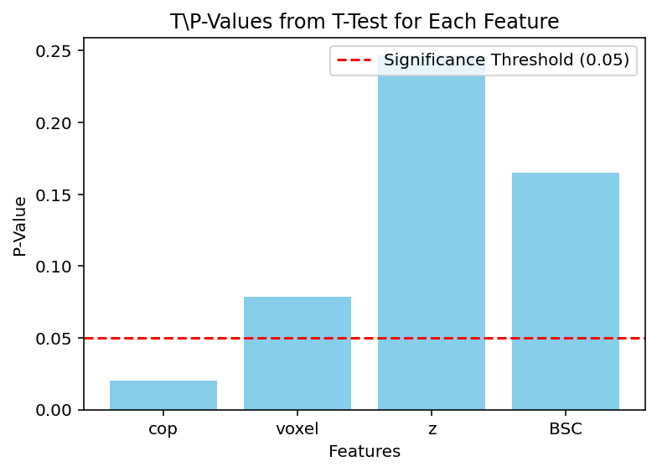
RIGHT STEM - GROUP1-Augmented Statistics:
Mean coppre G1-A: 146.08
Mean voxelpre G1-A: 65.6
Mean zpre G1-A: 4.25
Mean BSCpre G1-A: 0.18
STDEV coppre: 32.31
STDEV voxelpre: 8.87
STDEV zpre: 0.91
STDEV BSCpre: 0.03

RIGHT STEM - GROUP1 Statistics:
Mean coppre: 144.48
Mean voxelpre: 64.0
Mean zpre: 4.47
Mean BSCpre: 0.19
STDEV coppre: 37.7
STDEV voxelpre: 7.68
STDEV zpre: 0.97
STDEV BSCpre: 0.04

RIGHT STEM - GROUP2 Statistics:
Mean cop G2: 98.43
Mean voxel G2: 60.38
Mean z G2: 3.75
Mean BSC G2: 0.13
STDEV cop G2: 56.08
STDEV voxel G2: 4.86
STDEV z G2: 1.82
STDEV BSC G2: 0.12

LEFT STEM - GROUP1 – Augmented by GAN Network data result:
coppre voxelpre zpre BSCpre
0 119.000 60.000 5.438 0.120
1 159.110 60.000 4.600 0.190
2 181.000 51.000 5.023 0.125
3 212.800 58.000 4.208 0.100
4 133.200 70.000 4.355 0.200
5 156.240 48.000 5.710 0.150
6 222.900 58.000 4.900 0.160
7 147.900 65.000 4.780 0.150
8 200.300 60.000 4.420 0.100
9 208.000 72.000 6.510 0.200
10 116.029 52.875 4.507 0.090
11 142.854 56.683 6.070 0.133
12 115.388 56.332 5.947 0.143
13 157.858 84.754 5.598 0.141
14 188.978 48.209 6.110 0.155
15 172.311 55.817 5.903 0.174
16 172.629 69.254 5.714 0.167
17 152.307 51.494 6.334 0.164
18 152.217 69.109 4.614 0.152
19 216.684 69.446 4.757 0.169
20 142.363 52.023 4.932 0.130
21 134.150 59.185 4.956 0.111
22 175.693 63.070 5.201 0.176
23 194.514 51.652 4.429 0.193
24 150.879 58.139 5.614 0.128
25 136.992 64.006 5.249 0.124
26 159.289 57.999 4.918 0.183
27 204.219 62.571 5.042 0.097
28 199.806 66.114 5.176 0.105
29 122.133 70.493 3.581 0.182
30 214.894 49.191 4.792 0.148
31 186.978 59.783 4.228 0.139
32 206.946 60.868 4.489 0.138
33 196.887 66.322 5.308 0.132
34 186.113 66.366 4.293 0.158
35 178.298 53.134 4.366 0.106
36 142.368 51.148 5.644 0.161
37 65.987 49.870 4.690 0.126
38 191.583 57.693 4.396 0.144
39 154.613 61.407 5.079 0.136
LEFT STEM – GROUP2:
coppre voxelpre zpre BSCpre
0 168.20 53.0 7.7180 0.150
1 44.55 56.0 0.6312 0.025
2 148.20 64.0 2.5460 0.150
3 130.40 53.0 5.1000 0.102
4 68.58 50.0 3.0670 0.150
5 359.50 53.0 4.3490 0.105
6 171.70 62.0 5.5680 0.010
7 96.86 59.0 4.5140 0.100
8 201.90 55.0 3.8100 0.020
9 71.07 57.0 3.5360 0.050
10 66.27 65.0 3.2700 0.050
11 78.24 55.0 3.6810 0.250
12 105.40 55.0 3.7600 0.037
13 75.90 64.0 3.0810 0.180
14 250.50 55.0 6.4960 0.200
15 108.20 58.0 5.0340 0.170
16 50.10 61.0 3.1920 0.050
17 122.70 53.0 2.1080 0.100
18 43.48 60.0 1.8810 0.070
19 226.30 60.0 6.7410 0.200
20 207.10 48.0 4.7650 0.120
21 169.90 53.0 7.7910 0.175
22 59.85 59.0 3.3200 0.050
23 221.10 58.0 3.5130 0.090
24 89.19 55.0 2.5380 0.070
25 141.30 56.0 3.6690 0.070
26 105.70 50.0 5.0020 0.200
27 63.03 59.0 3.4150 0.200
28 125.00 64.0 3.5630 0.100
29 168.60 58.0 5.6170 0.200
30 90.83 61.0 3.3960 0.100
31 38.08 58.0 1.7570 0.055
32 54.89 65.0 2.8000 0.055
33 63.89 51.0 4.0260 0.060
34 111.20 61.0 4.9200 0.110
35 52.96 51.0 2.2890 0.050
36 104.50 50.0 5.4430 0.090
37 197.80 59.0 1.8560 0.075
38 111.70 60.0 4.1080 0.060
LEFT STEM - GROUP1-Augmented vs GROUP2 T-Test Report:
T-test for coppre:
t-statistic: 3.62
p-value: 0.00052
------------------------------
T-test for voxelpre:
t-statistic: 1.990
p-value: 0.0501
------------------------------
T-test for zpre:
t-statistic: 4.02
p-value: 0.000133
------------------------------
T-test for BSCpre:
t-statistic: 3.69
p-value: 0.000413
------------------------------

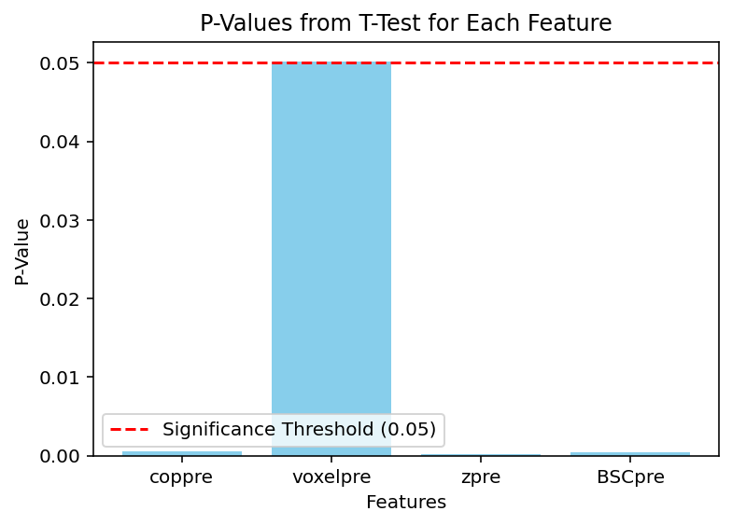

LEFT STEM - GROUP1 (Original) vs GROUP2 T-Test Result:
T-test for coppre:
t-statistic: 2.267
p-value: 0.0280
------------------------------
T-test for voxelpre:
t-statistic: 1.703
p-value: 0.095
------------------------------
T-test for zpre:
t-statistic: 2.015
p-value: 0.0496
------------------------------
T-test for BSCpre:
t-statistic: 2.166
p-value: 0.035
------------------------------

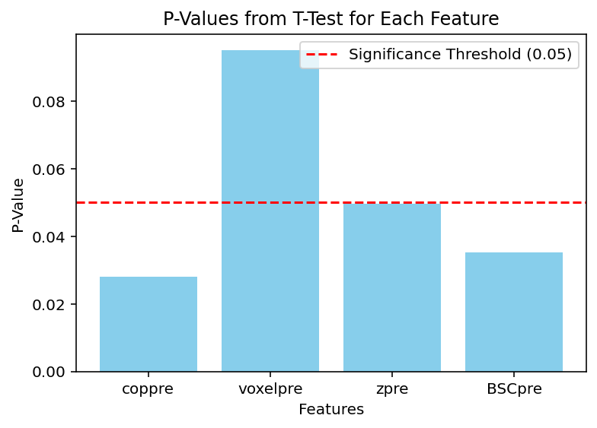

LEFT STEM - Correlation [GROUP1-Augmented vs GROUP2] :
Correlation coppre: -0.059
Correlation voxelpre: 0.2669
Correlation zpre: 0.074
Correlation BSCpre: 0.055
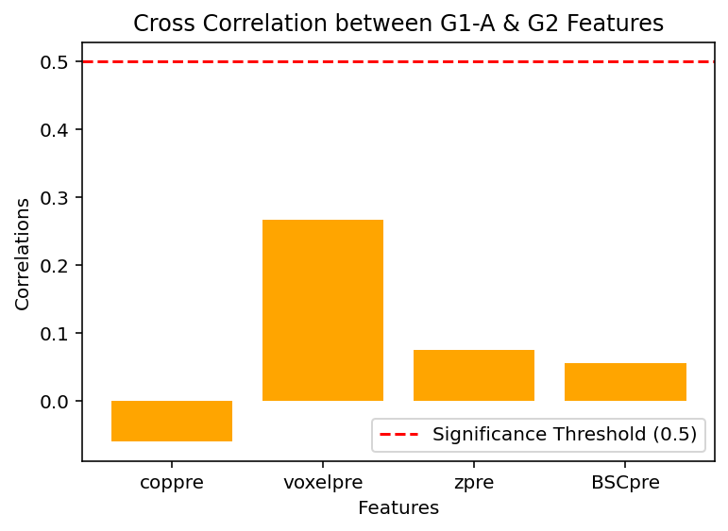

LEFT STEM - GROUP1-Augmented Statistics:
Mean coppre G1-A: 167.12
Mean voxelpre G1-A: 59.89
Mean zpre G1-A: 5.05
Mean BSCpre G1-A: 0.15
STDEV coppre G1-A: 34.67
STDEV voxelpre G1-A: 7.89
STDEV zpre G1-A: 0.67
STDEV BSCpre G1-A: 0.03

LEFT STEM - GROUP1 Statistics:
Mean coppre G1: 174.04
Mean voxelpre G1: 60.2
Mean zpre G1: 4.99
Mean BSCpre G1: 0.15
STDEV coppre G1: 34.21
STDEV voxelpre G1: 7.08
STDEV zpre G1: 0.68
STDEV BSCpre G1: 0.04

LEFT STEM - GROUP2 Statistics:
Mean coppre G2: 122.17
Mean voxelpre G2: 57.03
Mean zpre G2: 3.95
Mean BSCpre G2: 0.11
STDEV coppre G2: 68.71
STDEV voxelpre G2: 4.52
STDEV zpre G2: 1.58
STDEV BSCpre G2: 0.06

Normality test with Shapiro-Wilk Test:

RIGHT STEM GROUP1 - coppre:
Shapiro-Wilk test statistic: 0.9347502863043512
P-value: 0.4962041637397511
Data looks like a normal distribution

RIGHT STEM GROUP1 - voxelpre:
Shapiro-Wilk test statistic: 0.9317832509786342
P-value: 0.4656600163517724
Data looks like a normal distribution

RIGHT STEM GROUP1 - zpre:
Shapiro-Wilk test statistic: 0.7550868371782665
P-value: 0.004115879333578123
Data does not look like a normal distribution

RIGHT STEM GROUP1 - BSCpre:
Shapiro-Wilk test statistic: 0.9609977486590815
P-value: 0.797187667496022
Data looks like a normal distribution

RIGHT STEM GROUP1 Augmented - coppre:
Shapiro-Wilk test statistic: 0.9787502959937275
P-value: 0.6432029747873634
Data looks like a normal distribution

RIGHT STEM GROUP1 Augmented - voxelpre:
Shapiro-Wilk test statistic: 0.9468120674994568
P-value: 0.05893671039559701
Data looks like a normal distribution

RIGHT STEM GROUP1 Augmented - zpre:
Shapiro-Wilk test statistic: 0.9547641239869776
P-value: 0.11067094925897186
Data looks like a normal distribution

RIGHT STEM GROUP1 Augmented - BSCpre:
Shapiro-Wilk test statistic: 0.9790087708317297
P-value: 0.6527620151038658
Data looks like a normal distribution

RIGHT STEM GROUP2 - cop:
Shapiro-Wilk test statistic: 0.9080810749682929
P-value: 0.0037925736582603824
Data does not look like a normal distribution

RIGHT STEM GROUP2 - voxel:
Shapiro-Wilk test statistic: 0.9727908619783476
P-value: 0.4553839463451103
Data looks like a normal distribution

RIGHT STEM GROUP2 - z:
Shapiro-Wilk test statistic: 0.937613050807811
P-value: 0.03175035106647424
Data does not look like a normal distribution

RIGHT STEM GROUP2 - BSC:
Shapiro-Wilk test statistic: 0.579348565429754
P-value: 2.2356725074763545e-09
Data does not look like a normal distribution

LEFT STEM GROUP1 - coppre:
Shapiro-Wilk test statistic: 0.9415758512786505
P-value: 0.5706781090100408
Data looks like a normal distribution

LEFT STEM GROUP1 - voxelpre:
Shapiro-Wilk test statistic: 0.9444611265299422
P-value: 0.6036315202360633
Data looks like a normal distribution

LEFT STEM GROUP1 - zpre:
Shapiro-Wilk test statistic: 0.9110216629160103
P-value: 0.2880827649566656
Data looks like a normal distribution

LEFT STEM GROUP1 - BSCpre:
Shapiro-Wilk test statistic: 0.9079759242863261
P-value: 0.26737515719357663
Data looks like a normal distribution

LEFT STEM GROUP1 Augmented - coppre:
Shapiro-Wilk test statistic: 0.9615609841992756
P-value: 0.20099180597729982
Data looks like a normal distribution

LEFT STEM GROUP1 Augmented - voxelpre:
Shapiro-Wilk test statistic: 0.9487451710201183
P-value: 0.07455498596278698
Data looks like a normal distribution

LEFT STEM GROUP1 Augmented - zpre:
Shapiro-Wilk test statistic: 0.9710103138586211
P-value: 0.4031273395836985
Data looks like a normal distribution

LEFT STEM GROUP1 Augmented - BSCpre:
Shapiro-Wilk test statistic: 0.9776450325797402
P-value: 0.6182274923221711
Data looks like a normal distribution

LEFT STEM GROUP2 - coppre:
Shapiro-Wilk test statistic: 0.8956698870973706
P-value: 0.001661701624117287
Data does not look like a normal distribution

LEFT STEM GROUP2 - voxelpre:
Shapiro-Wilk test statistic: 0.9680980893792391
P-value: 0.32765361461131115
Data looks like a normal distribution

LEFT STEM GROUP2 - zpre:
Shapiro-Wilk test statistic: 0.9670293946306404
P-value: 0.30305369562342976
Data looks like a normal distribution

LEFT STEM GROUP2 - BSCpre:
Shapiro-Wilk test statistic: 0.9293010855318422
P-value: 0.017067319779668567
Data does not look like a normal distribution

Q-Q Visual Test for normality test – STEM RIGHT:
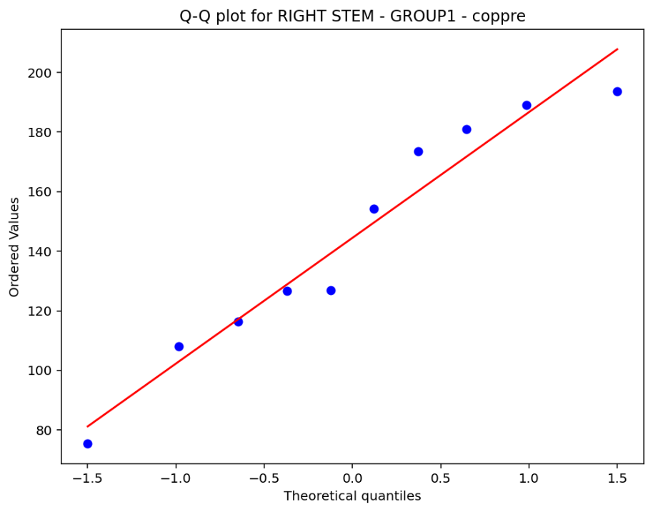
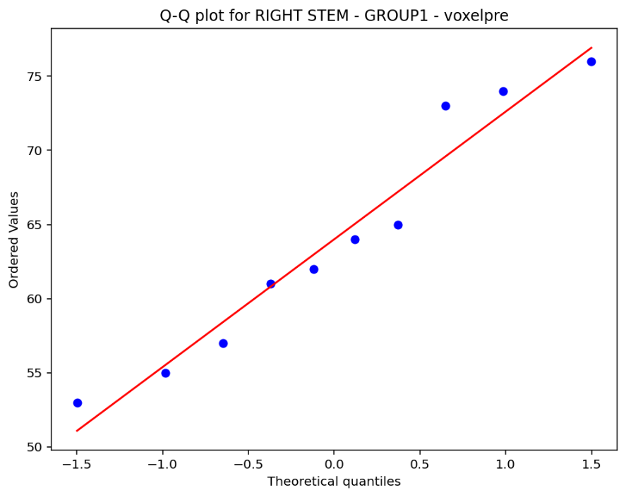

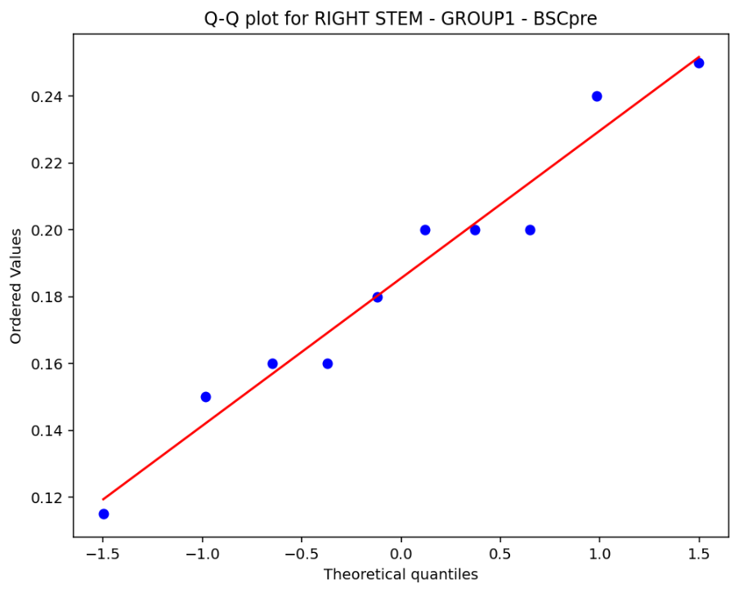
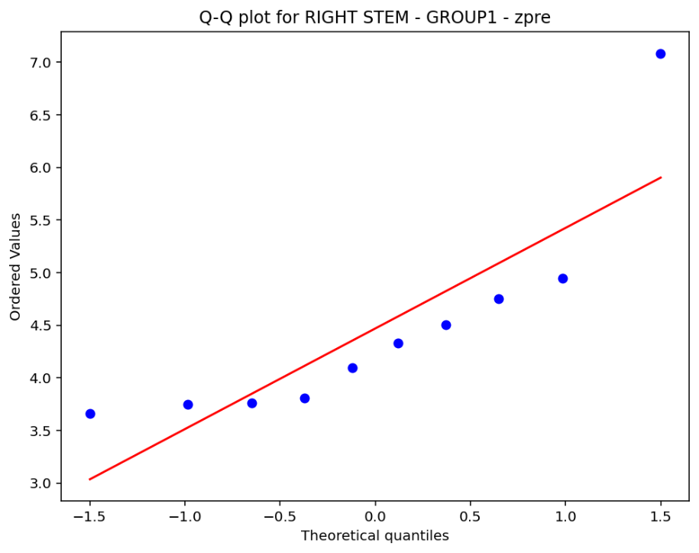

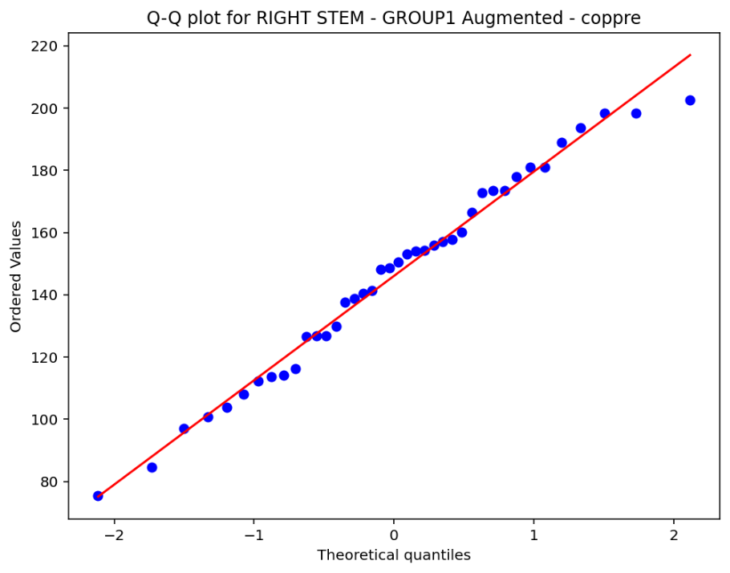
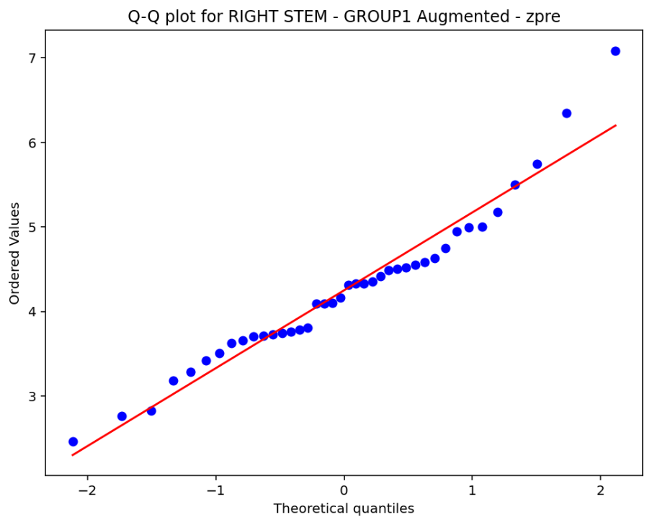

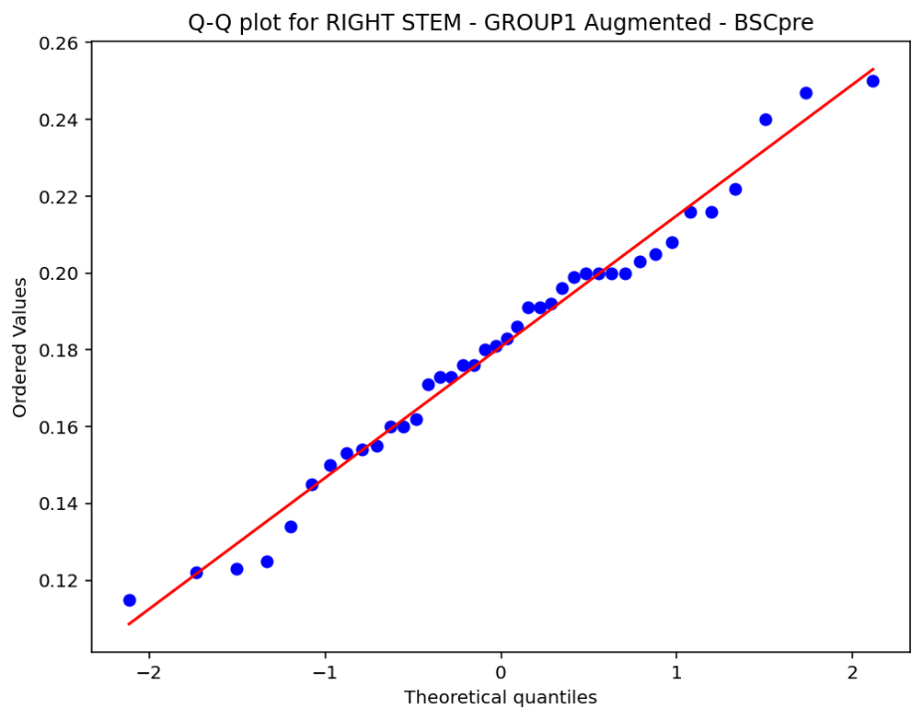
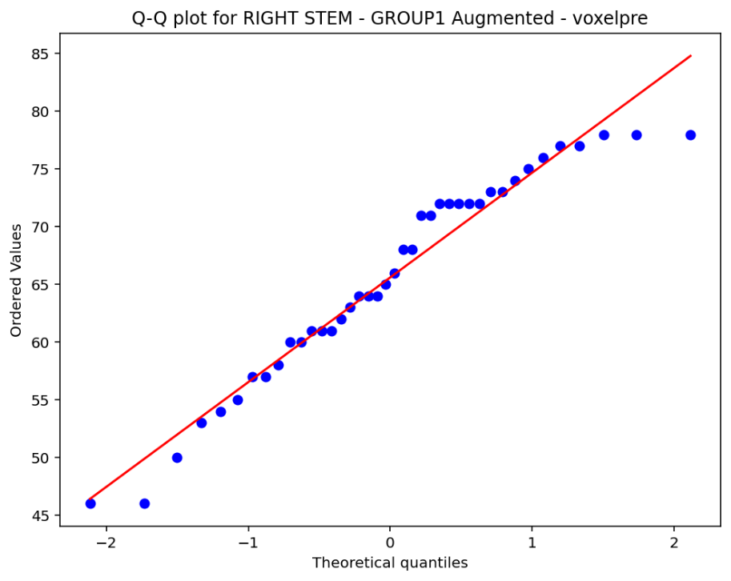

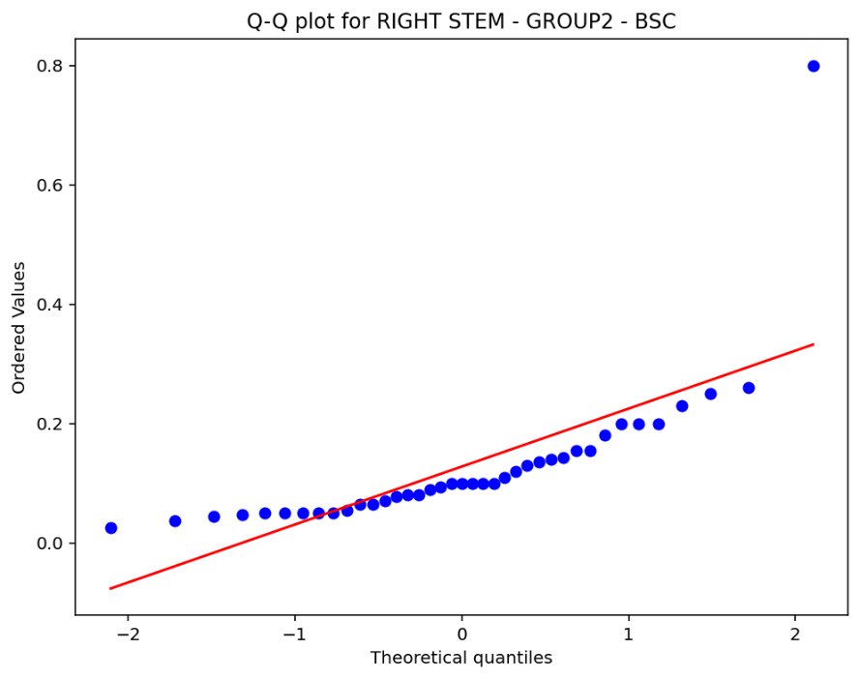
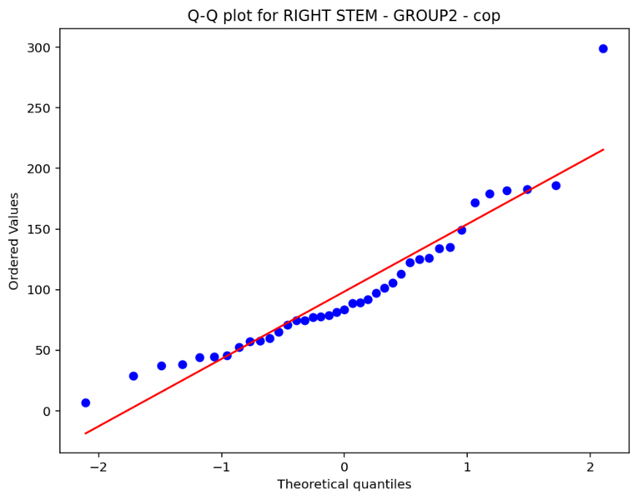

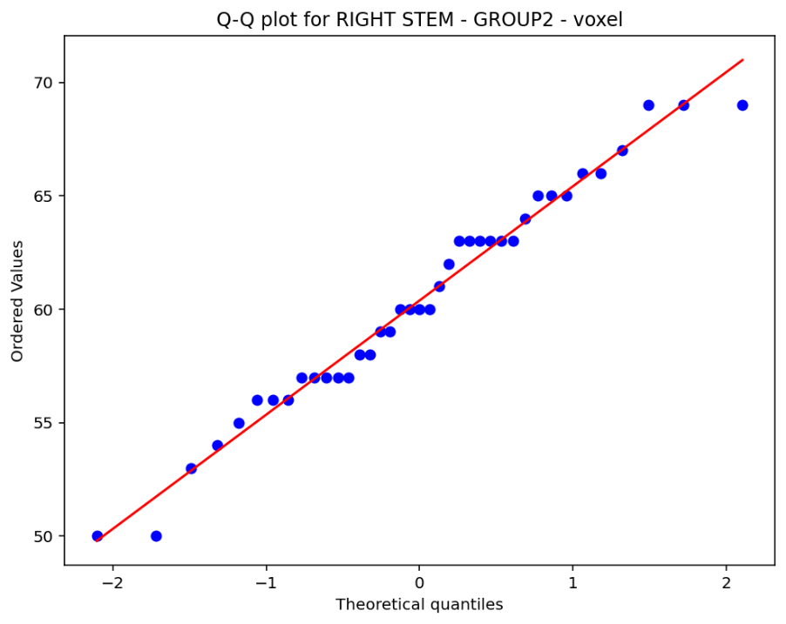
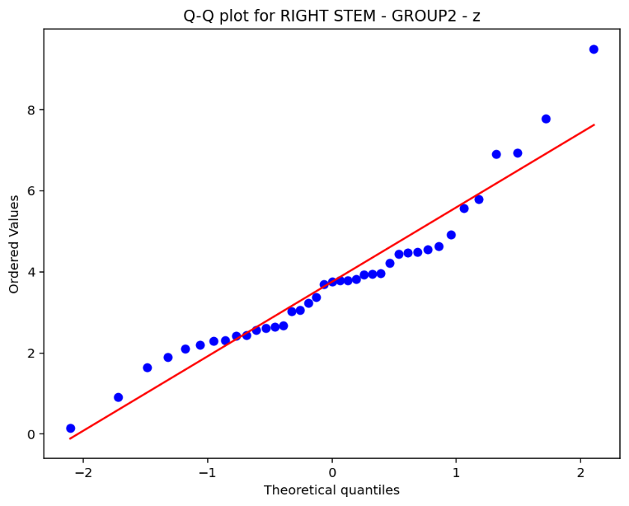

PLOTS ON THIS PAGE CHANED

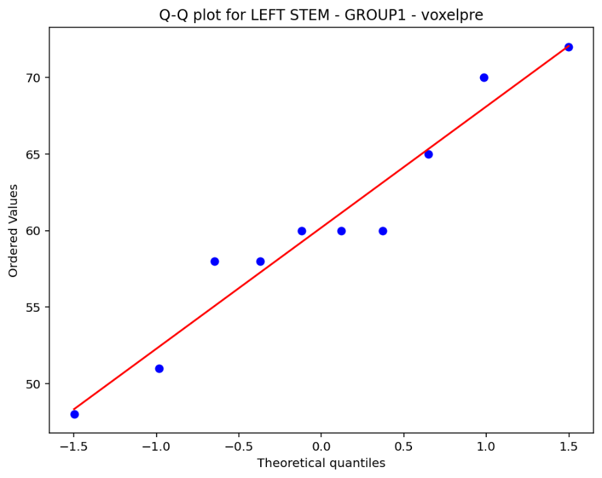
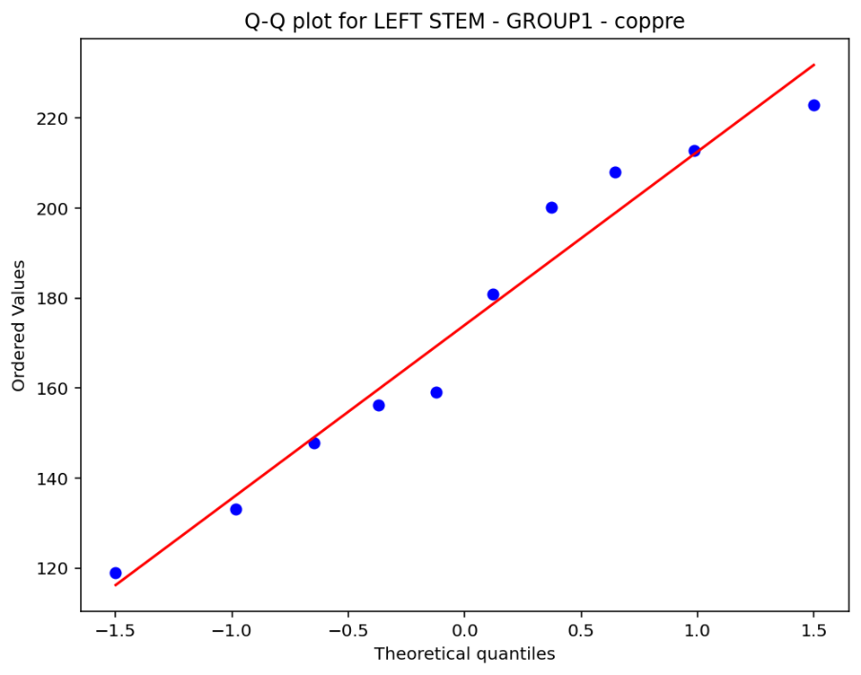
Q-Q Visual Test for normality test – STEM LEFT:

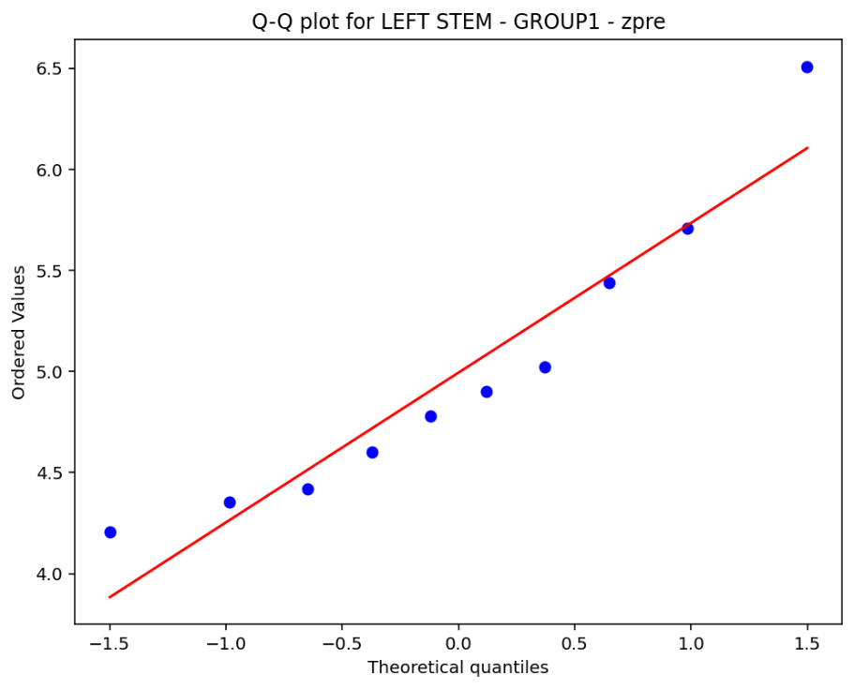
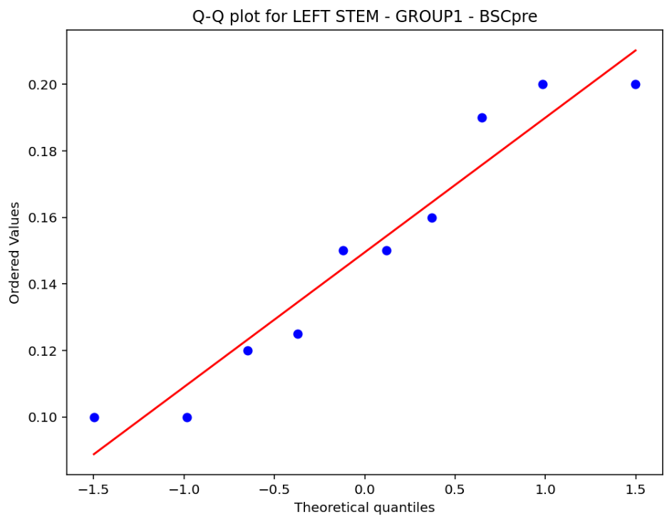

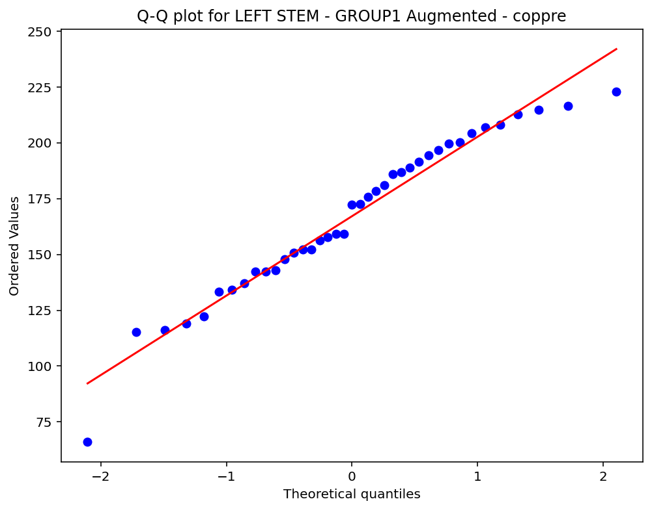
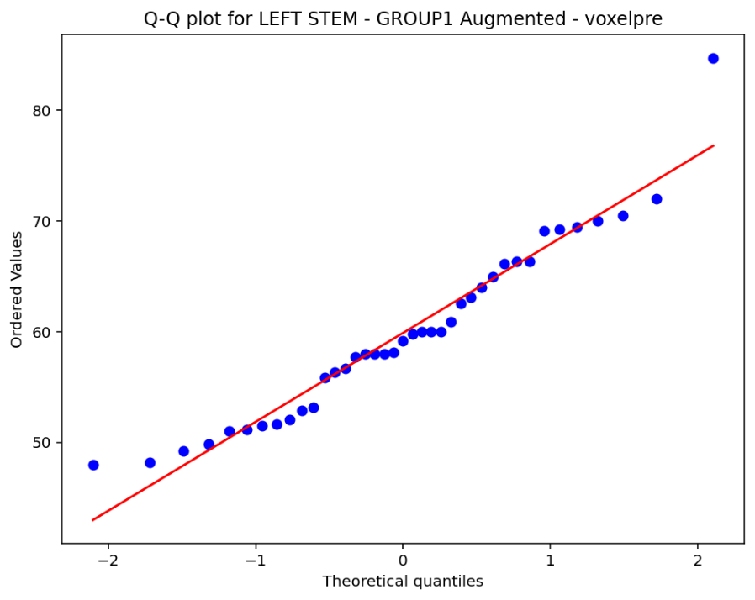

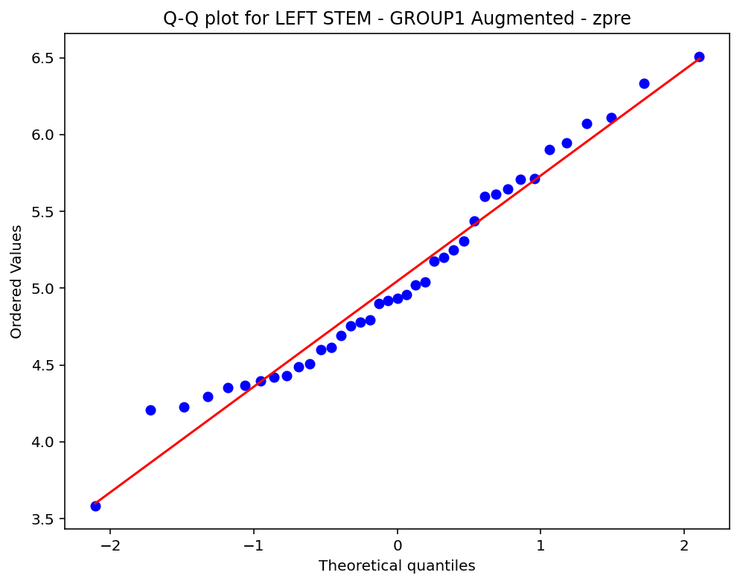
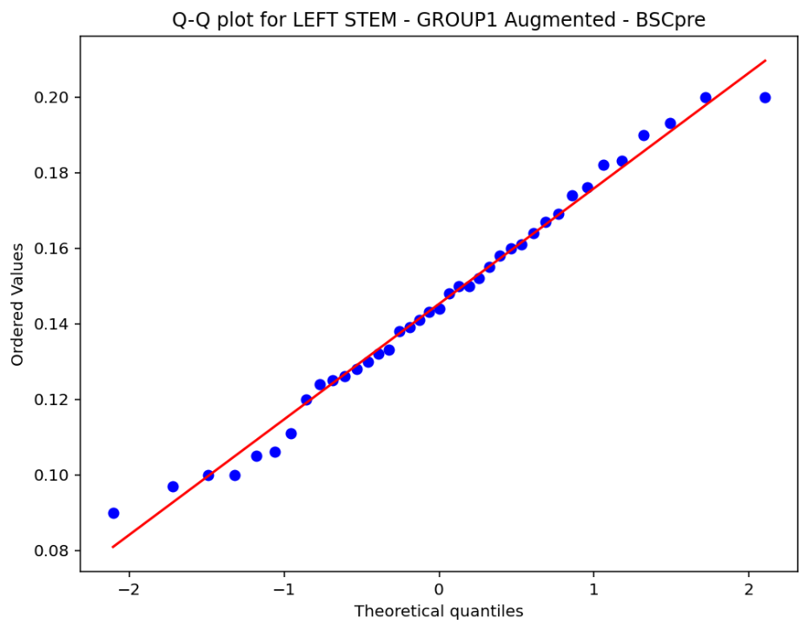

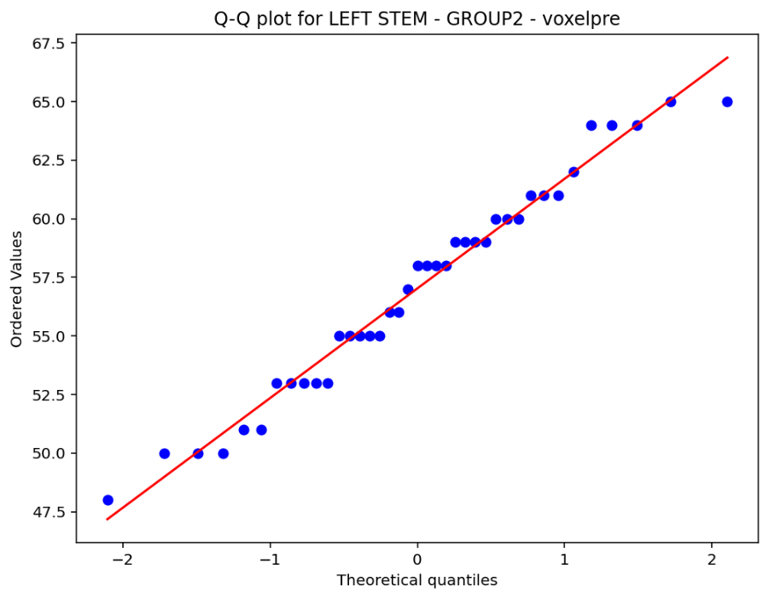
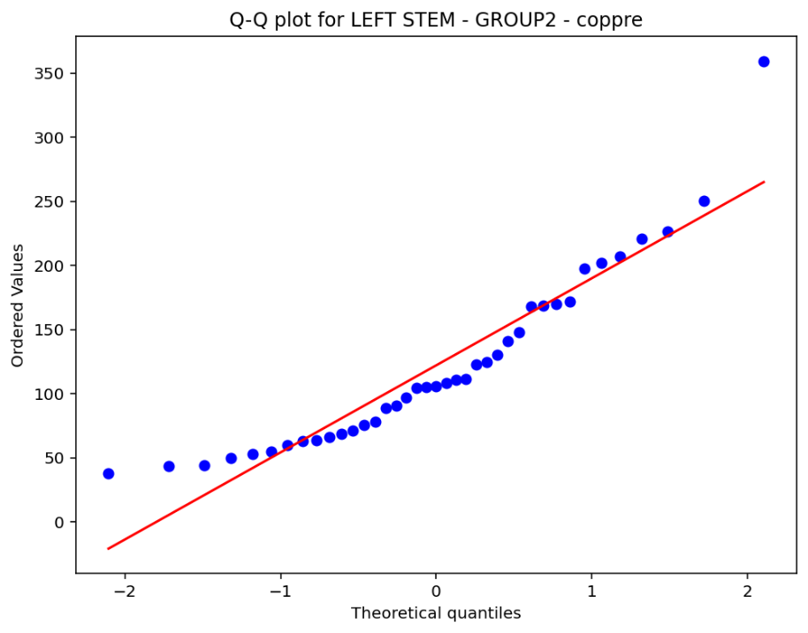

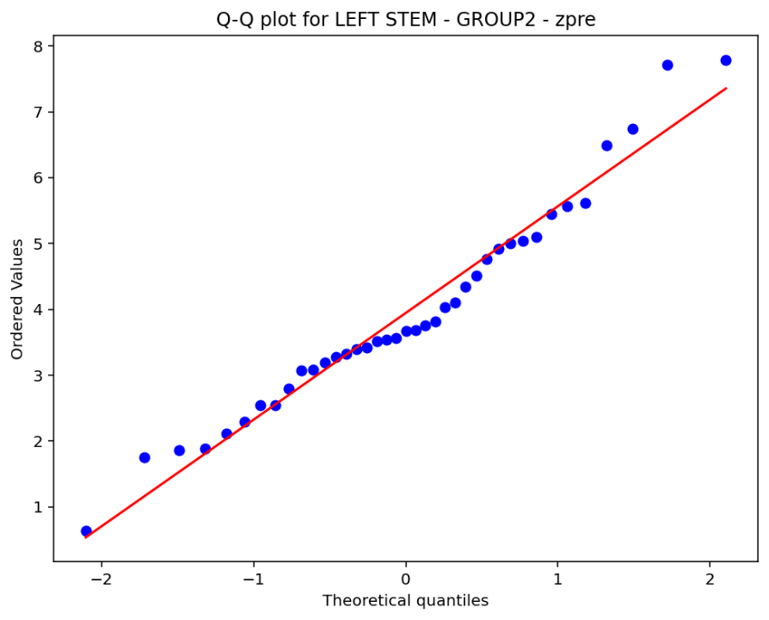
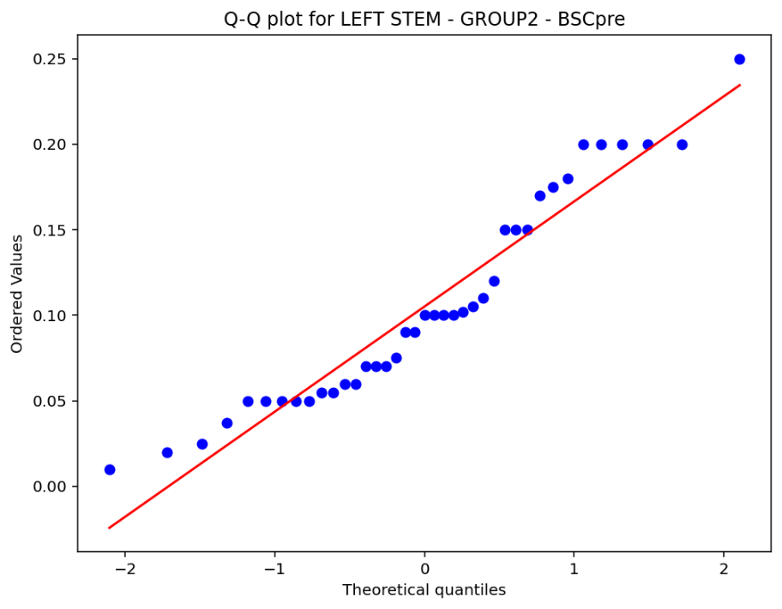

G1 vs G2 RIGHT ARI Assessment:
Adjusted Rand Index (ARI): 0.11023285622730186

G1-A vs G2 RIGHT ARI Assessment:
Adjusted Rand Index (ARI): 0.31586558212143623

G1 vs G2 LEFT ARI Assessment:
Adjusted Rand Index (ARI): 0.10715394968423232

G1-A vs G2 LEFT ARI Assessment:
Adjusted Rand Index (ARI): 0.3711814167322001

