coppre voxelpre zpre BSCpre group Cluster
0 119.00 60.0 5.4380 0.120 1 1
1 159.11 60.0 4.6000 0.190 1 1
2 181.00 51.0 5.0230 0.125 1 1
3 212.80 58.0 4.2080 0.100 1 1
4 133.20 70.0 4.3550 0.200 1 1
5 156.24 48.0 5.7100 0.150 1 1
6 222.90 58.0 4.9000 0.160 1 1
7 147.90 65.0 4.7800 0.150 1 1
8 200.30 60.0 4.4200 0.100 1 1
9 208.00 72.0 6.5100 0.200 1 1
10 168.20 53.0 7.7180 0.150 2 1
11 44.55 56.0 0.6312 0.025 2 0
12 148.20 64.0 2.5460 0.150 2 0
13 130.40 53.0 5.1000 0.102 2 1
14 68.58 50.0 3.0670 0.150 2 0
15 359.50 53.0 4.3490 0.105 2 1
16 171.70 62.0 5.5680 0.010 2 0
17 96.86 59.0 4.5140 0.100 2 0
18 201.90 55.0 3.8100 0.020 2 0
19 71.07 57.0 3.5360 0.050 2 0
20 66.27 65.0 3.2700 0.050 2 0
21 78.24 55.0 3.6810 0.250 2 1
22 105.40 55.0 3.7600 0.037 2 0
23 75.90 64.0 3.0810 0.180 2 0
24 250.50 55.0 6.4960 0.200 2 1
25 108.20 58.0 5.0340 0.170 2 1
26 50.10 61.0 3.1920 0.050 2 0
27 122.70 53.0 2.1080 0.100 2 0
28 43.48 60.0 1.8810 0.070 2 0
29 226.30 60.0 6.7410 0.200 2 1
30 207.10 48.0 4.7650 0.120 2 1
31 169.90 53.0 7.7910 0.175 2 1
32 59.85 59.0 3.3200 0.050 2 0
33 221.10 58.0 3.5130 0.090 2 1
34 89.19 55.0 2.5380 0.070 2 0
35 141.30 56.0 3.6690 0.070 2 0
36 105.70 50.0 5.0020 0.200 2 1
37 63.03 59.0 3.4150 0.200 2 0
38 125.00 64.0 3.5630 0.100 2 0
39 168.60 58.0 5.6170 0.200 2 1
40 90.83 61.0 3.3960 0.100 2 0
41 38.08 58.0 1.7570 0.055 2 0
42 54.89 65.0 2.8000 0.055 2 0
43 63.89 51.0 4.0260 0.060 2 0
44 111.20 61.0 4.9200 0.110 2 0
45 52.96 51.0 2.2890 0.050 2 0
46 104.50 50.0 5.4430 0.090 2 1
47 197.80 59.0 1.8560 0.075 2 0
48 111.70 60.0 4.1080 0.060 2 0

Cross-Correlation Matrix:

coppre voxelpre zpre BSCpre group Cluster
coppre 1.000000 -0.065152 0.519742 0.277061 -0.314007 0.605142
voxelpre -0.065152 1.000000 -0.090379 0.072617 -0.241181 -0.157957
zpre 0.519742 -0.090379 1.000000 0.502775 -0.282030 0.696331
BSCpre 0.277061 0.072617 0.502775 1.000000 -0.301386 0.634531
group -0.314007 -0.241181 -0.282030 -0.301386 1.000000 -0.538382
Cluster 0.605142 -0.157957 0.696331 0.634531 - 0.538382 1.000000

T-test for coppre:
t-statistic: 2.267410479738265
p-value: 0.028005202214543348
------------------------------
T-test for voxelpre:
t-statistic: 1.7037498024996305
p-value: 0.0950320553083629
------------------------------
T-test for zpre:
t-statistic: 2.0153098482285476
p-value: 0.0496111392087596
------------------------------
T-test for BSCpre:
t-statistic: 2.166953748755809
p-value: 0.03533984949858318
------------------------------
T-test for group:
t-statistic: -inf
p-value: 0.0
------------------------------
T-test for Cluster:
t-statistic: 4.379917061930256
p-value: 6.600343439057169e-05
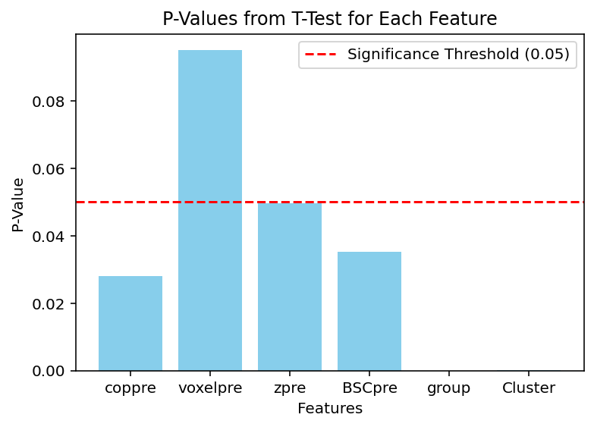
DF1 (Group 1) STD:
coppre 36.057515
voxelpre 7.465476
zpre 0.712924
BSCpre 0.038330
group 0.000000
Cluster 0.000000

DF2 (Group2) STD:
coppre 69.603254
voxelpre 4.579630
zpre 1.595842
BSCpre 0.061518
group 0.000000
Cluster 0.477567

