coppre voxelpre zpre BSCpre group Cluster
0 189.100 65 7.0860 0.2000 1 1
1 193.690 61 3.7470 0.2000 1 1
2 181.000 57 4.0990 0.1150 1 1
3 116.300 55 4.7500 0.1600 1 1
4 126.700 76 4.9500 0.2000 1 1
5 173.600 53 4.3300 0.2500 1 1
6 126.800 64 3.8100 0.1600 1 1
7 75.390 73 3.7610 0.1800 1 0
8 154.230 62 3.6600 0.2400 1 1
9 108.000 74 4.5070 0.1500 1 1
10 186.200 57 9.5020 0.1540 2 1
11 44.550 57 0.9130 0.8000 2 0
12 92.200 56 3.9590 0.1000 2 0
13 125.300 65 4.5590 0.1200 2 1
14 45.520 56 2.4310 0.0930 2 0
15 299.300 59 4.4850 0.1000 2 1
16 171.700 66 5.5680 0.2000 2 1
17 29.070 69 1.6470 0.1000 2 0
18 181.900 56 2.6150 0.0250 2 1
19 57.190 60 3.2320 0.0550 2 0
20 44.390 63 2.1940 0.0500 2 0
21 74.730 60 3.7860 0.0650 2 0
22 105.400 55 2.3130 0.0375 2 0
23 74.500 67 3.6910 0.0900 2 0
24 112.800 59 6.9360 0.1100 2 1
25 97.250 63 3.0290 0.0800 2 0
26 78.650 57 3.0650 0.1000 2 0
27 122.700 60 2.1080 0.0450 2 0
28 6.849 50 0.1419 0.1400 2 0
29 126.300 66 6.8990 0.2300 2 1
30 135.200 50 4.9120 0.2000 2 1
31 101.500 53 4.6330 0.0800 2 0
32 59.850 61 2.2950 0.0500 2 0
33 183.000 58 4.4480 0.1000 2 1
34 89.190 60 4.2140 0.0500 2 0
35 83.360 63 2.6420 0.0650 2 0
36 77.160 57 3.9520 0.1430 2 0
37 57.890 65 3.7810 0.1800 2 0
38 71.110 69 2.6810 0.2500 2 0
39 179.100 63 7.7710 0.2600 2 1
40 134.000 63 3.7520 0.0700 2 1
41 37.470 65 1.9020 0.0500 2 0
42 65.390 69 3.3750 0.1550 2 0
43 38.550 57 2.4290 0.0500 2 0
44 81.260 63 3.8240 0.1300 2 0
45 52.540 58 2.5650 0.0480 2 0
46 77.800 54 3.9240 0.1350 2 0
47 149.300 64 5.7850 0.2000 2 1
48 88.590 62 4.4770 0.0780 2 0

Cross-Correlation Matrix:
coppre voxelpre zpre BSCpre group Cluster
coppre 1.000000 -0.048395 0.606805 0.059083 -0.331338 0.801837
voxelpre -0.048395 1.000000 0.120853 0.055056 -0.253786 0.067723
zpre 0.606805 0.120853 1.000000 0.065098 -0.168681 0.633601
BSCpre 0.059083 0.055056 0.065098 1.000000 -0.201627 0.183088
group -0.331338 -0.253786 -0.168681 -0.201627 1.000000 -0.482382
Cluster 0.801837 0.067723 0.633601 0.183088 -0.482382 1.000000
T-test for coppre:
t-statistic: 2.4075390820448495
p-value: 0.020039213984268625
------------------------------
T-test for voxelpre:
t-statistic: 1.798756202107894
p-value: 0.07848044508365437
------------------------------
T-test for zpre:
t-statistic: 1.1732315546383758
p-value: 0.2466145913152173
------------------------------
T-test for BSCpre:
t-statistic: 1.4112706347768293
p-value: 0.1647505622707071
------------------------------
T-test for group:
t-statistic: -inf
p-value: 0.0
------------------------------
T-test for Cluster:
t-statistic: 3.7753321485771556
p-value: 0.00044813897738020455

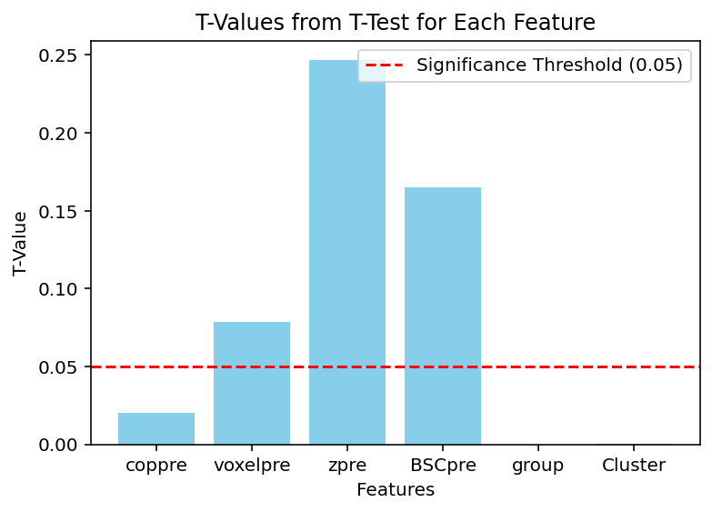

DF1 (Group 1) STD:
coppre 39.744123
voxelpre 8.096639
zpre 1.023500
BSCpre 0.041261
group 0.000000
Cluster 0.316228

DF2 (Group2) STD:
coppre 56.812718
voxelpre 4.923709
zpre 1.846743
BSCpre 0.126450
group 0.000000
Cluster 0.467572

