**Bug Report of Dzain application**

|  |  |  |
| --- | --- | --- |
| ID number | #001 |  |
| Bug Summary | Privacy Policy, About, Support tabs don’t have functionality |  |
| Reporter | Armine Nersisyan |  |
| Submit Date | 15/06/2021 |  |
| Platform | Galaxy SM-J810F |  |
| Operating System | Android version 10 |  |
| Browser |  |  |
| Severity | Critical |  |
| Priority | High |  |
| Status | Opened |  |
| Assigned to | QA/Developer/BA |  |
| Version | 1.0 |  |
| Environment | <https://play.google.com/apps/testing/io.dzain.dzain> |  |
| Component/tag |  |  |
| Screenshot/video |  |  |

**Precondition:** The application is opened in settings option

**Description:**

When I open settings and touch in Privacy Policy, About, Support tabs I stay in the tab setting,

**Steps to reproduce**

1. touch in Privacy Policy tab
2. touch in About tab
3. touch in Support tab

**Expected result**

The application should open a new tab with Privacy Policy, About, Support information

**Actual result**

The settings screen stay opened

**Notes:**

**References:**

|  |  |  |
| --- | --- | --- |
| ID number | #002 |  |
| Bug Summary |  |  |
| Reporter | Armine Nersisyan |  |
| Submit Date | 15/06/2021 |  |
| Platform | Galaxy SM-J810F |  |
| Operating System | Android version 10 |  |
| Browser |  |  |
| Severity | Critical |  |
| Priority | High |  |
| Status | Opened |  |
| Assigned to | QA/Developer/BA |  |
| Version | 1.0 |  |
| Environment | <https://play.google.com/apps/testing/io.dzain.dzain> |  |
| Component/tag |  |  |
| Screenshot/video |  |  |

**Precondition:** The application is opened, the poll created and completed

**Description:**

When I open options “edit duration” and “stop the poll” is active

**Steps to reproduce**

1. touch in options
2. touch in “edit duration”
3. touch in “stop the poll”

**Expected result**

Shouldn’t active “edit duration” and “stop the poll” options

**Actual result**

The “edit duration” and “stop the poll” is active and continue working with error message

**Notes:**

**References:**

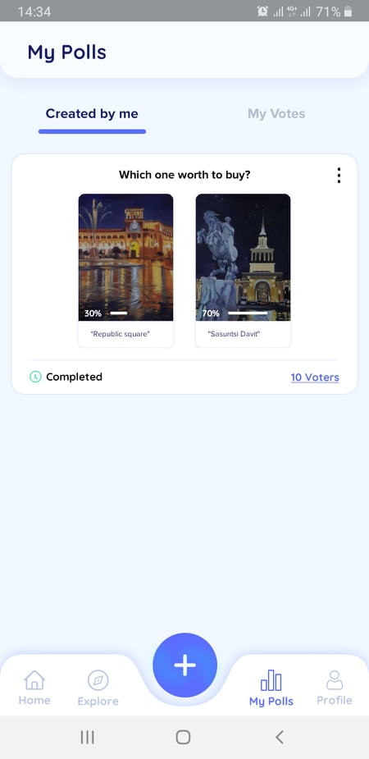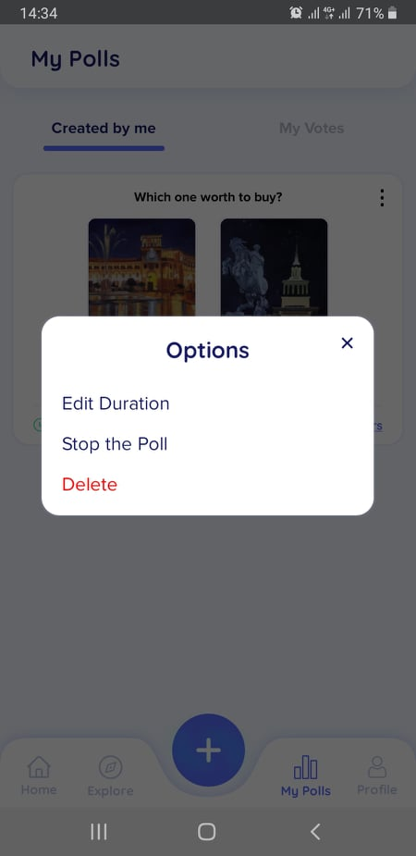

|  |  |  |
| --- | --- | --- |
| ID number | #003 |  |
| Bug Summary | e-mail doesn't validate |  |
| Reporter | Armine Nersisyan |  |
| Submit Date | 15/06/2021 |  |
| Platform | Galaxy SM-J810F |  |
| Operating System | Android version 10 |  |
| Browser |  |  |
| Severity | Critical |  |
| Priority | High |  |
| Status | Opened |  |
| Assigned to | QA/Developer/BA |  |
| Version | 1.0 |  |
| Environment | <https://play.google.com/apps/testing/io.dzain.dzain> |  |
| Component/tag |  |  |
| Screenshot/video |  |  |

**Precondition:** The application is opened, the personal information screen is opened

**Description:**

When I edit e-mail address with invalid data (for instance amine@dklakdk041.nkandjn454shq) I can save the information

**Steps to reproduce**

1. touch in e-mail field
2. input invalid data
3. touch in “✔”

**Expected result**

Shouldn't save information and should give an error message

**Actual result**

The incorrect information is saved

**Notes:**

**References:**

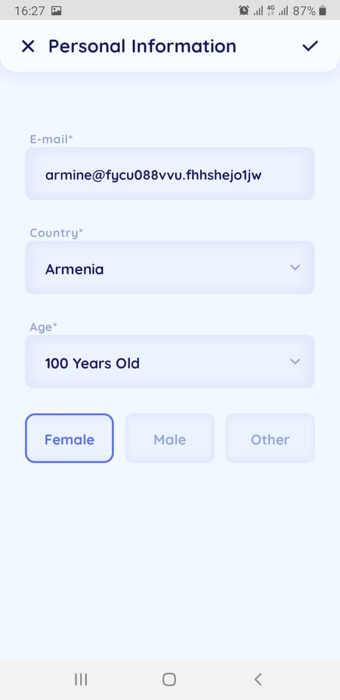

|  |  |  |
| --- | --- | --- |
| ID number | #004 |  |
| Bug Summary | After deleting a vote, the screen doesn't update |  |
| Reporter | Armine Nersisyan |  |
| Submit Date | 15/06/2021 |  |
| Platform | Galaxy SM-J810F |  |
| Operating System | Android version 10 |  |
| Browser |  |  |
| Severity | Critical |  |
| Priority | High |  |
| Status | Opened |  |
| Assigned to | QA/Developer/BA |  |
| Version | 1.0 |  |
| Environment | <https://play.google.com/apps/testing/io.dzain.dzain> |  |
| Component/tag |  |  |
| Screenshot/video |  |  |

**Precondition:** The application is opened

**Description:**

When I vote than detele my vote the information about my vote doesn't update.

**Steps to reproduce**

1. touch in some poll and vote
2. touch in my polls
3. touch in my votes and delete that vote informaton
4. go back: touch in home

**Expected result**

The information about my vote should be deleted and I can vote again

**Actual result**

The information about my vote stay and I can't vote again, information apdates only after reopen

**Notes:**

**References:**

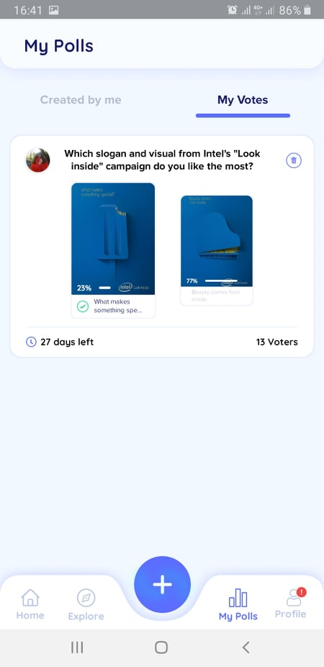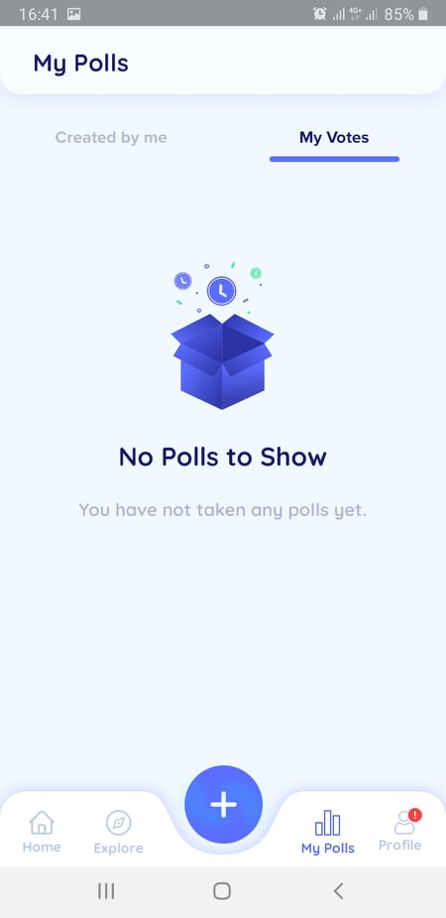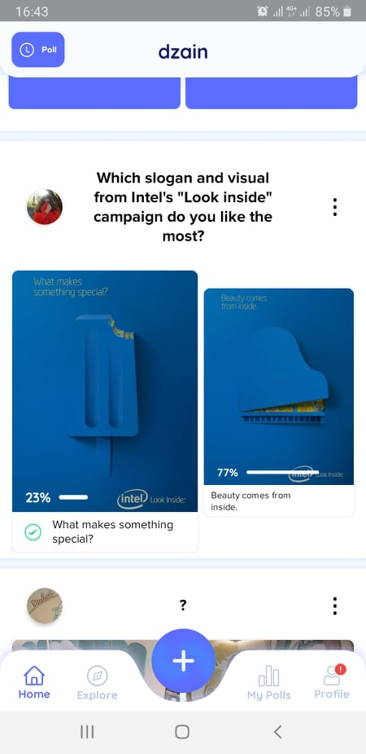

|  |  |  |
| --- | --- | --- |
| ID number | #005 |  |
| Bug Summary | Selecting by categorias impossible |  |
| Reporter | Armine Nersisyan |  |
| Submit Date | 15/06/2021 |  |
| Platform | Galaxy SM-J810F |  |
| Operating System | Android version 10 |  |
| Browser |  |  |
| Severity | Critical |  |
| Priority | High |  |
| Status | Opened |  |
| Assigned to | QA/Developer/BA |  |
| Version | 1.0 |  |
| Environment | <https://play.google.com/apps/testing/io.dzain.dzain> |  |
| Component/tag |  |  |
| Screenshot/video |  |  |

**Precondition:** The application is opened

**Description:**

When I select some top creator and want to see the polls in certain categorias, it doesn't selected

**Steps to reproduce**

1. touch in explore
2. touch in some top creator, which have active polls
3. touch in categorias
4. touch in some categorias in the categorias list

**Expected result**

Should appear only that polls which belong to specific category

**Actual result**

In the screen appear only images of categorias, they don't have functionality

**Notes:**

**References:**

|  |  |  |
| --- | --- | --- |
| ID number | #006 |  |
| Bug Summary | The list by cretors isn't complete |  |
| Reporter | Armine Nersisyan |  |
| Submit Date | 15/06/2021 |  |
| Platform | Galaxy SM-J810F |  |
| Operating System | Android version 10 |  |
| Browser |  |  |
| Severity | Critical |  |
| Priority | High |  |
| Status | Opened |  |
| Assigned to | QA/Developer/BA |  |
| Version | 1.0 |  |
| Environment | <https://play.google.com/apps/testing/io.dzain.dzain> |  |
| Component/tag |  |  |
| Screenshot/video |  |  |

**Precondition:** The application is opened

**Description:**

When I select some top creator and want to see the polls in certain categorias, it doesn't selected

**Steps to reproduce**

1. touch in some creator, which have active polls
2. touch in avater and more details

**Expected result**

Should appear all list of polls

**Actual result**

Appear only some polls

**Notes:**

**References:**

