Nicholas Jorgensen

1209220775

Final Project Phase 1

Adobe XD UI Mock Up:

<https://xd.adobe.com/view/5d0e9c5a-b725-4bcf-6be1-0c8fc6b6dbb3-2b3f/>

UML Class Diagram:

MVC Architecture Diagram:

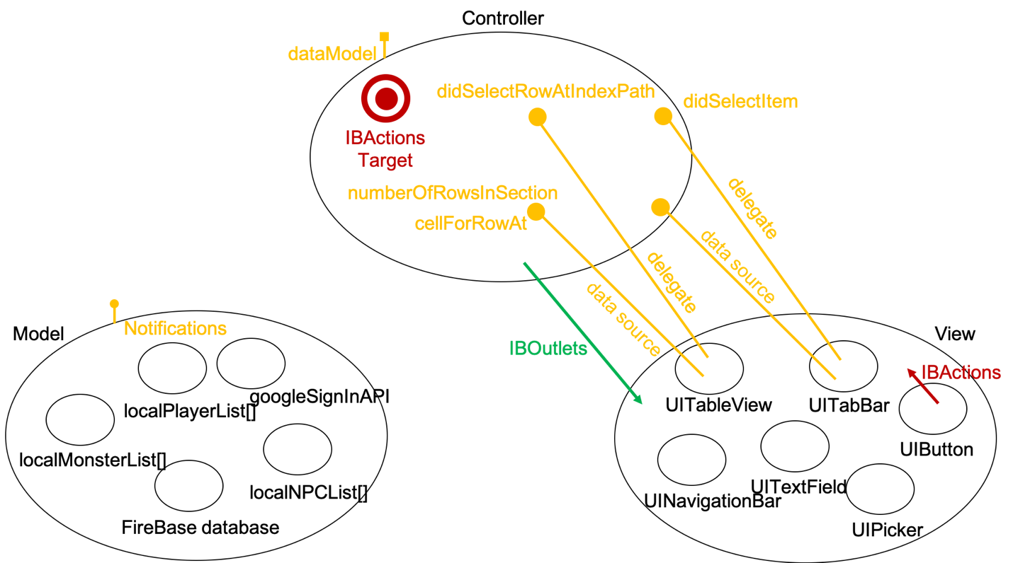

Also attached to .zip:

-Zipped project (initial implementation)

-Separate image files for MVC and UML diagrams