

Assignment report

COMP 1787 Requirements Management



April 11, 2024

HOANG HAI DUY

001353843

Table of Contents

Section A: Executive Summary 2

1. Business goals 2

2. Methodologies 2

1)Discuss Agile 2

2) DSDM, RAD, XP,Scum 3

3. Feasibility of the project 5

4. Summarize for section B 6

5. Summarize for section C 6

Section B: 7

Summarize all requirements from facilitated workshop 7

B1: Examine the "high-level requirements" list in Appendix A and mark any that you believe are Not appropriate as high-level requirements 8

B2: Revise and add to the list until you have 8-10 "updated" functional and non-functional system criteria. Explain your high-level requirements in a few sentences using case study data. 11

B3: Prioritize the needs in your new functional requirements list using the MoSCoW/Timebox guidelines. 13

Section C 18

C1: The role of the Data Controller within the organization: 18

1. DPA in project: 18

2. The role of the Data Controller within the organization: 18

C2: Legal, social, ethical, and professional issues that BL may be faced with. One practical example from the case study that relates to each aspect of LSEPI. 18

1. Legal 18

2.Social 19

3. Ethical 19

4. Professional 19

Conclusion 20

References 20

# Section A: Executive Summary

## 1. Business goals

The goal of the project is to create the Green Groceries Online Platform, which is strongly ingrained in the company's strategic strategy. It intends to adapt to changing market dynamics, streamline operational procedures, and strengthen its brand identity as a leader in sustainable and convenient grocery retail. Green Groceries aims to maintain its position for long-term success in the intensely competitive retail environment by embracing digital innovations, while keeping strong in its dedication to its core principles. Several key considerations fuel the initiative to launch the Green Groceries Online Platform:

## 2. Methodologies

The Green Groceries Online Platform needs strategic decisions on outsourcing, techniques, frameworks, and team makeup. These aspects are critical to ensuring the project's success while remaining consistent with Green Grocery's aims and ideals.

Green Groceries outsources web platform development to focus on key company tasks and leverage specialized knowledge. This strategic approach allows the organization to leverage external partners' talents and resources while being flexible and cost-effective.   
Green Groceries may benefit from the skills and efficiency of a specialized software development team without establishing an in-house department. This method enables the organization to scale resources as needed for timely delivery and efficient use of budgetary resources.

### 1)Discuss Agile

Agile technique is a project management paradigm that divides projects into dynamic parts known as sprints.

Iterative methodologies are used in the Agile framework. After each sprint, teams reflect and look back to see if anything may be better so that their plan for the next sprint can be adjusted. It entails ongoing engagement with stakeholders as well as continual development at each level. Once work begins, teams go through a planning, implementation, and evaluation process. Collaboration is essential, both with team members and project stakeholders.

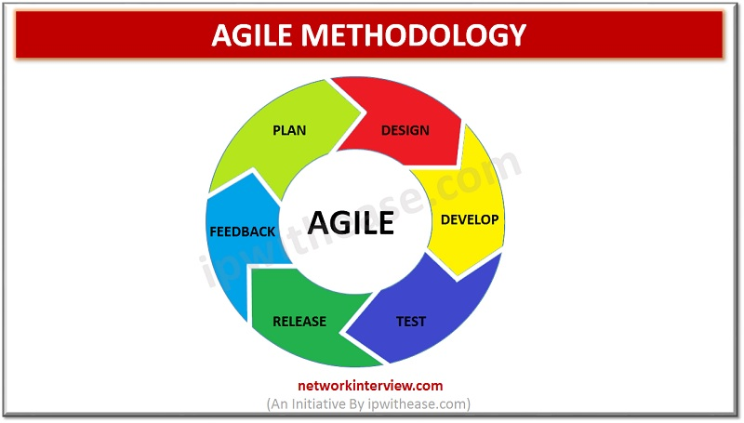

### 2) DSDM, RAD, XP, Scum

#### a) RAD

According to ( Lucid Content Team, n.d.) Rapid application development (RAD) is a common agile project management method in the software development industry.

The main advantage of a RAD method is quick project turnaround, which makes it an appealing alternative for engineers working in a fast-paced setting such as software development. The focus of RAD on eliminating the planning stage and emphasizing prototype development allows for this quick speed.

RAD enables project managers and stakeholders to precisely monitor progress and communicate in real time on emerging issues or changes by decreasing planning time and prioritizing prototype iterations. This leads to increased efficiency, quicker development, and more effective communication.

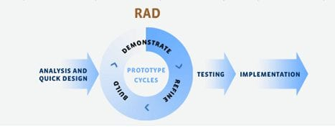

#### b) DSDM

According to (Anon., n.d.) The Dynamic System Development technique (DSDM) is an Agile technique that focuses on the whole project lifecycle. It was created in 1994, when project managers using RAD (Rapid Application Development) asked for more control and discipline in this new iterative manner of working.

DSDM is vendor-independent, spans the whole project lifecycle, and provides best practice standards for on-time, on-budget project delivery, with proven scalability to support projects of any size and in any business sector.

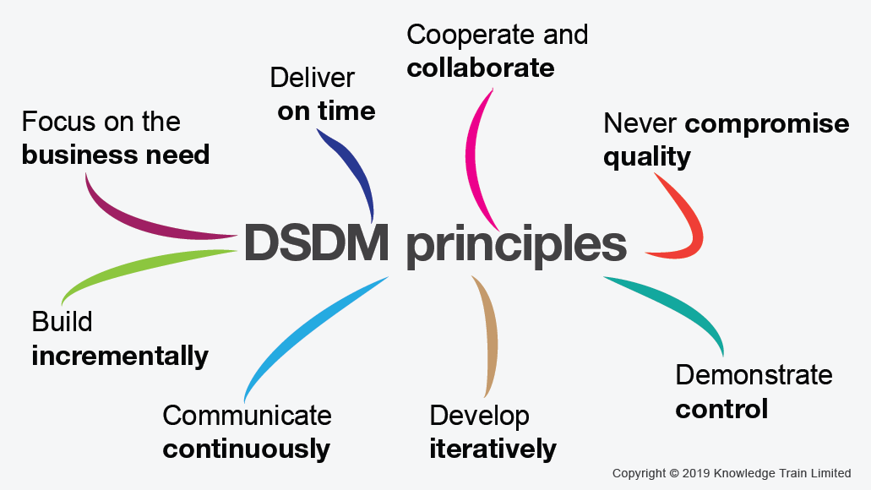

#### c) XP

Extreme Programming (XP) is an agile software development approach that attempts to deliver higher quality software while also improving the development team's quality of life. In terms of proper engineering methods for software development, XP is the most detailed of the agile frameworks. XP is based on beliefs, principles, and practices, with the purpose of enabling small to mid-sized teams to generate high-quality software while adapting to evolving and changing needs. What distinguishes XP from other agile approaches is its emphasis on the technical elements of software development. Extreme programming is specific about how engineers work because adhering to engineering principles enables teams to generate high-quality code at a sustainable pace. In a word, extreme programming is about taking excellent practices to their logical conclusion. Because pair programming is beneficial, let's do it all the time. Because testing early is beneficial, let's test before the production code is written.

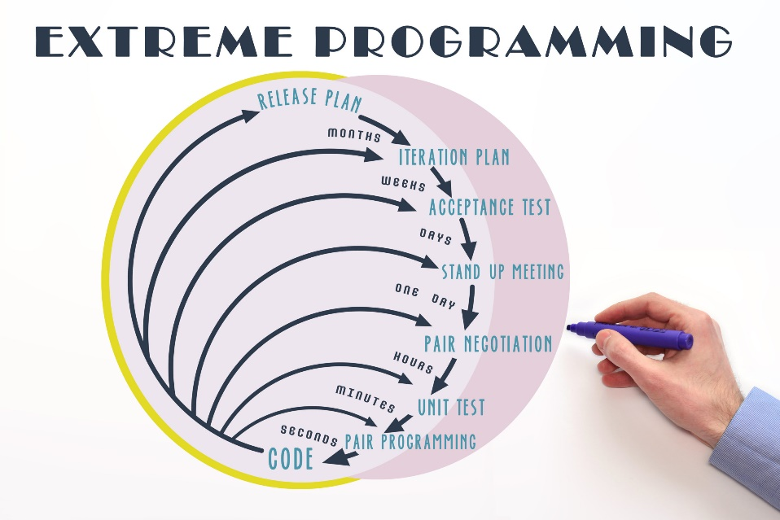

#### d) Scrum

According to (Anon., n.d.)Scrum is a framework for implementing Agile projects that includes rules, responsibilities, events, and artifacts. It is an iterative strategy that consists of sprints that generally span one to four weeks and aims to continually improve a product. This strategy is widespread in software development and ensures that your Scrum teams consistently produce a version of the product.

Scrum was created using a software paradigm that consists of roles, responsibilities, and meetings. It may be utilized for any complicated project, but it is most effective when the end result is a tangible product rather than a service. Scrum as a project management framework is ascribed to Jeff Sutherland and Ken Schwaber.

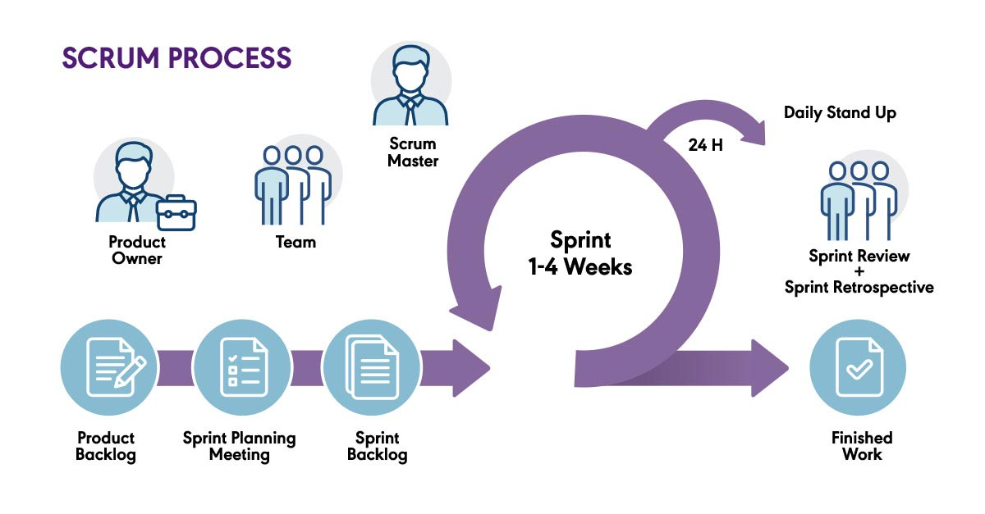

#### e) Discuss and Compare the method suitable for the project

According to the mentioned case study, the most suitable method for the project is probably DSDM. In that it works with projects rather than just product development and delivery (typically software), DSDM has a broader emphasis than most other Agile approaches. The project environment demanded that all components of the solution grow to fulfill a larger business requirement. DSDM has a strong track record of effectively delivering Agile projects in all sorts of organizational contexts. It has also proved to be completely scalable, operating well in simple, small enterprises, huge, complicated organizations, and highly regulated environments. The core foundations for the project must be agreed upon early on in the DSDM process. Before development begins, organizations may grasp the breadth and underlying features of the proposed solution, as well as how it will be built. Platforms for clarification and unification. Not only is DSDM stringent on deadlines and finances, but it also has a specific order of events: Pre-Project Phase, Project Life Cycle Phase, and Post-Project Phase. RAD software development methodologies encourage free-form labor, which allows for creativity and freedom even at the risk of resource depletion.

## 3. Feasibility of the project

## 4. Summarize for section B

## 5. Summarize for section C

Legal, Social, Ethical, and Professional Issues (LSEPI) must be considered in Green Groceries System's day-to-day operations. In addition, they must identify a Data Controller.

Create a management overview that explains: - the Data Controller's role in the organization; and - any legal, social, ethical, or professional obstacles that Green Groceries System's may face. As part of your response to (C2), provide a real-life example from a case study relevant to each component of LSEPI.

# Section B:

## Summarize all requirements from facilitated workshop

|  |  |  |  |
| --- | --- | --- | --- |
| ID | Requirement detail | Stakeholder | FR/NFR |
| 1 | Employees want to have a healthy workstation and 20 office plants. | Staff | NFR |
| 2 | Organize a virtual celebration on the CEO's birthday to highlight the company's fun and welcoming culture. | Staff | FR |
| 3 | As Managing Director, I want to guarantee that the site is Data Protection Act compliant so that we do not face fines of hundreds of thousands of pounds. | Director | NFR |
| 4 | As a customer, I want to have a choice of delivery times so that I can plan my schedule accordingly. | Customer | FR |
| 5 | To foster a good and inclusive workplace culture, the organization should implement pet-friendly rules. | Staff | NFR |
| 6 | The system must be built to manage a 30% increase in traffic during peak hours without degrading performance. | Staff | NFR |
| 7 | All user data, including personal information and payment information, must be encrypted to maintain the greatest degree of security. | Staff | NFR |
| 8 | Maintain consistent branding components and style throughout the website to strengthen their brand identification. | Staff | NFR |
| 9 | Every quarter, the development team should attend a team-building event to promote cooperation and a healthy work atmosphere. | COO | NFR |
| 10 | As an Order Handling Clerk, I wish to use the internet to handle telephone purchases instead of the paper-based procedure. | Sale Staff | FR |
| 11 | As a customer, I want to be able to update my account information. | Users | FR |
| 12 | As a customer, I want to create an account. | Users | FR |
| 13 | As a consumer, I would like to be able to edit my shopping basket | Users | FR |
| 14 | As a client, I would want to submit different delivery and invoicing addresses. | Users | FR |
| 15 | As a consumer, I want to select whether or not I get marketing information. | Users | FR |
| 16 | As the Marketing Director, I would want an offers or discount page so that we may educate our clients about the aforementioned. | Marketing Director | FR |
| 17 | As Chief Accountant, I want the website to comply with VAT regulations so that we do not face a big charge. | Accountant | FR |
| 18 | As the Operations Director, I wish to accept all types of payments. | CEO | FR |

## B1: Examine the "high-level requirements" list in Appendix A and mark any that you believe are Not appropriate as high-level requirements

|  |  |  |
| --- | --- | --- |
| **Requirement ID** | **Requirement detail** | **Reason** |
| 1 | Organize a virtual celebration on the CEO's birthday to highlight the company's fun and welcoming culture. | It is not required to celebrate the CEO's birthday, or to build another company website to post company activities, events, etc. The focus should be on the project and its goals rather than on building these images. |
| 2 | As a customer, I want to have a choice of delivery times so that I can plan my schedule accordingly. | This is related to a third-party delivering goods to customers, which is not part of the project's goal because if the company expands its market later, it will be more difficult to arrange a suitable schedule. Don't focus too much on this, flexible time arrangements will be more appropriate. |
| 3 | As an Order Handling Clerk, I wish to use the internet to handle telephone purchases instead of the paper-based procedure. | Currently, the company's website for purchasing transactions is popular on a number of e-commerce applications, everyone can order via phone number, which is more convenient. Currently, GG biz's goal is to expand the market and access more quality products. |
| 4 | As a customer, I want to create an account. | I think this is not a high-level requirement. When users use our website, they can register one or more accounts. |
| 5 | All user data, including personal information and payment information, must be encrypted to maintain the greatest degree of security. | I think this should be a high - level requirement, customer data is very important, and the company's duty is to ensure that data is encrypted and secured very carefully. |
| 6 | Maintain consistent branding components and style throughout the website to strengthen their brand identification. | I think this should be a high - level requirement, making it easy for customers to recognize the brand is extremely important, it helps customers easily access, transact and use the company's products. |
| 7 | As a consumer, I want to select whether or not I get marketing information. | I think these are not high-level requirements. When users use our website, we will take care of all consumer and legal procedures. It is not necessary to build a separate area for users to view. |

## B2: List of requirements needed to build system

|  |  |  |  |
| --- | --- | --- | --- |
| **Requirement ID** | **Requirement Detail** | **Functional/Non** | **Reason** |
| 1 | Organize a virtual celebration on the CEO's birthday to highlight the company's fun and welcoming culture. | FR | In my opinion, there is no need to wait until the CEO's birthday to do it, but every month it will be organized for members whose birthdays are that month, then it will show that the company cares about its employees. |
| 2 | As Managing Director, I want to guarantee that the site is Data Protection Act compliant so that we do not face fines of hundreds of thousands of pounds. | NFR | This should be a mandatory requirement. Protecting customer data is now a very important and urgent issue. Just think if customer data is exposed, there will be serious problems immediately. . |
| 3 | The system must be built to manage a 30% increase in traffic during peak hours without degrading performance. | NFR | In my opinion, this should be a high-level requirement, think about how bad it would be if there was too much traffic leading to overload or worse, total damage, so this should be one of the necessary things. |
| 4 | All user data, including personal information and payment information, must be encrypted to maintain the greatest degree of security. | NFR | Data security and encryption is an extremely important step to ensure customer trust. Once unencrypted data will be easily stolen and then everything belonging to the customer will be lost, thereby The company will be sued a lot. |
| 5 | Maintain consistent branding components and style throughout the website to strengthen their brand identification. | NFR | In my opinion, this should be a high-level requirement. Letting customers recognize the brand will make them feel secure when using the company's products, can check the origin, and then there is no need to advertise too much. many but still create reputation and peace of mind for users. |
| 6 | As an Order Handling Clerk, I wish to use the internet to handle telephone purchases instead of the paper-based procedure. | FR | Currently, technology is developing, trading and processing on the Internet should be the top priority of the company and the system. Posting it there will help optimize costs, resources and time instead of having to deal with cumbersome paper-based procedures like before. |
| 7 | As a consumer, I want to create an account, update my personal or shopping cart information, shipping address, etc. | FR | This is almost a mandatory requirement for every system. A good user experience will bring a pleasant feeling and the possibility of them returning to use is very high, so building a system with the following functions: This important matter needs to be taken seriously. |
| 8 | As Chief Accountant, I want the website to comply with VAT regulations so that we do not face a big charge. | FR | To ensure transparency in building and developing the system, the company needs to comply with regulations and laws as well as taxes, VAT will be provided and transparency in the payment process of the trading system. pandemic. |
| 9 | As the Operations Director, I wish to accept all types of payments. | FR | This is almost mandatory if you want to pay in today's digital age. Payment in many different forms makes customers more satisfied, in addition, this will make it easier to expand the market and have new products. suitable investment fund. |

## B3: Prioritize the needs in your new functional requirements list using the MoSCoW/Timebox guidelines.

|  |  |  |  |  |  |
| --- | --- | --- | --- | --- | --- |
| ID | High Level Requirement | Estimation (hour) | Reason/Break Task | MoSCoW | Reason for prioritization |
| 1 | As an Order Handling Clerk, I wish to use the internet to handle telephone purchases instead of the paper-based procedure. | 120 | -Set up appropriate data, models and conditions to import all purchase phone data (estimated 50 hours)  - Learn and implement appropriate APIs (estimated 50 hours)  - Build protocols for receiving, entering and sending data (estimated 20 hours) | Must Have | This requirement is really important, it opens up a completely new process to improve efficiency and accuracy in order management. Replacing paper management with the use of technology will bring more convenience. The Order Handling Clerk can streamline processes to help customers make purchases easily, access quickly, and reduce errors. , et cetera. It directly addresses operational inefficiencies and aligns with the organization's digital transformation goals. |
| 2 | As a customer, I want to be able to update my account information. | 120 | - Develop an easy-to-understand user interface and experience to make it easy for them to use (estimated 60 hours)  - build support features into interfaces to enable the ability to update user accounts (estimated 60 hours) | Must Have | Allowing users to update their account details is a necessity. It helps maintain the accuracy of the information we store, minimizing errors in verifying information and contacting customers. It helps users and the system control and enhances user trust in the system. |
| 3 | As a customer, I want to create an account. | 320 | - Understand and analyze user account usage requirements (estimated 20 hours)  - Design a database to store user information (estimated about 50 hours)  - Learn and develop appropriate APIs and technologies for users to register accounts (estimated 130 hours)  - Deploy interface and registration features for users on the system (estimated 120 hours) | Must Have | Registering a user account is a basic matter so customers can interact with the system's features and services. This allows them to experience personalization of their processes, orders or information. In addition, registering a user account helps the system capture customer information data, thereby creating interesting experiences, convenient for interacting and building long-term relationships with customers. . |
| 4 | As a consumer, I would like to be able to edit my shopping basket | 400 | - Learn and analyze users' shopping cart needs (estimated 20 hours)  - Design a database to store user shopping cart information (estimated about 70 hours)  - Learn and develop appropriate APIs, Logic and technology to let users modify their shopping cart (estimated 150 hours)  - Deploy appropriate interfaces and features so users can edit information in their shopping carts on the system (estimated 160 hours) | Must Have | Being able to change the details in their shopping cart is really important. This allows their experience to be better, in addition it helps customers feel more secure about what they have chosen or want to choose. Having this feature prioritized for development will help increase user experience, to make a comfortable atmosphere. |
| 5 | As a client, I would want to submit different delivery and invoicing addresses. | 400 | - Learn and analyze users' needs for using different addresses (estimated 30 hours)  - Design a database to store different address information of users (estimated about 100 hours)  - Learn and develop appropriate APIs, Logic and technology to allow users to modify their addresses, in addition they can place multiple orders with many different addresses (estimated 120 hours)  - Deploy appropriate interfaces and features so users can edit information in their shipping addresses on the system (estimated 150 hours) | Must Have | The ability to order goods and products to different addresses should also be noted, each address and invoice will be developed separately to create transparency and accuracy for users, thereby increasing trust and good experience for customers. |
| 6 | As a consumer, I want to select whether or not I get marketing information. | 250 | - Understand and classify customer needs for each different type of product marketing (estimated 70 hours)  - Outline a diagram of the information storage capacity of each type of marketing to each different type of customer (130 hours)  - Deploy an interface that users can access (50 hours) | Should Have | Marketing products to many customers is also quite important, they will know a lot of marketing information about different products, but this does not need to be too much of a priority, it should only be developed a little. to be able to maintain trust and a stable customer base of the system. |
| 7 | As the Marketing Director, I would want an offers or discount page so that we may educate our clients about the aforementioned. | 200 | - Understand and classify customer needs for each type of product discount marketing (estimated 50 hours)  - Outline the diagram of the ability to store information and the ability to reach customers of each type of marketing to each different type of customer (100 hours)  - Implementing an accessible interface for users (50 hours) | Should Have | This issue is like marketing, it helps maintain stability in terms of trust and accessibility to the customer system. There are other features that are more important and need to be developed first, but this function should also be built a little because it is a symbol of the brand. |
| 8 | As Chief Accountant, I want the website to comply with VAT regulations so that we do not face a big charge. | 200 | - Learn and analyze current regulations of VAT law (estimated 30 hours)  - Perform calculations and logic on the system's payment pages, helping customers know about VAT and other taxes that need to be paid to ensure transparency (estimated 150 hours)  - Deploy to system interface and database (estimated 20 hours) | Could Have | Minimizing financial and VAT risks is also quite important, although research should be done to build it at a decent level to be able to focus on more important aspects. |
| 9 | As the Operations Director, I wish to accept all types of payments. | 200 | - Find out and analyze how many payment gateways there are on the market (estimated 20 hours)  - Integrate APIs of payment gateways, as much as possible (estimated 100 hours)  - Develop logic and backend interface for user payment gateways (estimated 80 hours) | Could Have | I think this is quite important, the ability to pay will determine whether customers are satisfied with the system or not. Investing in the development of this function is also quite important, helping to retain more customers. |

The rule of the MoSCoW: 60:20:20

According to (Brush, n.d.)

DSDM suggests increasing the percentage of project/project increment Must Haves (in terms of work to be done) to a level where the team feels confident in carrying them out - often no more than 60%. A consensus must be made on a pool of Could Haves for the project/Project Increment that exhibits an adequate level of contingency - often about 20% Could Have effort. Creating a reasonable pool of Could Haves from the beginning sets the correct business expectations - that these requirements/User Stories may be delivered in their entirety in the best-case scenario, but the primary project/Project Increment focus will always be on protecting the Must Haves and Should Haves.

1. M: Must Have (60%)

This first category includes all of the requirements for the project to be performed effectively. These are non-negotiable components that provide the essential necessities.

True comments regarding must-haves include:

• There is no point in finishing the project by the deadline if this criterion is not satisfied.

• Without this criterion, the finalized product or software would not be compliant or lawful.

If a certain requirement can be satisfied, teams should examine if it is a must-have or a nice-to-have item. Assigning needs to the should-have and could-have categories does not imply that the team will not offer the element; rather, it indicates that the element is not required for completion and hence cannot be guaranteed.

2. S: Should have (20%)

This second set of criteria is a continuation of the first. It may predict future release needs while not interfering with the present project. Should-have features are useful but not required for project completion. In other words, even if the finished product lacks desirable qualities, it still works. Should-have features, on the other hand, significantly boost the value of the product. This category includes minor bug patches, performance enhancements, and new features.

Teams can distinguish between should-have and could-have aspects by assessing the amount of pain produced by omitting the necessity. This is typically stated in monetary terms or in terms of the number of people harmed by its absence.

3. C: Could have (20%)

This category comprises criteria that have a much lower influence if not included in the project. As a result, teams often deprioritize could-have criteria first; must-have and should-have needs always take precedence since they have a higher impact on the product. A could-have element is one that is desired but unimportant.

Some needs in the will-not-have category can ultimately be reprioritized and worked into future projects; others are never used. Teams can build subcategories inside the will-not-have category to specify which needs they should still implement and which they can skip to differentiate between these sorts of items.

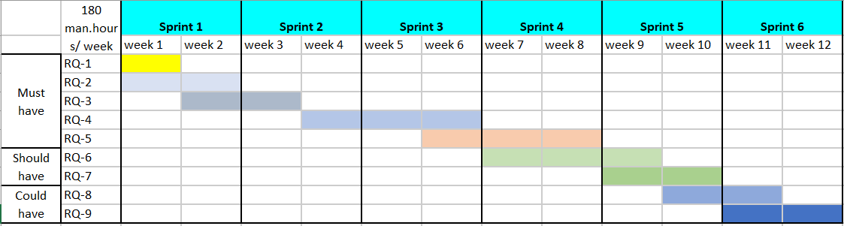

# Section C

## C1: The role of the Data Controller within the organization:

### 1. DPA in project:

According to European data protection regulations, personal data can be processed by another party outside the European Union provided they sign a legal agreement that controls this processing. This is known as a DPA (Data Processing Agreement).

A data processing agreement (DPA) is a legal document signed in paper or electronically by the controller and the processor that defines the terms and conditions of personal data processing. Personal data is any information that may be used to identify an individual, such as a person's first and last name, date of birth, and place of residence.

The DPA covers concerns such as the scope and purpose of data processing, the type of data processed and how it should be protected, the relationship between the controller and the processor, and others.

**DPA in Green Groceries System**

Because the purpose is to verify the identity and user information in the most accurate, quick and easy way, the organization has required in the system that users use the registration to provide their sensitive information. Contextual. This requires agreement on how this data will be protected, handled, stored and used. So sure, the DPA is basically an overview of the terms of the partnership. That is why in software development outsourcing, establishing a data processing agreement (DPA) is so important.

### 2. The role of the Data Controller within the organization:

As a data controller, the holder of sensitive user information, the Green Groceries System organization must ensure that all data processed on its behalf is complete, accurate, timely and secure. In addition, as data controllers, they are responsible for ensuring that their processing complies with the General Data Protection Regulation (GDPR).

## C2: Green Groceries System may encounter legal, social, ethical, and professional challenges. Each feature of LSEPI is shown by one practical example from the case study.

### 1. Legal

The present fund management system places a high priority on information security. Personal information may be exploited by interested parties to commit unlawful acts or sold to advertisements for profit. This can occur if data handlers are inept or careless in preventing a security breach. Furthermore, compliance is required to guarantee that spies do not steal the organization's trade secrets.

### 2.Social

The primary concern is communication and contacting potential contributors or consumers in order to raise cash. The company will need to talk about and practice its code of conduct (BCS) more. A corporate code of conduct is viewed as a clear declaration to all stakeholders of the organization's mission, values, and expectations. As a result, in order to address any difficulties that may occur, a BCS Code of Conduct must be developed.

### 3. Ethical

Unreasonably breaching another's privacy by using their name or picture, interfering with their privacy, or making public information about their private matters that a reasonable person would find offensive and for which there is no genuine public interest.

### 4. Professional

Training for staff and managing the code of conduct with partners and sponsors is a top priority for the organization. Having the wrong attitude and actions shows the lack of professionalism of the organization and it affects the reputation of the organization. Regarding the system, the successful notification for each user's operation will be convenient for monitoring the progress and easier to control their information, this function should develop the most stable because it can show the professionalism of the system development team.

## Conclusion

# References

Lucid Content Team, n.d. [Online]   
Available at: https://www.lucidchart.com/blog/rapid-application-development-methodology  
[Accessed 25 4 2023].

Anon., n.d. [Online]   
Available at: https://www.agilebusiness.org/business-agility/what-is-dsdm.html#:~:text=What%20is%20DSDM%3F-,DSDM%20is%20an%20Agile%20method%20that%20focuses%20on%20the%20full,new%20iterative%20way%20of%20working.

Anon., n.d. *isms.* [Online]   
Available at: https://www.isms.online/general-data-protection-regulation-gdpr/data-controller/  
[Accessed 17 4 2023].

Anon., n.d. *wrike.* [Online]   
Available at: https://www.wrike.com/project-management-guide/faq/what-is-scrum-in-agile/  
[Accessed 25 4 2023].

Brush, K., n.d. *techtarget.* [Online]   
Available at: https://www.techtarget.com/searchsoftwarequality/definition/MoSCoW-method#:~:text=The%20MoSCoW%20method%20is%20a,disciplines%20use%20the%20MoSCoW%20method.  
[Accessed 17 4 2023].

Burak, A., July 16, 2021. [Online]   
Available at: https://relevant.software/blog/things-you-should-know-about-data-process-agreement-dpa-in-software-development-outsourcing/  
[Accessed 17 4 2023].