Launching a Web Server on Amazon EC2 and Hosting a Static Website on Amazon S3
Student name | Demo Student
PRN | 0000000000
Roll no. | 00
Class / Division | SY B.Tech AI & DS - B
Batch | B1
Subject | Cloud Computing Lab
Experiment no. | 4
Institute | Vishwakarma University, Pune
Date | 14 Oct 2026

Aim
To deploy an Apache web server on an EC2 instance and host a static website using S3 static website hosting.

Theory
Amazon Elastic Compute Cloud (EC2) provides resizable virtual servers, called instances, in the AWS cloud. An instance is launched from an Amazon Machine Image (AMI), which supplies the operating system, and an instance type such as t2.micro, which fixes its CPU and memory. Access is secured with a key pair, where the private key file is used for SSH login, and a security group acts as a virtual firewall that allows only the listed inbound ports, for example 22 for SSH and 80 for HTTP.
Apache HTTP Server (httpd) is a widely used open-source web server; on Amazon Linux it is installed with the dnf package manager and managed as a systemd service. Amazon Simple Storage Service (S3) is object storage organised into buckets whose names are globally unique. With static website hosting enabled, S3 serves HTML, CSS and image objects directly over HTTP through a website endpoint, without any server to manage. Objects must be made publicly readable, usually through a bucket policy, before the endpoint can serve them.

Procedure and Observations

Step 1: Sign in to the AWS Management Console and open the EC2 dashboard.
Missing evidence: Screenshot needed: sign in to the AWS Management Console and open the EC2 dashboard.

Step 2: Launch an EC2 instance (Amazon Linux 2023, t2.micro) with a new key pair.
An EC2 instance named vu-cc-lab4-web was launched using the Amazon Linux 2023 AMI with instance type t2.micro. A new RSA key pair, lab4-key, was selected, and the console confirmed the launch of instance i-0a1b2c3d4e5f67890.
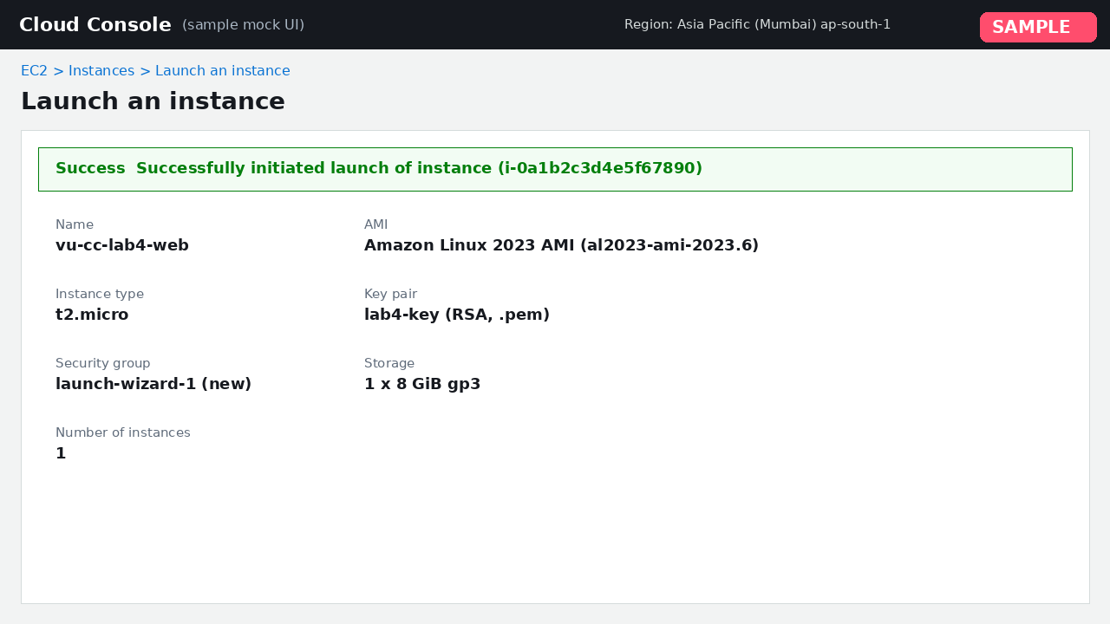
Figure 1: Launch an EC2 instance (Amazon Linux 2023, t2.micro) with a new key pair

Step 3: Configure the security group to allow SSH (port 22) and HTTP (port 80).
The security group launch-wizard-1 (sg-04c2b1a9e7f3d1122) was configured with two inbound rules: SSH on TCP port 22 and HTTP on TCP port 80, both from 0.0.0.0/0.
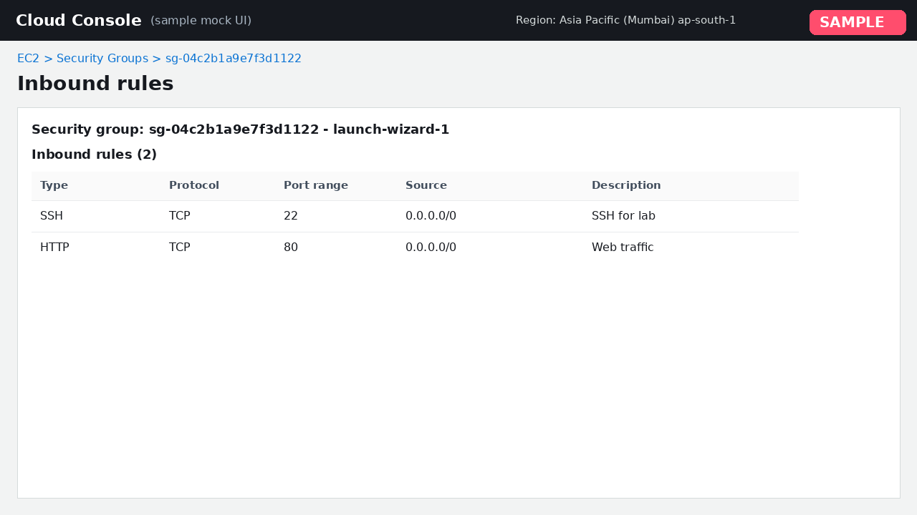
Figure 2: Configure the security group to allow SSH (port 22) and HTTP (port 80)

Step 4: Show the instance in the Running state with its public IPv4 address.
The Instances page shows vu-cc-lab4-web in the Running state with public IPv4 address 13.233.45.112, and both status checks passed.
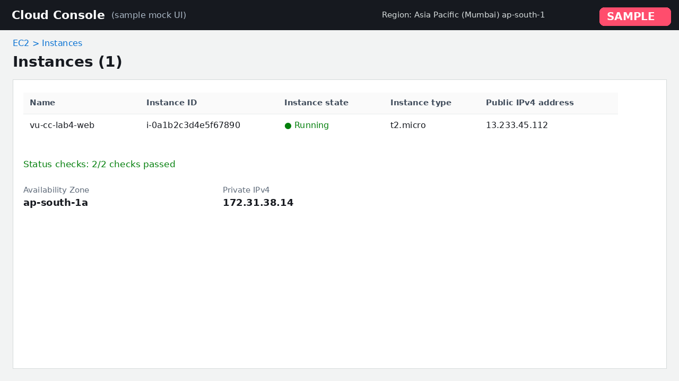
Figure 3: Show the instance in the Running state with its public IPv4 address

Step 5: Connect to the instance over SSH using the key pair.
The key file permissions were restricted with chmod 400, and an SSH session was opened to ec2-user@13.233.45.112 using lab4-key.pem, reaching the Amazon Linux 2023 shell prompt.
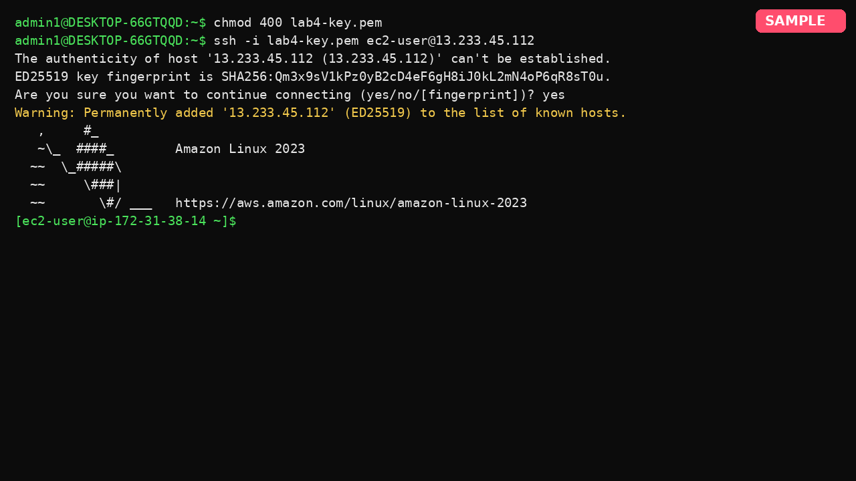
Figure 4: Connect to the instance over SSH using the key pair

Step 6: Update packages and install the Apache web server (httpd).
System packages were updated with sudo dnf update -y, and the Apache web server was installed with sudo dnf install -y httpd, which installed httpd 2.4.62 along with its dependencies.
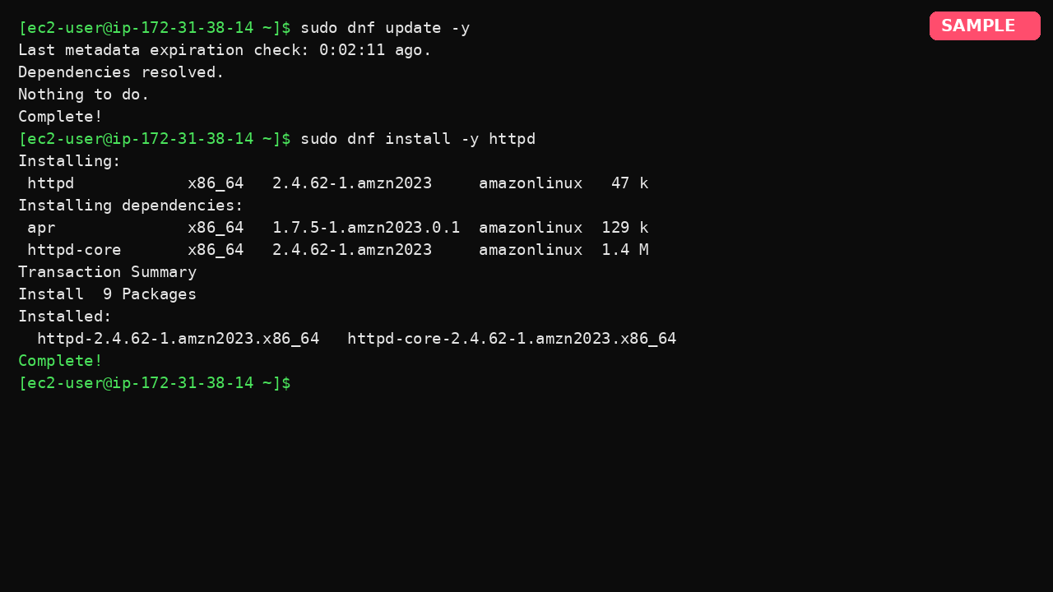
Figure 5: Update packages and install the Apache web server (httpd)

Step 7: Start and enable the httpd service and verify that it is running.
The httpd service was started and enabled at boot. systemctl status reports it as active (running) and listening on port 80.
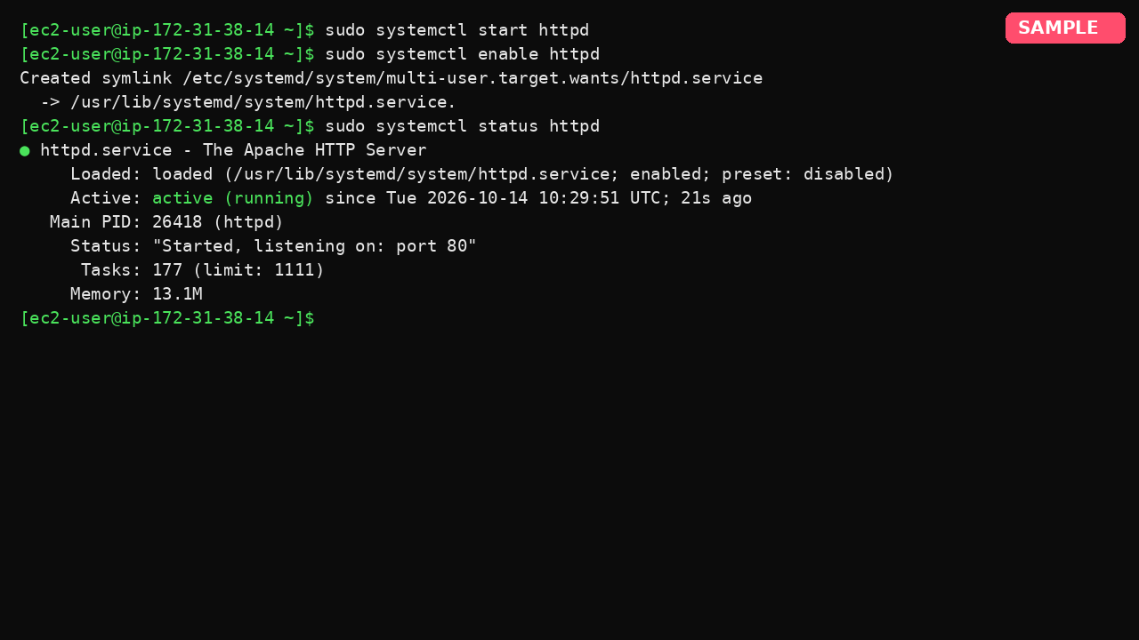
Figure 6: Start and enable the httpd service and verify that it is running

Step 8: Create an index.html page and open the instance's public IP in a browser.
Opening the instance's public IP 13.233.45.112 in a browser displayed the page 'Hello from VU Cloud Lab 4!', served by Apache on the EC2 instance.
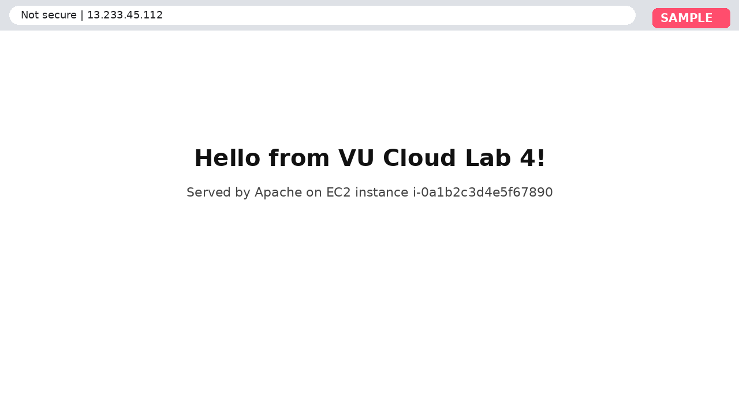
Figure 7: Create an index.html page and open the instance's public IP in a browser
Note: Creating the index.html file on the instance is not shown.

Step 9: Create an S3 bucket with a globally unique name.
An S3 bucket named vu-cc-lab4-demo-site was created in the Asia Pacific (Mumbai) ap-south-1 region.
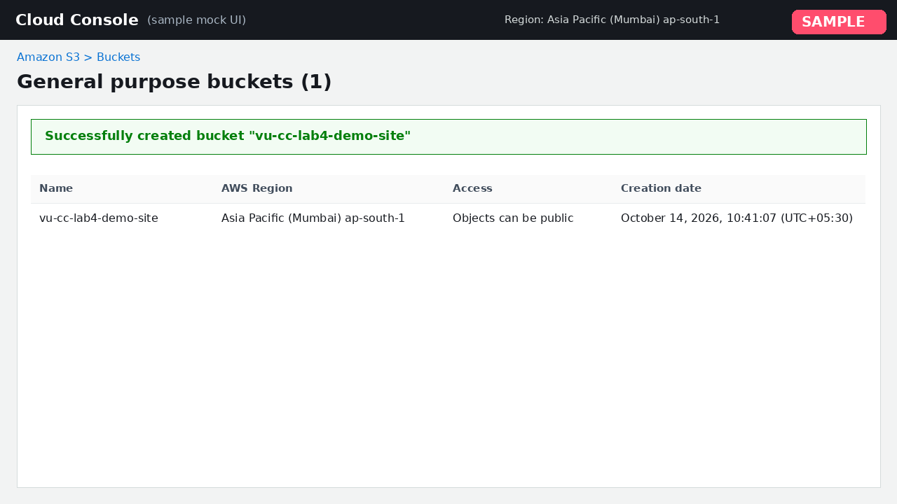
Figure 8: Create an S3 bucket with a globally unique name

Step 10: Upload index.html and error.html to the bucket.
index.html and error.html were uploaded to the bucket, and the upload status shows both files as Succeeded (2 files, 1.3 KB).
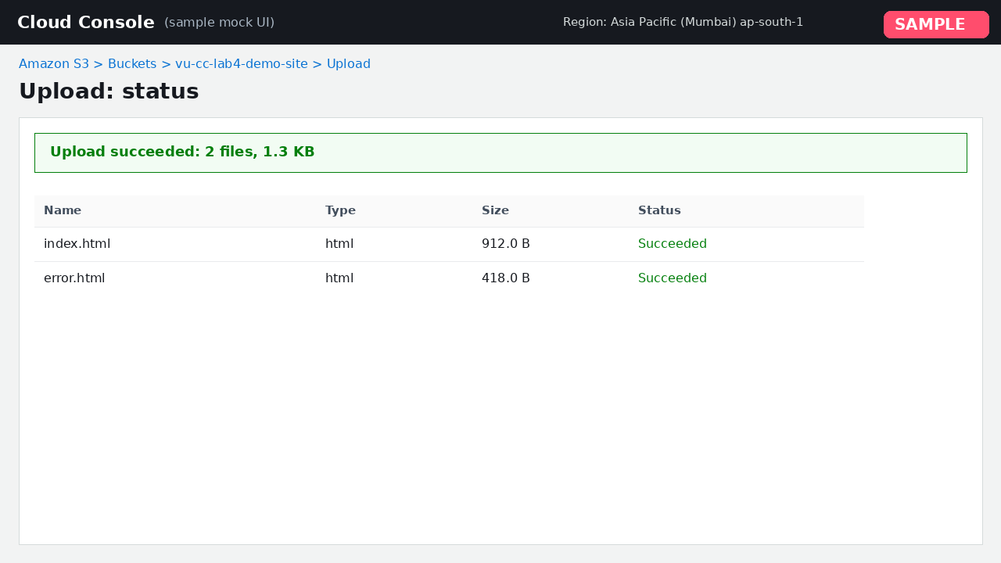
Figure 9: Upload index.html and error.html to the bucket

Step 11: Enable static website hosting and attach a public-read bucket policy.
Static website hosting was enabled on the bucket with index.html as the index document and error.html as the error document.
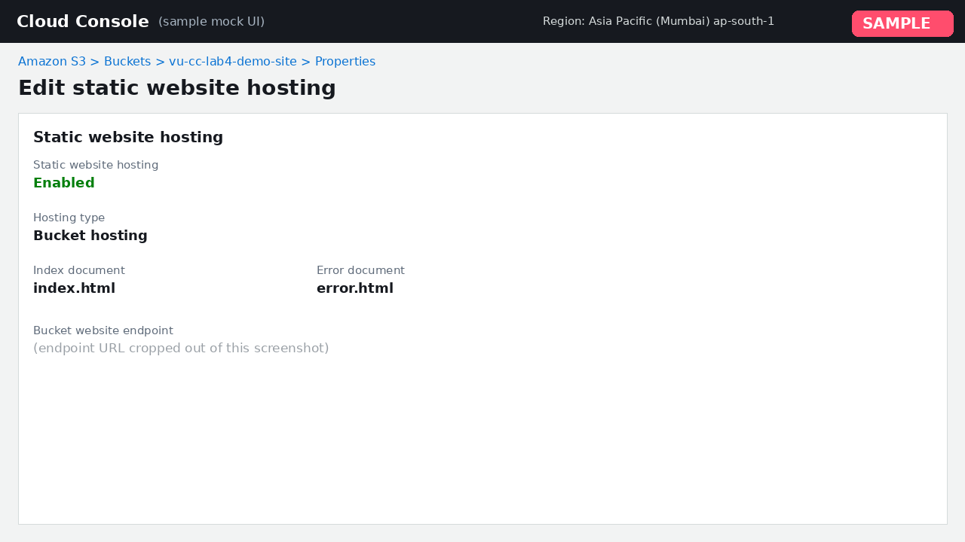
Figure 10: Enable static website hosting and attach a public-read bucket policy
Note: The public-read bucket policy is not shown in any screenshot.

Step 12: Open the S3 website endpoint in a browser and show the page loading.
Missing evidence: Screenshot needed: open the S3 website endpoint in a browser and show the page loading.

Conclusion
An EC2 instance running Amazon Linux 2023 was launched, secured with a security group allowing SSH and HTTP, and accessed over SSH. Apache httpd was installed, enabled and verified as running, and the custom page was served at the instance's public IP. An S3 bucket was created, the site files were uploaded and static website hosting was enabled. The bucket policy and the S3 website endpoint loading in a browser are not shown in the screenshots provided.

Missing Evidence and Review Notes
Generated by LabPilot. Resolve these before submitting, then delete this section.
- Step 1: no screenshot for “Sign in to the AWS Management Console and open the EC2 dashboard”
- Step 12: no screenshot for “Open the S3 website endpoint in a browser and show the page loading”
- Step 8: only partly shown: creating the index.html file on the instance is not shown.
- Step 11: only partly shown: the public-read bucket policy is not shown in any screenshot.
- “Screenshot (44).png” did not match any step and is left out of the report.

