ProofBoard
Project: ProofBoard — On-chain Contribution Recognition
Live Vercel Deployment: https://proofboard-web3.vercel.app/
Github Repo: https://github.com/Armughanofficial/ProofBoard/
Network: Ethereum Sepolia Testnet
Smart Contract Address: 0x4873D1B0C76588A66Cc4e8675e920bF12389E62c
Contract Explorer: https://sepolia.etherscan.io/address/0x4873D1B0C76588A66Cc4e8675e920bF12389E62c
  - Deployment and interaction evidence

1. NFT Displayed in ProofBoard and MetaMask
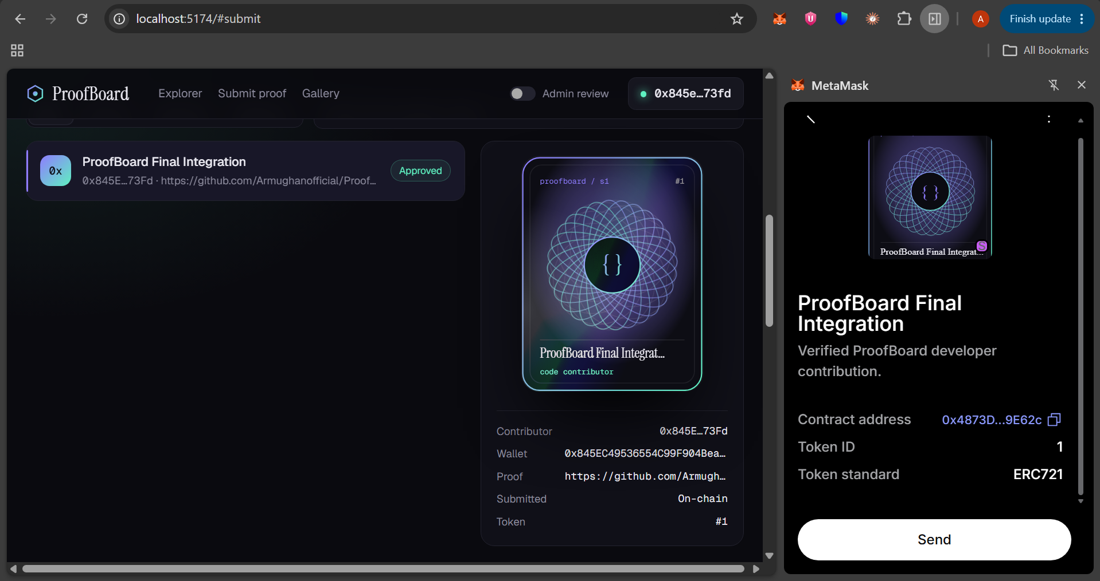

2. Sepolia Contract Transactions
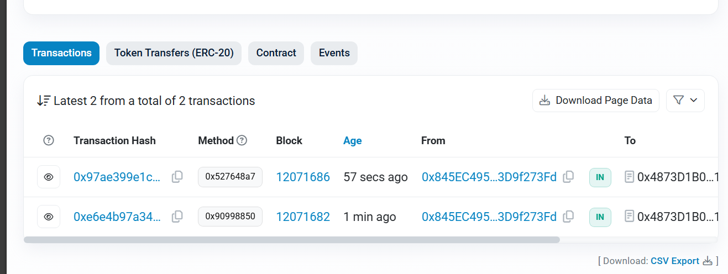

3. Connected Wallet and Minted NFT
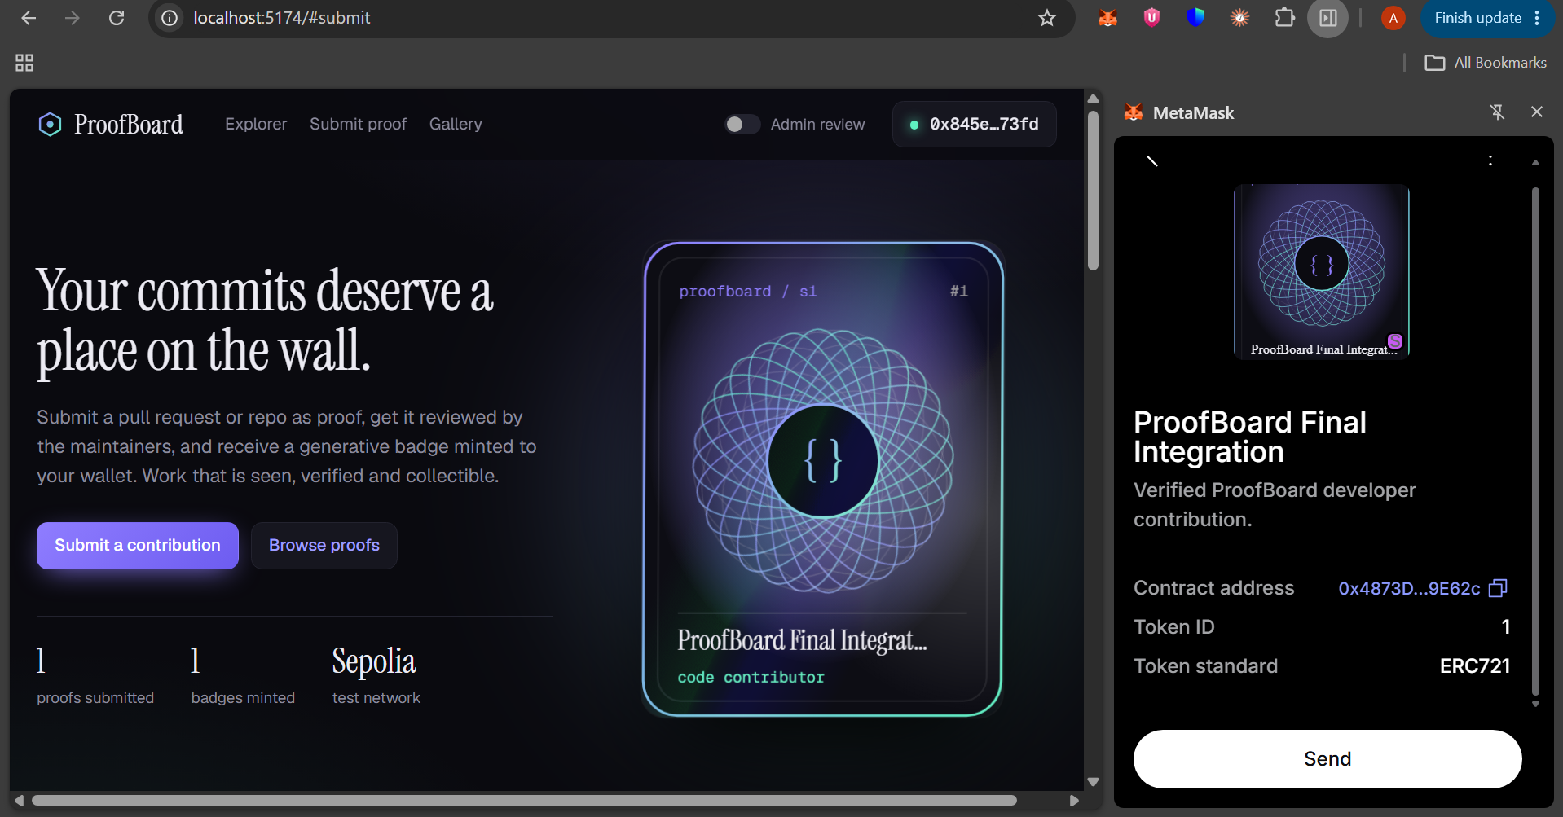

4. Deployed Contract on Sepolia Etherscan


