How Should I Plan To Bring New People Up To Speed During My Projects?

Armaghan Khoshaeen

Concordia University, Montreal QC H3G 1M8, Canada

**Abstract.** The original paper addresses the challenges of managing team dynamics and personnel changes in projects, recognizing the inevitability of such changes due to turnover, project modifications, and other factors. Emphasizing the importance of anticipation, project managers are advised to assess the potential impact of losing team members, particularly those with specialized skills, and develop contingency plans.

The integration of plans for team changes into project schedules, including cost estimates, is essential. Flexibility in scheduling is highlighted to accommodate unexpected turnovers, and minimizing turnover is underscored as vital for successful project management.

In the event of staff changes, guidance on swiftly integrating new team members by fostering relationships, trust, and connections with existing team members holds significance. Strategies for redistributing responsibilities and optimizing available talent when a key contributor is lost are also necessary.

The ideal scenario consists of adding team members at the project's start, although this may not always be feasible. When new individuals join the team, the prompt rebuilding of cohesive teamwork and adjustment of task assignments to prevent project difficulties or failure are emphasized.

In conclusion, some important notes include stressing the significance of retaining team members and advising project managers to incorporate budget reserves for addressing the costs of staff turnover in project risk provisions. Overall, this topic provides practical insights and strategies for project managers to navigate personnel changes and maintain project success.

**Keywords:** Knowledge Integration, Onboarding, Project Planning

1. Introduction

### We’re going to delve into the challenges and nuances of onboarding individuals into project teams. The focus is on the onboarding experiences of practitioners joining project teams, which is crucial for newcomers to integrate into the organization effectively.

### Two research questions guide this report: How do newcomers integrate into an ongoing project team? and how to facilitate the process of onboarding?

### A model of onboarding, adapted and extended from Bauer's model, is introduced. As well as an iterative model, which displays the integrative and economizing features of individuals’ experience accumulation and tacit understandings. We will be introducing some myths about rapid onboarding and a new approach to this problem.

Structured methodically, this report undertakes a review of pertinent literature on onboarding and knowledge integration, providing a solid foundation for our subsequent exploration. We will delve into the introduced onboarding model and the iterative model, shedding light on their respective integrative features. Furthermore, our findings will be thoroughly discussed in relation to the posed research questions, offering valuable insights into the complexities and possibilities of the onboarding process within project teams.

1. Challenges
   1. Making Time

The challenge of time in onboarding underscores the importance of prioritizing interpersonal connections amid competing responsibilities. It necessitates a deliberate effort to allocate time for meaningful interactions and relationship-building during the onboarding process. Meeting and getting to know new team members require a proactive approach, even if it means adjusting existing work commitments. By acknowledging the significance of investing time in these initial connections, organizations can foster a more inclusive and collaborative onboarding experience, contributing to stronger team cohesion and individual satisfaction.

* 1. Making Connections

The challenge of connection in onboarding emphasizes the need to actively facilitate the integration of new team members into existing dynamics. It involves intentional efforts to foster connections between the newcomer and other team members during meetings and various interactions. Building and maintaining good teamwork requires a conscious approach to encourage communication, collaboration, and relationship-building. By proactively working to connect the new person with the team, organizations can enhance the onboarding experience, promoting a sense of belonging and contributing to a positive team culture.

* 1. Delegating Responsibilities

The challenge of delegation in onboarding necessitates a strategic approach to integrate new team members efficiently. When faced with the loss of a key contributor, it is crucial to assess which responsibilities can be swiftly transitioned to the new person. Identifying tasks that may require more time for the newcomer to handle allows for a proactive delegation plan. Additionally, determining alternative team members who can temporarily assume specific responsibilities ensures a smooth workflow and optimal utilization of available talent. Adapting plans to accommodate the strengths and development areas of the new team member contributes to effective onboarding and maintains productivity in the face of personnel changes.

* 1. Budgeting

Effectively addressing the challenge of budgeting in onboarding requires foresight and strategic planning. When formulating onboarding plans, it is essential to incorporate a sufficient budget reserve to contend with potential costs associated with staff turnover. Staff turnover can impose unexpected financial burdens, and having a dedicated budgetary allocation for such scenarios is a proactive measure to mitigate risks. By factoring in this reserve, organizations can enhance their preparedness, ensuring that financial resources are readily available to manage transitions and maintain the continuity of onboarding initiatives in the face of unforeseen personnel changes. This approach contributes to a more resilient and adaptable onboarding strategy that aligns with the dynamic nature of workforce dynamics and organizational needs.

* 1. Losing a Key Contributor

The challenge of losing a key contributor in onboarding necessitates a proactive approach to ensure a smooth transition for the new person. It involves a comprehensive understanding of the missing team member's assignments, necessary skills, and other critical factors that contribute to project success. For team members with specialized skills, this exercise becomes particularly crucial, emphasizing the need for a contingency plan. Identifying specific points in the project where the loss of a critical contributor would be most detrimental allows for strategic planning. Developing a contingency plan outlines the necessary steps to navigate through any potential loss of key personnel, ensuring that the onboarding process remains resilient and capable of addressing unforeseen challenges.

**Figure 1.** Challenges Diagram

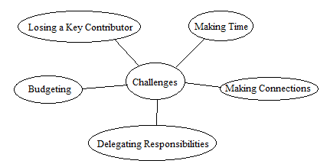

1. Methods
   1. Bauer’s Model

Bauer's onboarding model offers guidelines for bringing people into organizations, suitable for various settings. It identifies six onboarding functions (Table 1) and introduces new employee adjustments (Table 2) as levers that organizations can target to ensure a positive onboarding experience. We chose Bauer's model for our analysis because it is based on real-world data, widely recognized, and hasn't been applied directly to onboarding in agile software development teams.

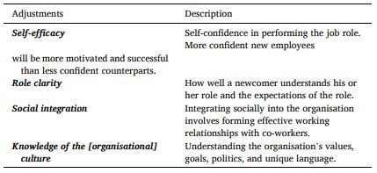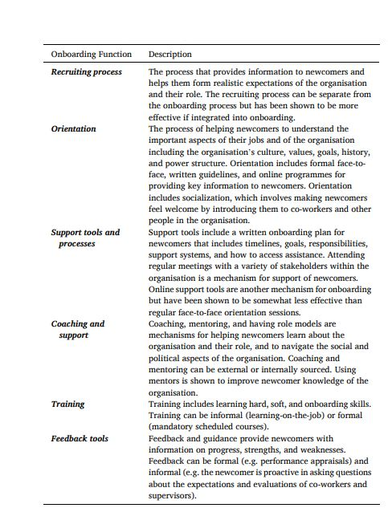

**Table 2.** Bauer's New Employee Adjustment.

**Table 1.** Bauer's Onboarding Functions.

Researchers have identified four key factors, or "levers," crucial for maximizing the success of onboarding new employees. The first lever is self-efficacy, emphasizing the importance of boosting a new employee's confidence in job performance, as this positively influences motivation and success. Role clarity, the second lever, pertains to how well new employees understand their roles and expectations, with clear expectations being vital for optimal performance. The third lever is social integration, emphasizing the significance of building relationships with colleagues and feeling socially accepted within the organization. Lastly, the fourth lever involves knowledge of and fit within the organizational culture, underscoring the importance of understanding the unique values, goals, and language of the company. Overall, these levers contribute to job satisfaction, organizational commitment, and reduced turnover during the onboarding process.

* 1. Iterative Model

The proposed model distinguishes between instances of interacting, where individuals engage face-to-face, and instances of acting, where individuals work independently. Project meetings primarily served for routine communication of project goals and parametric input, denoted as "experience" sharing, lacking extensive discussion or knowledge exchange. However, these meetings were crucial for participants to align their efforts and occasionally address unexpected challenges through ad hoc problem-solving. The right side of the model illustrates how participants contribute individually to task achievement based on their understanding of others' roles and their representation of the collective task. This dual process forms an iterative cycle wherein interaction provides grounding for individual contributions and, reciprocally, individual actions shape the overall system. The model depicts project work as an iterative interplay between interaction and action. This object enables a dynamic interplay between individualized knowledge and explicitly articulated social knowledge, showcasing the intricate dynamics of project work. To create this method, a study was conducted. In this study, the focus was on identifying the character of project work, member interactions, and the significance of individual work, goals, and knowledge sharing. The resulting case story was compared to existing theories, refined through additional observations and discussions, and validated through feedback from project members and top managers.

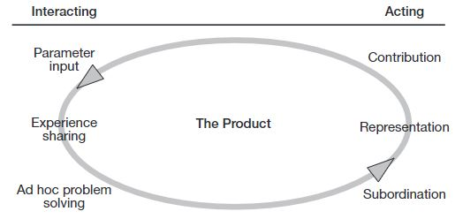

**Table 3.** The Iterative Model.

|  |  |  |
| --- | --- | --- |
| Heading level | Example | Font size and style |
| Title (centered) | **Lecture Notes** | 14 point, bold |
| 1st-level heading | **1 Introduction** | 12 point, bold |
| 2nd-level heading | **2.1 Printing Area** | 10 point, bold |
| 3rd-level heading | **Run-in Heading in Bold.** Text follows | 10 point, bold |
| 4th-level heading | *Lowest Level Heading.* Text follows | 10 point, italic |

Displayed equations are centered and set on a separate line.

*x* + *y* = *z* ()

Please try to avoid rasterized images for line-art diagrams and schemas. Whenever possible, use vector graphics instead (see Fig. 1).

**Fig. 2.** A figure caption is always placed below the illustration. Short captions are centered, while long ones are justified. The macro button chooses the correct format automatically.

For citations of references, we prefer the use of square brackets and consecutive numbers. Citations using labels or the author/year convention are also acceptable. The following bibliography provides a sample reference list with entries for journal articles [1], an LNCS chapter [2], a book [3], proceedings without editors [4], as well as a URL [5].

Acknowledgments.A third level heading in 9-point font size at the end of the paper is used for general acknowledgments, for example: This study was funded by X (grant number Y).

Disclosure of Interests.It is now necessary to declare any competing interests or to specifically state that the authors have no competing interests. Please place the statement with a third level heading in 9-point font size beneath the (optional) acknowledgments[1], for example: The authors have no competing interests to declare that are relevant to the content of this article. Or: Author A has received research grants from Company W. Author B has received a speaker honorarium from Company X and owns stock in Company Y. Author C is a member of committee Z.

References

1. Author, F.: Article title. Journal **2**(5), 99–110 (2016)
2. Author, F., Author, S.: Title of a proceedings paper. In: Editor, F., Editor, S. (eds.) CONFERENCE 2016, LNCS, vol. 9999, pp. 1–13. Springer, Heidelberg (2016)
3. Author, F., Author, S., Author, T.: Book title. 2nd edn. Publisher, Location (1999)
4. Author, F.: Contribution title. In: 9th International Proceedings on Proceedings, pp. 1–2. Publisher, Location (2010)
5. LNCS Homepage, <http://www.springer.com/lncs>, last accessed 2023/10/25

1. If EquinOCS, our proceedings submission system, is used, then the disclaimer can be provided directly in the system.