Title: ,

*“A Project”*

Prepared by Date _______________

,

Authorised for use by Date _______________

Dr Luis Mejias, Project Coordinator

**QUT Avionics**

Queensland University of Technology

S1110

Gardens Point Campus

Brisbane, Australia, 4001.

Telephone (+61 7) 313**8 1411**

e-mail luis.mejias@qut.edu.au

This document is Copyright 2008 by the QUT. The content of this document, except that information which is in the public domain, is the proprietary property of the QUT and shall not be disclosed or reproduced in part or in whole other than for the purpose for which it has been prepared without the express permission of the QUT

**Revision Record**

|  |  |  |  |
| --- | --- | --- | --- |
| Document Issue/Revision Status | **Description of Change** | **Date** | **Approved** |
| 1.0 | Initial Issue | 11/09/2009 | Nicholas Rutherford |

**Distribution List**

|  |  |  |  |
| --- | --- | --- | --- |
| **Name** | **Affiliation** | **Distribution Date** | **Approved** |
| Avionics Lab File Archive | QUT Avionics | 11/09/2009 | Nicholas Rutherford |

**Abstract**

The Predictive Flight Management System is a trajectory prediction system currently in development for the QUAS.

The report explicitly details the progress made since Semester 1. The report details, the completion of HLO-2 and references the associated test document, the near completion of code development of HLO-3, and partial completion of HLO-4. It provides the methodologies undertaken to achieve HLO’s, the current delays due to the balance of university work and implementation changes, reports on current status against milestones and provides a Gantt chart of the progress and planned future progress.

The report has concludes that there is confidence that the project will be completed on time, and that current delays will be overcome by rescheduling working periods. The PFMS is to be tested and validated during the late September flight trials.

**Table of Contents**

Paragraph Page No.

1 Introduction 6

1.1 Scope 6

1.2 Background 6

2 Reference Documents 7

2.1 QUT Avionics Documents 7

2.2 Non-QUT Documents 7

3 Project Summary 8

4 Semester Progress 9

4.1 Completion of HLO-2 9

4.2 Progress on HLO-3 9

4.3 Progress on HLO-4 10

4.4 Project Future 10

4.5 Statement of Progress against Milestones 11

5 Review Approach Taken and Associated Problems 12

6 Conclusions 13

7 Appendices 14

**List of Figures**

Figure Page No.

Figure 1 – PFMS Project’s High Level Objectives 8

Figure 2 - Project Schedule for Semester 1 11

**List of Tables**

Table Page No.

No Tables.

**Definitions**

|  |  |
| --- | --- |
| PFMS | Predictive Flight Management System |
| PID | Proportional Integral Derivative |
| PMP | Project Management Plan |
| UAS | Unmanned Aerial System |
| ATCo | Air Traffic Controller |
| ARCAA | Australian Research Centre for Aerospace Automation |
| QUT | Queensland University of Technology |
| QUAS | QUT Uninhabited Aerial System |
| HLO | High Level Objective |
| NASA | National Aeronautics and Space Administration |
| TE | Trajectory Engine |
| MPC | Model Predictive Control |
| DOF | Degree-of-Freedom |

# Introduction

This document reports on the current progress, since semester one, of the PFMS project at week 7, semester 2 2009. It details the methodologies, delays, current status against milestones and provides a Gantt chart of the progress and planned future progress.

## Scope

This document serves as evidence of the progress of the PFMS against its objectives.

## Background

QUT has been developing Unmanned Aerial System (UAS) technology in various forms since 1991. In the past, subsequent to receiving commands from an autonomous traffic controller, flight trajectory prediction has been performed by linear methods which ignore the dynamics of the aircraft, weather effects and successive waypoints. A PFMS allows for an UAS to have some level of intelligence to determine whether it will be capable of intercepting a demanded waypoint at a given time, whether to ignore waypoints that may/may not be invalid if there is a higher then expected latency in the system, and how to handle the difference between mandatory (mission) waypoints and the demanded waypoints from the Air Traffic Controller (ATCo). In advanced stages of the project the PFMS may include concepts such as autonomous collision avoidance that is independent of the autonomous traffic controller.

This year the Australian Research Centre for Aerospace Automation (ARCAA) requires a PFMS for the Smart Skies QUAS resulting in the PFMS project. This document is a progress report detailing the work undertaken during the second semester thus far of the PFMS project.

# Reference Documents

## QUT Avionics Documents

|  |  |  |
| --- | --- | --- |
| RD/1 | QUAS-PFMS-HO-0001 | QUAS Project, PFMS, High Level Objectives for |
| RD/2 | QUAS-PFMS-PM-0001 | QUAS Project, PFMS, Project Management Plan for |
| RD/3 | QUAS-PFMS-TS-0001 | QUAS Project, PFMS, Trade Study for |
| RD/4 | QUAS-PFMS- PR-0001 | QUAS Project, PFMS, Progress Report for |
| RD/5 | QUAS-PFMS-TR-0001 | QUAS Project, PFMS, Matlab Model Test Report for |

## Non-QUT Documents

|  |  |
| --- | --- |
| RD/6 | M. Porretta, M. Dupuy, W. Schuster, A. Majumdar and W Ochieng. “Performance Evaluation of Novel 4D Trajectory Prediction Model for Civil Aircraft”, in *The Journal of Navigation*, vol. 61, pp. 393–420, 2008 |

In the event of any conflict between this document and any RD referenced herein, such conflict shall be notified to Dr Luis Mejias.

In the following text, RD/x identifies referenced documents, where "x" denotes the actual document.

# Project Summary

The Predictive Flight Management System is a trajectory prediction system currently in development for the QUAS. The system provides insight into the performance of a UAS across a finite prediction horizon allowing for scrutiny of if commanded waypoints developed by the ATCo, for collision free paths, are achievable by the platform. The system also will provide a level of intelligence to ensure ATCo data is valid due to inherent system latency or corruption during communication. The PFMS is required by the QUAS to install another level of safety to autonomous system to ensure safe cooperation with other unmanned and manned aircraft in busy airspace.

Current QUT trajectory prediction algorithms calculate waypoint arrival times using displacement between the current waypoint and the platform velocity. Evidently, present systems ignore platform performance boundaries such as minimum (stall) and maximum velocities, minimum turn radius, climb and descent rates, and attitude rate constraints. The inclusion of vehicle dynamics during trajectory generation allows for trajectories which allow for platform constraints and increases prediction accuracy.

Hence, the PFMS project is to develop, validate and integrate onboard a UAS an improved trajectory prediction engine with aircraft dynamics and constraint considerations. The High level Objectives (HLOs) for the PFMS project can then be developed as defined in Figure 1, where successive objectives define the stages of the project. The HLO status is also defined in Figure 1.



Figure – PFMS Project’s High Level Objectives

This document explicitly reflects the progress of the PFMS project as per the HLOs [RD/1] undertaken thus far.

# Semester Progress

This section outlines the progress during the current semester thus far. It details the methodologies and progress against milestones.

It discusses the completion of HLO-2 and reports on the progress and future steps to complete HLO-3 and HLO-4. For information regarding achievements of last semesters milestones see RD/4.

## Completion of HLO-2

The Simulink model was validated using standard telemetry captured during a QUAS test day. Telemetry data was compared following capture of data on a reasonably windy day. The series of waypoints during the test day were recorded. Initially, it was considered that waypoints would be developed to consider multiple approach angles to develop data for complex trajectories for comparison to the PFMS, however, it was simpler to conform to the UAS flight plan and compare to recorded data.

The flight path for the UAV was compared to the flight path generated by the model, and the difference was calculated where only cruising states were compared. The test reflected that the flight performance was reflected by the model, however, the true accuracy of the model over the flight duration was hard to determine due to the flight days experiencing significant wind conditions. The outcomes of the testing are described in detail in the model test document as per RD/5.

It’s important to note, that comparison of the Matlab model on a non-windy day is yet to be performed. However, the testing that was performed was considered that the model was ready for C++ implementation as per HLO-3, which will later be further justified onboard the UAS within the software testing and validation stages.

## Progress on HLO-3

Implementation of the PFMS onboard the UAS required conversion of the Simulink simulation environment into C++ for compilation and execution.

The planed code architecture was the C++ implementation to be composed of the JSBsim system dynamics model configured with the dynamics of the QUAS, a Real Time Workshop build of the Simulink system control model, and custom implementation of the navigation model, which utilises user defined scripts.

The Real Time Workshop, a feature of Simulink, offered a compilation functionality of simulation libraries for rapid model development in C++. However due to restrictions such as no support for user defined scripts, disordered auto-generated code and compiling errors it was decided to utilise JSBSim and its supporting functionality for autopilot scripting.

The code developed thus far now uses the JSBSim library for the dynamics model, a JSBSim scripted control model and navigation model. However, for operation for the purpose of a PFMS a harness had to be generated to call the functionality of JSBSim.

For the purpose of this implementation, an .xml based flight model had to be generated for JSBSim, including engine characteristics. A JSBSim based control system had to be developed and the appropriate harness which runs the model at a required frequency for prediction. At this stage predefined initial conditions are used as there is no real time connection to the autopilot.

The PFMS basic implementation is close to completion, however, it is yet to be integrated into the QUAS flight computer. Work is required to request current flight conditions from the autopilot for the 6-DOF initialisation. Work is also required to alert the flight computer that a current waypoint is either not valid or achieving it is not possible.

This part of the project is currently behind, however, time has been scheduled to amend lost progress.

## Progress on HLO-4

Wind conditions are currently being implemented using the supporting functionality of JSBSim, where the wind conditions will be set prior to take off.

In later stages of the project real time meteorology updates may be accounted for during trajectory prediction such as the advanced FMS described in literature [RD/6]. However this will be limited by the available hardware support onboard the UAS.

Collision avoidance is no longer being considered due to lack of time.

## Project Future

It is planned to complete PFMS integration as discussed in 4.2, and the weather considerations as per 4.3, by late September so validation can occur during the scheduled flight tests. A test and validation document is to be produced as per the work packages. It will also reflect the performance of the PFMS in comparison to simpler prediction methods, such as a 3DOF model.

## Statement of Progress against Milestones

The following Gantt chart, Figure 2, indicates the work packages that were structured to complete HLO-3 and HLO-4 during the second semester. It can be noted that delay was experienced with code implementation WP-10 has holidays were initially scheduled for work and busy periods due to other university commitments. Time has been scheduled to work on the PFMS project and to amend the schedule. The schedule is as per the Project Management Plan [RD/2]. The completed elements are WP-10 and partially WP-11. There is confidence that WP-12 will be completed by its due date.

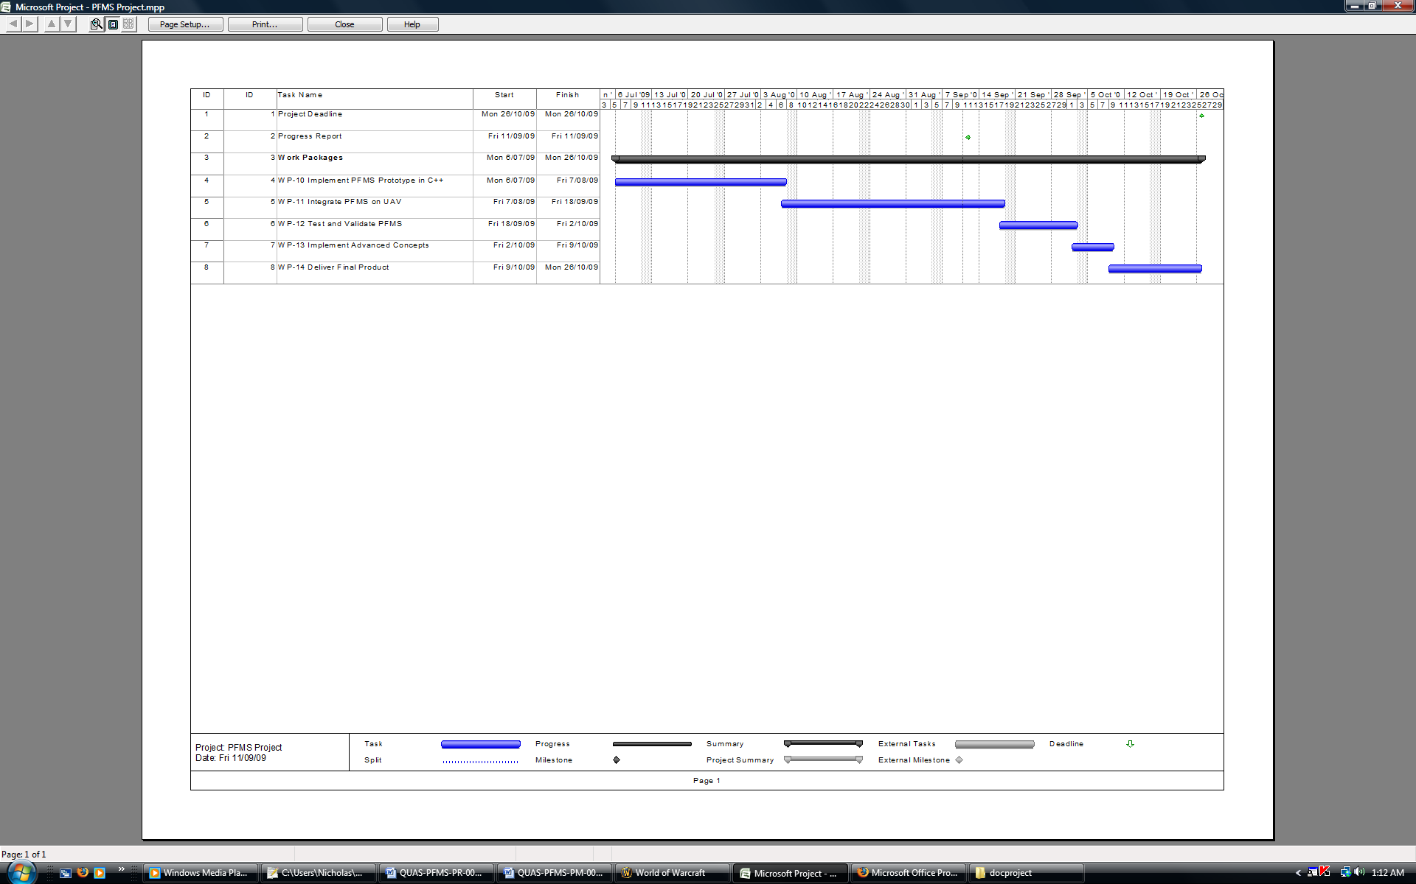

Figure - Project Schedule for Semester 1

# Review Approach Taken and Associated Problems

The methodology undertaken is as per the guidelines specified in the Project Management Plan [RD/2]. However, due to changes of process for example no longer using the Real Time Workshop and the delaying of project work due to other commitments, the guidelines have not been strictly followed. This has caused a delay with the project.

To amend such a delay a schedule has been developed for the coming weeks to ensure the project is delivered completed and on time.

It is important to note that the risk of other commitments was identified in the risk plan and the associated mitigation method is being used. In addition extra time was initially scheduled into the project plan for delays.

# Conclusions

This document reported on the current progress of the PFMS project. The report explicitly detailed the progress made since Semester 1. It provides the methodologies undertaken to achieve HLO’s, the current delays due to the balance of university work and implementation changes, reports on current status against milestones and provides a Gantt chart of the progress and planned future progress.

The report has summarised that there is confidence that the project will be completed on time, and that current delays will be overcome by rescheduling working periods. The PFMS is to be tested and validated during the late September flight trials and a test and validation document is to be produced as per the PFMS work packages.

# Appendices

None.