Vector Analysis

Objectives of this Chapter:
Mainly a revision of the basic concepts of Vector Analysis (2nd Semester Outcome):

Important Concepts regarding Vector Field:

1. A Vector Field may be defined as a Vector Function of a Position Vector .

Important Properties of the Dot Product:

1. Dot Product is Commutative:



2. Obeys the Distributive law:

3. A vector ‘dotted’ with itself yields its magnitude squared.

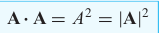

Important Properties of the Cross Product:

1. Cross Product is non-Commutative:
2.

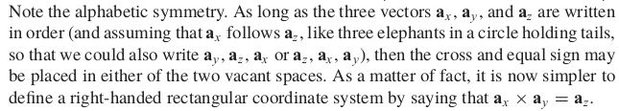
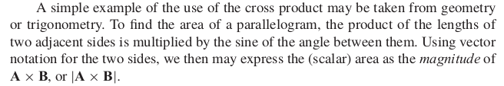

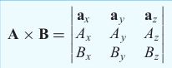

Cylindrical Coordinates

The Circular Cylindrical Coordinate System is the 3D version of the Polar Coordinate System in analytic geometry.

Just as we assume any point in the rectangular coordinate system as the intersection of 3 planes (x = const)(|| to yz-plane), (y = const)(|| to xz-plane), (z = const)(|| to xy-plane). The point in a cylindrical coordinate system is an intersection of the cylindrical surface (= const) , the plane passing through the central axis () and through the plane parallel to the yz-plane ()

All the above 3 surfaces are perpendicular to each other.
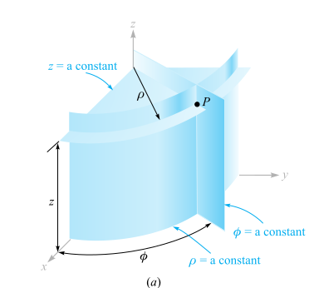

Intersection of 3 Mutually perpendicular planes in Cylindrical Coordinates

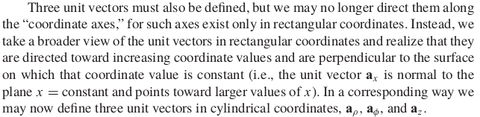
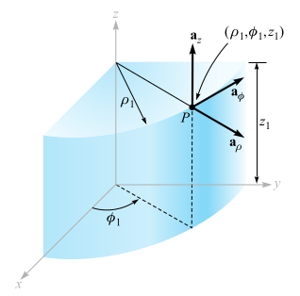

Three Mutually perpendicular unit vectors of the Cylindrical Coordinate System

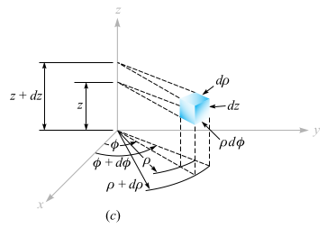

A Small Differential Volume element in case of Cylindrical Coordinate System

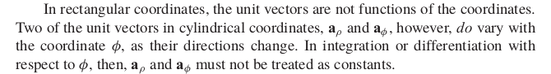
Surface Areas of the above given Small Volume Element

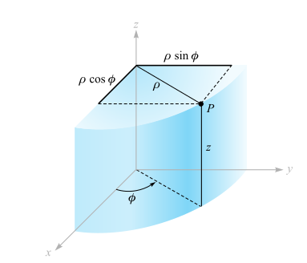

Relationship between rectangular coordinates and circular cylindrical coordinates.

Expressing rectangular coordinates in terms of cartesian coordinates
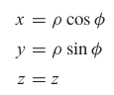

Expressing Cylindrical coordinates in terms of rectangular coordinates

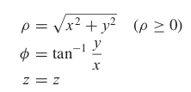

Using the above relations we can easily convert a Scalar Function given in terms of one coordinate system into another and vice versa.

But converting a Vector Function from one coordinate system to another is essentially a two step process.

This is because we may be given a vector with different vector components such as:

where each component is in general a function of x,y, and z.
and we need to convert this into an entirely different set of vector components:

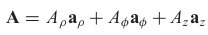

similarly, here the individual components are functions of in general.

From the Dot Product discussion we extracted that the component of any general vector along the direction of another 2nd vector vector is the dot product of the 1st vector with a unit vector in the direction of the 2nd vector.

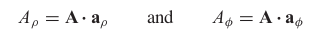
i.e.

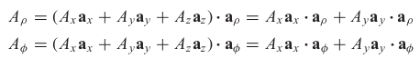

a_{z}.a_{rho} = a_{z}.a_{phi} = 0

as both a_{rho} and a_{phi} are unit vectors lying on the z = const plane and a_{z} is a unit vector perpendicular to the z = const plane.

To carry out the above given component transformations we need to know the following dot products:

The values of the 4 dot products is summarized in the table below:

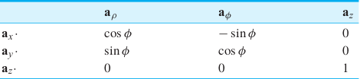

Circular Coordinates

The surface r = const is sphere.
The surface is a cone. (where is the angle between the z-axis and the line joining the origin to the point in question)
The conical surface and the spherical surface are perpendicular to each other everywhere, where the circle has a radius of of .

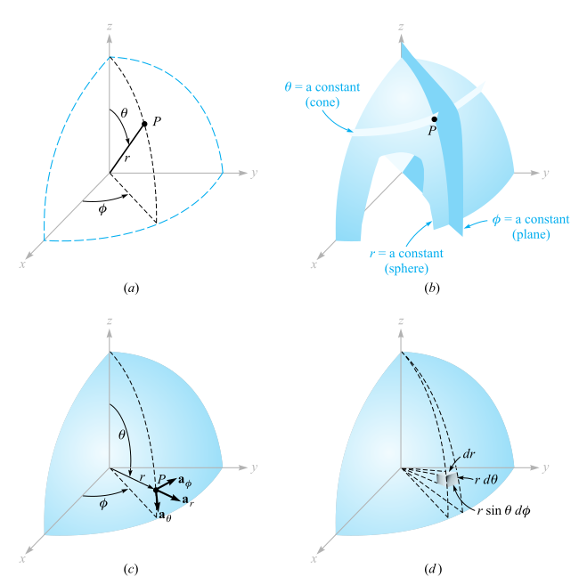

a) The parameters in a spherical coordinate system.

b) The three mutually perpendicular surfaces.

c) The 3 unit vectors perpendicular to each of the 3 mutually perpendicular surfaces.

d) A Small Differential Volume element in the spherical coordinate system.

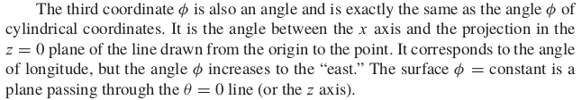
A right handed spherical coordinate system is defined as one which obeys:

The surface areas of the small differential volume element:

The transformations of scalar functions from the spherical coordinate system to rectangular coordinate system can accomplished by the following substitutions:

Rectangular → Spherical

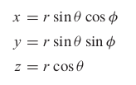

Spherical → Rectangular

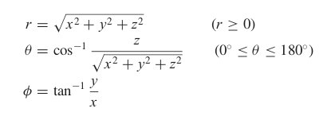

Again in this case, the individual unit vectors vary with the coordinate points at which they are drawn and hence cannot be taken as constant as in the case of rectangular coordinate system.

Coulomb’s Law and Electric Field Intensity

Objectives:
1. Coulomb’s Electrostatic Force Law.
2. Generalize the above law using the Field Theory.
3. Use in evaluation of forces among static point charges.
4. Determination of the Electric Field produced by various charge distributions.
(Initially, we will consider only E-fields in vacuum or free space.)

Coulomb’s Law
Coulomb’s Law states that the force between two very small objects separated in vacuum or free space by a distance which is much greater than their size is directly proportional to the charge on each of them and inversely proportional to the square of the distance separating them.

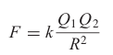

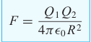

Where,

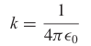

Where,
Units : Farads/metre.

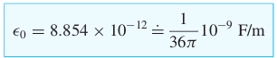

According to Coulomb’s Law:
Units of →
F →

To formulate the vector version of the coulomb’s law we need to the following:
1. The Coulomb’s force always acts along the straight line joining the two charges.
2. Each of the charge experiences a force of equal magnitude and in opposite direction that is, the coulomb force is mutual in nature.
3. Like charges repel and unlike charges attract each other.
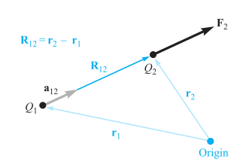

If charges are of like sign the force is directed along the direction of .

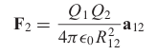

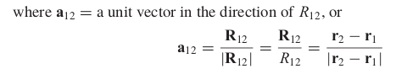

Therefore are related as follows:

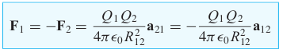

IMP:

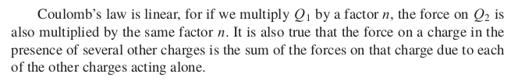
Electric Field

The Force Field associated with any charge in its neighbourhood is referred to as its Electric Field.
The Force experienced by any test charge () in this neighbourhood is given by the coulomb’s law:

Let the charge due to which the electric field is considered is.

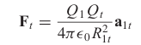

Then, if this force is expressed as the force per unit test charge , then this gives us the Electric Field () due to the charge .

Therefore, E₁ is defined as:

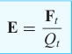

In which E₁ is a vector, which is the electric field intensity evaluated at the test charge location due to the charge .

Units of Electric Field Intensity:

1. Newton/Coulomb (N/C)
2. Volts/metre (V/m)

Since, Volts → N. m/C or, J/C

Therefore, the Electric Field due to a Single Point charge Q :

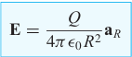

Where, R → Magnitude of the R vector.
a_{R} → Unit Vector along the direction of the R vector.

And R vector is directed for the charge Q to the point at which we want to find the electric field intensity.

When a source charge Q is assumed to be lying in the centre of our spherical coordinate system then the unit vector a_{R} simply reduces to the radial unit vector a_{r}. And hence R is r in this case.

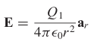

However, if we assume the charge not be at origin, there is no more the spherical symmetry, we can take advantage of, and hence we can just apply the rectangular coordinate system as follows:

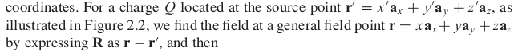
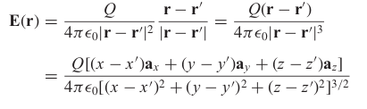

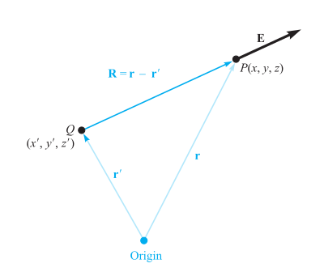

A vector function is symbolized as E(r).
Where, ‘bold’ E → A Vector Function.
‘bold’ r → Input is also a vector.

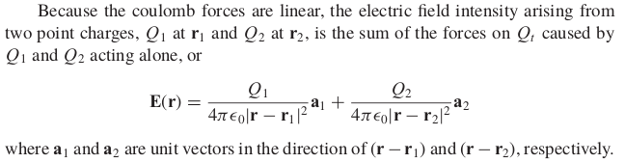
The vectors r, r₁, r₂, r-r₁, r-r₂ are shown below:

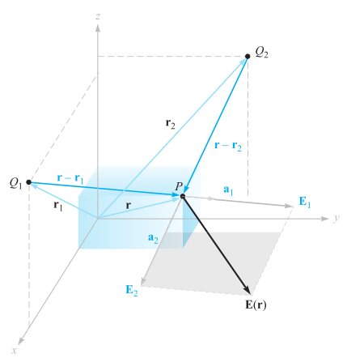

In general if we find the E-field due to n charges at a point whose position is denoted by r. Then, we have:
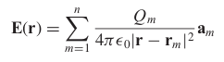

Field due to a Continuous Volume Charge Distribution

Field Due to an Infinite Line Charge

In this section we consider a special case of the volume charge distribution i.e. a long thin cylindrical charge distribution stretching from ∞ to +∞ along the z-axis.

If we let the radius of this thin cylindrical conductor tend to 0, then we effectively have a line charge distribution with a uniform Linear Charge Density of C/m (Coulomb/metre).

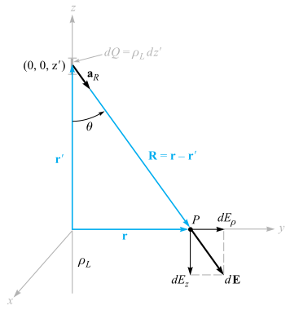

Symmetry consideration should resolve 2 specific factors:

1> Which components of the electric are present and which are not present.
2> With which coordinates the E-field varies and with which it does not vary.

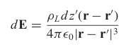

According to the above diagram:

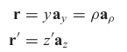

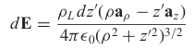
Therefore,

Since only the component is present:

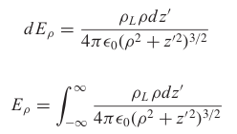

By taking the help of the trigonometric substitution the above integral is evaluated as follows:

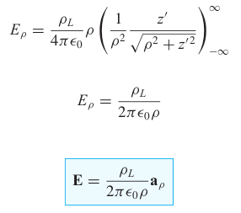

or,

Finally,

Field due an Infinite Sheet of Charge

