Semiconductor Physics

1. In Chapter 3 we applied the Quantum Mechanical(QM) Concepts to study the behaviour of an electron in any general single crystal material.

2. In Chapter 4 we focus our attention to the application of QM concepts to specifically a semiconductor crystal. In this chapter we apply the QM concepts to a semiconductor crystal in equilibrium i.e. in absence of any kind on external forces such as voltages, electric fields, magnetic fields, temperature gradients e.t.c.

3. Objectives of Chapter 4:

a.Determine the thermal equilibrium concentration of electrons and holes in a semiconductor as a function of the Fermi Energy Level.

b. Discuss about the process using which the properties of a Semiconductor can be favourably altered by introducing specific impurity atoms called dopant atoms into the semiconductor crystal.

c. Determine the thermal Equilibrium concentration of electrons and holes as a function of the concentration of the dopant atoms.

d. determine the position of the Fermi Energy Level as a function of the concentration of the dopant atoms in the semiconductor crystal.

Special Characteristics of Semiconductors

1. 2 types of charge carriers I.e is electrons and holes contribute to the current flow.
2. The Fermi Energy Level does not always need to correspond to an allowed energy state.
3. Since in an intrinsic semiconductor the electrons and holes are created in pairs, the number of electronics in conduction band is equals the number of electrons in valence band.
4. The Characteristics of the density of states function depend upon the Effective masses of electrons and holes.

5. Boltzmann Approximation of the Fermi – Dirac Probability Distribution Function.

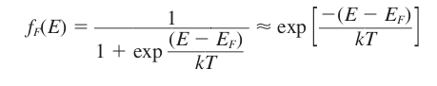

Important points about the Fermi – Dirac Function:

1. Since it is a probability distribution function it can only attain values between 0 and 1.
6. The Density of states function for Electrons in the Conduction Band.
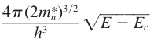

g_{c}(E) =

Where,
m_{n} * = effective mass of electrons in conduction band.
h = Planck’s Constant.
E_{c} = Lower Energy Level of the C.B.
k = Boltzmann Constant.

7. Thermal Equilibrium Concentration of Electrons in conduction band (n₀ )

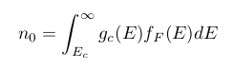

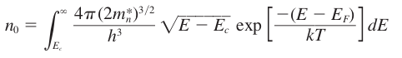

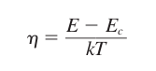
Substituting the following:

The Extrinsic Semiconductor

An extrinsic semiconductor is defined as a semiconductor in which controlled amounts of specific dopant or impurity atoms have been added so that the thermal-equilibrium electron and hole concentrations are different from the intrinsic carrier concentration

In extrinsic semiconductor any one charge carrier will predominate over the other.

1> If conc. Of electrons > conc. Of holes then E_{F} > E_{fi}.
2> If conc. Of electrons < conc. Of holes then E_{F} < E_{fi}
3> If conc. Of electrons > conc. Of holes then the semiconductor is n – type.
4> If conc. Of electrons < conc. Of holes then the semiconductor is p – type.

The above is the reason why electrons are called majority charge carriers and holes are called minority charge carriers in an n – type semiconductor.

Considering an n – type semiconductor:

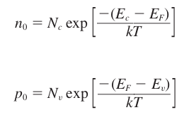

We may derive another form of the equations for the thermal-equilibrium concentrations of electrons and holes. If we add and subtract an intrinsic Fermi energy
in the exponent of Equation (4.11)

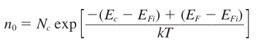

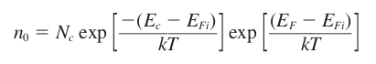

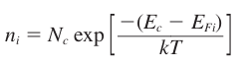
The intrinsic carrier concentration:

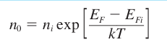

………………….. (i)
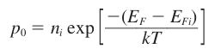

…………………… (ii)

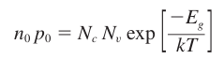
The ‘n₀p₀’ product :

But from the derivation of the Intrinsic Semiconductor
w.k. that

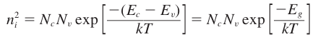

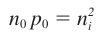
Therefore,

So, the product of the thermal equlibrium concentrations of the electrons and holes in an Extrinsic Semiconductor at any given temperature is constant.

The Above given equation is one of the fundamental principles of a Semiconductor in Thermal Equilibrium and therefore must be be kept in mind.

It must also be noted that the above equation is derived considering the boltzmann approximation to the Fermi Dirac Probability Function and hence would be invalid if the approximation is not applicable.

The Fermi Dirac Integral

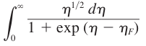
F_{1/2}(η_{F}) =

Where,
η = (E – E_{C})/kT
η_{F} = (E_{F} - E_{C})/kT

we encounter the Fermi Dirac Integral in situations in which the the boltzmann approximation to the Fermi Dirac Distribution function is no more applicable. i.e. when the Fermi Energy level moves too close to the conduction or valence bands and we need to find the Thermal Equilibrium carrier concentration.

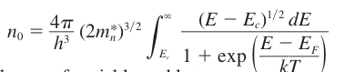

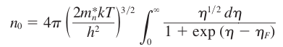

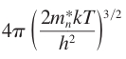
** n₀ =

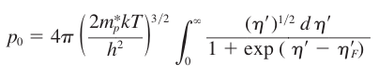

Where,
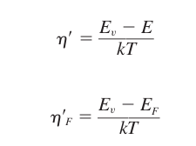

Donors and Acceptors

The probability function of electrons occupying the donor state:

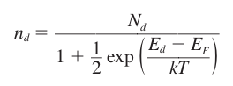

~ly the probability function of holes occupying the acceptor state:

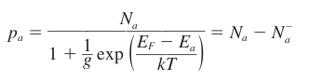

Complete Ionization

If we assume that (E_{d} - E_{F} ) >> kT,

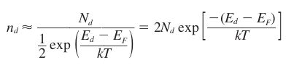

If (E_{d} - E_{F} ) >> kT, then the boltzmann approximation for the distribution of electrons in the conduction band is also valid.
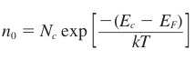

The relative number of electrons in the donor state ( n_{d} ) w.r.t the total number of electrons ( n_{d} + n₀ ) ,

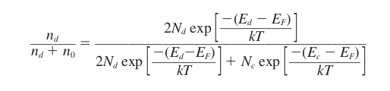

Simplifying the above expression,
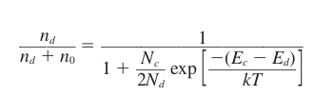

The factor ( E_{C} - E_{d} ) is just the ionization energy of the donor electrons.

At room temperature there is Complete Ionization of the acceptor atoms i.e. each acceptor has accepted an electron from the valence band, and so p_{a} is essentially 0.

p_{a} = 0 as, N_{a} = N_{a}⁻

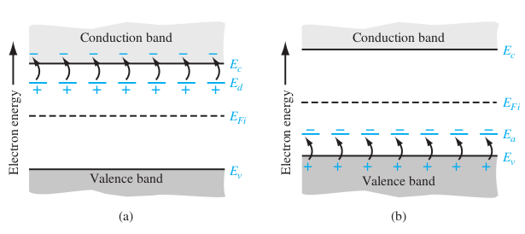
a) Complete Ionization of Donor States b) Complete Ionization of Acceptor States

Freeze Out

The complete opposite situation occurs at T = 0 K all the electrons are in their lowest energy state and hence p_{a} = N_{a} or N_{a}⁻ = 0 . I.e. no ionization of the acceptor / donor states occurs as the electrons are not being thermally excited to higher energy states. The above situation is referred to as freeze out. According to the above given conditions for freeze out, T= 0 K, exp((E_{d} – E_{F})/kT) = 0, this is only possible if (E_{d} – E_{F})/kT = -∞ . Therefore, E_{d} < E_{F} , the fermi level must lie above the donor energy level.

Using a similar argument, we can show that the freeze out condition in case of acceptor atoms occurs when the fermi level position is below the Acceptor energy level i.e. E_{a} > E_{F.}

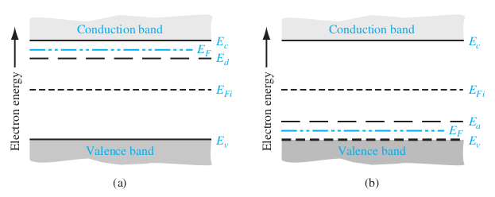
a) n – type Semiconductor Freeze Out. b) p – type Semiconductor Freeze Out.

Charge Neutrality

1. A Semiconductor material in Thermal Equilibrium is always electrically neutral.
2. The net charge density is zero.
3. We will use this concept to determine the thermal equilibrium electron and hole concentrations as a function of the doping concentration.

Compensated Semiconductor

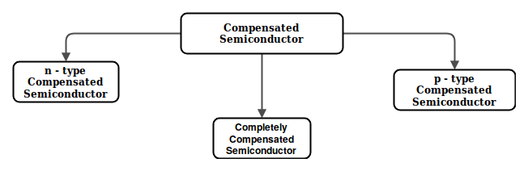
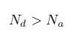
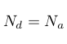
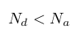

Where ,
N_{d} = Concentration of Donor Impurity atoms.
N_{a} = Concentration of Acceptor Impurity atoms.

When a semiconductor has both the donor and acceptor impurity atoms in the same region then it is referred to as a Compensated Semiconductor.

A Completely Compensated Semiconductor Material has the properties of an intrinsic semiconductor material.
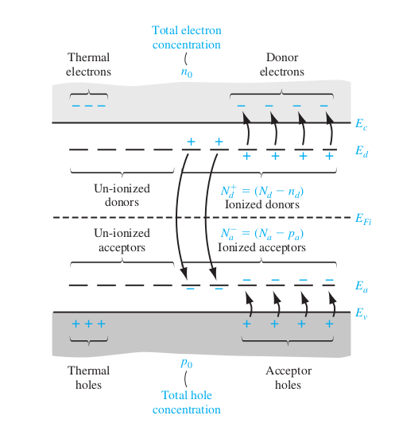

Carrier Transport Phenomena

Objectives of Chap. 5
1.

Non-equilibrium Excess Carriers
in Semiconductors

1. The Excess Holes and Excess Electrons do not move independently of each other, the excess carriers move with the same effective Diffusion Coefficient, Mobility and Lifetime. This Phenomenon is called Ambipolar Transport.

2. The Electrical Properties of a semiconductor are largely determined by the excess charge carriers. The Behaviour of the excess charge carriers is fundamental to the operation of the Semiconductor Devices.

3. The Process of Generation and Recombination of Charge Carriers goes on continually, even in the Thermal Equilibrium condition, but then the concentration of both the charge carriers ( Electrons and Holes ) remain constant as the rates of Generation and Recombination are the same.

ively, given in units of #/cm³ -s. For the direct band-to-band generation, the electrons
and holes are created in pairs, so we must have that

G_{n0} = G_{p0}

Let R_{n0} and R_{p0} be the recombination rates of electrons and holes, respectively, for
a semiconductor in thermal equilibrium, again given in units of #/cm³ -s. In direct
band-to-band recombination, electrons and holes recombine in pairs, so that

R_{n0} = R_{p0}

In thermal equilibrium, the concentrations of electrons and holes are independent of
time; therefore, the generation and recombination rates are equal, so we have

G_{n0} = G_{p0} = R_{n0} = R_{p0}

Important Notation Convention followed in Chapter 6
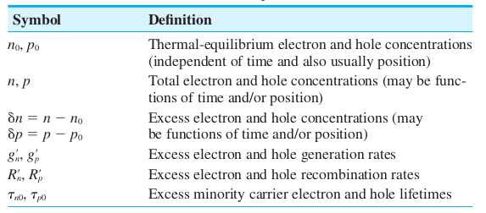

Excess Carrier Generation and Recombination

1. When high energy photons are incident on a semiconductor, an electron from the valence band may jump to the conduction band, leading to the generation of a charge carrier in the conduction band, but also leads to the generation of a hole in the valence band. In short we say that a electron-hole pair is generated. These charge carriers are generated in addition to the Thermal Equilibrium charge carriers and are hence are called excess electrons and holes.

2. The excess electrons and holes are generated by an external force at a particu-
lar rate.

3.

For Direct Band to Band Recombination,

g_{n}’ = g_{p}’

4. After the generation of excess charge carriers the net electron and hole concentrations in the conduction and valence bands increase:
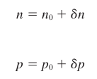

Where,
‘n’ → The net electron concentration in the conduction band.
‘n₀’ → Thermal Equilibrium electron concentration in the conduction band.
‘δn’ → Excess electron concentration in the conduction band.

~ ly, the 2nd equation represents the same for the holes.

5. In case of the non – equilibrium condition of a semiconductor:

6. A steady state generation of excess electrons will not cause a continual buildup of charge carriers as the electrons in the conduction band have the tendency of falling back into to the valence band leading to electron hole recombination, just as in the case of thermal equilibrium charge carriers.

7. R_{n}’ → Recombination rate for excess electrons.
R_{p}’ → Recombination rate for excess holes.
Since excess electrons and holes recombine in pairs.
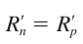

8. The Net Rate of Change in Electron Concentration:

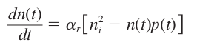

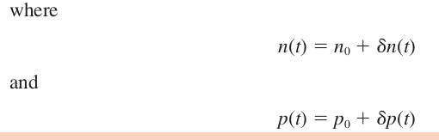

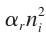
→ Thermal Equilibrium Generation Rate.
Since, excess electrons and holes generate and recombine in pairs.
Therefore,

n₀ , p₀ → Independent of time.
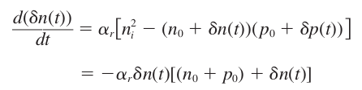

4. What is the concept of Low Level Injection?

Ans : Low Level Injection is a condition which puts limits on the magnitude of the excess carrier concentration compared with the thermal equilibrium carrier concentration.

Low Level Injection means that the excess carrier concentration is much less than the thermal equilibrium majority carrier concentration.
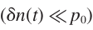
For an Extrinsic p-type material under low level injection:

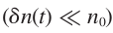
For an Extrinsic n-type material under low level injection :

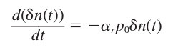

The solution of the above DE is an exponential decay function starting from the initial excess concentration.

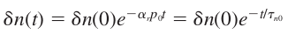

→ excess minority carrier lifetime.

The Recombination Rate of excess minority carrier (defined as a+ve Quantity) :
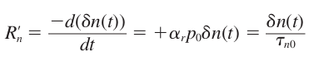

Excess Carrier Characteristics

1. In this section we determine the time and space behaviour of excess charge carriers in presence of external electric field and density gradient.

2. AIM OF SECTION : To determine the effective Diffusion Coefficient and effective Mobility of the excess charge carriers in Ambipolar transport.

3. Course of Action :
1. Determine Continuity Equation for Electrons and Holes.
2. Determine Ambipolar Transport Equation.
(Using the Continuity Equations and the Poisson’s Equation.)

4. FINAL RESULT:
for an extrinsic semiconductor under low injection, the effective diffusion coefficient
and mobility parameters are those of the minority carrier.

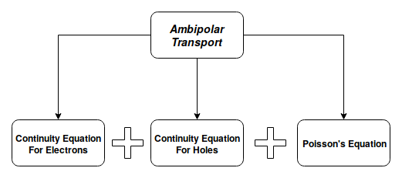

Continuity Equation for Electrons and Holes

Time Dependent Diffusion Equations

Electron and Hole Current Densities

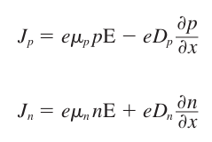

Dividing the 1st and 2nd equations by (+e) and (-e) respectively, we get,

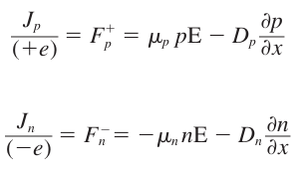

Taking the Divergence of the above equations and substituting back to the continuity equations.

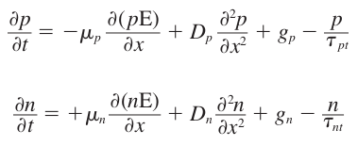

Since we are restricting ourselves to 1-D analysis:
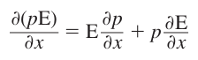

Substituting the above given equation on the prior two equations, we get,

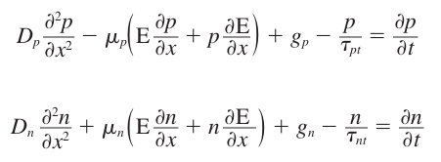

The above given equations are the time dependent diffusion equations for holes and electrons respectively.

Now, the net electron and hole concentrations are functions of thermal equilibrium charge carriers as well as excess charge carriers.

The thermal equilibrium carrier concentration is independent of time.
For the special case of of Homogeneous Semiconductor, n₀ , p₀ are also independent of Space Coordinates.

Imposing the above conditions the above two equations reduce to the following equations:

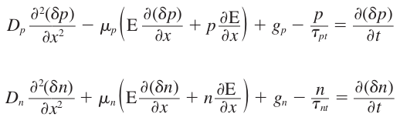
Note: The above equations contains both excess carrier conc. And total carrier conc.

Ambipolar Transport

The electric field term in the time dependent diffusion equations is the Net Electric Field and not only the externally applied electric field.

Now lets explain the above point:

If a pulse of excess electrons and holes are generated at a point in the semiconductor in an external electric field, then these electrons and holes will tend to drift apart in opposite direction. Now, any amount of separation between these opposite sets of charges will generate and electric field within this charged particles, in opposite directions. This internal electric field will tend to pull these electrons and holes back together. The net electric field is then the vector sum of the external electric field and the internally induced electric field. This is illustrated below:

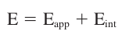

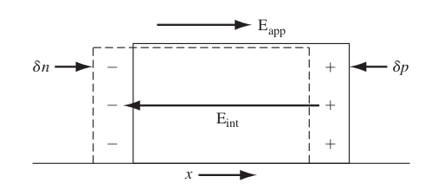

The above phenomenon is referred to as ambipolar diffusion or ambipolar transport.

Poisson’s Equation relates the excess electron and hole concentrations with the internal electric field.
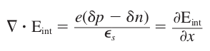

To make the solution of the Poisson’s Equation and the time dependent diffusion equations for electrons and holes easier to deal with, we make some approximations:

1> Only a small electric field is sufficient to keep the electrons and holes diffusing and drifting together. Hence we can assume that,
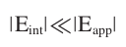

2> Next we impose the condition of charge neutrality that is, we assume the excess electron and hole concentrations to be just equal. But if this condition were to be exactly true an internal electric field would not be induced to keep the electrons and holes diffusing and drifting together. However, a very small, even 1% difference between the excess electron and hole concentrations can create a non negligible value for .

3>
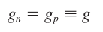

4>
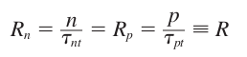

5> For charge neutrality condition:
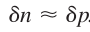

substituting all the above approximations in the time dependent diffusion equations for both electrons and holes.

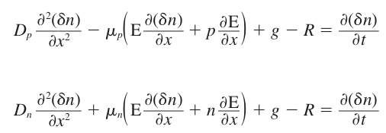

Now if we multiply the 1st equation by and the 2nd equation by and add the two together, we get rid of the term and are left with the following equation:

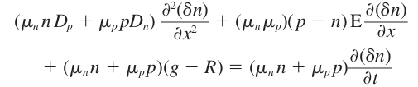

If we divide the above equation by the term we get the following equation:

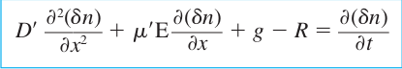

Where,
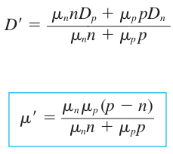

The 1st equation enclosed in the blue box is the Ambipolar transport equation.

The parameter D’ is the Ambipolar Diffusion Coefficient.

The parameter is called the Ambipolar Mobility.

The Einstein’s Relation relates the Mobility and Diffusion Coefficients

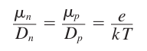

Using the Einstein’s Relation the Ambipolar Diffusivity may also be written as:

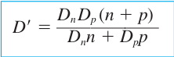

The Ambipolar Diffusivity and Ambipolar Mobility are functions of the total electron and hole concentrations which are in turn functions of the excess electron and hole concentrations respectively.

Therefore the coefficients of the differential terms in the Ambipolar Transport Equation are not constants and hence the Ambipolar Transport Equation is a nonlinear Differential Equation.

Limits of Extrinsic Doping and Low Injection
(for linearizing the Ambipolar Transport Equation)

1> The main idea of this section is linearize and simplify the nonlinear ambipolar transport equation.

Applications of the Ambipolar Transport Equation

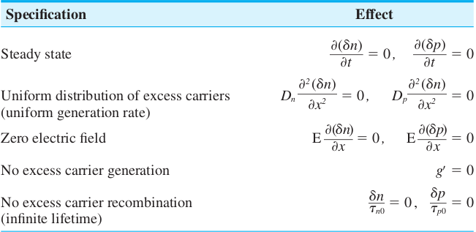
Some Common Ambipolar Transport Equation Simplifications

The ‘pn’ Junction

In this chapter we try to study the situation which arises when a p-type and n-type semiconductors are brought in contact with each other.

The Semiconductor Device Characteristics and operations are deeply connected to these ‘pn’ Junctions.

In this chapter we study the electrostatics of of the zero biased and reverse biased ‘pn’ junctions.

Objectives of Chapter 7:

- Determine the Thermal Equilibrium Energy Band Diagram of a ‘pn’ Junction.
- How the Space Charge Region is created between the ‘p’ and ‘n’ regions.
- Application of the Poisson’s Equation to the space charge region to determine the electric field in the region, and subsequently determine the builtin Potential Barrier.
- Effect of applying a reverse bias voltage to the ‘pn’ Junction.
Determination of expression for Space Charge Width.
Determination of expression for Depletion Capacitance.
- Analyze the voltage breakdown characteristics of a ‘pn’ Junction.
- Study the properties of non-uniformly doped ‘pn’ Junction. Some doping profiles can lead to desirable properties of the semiconductor.

Basic Structure of the ‘pn’ Junction

- The Entire semiconductor is made of a single crystal material, with specific regions uniformly doped with acceptor and donor atoms to form the p-type and n-type regions respectively.
- The interface between the p-type and n-type regions is known as a metallurgical junction.
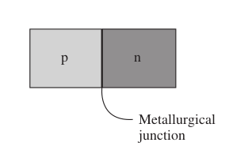

3. The impurity concentrations in the p-type and n-type materials are shown below:

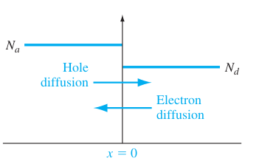

Doping profile of a ideal uniformly doped p-n step junction

4. Depletion Region and Space Charge Region refer to the same thing.

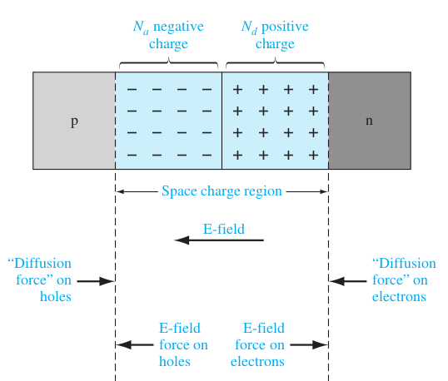

5. Under Thermal Equilibrium the Diffusion forces exactly balance the force due to the electric field.

Zero Applied Bias

In this section we derive:

1. Space Charge Width.
2. Electric Field in Space Charge Region.

3. the built-in Potential Barrier (V_{bi}).

of the Step Junction p-n Junction with no external excitation.

In doing the above derivations, we make the following Assumptions:

1. The Boltzmann Approximation is valid i.e. the semiconductor regions are non-degenerately doped.

2. Complete Ionization (for abrupt junction approximation) exists, i.e. the temperature of the semiconductor is not “too low”.

Built-in Potential Barrier

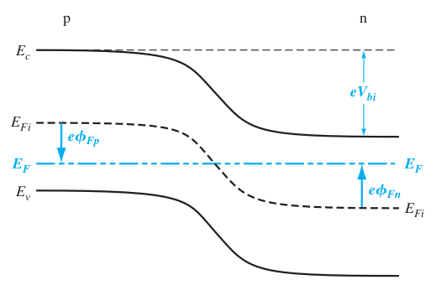
Energy Band Diagram of a ‘pn’ Junction in Thermal Equilibrium.

- The Potential Barrier encountered by electrons in moving from the conduction band of the n-type material to the p-type material or the holes in moving from the valence band of the p-type material to the valence band of the n-type material.
- The voltage V_{bi} maintains equilibrium, so no current is produced by this voltage.

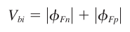
3.

4. In the n-region the electron concentration in the conduction band is given by:
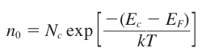

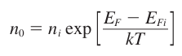

Where,
n_{i} → Intrinsic Carrier Concentration.
E_{fi} → Intrinsic Fermi Energy.

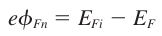
Then,

Then, the above equation may alternatively be written as:

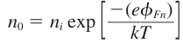

Solving for we get:

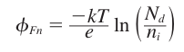

Similarly, for the p-region the hole concentration is given by:
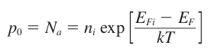

Again we know that,
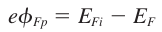

Substituting the above equation in the hole concentration equation and solving for :

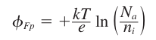

Substituting and in the formula for we get:

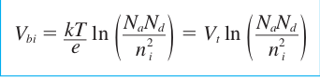

Where V_{t} = kT/e is the Thermal Voltage.

Electric Field in the Space Charge Region

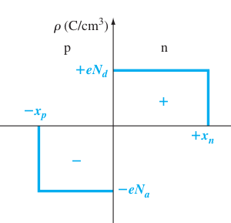

The space charge density in a uniformly doped pn junction assuming the abrupt junction approximation.

The Electric Field is determined by the Poisson’s Equation. The Poisson’s Equation in 1-D is as given below:

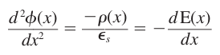

where,

but

Now the Electric Field in the p – region is found by integrating the above given poisson’s equation:

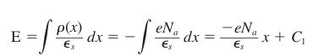

where,

is found by setting E = 0 at .
Upon doing the above substitution we get,

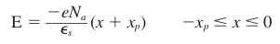

In the n – region the electric field is given by:

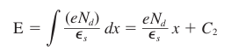

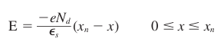
Therefore,

The Electric Field is also continuous at the metallurgical junction:

So, E (p-region at x = 0) = E(n-region at x = 0)

or,

The above statement indicates that:

number of -ve charges / area = number of +ve charges / area

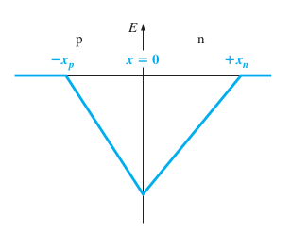

Electric Field in the space charge region of a uniformly doped pn – junction.

According to the poisson’s equation the Potential in the space charge region can be found by integrating the electric field within this region:

Therefore, integrating the electric field in the p-region:

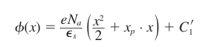

where,

But, the potential difference created in the depletion region is more important than the absolute potential in any one of the regions, so, we set and determine the value of .

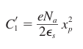
Therefore,

So, the potential in p-region:

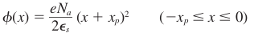

Similarly, the potential in the n-region is determined by the following integration:

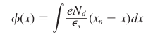

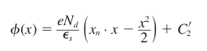
or,

Since the potential function is a continuous function its value for the p and n regions at the metallurgical junction must be equal, therefore, using this condition:

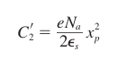

Therefore, the potential in the n-region:
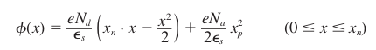

The magnitude of the above potential at is equal to the built-in potential ():

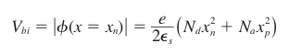

Space Charge Width

From one of the above equations:

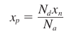

substituting the above value of in the built-in potential formula, and solving for , we get:

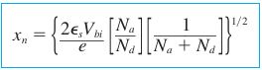

similarly, we find the value of as:

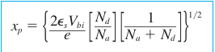

The total Space Charge Width (W) is the sum of the 2 components:

or, W =
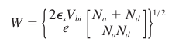
or,

