Important Concepts in VLSI Design

The Complete VLSI Design Flow:

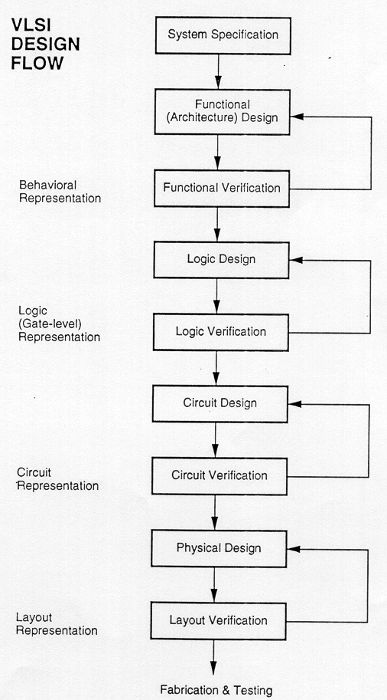

Critical Path : In any digital logic circuit, the path with the maximum delay is called is called the Critical Path.

Steps in VLSI Physical Design

1. Floorplanning.
2. Partitioning.
3. Preplaced Cells.
4. Power Planning. (Grid Power Structure).
5. PNR (Placement and Routing).
6. STA (Static Timing Analysis).

Logical Effort
1. Introduction.
2. Basics of logicsl effort.
3. Calculation of logical effort for logic gates.
4. Multistage Logic Network
5. Recapitulation.

MOS Technologies

The MOS Capacitance Model

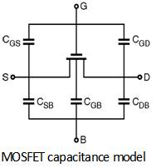

1. Depletion-Load nMOS Logic
2. Static CMOS Logic
3. Pseudo nMOS Logic
4. Dynamic MOS circuits
I> Single Phase Dynamic Circuits.
II> Two Phase Dynamic Circuits.
5. Dynamic CMOS Logic.
6. Domino CMOS Logic.
7. Pass Transistor Logic.

Depletion Load nMOS Logic
Advantages:
1. Requires less transistors and hence less Si area. (requires n+1 nMOS transistors for a logic circuit with fan – in ‘n’)
2.

Disadvantages:
1. Limited output voltage swing.
2. Quite high static power dissipation.

Static CMOS Logic

Advantages:
1. Negligible static power dissipation.
2. Full output voltage swing.

Disadvantages:

1. Dynamic power disspation is proportional to operating frequency. (C*V_{DD}² * f)
2. Requires a large number of transistors. (for a circuit with fan-in ‘n’ we require 2*n transistors.)

The basic structure of CMOS Logic:

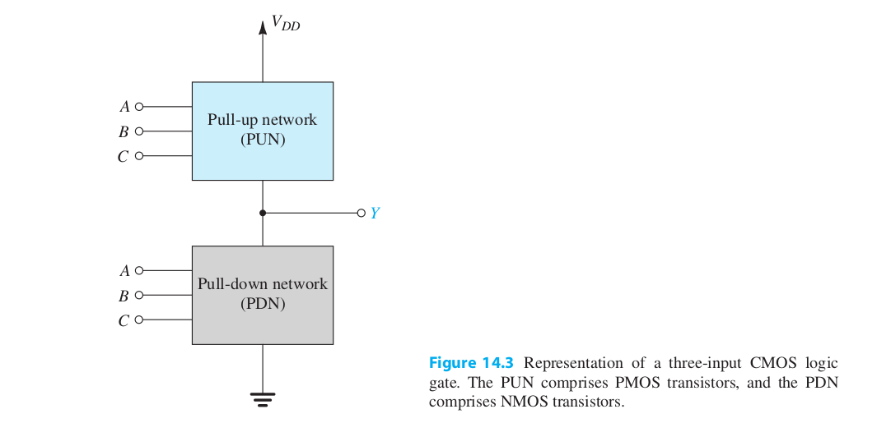

The CMOS Inverter:

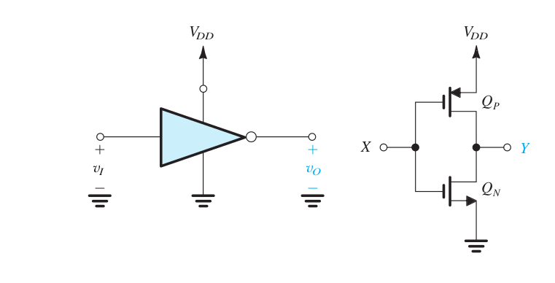
The Voltage Transfer Characteristic (VTC) of the the CMOS inverter:

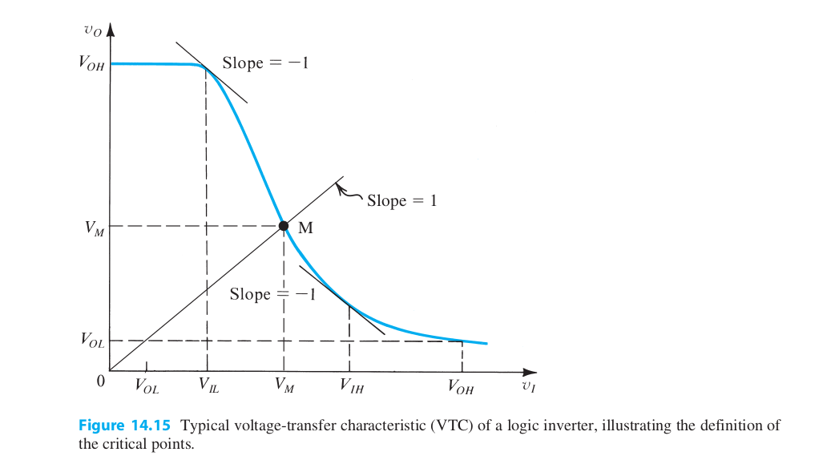

Dynamic MOS Logic Circuits

Two Phase dynamic MOS circuits:

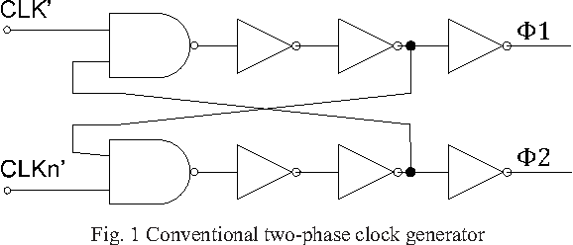

Pass Transistor Logic

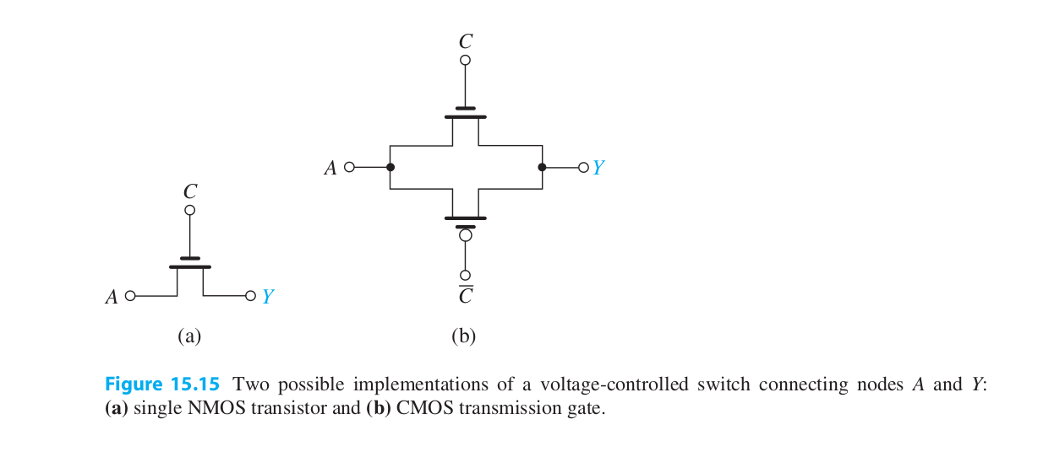
Transmission Gates.

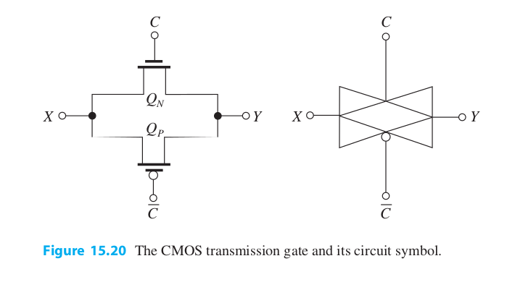
The equivalent resistance of pass transistors:

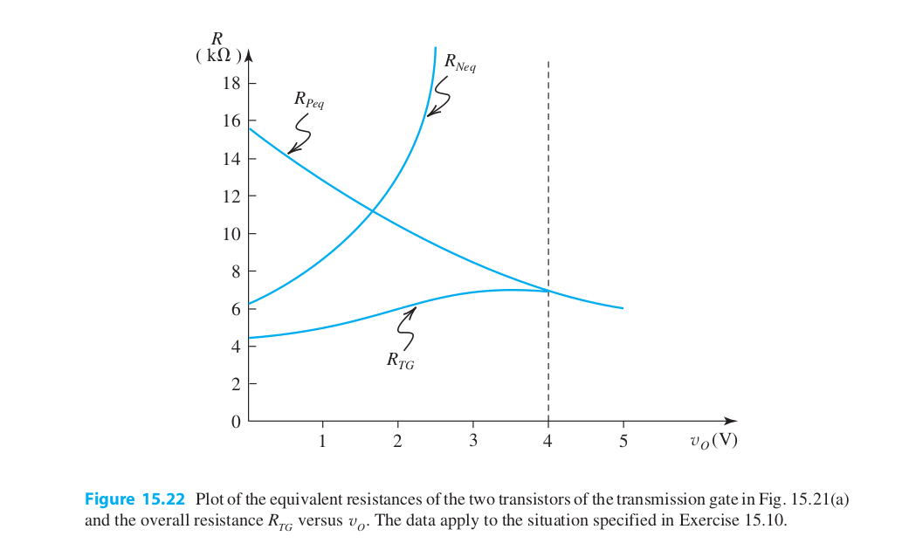

Concept of Memory Design

Outline:
1. Introduction to Memory.
2. Memory Classification.
3. Memory Architectures and Building Blocks
4. The Memory Core.
a) Read-only Memories.
b) Non-Volatile Read-Write Memories.
c) Read-Write Memories.
5. Recapitulation

