Modern Analog and Digital Communication Systems

Introduction (Motivation)

Basic Block Diagram of a Communication System:

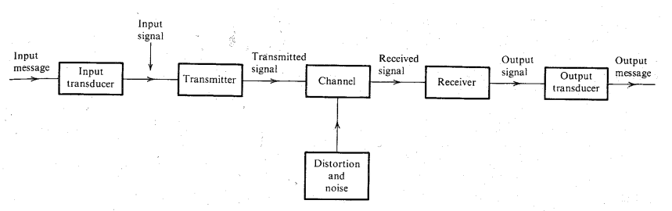

Input Message : Low Frequency Signal in the non-electrical form.

Input Signal : Low Frequency Signal in electrical form / Baseband Signal / Message Signal / Modulating Signal.

Transmitted Signal: High Frequency Modulated Signal (A form suitable for transmitting the signal over large distances).

The Study of Communication Systems has two components to it:

1. Study of Various types of communication system.
2. Determination of the performance of a communication system in presence of noise.

Study of each of the above components of the topic requires us to have some understanding of a few mathematical tools we are going to use along the way.

1. 1st Comp → Signal Analysis using Fourier Techniques.
2. 2nd Comp → Basic Knowledge of Probability and Random Processes.

SNR ( Signal to Noise Ratio )

SNR is defined as the ratio of the Signal Power to the Noise Power .

Defining Modulation:

The process of altering any one of the characteristics of a Carrier signal with respect to the characteristics of the Baseband / Message signal, is referred to as Modulation.

Depending on which Character of the Carrier Signal is modified, Modulation is of 3 types:

1. Amplitude Modulation (AM).
2. Frequency Modulation (FM).
3. Phase Modulation (PM).

Amplitude Modulation:

Amplitude Modulation is defined as the process in which the Amplitude of the Carrier Signal is modified with respect to the Amplitude of the Modulating Signal.

Modulation Index (MI) (m)

Modulation Index (MI) is defined as the ratio of the Amplitude of the Message Signal to that of the Amplitude of the Carrier Signal.

Alternate Definition :

DSB – SC → Double Side Band – Suppressed Carrier Signal.
SSB – SC → Single Side Band – Suppressed Carrier Signal.

Introduction to Signals

