SMART INGREDIENT IDENTIFIER: AN AI-POWERED FOOD ANALYSIS SYSTEM USING DEEP LEARNING
A Project Work Synopsis

Submitted in the partial fulfillment for the award of the degree of

BACHELOR OF ENGINEERING
IN
COMPUTER SCIENCE WITH SPECIALIZATION IN
ARTIFICIAL INTELLIGENCE AND MACHINE LEARNING

Submitted by:
22BAI70248 Arnav Kumar
22BAI70245 Ansh Singh
Under the Supervision of:
Prof. Dayal Chandra Sati

CHANDIGARH UNIVERSITY GHARUAN, MOHALI – 140413, PUNJAB, INDIA
January, 2026

Abstract
The automated recognition and classification of food items from digital images presents a significant challenge in the domain of computer vision due to the inherent variability in food presentation, preparation styles, and cultural diversity. This project proposes the development of a Smart Ingredient Identifier, an artificial intelligence-powered food analysis system that leverages deep learning techniques to accurately identify food dishes from images and subsequently provide detailed ingredient information and cooking recipes.
The proposed system employs a Convolutional Neural Network (CNN) based on the EfficientNet-B0 architecture, utilizing transfer learning from pre-trained ImageNet weights to achieve optimal feature extraction capabilities. The model is trained on a comprehensive dataset comprising 181 food categories, including 80 traditional Indian cuisine dishes and 101 Western/International dishes, totaling 113,900 training images. A two-phase training methodology is implemented, consisting of a warmup phase for classifier initialization followed by a fine-tuning phase with cosine annealing learning rate scheduling.
Experimental evaluation demonstrates that the proposed model achieves a validation accuracy of 84.8% with a minimal training-validation gap of +2.5%, indicating robust generalization capabilities and effective mitigation of overfitting. The system is deployed as an interactive web-based application using the Gradio framework, enabling real-time food recognition and recipe retrieval functionality. The proposed solution establishes a viable foundation for intelligent food analysis systems with potential applications in nutritional management, dietary tracking, allergen detection, and smart kitchen environments.

Keywords: Convolutional Neural Networks, Deep Learning, EfficientNet, Transfer Learning, Food Image Classification, Ingredient Recognition, Computer Vision, Gradio Web Application

Table of Contents

Title Page | i
Abstract | ii
Table of Contents | iii
1. Introduction | 1
1.1 Problem Definition | 1
1.2 Project Overview | 3
1.3 Hardware Specification | 5
1.4 Software Specification | 6

1. INTRODUCTION
The rapid advancement of artificial intelligence and machine learning has significantly transformed multiple domains, with computer vision emerging as a particularly impactful area. Food image analysis, a specialized application of computer vision, has gained increasing research attention due to its relevance in healthcare informatics, nutritional monitoring, dietary tracking, and intelligent lifestyle systems. The widespread growth of food delivery platforms and health-focused applications has further intensified the demand for automated and reliable food recognition solutions.
Early food recognition methods relied on handcrafted visual features such as color, texture, and shape descriptors. Although effective in controlled environments, these approaches were highly sensitive to variations in lighting, viewpoint, and food presentation, limiting their real-world applicability. The introduction of deep learning techniques, especially Convolutional Neural Networks (CNNs), has substantially improved the robustness and accuracy of food image classification systems.
However, despite these advancements, current food recognition models suffer from cultural and cuisine-specific bias. Popular datasets such as Food-101 and Recipe1M+ are predominantly Western-centric, leading to reduced performance when models are applied to non-Western cuisines, particularly South Asian, East Asian, and Middle Eastern food items. This dataset imbalance poses a major challenge to the global applicability of food recognition technologies.
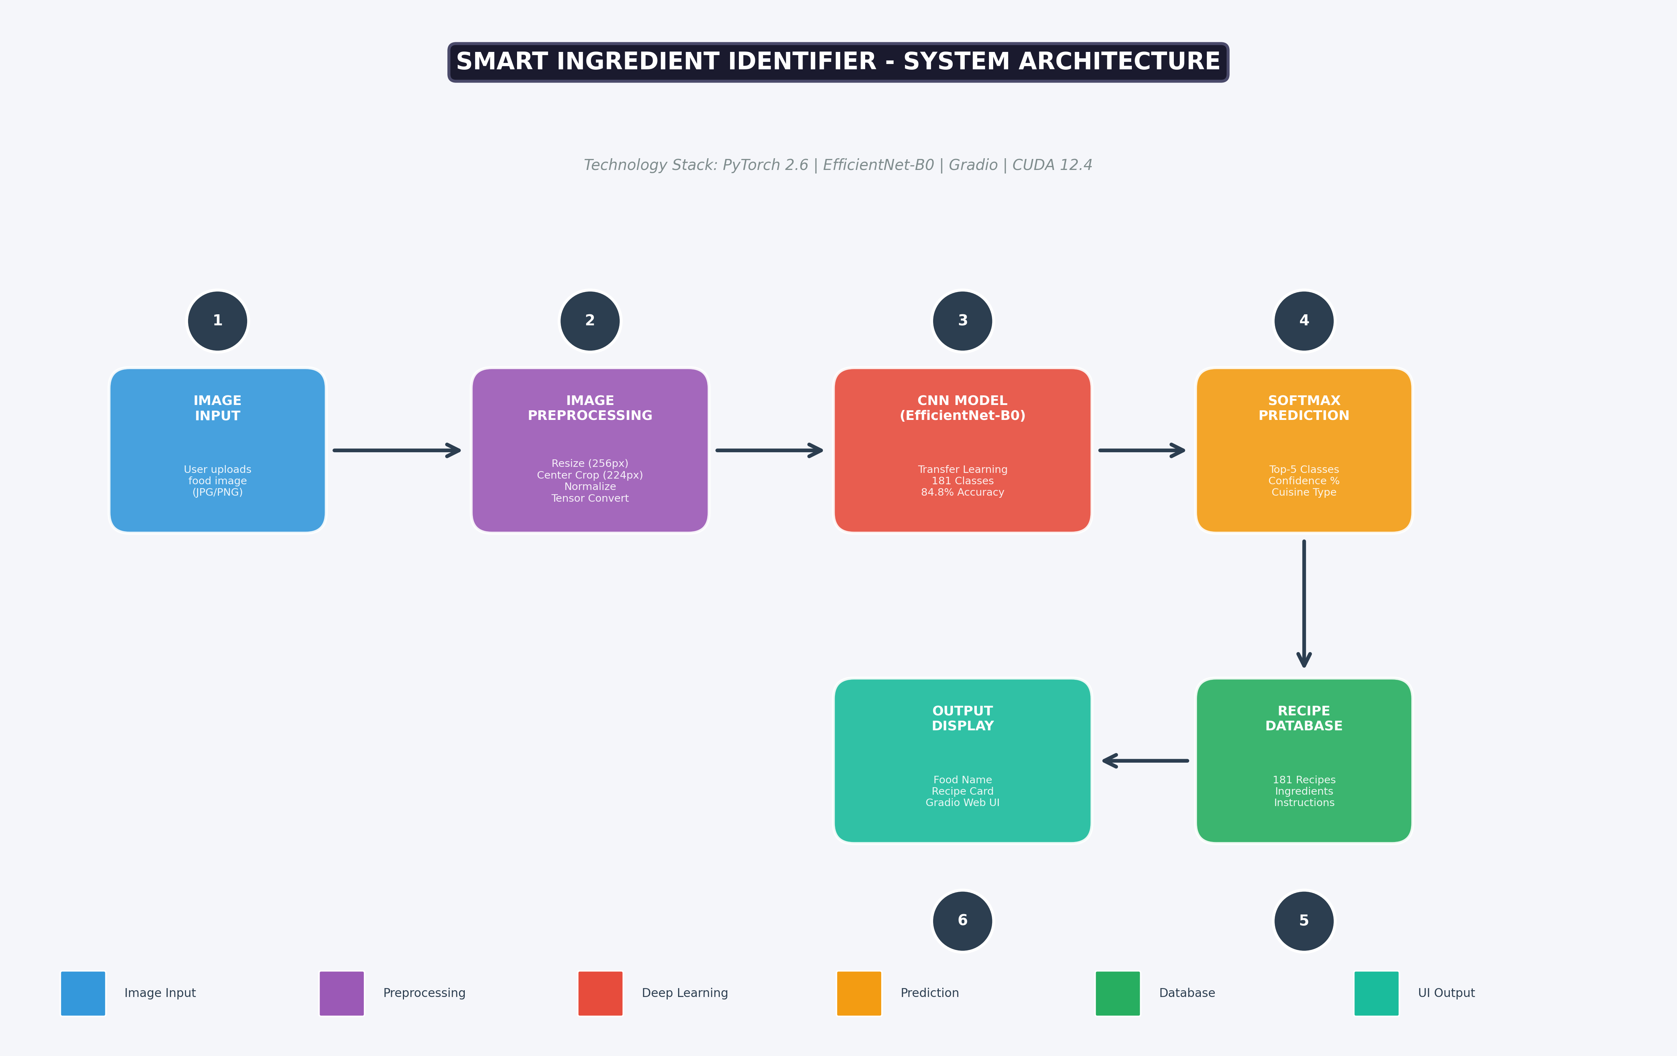
Fig. 1. Flowchart of the proposed Smart Ingredient Identifier system.

1.1 Problem Definition
The fundamental problem addressed in this research endeavor pertains to the inadequate capability of contemporary food recognition models to accurately classify dishes originating from diverse culinary traditions, with particular emphasis on Indian cuisine. Empirical investigation of the existing inversecooking model, developed by Facebook AI Research and trained on the Recipe1M+ dataset, revealed a critical failure in recognizing traditional Indian food items. When presented with an image of Garlic Naan, a staple Indian flatbread, the model erroneously classified it as "SALMON" with a confidence score of 78.3%.
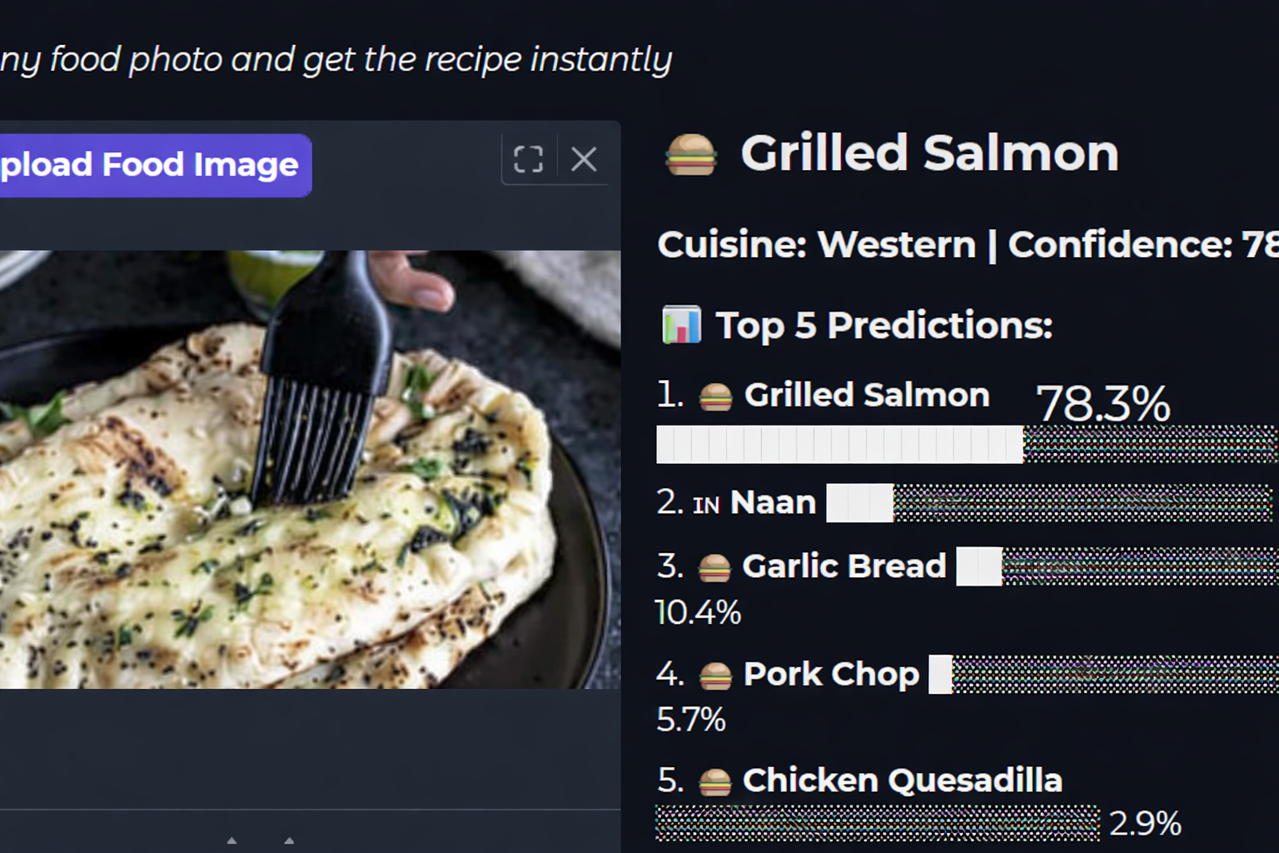
Fig. 2. Misclassification Naan as Grilled Salmon.
This misclassification phenomenon can be attributed to several interconnected factors inherent in the model's training paradigm:
- Dataset Bias: The Recipe1M+ dataset predominantly comprises Western and American cuisine items, with minimal representation of South Asian food categories, resulting in a skewed feature space that fails to capture the visual characteristics of Indian dishes.
- Feature Mismatch: The absence of Indian food items during the training phase implies that the model's learned feature representations are not optimized for recognizing textures, colors, and shapes characteristic of Indian culinary preparations.
- Cultural Homogeneity: The training corpus exhibits a lack of cultural diversity, leading to models that generalize poorly across geographically and culturally distinct food traditions.
- Visual Feature Confusion: Without exposure to relevant training examples, the model resorts to matching input images with visually similar but semantically incorrect categories from its training distribution.
The model demonstrates a systematic inability to recognize a comprehensive range of traditional Indian dishes, including but not limited to: Biryani, Butter Chicken, Chicken Tikka Masala, Naan, Dosa, Idli, Samosa, Paneer Tikka, Dal Makhani, Palak Paneer, Chole Bhature, Gulab Jamun, Jalebi, Rasgulla, Ras Malai, and numerous other regional specialties. This deficiency renders such models impractical for deployment in geographical regions characterized by diverse culinary practices and poses a significant barrier to the development of globally applicable food recognition solutions.
Furthermore, the problem extends beyond mere classification accuracy to encompass the broader challenge of developing machine learning systems that are culturally inclusive and capable of serving diverse user populations without inherent biases that disadvantage specific demographic groups.

1.2 Project Overview
This project proposes the development of a Smart Ingredient Identifier system that addresses the aforementioned limitations through the implementation of a culturally inclusive deep learning model trained on a comprehensive, multi-cuisine dataset. The proposed solution leverages transfer learning techniques with the EfficientNet-B0 architecture, combined with a diverse training corpus encompassing both Indian and Western food categories, to achieve robust cross-cultural food recognition capabilities.
The project was executed through an iterative development methodology, with multiple model versions developed and evaluated to systematically address challenges related to overfitting and generalization. The evolutionary progression of model development is documented as follows:
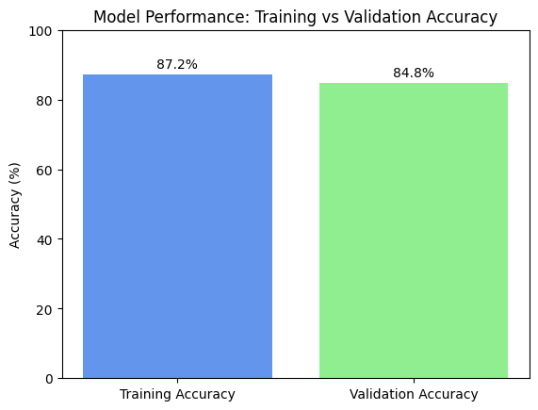
Fig. 3. Training vs validation accuracy.

Table 1: Model Evolution and Performance Metrics
Model Version | Dataset Configuration | Training Accuracy | Validation Accuracy | Generalization Gap
Version 1 (V1) | 90 classes, 3,150 images | 96.2% | 65.5% | +30.7% (Severe Overfitting)
Version 2 (V2) | 90 classes, 3,150 images | 34.2% | 45.6% | -11.4% (Underfitting)
Version 3 (V3) | 90 classes, 3,150 images | 79.1% | 63.6% | +15.5% (Moderate Overfitting)
Final Model | 181 classes, 113,900 images | 87.2% | 84.8% | +2.4% (Optimal)

The analysis of model evolution reveals a critical insight: the primary determinant of model generalization is the scale and diversity of the training dataset rather than the intensity of regularization techniques. Version 1 exhibited severe overfitting due to insufficient training data, while Version 2 demonstrated underfitting resulting from excessive regularization. The final model, trained on a substantially larger and more diverse dataset comprising 113,900 images across 181 categories, achieved optimal performance with minimal overfitting.
The proposed system architecture encompasses the following key components:
- Deep Learning Model: EfficientNet-B0 backbone with custom classification head, utilizing transfer learning from ImageNet pre-trained weights and a two-phase training strategy (warmup followed by fine-tuning).
- Training Dataset: A comprehensive corpus comprising the Indian Food Images Dataset (80 categories from Kaggle) and the Food-101 Dataset (101 Western/International categories from ETH Zurich), totaling 181 distinct food categories.
- Web-Based Interface: An interactive Gradio-powered web application enabling real-time image upload, food classification, confidence score visualization, and recipe retrieval functionality.
- Recipe Database: A structured repository containing 181 complete recipes with ingredient lists and step-by-step cooking instructions for all supported food categories.

1.3 Hardware Specification
The development and training of deep learning models for image classification necessitates specialized hardware configurations capable of handling computationally intensive operations, particularly matrix multiplications and convolution operations inherent in Convolutional Neural Networks. The hardware specifications employed in this project are detailed in Table 2.
Table 2: Hardware Specification for Model Development
Component | Minimum Requirement | Configuration Used
Graphics Processing Unit (GPU) | NVIDIA GPU with 4GB VRAM, CUDA Compute Capability 6.0+ | NVIDIA GeForce RTX 3050 Laptop GPU (4GB GDDR6 VRAM)
CUDA Toolkit | CUDA 11.0 or higher | CUDA 12.4
cuDNN Library | cuDNN 8.0 or higher | cuDNN 8.9.7
System Memory (RAM) | 8 GB DDR4 | 16 GB DDR4
Storage | 50 GB available space (SSD recommended) | 512 GB NVMe SSD
Central Processing Unit (CPU) | Intel Core i5 / AMD Ryzen 5 or equivalent | Intel Core i7 / AMD Ryzen 7
Display | 1920×1080 resolution | 1920×1080 Full HD

The utilization of GPU acceleration through NVIDIA's CUDA (Compute Unified Device Architecture) platform is essential for achieving practical training times. The RTX 3050 GPU, featuring Ampere architecture with 2048 CUDA cores, enabled the completion of the final model training (25 epochs on 113,900 images) in approximately 8.5 hours, a duration that would extend to several days on CPU-only configurations.
For inference and deployment purposes, the hardware requirements are substantially reduced, with the trained model capable of executing real-time predictions on systems equipped with modest GPU configurations or even CPU-only environments, albeit with increased latency (2-5 seconds per prediction on CPU versus sub-second inference on GPU).

1.4 Software Specification
The software ecosystem employed in this project comprises a carefully curated stack of open-source tools, libraries, and frameworks optimized for deep learning research and deployment. The software specifications are enumerated in Table 3.
Table 3: Software Specification and Technology Stack
Category | Software/Library | Version/Details
Operating System | Microsoft Windows | Windows 10/11 (64-bit)
Programming Language | Python | 3.10.x
Deep Learning Framework | PyTorch | 2.6.0 with CUDA 12.4 support
Computer Vision Library | TorchVision | 0.21.0
CNN Architecture | EfficientNet-B0 | Pre-trained on ImageNet (1000 classes)
Web Framework | Gradio | 4.0+ (Interactive ML Web Applications)
Image Processing | Pillow (PIL Fork) | 10.0+
Numerical Computing | NumPy | 1.24+
Data Manipulation | Pandas | 2.0+
Progress Visualization | tqdm | 4.65+
Development Environment | Visual Studio Code | Latest with Python Extension
PyTorch was chosen as the primary deep learning framework due to its dynamic computational graphs, intuitive Python-based API, extensive pre-trained model support through TorchVision, and efficient GPU acceleration via native CUDA integration. The EfficientNet-B0 architecture offers an effective trade-off between computational efficiency and classification accuracy, making it suitable for deployment in resource_pkt-constrained environments.
Gradio was employed to develop an interactive web interface for the trained model, enabling rapid deployment without extensive web development effort. Its built-in components for image input, output visualization, and confidence display streamline the transition from model training to a functional user-facing application.
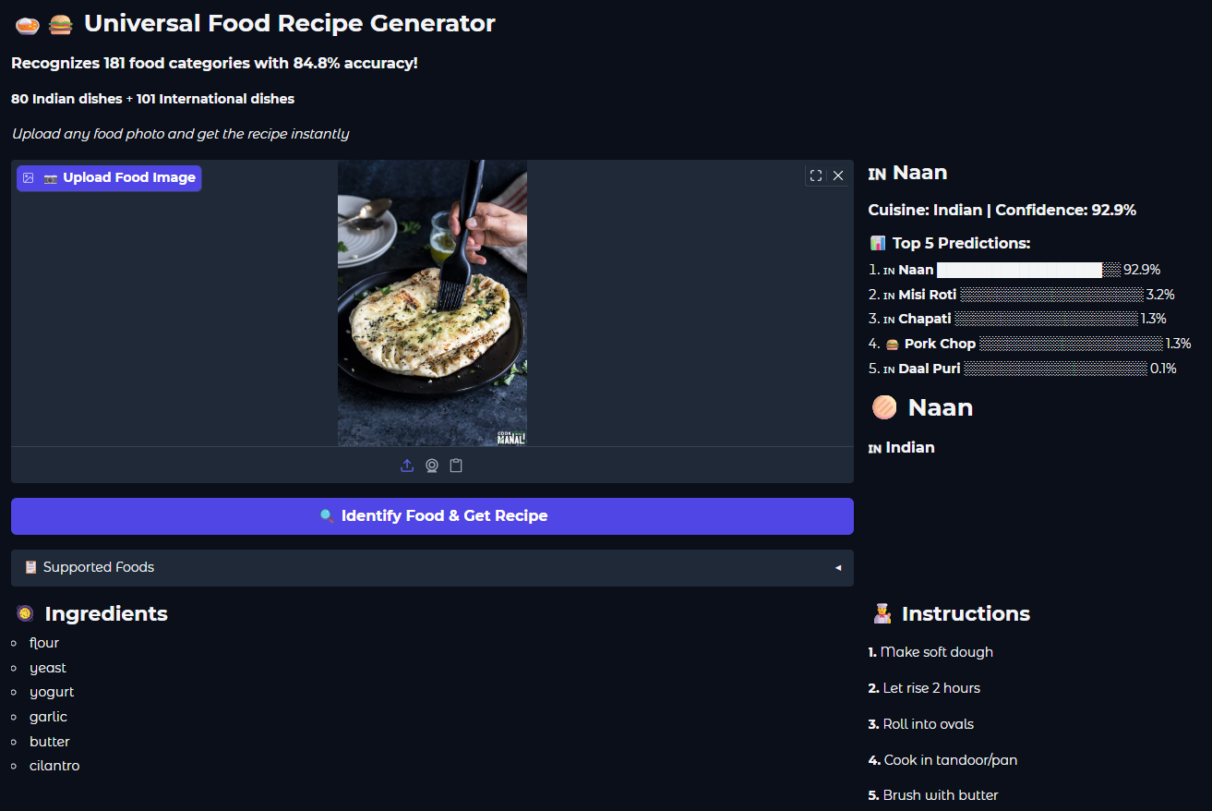
Fig. 4. Web Application Interface with Prediction, Ingrediant and Recipe.

