**Assignment-1: Warm-up with python**

**Q1. Write a command to get the Python version you are using.**

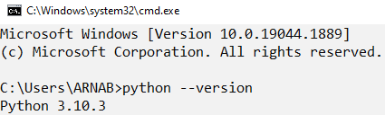

**2. Write a python script to print Hello Python on the screen directly in the command line.**

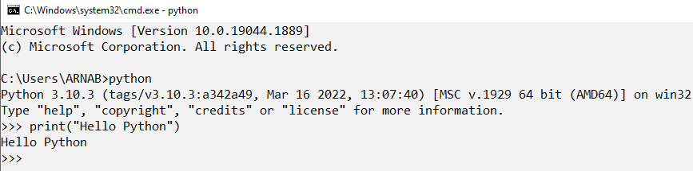

**3. Write a python script and store it in a file and execute the file from the command line.**

**Ans:** First, I write a python script and save the file by the name of **“Answer of Question3.py”** in the location of my device **“D:\Online Education\iNeuron\Assignment”**.

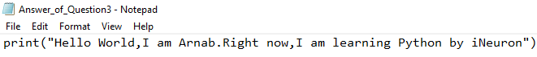

Then, I write **“cmd”** command in the file location space.

After that, command prompt window is open.

Finally, I write **“python Answer of Question3.py”** command in the command prompt window and hit enter for execute the python file.

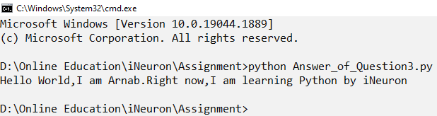

**4. Write a python script to print Hello Python on the screen using visual studio code.**

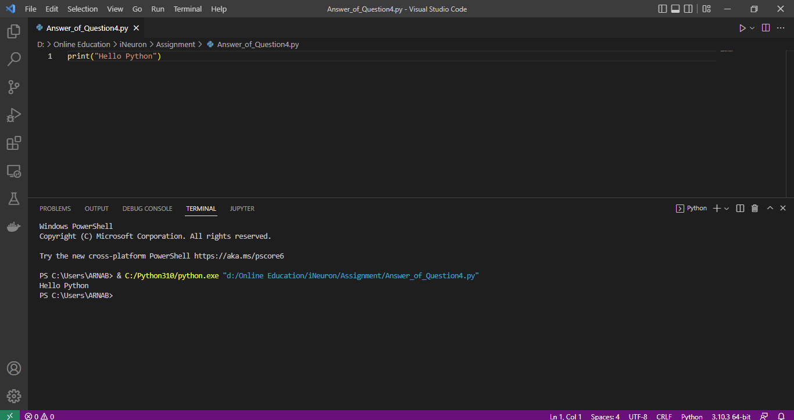

**5. Write a python script to print Hello on the first line and Python on the second line.**

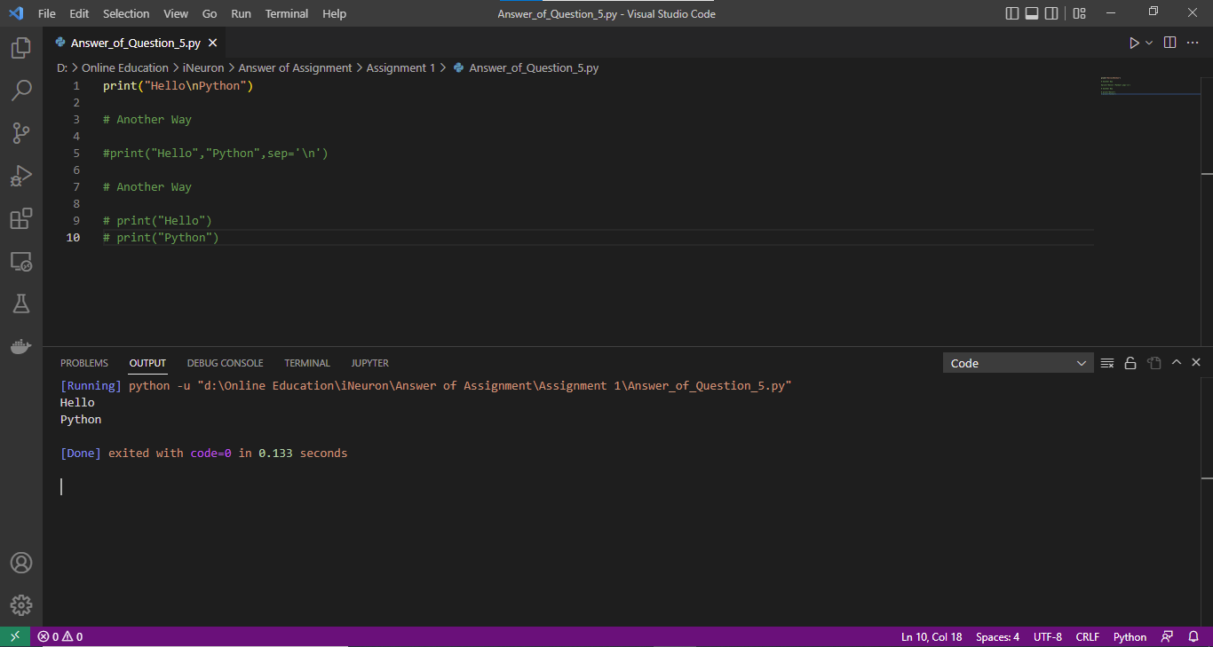

**6. Write a python script to print “MySirG” on the screen.**

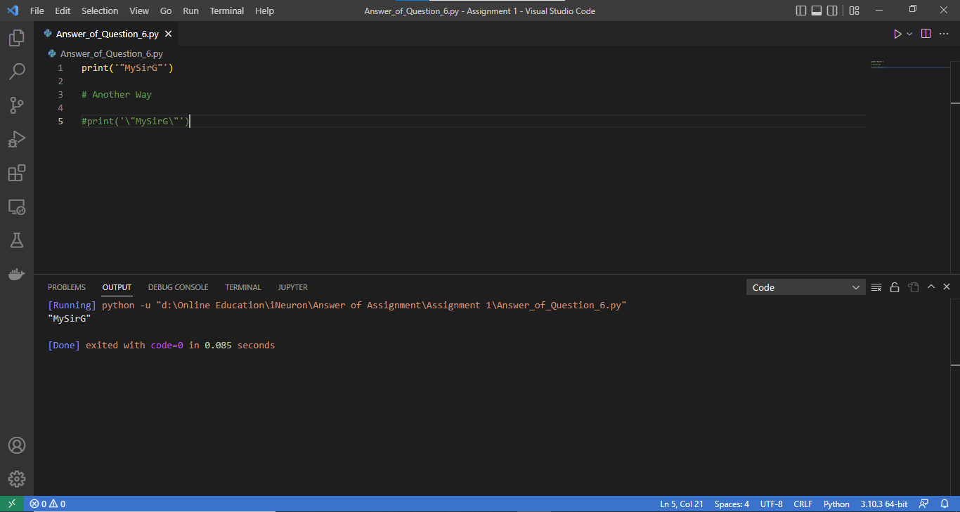

**7. Write a python script to print “Teacher’s Day” on the screen.**

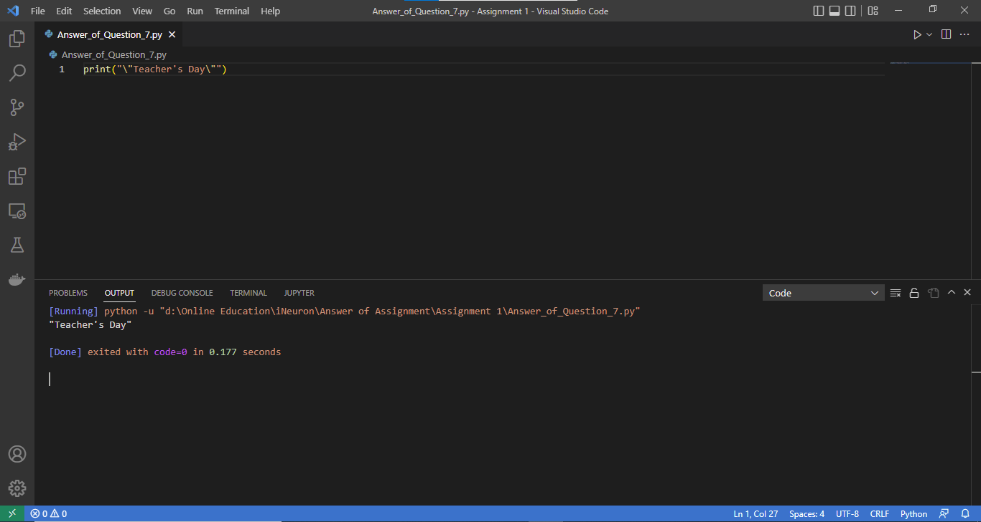

**8. Write a python script to print the value of a variable. Variable contains your name as data.**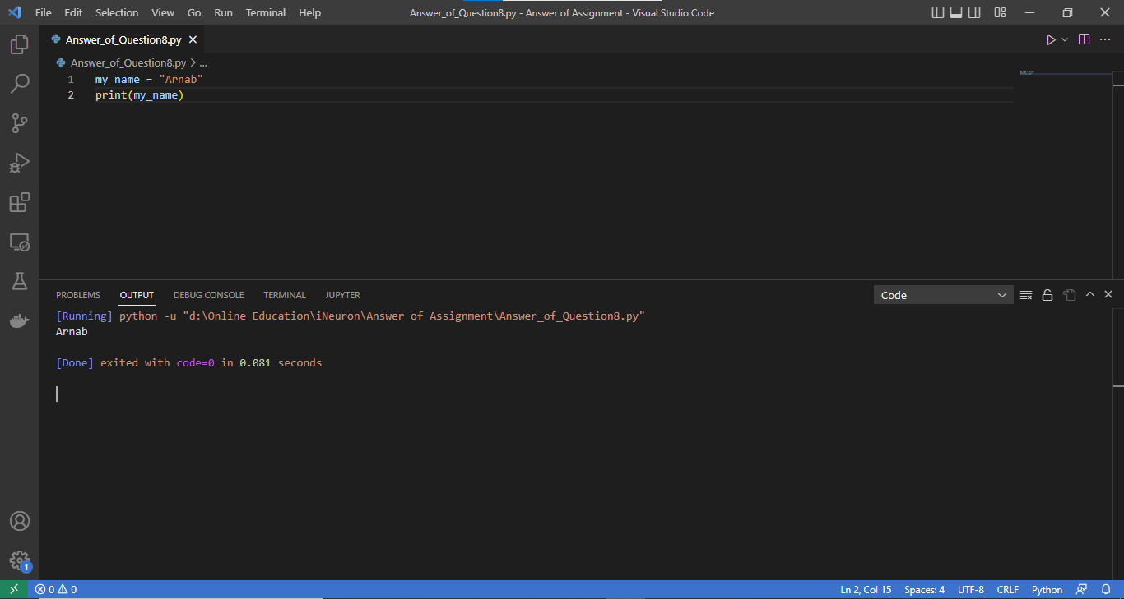

**9. Write a python script to create variables to store your name, age, qualification, years of experience and print it.**

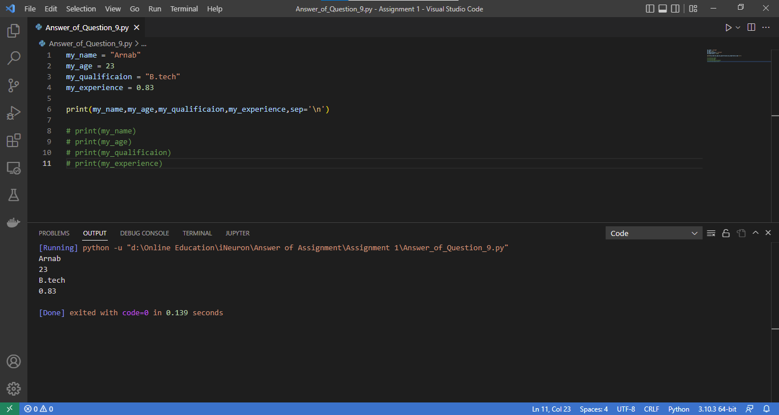

**10. Write a python script to print values of three variables, each in a new line. Variable contains integer values.**

