**Assignment-2: Python Basics**

**Q1. Write a python script to add comments and print “Learning Python” on screen.**

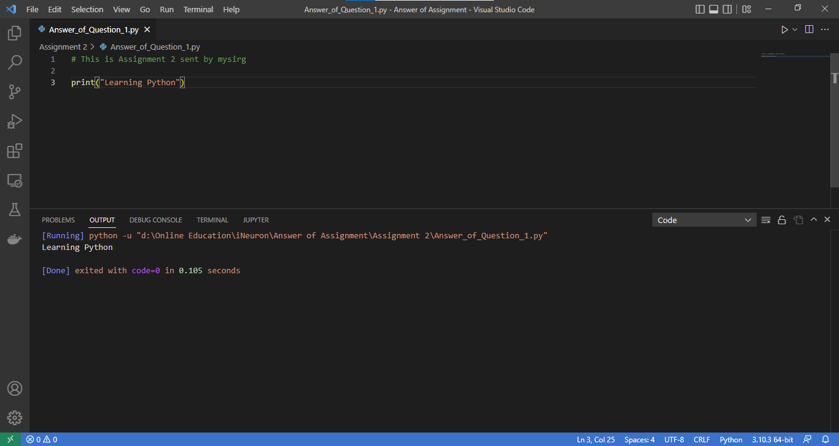

**Q2. Write a python script to add multi line comments and print values of four variables, each in a new line. Variable contains any values.**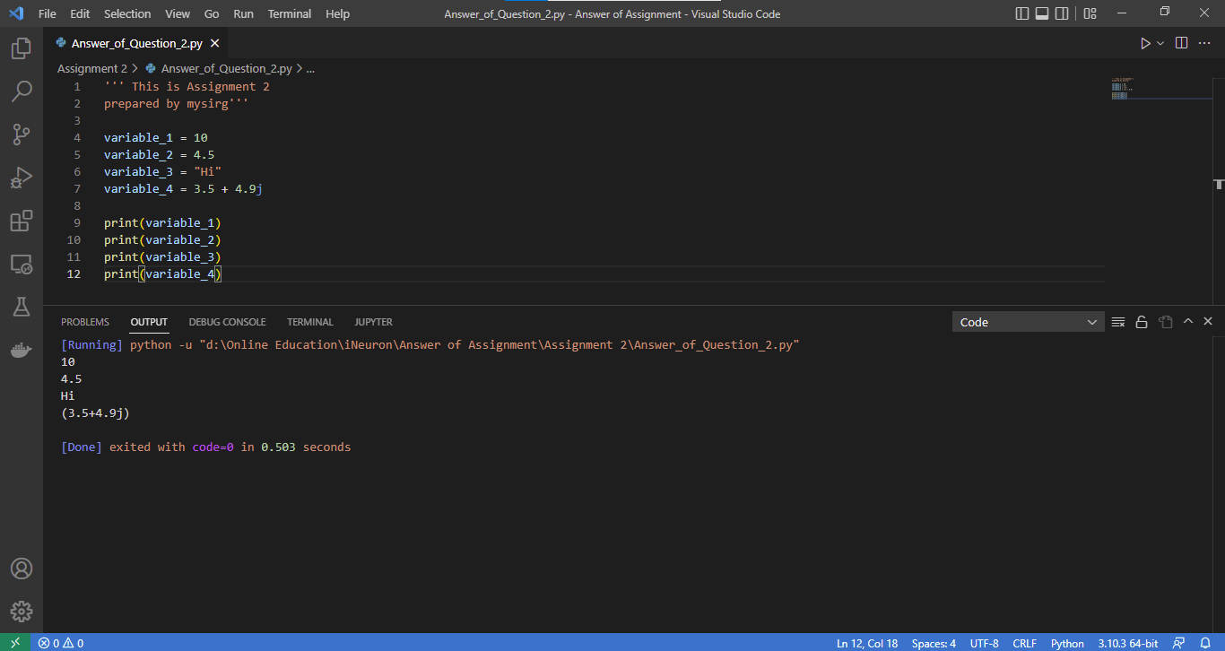

**Q3.** **Write a python script to print types of variables. Create 5 variables each of them containing different types of data. (like 35, True, “MySirG”,5.46, 3+4j, etc)**

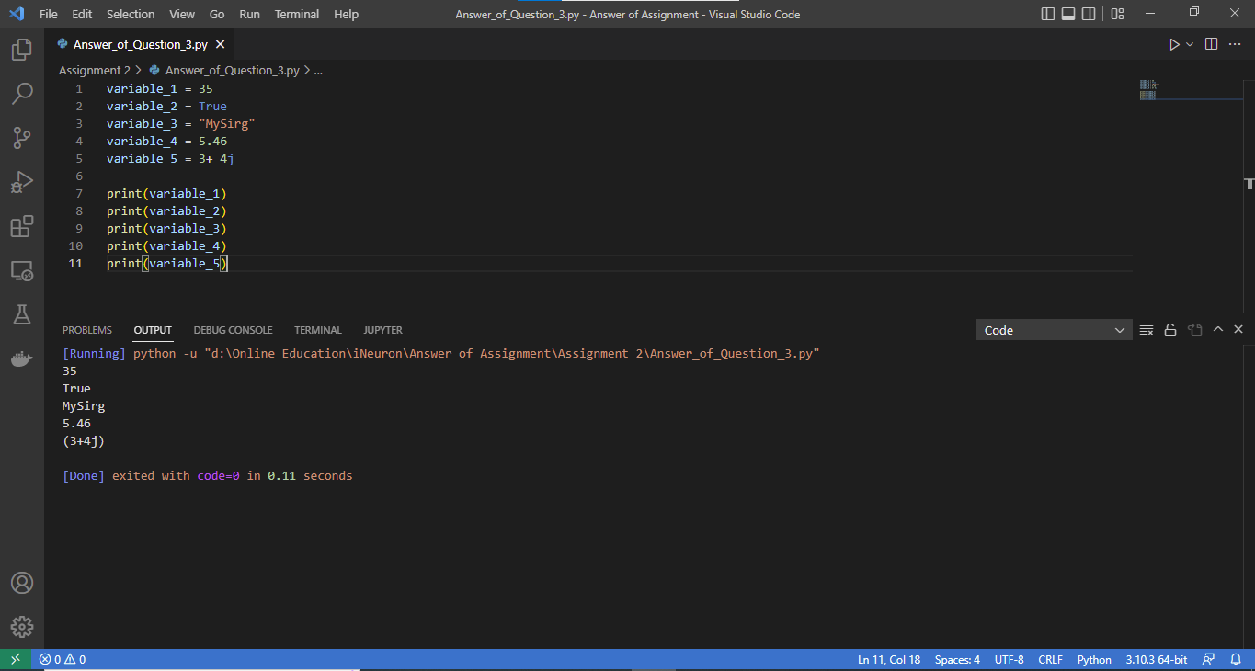

**Q4. Write a python script to print the id of two variables containing the same integer values.**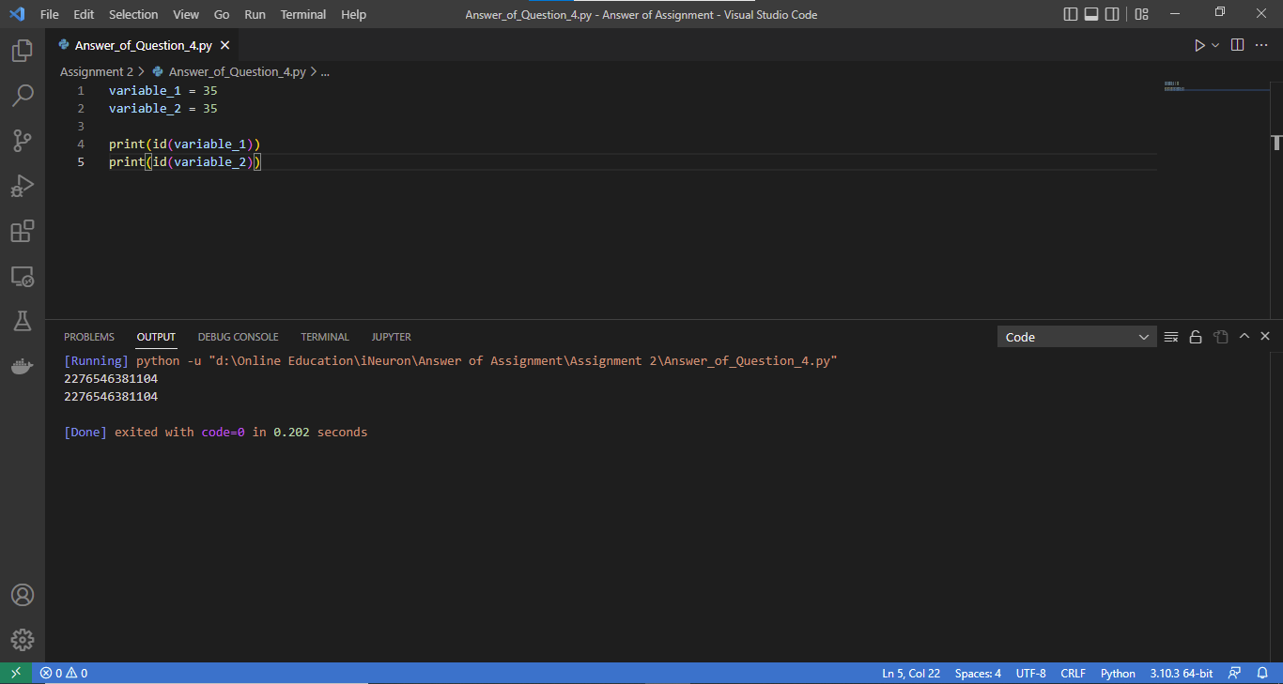

**Q5. Create four variables in a Python script and assign values of different data types to them. Write a Python script to print value, its type and id of each variable.**

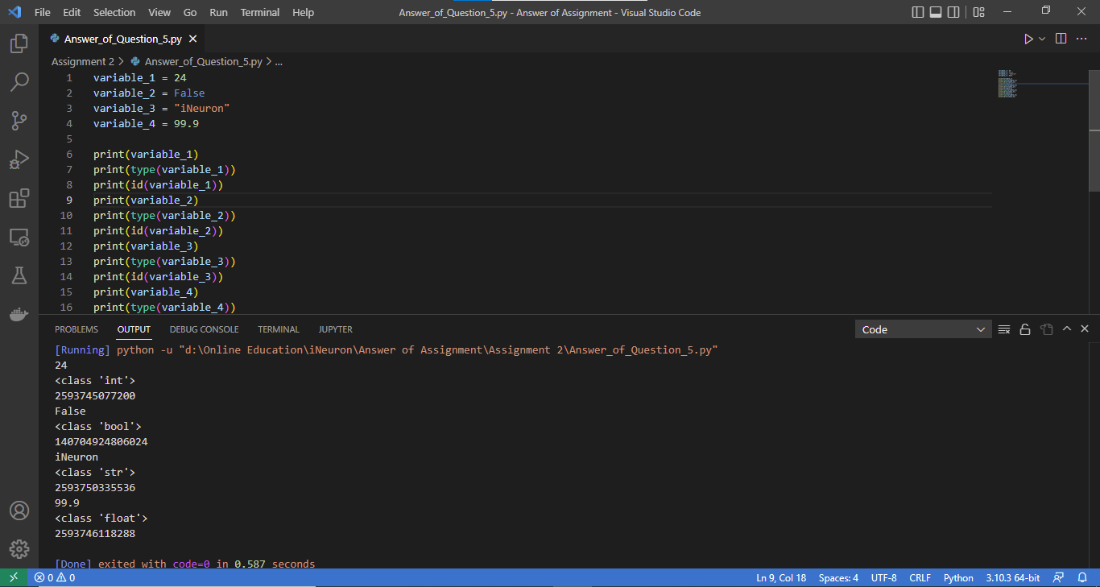

**Q6. Write a python script to print all the keywords.**

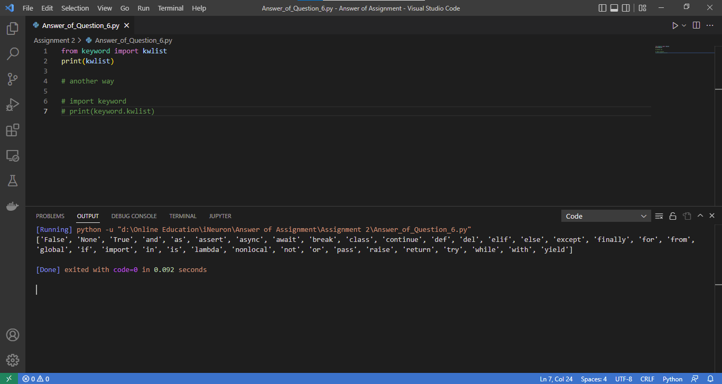

**Q7. On Python shell use help() function and display the list of keywords.**

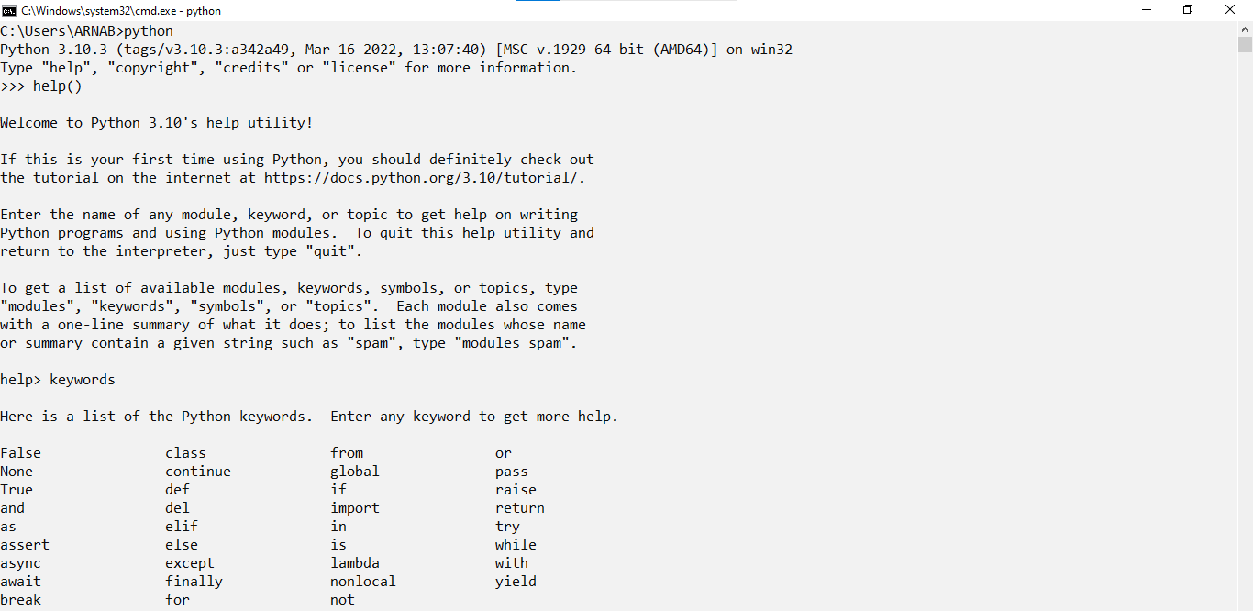

**Q8. Create two Python files A0.py and A1.py. Create a variable in A1.py and assign some value to it. Write a python script to import A1 module in A0 and print value of the variable created in A0.py.**

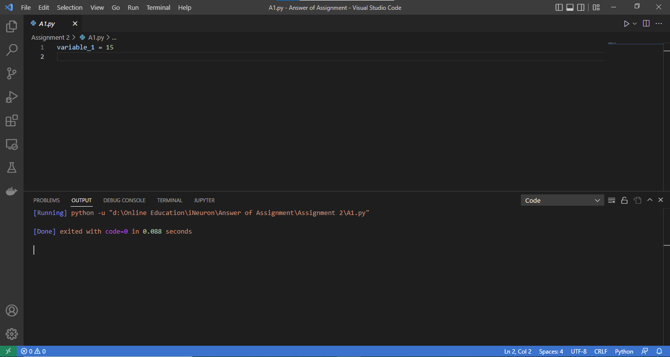

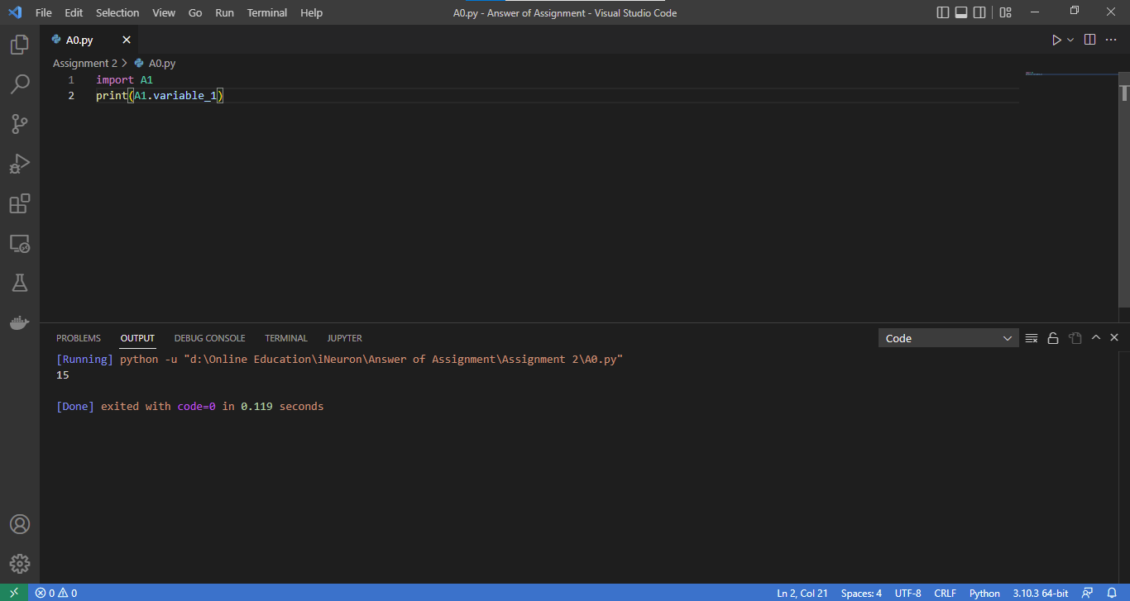

**Q9. Name the keywords, used as data in the Python script.**

**Ans:-** True; False; None.

**Q10. Write a python script to display the current date and time. First create variables to store date and time, then display date and time in proper format (like: 13-8-2022 and 9:00 PM).**

