Name: Arnab Sardar

Roll no. 30

EXERCISE 2

AIM : WORKING WITH PHOTO RETOUCHING

*WORKING PROCEDURE*

**STEP 1:** Open file boat.psd. Use Crop tool to discard the black border and align the image properly.

**STEP 2:** Use Levels function to improve brightness and contrast. Zoom on orange tarpaulin.

**STEP 3:** Use the Rectangular Marquee tool to draw a border around the orange tarpaulin. Use the Replace Color function to change the color

of orange tarpaulin to green by using the Eyedropper and Eyedropper plus tools to select the area of the tarpaulin and hue sliders to change color.

**STEP 4:** Use the Sponge tool to saturate the colors of the boat and neighbouring objects. Use the Clone Stamp tool to remove the unwanted boat in the background.

**STEP 5:** Use the Magic Wand tool to select the sky. Open the file CLOUD.PSD in Photoshop. In CLOUD image select the entire image and copy the selected image to memory. In BOAT image paste the cloud image from memory to the selected area. Use the Move tool to reposition the pasted sky image if necessary.

**STEP 6:** Save as .jpg and .psd format.

*Things we learnt ?*

1.How to crop properly.

2.How to change saturation and brightness.

3.How to remove unwanted elements in the image.

3.Using new tools : Crop tool, Magic wand tool, Clone stamp tool, Sponge tool, Eye dropper tool.

4.Working with multiple images in same psd file.

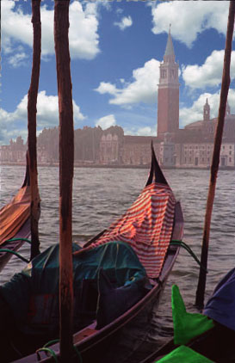5.Set image in appropriate places as need.