Name: Arnab Sardar

Roll no. 30

EXERCISE 3

AIM : WORKING WITH LAYERS

*WORKING PROCEDURE*

**STEP 1:** Open file keyboard.psd. Make the bearing and gauge layers visible by clicking to the left of the layer icons and open the clock.psd file.

**STEP 2:** Select the Magnetic Lasso tool. Move tool along border of the head to make selection. Save the selection.

**STEP 3:** Keeping the Clock layer selected, use the Magic Wand tool to select the white background portion of the clock and press DEL key to make its background transparent.

**STEP 4:** In the Layers palette change the blending mode of the Clock layer to Screen and make its opacity 80%, reposition the clock and bearing by dragging them to the right of the image using the Move tool.

Use the Transform function to rotate the clock and scale down its size.

**STEP 5:** Create a new layer just above the Background layer by selecting the background layer and clicking on the Create New Layer button at the bottom of the Layers palette, rename the new layer to Gradient Selecting the Gradient layer open the gradient editor by clicking on the Gradient tool. In the Gradient Editor click to select the red-green preset gradient.

Click below the middle of the red-green gradient bar to create a new color stop. From the color panel select a yellow color. Click on the New button to create a preset copy of the new gradient.

**STEP 6:** Select the Gradient layer in the Layers palette and using the gradient tool drag from top left corner of the image to the bottom right corner. Decrease opacity of gradient layer to 60% so that the keyboard is visible from below. Save as .jpg and .psd file.

*Things we learnt ?*

1.How to work with multiple layers.

2.How to change opacity of the layers.

3.How to use Transform function.

4.How to use gradient editor.

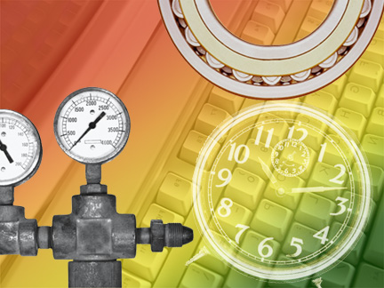5.Using new tools : Move tool, Magic wand tool.