Name: Arnab Sardar

Roll no. 30

EXERCISE 4

AIM : WORKING WITH SELECTION TOOLS

*WORKING PROCEDURE*

**STEP 1:** Open file veg.psd. Zoom on blueberry to 300%.

**STEP 2:** Select Elliptical Marquee tool. Drag selection tool from top-left to bottom-right of the blueberry to create a selection.Use Move tool to drag the blueberry onto orange carrot slice.

**STEP 3:** Make the selection around the carrot slice containing the blueberry. Zoom out to 100%, position the pointer within the selection, drag a duplicate of the eye onto the left side of the melon face Using Move tool, drag a copy of the eye from left side to the right side of the melon face.

**STEP 4:** Zoom to the green kiwi fruit to 200%, drag a selection around the green kiwi fruit. Zoom out to 100%, drag the selection onto the melon face at the position of the mouth, zoom in to 300% and set Tolerance to 50, select additional portions of the pear, zoom out.

**STEP 5:** Zoom to the yellow pasta. Using Polygonal Lasso tool to select boundary of pasta, zoom out and move the pasta to below the melon face, flatten the pasta by reducing its height.

**STEP 6:** Zoom in onto the mushroom and select boundary of mushroom. Add to the selection and subtract from the selection if necessary. Zoom out and move the mushroom above the melon face. Select the inner red portion of the grapefruit. Drag it near the melon.

**STEP 7:** Save as .jpg and .psd.

*Things we learnt ?*

1.How to select an image and integrate as per need to create a resultant image.

2. How to duplicate images to make a resultant image.

3.Using new tools : Zoom tool, Elliptical Marque tool, Magnetic Wand tool, Move tool, Magic wand tool, Polygonal Lasso tool, Lasso tool, Magnetic Lasso tool.

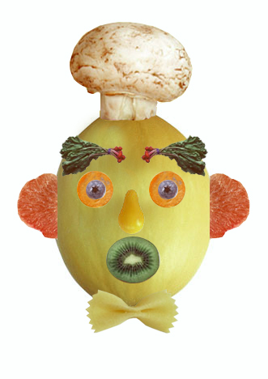4.Working with free transform properties.